**ATMA RAM SANATAN DHARMA COLLEGE**

**UNIVERSITY OF DELHI**



**DATABASE MANAGEMENT SYSTEMS**

**PRACTICAL FILE**

**SUBMITTED BY:**

**PIYUSH SOLANKI**

**COLLEGE ROLL NO: 21/18092**

**BSC (HONS) COMPUTER SCIENCE**

**SUBMITTED TO:**

**Ms. MANISHA BAGRI**

**DEPARTMENT OF COMPUTER SCIENCE**

**INDEX**

|  |  |
| --- | --- |
| SNO. | DESCRIPTION |
| 22. | Query to display Name , Department Name and Department No. for all the employees. |
| 23. | Query to display Unique listing of all Jobs that are in Department number 30. |
| 24. | Query to display Name , Dept Name of all employees who have an ‘A’ in their name. |
| 25. | Query to display Name , Job, Department no. and Department Name for all the employees working at the Dallas location. |
| 26. | Query to display Name and Employee no. Along with their supervisor’s Name and the supervisor’s employee no. ; along with the Employees’ Name who do not have a supervisor. |
| 27. | Query to display Name , Dept No. and Salary of any employee whose Department No. and Salary matches both the Department no. and the salary of any employee who earns a commission. |
| 28. | Query to display Name and Salaries represented by asterisks , where each asterisk (*) signifies $100. |
| 29. | Query to display the Highest , Lowest , Sum and Average Salaries of all the employees. |
| 30. | Query to display the number of employees performing the same Job type functions. |
| 31. | Query to display the total number of supervisors without  listing their names. |
| 32. | Query to display the Department Name, Location Name,  No. of Employees and the average salary for all  employees in that department. |
| 33. | Query to display Name and Hire Date for all employees  in the same dept. as Blake. |
| 34. | Query to display the Employee No. And Name for all  employees who earn more than the average salary. |
| 35. | Query to display Employee Number and Name for all  employees who work in a department with any  employee whose name contains a ‘T. |
| 36. | Query to display the names and salaries of all employees  who report to supervisor named ‘King’. |
| 37. | Query to display the department no, name and job for  all employees in the Sales department. |
| 38. | Display names of employees along with their  department name who have more than 20 years’  experience. |
| 39. | Display total number of departments at each location. |
| 40. | Find the department name in which at least 20  employees work in. |
| 41. | Query to find the employee’ name who is not supervisor  and name of supervisor supervising more than 5  employees. |
| 42. | Query to display the job type with maximum and  minimum employees. |

**DATABASE SCHEMA**

Relation : EMPLOYEE

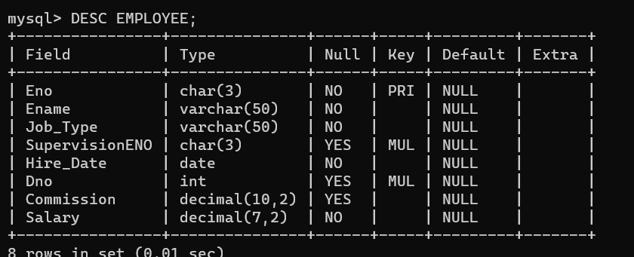

Relation : DEPARTMENT

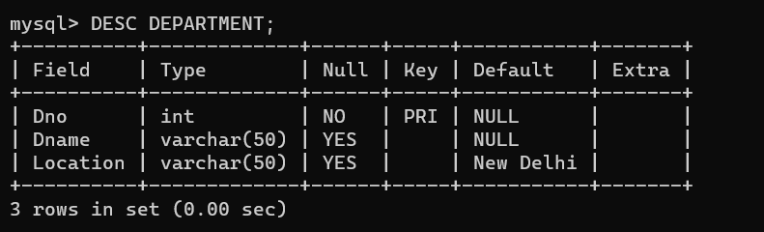

**DDL**

CREATE TABLE EMPLOYEE(

Eno CHAR(3) NOT NULL PRIMARY KEY,

Ename VARCHAR(50) NOT NULL ,

Job_Type VARCHAR(50) NOT NULL,

SupervisionENO CHAR(3) ,

Hire_Date DATE NOT NULL,

Dno INT , Commission DECIMAL(10,2) ,

Salary DECIMAL(7,2) NOT NULL);

CREATE TABLE DEPARTMENT(

Dno INT NOT NULL,

Dname VARCHAR(50) ,

Location VARCHAR(50) DEFAULT ‘New Delhi’ ,

PRIMARY KEY(Dno) );

ALTER TABLE EMPLOYEE

ADD CONSTRAINT SupervisionConstraint

FOREIGN KEY (SupervisionENO) REFERENCES EMPLOYEE(Eno);

ALTER TABLE DEPARTMENT

ADD CONSTRAINT DepartmentConstraint

FOREIGN KEY (Dno) REFERENCES DEPARTMENT(Dno);

**DML**

INSERT INTO DEPARTMENT VALUES(10,'Headquarters' ,'Mumbai'),(45,'Legal','Mumbai'),(30,'IT','Bengaluru'),(20,'Outreach','Dallas'),(95,'Purchase','Dallas');

INSERT INTO DEPARTMENT (Dno ,Dname) VALUES(90,'Sales'),(40,'Administration'),(50,'Research');

INSERT INTO EMPLOYEE

VALUES('811','Shay Restieaux','Lawyer','232','1999-04-16',45,574.69,500.22),

('823','Marcille Occleshaw','Lawyer','232','2003-12-27',45,574.68,507.10),

('832','Desiri Allott','Payment Coordinator','89','2007-11-03',95,239.84,683.09),

('87','Blake Lewis','Sales Intern','86','2008-05-02',90,125.45,921.37),

('997','Mag Giacomo','Tech Intern','23','2009-05-12',30,NULL,200.80);

INSERT INTO EMPLOYEE

VALUES ('763','Rodrick Haighton','Computer System Engineer','23','2005-05-08',30,NULL,627.74),

('981','Nina Fisby','System Analyst','23','2017-07-26',30,324.39,920.84),

('809','Cornie Munby','Software Consultant','23','1986-06-07',30,NULL,688.37),

('915','Layton Murrie','Graphic Designer','23','2006-06-24',30,NULL,640.31),

('498','Skell Woolerton','Software Tester','23','2004-04-04',30,NULL,506.44),

('842','Rivy Buzek','Help Desk Technician',NULL,'1982-05-25',30,NULL,295.31);

INSERT INTO EMPLOYEE

VALUES('778','John Smith','Managing Director',NULL,'1980-06-12',10,NULL,5800.23),

('153','Andy Beaford','VP Accounting','778','2000-09-08',40,NULL,502.30),

('23','Piyush Solanki','SDE Manager','778','2001-09-19',30,NULL,2465.92),

('25','Jatin Solanki','Accounts Manager','778','2003-03-01',40,NULL,2865.92),

('86','Tania Chauhan','Sales Manager','778','1983-08-14',90,235.90,2921.37),

('89','Alicia Jones','Purchase Manager','778','1982-10-26',95,NULL,980.35),

('232','Isa Haques','Legal Manager','778','1996-07-23',45,NULL,651.05);

**QUERY 22**

**Description**

**Query to display Name, Department Name and Department No for all the employees.**

**Query along with result:  
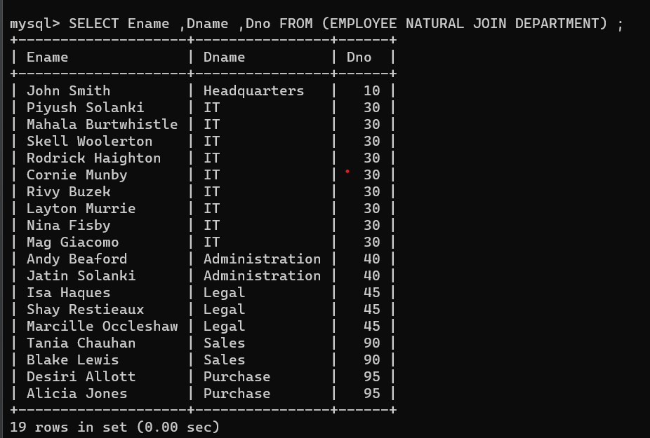**

**QUERY 23**

**Description**

**Query to display Unique Listing of all Jobs that are in Department number 30.**

**Query along with result:**

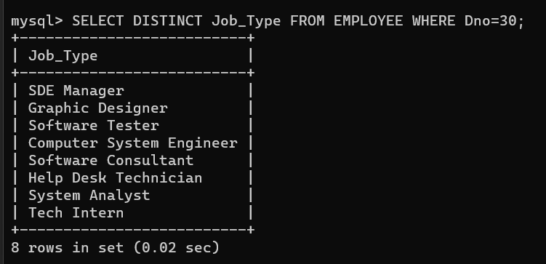

**QUERY 24**

**Description**

**Query to display Name, Dept Name of all employees who have an ‘A’ in their name.**

**Query along with result:**

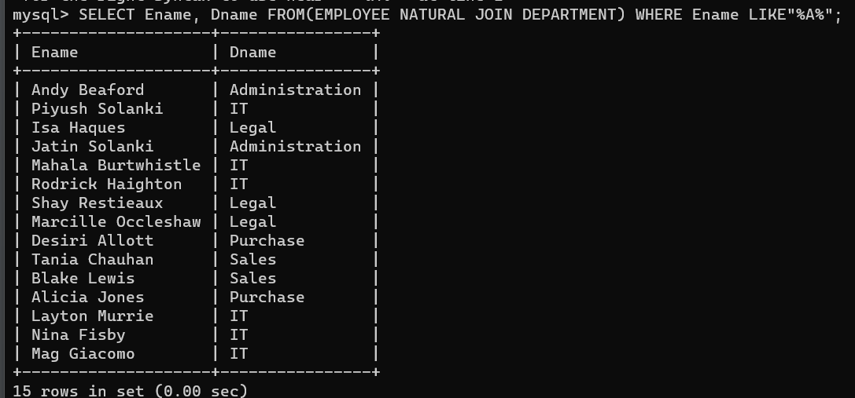

**QUERY 25**

**Description**

**Query to display Name, Job, Department No. And Department Name for all the employees working at the Dallas location.**

**Query along with result:**

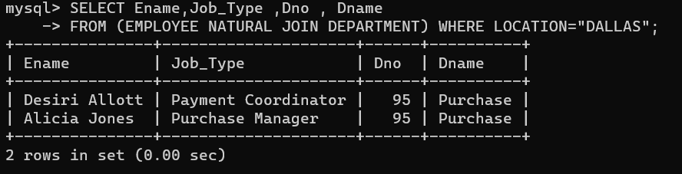

**QUERY 26**

**Description**

**Query to display Name and Employee no. Along with their supervisor’s Name and the supervisor’s employee no; along with the Employees’ Name who do not have a supervisor.**

**Query along with result:**

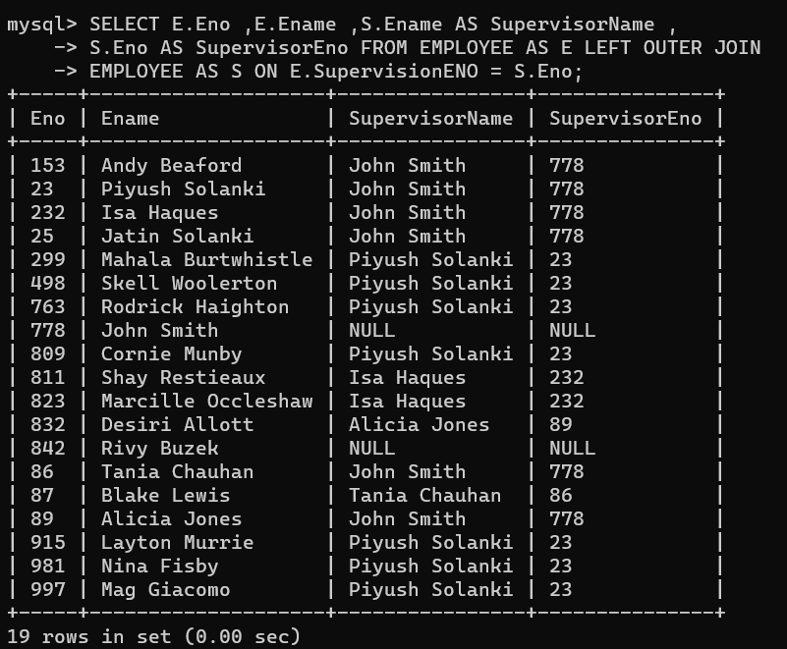

**QUERY 27**

**Description**

**Query to display Name, Dept No. And Salary of any employee whose department No. and salary matches both the department no. And the salary of any employee who earns a commission.**

**Query along with result:  
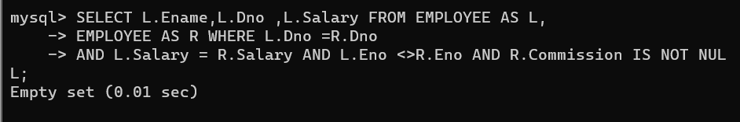**

**QUERY 28**

**Description**

**Query to display Name and Salaries represented by asterisks, where each asterisk (*) signifies $100.**

**Query along with result:  
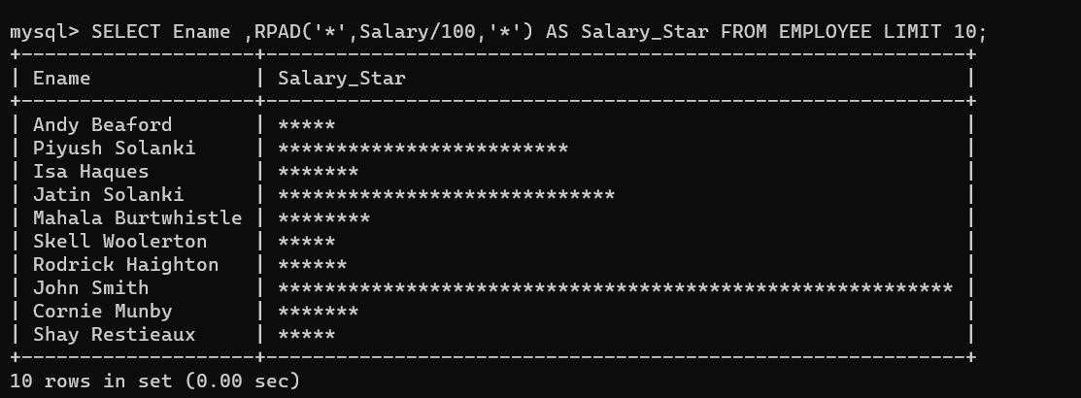**

**QUERY 29**

**Description**

**Query to display the Highest, Lowest, Sum and Average Salaries of all the employees.**

**Query along with result:**

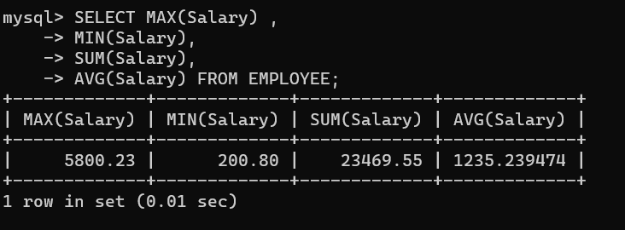

**QUERY 30**

**Description**

**Query to display the number of employees performing the same Job type functions.**

**Query along with result:**

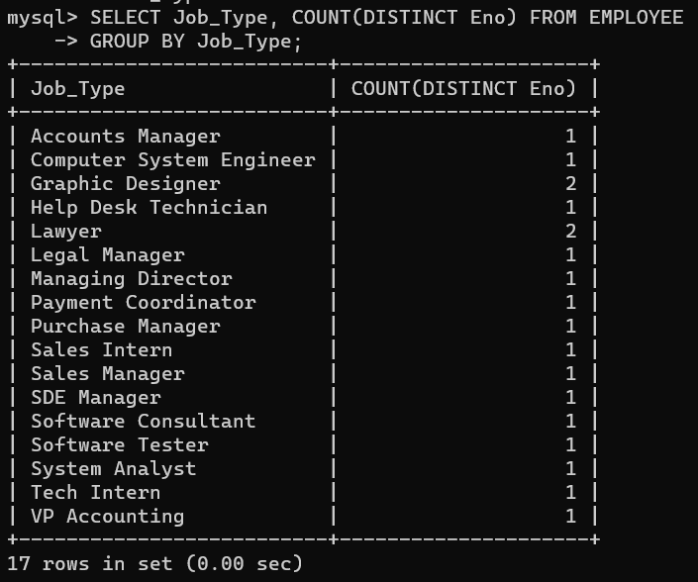

**QUERY 31**

**Description**

**Query to display the total number of supervisors without listing their names.**

**Query along with result:**

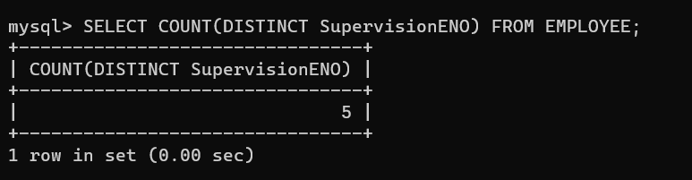

**QUERY 32**

**Description**

**Query to display the Department Name, Location Name, No. of Employees and the average salary**

**for all employees in that department.**

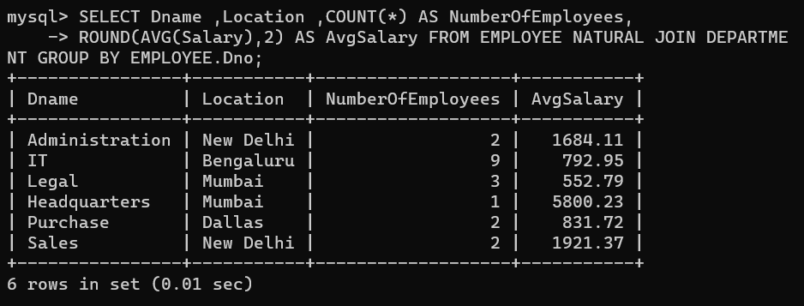

**QUERY 33**

**Description**

**Query to display Name and Hire Date for all employees in the same department as Blake.**

**Query along with result:**

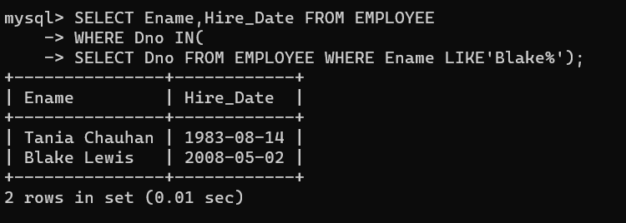

**QUERY 34**

**Description**

**Query to display the Employee No. And Name for all employees who earn more than the average**

**salary.**

**Query along with result:**

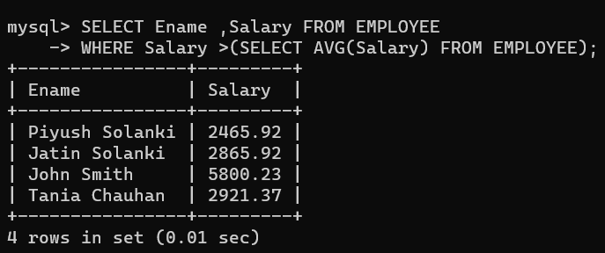

**QUERY 35**

**Description**

**Query to display Employee Number and Name for all employees who work in a department with any**

**employee whose name contains a ‘T’.**

**Query along with result:**

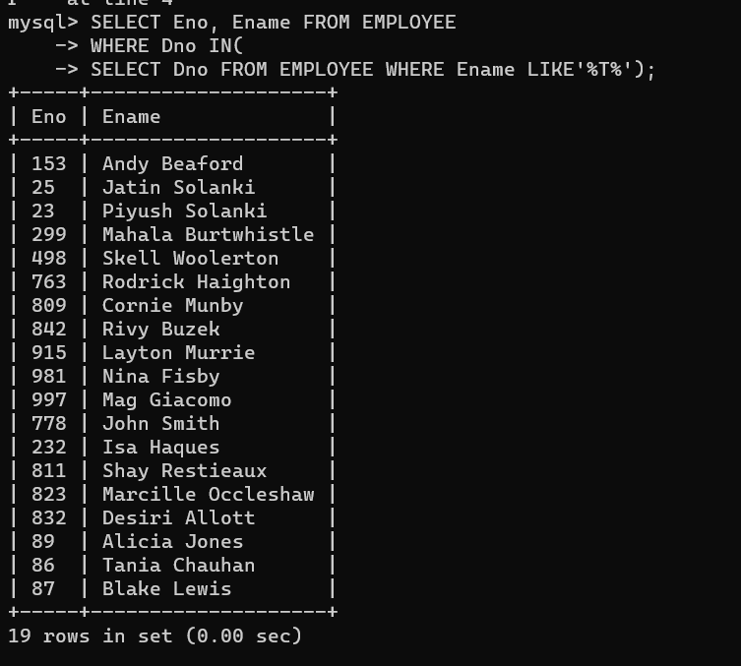

**QUERY 36**

**Description**

**Query to display the names and salaries of all employees who report to supervisor named ‘King’.**

**Query along with result:**

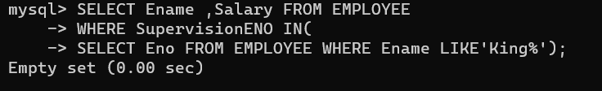

**QUERY 37**

**Description**

**Query to display the department no, name and job for all employees in the Sales department.**

**Query along with result:**

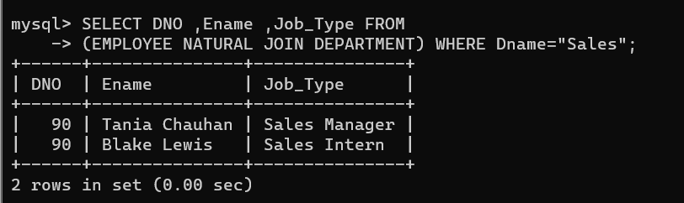

**QUERY 38**

**Description**

**Display names of employees along with their department name who have more than 20 years’**

**experience.**

**Query along with result:**

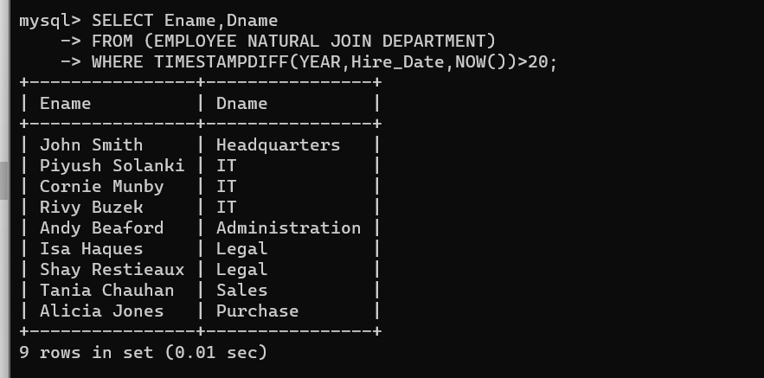

**QUERY 39**

**Description**

**Display total number of departments at each location.**

**Query along with result:**

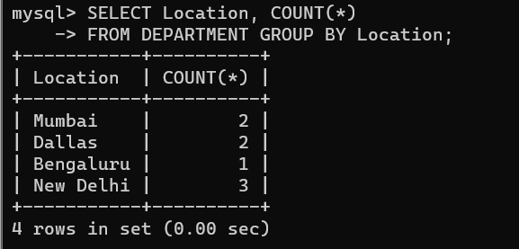

**QUERY 40**

**Description**

**Find the department name in which at least 5 employees work in.Query along with result:**

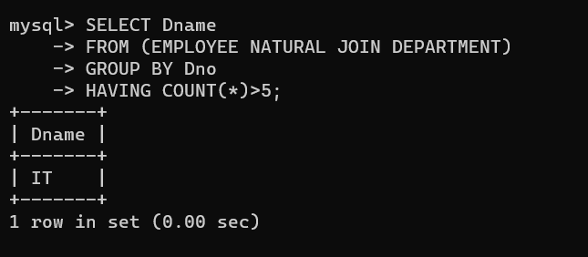

**QUERY 41**

**Description**

**Query to find the employees’ name who is not supervisor and name of supervisor supervising more**

**than 5 employees.**

**Query along with result:**

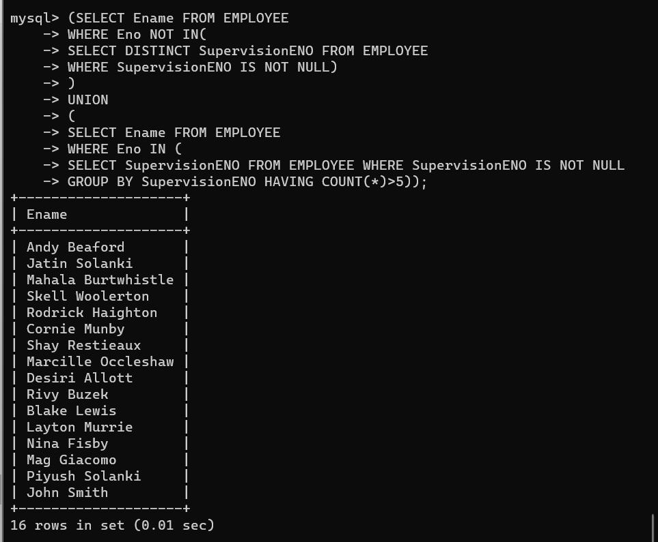

**QUERY 42**

**Description**

**Query to display the job type with maximum and minimum employees.**

**Query along with result:**

