**AATMA RAM SANTAN DHARMA COLLEGE**

**DELHI UNIVERSITY**



**DISCRETE STRUCTURES**

**PRACTICAL FILE**

SUBMITTED BY:- PIYUSH SOLANKI

ROLL NO:- 21/18092

SUBMITTED TO:- DR. SHALINI GUPTA

**INDEX**

1. WRITE A PROGRAM TO CREATE A SET “A” AND DETERMINE THE CARDINALITY OF THE SET FOR AN INPUT ARRAY OF ELEMENTS (REPETITION ALLOWED) AND PERFORM THE FOLLOWING OPERATIONS ON THE SET:

i) IsMember(a, A): CHECK WHETHER AN ELEMENT BELONGS TO SET OR NOT AND RETURN VALUE AS TRUE/FALSE.

ii)powerSet(A): LIST ALL THE ELEMENTS OF POWER SET OF A.

2. CREATE A CLASS SET AND TAKE TWO STES AS INPUT FROM THE USER TO PERFORM FOLLOWING OPERATIONS:

i) SUBSET: CHECK WHETHER ONE SET IS A SUBSET OF OTHERS OR NOT.

ii)UNION AND INTERSECTION OF TWO SETS.

iii)COMPLEMENT: ASSUME UNIVERSAL SET AS PER THE INPUTS ELEMENTS FROM THE USER.

iv)SET DIFFERENCE AND SYMMETRIC DIFFERENCE BETWEEN TWO SETS.

v)CARTESIAN PRODUCT OF SETS.

3. CREATE A CLASS RELATION , AND USE MATRIX NOTATION TO REPRESENT A RELATION.INCLUDE FUNCTIONS TO CHECK IF RELATION IS REFLEXIVE, SYMMETRIC, ANTI SYMMETRIC AND TRANSITIVE. WRITE A PROGRAM TO USE THIS CLASS.

4.USE THE FUNCTIONS DEFINED IN QUESTION 3 TO CHECK WHETHER GIVEN RELATION IS:

i) EQUIVALENT

ii)PARTIAL ORDER RELATION

iii) NONE

5. WRITE A PROGRAM TO GENERATE FIBONACCI SERIES USING RECURSION.

6.WRITE A PROGRAM TO IMPLEMENT TOWER OF HANOI USING RECURSION.

7.WRITE A PROGRAM TO IMPLEMENT BINARY SEARCH USING RECURSION.

8.WRITE A PROGRAM TO IMPLEMENT BUBBLE SORT.FIND THE NUMBER OF COMPARISONS DURING EACH PASS AND DISPLAY INTERMEDIATE RESULT.

9.WRITE A PROGRAM TO IMPLEMENT INSERTION SORT. FIND THE NUMBER OF COMPARISONS DURING EACH PASS AND DISPLAY INTERMEDIATE RESULT.

10. WRITE A PROGRAM THAT GENERATES ALL THE PERMUTATIONS OF A GIVEN SET OF DIGITS, WITH OR WITHOUT REPETITION.

11.WRITE A PROGRAM TO CALCULATE PERMUTATION AND COMBINATION FOR AN INPUT VALUE n AND r USING RECURSIVE FORMULA nCr AND nPr.

12.FOR ANY NUMBER n , WRITE A PROGRAM TO LIST ALL THE SOLUTIONS OF THE EQUATION x1+x2+x3+….+xn=C WHERE C IS CONSTANT (C<=10).

13.WRITE A PROGRAM TO ACCEPT THE TRUTH VALUES OF VARIABLES x AND y AND PRINT TRUTH TABLE FOR FOLLOWING:

i) CONJUCTION ii)DISJUNCTION iii)EXCLUSIVE OR iv)CONDITIONAL v)BICONDITIONAL vi)EXCLUSIVE NOR vii)NEGATION viii)NAND ix)NOR

14.WRITE A PROGRAM TO REPRESENT GRAPHS USING ADJACENCY MATRIX AND CHECK IF IT IS COMPLETE OR NOT.

15.WRITE A PROGRAM TO TAKE INPUT OF DIRECTED GRAPH AND CALCULATE INDEGREE AND OUTDEGREE OF EACH VERTEX.

16.GIVEN AN ADJACENCY MATRIX OF A GRAPH,WRITE A PROGRAM TO CHECK WHETHER A GIVEN SET OF VERTICES {v1,v2,v3,….vn} FORMS AND EULER PATH OR EULER CIRCUIT OR BOTH.

17. GIVEN A FULL m-arry TREES WITH I INTERNAL VERTICES. WRITE A PROGRAM TO FIND NUMBER OF LEAF NODES.

18. WRITE A PROGRAM TO STORE A FUNCTION (POLYNOMIAL / EXPONENTIAL), AND THEN EVALUATE THE POLYNOMIAL.

1. WRITE A PROGRAM TO CREATE A SET “A” AND DETERMINE THE CARDINALITY OF SET FOR AN INPUT ARRAY OF ELEMENTS (REPITION ALLOWED) AND PERFORM THE FOLLOWING OPERATIONS ON THE SET:

i) IsMember(a,A): CHECK WHETHER AN ELEMENT BELONGS TO SET OR NOT AND RETURN VALUE AS TRUE/FALSE.

ii)powerSet(A): LIST ALL THE ELEMENTS OF POWER SET OF A.

SOL:

#include <iostream>

#include <math.h>

#include <iomanip>

using namespace std;

bool ismember(int size,int A[])

{

int a;

cout << "\nEnter the element to be searched: ";

cin >> a;

for(int i=0;i<size;i++)

{

if(A[i]==a)

return true;

}

return false;

}

void print(char code[],int arr[], int n)

{

int i;

cout << "\t{";

for(i=0; i<n; i++)

{

if(code[i] == '1')

cout << arr[i] << " ";

}

cout << "}";

cout << " {";

for(i=0; i<n; i++)

{

if(code[i] == '0')

cout << arr[i] << " ";

}

cout << "}\n";

}

void genUnionSet(int arr[], int n)

{

int i,r,l;

char binary[n];

r=pow(2,n-1);

for(i=0; i<n; i++)

binary[i]='0';

for(i=0; i<r; i++)

{

print(binary, arr, n);

l=n-1;

h:

if(binary[l] == '0')

binary[l]='1';

else

{

binary[l]='0';

l--;

goto h;

}

}

}

int main()

{

bool x;

int size;

char ch = 'Y';

while(ch == 'Y')

{

cout << "\nEnter the size of set: ";

cin >> size;

int A[size];

cout << "\nEnter the elements: ";

for(int i=0;i<size;i++)

{

cin >> A[i];

}

x=ismember(size,A);

if(x==true)

cout << "\n\tValue is present!!!";

else

cout << "\n\tValue is not present!!!";

cout << "\n\nThe possible subset pairs\n" << endl;

genUnionSet(A,size);

cout << "\nDo you want to continue? (Y/N): ";

cin >> ch;

}

cout << "\n@@@@EXITING@@@";

return 0;

}

Output:

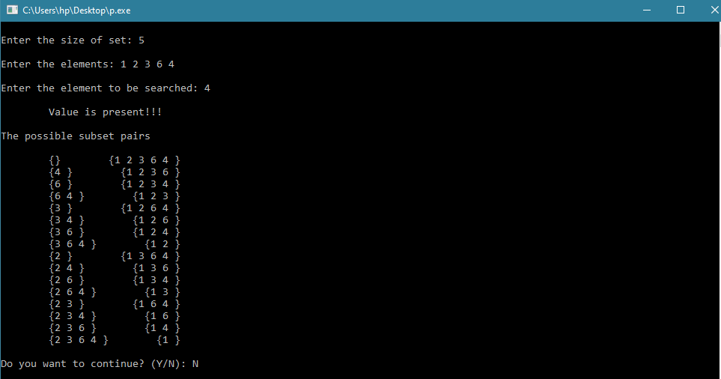

2. CREATE A CLASS SET AND TAKE TWO STES AS INPUT FROM THE USER TO PERFORM FOLLOWING OPERATIONS:

i) SUBSET: CHECK WHETHER ONE SET IS A SUBSET OF OTHERS OR NOT.

ii)UNION AND INTERSECTION OF TWO SETS.

iii)COMPLEMENT: ASSUME UNIVERSAL SET AS PER THE INPUTS ELEMENTS FROM THE USER.

iv)SET DIFFERENCE AND SYMMETRIC DIFFERENCE BETWEEN TWO SETS.

v)CARTESIAN PRODUCT OF SETS.

Sol:

#include <iostream>

using namespace std;

class SET

{

private:

int i,j;

public:

void Subset(int *arrA, int sizeA, int *arrB, int sizeB)

{

int c=0;

for(i=0; i<sizeA; i++)

for(j=0; j<sizeB; j++)

if(arrA[i] == arrB[j])

c++;

if(c != sizeA)

cout << "SET A is not a subset of SET B" << endl;

else

cout << "SET A is a subset of SET B" << endl;

int c1=0;

for(i=0; i<sizeB; i++)

for(j=0; j<sizeA; j++)

if(arrB[i] == arrA[j])

c1++;

if(c != sizeB)

cout << "SET B is not a subset of SET A" << endl;

else

cout << "SET B is a subset of SET A" << endl;

cout << "-------------------------------------------------" << endl;

}

void UnionInter(int *setA, int sizeA, int *setB, int sizeB)

{

int uSize=sizeA+sizeB;

int uSet[uSize];

int unionSet[uSize];

int iSet[uSize];

int x=0,y=0;

for(i=0; i<sizeA; i++)

{

uSet[x]=setA[i];

x++;

}

for(i=0; i<sizeB; i++)

{

uSet[x]=setB[i];

x++;

}

for(i=0; i<x; i++)

{

for(j=i+1; j<x; j++)

{

if(uSet[i] == uSet[j])

{

iSet[y]=uSet[i];

y++;

for(int k=j; k<x-1; k++)

uSet[k]=uSet[k+1];

x--;

}

else

continue;

}

}

cout << "Union of two sets is : {";

for(i=0; i<x; i++)

cout << uSet[i] << " ";

cout << "}";

cout << endl;

if(y != 0)

{

cout << "Intersection of two sets is : {";

for(i=0; i<y; i++)

cout << iSet[i] << " ";

cout << "}";

}

else

cout << "No intersection found";

cout << endl;

cout << "-------------------------------------------------" << endl;

}

void Complement(int *setA, int sizeA, int *setB, int sizeB)

{

int sizeU;

cout << "Enter the no. of elements of universal set : ";

cin >> sizeU;

cout << "Enter the elemnts of universal set : ";

int U[sizeU];

for(i=0; i<sizeU; i++)

cin >> U[i];

int AC[sizeU],p=0,c=0;

for(i=0; i<sizeU; i++)

{

for(j=0; j<sizeA; j++)

{

if(U[i] == setA[j])

c++;

else

continue;

}

if(c == 0)

{

AC[p]=U[i];

p++;

}

c=0;

}

cout << endl;

cout << "Complement of SET A is : {";

for(i=0; i<p; i++)

cout << AC[i] << " ";

cout << "}" << endl;

int BC[sizeU],q=0,ctr=0;

for(i=0; i<sizeU; i++)

{

for(j=0; j<sizeB; j++)

{

if(U[i] == setB[j])

ctr++;

else

continue;

}

if(ctr == 0)

{

BC[q]=U[i];

q++;

}

ctr=0;

}

cout << "Complement of SET B is : {";

for(i=0; i<q; i++)

cout << BC[i] << " ";

cout << "}" << endl;

cout << "-------------------------------------------------" << endl;

}

void setNSymDiff(int *setA, int sizeA, int *setB, int sizeB)

{

int ABDif[100],q=0,ctr=0;

for(i=0; i<sizeA; i++)

{

for(j=0; j<sizeB; j++)

{

if(setA[i] == setB[j])

ctr++;

else

continue;

}

if(ctr == 0)

{

ABDif[q]=setA[i];

q++;

}

ctr=0;

}

cout << "Set difference A-B is : {";

for(i=0; i<q; i++)

cout << ABDif[i] << " ";

cout << "}" << endl;

int BADif[100],p=0,c=0;

for(i=0; i<sizeB; i++)

{

for(j=0; j<sizeA; j++)

{

if(setB[i] == setA[j])

c++;

else

continue;

}

if(c == 0)

{

BADif[p]=setB[i];

p++;

}

c=0;

}

cout << "Set difference B-A is : {";

for(i=0; i<p; i++)

cout << BADif[i] << " ";

cout << "}" << endl;

int uSize=q+p;

int symDif[uSize];

int x=0,y=0;

for(i=0; i<q; i++)

{

symDif[x]=ABDif[i];

x++;

}

for(i=0; i<p; i++)

{

symDif[x]=BADif[i];

x++;

}

cout << "Symmetric difference b/w two sets is : {";

for(i=0; i<x; i++)

cout << symDif[i] << " ";

cout << "}";

cout << endl;

cout << "-------------------------------------------------" << endl;

}

void cartesianPro(int *setA, int sizeA, int *setB, int sizeB)

{

int sizeAB,sizeBA,x=0,y=0;

sizeAB=sizeA*sizeB;

sizeBA=sizeAB;

int AB[sizeAB*2],BA[sizeBA*2];

for(i=0; i<sizeA; i++)

{

for(j=0; j<sizeB; j++)

{

AB[x++]=setA[i];

AB[x++]=setB[j];

}

}

for(i=0; i<sizeB; i++)

{

for(j=0; j<sizeA; j++)

{

BA[y++]=setB[i];

BA[y++]=setA[j];

}

}

cout << "A X B = { ";

for(i=0; i<x; i++)

{

if(i%2 == 0)

cout << "(";

cout << AB[i] << " ";

if(i%2 != 0)

cout << ")";

}

cout << " }" << endl;

cout << "B X A = { ";

for(i=0; i<y; i++)

{

if(i%2 == 0)

cout << "(";

cout << BA[i] << " ";

if(i%2 != 0)

cout << ")";

}

cout << " }" << endl;

cout << "-------------------------------------------------" << endl;

}

};

int main()

{

cout << endl;

int i,sizeA,sizeB;

cout << "Enter the no. of elements in SET A : ";

cin >> sizeA;

int arrA[sizeA];

cout << "Enter the elements : ";

for(i=0; i<sizeA; i++)

cin >> arrA[i];

cout << "Enter the no. of elements in SET B : ";

cin >> sizeB;

int arrB[sizeB];

cout << "Enter the elements : ";

for(i=0; i<sizeB; i++)

cin >> arrB[i];

cout << "-------------------------------------------------" << endl;

SET ob;

cout << "\tSUBSET\n" << endl;

ob.Subset(arrA, sizeA, arrB, sizeB);

cout << "\tUNION and INTERSECTION\n" << endl;

ob.UnionInter(arrA, sizeA, arrB, sizeB);

cout << "\tCOMPLEMENT\n" << endl;

ob.Complement(arrA, sizeA, arrB, sizeB);

cout << "\tSET and SYMMETRIC DIFFERENCE\n" << endl;

ob.setNSymDiff(arrA, sizeA, arrB, sizeB);

cout << "\tCARTESIAN PRODUCT\n" << endl;

ob.cartesianPro(arrA, sizeA, arrB, sizeB);

return 0;

}

Output:

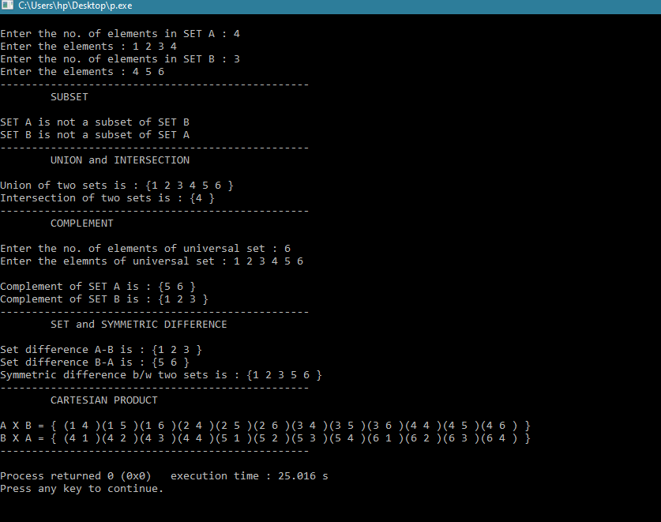

3. CREATE A CLASS RELATION , AND USE MATRIX NOTATION TO REPRESENT A RELATION.INCLUDE FUNCTIONS TO CHECK IF RELATION IS REFLEXIVE, SYMMETRIC, ANTI SYMMETRIC AND TRANSITIVE. WRITE A PROGRAM TO USE THIS CLASS.

Sol:

#include<iostream>

#include<stdio.h>

#include<conio.h>

using namespace std;

class RELATION

{

private:

int i,j,k,x,y,z,ctr,iA,iB,nA,nR,*A,*R,**RM,**T;

public:

void empty();

int inputSet();

void inputRelation();

void printSet();

void printRelation();

void Matrix();

int reflexive();

int symmetric();

bool antiSymmetric();

bool transitive();

};

void RELATION::empty()

{

cout << "Set A is empty\n";

printSet();

cout << "Set A has no member.";

cout << "\nHence, relation R is empty.\n";

nR = 0;

printRelation();

cout << "Therefore, no matrix notation.";

cout << "\nRelation R is NOT REFLEXIVE.";

symmetric();

antiSymmetric();

transitive();

}

int RELATION::inputSet()

{

cout << "Enter the size of SET A : ";

cin >> nA;

A = new int[nA];

if(nA == 0)

return 1;

cout << "Enter the elements : ";

for(i=0; i<nA; i++)

cin >> A[i];

}

void RELATION::inputRelation()

{

cout << "Enter the no of relations (R on A) : ";

cin >> nR;

R = new int[nR * 2];

cout << "Enter the relations in pair :\n";

for(i=0; i<nR*2; i++)

cin >> R[i];

}

void RELATION::printSet()

{

cout << "A = {";

for(i=0; i<nA; i++)

cout << A[i] << " ";

cout << "}\n";

}

void RELATION::printRelation()

{

cout << "R = {";

for(i=0; i<nR*2; i++)

{

if(i%2 == 0)

cout << "(";

cout << R[i] << " ";

if(i%2 != 0)

cout << ")";

}

cout << "}\n";

}

void RELATION::Matrix()

{

cout << "\nMATRIX NOTATION\n\n";

RM = new int *[nA];

for(i=0; i<nA; i++)

RM[i]=new int[nA];

for(i=0; i<nA; i++)

{

for(j=0; j<nA; j++)

{

RM[i][j]=0;

}

}

for(i=0; i<nR*2; i+=2)

{

for(j=0; j<nA; j++)

{

if(R[i] == A[j])

{

iA=j;

break;

}

}

for(k=0; k<nA; k++)

{

if(R[i+1] == A[k])

{

iB=k;

break;

}

}

RM[iA][iB]=1;

}

cout << " ";

for(int x=0; x<nA; x++)

cout << " " << A[x] << " ";

cout << endl << endl;

for(i=0; i<nA; i++)

{

cout << A[i] << " | ";

for(j=0; j<nA; j++)

{

cout << RM[i][j] << " ";

}

cout << "|";

cout << endl;

}

}

int RELATION::reflexive()

{

x=0;

for(i=0; i<nA; i++)

{

if(RM[i][i] == 1)

x++;

}

if(x == nA)

{

cout << "\nRelation R is REFLEXIVE.";

return x = 0;

}

else

{

cout << "\nRelation R is NOT REFLEXIVE.";

return x = 1;

}

}

int RELATION::symmetric()

{

ctr = 0;

for(i=0; i<nA; i++)

{

for(j=0; j<nA; j++)

{

if(RM[i][j] == RM[j][i])

continue;

else

{

ctr++;

break;

}

}

}

if(ctr != 0)

cout << "\nRelation R is NOT SYMMETRIC.";

else

cout << "\nRelation R is SYMMETRIC.";

return ctr;

}

bool RELATION::antiSymmetric()

{

bool flag = true;

for(i=0; i<nR*2; i+=2)

{

for(j=0; j<nR*2; j+=2)

{

if((R[i] == R[j+1]) && (R[i+1] == R[j]))

if(R[i] == R[i+1])

{

continue;

}

else

{

flag = false;

}

}

}

if(flag != true)

cout << "\nRelation R is NOT ANTI-SYMMETRIC.";

else

cout << "\nRelation R is ANTI-SYMMETRIC.";

return flag;

}

bool RELATION::transitive()

{

bool flag = true;

for(i=0; i<nR*2; i+=2)

{

for(j=0; j<nR*2; j+=2)

{

if(R[i+1] == R[j])

for(k=0; k<nR*2; k+=2)

{

if((R[k] == R[i]) && (R[k+1] == R[j+1]))

{

flag = true;

break;

}

else

flag = false;

}

}

}

if(flag != true)

cout << "\nRelation R is NOT TRANSITIVE.";

else

cout << "\nRelation R is TRANSITIVE.";

return flag;

}

int main()

{

int p = 0;

RELATION ob;

p = ob.inputSet();

if(p == 1)

ob.empty();

else

{

ob.printSet();

ob.inputRelation();

ob.printRelation();

ob.Matrix();

ob.reflexive();

ob.symmetric();

ob.antiSymmetric();

ob.transitive();

}

return 0;

}

Output:

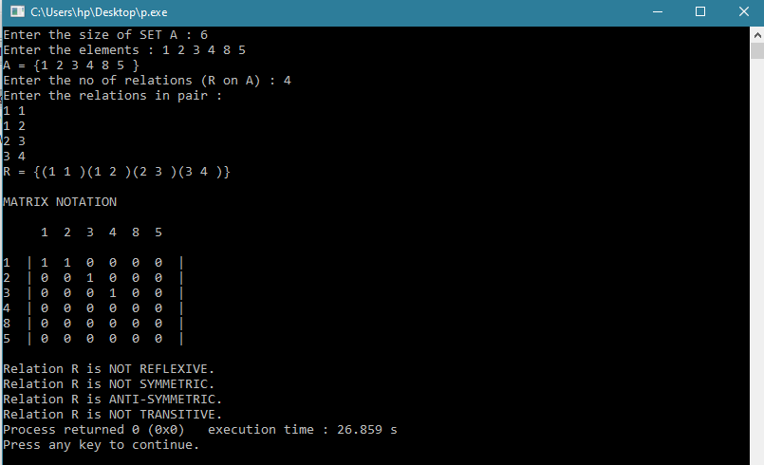

4.USE THE FUNCTIONS DEFINED IN QUESTION 3 TO CHECK WHETHER GIVEN RELATION IS:

i) EQUIVALENT

ii)PARTIAL ORDER RELATION

iii) NONE

Sol:

#include<iostream>

#include "Relations.cpp"

using namespace std;

class checkRELATION : public RELATION

{

public:

int equivalent(int, int, bool);

int partialOrder(int, bool, bool);

void neither(int, int);

};

int checkRELATION::equivalent(int r, int s, bool t)

{

if((r == 0) && (s == 0) && (t == true))

cout << "\nRelation R is EQUIVALENT relation";

else

return 0;

return 1;

}

int checkRELATION::partialOrder(int r, bool a, bool t)

{

if((r == 0) && (a == true) && (t == true))

cout << "\nRelation R is PARTIAL ORDER relation";

else

return 0;

return 1;

}

void checkRELATION::neither(int e, int po)

{

if((e != 1) && (po != 1))

cout << "\nRelation R is NEITHER equivalent NOR partial order relation";

}

int main()

{

int p=0,r,s,e,po;

bool a,t;

checkRELATION ob1;

p = ob1.inputSet();

if(p == 1)

{

ob1.empty();

}

else

{

ob1.printSet();

ob1.inputRelation();

ob1.printRelation();

ob1.Matrix();

r = ob1.reflexive();

s = ob1.symmetric();

a = ob1.antiSymmetric();

t = ob1.transitive();

}

e = ob1.equivalent(r, s, t);

po = ob1.partialOrder(r, a, t);

ob1.neither(e, po);

return 0;

}

Output:

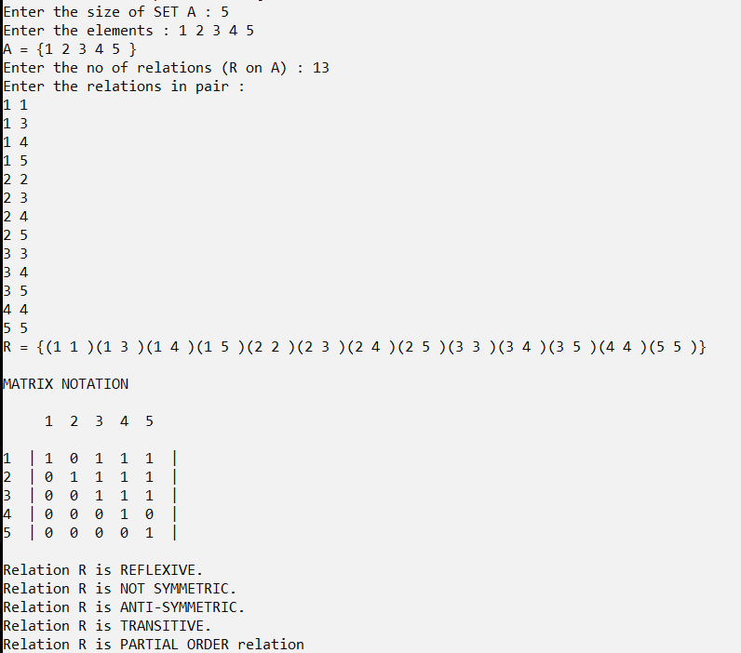

5. WRITE A PROGRAM TO GENERATE FIBONACCI SERIES USING RECURSION.

Sol:

#include<iostream>

using namespace std;

int fibonacci(int num)

{

if((num == 1) || (num == 0))

return(num);

else

return(fibonacci(num-1) + fibonacci(num-2));

}

int main()

{

int num,i=0;

cout << "\nEnter the limit: ";

cin >> num;

cout << "\nFibonacci Series: ";

while(i<num)

{

cout << " " << fibonacci(i);

i++;

}

return 0;

}

Output:

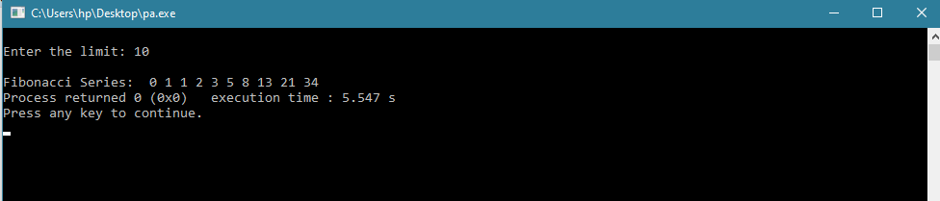

6.WRITE A PROGRAM TO IMPLEMENT TOWER OF HANOI USING RECURSION.

Sol: #include<iostream>

using namespace std;

void towerOfHanoi(int n, char from_rod, char to_rod, char aux_rod)

{

if(n == 1)

{

cout << "Move disk 1 from rod " << from_rod << " to rod " << to_rod << endl;

return;

}

towerOfHanoi(n-1, from_rod, aux_rod, to_rod);

cout << "Move disk " << n << " from rod " << from_rod << " to rod " << to_rod << endl;

towerOfHanoi(n-1, aux_rod, to_rod, from_rod);

}

int main()

{

int n;

cout << "\nEnter the number of disks: ";

cin >> n;

towerOfHanoi(n, 'A', 'C', 'B');

return 0;

}

Output:

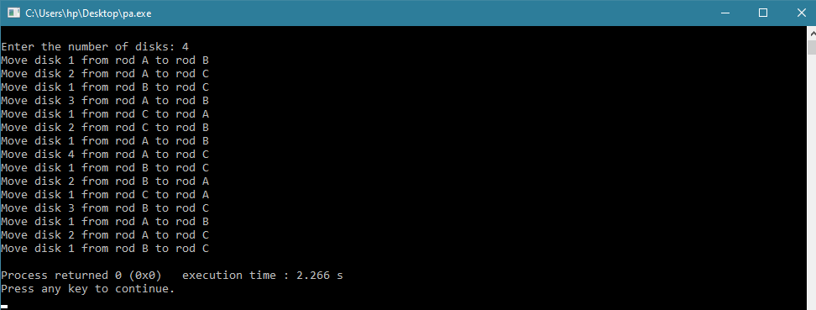

7.WRITE A PROGRAM TO IMPLEMENT BINARY SEARCH USING RECURSION.

Sol: #include <iostream>

using namespace std;

int BinarySearch(int arr[], int num, int beg, int end)

{

int mid;

if (beg > end)

{

cout << "\nNumber is not found";

return 0;

}

else

{

mid = (beg + end) / 2;

if(arr[mid] == num)

{

cout << "\nNumber is found at " << mid+1 << " position.\n";

return 0;

}

else if (num > arr[mid])

{

BinarySearch (arr, num, mid+1, end);

}

else if (num < arr[mid])

{

BinarySearch (arr, num, beg , mid-1);

}

}

}

int main()

{

int arr[100], num, i, n, beg, end;

cout <<"\nEnter the size of an array (Max 100): ";

cin >> n;

cout <<"\nEnter the sorted values: ";

for(i=0; i<n; i++)

{

cin >> arr[i];

}

cout <<"\nEnter a value to be search: ";

cin >> num;

beg = 0;

end = n-1;

BinarySearch (arr, num, beg, end);

return 0;

}

Output:

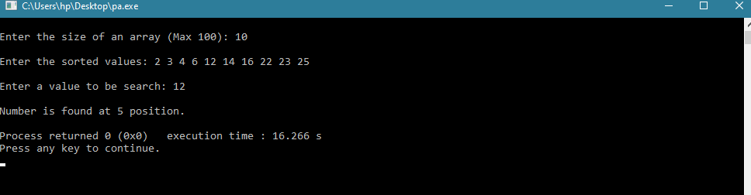

8.WRITE A PROGRAM TO IMPLEMENT BUBBLE SORT.FIND THE NUMBER OF COMPARISONS DURING EACH PASS AND DISPLAY INTERMEDIATE RESULT.

Sol: #include<iostream>

#include<stdio.h>

#include<conio.h>

#include<cstdlib>

using namespace std;

int i,j,k;

void bubbleSort(int*, int);

int main()

{

int size,ele;

cout << "\nEnter the size of array: ";

cin >> size;

int array[size];

cout << "\nWORST CASE:";

cout << "\n-------------\n";

for(i=0; i<size; i++)

array[i] = size - i;

bubbleSort(array, size);

cout << "\n\nBEST CASE:";

cout << "\n-------------\n";

for(i=0; i<size; i++)

array[i] = i+1;

bubbleSort(array, size);

cout << "\n\nAVERAGE CASE:";

cout << "\n-------------\n";

for(i=0; i<size; i++)

{

ele = ((int)rand()%10);

if(ele == 0)

continue;

else

array[i] = ele;

}

bubbleSort(array, size);

return 0;

}

void bubbleSort(int *array, int size)

{

int temp = 0;

int ctr = 0;

int totalCom = 0;

cout << "Array: ";

for(i=0; i<size; i++)

cout << array[i] << " ";

cout << endl << endl;

for(i=0; i<size-1; i++)

{

ctr = 0;

for(j=0; j<size-i-1; j++)

{

if(array[j+1] < array[j])

{

temp = array[j];

array[j] = array[j+1];

array[j+1] = temp;

}

ctr++;

totalCom++;

}

cout << "After pass " << i+1 << ": ";

for(k=0; k<size; k++)

cout << array[k] << " ";

cout << "\nComparisions made in pass " << i+1 << ": " << ctr;

cout << endl << endl;

}

cout << "Total comparisions: " << totalCom;

}

Output:

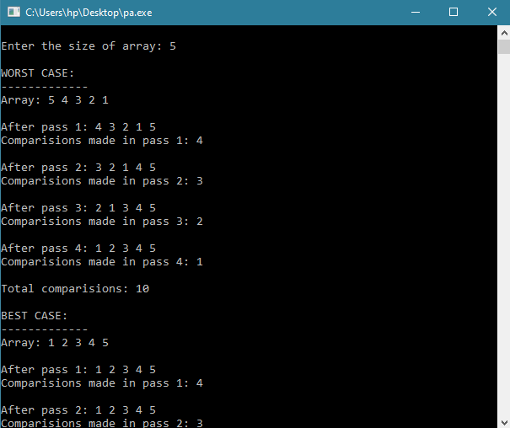

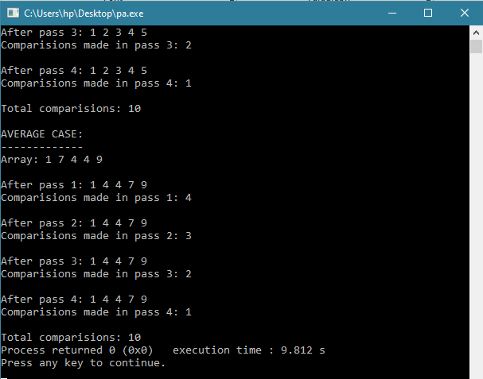

9.WRITE A PROGRAM TO IMPLEMENT INSERTION SORT. FIND THE NUMBER OF COMPARISONS DURING EACH PASS AND DISPLAY INTERMEDIATE RESULT.

Sol:

#include<iostream>

#include<stdio.h>

#include<conio.h>

#include<cstdlib>

using namespace std;

int i,j,k;

void insertionSort(int*, int);

int main()

{

int size,ele;

cout << "\nEnter the size of array: ";

cin >> size;

int array[size];

cout << "\nWORST CASE:";

cout << "\n-------------\n";

for(i=0; i<size; i++)

array[i] = size - i;

insertionSort(array, size);

cout << "\n\nBEST CASE:";

cout << "\n-------------\n";

for(i=0; i<size; i++)

array[i] = i+1;

insertionSort(array, size);

cout << "\n\nAVERAGE CASE:";

cout << "\n-------------\n";

for(i=0; i<size; i++)

{

ele = ((int)rand()%10);

if(ele == 0)

continue;

else

array[i] = ele;

}

insertionSort(array, size);

return 0;

}

void insertionSort(int* array, int size)

{

int temp=0;

int ctr = 0;

int totalCom = 0;

cout << "Array: ";

for(i=0; i<size; i++)

cout << array[i] << " ";

cout << endl << endl;

for(i=1; i<size; i++)

{

temp = array[i];

ctr = 0;

for(j=i-1; j>=0; j--)

{

ctr++;

totalCom++;

if(array[j] > temp)

{

array[j+1] = array[j];

}

else

break;

}

array[j+1] = temp;

cout << "After pass " << i << ": ";

for(k=0; k<size; k++)

cout << array[k] << " ";

cout << "\nComparisions made in pass " << i << ": " << ctr;

cout << endl << endl;

}

cout << "Total comparisions: " << totalCom;

}

Output:

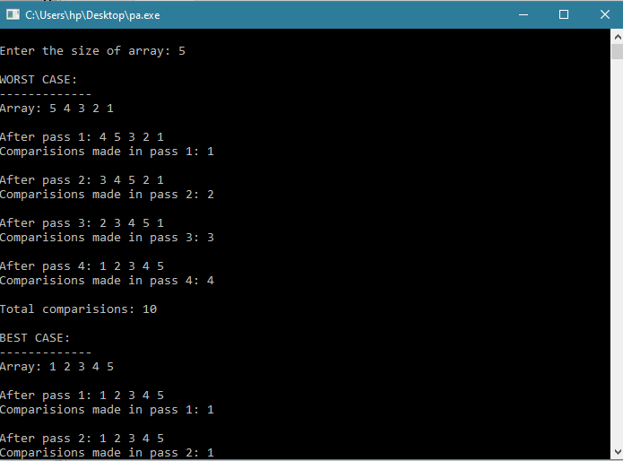

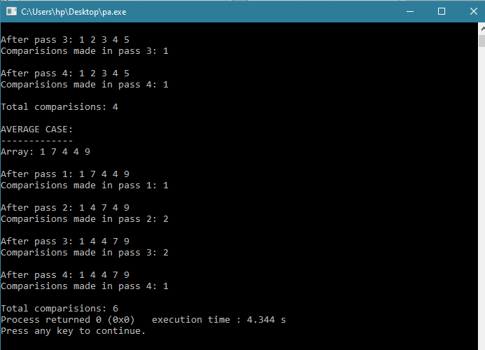

10. WRITE A PROGRAM THAT GENERATES ALL THE PERMUTATIONS OF A GIVEN SET OF DIGITS, WITH OR WITHOUT REPETITION.

Sol:

#include<iostream>

#include<stdio.h>

#include<conio.h>

#define MAX_DIM 100

using namespace std;

void withRepetition(int*, int);

void withoutRepetition(int*, int);

void printWithRepetition(int*, int, int*, int, int);

void printWithoutRepetition(int*, int, int, int);

void swap(int &, int &);

int main()

{

int size;

char ch;

cout << "Enter the size of set: ";

cin >> size;

int array[MAX_DIM];

cout << "Enter the elements: ";

for(int i=0; i<size; i++)

cin >> array[i];

cout << "\nIs repetition allowed (Y/N): ";

cin >> ch;

switch(ch)

{

case 'Y':

withRepetition(array, size);

break;

case 'N':

withoutRepetition(array, size);

break;

default:

cout << "\nWrong Choice";

}

return 0;

}

void withRepetition(int* array, int size)

{

int data[MAX_DIM] = {0};

printWithRepetition(array, size, data, size-1, 0);

cout << endl;

}

void printWithRepetition(int* array, int size, int *data, int last, int index)

{

for(int i=0; i<size; i++)

{

data[index] = array[i];

if(index == last)

{

cout << "{";

for(int j=0; j<index+1; j++)

cout << data[j] << " ";

cout << "}";

}

else

{

printWithRepetition(array, size, data, last, index+1);

}

}

}

void withoutRepetition(int* array, int size)

{

printWithoutRepetition(array, size, 0, size-1);

cout << endl;

}

void printWithoutRepetition(int* array, int size, int start, int end)

{

if(start == end)

{

cout << "{";

for(int i=0; i<size; i++)

cout << array[i] << " ";

cout << "}";

}

else

{

for(int i=start; i<end+1; i++)

{

swap(array[start], array[i]);

printWithoutRepetition(array, size, start+1, end);

swap(array[start], array[i]);

}

}

}

void swap(int &a, int &b)

{

int t = b;

b = a;

a = t;

}

Output:

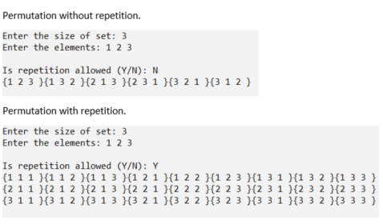

11.WRITE A PROGRAM TO CALCULATE PERMUTATION AND COMBINATION FOR AN INPUT VALUE n AND r USING RECURSIVE FORMULA nCr AND nPr.

Sol:

#include<iostream>

using namespace std;

int nCr(int, int);

int nPr(int, int);

int nPr(int n, int r)

{

if(r == 0)

return 1;

if(r > n)

return 0;

return nPr(n-1, r) + r * nPr(n-1, r-1);

}

int nCr(int n, int r)

{

if(r ==0 || r ==n)

return 1;

return nCr(n-1, r) + nCr(n-1, r-1);

}

int main()

{

int n,r;

cout << "\nEnter the value of n: ";

cin >> n;

cout << "\nEnter the value of r: ";

cin >> r;

cout << "\nPERMUTATION " << "P(" << n << ", " << r << "): " << nPr(n, r);

cout << "\nCOMBINATION " << "C(" << n << ", " << r << "): " << nCr(n, r);

return 0;

}

Output:

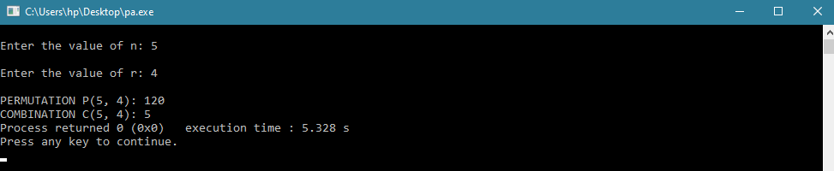

12.FOR ANY NUMBER n , WRITE A PROGRAM TO LIST ALL THE SOLUTIONS OF THE EQUATION x1+x2+x3+….+xn=C WHERE C IS CONSTANT (C<=10).

Sol:

#include<iostream>

using namespace std;

void bruteForce(int*, int, int*, int, int, int, int&);

int main()

{

int n, C, counter = 0, size = 11;

int arr[size], data[100] = {0};

cout << "\nFinding solutions to x1 + x2 + ... + xn = C\n";

cout << "Enter the value of n: ";

cin >> n;

for (int i=0; i <= 10; i++)

arr[i] = i;

cout << "Enter the sum constant (C <= 10): ";

cin >> C;

cout << "Possible Non-negative Integral solutions [ ";

for(int i=0; i<n; i++)

cout << "x" << i+1 << " ";

cout << " ] :" << endl;

bruteForce(arr, size, data, n-1, 0, C, counter);

cout << "\nFound " << counter << " Solutions\n";

return 0;

}

void bruteForce(int* arr, int size, int* data, int last, int index, int C, int &counter)

{

for(int i=0; i<size; i++)

{

data[index] = arr[i];

if(index == last)

{

int sum = 0;

for(int j=0; j<index+1; j++)

sum += data[j];

if(sum == C)

{

cout << "[ ";

for(int j=0; j<index+1; j++)

cout << data[j] << " ";

cout << "] ";

counter++;

}

}

else

bruteForce(arr, size, data, last, index+1, C, counter);

}

}

Output:

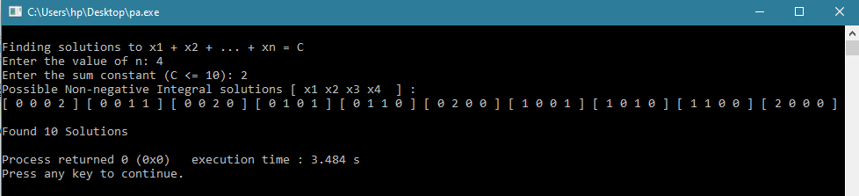

13.WRITE A PROGRAM TO ACCEPT THE TRUTH VALUES OF VARIABLES x AND y AND PRINT TRUTH TABLE FOR FOLLOWING:

i) CONJUCTION ii)DISJUNCTION iii)EXCLUSIVE OR iv)CONDITIONAL v)BICONDITIONAL vi)EXCLUSIVE NOR vii)NEGATION viii)NAND ix)NOR

Sol:

#include<iostream>

#include<stdio.h>

#include<conio.h>

using namespace std;

int main()

{

int n;

char x,y;

cout << "Enter the no. of trials: ";

cin >> n;

bool value[n][2];

for(int i=0; i<n; i++)

{

cout << "Enter the truth value for x" << i+1 << " y" << i+1 << ": ";

cin >> x >> y;

value[i][0] = (x == 't' || x == 'T');

value[i][1] = (y == 't' || y == 'T');

}

cout << endl;

cout << "x\ty\tAND\tOR\tXOR\tx->y\tx<->y\tXNOR\tNOT\tNAND\tNOR";

cout << "\n-------------------------------------------------------"

<< "-------------------------------------------------------\n";

for(int i=0; i<n; i++)

{

int x = value[i][0], y = value[i][1];

cout << (x ? "T" : "F") << "\t" << (y ? "T" : "F") << "\t"

<< ((x && y) ? "T" : "F") << "\t"

<< ((x || y) ? "T" : "F") << "\t"

<< (((x || y) && !(x && y)) ? "T" : "F") << "\t"

<< ((!x || y) ? "T" : "F") << "\t"

<< (((!x || y) && (!y || x)) ? "T" : "F") << "\t"

<< ((!((x || y) && !(x && y))) ? "T" : "F") << "\t"

<< ((!x) ? "T" : "F") << " " << ((!y) ? "T" : "F") << "\t"

<< (!(x && y) ? "T" : "F") << "\t"

<< (!(x || y) ? "T" : "F") << "\n";

cout << endl;

}

return 0;

}

Output:

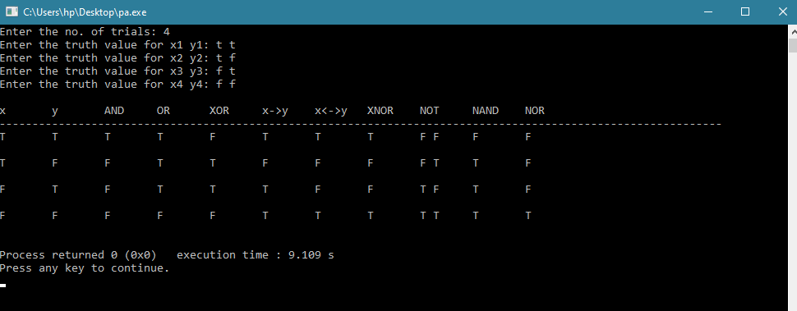

14.WRITE A PROGRAM TO REPRESENT GRAPHS USING ADJACENCY MATRIX AND CHECK IF IT IS COMPLETE OR NOT.

Sol:

#include <iostream>

using namespace std;

int a[100][100];

int main(){

int v,e;

cout<<"Enter the No. of Vertices :";

cin>>v;

cout<<"Enter the No. of Edges :";

cin>>e;

cout<<"Enter the Adjacent Vertices"<<endl;

for(int i=1; i<=e ;i++){

int v1,v2;

cin>>v1>>v2;

a[v1][v2]=1;

a[v2][v1]=1;

}

cout<<"The Matrix for given data is:";

cout<<endl;

for(int i=1; i<=v ; i++){

for(int j=1; j<=v ; j++){

cout<<a[i][j]<<" ";

}

cout<<endl;

}

bool check= false;

if(e == v*(v-1)/2)

{ check= true;

cout<<"The Graph is Complete Graph.";

}

else {

cout<<"The Graph is not Complete." ;

}

return 0;

}

Output:

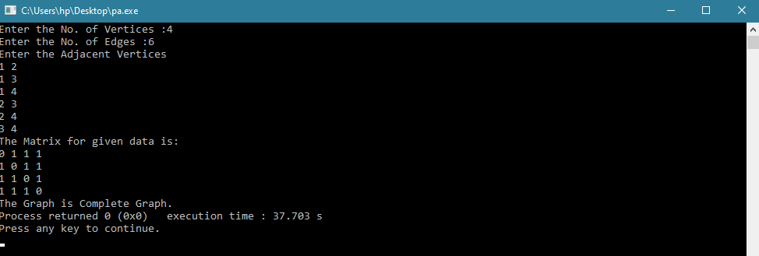

15.WRITE A PROGRAM TO TAKE INPUT OF DIRECTED GRAPH AND CALCULATE INDEGREE AND OUTDEGREE OF EACH VERTEX.

Sol:

#include <iostream>

using namespace std;

int a[100][100];

int main(){

int v,e;

int in=0, out=0;

cout<<"Enter the No. of Vertices :";

cin>>v;

cout<<"Enter the No. of Edges :";

cin>>e;

cout<<"Enter the Directed Vertices"<<endl;

for(int i=1; i<=e ;i++){

int v1,v2;

cin>>v1>>v2;

a[v1][v2]=1;

a[v2][v1]=0;

}

cout<<"The Matrix for the Given data is: "<<endl;

for(int i=1;i<e;i++){

for(int j=1;j<e;j++){

cout<<a[i][j]<<" ";

}

cout<<endl;

}

for(int i=1; i<e;i++){

cout<<"Out degree for "<<i<< " : ";

for(int j=1; j<e;j++){

if(a[i][j]== 1){

out=out+1;

}

}

cout<<out;

cout<<endl;

out=0;

}

cout<<endl<<endl;

for(int i=1; i<e;i++){

cout<<"In degree for "<<i<< " : ";

for(int j=1; j<e;j++){

if(a[j][i]== 1){

in=in+1;

}

}

cout<<in;

cout<<endl;

in=0;

}

return 0;

}

Output:



16.GIVEN AN ADJACENCY MATRIX OF A GRAPH,WRITE A PROGRAM TO CHECK WHETHER A GIVEN SET OF VERTICES {v1,v2,v3,….vn} FORMS AND EULER PATH OR EULER CIRCUIT OR BOTH.

Sol:

#include<iostream>

using namespace std;

int main() {

int n;

cout << "\nEnter the number of vertices: ";

cin >> n;

int matrix[n][n];

for(int i=0; i<n; i++)

for(int j=0; j<n; j++)

matrix[i][j] = 0;

cout << "Enter the adjacency matrix:\n";

for(int i=0; i<n; i++)

for(int j=0; j<n; j++)

cin >> matrix[i][j];

int degree, order = 0;

for(int i=0; i<n; i++) {

degree = 0;

for(int j=0; j<n; j++)

degree += matrix[i][j];

if(degree % 2 != 0)

order++; }

if(order == 0)

cout << "Graph has an Eulerian Circuit!" << endl;

else if(order == 2)

cout << "Graph has an Eulerian Path!" << endl;

else

cout << "Graph is Not Eulerian!" << endl;

return 0; }

Output:

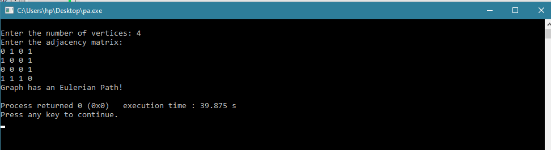

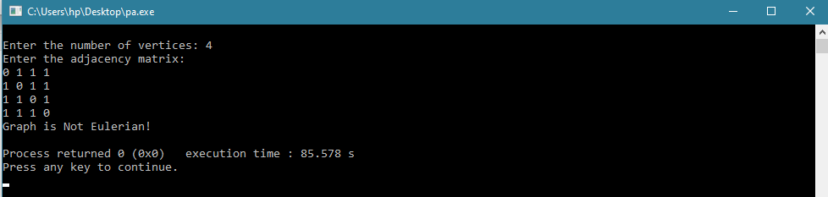

17. GIVEN A FULL m-arry TREES WITH I INTERNAL VERTICES. WRITE A PROGRAM TO FIND NUMBER OF LEAF NODES.

Sol:

#include<iostream>

using namespace std;

int calcNodes(int m, int I){

int result = 0;

result = I * (m - 1) + 1;

return result; }

int main(){

int m,I,N;

cout << "\nEnter the maximum no. of children in full m-ary tree: ";

cin >> m;

cout << "Enter the number of internal vertices: ";

cin >> I;

N = calcNodes(m, I);

cout << "Number of Leaf Nodes in the full m-ary tree: " << N;

return 0;

}

Output:

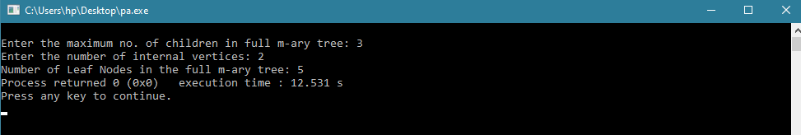

18. WRITE A PROGRAM TO STORE A FUNCTION (POLYNOMIAL / EXPONENTIAL), AND THEN EVALUATE THE POLYNOMIAL.

Sol:

#include<iostream>

#include<stdio.h>

#include<conio.h>

#include<cmath>

using namespace std;

int i;

class FUNCTION

{

private:

int n;

double *coefficient;

double *exponential;

public:

void input();

void display();

double evaluate(double);

};

void FUNCTION::input()

{

int n;

cout << "\nEnter the number of terms: ";

cin >> this->n;

coefficient = new double[n];

exponential = new double[n];

for(i=0; i<this->n; i++)

{

cout << "Enter coefficient and exponential of term " << i+1 << ": ";

cin >> coefficient[i] >> exponential[i];

}

}

void FUNCTION::display()

{

for(i=0; i<this->n; i++)

{

if(coefficient[i] >= 0)

cout << " + ";

else

cout << " - ";

cout << abs (coefficient[i]);

if(exponential[i] != 0)

cout << "(x^" << exponential[i] << ")";

}

}

double FUNCTION::evaluate(double x)

{

double result = 0.0;

for(i=0; i<this->n; i++)

{

result += coefficient[i] * (pow(x, exponential[i]));

}

return result;

}

int main()

{

double x;

FUNCTION ob;

ob.input();

cout << "Function is f(x) = ";

ob.display();

cout << "\nEnter the value of x: ";

cin >> x;

cout << "\nValue of f(" << x << "): " << ob.evaluate(x) << endl;

return 0;

}

Output:

