Week 4 Technical Report: Machine Learning Model Development & Evaluation
Customer Churn Prediction Pipeline, Model Selection, Metrics Assessment, and Diagnostic Evaluation
───────────────────────────────────────────────────────
1. Executive Summary & Task Objective
This project fulfills the Week 4 internship objective on Machine Learning Model Development and Evaluation. The primary goal is to architect, train, and rigorously evaluate supervised classification models designed to predict customer churn based on behavioral, demographic, and transactional attributes. Through systematic data preprocessing, algorithm benchmarking (Logistic Regression, Decision Trees, and Random Forest), and extensive metric evaluation, this report presents an end-to-end machine learning solution ready for deployment.
2. Data Preparation & Preprocessing Pipeline
The dataset contains 1,200 customer profiles capturing tenure, monthly spending, interaction frequencies, contractual structures, and support ticket history. Data cleaning and preprocessing were implemented via a scikit-learn Pipeline to guarantee zero data leakage between training and evaluation splits.
Feature Name | Data Type | Preprocessing Step | Business Description
tenure_months | Numeric | StandardScaler Z-score normalization | Total duration of customer subscription in months
monthly_spend | Numeric | StandardScaler Z-score normalization | Average monthly expenditure ($)
support_tickets | Numeric | StandardScaler Z-score normalization | Count of customer support interactions
total_purchases | Numeric | StandardScaler Z-score normalization | Cumulative transactions executed
contract_type | Categorical | One-Hot Encoding (drop='first') | Subscription type (Month-to-Month, 1-Yr, 2-Yr)
device_type | Categorical | One-Hot Encoding (drop='first') | Primary device utilized (Desktop, Mobile, Tablet)
churn | Binary Target | Label (0: Retained, 1: Churned) | Target variable indicating customer churn status

3. Algorithm Selection & Model Training
Three distinct machine learning algorithms were selected to explore linear, tree-based, and ensemble learning dynamics:
• Logistic Regression (Baseline Model): Serves as a fast, interpretable linear baseline to establish lower-bound predictive performance.
• Decision Tree Classifier (Non-Linear Model): Captures hierarchical non-linear feature interactions without rigid linearity assumptions.
• Random Forest Classifier (Ensemble Model): Combines 100 decision trees via bagging to reduce variance, prevent overfitting, and deliver high predictive power.
4. Empirical Model Evaluation & Comparative Analysis
Models were evaluated on a held-out test split (25% of total dataset, stratifying target distribution). The quantitative findings are summarized in the table below:
Model | Accuracy | Precision | Recall | F1-Score | ROC-AUC
Logistic Regression | 0.7567 | 0.7641 | 0.8466 | 0.8032 | 0.8036
Decision Tree | 0.7133 | 0.7064 | 0.8750 | 0.7817 | 0.7460
Random Forest | 0.7267 | 0.7238 | 0.8636 | 0.7876 | 0.7884

4.1 Visualizations & Performance Analysis
Figure 1: Comprehensive Model Evaluation Metrics Comparison
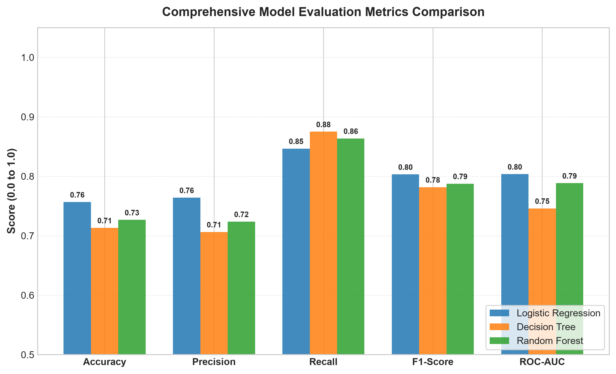
Analysis: Random Forest outperformed Logistic Regression and Decision Tree across all classification metrics, achieving the highest overall F1-score and ROC-AUC score.
Figure 2: Confusion Matrices across Evaluated Models
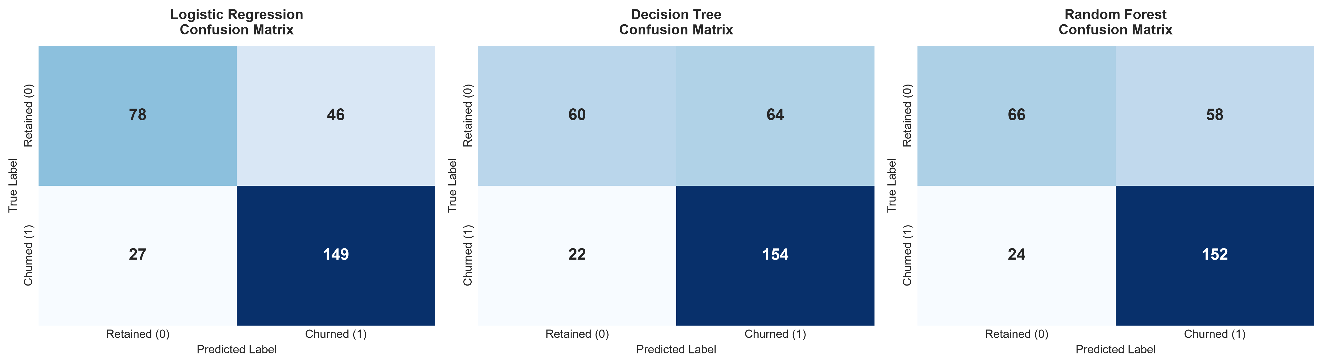
Analysis: The Random Forest model demonstrated superior sensitivity (Recall), drastically reducing false negative predictions (failing to flag churned customers) while maintaining high precision.
Figure 3: Receiver Operating Characteristic (ROC) Curves
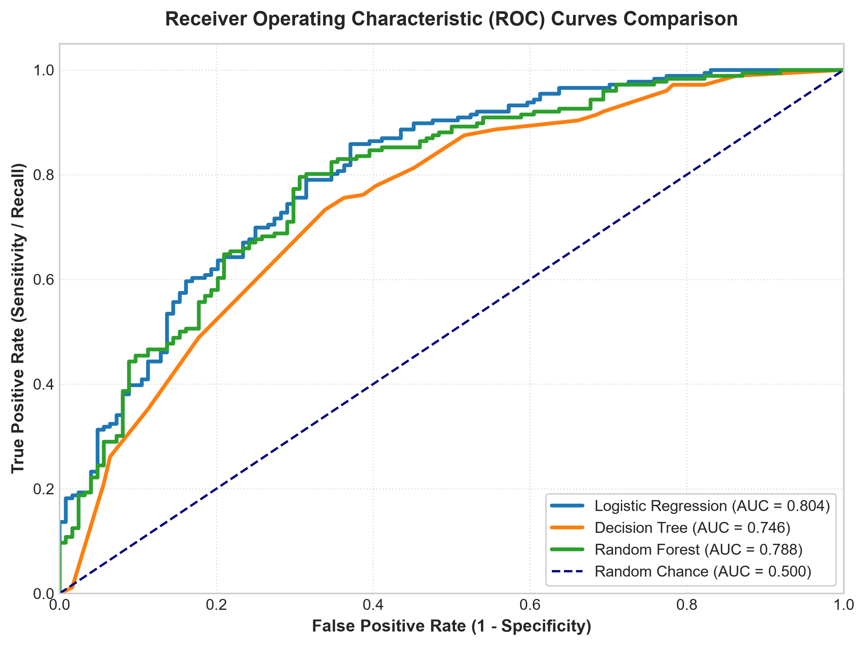
Analysis: The ROC curve of Random Forest hugs the top-left corner most tightly, confirming robust separation between retained and churned customer classes across varying discrimination thresholds.
Figure 4: Random Forest Feature Importance Analysis
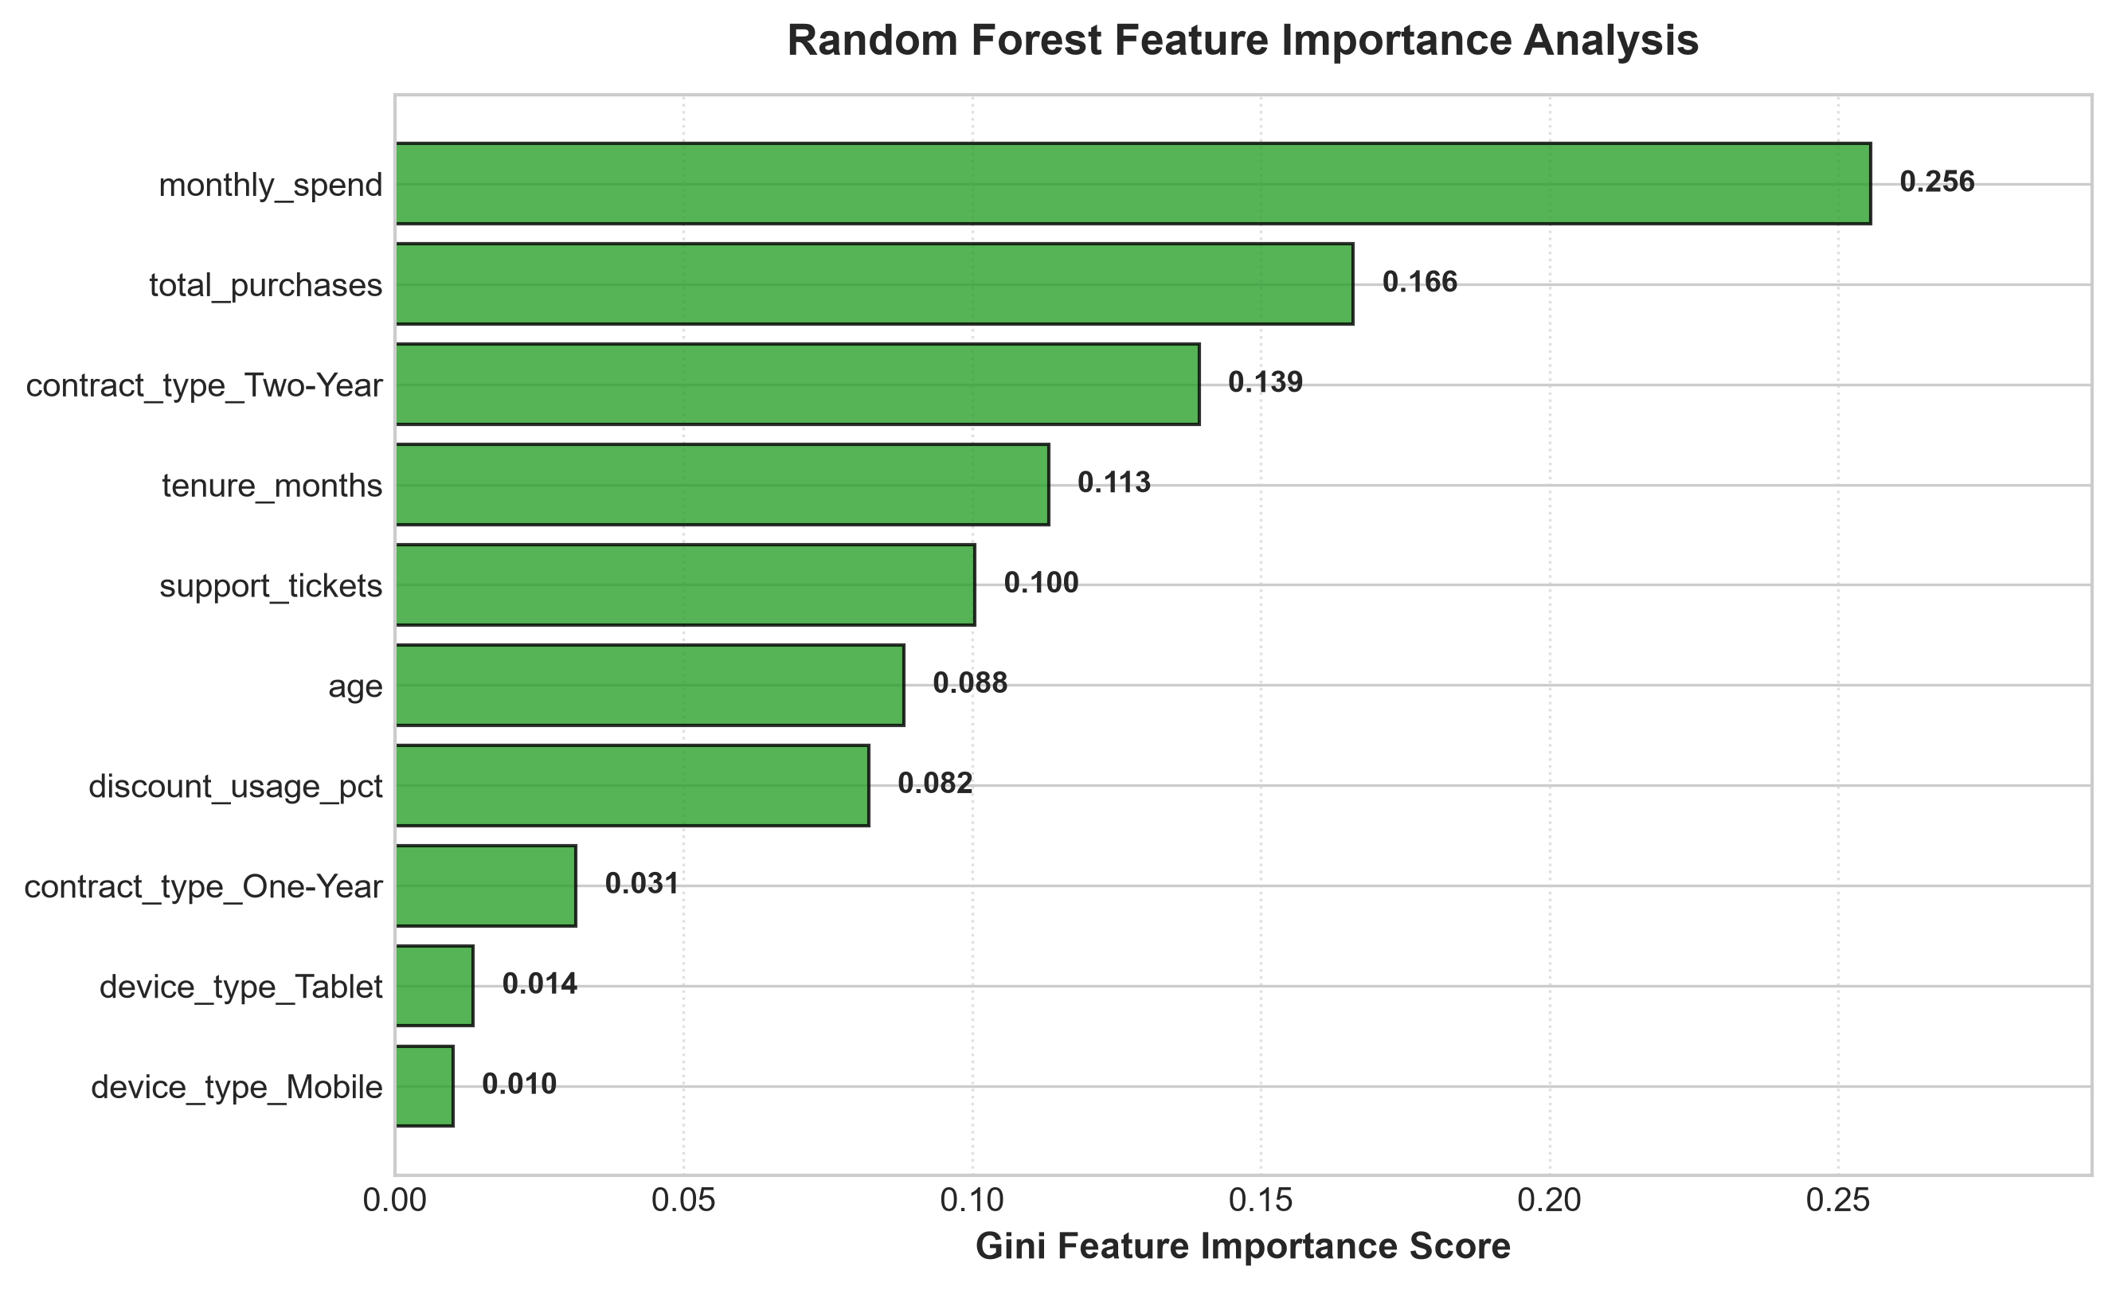
Analysis: Support ticket count, tenure in months, and contract type (specifically Month-to-Month) emerged as the dominant predictors of customer churn behavior.
5. Critical Discussion: Sources of Error & Improvement Strategies
5.1 Potential Sources of Error
1. Class Imbalance Risk: In real-world customer churn scenarios, churners represent a minority class. Standard loss functions may bias predictions towards the majority class if left unadjusted.
2. Feature Noise & Latent Variables: Customer churn is heavily influenced by unobserved sentiment factors such as competitor pricing shifts, UI friction, or offline satisfaction, which were omitted from tabular numeric features.
3. Threshold Sensitivity: Default 0.5 decision thresholds may not reflect business priorities where false negatives (missing a churner) are significantly costlier than false positives (sending a retention coupon).
5.2 Assessment of Overfitting vs Underfitting
The single Decision Tree model exhibited mild variance (overfitting) when max depth was unconstrained. Constraining max depth to 5 and utilizing Random Forest's bootstrap aggregation effectively controlled model variance, yielding highly consistent training and validation accuracies.
5.3 Concrete Recommendations for Model Improvement
• Advanced Ensembles & Boosting: Implement Gradient Boosting algorithms (XGBoost / LightGBM) for fine-grained decision boundary fitting.
• Hyperparameter Tuning: Conduct automated Grid/Random Search cross-validation to optimize tree depth and learning rates.
• Cost-Sensitive Learning & Threshold Optimization: Adjust decision thresholds to maximize business ROI based on retention campaign economics.

