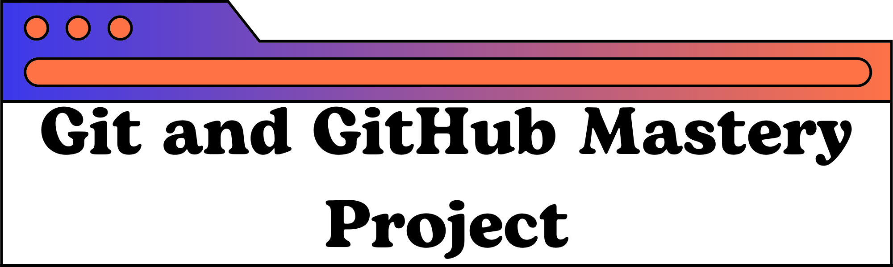

* **Name : Piyush Suthar**
* **BCA (Sunstone)**
* **CDU , Hyderabad**
* **E-mail = piyushsuthar6300@gmailcom**
* **GitHub Link :** <https://github.com/PiyushSutharScriptor>
* **GitHub Repo :** <https://github.com/PiyushSutharScriptor/Piyush-Suthar-Learning-Git>
* **Published Site :** <https://piyushsutharscriptor.github.io/Piyush-Suthar-Learning-Git/>
* **Fork-Repository :** <https://github.com/PiyushSutharScriptor/Movie-Fork-Git-Project>



**PROJECT OVERVIEW :**

In this project, I will demonstrate my understanding and proficiency in using Git and GitHub by completing a series of tasks that simulate real-world scenarios. These tasks will cover various aspects of version control, collaboration, and project management using Git and GitHub.

**CONTENTS :**

* Setup
* Reposiory Creation
* Basic Commands
* Working with others
* Undoing Changes
* Github Practice
* Advanced Tools and Hosting

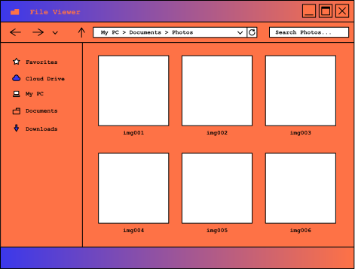

1. **Set up Git**

**Install Git on your system**

* Go to the Git Official website :

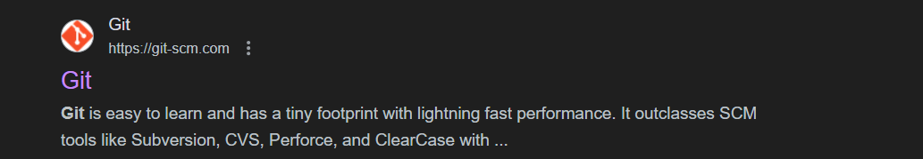

* Download and install the appropriate version of Git to your operating system :

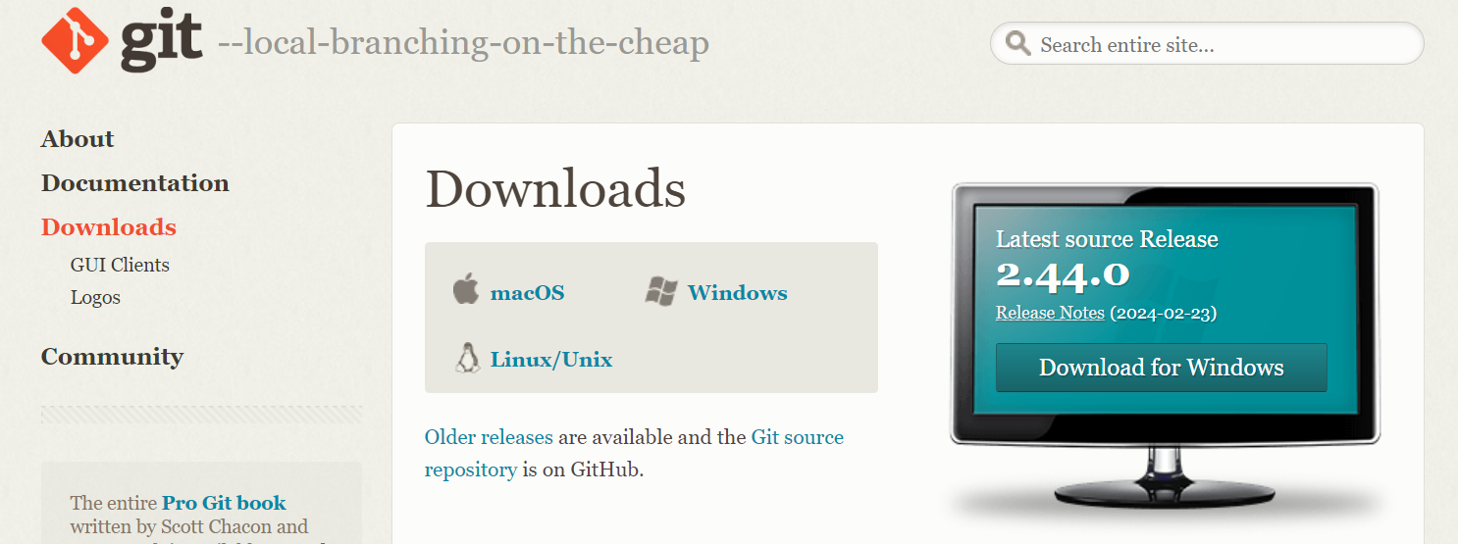

Create a GitHub account :

* Go to the GitHub Official website :

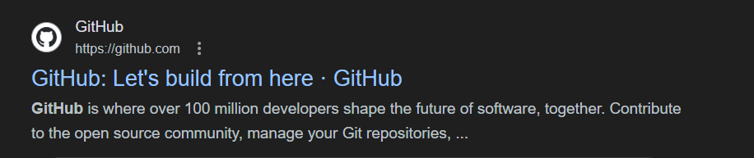

* Login if you have an account or create a new one and sign-up with username , email address and strong password :

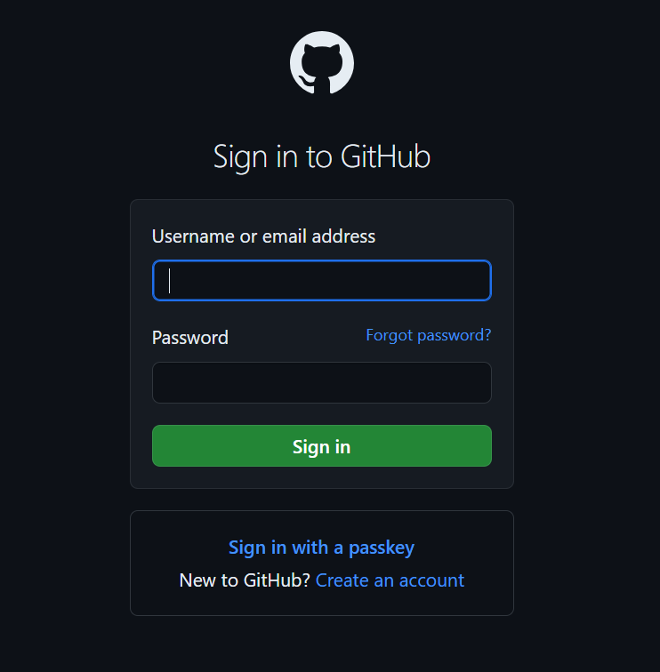

Install Visual Studio on your system :

* Go to the Visual Studio Official website :

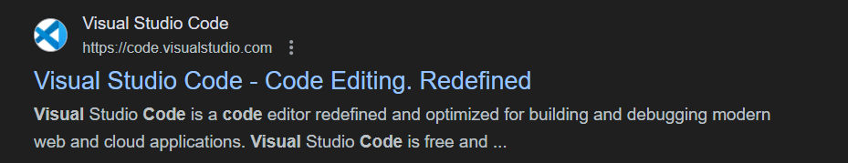

* Download and install the appropriate version of Visual Studio to your operating system and set up :

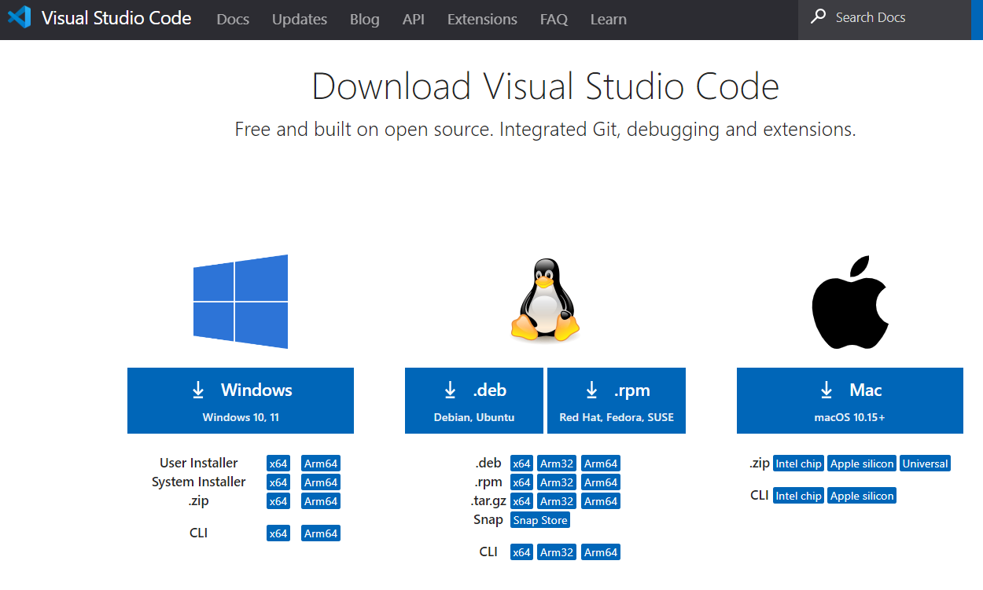

Install GitHub Desktop on your system :

* Go to the GitHub Desktop website :

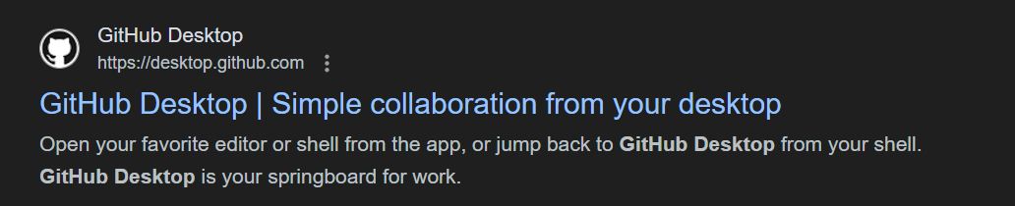

* Download and install the appropriate version of GitHub Desktop to your operating system :

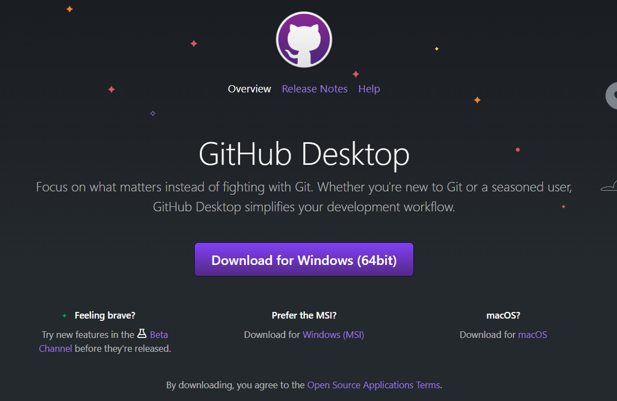

1. Repository Creation :

* Creating a new repository on GitHub with name “Piyush-Suthar-Learning-Git”

Steps :

1. Go to profile and click on “+” icon on top bar.
2. Select the “New repository” option .

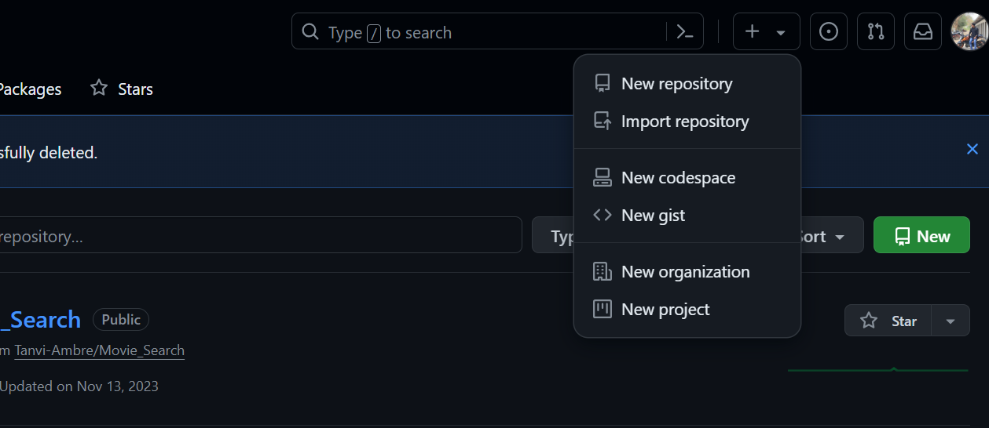

1. Name the Repository name as “Piyush-Suthar-Learning-Git” .

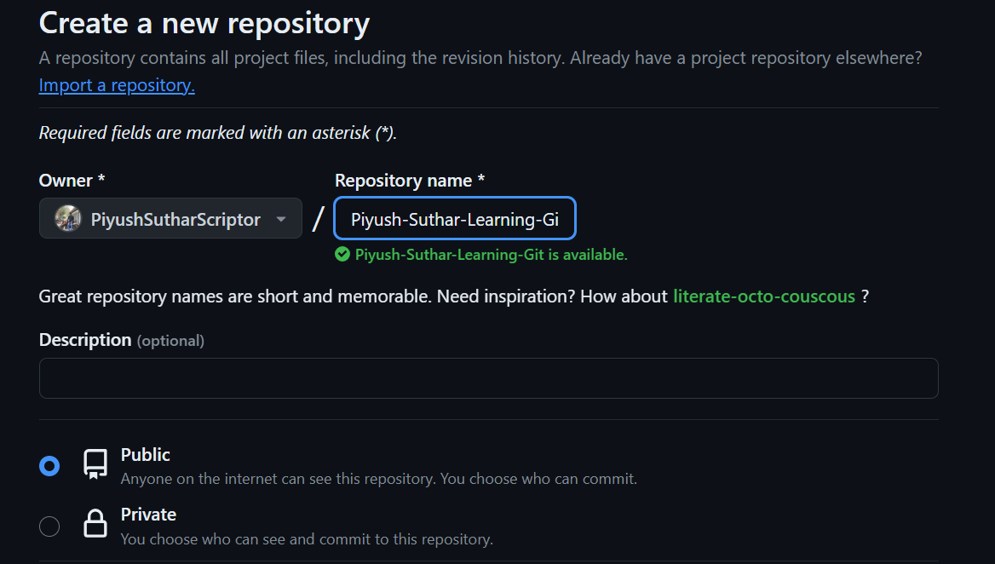

1. Choose the visibility of Repository as Public and we can initialize this repository with a README file.

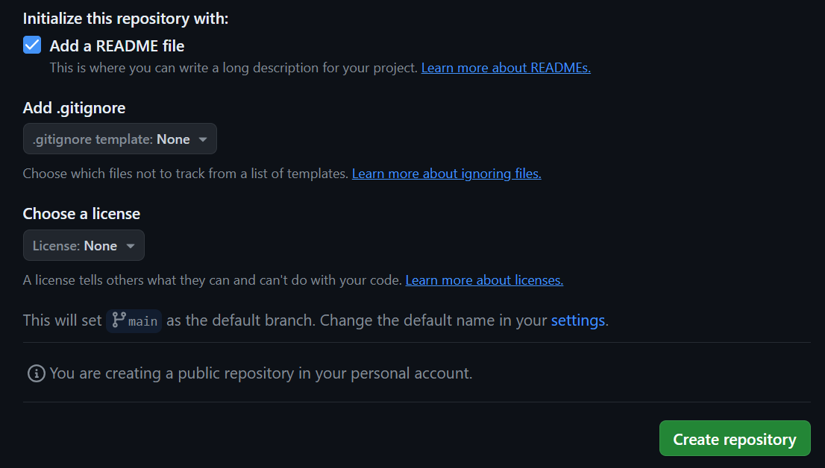

* Clone the repository to your local machine :

Steps :

1. Navigate to newly created repository “Piyush-Suthar-Learning-Git” and select “<>Code”

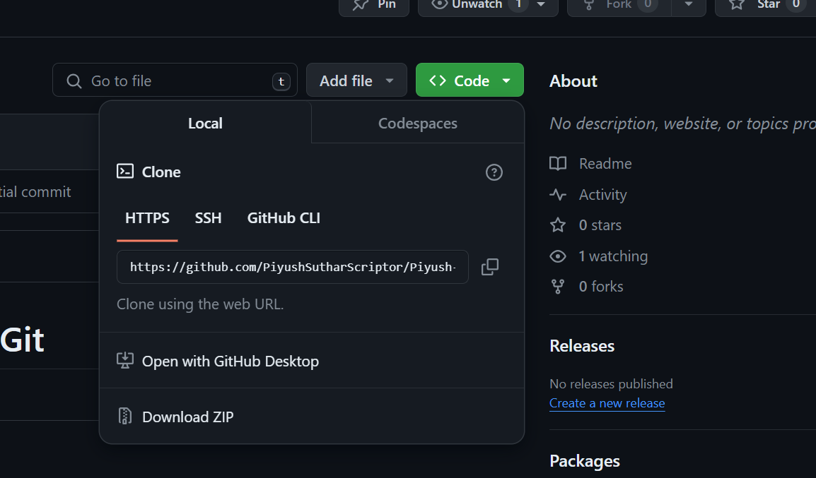

1. Copy the url to clipboard as shown below :

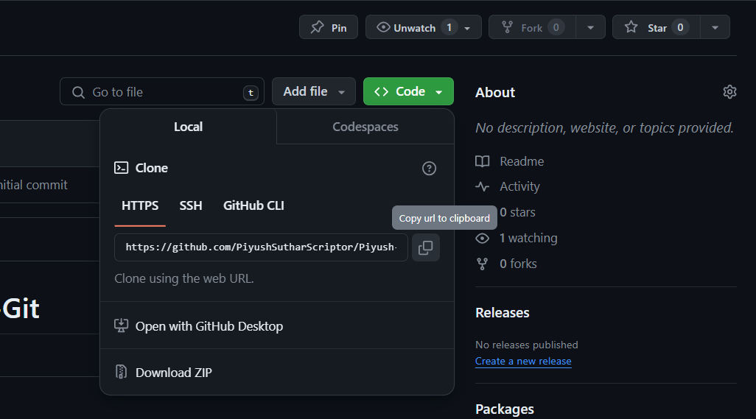

1. Open Command Prompt (CMD) and navigate to Desktop :

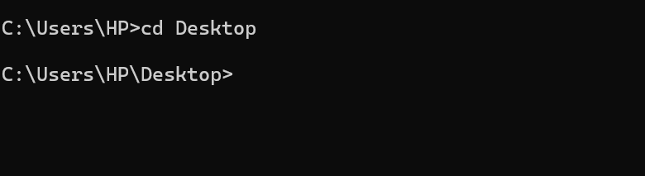

1. Use the ‘git clone‘ followed by the URL of the repository and press enter :

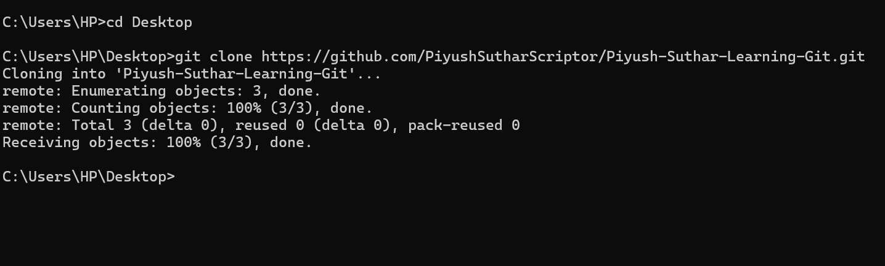

1. Use the following command to set git email address :



1. Use the following command to set git email address :



1. We can verify the username and email using the following command :

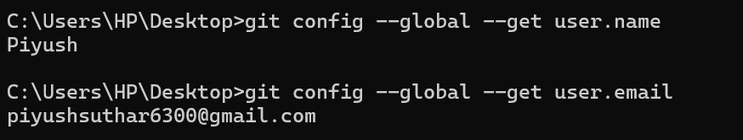

1. Open Visual Studio using the following command :



1. **Basic Commands :**

* Create a new file in Visual Studio by CMD Using command ‘echo’ and name the file as ‘’main.txt’’



* Create a new branch named "feature-branch" from the main/master branch using the command shown below :



* Making changes(Adding Content) to ‘main.txt’ file :

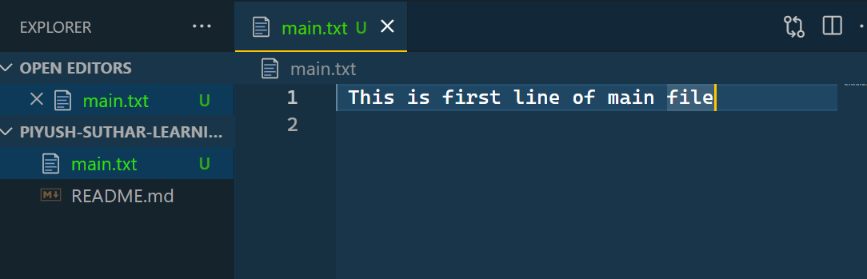

* Adding the changes to the staging area using the command shown below :



* Commit the changes with commit name “FirstCommitAddingContent” using the command shown below :

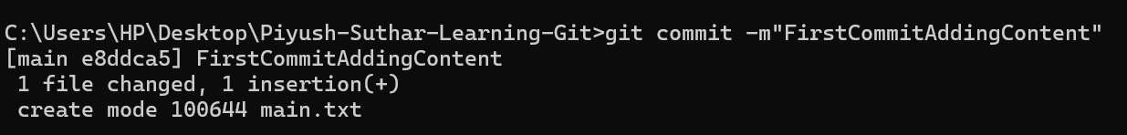

* Using command to view the git status and working tree as shown below :

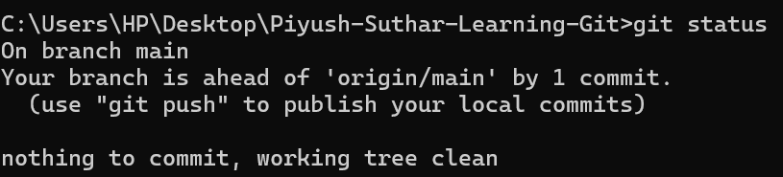

* Pushing the changes to the remote repository using push command as shown below :

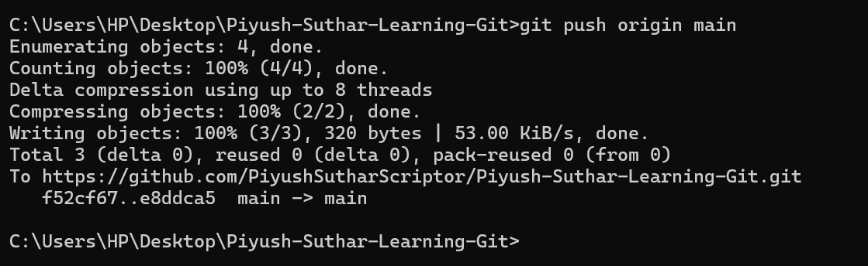

1. **Working with others :**

* Creating a new branch named "collaborator-branch" from the primary/master branch using the command as shown below :



* Make conflicting changes to the same file in both branches as shown as below :

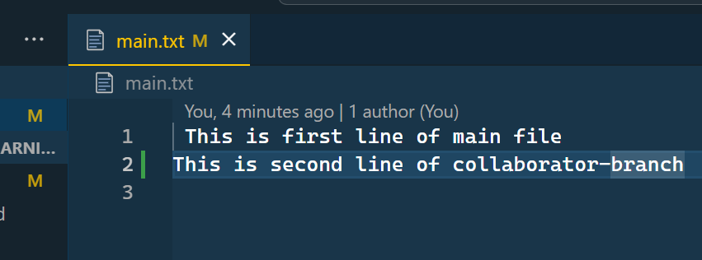

* Merge the "collaborator-branch" into the main/master branch.

1. Switch to main branch using the command as shown below :

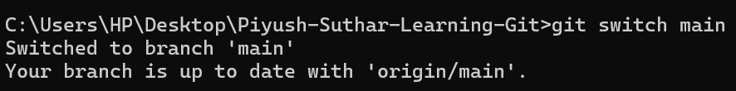

1. Merging the “collaborator-branch” into the main branch using the command as shown below :

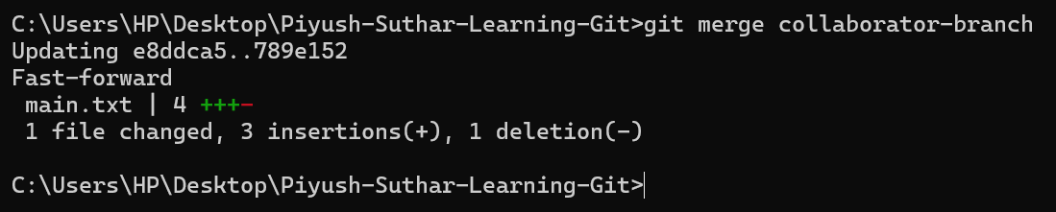

1. **Undoing Changes :**

* Using Git checkout to switch to a previous commit.



* Using Git reset to undo the last commit.



* Using Git revert to undo a specific commit :



1. **GitHub Practice :**

* Create a pull request from "collaborator-branch" to main/master.

1. Navigate to Collaborator-branch using the command shown below :



1. Push your changes to remote repository using the command shown below :



1. Go to your GitHub and select pull request (make sure you are in same repository) :

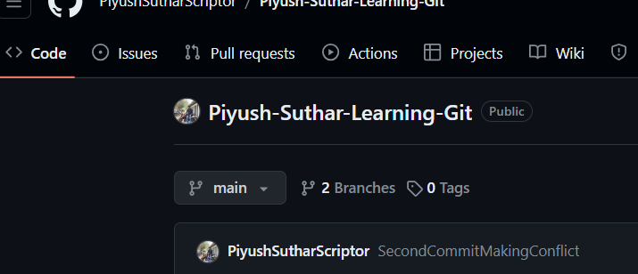

1. Label issue and click on New pull request :

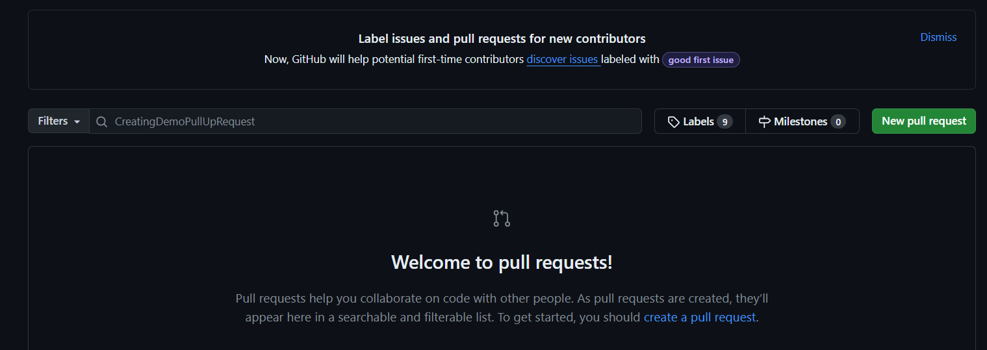

1. Select the branch i.e. from "collaborator-branch" to main/master.

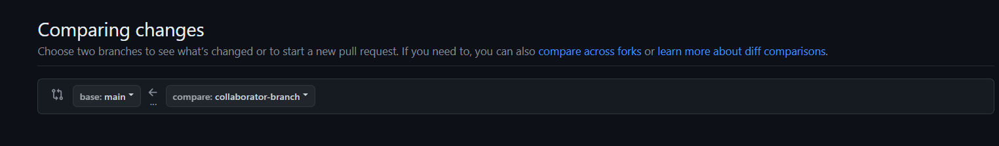

1. Finally click on Create pull request :

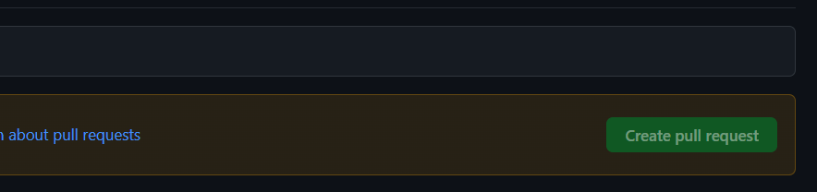

* Fork a repository from another user's account. (Fork this repo - <https://github.com/Tanvi-Ambre/Movie_Search)> :

1. Navigate to above link of Repository in GitHub and click on Fork :

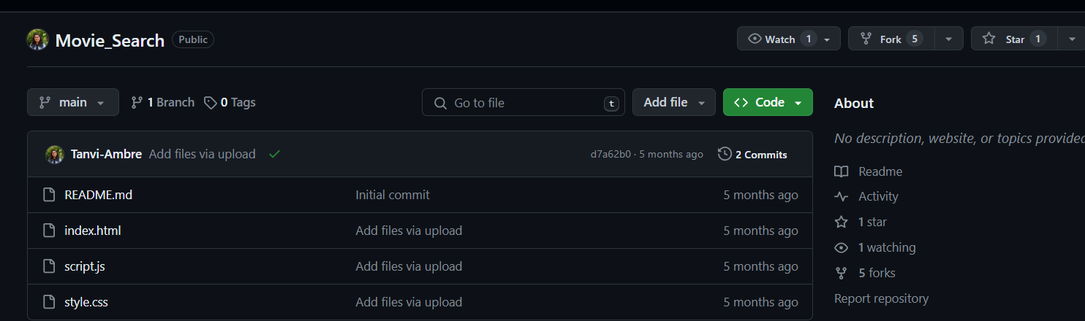

1. Enter the Repository name where you want to fork and click on Create Fork :

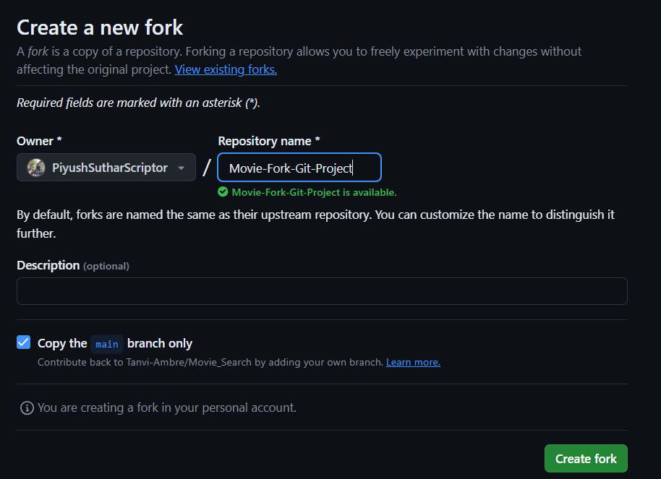

* Creating a new branch in the forked repository.

1. Navigate to Movie-Fork-Git-Project Repository and Click on branch :

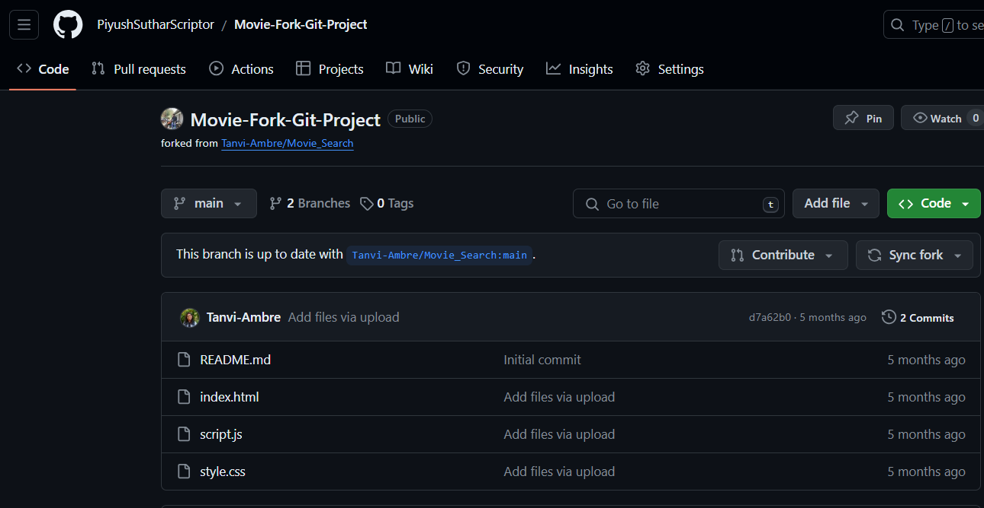

1. Click on New branch to create a New branch :



1. Enter the branch name and choose the upstream repository and click on Create new branch :

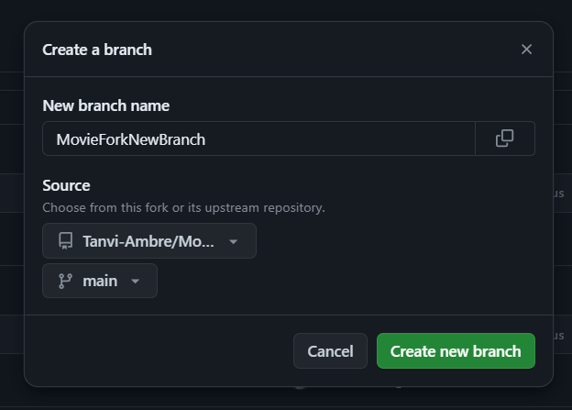

* Making changes and creating a pull request to the original repository.

1. Navigate to Movie-Fork-Git-Project and select the file in which you want to make changes :

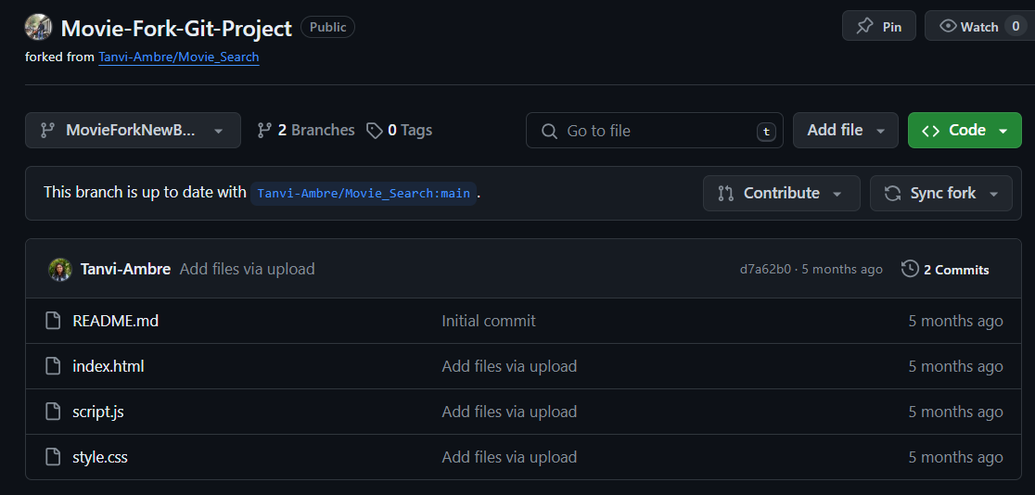

1. Make the changes in the selected file :

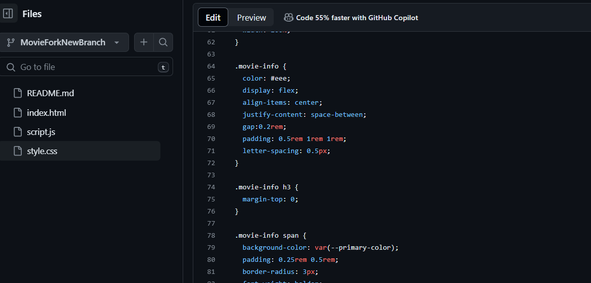

1. After making changes in the file click on Preview :

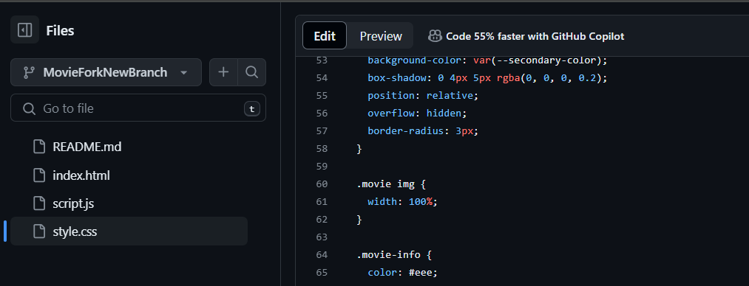

1. Preview the changes you have made , compare with the previous code and click on Commit changes :

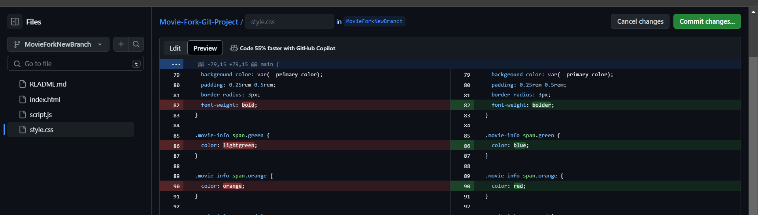

1. Commit changes such as Commit message and description , select the branch and click on Commit changes :

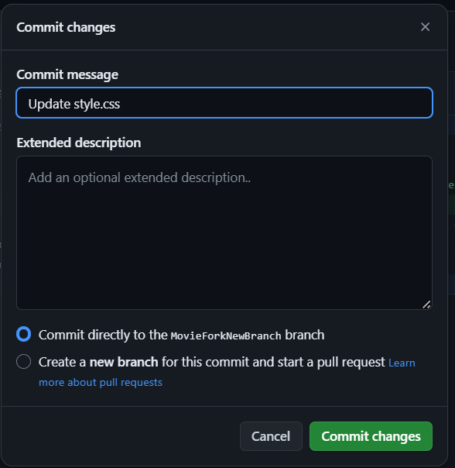

1. Again Navigate to the repository where a “Compare & pull request” bar will be visible. Click on “Compare & pull request” :

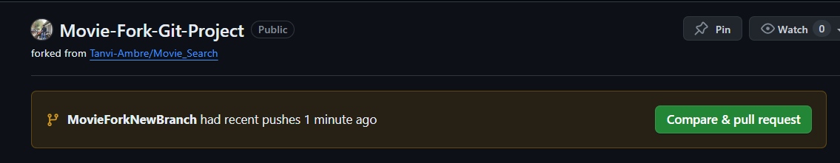

1. Add a title and description for pull request and click on “Create pull request” :

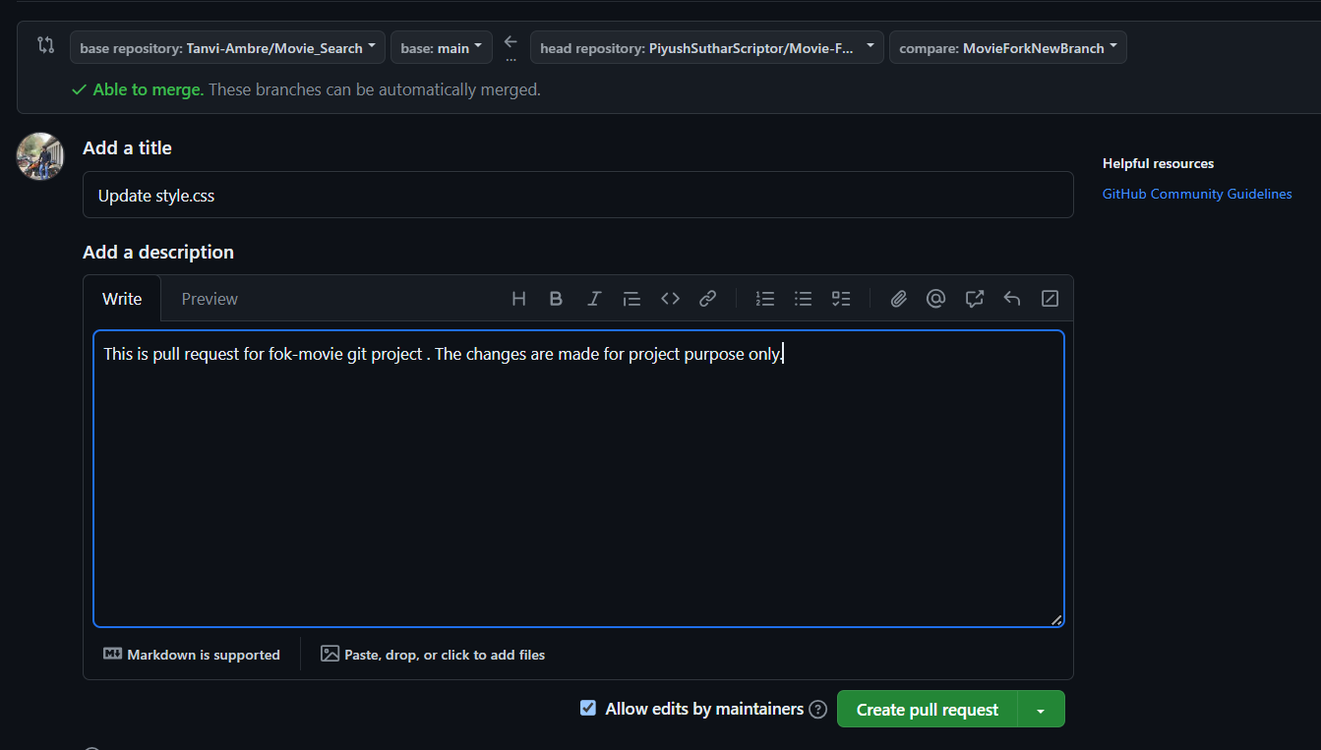

1. After Clicking on “Create pull request ” the page will redirect to the request you made where you can view the request :

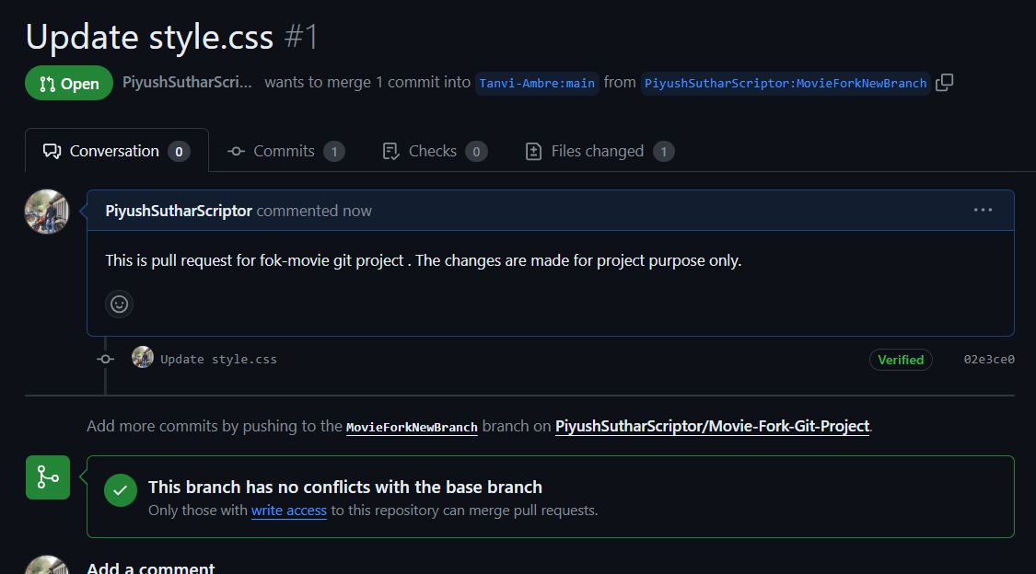

1. **Advanced Tools and Hosting ;**

* Use the Git Lens extension in Visual Studio Code to visualize Git history.

1. Open Visual Studio and go to the “Extension” menu :

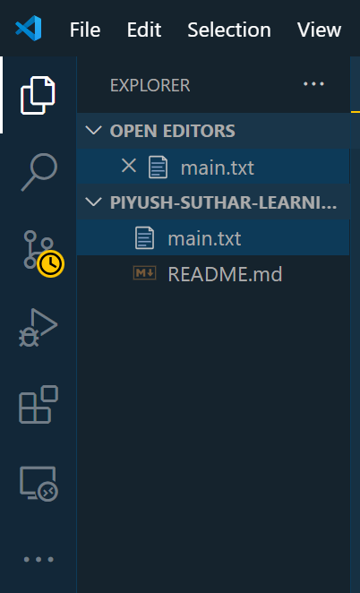

1. At the search box , type “GitLens” and select the first extension :

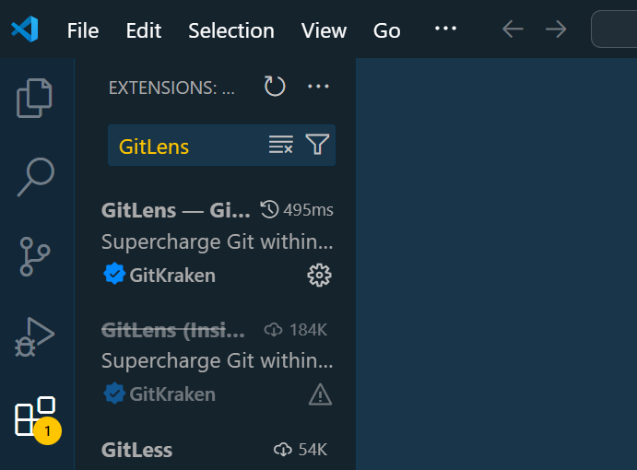

1. Click on the "Download" or "Install" button next to GitLens :

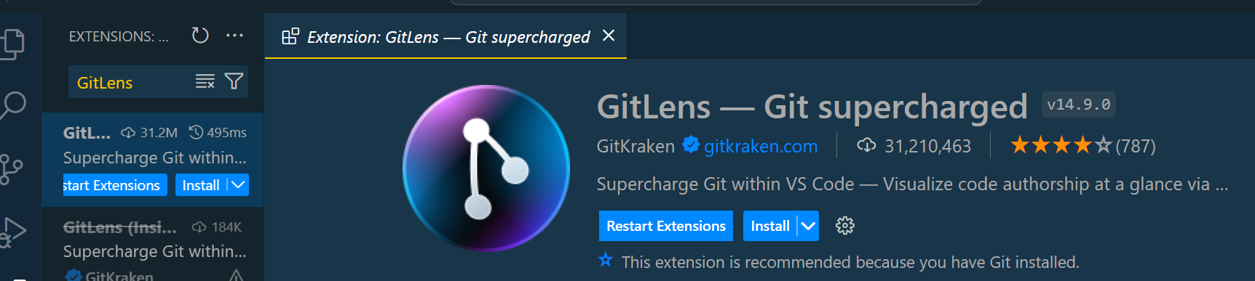

1. Select a file and click on GitLens on the left bar :

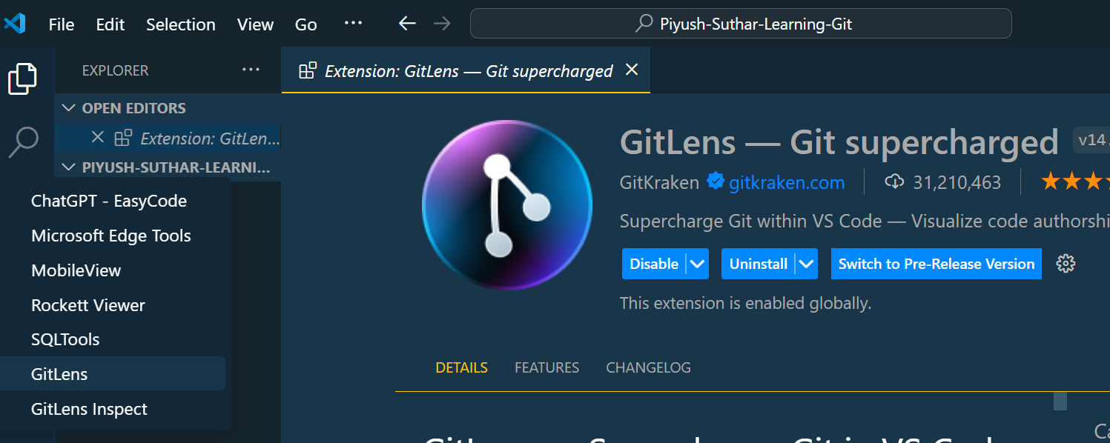

1. Select the “Commit Graph” option to view the comment :

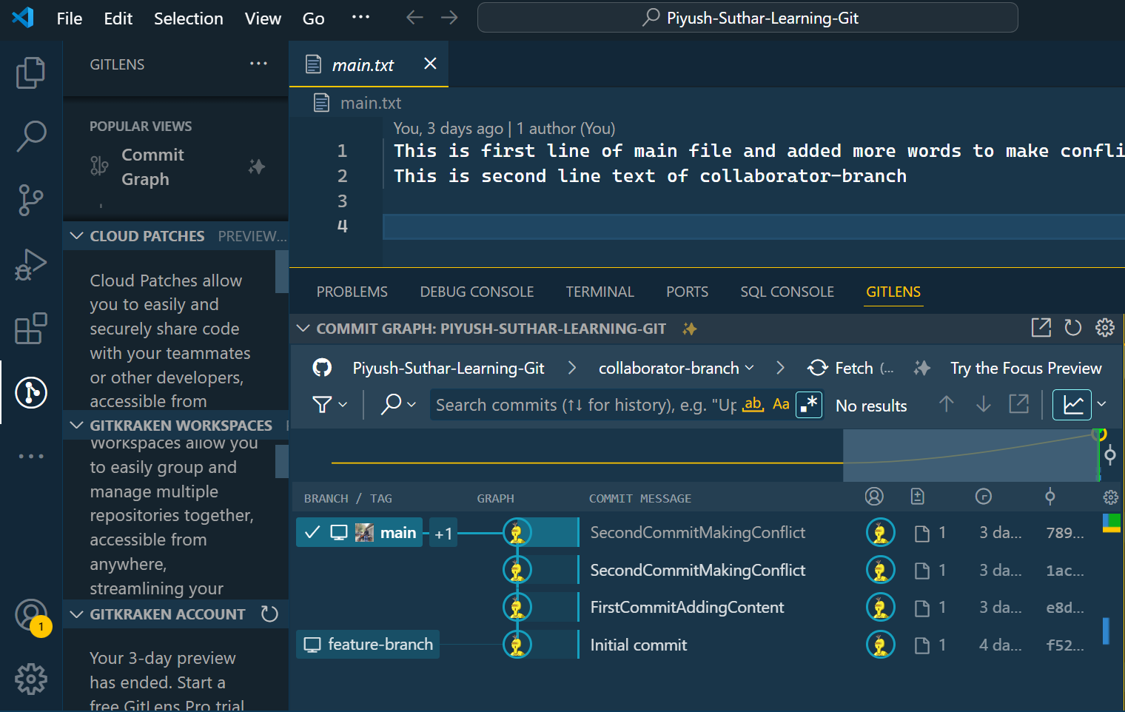

* Deploy a static website using GitHub Pages :

1. Navigate to “Piyush-Suthar-Learning-Git” repository and go to “Setting” :

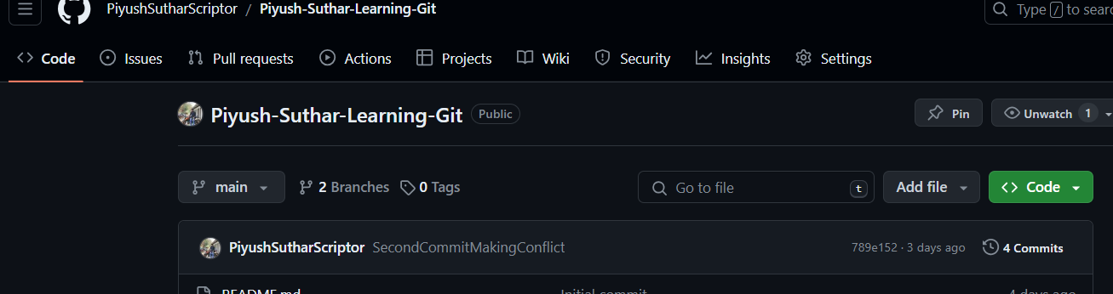

1. Click on “Pages ” on left drop bar :

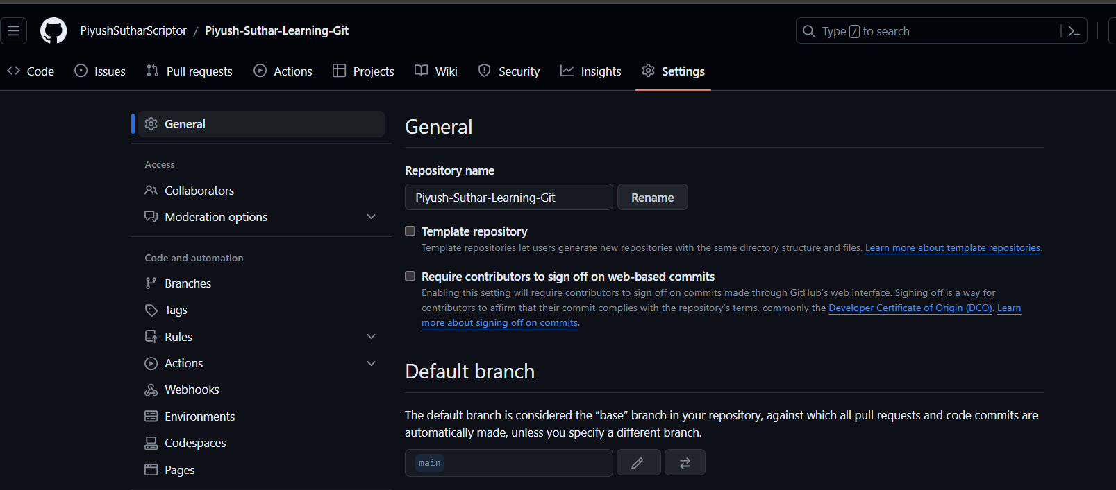

1. Select the branch (main) on the GitHub Pages:

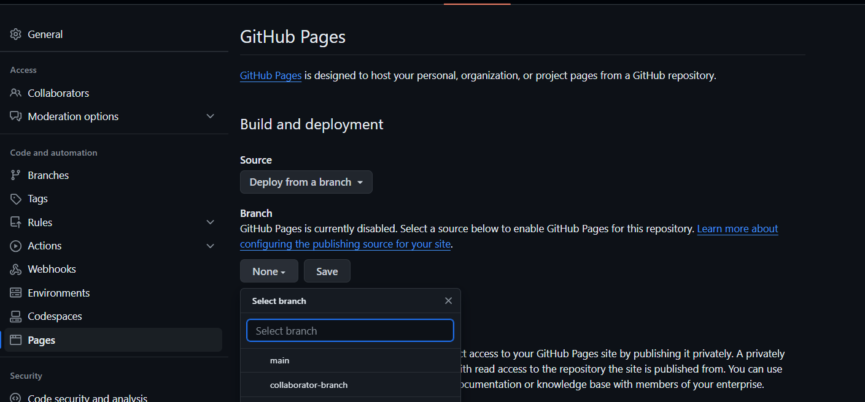

1. After selecting Branch , Click on Save to publish site :

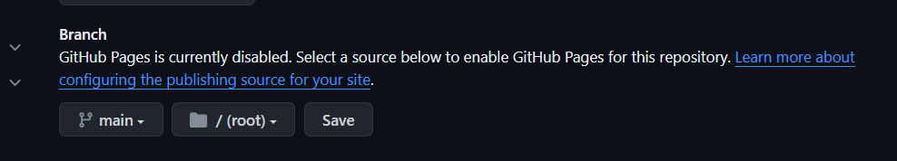

1. Refresh the page and after few seconds a block will be visible which shows that your site is live at https://piyushsutharscriptor.github.io/Piyush-Suthar-Learning-Git/

* Click on Visit site to view the published site :

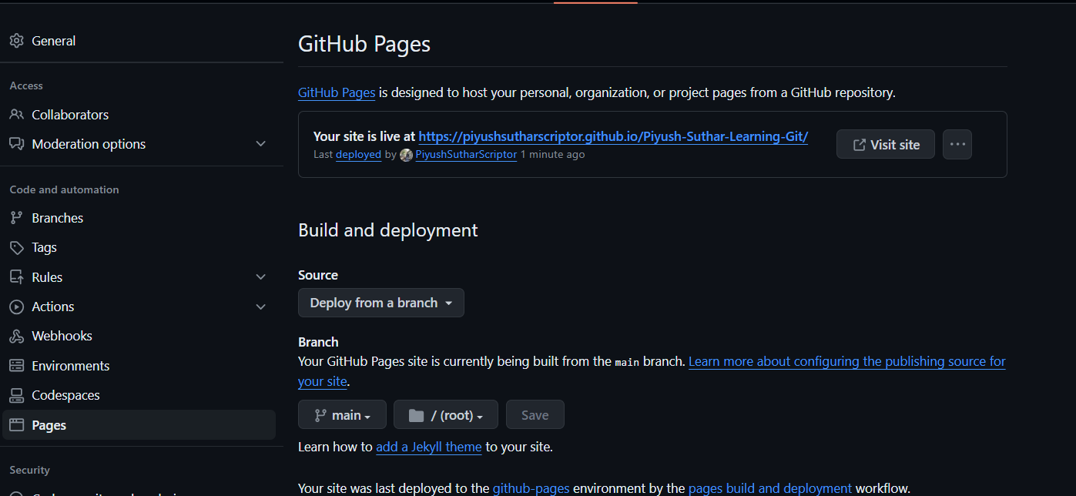

+

**Piyush Suthar**

**BCA(Sunstone)**

**Piyushsuthar6300@gmail.com**