Standard Operating Procedure (SOP) for OPTARIFF

Document Information
Prepared for: | CEA
Prepared by: | The Lantau Group  www.lantaugroup.com
Contact: | Dr. Puneet Chitkara - pchitkara@lantaugroup.com  (+91 9811611522)  Piyush Thukral - pthukral@lantaugroup.com  (+91 9013089443)
Document Status: | Draft
Date: | 30 May 2025

Disclaimer
This internal draft document is supplied for the purposes of facilitating discussions with CEA. It is not a final work product, may not have been reviewed or data managed, and may have factual or other errors. It is therefore not to be further reproduced or distributed without express permission from The Lantau Group. Neither the author(s), nor The Lantau Group make any representation or warranty as to the accuracy or completeness of this document, or accept any liability for any errors or omissions, or for statements, opinions, information or matters arising out of, contained in or derived from this document, or related communications, or for any actions taken on such a basis. The views expressed in this report are those of the authors and do not necessarily reflect the views of other TLG staff.

Table of contents
1. Background 1
1.1. Benefits of Customized Retail Plans 1
2. Model Structure 2
2.1. Approach and Methodology 2
2.2. Technical Details of the Model 3
3. Input Data Preparation 4
3.1. Controls 5
3.1.1. INPUT CONTROL PARAMETERS 5
4. GUI 6
4.1. 👤 Individual Tariff Workflow 7
4.2. 👥Cluster Tariff Workflow 13

Table of Figures
Figure 1: Model structure 2

Table of Tables
Table 1: Input control parameters 5

Table of Abbreviations
Abbreviations | Full Form
ADB | Asian Development Bank
CEA | Central Electricity Authority
CSV | Comma separated values
CvaR | Conditional Value at Risk
CERC | Central Electricity Regulatory Commission
DAM | Day Ahead Markets
DISCOMS | Distribution Companies
DR | Demand Response
DSM | Demand Side Management
MILP | Mixed Integer Linear Programming
MINLP | Mixed Integer Non-Linear Programming
MoP | Ministry of Power
NLP | Non-Linear Programming
RE | Renewable Energy
RTM | Real-Time Market
SCADA | Supervisory Control and Data Acquisition
SLDC | State Load Despatch Centre
SoC | State of Charge
SoW | Statement of Work
SRAS | Secondary Reserve Ancillary Services
STU | State Transmission Utility
TA | Technical Assistance
T&D | Transmission and Distribution
TLG | The Lantau Group
ToD | Time of Day
ToU | Time of Use
Var | Value at Risk

Background
India has long embarked on a focused mission towards promoting renewable energy to decarbonize its power sector. However, it is still grappling with issues of meeting peak load during summer months. To handle this, the most common strategies to manage peak have been to load shedding or use of peaking power plants. However, these have implications on interrupting power supply to important services and the low-utilization factor of expensive gas-based plants. Increasingly, there is a rising interest and adoption towards Demand-side management practices to reduce/manage consumption in peak hours from consumer end. Time-of-Use tariffs is one such approach to signal costs on system to consumers and reduction of demand during peak hours.

This particular use case under Outcome 4 focuses on developing software for customised electricity retail tariffs based on smart meter data analysis. DISCOMs can create tailored pricing schemes aligned with regulatory guidelines according to their energy usage patterns. This approach enhances customer satisfaction, improves demand response, and facilitates effective demand-side management (DSM) by encouraging consumers to adjust their energy usage patterns in response to price signals.

TLG (Core Team: Dr. Puneet Chitkara (+91 9811611522) and Piyush Thukral (+91 9013089443) ) has developed a comprehensive software solution enabling DISCOMs to design and implement customised tariff structures. These tariffs will be aligned with regulatory requirements and promote demand-side management by incentivising energy efficiency and load shifting. TLG's solution will ensure practical deployment, improve operational efficiency for DISCOMs, and deliver more excellent value to consumers.

Benefits of Customized Retail Plans

- Accuracy: Retail prices reflect the unique load pattern and electricity consumption of specific end-user clusters.
- Explanatory Pricing: Prices consist of risk premiums, which can be explained through load and quantity analysis.
- Utilization of Price Elasticity: Custom prices leverage the different price elasticities of end-users, considering their unique load characteristics.
At the system level, it also has implications for the mitigation of peak demand, reduction in power purchase costs, avoidance of peaking power plants, etc.

Model Structure
Figure 1: Model structure

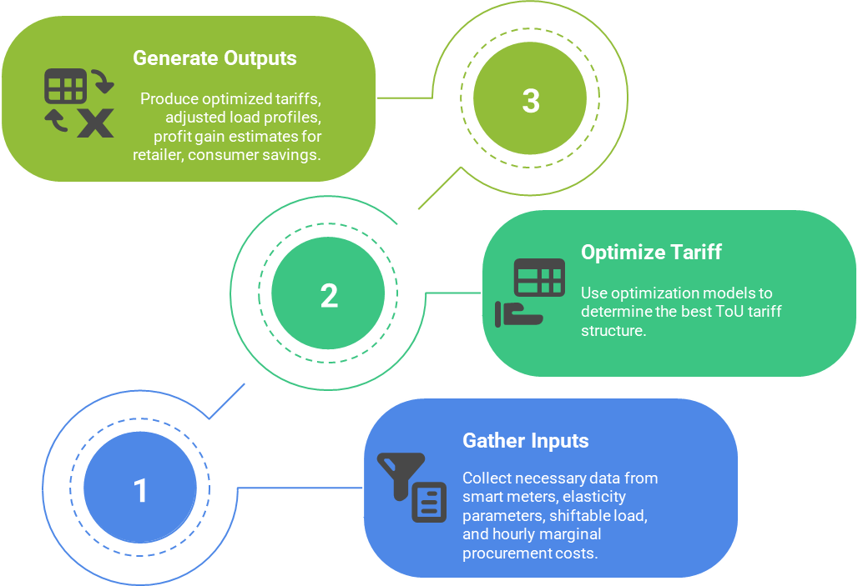

Approach and Methodology

This will use an optimization framework which maximizes the retailer’s profits while ensuring there is no adverse impact on the consumer.
First, residential load features, including the typical load pattern, the statistical feature of consumption quantity are acquired through data mining in the historical load data. Then, a model of customising ToU price plans for customers is established.
There are two approaches to the implementation of Dynamic Time-of-Use:
Individual Time-of-use tariffs: These are tariffs customized based on the electricity consumption of each consumer separately. These are relevant, especially for large industrial and commercial consumers.
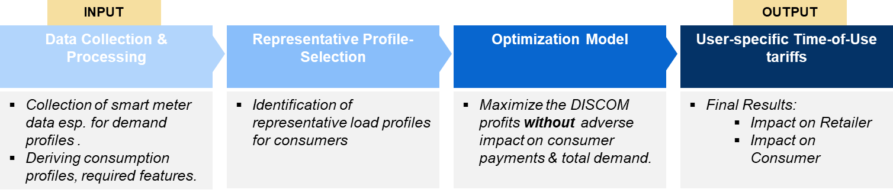

CLUSTER Time-of-use tariffs: These are tariffs customized basis the grouping of many consumers into clusters with similarities in their consumption features (such as total daily demand, total monthly demand, variability in demand, peak demand consumption hours, etc.).
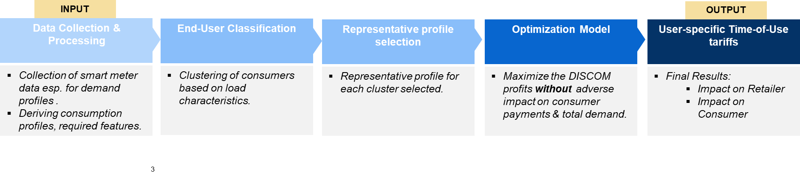
Retailers and regulators can choose the model which they wish to implement. The key difference between the two approaches is the clustering of consumers based on consumption profiles and features in the latter approach.

Technical Details of the Model

Optariff at the background runs an optimization model which models and ensures all relevant techno-economic constraints necessary for designing the above-described system. The details of the model are as follows:

Objective
MAXIMIZE Conditional Value-at-Risk of Profit for Retailer
Constraints
  - Energy consumed by the consumer throughout the day/period does not change
  - Payment of no customer can increase
  - Energy tariffs can not be negative
  - Power consumed by any consumer in any period (even after load-shifting) is positive
  - Demand load shift limits
  - Conditional-Value-at-Risk specific modelling constraints

This ensures that the retailer’s profit increases while consumer’s welfare does not worsen (by lower consumption or increased bills).
Note:
There are 2 sources of stochasticity/uncertainty in the model:
    - Stochasticity in procurement prices, and
    - Stochasticity in consumers’ response to tariff changes (i.e. elasticity)

Input Data Preparation
The following provides and overview of the most essential types of data needed to run the model.
On the consumer/consumption side, the 24-hour profile is required as a necessary input for all consumers. The following column variables are required:
- Date
- Consumer No
- Meter No
- Sanctioned Load
- Category
- MeterPhase_Name
- Consumption_Hr_1, Consumption_Hr_2, ….., Consumption_Hr_24 [Hourly consumption/power demand by respective consumers]
Note that,
- Consumption_Hr_1 indicates Consumption between 00:00 to 01:00 AM
- Consumption_Hr_2 indicates Consumption between 01:00 to 02:00 AM
- Consumption_Hr_24 indicates Consumption between 23:00 to midnight

Note: The input file must be prepared on Excel v16.0 or above/CSV format.

Controls

INPUT CONTROL PARAMETERS
This sheet defines the global parameters that control model behaviour, including the model’s starting year, the inclusion of certain equations, and system-level adjustments. (COLUMN A to COLUMN C).

Key Parameters:
Table 1: Input control parameters
Parameter | Description | Units of Input | Remarks
number_of_scenarios | Number of scenarios used in the stochastic optimization to capture uncertainty in inputs. | number | For stochasticity model, set 1 to run deterministic
Cvar_alpha | Confidence level (alpha) for CVaR risk assessment, typically between 0.8 and 0.95. | - | Risk weightage for calculation of Conditional Value at Risk (CVaR)  - higher value implies higher risk settings and vice-versa.  - For example, 0.8 value means, look at worst 20% outcomes.  - !! DO NOT set as 1, it will cause numerical errors (as in the formula it applies as 1/(1-Cvar_alpha))  Note. Rockafellar & Uryasev, Optimization of CVaR (Journal of Risk, 2000) – benchmarks α = .95, .99.
min_power_consumer_after_load_shifting | Minimum load (kW) that must remain after shifting to preserve essential usage. | - | Worst-case conditional value at risk of profit is equal to this setting
cvar_auxiliary_lower_limit | Lower bound on Conditional Value at Risk (CVaR) to ensure downside risk control. | - | Can put any upper limit, required for variable setting in optimization model
cvar_auxiliary_upper_limit | Upper bound on Conditional Value at Risk (CVaR) to limit excessive risk-taking. | - | Worst-case value at risk of profit is equal to this setting
var_lower_limit | Lower bound on Value at Risk (VaR) to restrict risk exposure. | - | Can put any upper limit, required for variable setting in optimization model
var_upper_limit | Upper bound on Value at Risk (VaR) to cap risk impact. |  | For stochasticity model, set 1 to run deterministic
marginal_price_of_procurement | Hourly cost of electricity procurement from market or supplier. | INR/MWh | 1. Vector length should be as much as the number of timeblocks modelled in ToD_for_tariff  2. Units are INR/MWh
stochasticity_procurement_costs | Variability present in procurement costs | - | This creates scenarios by adding 'errors' drawn from a normal distribution whose standard deviation is given in the std_dev_value column
stochasticity_elasticity | Variability present in elasticity/consumers’ demand response | - | This creates scenarios by adding 'errors' drawn from a normal distribution whose standard deviation is given in the std_dev_value column
elasticity_by_category | Price elasticity of demand differentiated by consumer category (e.g., residential, commercial). | - | The elasticity parameter gives the percentage change in demand to a percentage change in tariff/price of electricity for that user. The negative impact of price on demand is already incorporated in the model.  The values in model parameter file format from the tool are based from a literature survey.
load_shift  upper_limit | Permissible limits for load shifting for any consumer (e.g., max % shiftable load). | % | This implies, that for any consumer in any timeblock, maximum increase or decrease in consumption can only by up to a certain % (for example, 205)
lower_limit_tariff | Lower limit on energy charges/tariff | INR/kwh | For e.g., a lower limit of 4 would imply that even after optimization , the energy tariff >= 4 INR/kwh
upper_limit_to_tariff | Upper limit on energy charges/tariffs | INR/kwh | For e.g., a upper limit of 20 would imply that even after optimization, the energy tariff <= 20 INR/kwh
lower_limit_to_change_allowed | Lower limit on change allowed to energy tariffs | INR/kwh | For e.g., a lower limit of -9 implies that tariff can decrease at most by 9
upper_limit_to_change_allowed | Upper limit on change allowed to energy tariffs | INR/kwh | For e.g., a upper limit of 9 implies that tariff can increase at most by 9

Note: The input file must be prepared on Excel v16.0 or above/CSV format.

GUI
When you open the tool, you are greeted with a landing screen featuring two main options:

- Individual Tariff
- Cluster Tariff

Clicking on either option routes the user to a separate configuration flow, starting with the Individual Tariff pathway described below.

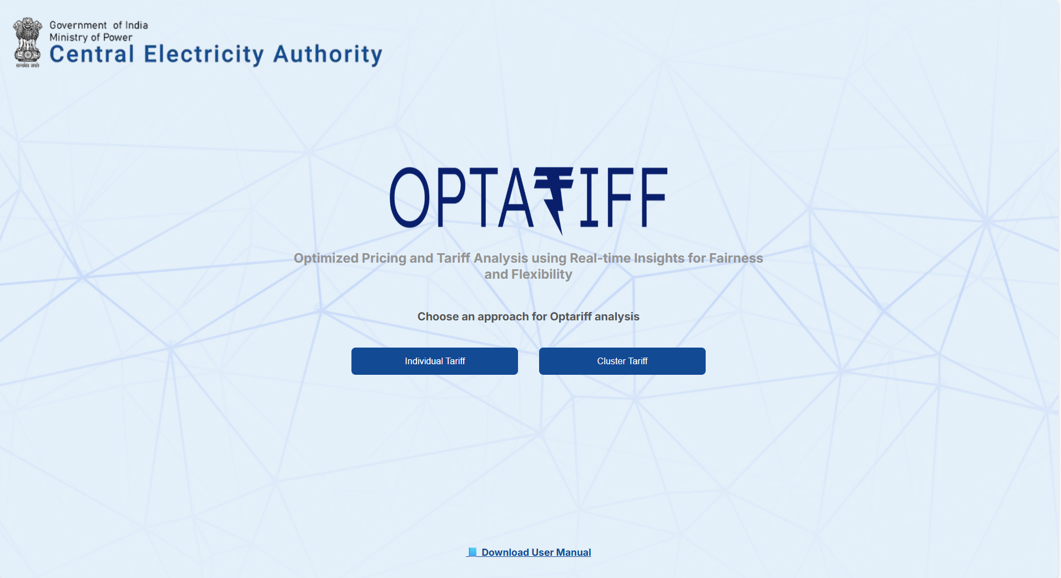

👤 Individual Tariff Workflow

Step 1: Upload Smart Meter Data

- Upload your smart meter Excel or CSV file using the upload widget.
- A sample file is available for download as a reference.
- The tool extracts hourly consumption data from the columns named Consumption_Hr_1 through Consumption_Hr_24.
Profile Visualization Area

After uploading:

- Use the Category, Sanctioned Load, and Consumer No. dropdowns to filter the data.
- The graph updates to show daily or hourly consumption of each consumer.
- Optionally, view a representative profile (e.g., median profile) across selected consumers.
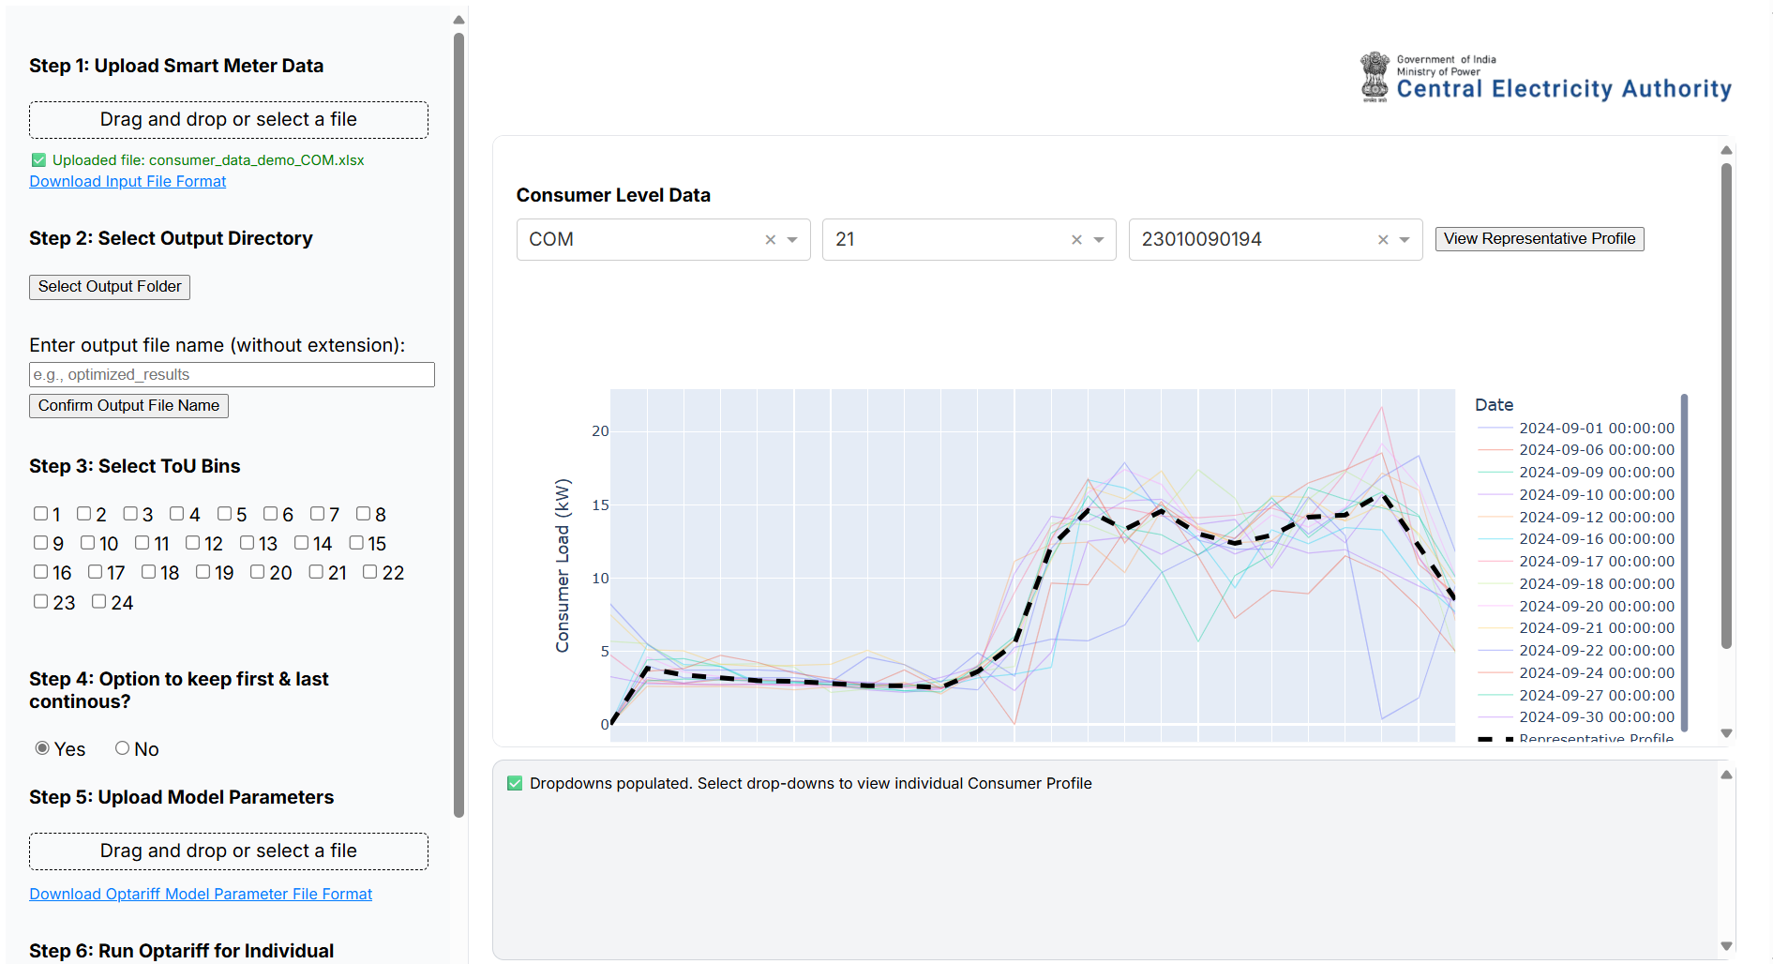

- 💾

Step 2: Select Output Directory and Input Output file name
- Choose the folder where all model outputs, plots, and logs should be saved.
- This ensures model results are persistent and easy to retrieve.
- Also input the desired name for the generated output file for easy location and access.

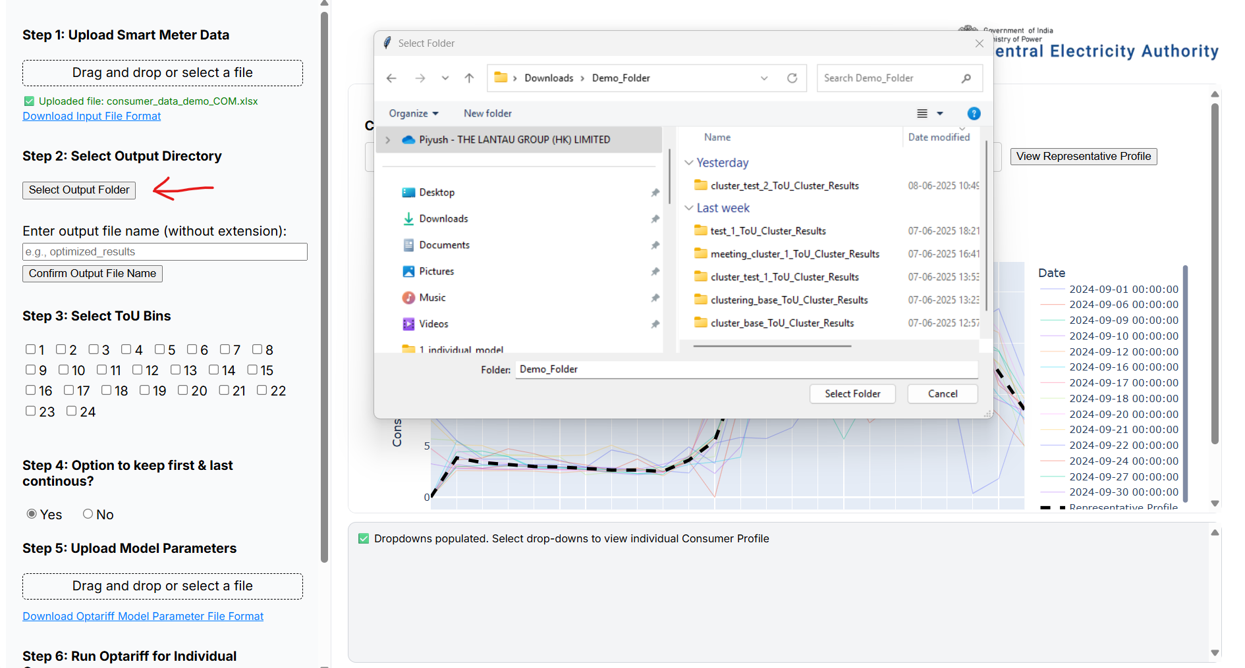

Step 3: Select Time of Use Bins in a Day

- Define time-of-use bin hours by entering the hour numbers.
  - For example: to capture solar hours between 6 AM and 5 PM, enter 6 and 17 (as hours are zero-indexed).
  - Note that the hour setting would work as follows: selection of [2, 10, 17, 19, 22] would mean:
      - Bin 1: [1, 2, 23, 24]
      - Bin 2: [3, 4, 5, 6, 7, 8, 9, 10]
      - Bin 3: [11, 12, 13, 14, 15, 16, 17]
      - Bin 4: [18, 19]
      - Bin 5: [20, 21, 22]

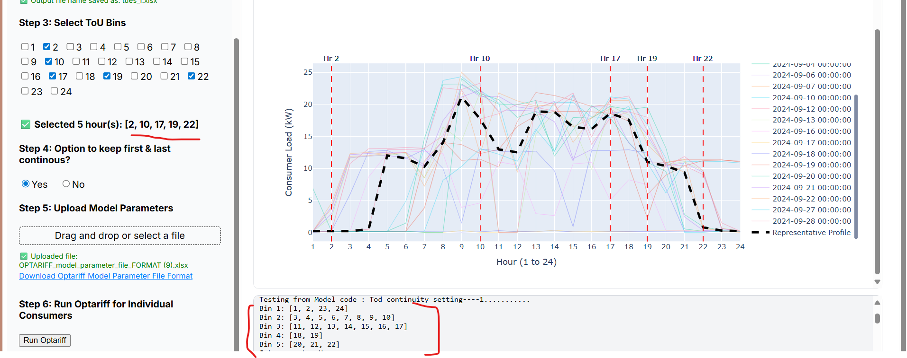

🔁 Step 4: Choose Bin Continuity

Choose whether first and last time of use bins should be continuous or not. For example, selection of [2, 10, 17, 19, 22] would mean:
  - Continuous = Yes ✅
      - Bin 1: [1, 2, 23, 24]
      - Bin 2: [3, 4, 5, 6, 7, 8, 9, 10]
      - Bin 3: [11, 12, 13, 14, 15, 16, 17]
      - Bin 4: [18, 19]
      - Bin 5: [20, 21, 22]
  - Continuous = No ❌
      - Bin 1: [1, 2]
      - Bin 2: [3, 4, 5, 6, 7, 8, 9, 10]
      - Bin 3: [11, 12, 13, 14, 15, 16, 17]
      - Bin 4: [18, 19]
      - Bin 5: [20, 21, 22]
      - Bin 6: [23, 24]
- This impacts how the model interprets consumer behaviour across different parts of the day.

Step 5: Upload Model Parameters

- Upload a parameter file (Excel) containing:
  - Cost and benefit assumptions
  - Tariff structure constraints
  - Policy preferences

- A sample parameter file can be downloaded to understand the format.

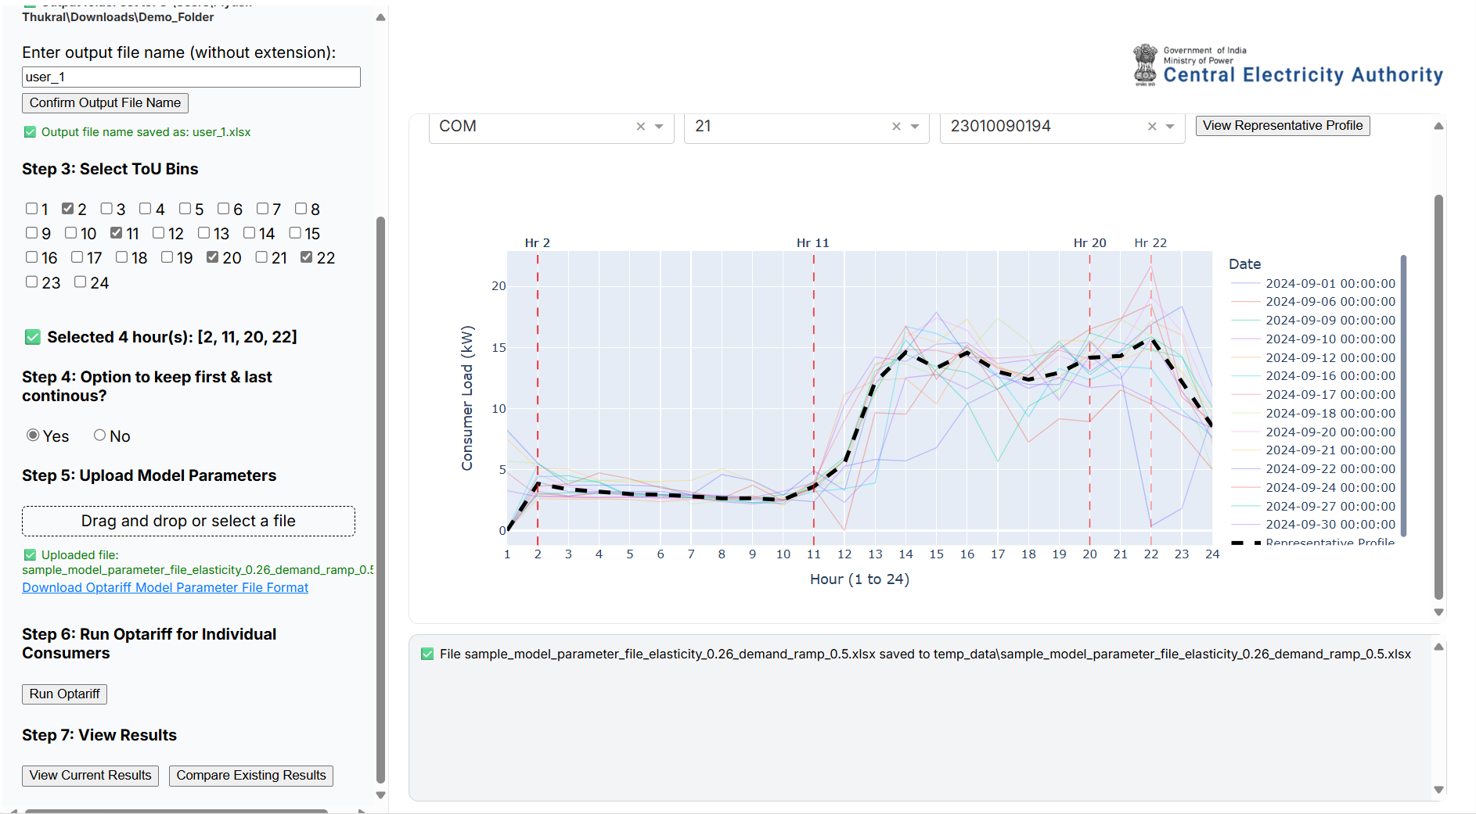

Step 6: Run the TOU Model

- Once all inputs are provided, click Run Optariff.
- Internally, the tool:
  - Creates ToU bins
  - Processes daily demand
  - Runs the optimization engine
  - Writes output files (tariffs, savings, plots) to the selected folder
- Progress and logs are shown at the bottom of the screen.
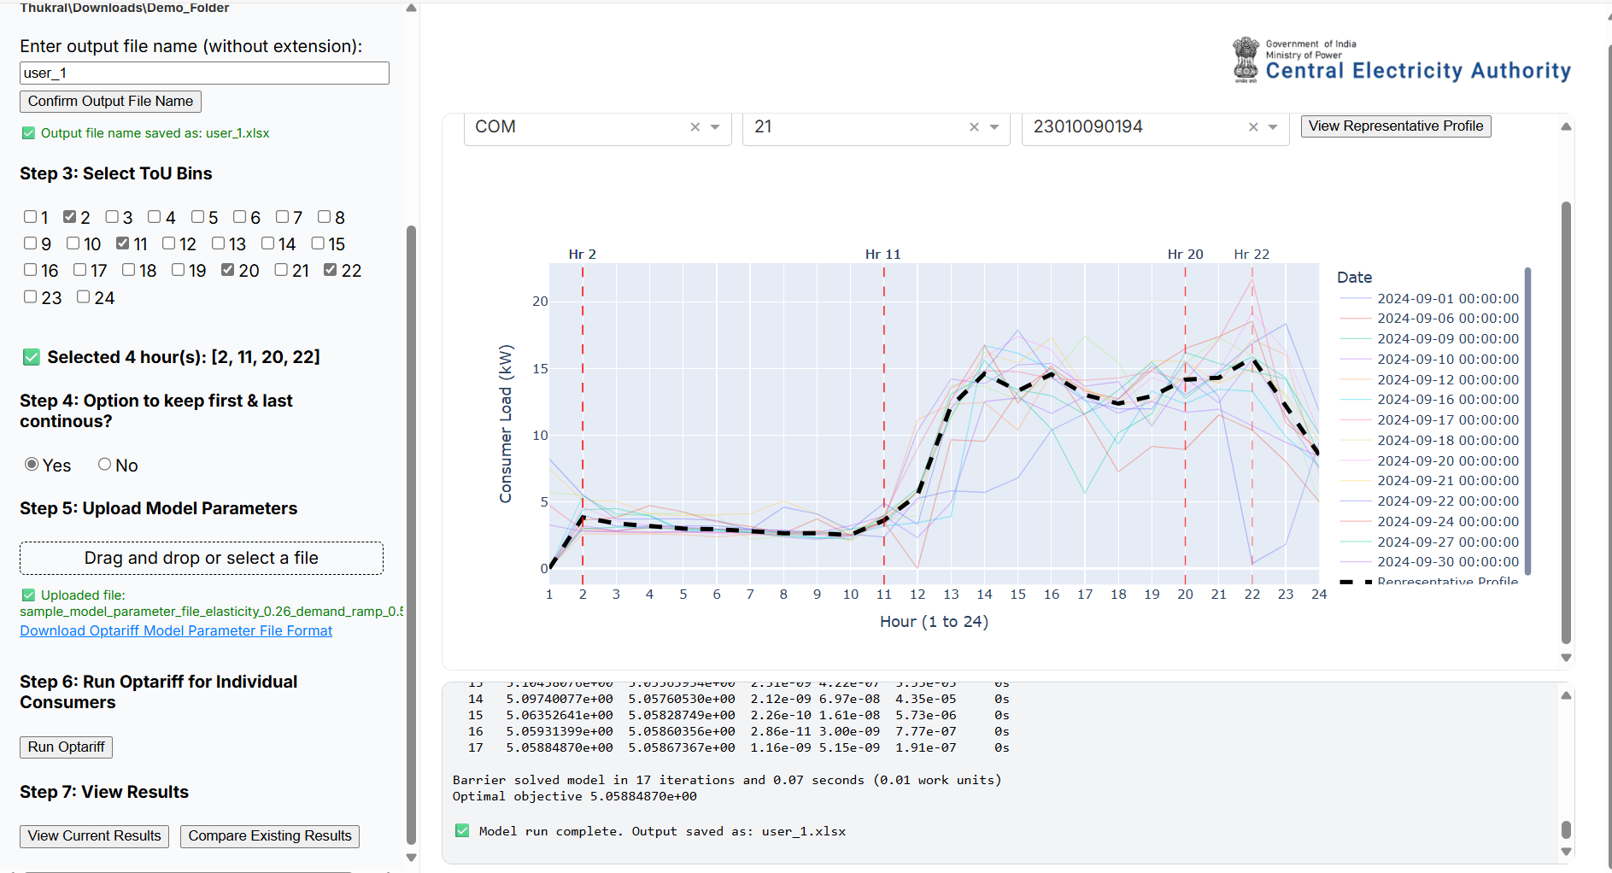

Step 7: Visualize Results

- Once the model finishes, output graphs will be displayed:
  - Daily demand vs. optimized demand
  - Cost savings per consumer
  - Tariff structure comparisons
- Users can export plots or inspect detailed Excel outputs from the output directory.
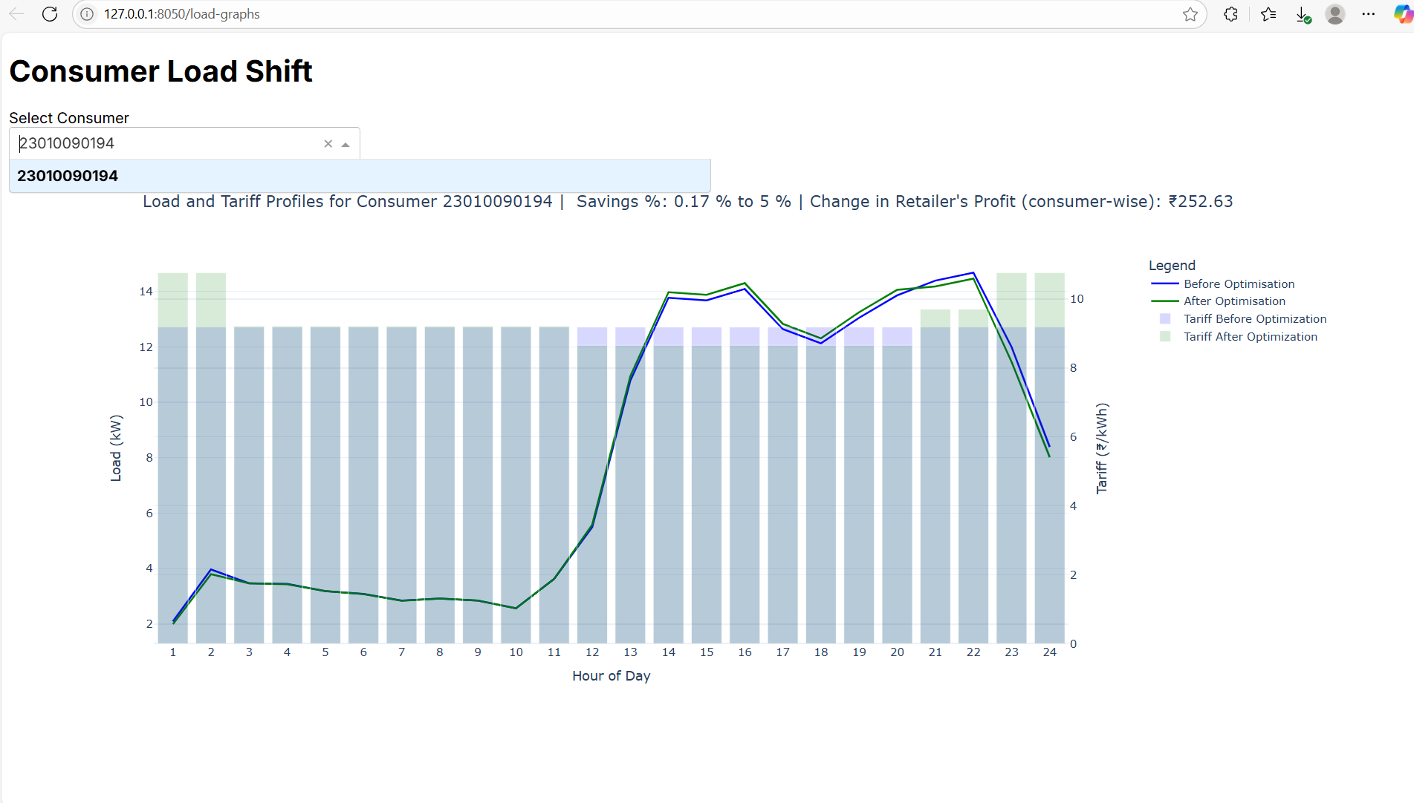

Step 8: Compare Results

- User can also compare the results drawn from two different studies to compare into the differences in outcomes across two different model runs.
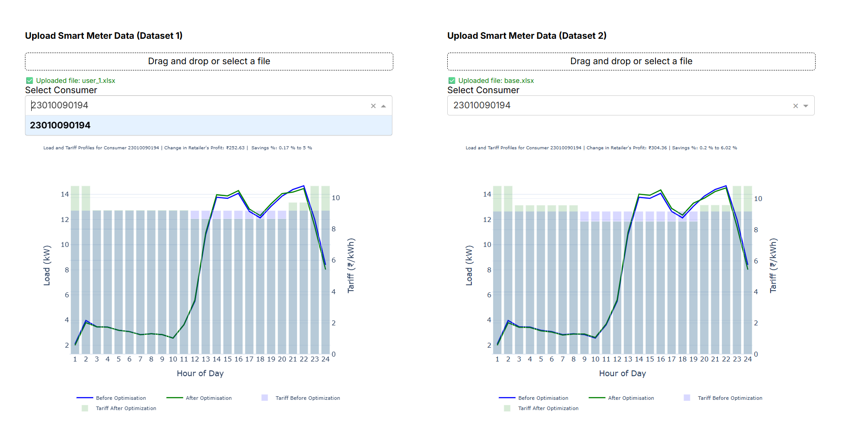

Tips & Troubleshooting

- Ensure the date format in the uploaded file is consistent (e.g., DD-MM-YYYY).
- All 24-hourly columns (Consumption_Hr_1 to Consumption_Hr_24) must be present.
- If a column is missing or an error is shown, check the logs area for more information.
- For other information, you may contact – Piyush Thukral (+ 90130 89443) for information on tweaks and further customizations required.

Outputs

The tool generates the following outputs in the selected directory:
- 📊 outputs.xlsx [Based on the name defined by the user)
- 📈 graphs.png [Options available to download every plot generated]

👥Cluster Tariff Workflow

The Cluster Tariff path in the Optariff tool’s home screen allows you to group and cluster similar consumers and analyse tariffs at a group level. Below are the step-by-step instructions for using this functionality:

Step 1: Upload Smart Meter Data

- Upload the smart meter data for all individual consumers using the file upload component.
- A sample file is available to guide the format. This is the same as in the run individual model screen.

Step 2: Select Output Directory and Input Output file name

- Choose the folder where all outputs (intermediate and results) will be saved.
- This directory will store the clustered profiles, model outputs, and logs.
- User should also provide the name of the input file as desired.
- This is the same as in the run individual model screen.

Step 3: Visualize and Configure Clustering

In the right panel (graph screen), two tabs are provided:

Tab 1: Distribution Overview

- Visualizes the frequency distributions for the following attributes:
  - Consumer Category
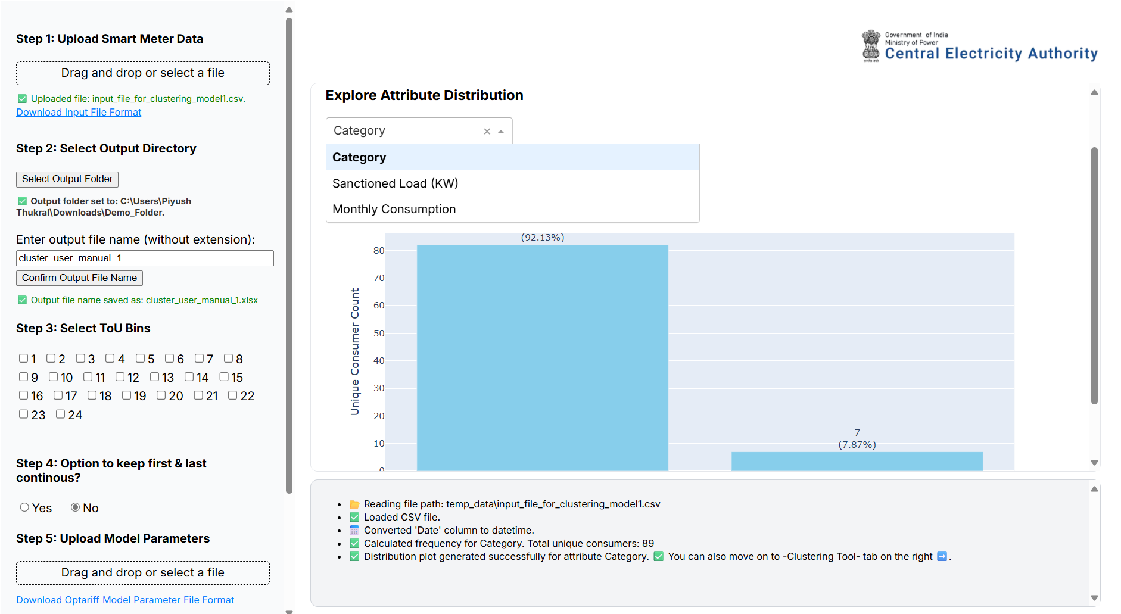

  - Sanctioned Load (kW)
  - Monthly Consumption (computed from the uploaded smart meter data)
This helps in understanding the data spread before clustering.

Tab 2: Clustering Settings

- Configure the logic for consumer segmentation using the following options:
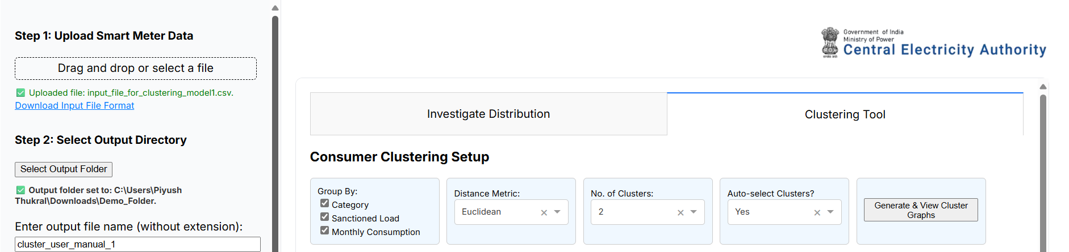

Clustering Level Options:

  - Cluster all consumers together (no segmentation)
  - Cluster separately within each Category
  - Cluster within each Category + Sanctioned Load bin
  - Cluster within each Category + Sanctioned Load bin + Monthly Consumption bin

Distance Metric:

  - Choose the metric to define similarity.
  - Default: Euclidean
Number of Clusters:

  - Let the algorithm automatically determine the optimal number of clusters
  - OR manually specify a fixed number of clusters
- Once settings are finalized, click “Generate Clusters” to perform clustering.
- Cluster profiles and metadata will be saved to the selected output directory from Step 2.
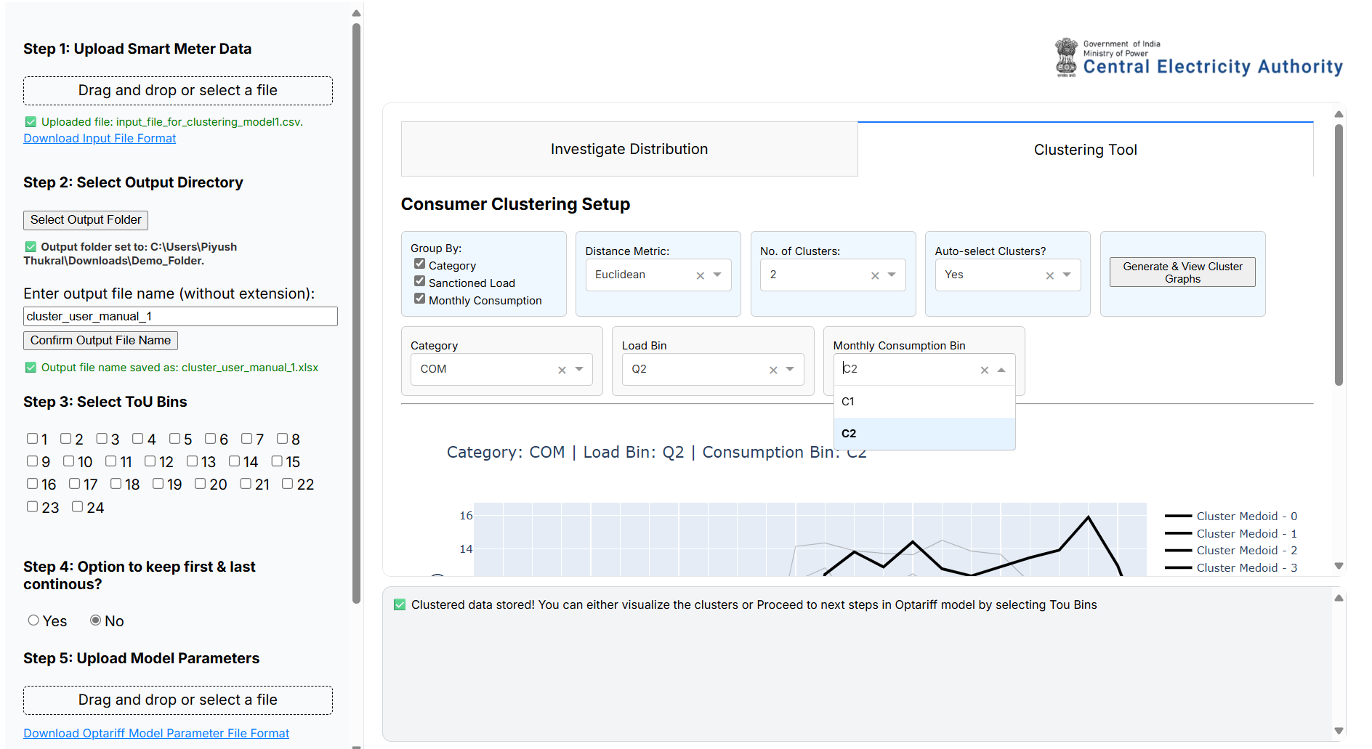

Step 4: Select ToU Dynamicity

- Choose the level of Time-of-Use (ToU) dynamicity as required (e.g., solar/non-solar hours).
- This step mirrors the dynamicity selection in the Individual Tariff Model.

Step 5: Configure First and Last Bin Logic

- Option to keep first and last bins continuous.
- If enabled: two bins are created (e.g., solar and non-solar).
- If disabled: three bins are created (e.g., early morning, solar hours, late night).

Step 6: Upload Model Parameters

- Upload the model parameter Excel file.
- A sample file is available to help users understand required inputs.

Step 7: Run Optariff for Clustered Data

- Run the Optariff model using the prepared cluster profiles and parameters.
- This step computes the optimized ToU pricing for each cluster.

Step 8: View Current Results or Compare Existing Results

- Navigate to the View Current Results tab to visualize model outputs.
- Results are also saved in the output folder specified earlier.
- You may also compare the results derived from two different model runs using the Compare Existing Result.
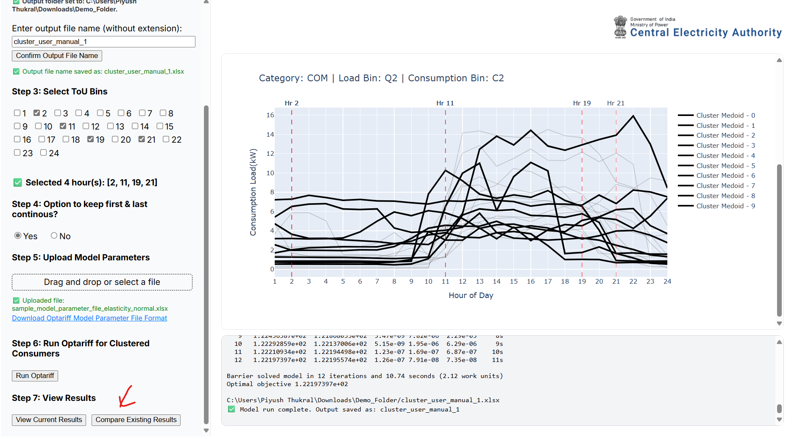

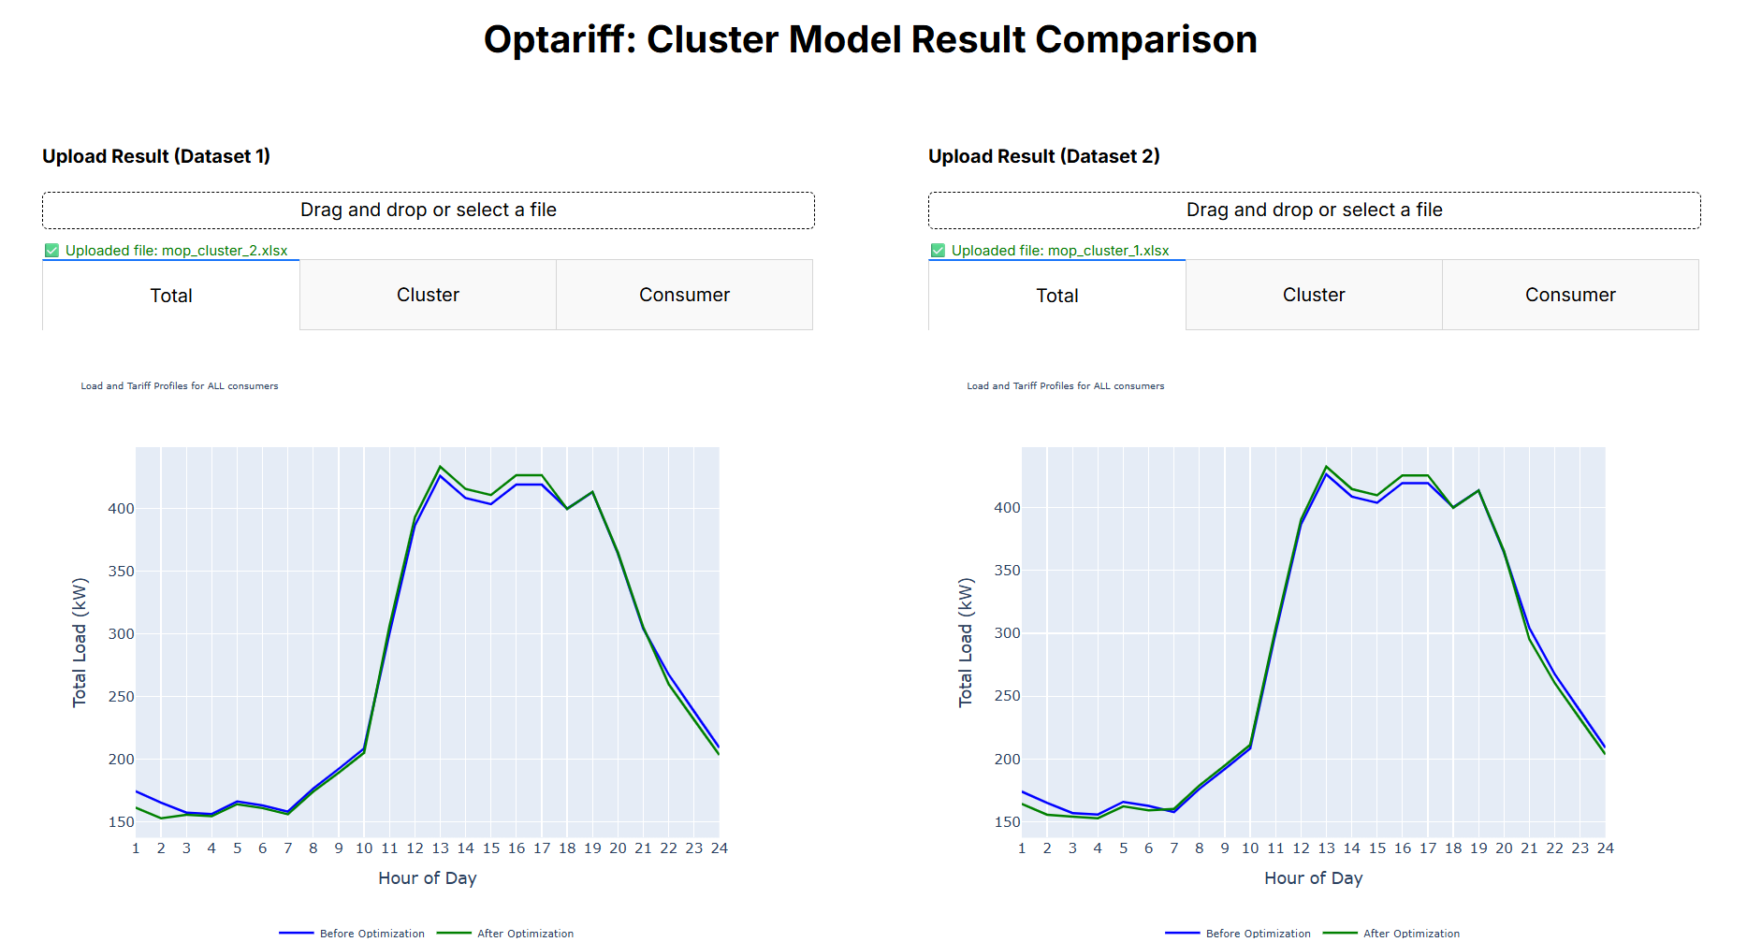

Rockafellar, R. Tyrrell, and Stanislav Uryasev. "Optimization of conditional value-at-risk." Journal of risk 2 (2000): 21-42. https://citeseerx.ist.psu.edu/document?repid=rep1&type=pdf&doi=0df3ccfb652189488337202933d4151fc20ac31d
The median profile of each consumer from the smart meter data uploaded would indicate the representative profile for that consumer in the Individual model workflow.

