User Manual for OPTARIFF

Background
India has long embarked on a focused mission towards promoting renewable energy to decarbonize its power sector. However, it is still grappling with issues of meeting peak load during summer months. To handle this, the most common strategies to manage peak have been to load shedding or use of peaking power plants. However, these have implications on interrupting power supply to important services and the low-utilization factor of expensive gas-based plants. Increasingly, there is a rising interest and adoption towards Demand-side management practices to reduce/manage consumption in peak hours from consumer end. Time-of-Use tariffs is one such approach to signal costs on system to consumers and reduction of demand during peak hours.
This particular use case under Outcome 4 focuses on developing software for customised electricity retail tariffs based on smart meter data analysis. DISCOMs can create tailored pricing schemes aligned with regulatory guidelines according to their energy usage patterns. This approach enhances customer satisfaction, improves demand response, and facilitates effective demand-side management (DSM) by encouraging consumers to adjust their energy usage patterns in response to price signals.
TLG (Core Team: Dr. Puneet Chitkara and Piyush Thukral (+91 9013089443) ) has developed a comprehensive software solution enabling DISCOMs to design and implement customised tariff structures. These tariffs will be aligned with regulatory requirements and promote demand-side management by incentivising energy efficiency and load shifting. TLG's solution will ensure practical deployment, improve operational efficiency for DISCOMs, and deliver more excellent value to consumers.

Benefits of Customized Retail Plans
- Accuracy: Retail prices reflect the unique load pattern and electricity consumption of specific end-user clusters.
- Explanatory Pricing: Prices consist of risk premiums, which can be explained through load and quantity analysis.
- Utilization of Price Elasticity: Custom prices leverage the different price elasticities of end-users, considering their unique load characteristics.

At the system level, it also has implications for the mitigation of peak demand, reduction in power purchase costs, avoidance of peaking power plants, etc.

Approach and Methodology
This will use an optimization framework which maximizes the retailer’s profits while ensuring there is no adverse impact on the consumer.
First, residential load features, including the typical load pattern, the statistical feature of consumption quantity are acquired through data mining in the historical load data. Then, a model of customising ToU price plans for customers is established.
There are two approaches to the implementation of Dynamic Time-of-Use:
- Customer-SPECIFIC Time-of-use tariffs: These are tariffs customized based on the electricity consumption of each consumer separately. These are relevant, especially for large industrial and commercial consumers.
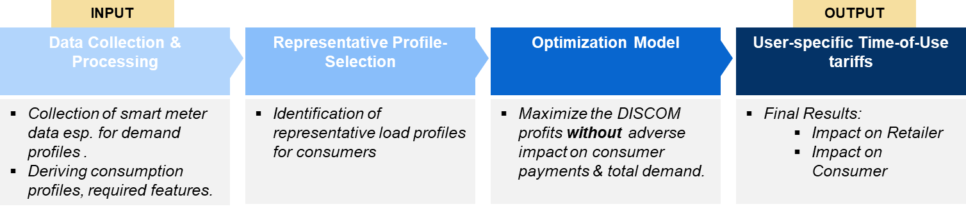

- CLUSTER-SPECIFIC Time-of-use tariffs: These are tariffs customized basis the grouping of many consumers into clusters with similarities in their consumption features (such as total daily demand, total monthly demand, variability in demand, peak demand consumption hours, etc.).
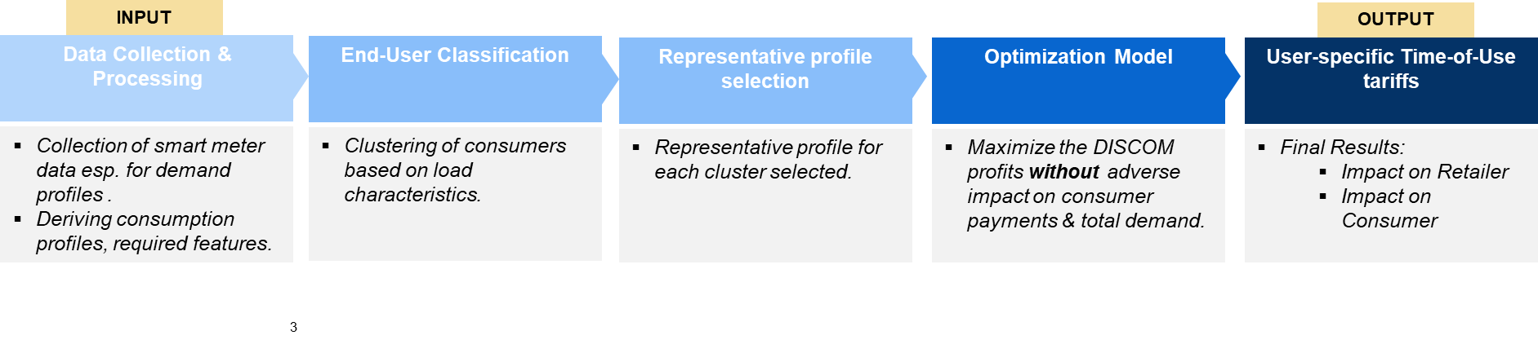
Retailers and regulators can choose the model which they wish to implement. The key difference between the two approaches is the clustering of consumers based on consumption profiles and features in the latter approach.

Technical Details of the Model
Optariff at the background runs an optimization model which models and ensures all relevant techno-economic constraints necessary for designing the above-described system. The details of the model are as follows:
Objective
MAXIMIZE Conditional Value-at-Risk of Profit for Retailer
Constraints
  - Energy consumed by consumer throughout the day/period does not change
  - Payment of no customer can increase
  - Energy tariffs can not be negative
  - Power consumed by any consumer in any period (even after load-shifting) is positive
  - Demand load shift limits
  - Conditional-Value-at-Risk specific modelling constraints
This ensures that the retailer’s profit increases while consumer’s welfare does not worsen (by lower consumption or increased bills).
Note:
There are 2 sources of stochasticity/uncertainty in the model:
    - Stochasticity in procurement prices, and
    - Stochasticity in consumer’s response to tariff changes (i.e. elasticity)

About the Tool and functionalities
The OPTARIFF Tool is an application designed to help electricity utilities determine optimized tariffs using real-time insights. Users can choose to run the tool for:
- Individual Consumers or
- Clustered Groups of Consumers
The tool enables visualization of smart meter data, configuration of time-of-use (ToU) bins, selection of model parameters, and execution of the tariff optimization engine.

🧭 1. Getting Started
When you open the tool, you are greeted with a landing screen featuring two main options:
- 🔵 Individual Tariff
- 🟢 Cluster Tariff
Clicking on either option routes the user to a separate configuration flow, starting with the Individual Tariff pathway described below.
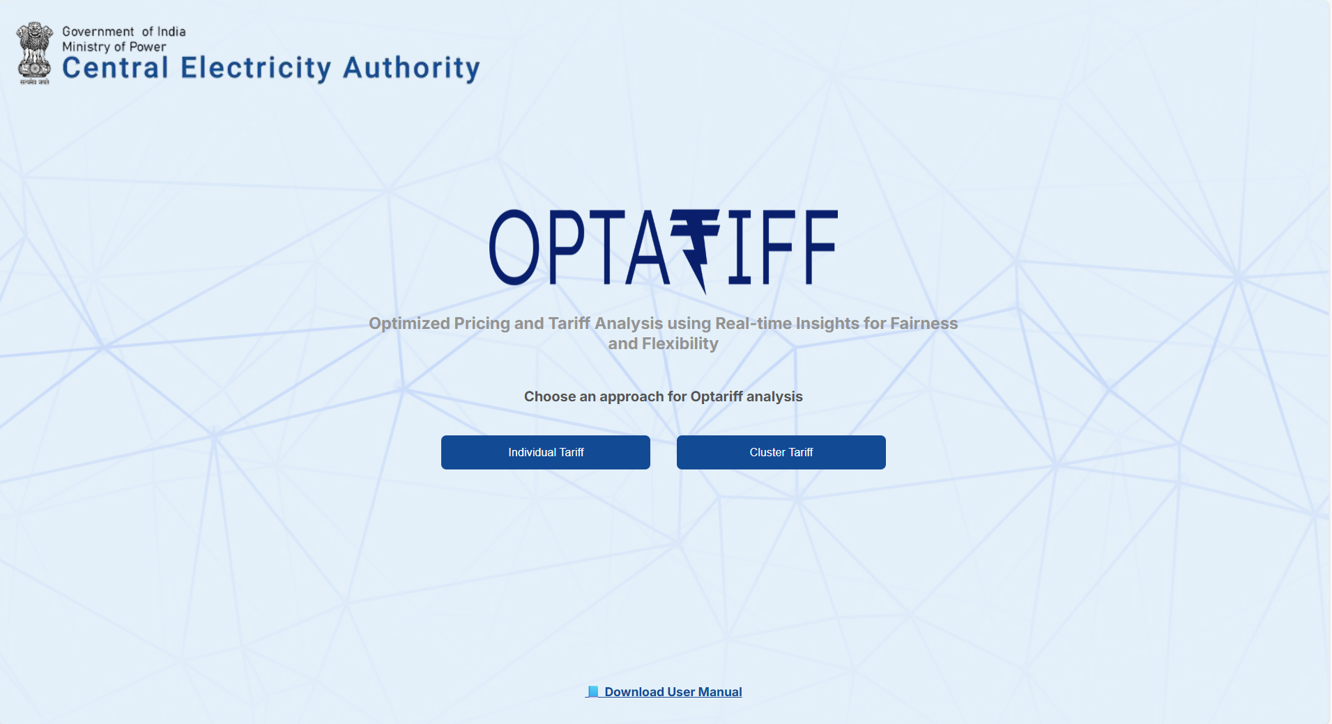

👤 Individual Tariff Workflow
📂 Step 1: Upload Smart Meter Data
- Upload your smart meter Excel or CSV file using the upload widget.
- A sample file is available for download as a reference.
- The tool extracts hourly consumption data from the columns named Consumption_Hr_1 through Consumption_Hr_24.
📊 Profile Visualization Area
After uploading:
- Use the Category, Sanctioned Load, and Consumer No. dropdowns to filter the data.
- The graph updates to show daily or hourly consumption of each consumer.
- Optionally, view a representative profile (e.g., median profile) across selected consumers.
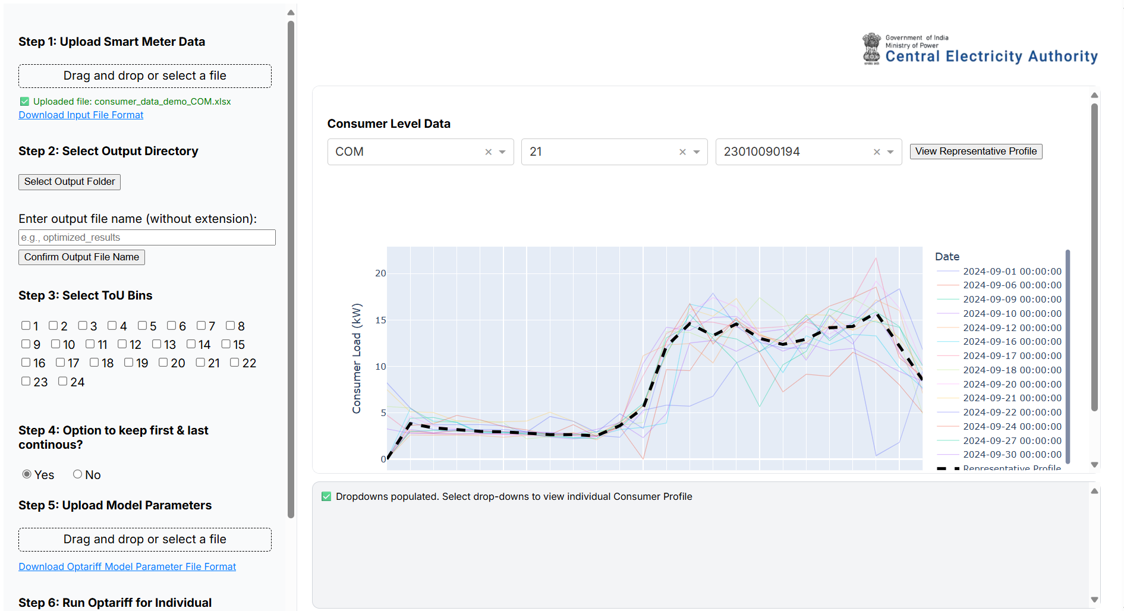

💾 Step 2: Select Output Directory and Input Output file name
- Choose the folder where all model outputs, plots, and logs should be saved.
- This ensures model results are persistent and easy to retrieve.
- Also input the desired name for the generated output file for easy location and access.
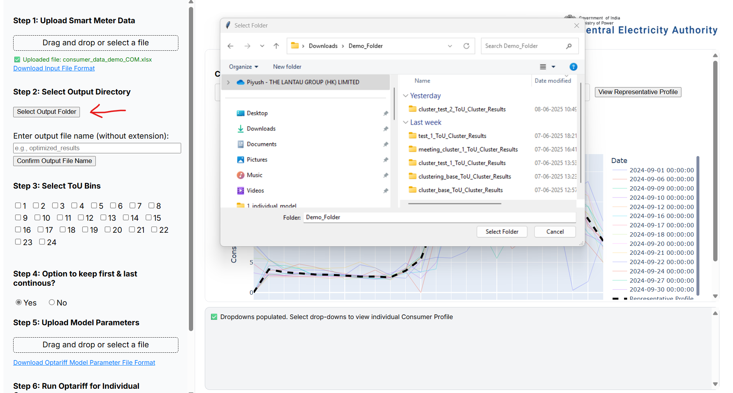

⏰ Step 3: Select Time of Use Bins in a Day
- Define time-of-use bin hours by entering the hour numbers.
  - For example: to capture solar hours between 6 AM and 5 PM, enter 5 and 17 (as hours are zero-indexed).
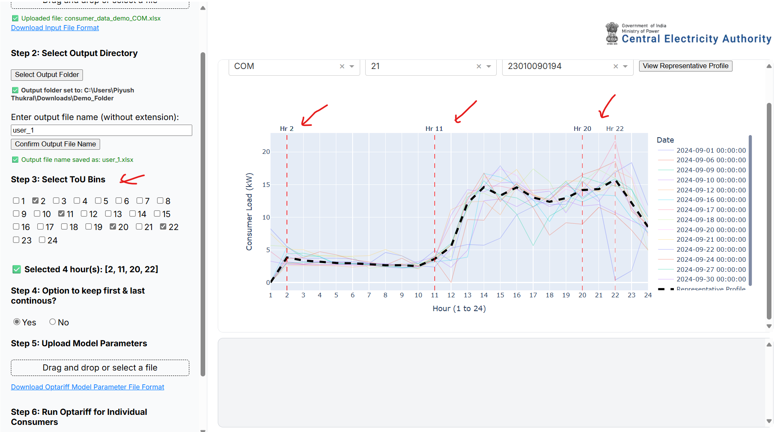

🔁 Step 4: Choose Bin Continuity
- Choose whether non-solar bins should be:
  - ✅ Continuous (e.g., 6–17 and all remaining hours grouped into a second bin), or
  - ❌ Split into three separate bins (e.g., 1–5, 6–17, 18–24).
- This impacts how the model interprets consumer behaviour across different parts of the day.

📥 Step 5: Upload Model Parameters
- Upload a parameter file (Excel) containing:
  - Cost and benefit assumptions
  - Tariff structure constraints
  - Policy preferences
- A sample parameter file can be downloaded to understand the format.
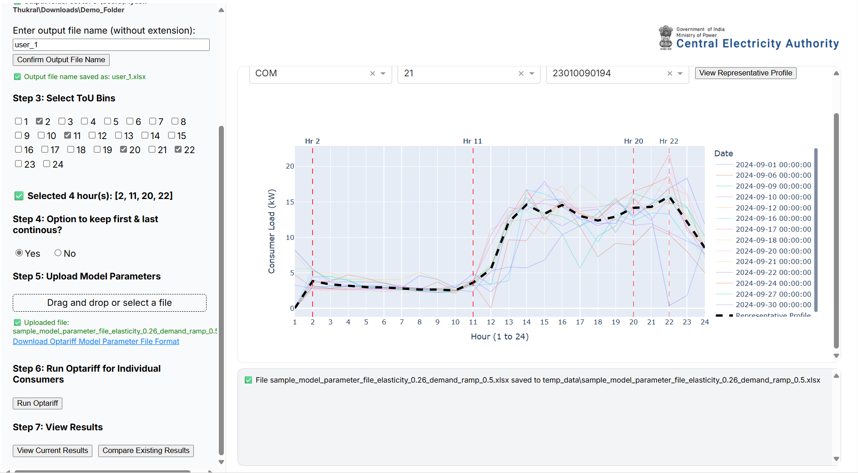

▶️ Step 6: Run the TOU Model
- Once all inputs are provided, click Run Optariff.
- Internally, the tool:
  - Creates ToU bins
  - Processes daily demand
  - Runs the optimization engine
  - Writes output files (tariffs, savings, plots) to the selected folder
- Progress and logs are shown at the bottom of the screen.
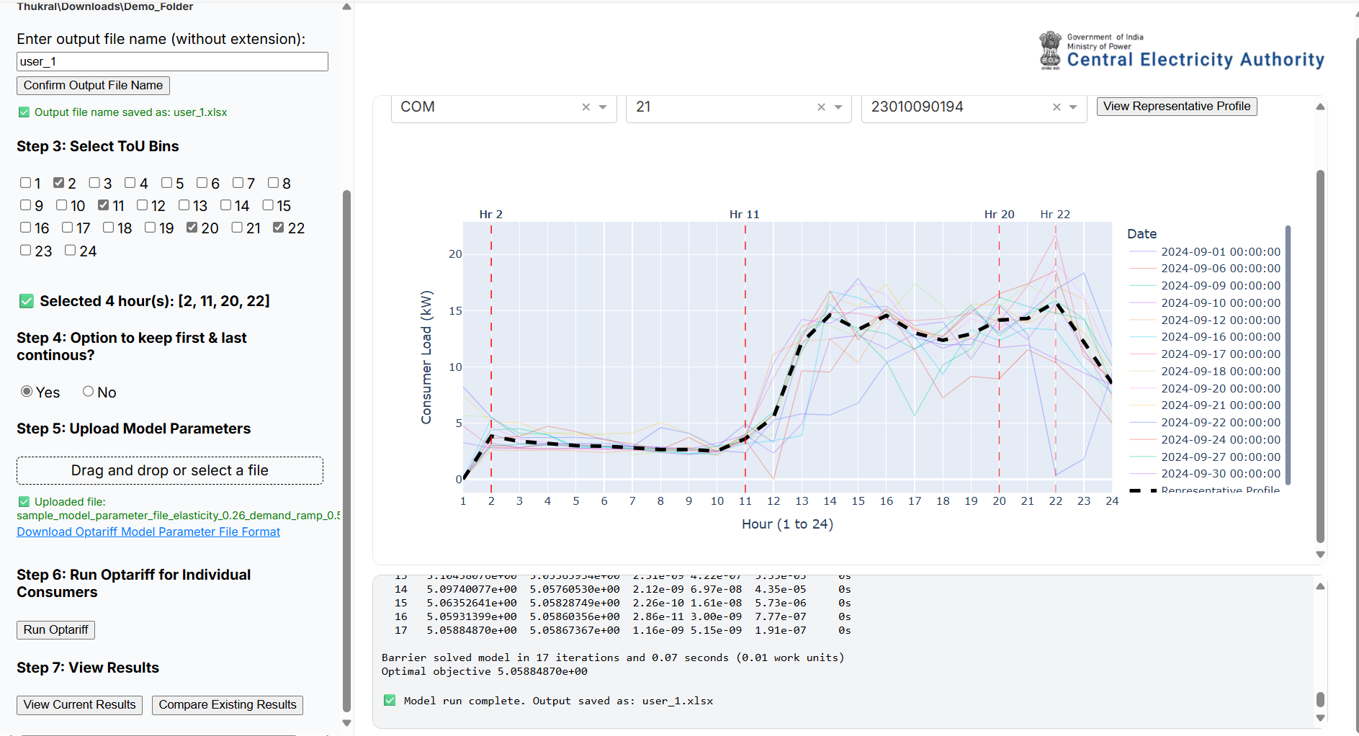

📈 Step 7: Visualize Results
- Once the model finishes, output graphs will be displayed:
  - Daily demand vs. optimized demand
  - Cost savings per consumer
  - Tariff structure comparisons
- Users can export plots or inspect detailed Excel outputs from the output directory.
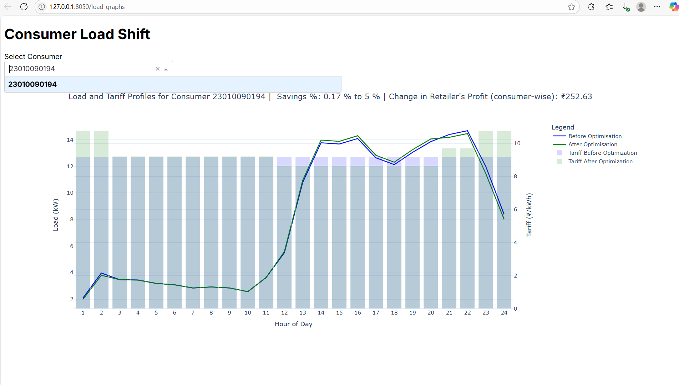

📈 Step 8: Compare Results
- User can also compare the results drawn from two different studies to compare into the differences in outcomes across two different model runs.
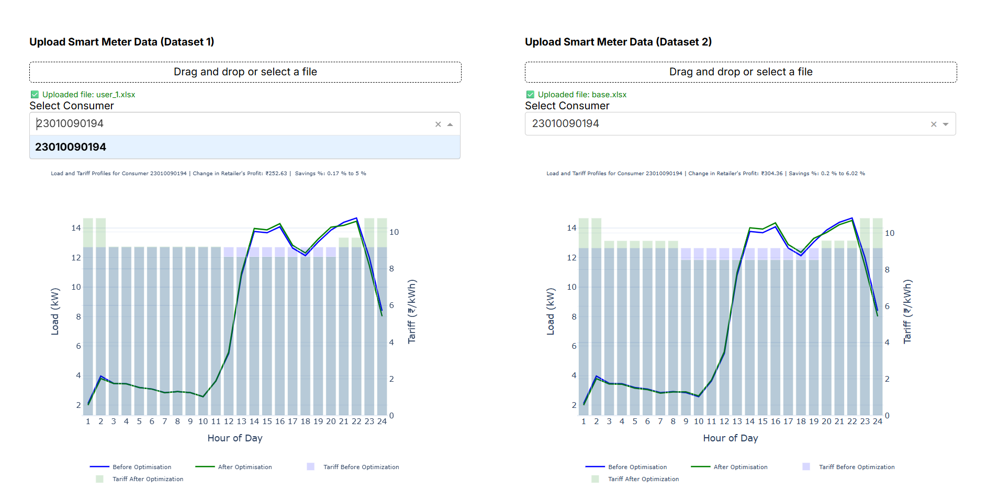

🛠️ Tips & Troubleshooting
- Ensure the date format in the uploaded file is consistent (e.g., DD-MM-YYYY).
- All 24-hourly columns (Consumption_Hr_1 to Consumption_Hr_24) must be present.
- If a column is missing or an error is shown, check the logs area for more information.
- For other information, you may contact – Piyush Thukral (+ 90130 89443) for information on tweaks and further customizations required.

📁 Outputs
The tool generates the following outputs in the selected directory:
- 📊 outputs.xlsx [Based on the name defined by the user)
- 📈 graphs.png [Options available to download every plot generated]

👥Cluster Tariff Workflow
The Cluster Tariff path in the Optariff tool’s home screen allows you to group and cluster similar consumers and analyze tariffs at a group level. Below are the step-by-step instructions for using this functionality:

Step 1: Upload Smart Meter Data
- Upload the smart meter data for all individual consumers using the file upload component.
- A sample file is available to guide the format. This is the same as in the run individual model screen.

Step 2: Select Output Directory and Input Output file name
- Choose the folder where all outputs (intermediate and final results) will be saved.
- This directory will store the clustered profiles, model outputs, and logs.
- User should also provide the name of the input file as desired.
- This is the same as in the run individual model screen.

Step 3: Visualize and Configure Clustering
In the right panel (graph screen), two tabs are provided:
Tab 1: Distribution Overview
- Visualizes the frequency distributions for the following attributes:
  - Consumer Category
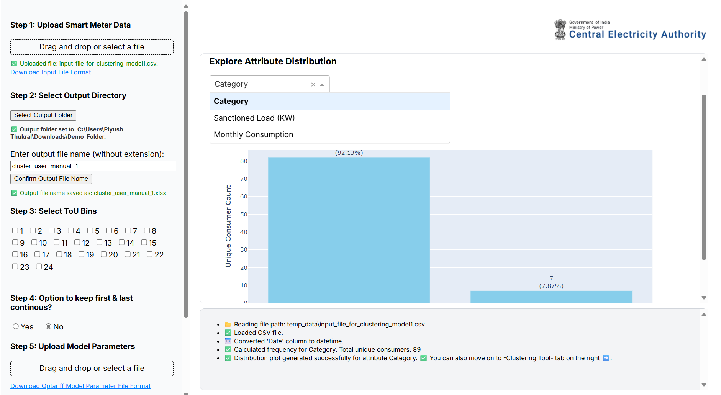

  - Sanctioned Load (kW)
  - Monthly Consumption (auto derived from the uploaded data)
This helps in understanding the data spread before clustering.
Tab 2: Clustering Settings
- Configure the logic for consumer segmentation using the following options:
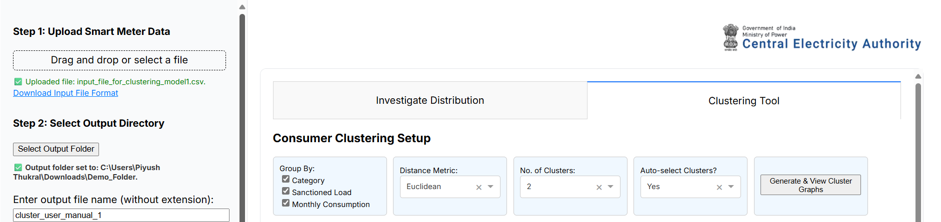
✅ Clustering Level Options:
  - Cluster all consumers together (no segmentation)
  - Cluster separately within each Category
  - Cluster within each Category + Sanctioned Load bin
  - Cluster within each Category + Sanctioned Load bin + Monthly Consumption bin
✅ Distance Metric:
  - Choose the metric to define similarity.
  - Default: Euclidean
  - Further details on various distance metrics is given in the appendix of this document.
✅ Number of Clusters:
  - Let the algorithm automatically determine the optimal number of clusters
  - OR manually specify a fixed number of clusters
- Once settings are finalized, click “Generate Clusters” to perform clustering.
- Cluster profiles and metadata will be saved to the selected output directory from Step 2.
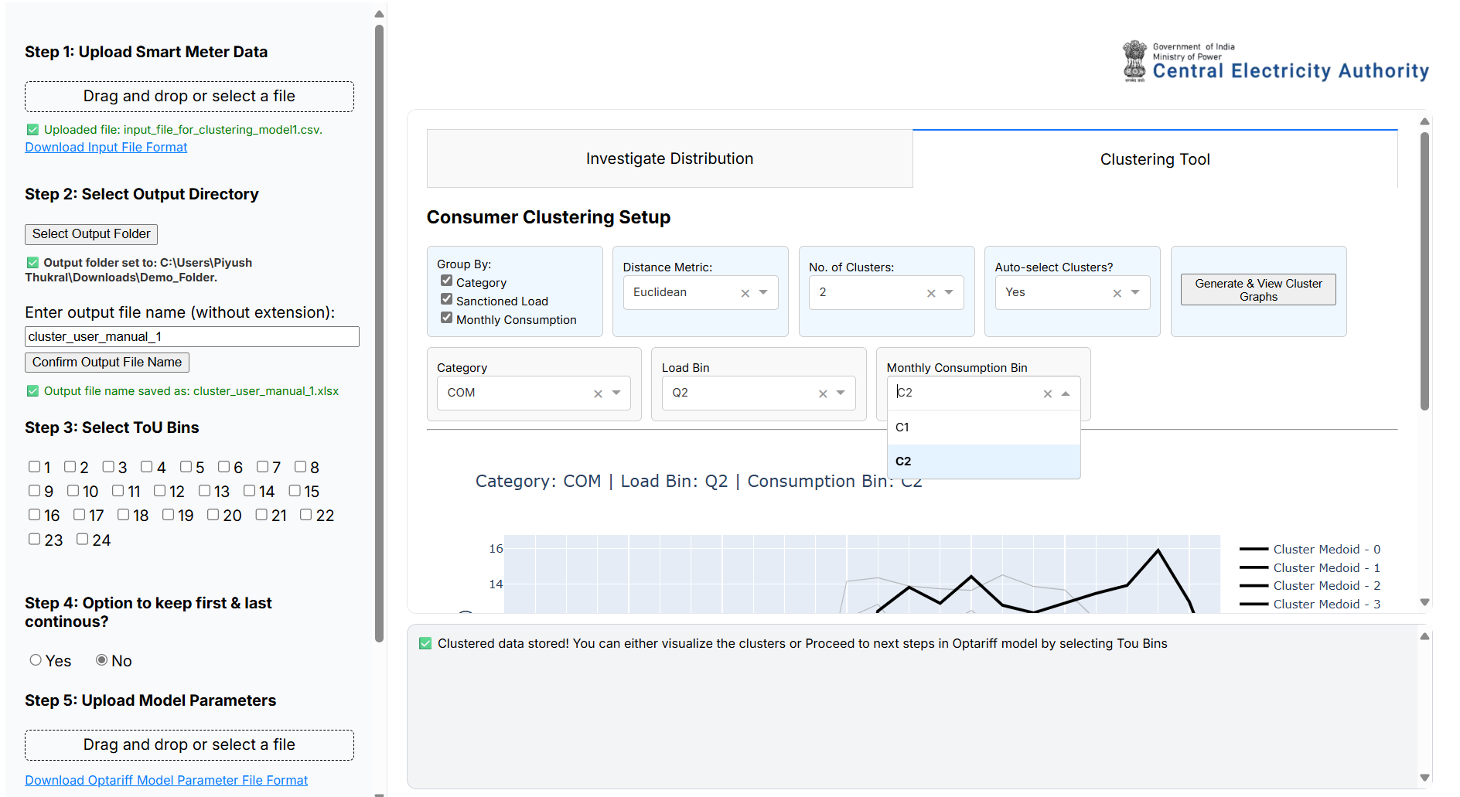

Step 4: Select ToU Dynamicity
- Choose the level of Time-of-Use (ToU) dynamicity as required (e.g., solar/non-solar hours).
- This step mirrors the dynamicity selection in the Individual Tariff Model.

Step 5: Configure First and Last Bin Logic
- Option to keep first and last bins continuous.
- If enabled: two bins are created (e.g., solar and non-solar).
- If disabled: three bins are created (e.g., early morning, solar hours, late night).

Step 6: Upload Model Parameters
- Upload the model parameter Excel file.
- A sample file is available to help users understand required inputs.

Step 7: Run Optariff for Clustered Data
- Run the Optariff model using the prepared cluster profiles and parameters.
- This step computes the optimized ToU pricing for each cluster.

Step 8: View Current Results or Compare Existing Results
- Navigate to the View Current Results tab to visualize model outputs.
- Results are also saved in the output folder specified earlier.
- You may also compare the results derived from two different model runs using the Compare Existing Result.
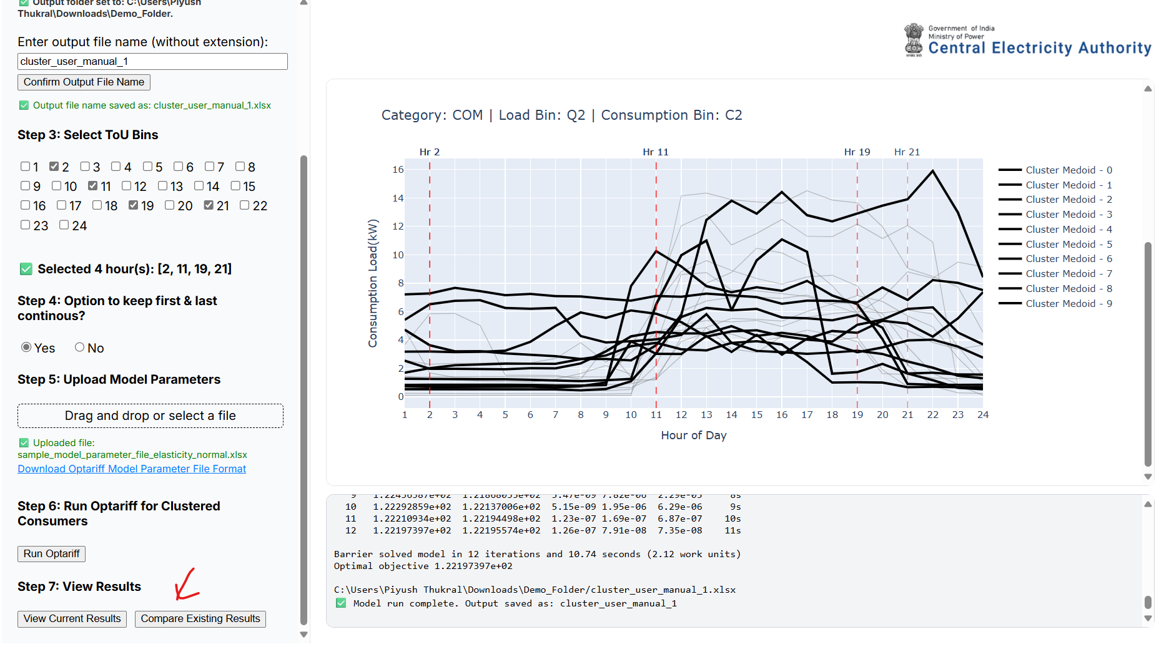

Appendix

Distance Metrics for Clustering

1️⃣ Euclidean Distance
- The most basic and intuitive distance metric.
- It measures the straight-line distance between two points (or two vectors) in multi-dimensional space.
Formula (for two vectors AAA and BBB of length n):

Interpretation:
If you think of each time point (hourly load, for example) as a coordinate, Euclidean distance simply sums up the squared differences across all time points.
Limitation:
- Sensitive to shifting: If two load profiles are similar but shifted in time (say, peak happens one hour later), Euclidean distance can be large even though the profiles look similar.

2️⃣ Cosine Distance (or Cosine Similarity → Distance = 1 - similarity)
- Measures the angle between two vectors rather than their absolute magnitude.
- Focuses on shape and pattern, not the overall energy level.
Formula:

Interpretation:
Two load profiles that follow the same shape (even if one is at a higher or lower level) will have a small cosine distance.
Useful when you care about relative profile patterns more than absolute consumption.
Limitation:
- Ignores magnitude — if absolute load level matters (for billing or grid impact), cosine distance alone is insufficient.

3️⃣ Dynamic Time Warping (DTW)
- A more flexible metric designed specifically for time series.
- It allows one series to be "warped" (time-shifted locally) to match another.
- Matches similar patterns even if they occur at slightly different times.
Idea:
- Rather than comparing point 1 to point 1, point 2 to point 2, etc., DTW finds the optimal alignment between the two series, minimizing total distance even if one series is "stretched" or "compressed" locally in time.
Interpretation:
Two load profiles that have similar patterns but with variable timing (for example, a residential consumer whose peak moves between 6 pm and 9 pm) will show small DTW distance, even though Euclidean distance would be large.
Limitation:
- Computationally more expensive.
- Can sometimes over-align noise or unimportant variations if not used carefully.

Summary Table
Metric | Captures | Sensitive to Time Shift? | Sensitive to Scale? | Use Case
Euclidean | Overall difference in values | Yes | Yes | Simple profile comparison when time alignment is guaranteed
Cosine | Shape (pattern) similarity | No | No | Cluster consumers by similar usage patterns, ignoring the magnitude
DTW | Shape similarity with time warping | No | Yes | Align profiles that have variable timing of key events (peak/off-peak shifts)

