First Person Shooting Game in Python: Doomsday

B. Tech Minor Project Report on
Game Development using Python

submitted by

Piyush Tripathi
(2021UG4009)

In partial fulfilment of the requirements for the

Degree of

Bachelors of Technology

in

Electronics & Communication Engineering

with Specialization (ES & IoT)



INDIAN INSTITUTE OF INFORMATION TECHNOLOGY RANCHI

AUTUMN SEMESTER 2024-2025

1

ACKNOWLEDGEMENTS

I would like to express my sincere gratitude to my supervisor, Dr. Shivang Tripathi (Department of Electronics and Communication Engineering) and Dr. Santosh Kumar Mahto (HOD, Department of Electronics and Communication Engineering) for his invaluable guidance, encouragement, and support throughout the course of this project. His expertise and insights were instrumental in shaping this task and ensuring its successful completion.

Additionally, I extend my heartfelt appreciation to all those who contributed directly or indirectly to this work. Your support has been appreciated.

2

ABSTRACT

This project revolves around the design and development of an engaging first-person shooting game using Python and its powerful game development library, Pygame. The primary goal of the project was to create an immersive and interactive gaming experience by implementing pseudo-3D visuals through raycasting techniques. These techniques allow the game to simulate three-dimensional environments within a 2D framework, creating an illusion of depth and realism for the player.
The game includes various key features, such as player-controlled mechanics for movement and shooting, AI-driven enemy behaviors that add challenges to gameplay, and a range of sound effects that enhance the atmosphere. The development process emphasized balancing visual appeal, gameplay functionality, and computational efficiency.
In addition to the technical accomplishments, this project provided an invaluable learning experience in programming, game design, and resource management. It bridged theoretical knowledge with practical application, enhancing my ability to tackle complex problems. The future scope of this project includes integrating advanced AI functionalities, developing multiplayer capabilities, and expanding the game to include new levels and customization options, further enriching the player's experience.

3

TABLE OF CONTENTS

• CHAPTER 1: INTRODUCTION
1.1 Motivation
1.2 Objectives

• CHAPTER 2: LITERATURE REVIEW
2.1 Review of Key Concepts and Technologies

• CHAPTER 3: METHODOLOGY AND DESIGN
3.1 Project Objectives
3.2 Methodology and Technical Design

• CHAPTER 4: RESULTS AND DISCUSSION
4.1 Simulation Setup and Development Process
4.2 Key Results and Insights

• CHAPTER 5: CONCLUSION
5.1 Summary of Achievements
5.2 Recommendations for Future Work

• BIBLIOGRAPHY

4

CHAPTER 1: INTRODUCTION

  - Motivation

The inspiration for this project stemmed from the desire to explore the fascinating world of game development and its potential to engage users in an immersive environment. First-person shooting games, in particular, have always been a popular genre due to their dynamic gameplay and visual appeal. By undertaking this project, I aimed to bridge the gap between theoretical knowledge and practical application, delving into complex topics such as raycasting, AI pathfinding, and interactive mechanics.
Furthermore, game development offers a unique opportunity to enhance programming skills, particularly in Python, while also fostering creativity in designing gameplay mechanics and user interfaces. By focusing on player engagement and challenge, this project seeks to offer an entertaining yet technically robust experience. Additionally, the potential for expanding this work into areas like virtual reality, multiplayer gaming, and mobile platforms serves as a strong motivation for future explorations.

5

  - Objective of the Project

- Develop a First-Person Shooting Game:
Create an immersive first-person shooting game using Python and Pygame, leveraging raycasting techniques to simulate pseudo-3D graphics for a realistic gaming experience.
- Implement Intuitive Controls:
Design a responsive control system that enables smooth player movement and shooting mechanics. Ensure the controls are user-friendly, catering to both beginners and experienced players.
- Integrate AI-Controlled Enemies:
Develop AI-driven enemies with intelligent pathfinding and attack behaviors to maintain a challenging and dynamic environment. The AI should adapt to player movements and provide varying levels of difficulty.
- Enhance Gameplay with Dynamic Sound Effects:
Incorporate realistic sound effects, such as gunfire, enemy interactions, and background music, to enrich the gaming atmosphere and improve player immersion.
- Optimize Performance for Stability:
Focus on efficient resource management to maintain a stable frame rate during gameplay. Optimize the raycasting engine and AI algorithms for smooth and seamless performance.
- Expand Future Possibilities:
  - Add multiplayer modes to foster social interactions and competitive gameplay.
  - Incorporate advanced AI with adaptive decision-making, making enemies more unpredictable and engaging.
  - Introduce customization features, such as selectable weapons, character skins, and modifiable settings, to increase replayability.
- Extend Game Features:
  - Add new levels and objectives with diverse environments, such as urban areas, forests, and deserts, to keep players engaged.
  - Include power-ups, traps, and hidden bonuses to enhance gameplay excitement and strategy.

6

CHAPTER 2: LITERATURE REVIEW

2.1 Literature Review

Review of Key Concepts and Technologies
The development of this game was grounded in existing research and advancements in game development and interactive design. The key technology employed was raycasting, a technique that allows the simulation of 3D environments in a 2D space. Research on raycasting methods, including their implementation in classic games like "Wolfenstein 3D," provided a strong foundation for building the game's graphical rendering system.
Additionally, artificial intelligence (AI) for game behaviour design played a pivotal role in creating challenging and engaging enemy interactions. Techniques such as pathfinding algorithms, particularly A*, were explored and implemented to enable intelligent enemy movement and attack patterns. These algorithms ensure that enemy behaviors are realistic and responsive to player actions.
The project also leveraged Pygame, a widely-used library for game development in Python. Its documentation and tutorials were invaluable resources, offering detailed insights into implementing 2D graphics, sound integration, and event handling

7

CHAPTER 3: METHODOLOGY AND DESIGN (SYSTEM MODEL)

3.1 Objectives

3.1 Project Objectives
The project aims to create a dynamic first-person shooting game that combines technical sophistication with user engagement. The objectives include developing a raycasting engine for pseudo-3D graphics, implementing responsive player controls for movement and shooting, and designing AI-driven enemies with advanced behaviors.
Another important goal was to integrate high-quality sound effects and background music to enhance the gaming experience. Additionally, the project focuses on maintaining efficient resource management to ensure stable performance, even with complex game mechanics and multiple active entities.

8
3.2 Methodology and Design

Simulation Components

The game development process was divided into distinct phases. In the initial phase, the focus was on understanding the fundamentals of raycasting and creating a framework for rendering the pseudo-3D environment. This involved calculating light rays and their interactions with walls to simulate depth and perspective.
In the next phase, player mechanics were designed, allowing the user to navigate the game environment and interact with elements such as enemies. Keyboard inputs were mapped for movement, and mouse inputs enabled aiming and shooting.
Finally, AI was integrated into the game using pathfinding algorithms. Enemies were programmed to track and attack the player dynamically. These AI behaviors were fine-tuned to ensure a balance between challenge and playability.

9

CHAPTER 4: RESULTS AND DISCUSSION

4.1 Simulation Setup and Development Process
The game was developed using Python 3.10 and Pygame 2.6. Extensive testing was conducted throughout the development cycle to ensure the stability of gameplay mechanics and visuals. The raycasting logic was optimized to render the environment seamlessly, maintaining a consistent frame rate during play.
4.2 Key Results and Insights
The game successfully implemented pseudo-3D graphics, interactive player
mechanics, and AI-driven enemy behaviors. Players experience a smooth and immersive game environment with realistic sound effects. Challenges encountered during development included optimizing performance for real-time rendering and ensuring that AI behaviors adapted well to various scenarios.

10

Gameplay Screenshots

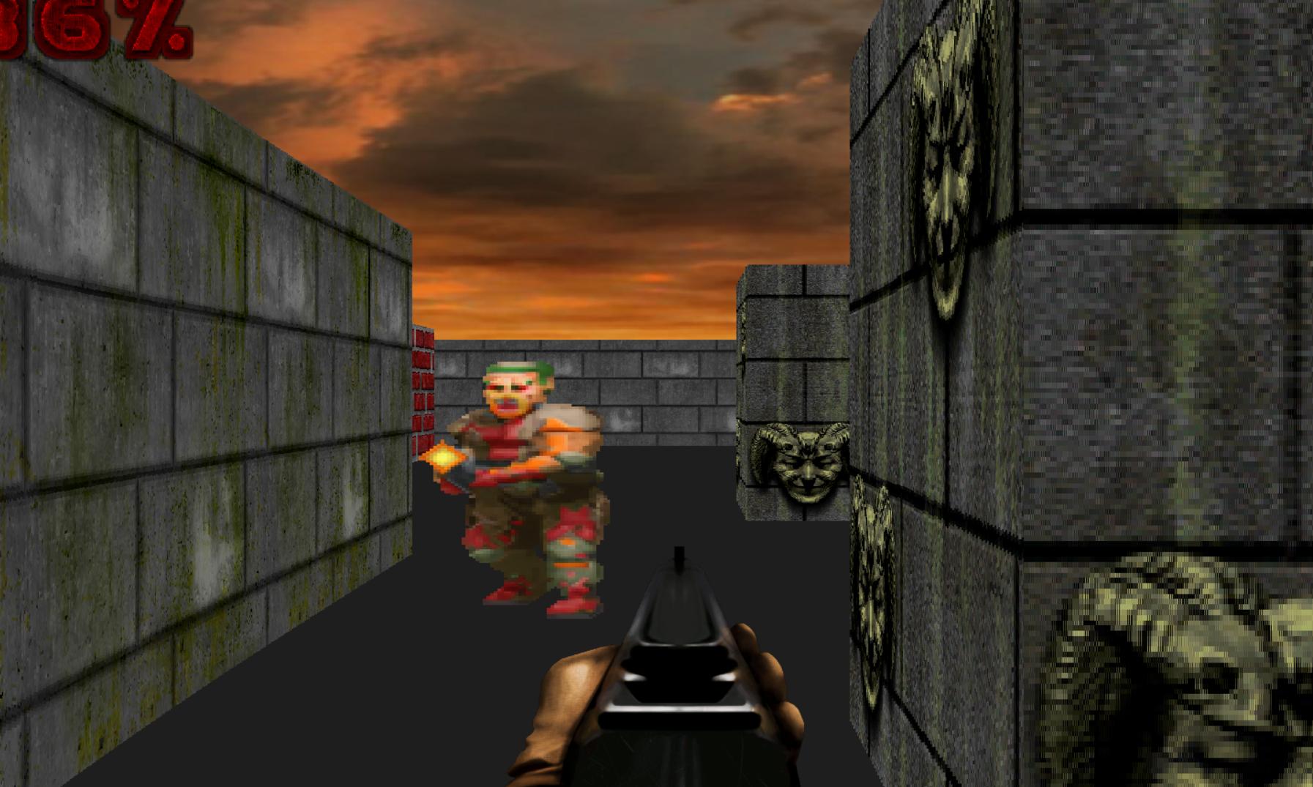

11
CHAPTER 5: CONCLUSION

5.1 Summary of Achievements
- Demonstrating the Potential of Python and Pygame:
The project highlighted the capability of Python and the Pygame library in developing dynamic, interactive, and visually engaging games.
- Successful Implementation of Core Features:
Key features, such as raycasting for pseudo-3D visuals, responsive player controls, and AI-driven enemy behaviors, were effectively developed and integrated.
- Showcasing Versatility in Game Development:
The project illustrated how Python and Pygame can be leveraged for sophisticated game mechanics, combining graphical rendering, artificial intelligence, and real-time interaction.
- Practical Learning and Skill Development:
The development process provided a platform to refine skills in Python programming, game design, AI implementation, and performance optimization, bridging theoretical knowledge and real-world application.

12

5.2 Recommendations for Future Work
- Integration of Multiplayer Functionality:
Introduce multiplayer modes, including local and online options, to enhance player engagement and allow competitive or cooperative gameplay.
- Advanced AI Behaviors:
Develop AI with adaptive decision-making, allowing enemies to respond intelligently to player actions and offer more dynamic challenges.
- Customizable Gameplay Elements:
Add customization features, such as weapon upgrades, character personalization, and environmental modifications, to increase replayability and player satisfaction.
- Optimization for Mobile Platforms:
Adapt the game for mobile devices with optimized touch controls and lightweight rendering for smooth performance.
- Cross-Platform Support:
Enable compatibility across multiple platforms, such as PCs, consoles, and mobile devices, to reach a broader audience and enhance usability.
By implementing these recommendations, the project can evolve into a more versatile, feature-rich, and widely accessible game.

13

BIBLIOGRAPHY

• Pygame Documentation - https://www.pygame.org/docs/
• Raycasting with Python - https://pythonprogramming.altervista.org/raycasting-with-pygame/
• Udemy Course: The Art of Doing - https://www.udemy.com/course/the-art-of-doing-video-game-creation-with-python-and-pygame/

