Software Requirement Specification (SRS)

Purpose:

The purpose of this document is to specify the software requirements, technologies going to use at front end and back end in the project. This document will also be mentioning the functionality of the project.

The purpose for the project is to make a faster and better way to make the leasing procedure occur as there are a lot of confusions regarding the bookings and prices for flights.

Product Scope:

The scope to develop “Flight Booking System” software package is:

* The large volumes of records and detailed documents that must be carefully managed and accessed. A Flight Booking System software with good database can take a better care of that and can help customers have efficiency and speed operations compared. With searching capabilities it will help to maintain data more accurately.
* A Flight Booking System software can help customers to in making better identification of flights or deals and make quick dealing decision. It will facilitate a Better-informed dealing process through quicker access to all of the right and useful information that is available instantly for the customer. It will provide a lower compliance costs and enhanced ability to provide accurate, timely and fruitful responses to the customer requirements. The better service can be provided because of the relevant information given.

Product Functionality:

The basic working principle for the working of Flight Booking System software is to make everything so easy that it can be remotely accessed.

In the front end part, there will be some details which a user is going to fill (regarding his name, address, credentials). This entries will be stored at the server side and according to the entries filled by customer the flight’s details will be generated.

This form (generated form) will be full of the data and pages which are must for a booking system.

System Architecture:

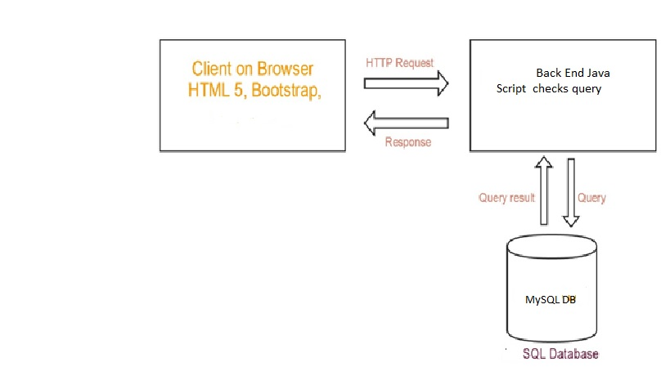

Technical Assistance: For the front-end layer and back-end layer the frameworks and software required are:

1. For Front End:

* CSS
* Bootstrap
* HTML5
* JavaScript

1. Back End:

* JavaScript
* MySQL DB

1. Required languages and softwares:

* MVC Model
* Eclipse IDE, STS
* Apache Tomcat Server 7
* JSP Language
* JDBC