Business_RCA_Report
The objective is to analyze delivery performance in the Olist e-commerce dataset, identify states and sellers with higher delivery delays, investigate possible operational patterns, and recommend data-driven improvements to delivery performance.
1. What percentage of delivered orders are delayed? – 0.3%
2. Which customer states have the highest delay rates? – SP and RJ
3. Which sellers are associated with higher delay rates? – b1b239
4. How does delivery performance change month by month? – Delays are generally high in winter and festive seasons
5. Are longer delivery durations associated with lower customer review scores? yes
RCA findings
Analysis area | Finding to investigate | Recommended action
Customer state | SP and RJ state high delay rates | Increase more availability
Seller | B1b39 Seller has high delay rates | Monitor seller-associated performance
Reviews | Review score differences is 2.34 | Investigate customer complaints
Monthly trends | September, March and December Months with increased delays | Most delays in winter and festive seasons

Analyze delays by customer state
SELECT
c.customer_state,
COUNT(*) AS eligible_orders,
COUNT(*) FILTER (
WHERE o.delivery_status = 'Delayed'
) AS delayed_orders,
ROUND(
100.0 * COUNT(*) FILTER (
WHERE o.delivery_status = 'Delayed'
) / NULLIF(COUNT(*), 0),
2
) AS delay_percentage,
ROUND(AVG(o.actual_delivery_days), 2)
AS avg_delivery_days
FROM warehouse.fact_orders o
JOIN warehouse.dim_customers c
ON o.customer_key = c.customer_key
WHERE o.delivery_status IN ('On Time', 'Delayed')
AND o.data_quality_status = 'Valid'
GROUP BY c.customer_state
ORDER BY delay_percentage DESC;
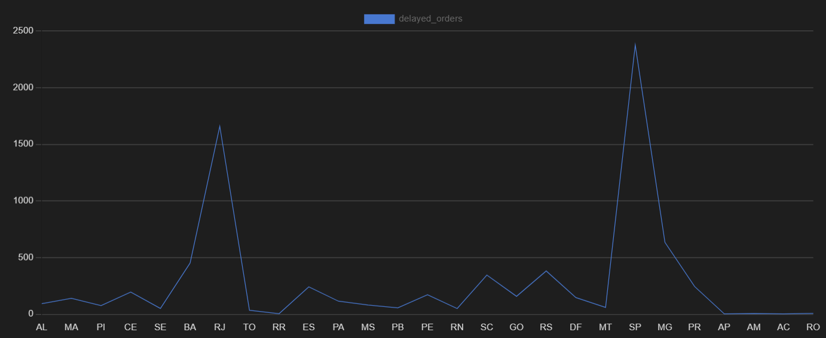
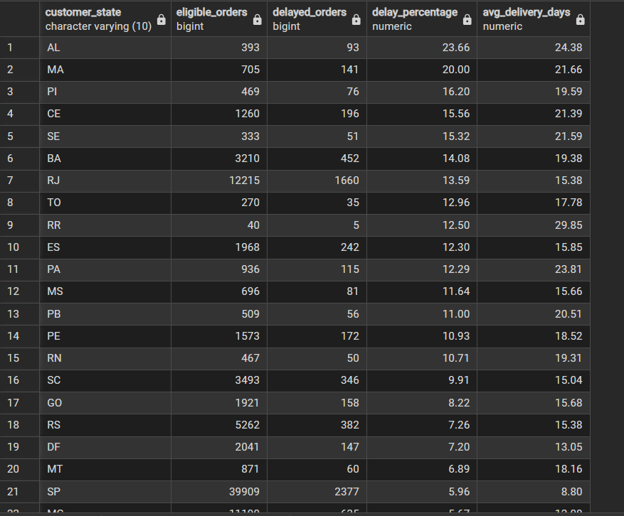

Analyze seller delivery performance
WITH seller_orders AS (
SELECT DISTINCT
oi.seller_key,
oi.order_id,
o.delivery_status
FROM warehouse.fact_order_items oi
JOIN warehouse.fact_orders o
ON oi.order_id = o.order_id
WHERE o.delivery_status IN ('On Time', 'Delayed')
AND o.data_quality_status = 'Valid'
)
SELECT
s.seller_id,
s.seller_state,
COUNT(*) AS eligible_orders,
COUNT(*) FILTER (
WHERE so.delivery_status = 'Delayed'
) AS delayed_orders,
ROUND(
100.0 * COUNT(*) FILTER (
WHERE so.delivery_status = 'Delayed'
) / NULLIF(COUNT(*), 0),
2
) AS delay_percentage
FROM seller_orders so
JOIN warehouse.dim_sellers s
ON so.seller_key = s.seller_key
GROUP BY s.seller_id, s.seller_state
HAVING COUNT(*) >= 5
ORDER BY delay_percentage DESC;
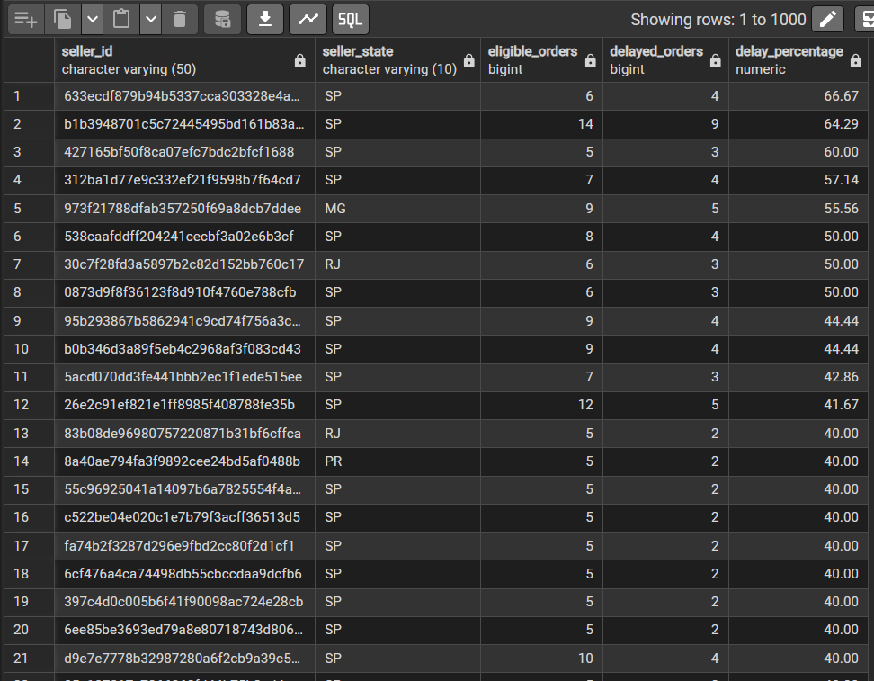

Analyze delivery delays and customer reviews
SELECT
o.delivery_status,
COUNT(DISTINCT r.review_key) AS review_count,
ROUND(AVG(r.review_score), 2) AS average_review_score
FROM warehouse.fact_orders o
JOIN warehouse.fact_reviews r
ON o.order_id = r.order_id
WHERE o.delivery_status IN ('On Time', 'Delayed')
AND o.data_quality_status = 'Valid'
GROUP BY o.delivery_status;
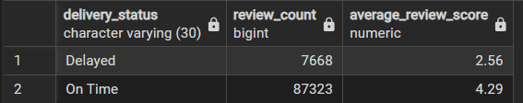

Identify monthly delivery trends
SELECT
EXTRACT(YEAR FROM order_purchase_timestamp) AS year,
EXTRACT(MONTH FROM order_purchase_timestamp) AS month,
COUNT(*) AS eligible_orders,
COUNT(*) FILTER (
WHERE delivery_status = 'Delayed'
) AS delayed_orders,
ROUND(
100.0 * COUNT(*) FILTER (
WHERE delivery_status = 'Delayed'
) / NULLIF(COUNT(*), 0),
2
) AS delay_percentage
FROM warehouse.fact_orders
WHERE delivery_status IN ('On Time', 'Delayed')
AND data_quality_status = 'Valid'
GROUP BY 1, 2
ORDER BY 1, 2;


