Assignment No 4

*) Create file name data.txt.

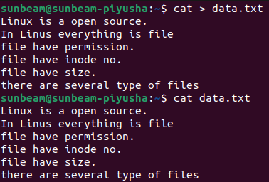

1) count the no. of words ,characters and lines from above 2 file.(man wc)

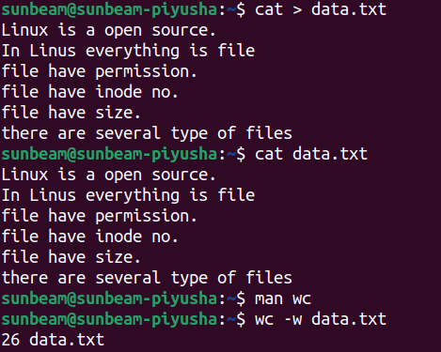

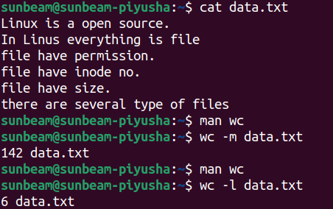

2) list the lines having word "files" (man grep)

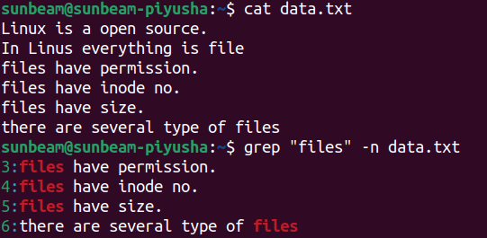

3) list the lines having word "file" (man grep)

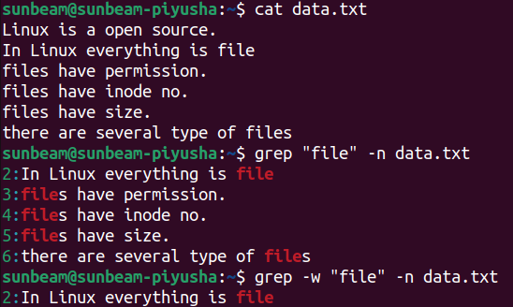

4) list the lines which don't have word "files" (man grep)

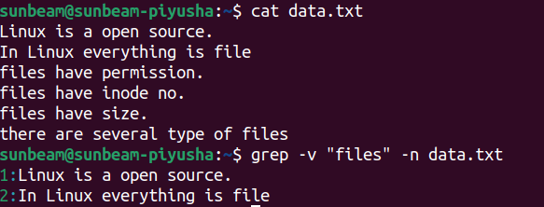

5) list the lines having word "have".
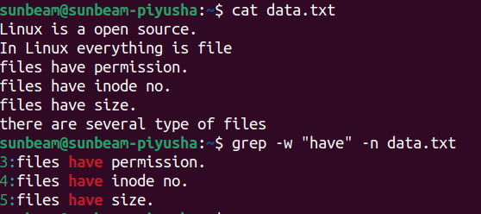

6) list the lines starts with letter "f".

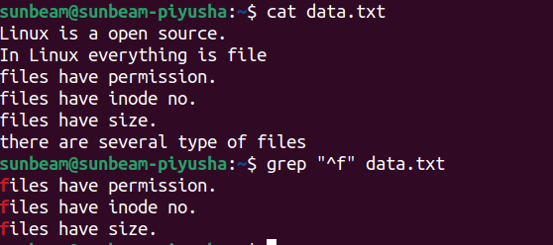
7) list the lines ends with "."

