1. Find Missing Number in Array

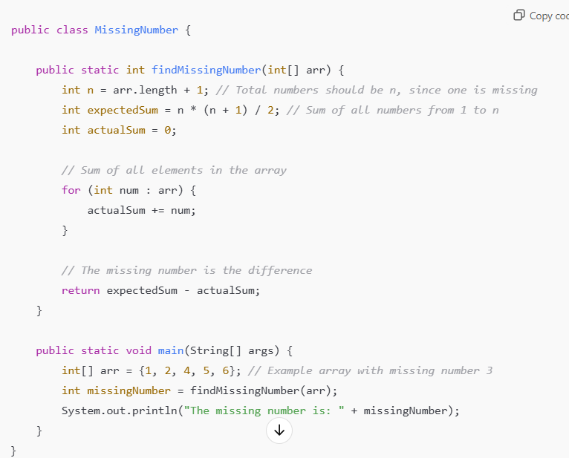

public class Main {  
 public static void main(String[] args) {  
  
 int[] arr = {1,2,4,5,6,7};  
 int n= arr.length+1;  
 int missingnum= *findmissingnum*(arr,n) ;  
 System.*out*.println("missing num is "+missingnum);  
  
 }  
 public static int findmissingnum(int[] arr,int n){  
 int expectedsum = n*(n+1)/2;  
 int actualsum = 0;  
 for (int num :arr){  
 actualsum=actualsum+num;  
  
 }  
 return expectedsum-actualsum;  
 }  
}

1. Reverse a string

Without using reverse keyword:

package org.example;  
public class Main {  
 public static void main(String[] args) {  
 String str = "Hello, World!";  
 *// Call the function to reverse the string* String reversed = *reverseString*(str);  
 *// Print the reversed string* System.*out*.println("Reversed String: " + reversed);  
 }  
 *// Method to reverse the string* public static String reverseString(String str) {  
 *// Initialize an empty string to store the reversed string* String reversed = "";  
 *// Loop through the string from end to beginning* for (int i = str.length() - 1; i >= 0; i--) {  
 reversed += str.charAt(i); *// Append each character to the result* }  
 return reversed;  
 }}

1. Merge and Sort Array

1. Binary Search

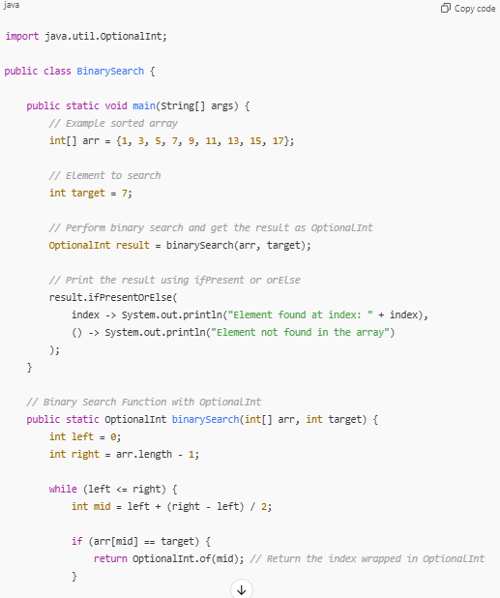

1. Fibonacci series

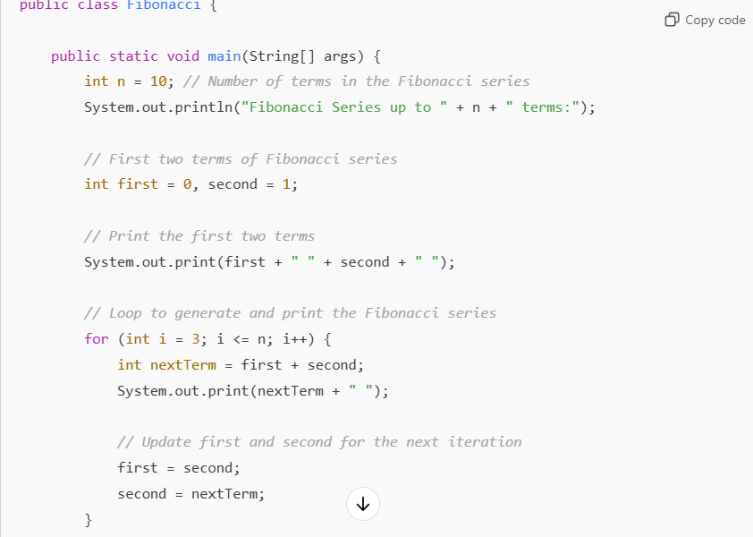

1. Count Occurrences of a Character in a String

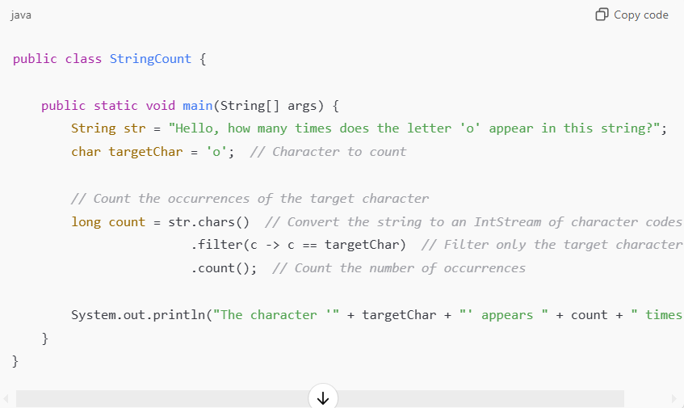

1. Find Duplicate Characters: Find all duplicate characters in a string and their counts without java8

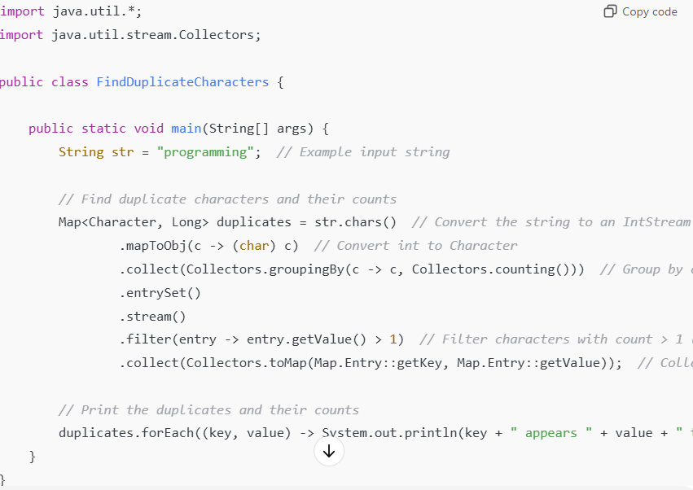

1. Next ascii characters

1. Palindrome

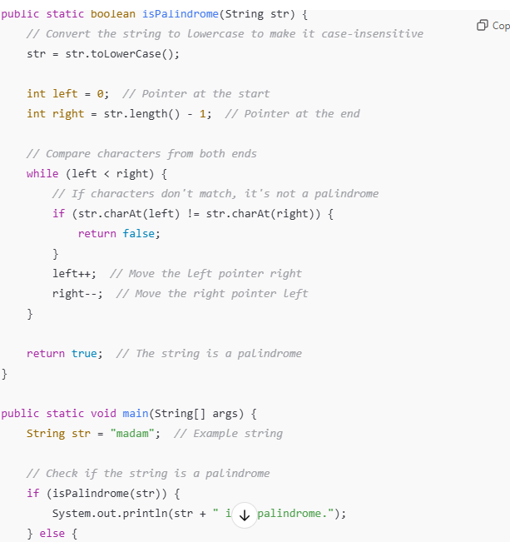

1. Given an integer array nums, return true if any value appears **at least twice** in the array, and return false if every element is distinct.

public class Main {  
 public static void main(String[] args) {  
 System.*out*.println(Main.*isduplicate*());  
 }  
  
public static boolean isduplicate( ){  
 List<Integer> names = Arrays.*asList*(1, 2, 3, 4, 5);  
  
 *// names.stream(nums).collect(Collectors.toList());* Set<Integer> set = new HashSet<>(names);  
 if (set.size() == names.size()) {  
 return false;  
  
 }  
 return true;  
  
  
 }}

1. **Write a Java 8 program to concatenate two Streams?**

public class Main {  
 public static void main(String[] args) {  
  
 List<String> names = Arrays.*asList*("java","Piyusha");  
 List<String> names1 = Arrays.*asList*("java8","microservices");  
  
 List<String> concatstream = Stream.*concat*(names.stream(),names1.stream()).toList();  
 System.*out*.println(concatstream);  
  
 }}

1. **Java 8 program to perform cube on list elements and filter numbers greater than 50.**

public class Main {  
 public static void main(String[] args) {  
  
 List<Integer> names = Arrays.*asList*(1,2,3,4,5,8,9);  
  
 names.stream().map(x-> x*x*x).filter(x->x>50).forEach(System.*out*::println);  
  
 }}

1. **How to count each element/word from the String ArrayList in Java8?**

public class TestNotes {  
  
 public static void main(String[] args) {  
 List<String> names = Arrays.asList("AA", "BB", "AA", "CC");  
 Map<String,Long> namesCount = names  
 .stream()  
 .collect(  
 Collectors.groupingBy(  
 Function.identity(), Collectors.counting()));  
 System.out.println(namesCount);  
 }  
}  
  
Output:  
{CC=1, BB=1, AA=2}

1. **Java 8 program to check if two strings are anagrams or not?**

public class Main {  
 public static void main(String[] args) {  
 {  
  
 String s1 = "Piyusha";  
 String s2 = "ahsuypi";  
  
 s1 = Stream.*of*(s1.split("")).map(String::toUpperCase).sorted().collect(Collectors.*joining*());  
 s2 = Stream.*of*(s2.split("")).map(String::toUpperCase).sorted().collect(Collectors.*joining*());  
 if (s1.equals(s2)){  
 System.*out*.println("it is anargrams");}  
 else {  
 System.*out*.println("not an anargrams");  
 }  
 }  
 }}

**without java8**

class Main {

public static void main(String[] args) {

String str = "Piyusha";

String str1 = "iyushap";

str = str.toLowerCase();

str1 = str1.toLowerCase();

if(str.length()!=str1.length()){

System.out.println("not anagram");

}

char[] chararr = str.toCharArray();

char[] chararr1 = str1.toCharArray();

Arrays.sort(chararr);

Arrays.sort(chararr1);

if(Arrays.equals(chararr,chararr1)){

System.out.println("it is anagram");}

else{ System.out.println("not an anagram");}

}}

1. **Find sum of all digits of a number in Java 8?**

1. **Find second largest number in an integer array?**

public class Main {  
 public static void main(String[] args) {  
 {  
List<Integer> num = Arrays.*asList*(12,3,4,6,11);  
Integer secondhighest = num.stream().sorted(Comparator.*reverseOrder*()).skip(1).findFirst().get();  
 System.*out*.println(secondhighest);  
 }  
 }  
 }

1. **Given a list of strings, sort them according to increasing order of their length?**

public class Main {  
 public static void main(String[] args) {  
 {  
List<String> names = Arrays.*asList*("java","Piyusha","kotlin","groovy");  
names.stream().sorted(Comparator.*comparing*(String::length)).forEach(System.*out*::println);  
 }}

1. **Reverse each word of a string using Java 8 streams?**

public class Main {  
 public static void main(String[] args) {  
 {  
  
 String str = "Java Concept Of The Day";  
 String reversedString = Arrays.*stream*(str.split(" " ))  
 .map(word ->new StringBuffer(word).reverse()).collect(Collectors.*joining*(" "));  
 System.*out*.println(reversedString);  
 }  
 }  
 }

1. **How do you extract duplicate elements from an array?**

public class Main {  
 public static void main(String[] args) {  
 {  
  
 List<Integer> listOfIntegers = Arrays.*asList*(111, 222, 333, 111, 555, 333, 777, 222);  
 Set<Integer> uniqueInt = new HashSet<>();  
 List<Integer> duplicateelements = listOfIntegers.stream()  
 .filter(i-> ! uniqueInt.add(i)).collect(Collectors.*toUnmodifiableList*());  
 System.*out*.println(duplicateelements);  
  
 }  
 }  
 }

1. **Find first repeated character in a string?**

o  
  
 }

1. **How do you get last element of an array?**

public class Main {  
 public static void main(String[] args) {  
 {  
  
 List<String> listOfStrings = Arrays.*asList*("One", "Two", "Three", "Four", "Five", "Six");  
 String lastelement = listOfStrings.stream().skip(listOfStrings.size()-1).findFirst().get();  
 System.*out*.println(lastelement);  
  
 }  
 }  
 }

1. **Find the age of a person in years if the birthday has given?**

public class Main {  
 public static void main(String[] args) {  
 {  
  
 LocalDate birthday = LocalDate.*of*(1998,9,07);  
 LocalDate today = LocalDate.*now*();  
  
 System.*out*.println(ChronoUnit.*YEARS*.between(birthday,today));  
 }  
 }  
 }

**Reverse a String**

1. Write a program to reverse a string without using the StringBuilder or StringBuffer reverse methods.

Example: "hello" → "olleh"

public class Main {  
 public static void main(String[] args) {  
 String input = "hello"; *// Input string* String reversed = *reverseString*(input); *// Reversing the string* System.*out*.println("Reversed string: " + reversed);  
 }  
  
 *// Method to reverse the string using a for loop* public static String reverseString(String str) {  
 String reversed = ""; *// Initialize an empty string to store the reversed string  
  
 // Iterate through the string in reverse order using a for loop* for (int i = str.length() - 1; i >= 0; i--) {  
 reversed = reversed+str.charAt(i); *// Append each character to the reversed string* }  
  
 return reversed;  
 }

Reverese a number

Reverse a string

Factorial

