
Department of Computer Engineering

“NLP Activity – Case study – Stanford tagger”

Submitted in partial fulfilment of the requirements for the degree of

BACHELOR OF ENGINEERING
In
COMPUTER ENGINEERING
Submitted By
Name of the Student: Piyusha Rajendra Supe
Roll No: 23CO315

Under the Guidance of
Mrs. Neha A. Rai

ALL INDIA SHRI SHIVAJI MEMORIAL SOCIETY’S COLLEGE OF ENGINEERING PUNE-411001
Academic Year: 2025-26 (Term-II)
Savitribai Phule Pune University

Case Study: The Stanford Log-Linear Part-Of-Speech Tagger
A Landmark in Computational Linguistics and Natural Language Processing

1. Introduction and Background
In the landscape of Natural Language Processing (NLP), few tools have achieved the breadth of adoption, longevity, and academic influence as the Stanford Log-Linear Part-Of-Speech (POS) Tagger. Developed by the Stanford Natural Language Processing Group, this tool represents over two decades of iterative research, engineering, and community-driven improvement. It began as an academic experiment in probabilistic tagging and evolved into a production-grade, multilingual, multi-platform NLP toolkit used in industry, academia, and government worldwide.
A Part-Of-Speech Tagger is a piece of software that reads text in some language and assigns parts of speech to each word and other tokens — such as noun, verb, adjective, and so on — although generally computational applications use more fine-grained POS tags like "noun-plural." POS tagging is foundational to nearly every downstream NLP task: parsing, named entity recognition, sentiment analysis, machine translation, question answering, and information extraction all depend on accurate POS tagging as an initial or intermediate step.
The Stanford Tagger distinguished itself from its contemporaries not merely through superior accuracy, but through its principled statistical underpinning — specifically its use of maximum entropy (log-linear) models — its rich feature engineering, and its open architecture that made it extensible across languages and deployment environments.
2. Origins and Research Foundation
2.1 The Founding Papers
This software is a Java implementation of the log-linear part-of-speech taggers described in two seminal papers. The first, by Kristina Toutanova and Christopher D. Manning (2000), was titled "Enriching the Knowledge Sources Used in a Maximum Entropy Part-of-Speech Tagger," published at the Joint SIGDAT Conference on Empirical Methods in Natural Language Processing. The second, by Toutanova, Klein, Manning, and Singer (2003), was titled "Feature-Rich Part-of-Speech Tagging with a Cyclic Dependency Network," published at HLT-NAACL 2003.
The 2000 paper laid the groundwork, demonstrating that maximum entropy models could be significantly enhanced by incorporating diverse knowledge sources — word identity, surrounding words, surrounding tags, and morphological features — into a unified probabilistic framework. The 2003 paper then introduced the critical innovation of the Cyclic Dependency Network, which allowed the model to leverage both left-context and right-context tag information simultaneously, a departure from the strictly left-to-right conditioning approach of traditional Hidden Markov Model (HMM) taggers.
2.2 The Team
The tagger was originally written by Kristina Toutanova, with subsequent code contributions from Christopher Manning, Dan Klein, William Morgan, Huihsin Tseng, Anna Rafferty, and John Bauer. A major rewrite for version 2.0 was performed by Michel Galley. This collaborative evolution — from a single researcher's dissertation work to a team-maintained enterprise-grade tool — is itself a case study in open academic software development.
3. The Technical Architecture
3.1 What is a Log-Linear (Maximum Entropy) Model?
The central statistical framework of the Stanford Tagger is the maximum entropy (MaxEnt) classifier, also known as a log-linear model. Unlike Hidden Markov Models which model the joint probability of a word sequence and a tag sequence, a MaxEnt model is discriminative: it directly models the conditional probability of a tag given a word and its surrounding context.
The key principle of maximum entropy is elegant: among all probability distributions that satisfy observed constraints (i.e., match the empirical feature expectations from the training data), choose the distribution with the highest entropy — the one that makes the fewest unwarranted assumptions. Given a word and its context, maximum entropy POS tagging assigns a probability to every tag in a predefined tagset, eventually enabling the estimation of the probability of a tag sequence given a word sequence. Out of all the possible distributions that satisfy a set of constraints, the one with maximum entropy is chosen, as it represents the most non-committal assignment of probabilities that meets the constraints.
3.2 The Cyclic Dependency Network
The 2003 breakthrough was the Cyclic Dependency Network (CDN), which is illustrated conceptually below:
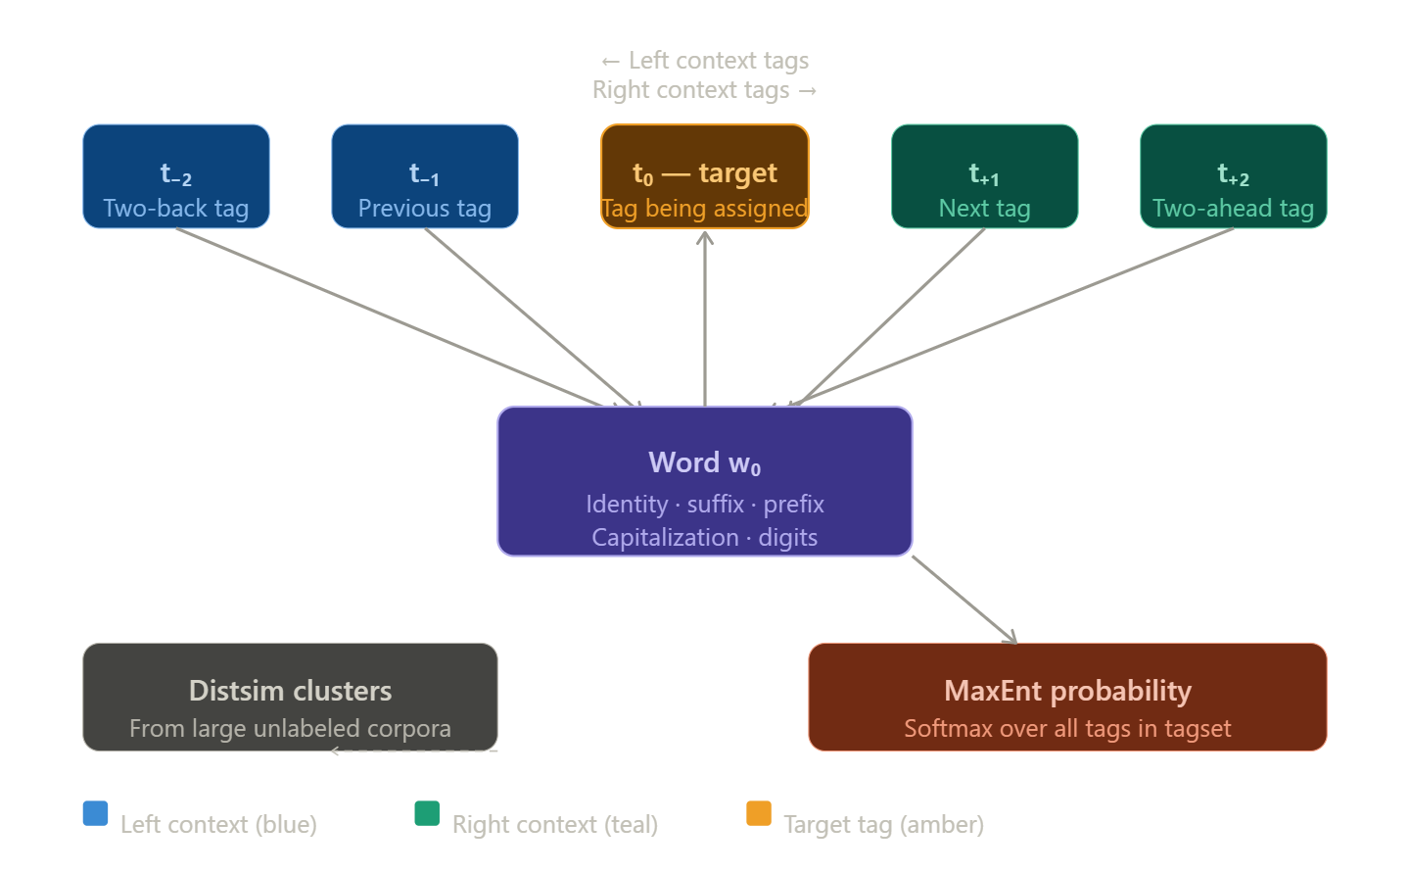
Traditional POS taggers conditioned on only the left context — the tags already assigned to words before the current word. The CDN introduced bidirectionality: a tag for word t₀ is chosen considering both what came before (left context) and what comes after (right context). Models using only the vertical features and a single set of tag-triple features were compared: left tags, right tags, or centered tags. The left context was better than the right, and the centered context was better than either alone. The best model, combining all context types, achieved remarkable accuracy on the Penn Treebank benchmark.
3.3 Feature Engineering
A key strength of the Stanford Tagger is its rich feature set. Features considered during tagging include:
- Word identity features: the current word itself, its lowercase form
- Prefix and suffix features: character n-grams from the start and end of the word (e.g., "-ing", "-tion", "pre-")
- Left context features: the previous one or two words and their tags
- Right context features: the next one or two words (and their hypothesized tags in the CDN)
- Capitalization features: whether the word is capitalized, all-caps, or mixed-case
- Numeric features: whether the word contains digits or punctuation
- Distributional similarity features (in "distsim" models): cluster-based features derived from large unlabeled corpora, which generalize across rare and unseen words
One of the most significant features was a crude company name detector which marked capitalized words followed within three words by a company name suffix like "Co." or "Inc.", suggesting that further gains could be made by incorporating a good named entity recognizer as a preprocessor to the tagger.
3.4 Tagger Models and Variants
The Stanford package ships with multiple model variants offering different tradeoffs between speed and accuracy:
Model | Context Used | Distsim | Speed | Accuracy
left3words | Left 3 words | No | Fastest | Good
left3words-distsim | Left 3 words | Yes | Fast | Better
bidirectional | Left + Right | No | Moderate | Very Good
bidirectional-distsim | Left + Right | Yes | Slower | Best
Current downloads contain three trained tagger models for English, two each for Chinese and Arabic, and one each for French, German, and Spanish. The tagger can be retrained on any language, given POS-annotated training text for the language.

4. System Requirements and Deployment
4.1 Prerequisites and Installation
The system requires Java 8+ to be installed. Depending on whether you are running 32 or 64 bit Java and the complexity of the tagger model, between 60 and 200 MB of memory is needed to run a trained tagger. Plenty of memory is needed to train a tagger — at least 1GB is usually needed, often more.
The Stanford POS Tagger does not require much of an installation. The basic version and the full version (including additional models for Arabic, Chinese, French, Spanish, and German) are available as zipped archives. Care should be taken that the installation directory name contains no whitespace and the path is not excessively long, as this can cause problems.
4.2 Invocation Modes
The package includes components for command-line invocation, running as a server, and a Java API. This software provides a GUI demo, a command-line interface, and an API. Simple scripts are included to invoke the tagger.
Command-Line Usage:
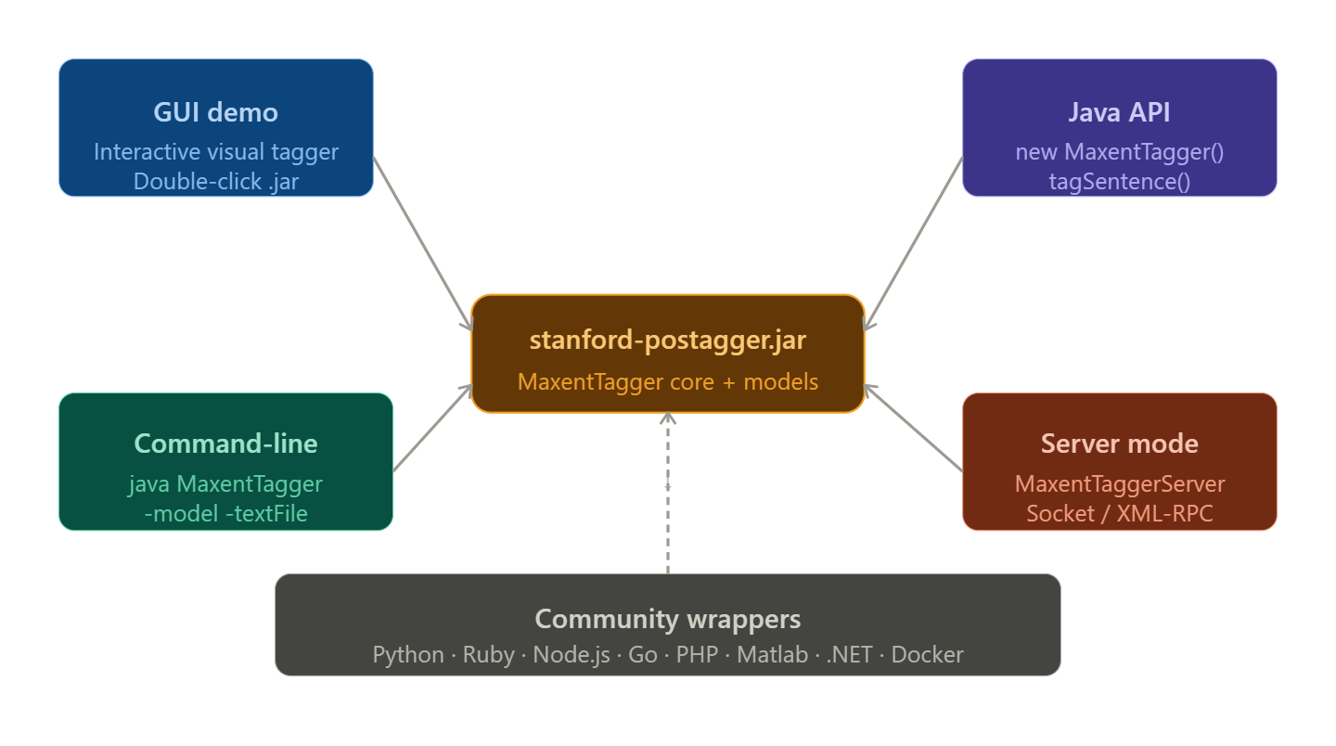
5. Multilingual Support
One of the most compelling attributes of the Stanford Tagger is its genuine multilingual capability. The tool is not merely English-centric; it is designed so that any language with annotated training data can be supported.
5.1 Languages and Tag Sets
The tagger is applicable for French, English, German, Spanish, and Arabic texts. For English texts the Penn Treebank tag set is used, for German texts the STTS tag set, for French texts the French Treebank tag set, for Spanish texts the Ancora Treebank tag set, and for Arabic texts an Arabic Penn Treebank tag set.
The French, German, and Spanish models all use the UD (v2) tagset. The Universal Dependencies (UD) tagset adoption for these languages was a significant architectural decision, ensuring that the Stanford Tagger's output could be directly integrated into the broader UD ecosystem — a worldwide effort to develop cross-linguistically consistent treebanks and NLP tools.
5.2 Accuracy Across Languages
State-of-the-art POS taggers for English achieve 97.64% accuracy, French 97.8%, German 96.9%, Arabic 96.26%, and Chinese 93.46%. These figures reflect performance on well-resourced languages with large annotated treebanks. The Stanford Tagger's framework, when applied to lower-resource languages with appropriate training data, has demonstrated comparable or superior performance relative to prior tools for those languages.
A case in point: when applied to Filipino — a morphologically rich language with free word order — the Filipino POS tagger achieved 96.15% tagging accuracy, the highest among existing Filipino POS taggers, using a 406k token corpus for training and incorporating unique Filipino linguistic phenomena such as high morphology and intra-sentential code-switches.
5.3 Training on New Languages
The tagger's retraining capability is straightforward. A .props file, which contains options for the tagger, must be provided. The .props files used to create the sample taggers are included in the models directory. For example, to train a new English tagger, one starts with the left3words tagger props file. For western languages other than English, the German or French props files are good starting points. For languages using a different character set, the Chinese or Arabic props files serve as models.

6. Performance and Speed
Speed is a practical concern for any production NLP system, and the Stanford POS Tagger was engineered with performance in mind alongside accuracy.
On a 2008 Intel server, the tagger processes about 15,000 words per second. This is also about four times faster than Tsuruoka's C++ tagger, which has accuracy in between the left3words and bidirectional-distsim models. Compared to the well-known MXPOST tagger by Adwait Ratnaparkhi — both using a second-order conditioning model and maximum entropy classifiers, both trained on similar amounts of data, and both implemented in Java — the Stanford POS Tagger is both more accurate and considerably faster.
The accuracy-speed tradeoff can be visualized as follows:
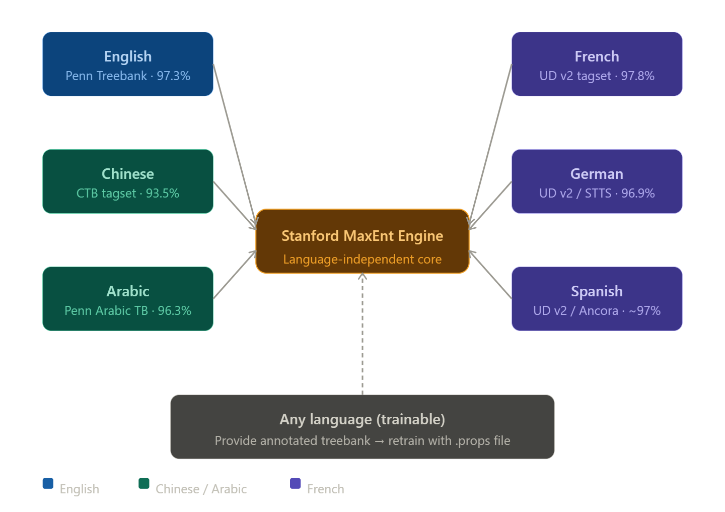
7. Integration Ecosystem
One of the most remarkable aspects of the Stanford POS Tagger's success is the thriving ecosystem of community-built integrations that have grown around it, spanning virtually every major programming language and deployment platform.
7.1 Language Bindings and Wrappers
Docker support is available via a Docker image for the Stanford POS Tagger with the XMLRPC service. F#/C#/.NET support is provided through a port of the Stanford POS tagger to F# (.NET) using IKVM. GATE (General Architecture for Text Engineering) includes a Stanford POS tagger plugin. Go bindings are available via Go-Stanford-NLP. JavaScript/Node.js support is available through a node.js client using the XML-RPC service. Matlab integration packages are available on GitHub. PHP wrappers have been written by multiple contributors.
For Python, the recommended approach in the 2020s is to use a Python interface to the CoreNLPServer for performant usage. Historically, NLTK 2.0+ contains an interface to the Stanford POS tagger. Ruby bindings are also available for the Stanford POS tagger and Named Entity Recognizer.
7.2 Integration with CoreNLP
Beyond the standalone POS tagger, the Stanford NLP Group provides a Python natural language analysis package with implementations of fast neural network models for tokenization, multi-word token expansion, POS and morphological features tagging, lemmatization, and dependency parsing using the Universal Dependencies formalism. Pretrained models are provided for more than 70 human languages. In addition, it can call the CoreNLP Java package and inherits additional functionality such as constituency parsing, coreference resolution, and linguistic pattern matching.
7.3 Python Pipeline Example (StanfordNLP)
Running the part of speech tagger requires tokenization and multi-word expansion. The pipeline can be run with tokenize, mwt, pos as the list of processors. After the pipeline is run, the document contains a list of sentences, and the sentences contain lists of words. The part-of-speech tags can be accessed via the upos and xpos fields.
import stanfordnlp
nlp = stanfordnlp.Pipeline(processors='tokenize,mwt,pos')
doc = nlp("Barack Obama was born in Hawaii.")
# Output:
# word: Barack upos: PROPN xpos: NNP
# word: Obama upos: PROPN xpos: NNP
# word: was upos: AUX xpos: VBD
# word: born upos: VERB xpos: VBN
# word: in upos: ADP xpos: IN
# word: Hawaii upos: PROPN xpos: NNP

8. Licensing and Distribution
The Stanford POS Tagger's licensing model is carefully designed to balance open academic collaboration with commercial sustainability.
The tagger code is dual licensed, in a manner similar to MySQL. The tagger is licensed under the GNU General Public License (v2 or later), which allows many free uses. Source is included. The package includes components for command-line invocation, running as a server, and a Java API. For distributors of proprietary software, commercial licensing is available.
This dual-licensing strategy has been highly effective:
- Academic and open-source users can use the tagger freely under the GPL, enabling rapid proliferation across universities, research groups, and open-source projects worldwide.
- Commercial users who need to incorporate the tagger into proprietary products can obtain a commercial license, generating revenue that supports continued maintenance and development.
- The community is encouraged to contribute back through gift funding for those who benefit from the tools but do not require a commercial license.

9. The Penn Treebank Tag Set
For English, the Stanford Tagger uses the Penn Treebank (PTB) tag set, a de facto standard in English NLP. This tag set contains 36 POS tags plus a set of punctuation labels. Some of the most commonly encountered tags include:
Tag | Part of Speech | Example
NN | Noun, singular | dog, city
NNS | Noun, plural | dogs, cities
NNP | Proper noun, singular | London, Barack
VB | Verb, base form | run, go
VBD | Verb, past tense | ran, went
VBG | Verb, gerund | running, going
VBN | Verb, past participle | run, gone
JJ | Adjective | big, happy
RB | Adverb | quickly, very
DT | Determiner | the, a, an
IN | Preposition / subordinating conjunction | in, of, that
CC | Coordinating conjunction | and, but, or
PRP | Personal pronoun | he, she, they
WP | Wh-pronoun | who, what
Here are some links to documentation of the Penn Treebank English POS tag set: the 1993 Computational Linguistics article in PDF, and the Chameleon Metadata list which includes recent additions to the set.

10. Lemmatization Support
Beyond bare POS tagging, the Stanford Tagger offers extended functionality for English through lemmatization — reducing inflected word forms to their dictionary (base) form.
For English only, lemmatization can be performed using the included Morphology class, with the flag -outputFormatOptions lemmatize. This produces lemmatized output alongside the POS tags in inlineXML or other output formats.
This is valuable for downstream tasks such as vocabulary normalization, text classification, and information retrieval, where "running," "ran," and "runs" should all map to the lemma "run."

11. Training Your Own Models
A key differentiator of the Stanford Tagger in its niche is that it is fully retrainable. Users are not locked into the provided pretrained models; they can train custom taggers for new languages, new domains, or new tag sets.
The training process involves:
- Preparing annotated training data in the appropriate format (word/tag pairs)
- Creating or selecting a .props configuration file specifying features, architecture choices, and hyperparameters
- Running the training command (MaxentTagger in training mode), which typically requires at least 1GB of RAM and more for complex models
- Evaluating the trained model on a held-out test set
The -genprops option in MaxentTagger can write a sample properties file with documentation for the user to modify, making the process accessible even to those unfamiliar with the internals of the tagger.

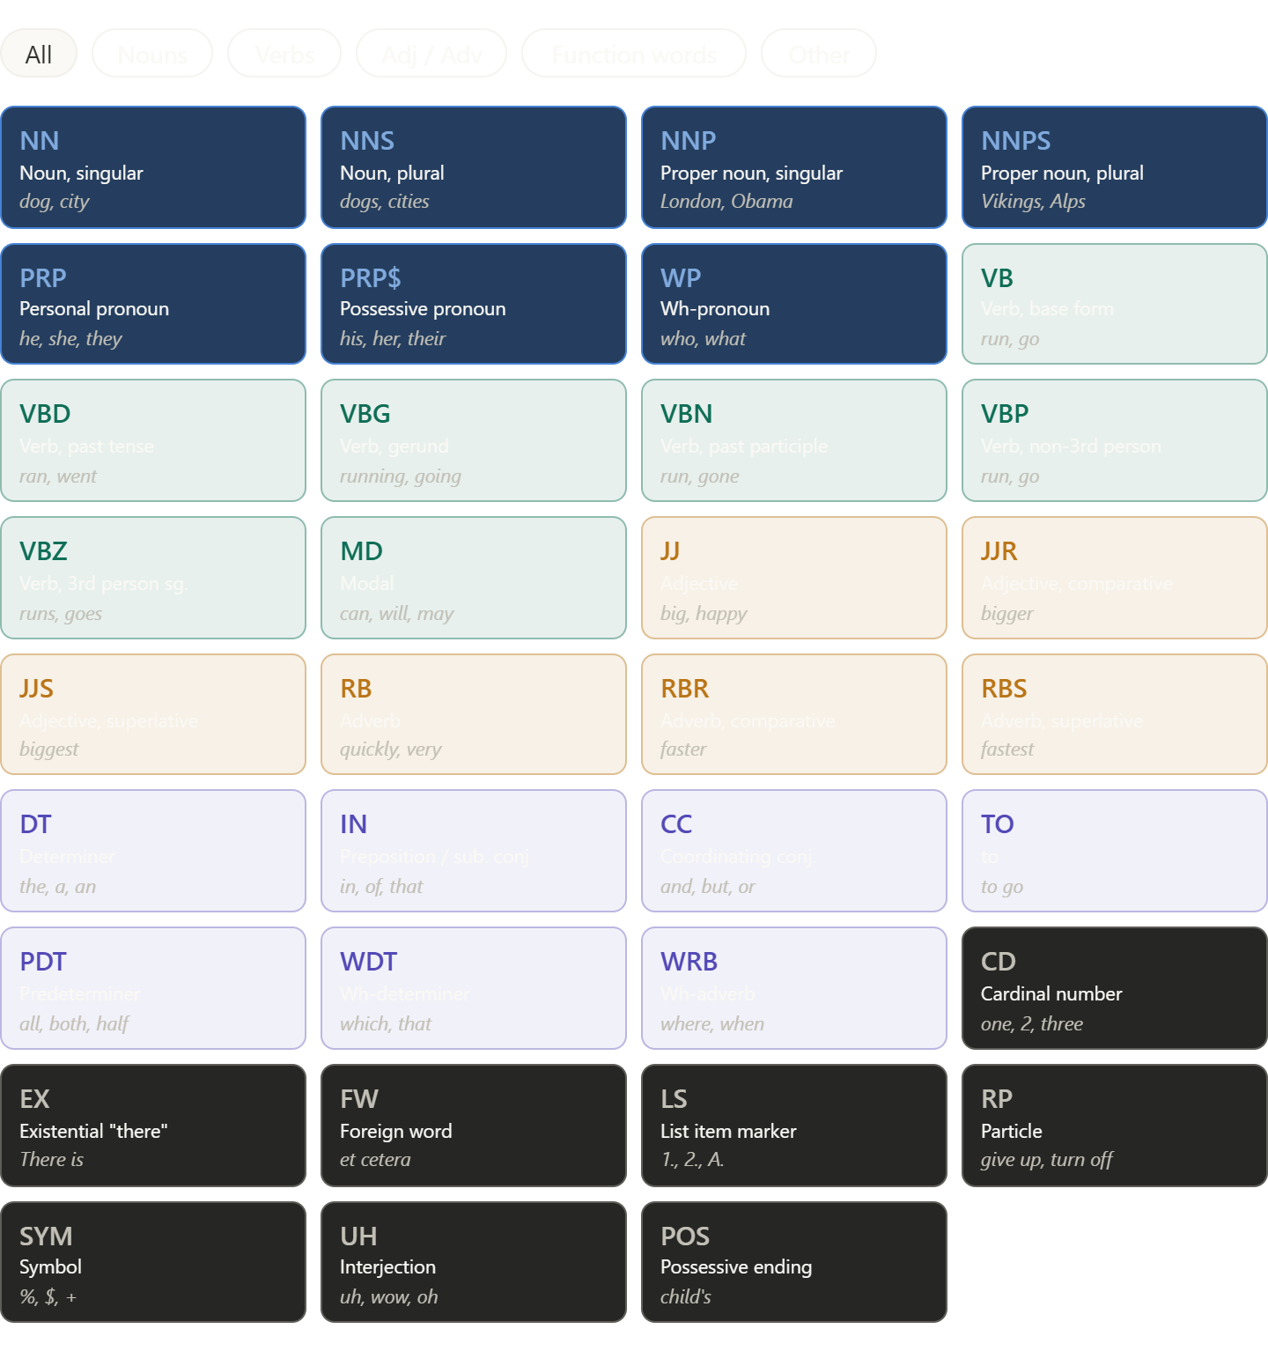
12. Challenges and Limitations
Despite its many strengths, the Stanford Tagger is not without limitations. An honest case study must acknowledge these:
Performance on Non-Standard Text: There is a significant gap between tagger performance on non-standard language varieties and on standard language, and the performance loss mainly comes from relatively subtle tagging errors within morphological categories as opposed to coarse errors across categories. This was demonstrated with student essays in Swiss Italian, where taggers trained on standard Italian struggled considerably.
Java Dependency: The requirement for Java 8+ is increasingly a friction point in a Python-dominated NLP ecosystem. While wrappers exist for many languages, they all ultimately depend on the Java runtime.
Speed vs. Accuracy Tradeoff: If speed is the paramount concern, users might want something still faster. This can be achieved by using a cheaper conditioning model class, using HMM-based taggers (which are faster than discriminative, feature-based models), or doing more code optimization.
Memory Requirements: For resource-constrained environments, the 60–200 MB RAM requirement for inference (and 1GB+ for training) can be prohibitive.
Neural Models Have Surpassed It: In the era of transformers and large language models, purely feature-based log-linear taggers have been eclipsed in raw accuracy by deep learning models like BERT-based taggers, which model contextual word representations rather than handcrafted features.

13. Legacy and Impact
Despite the emergence of neural approaches, the Stanford POS Tagger's legacy is profound and enduring:
- It established the maximum entropy framework as a dominant paradigm in NLP for over a decade, influencing countless subsequent tools and papers.
- It demonstrated the value of bidirectional context modeling, anticipating the direction that neural sequence models (LSTMs, transformers) would later take.
- Its multilingual architecture and retraining capability democratized POS tagging for under-resourced languages, enabling dozens of research projects that would not otherwise have been feasible.
- Its open-source release under the GPL inspired a generation of academic NLP software, contributing to the culture of tool-sharing that defines modern NLP research.
- The Stanford NLP Group's software packages are widely used in industry, academia, and government.
- The tagger is embedded in widely used toolkits including NLTK, GATE, KNIME, and many proprietary pipelines.
The Toutanova et al. 2003 paper remains one of the most highly cited papers in the NLP literature, and the tagger itself has been downloaded millions of times.

14. Architectural Flow Diagram
The complete pipeline from raw text to tagged output can be summarized as:
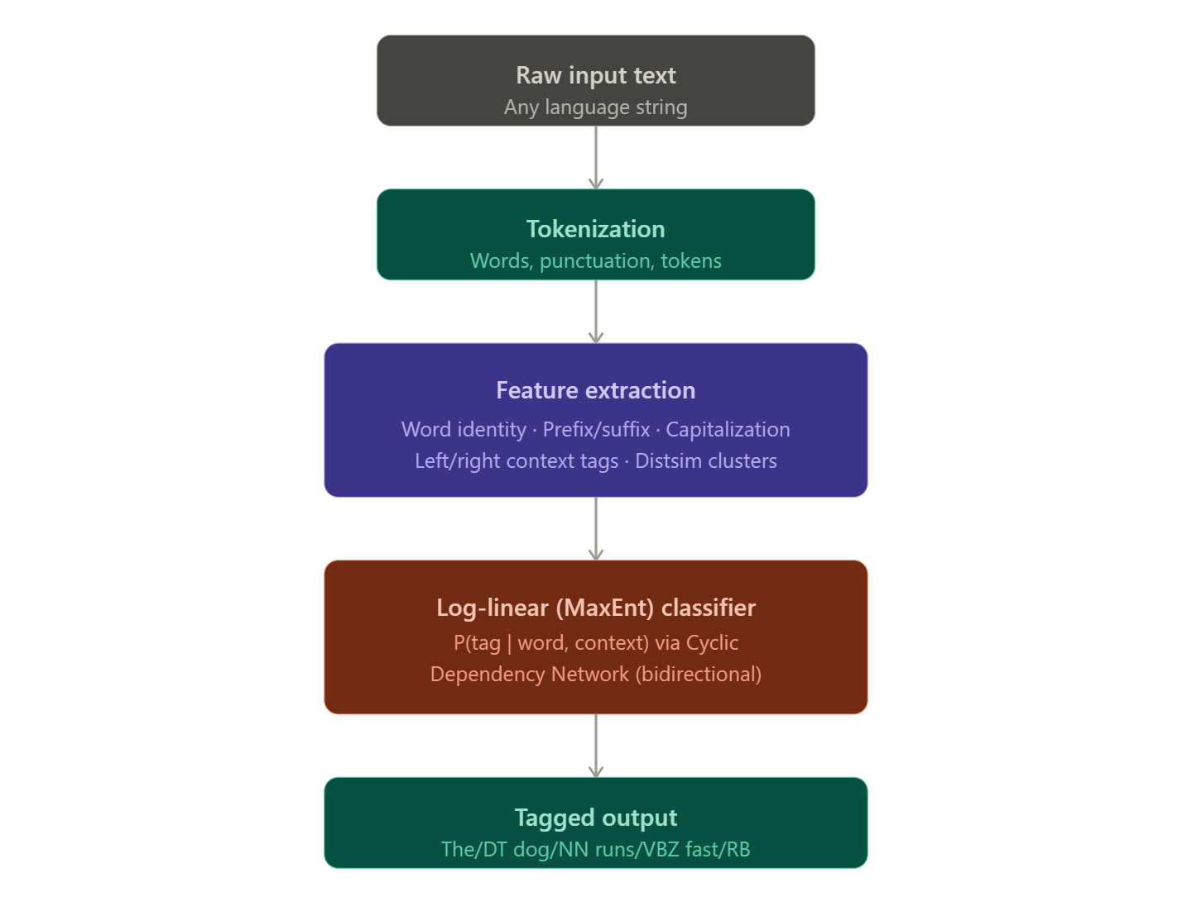
15. Conclusion
The Stanford Log-Linear Part-Of-Speech Tagger is a singular achievement in applied computational linguistics. Born from rigorous academic research in 2000 and continually refined over more than two decades, it represents the gold standard of feature-rich, probabilistic POS tagging. Its contributions include the practical validation of maximum entropy models for sequence labeling, the introduction of cyclic dependency networks for bidirectional tagging, robust multilingual support across six languages, and a thriving open ecosystem spanning every major programming language and deployment environment.
While the NLP field has moved toward neural architectures for the very highest accuracy benchmarks, the Stanford Tagger remains highly relevant as a fast, interpretable, retrainable, and richly documented baseline. For researchers entering new linguistic territory, for engineers deploying efficient NLP pipelines, and for students learning the foundations of sequence labeling, the Stanford POS Tagger remains an indispensable reference point.
Its story is not merely about a software package — it is about how carefully grounded academic research, made freely available and actively maintained, can catalyze an entire field.

References
- Toutanova, K., & Manning, C. D. (2000). Enriching the Knowledge Sources Used in a Maximum Entropy Part-of-Speech Tagger. Proceedings of the Joint SIGDAT Conference on Empirical Methods in Natural Language Processing and Very Large Corpora (EMNLP/VLC-2000), pp. 63–70.
- Toutanova, K., Klein, D., Manning, C. D., & Singer, Y. (2003). Feature-Rich Part-of-Speech Tagging with a Cyclic Dependency Network. Proceedings of HLT-NAACL 2003, pp. 252–259. (The primary citation for the Stanford POS Tagger)
- Manning, C. D., Surdeanu, M., Bauer, J., Finkel, J., Bethard, S. J., & McClosky, D. (2014). The Stanford CoreNLP Natural Language Processing Toolkit. Proceedings of the 52nd Annual Meeting of the ACL: System Demonstrations.
- Ratnaparkhi, A. (1996). A Maximum Entropy Model for Part-of-Speech Tagging. Conference on Empirical Methods in Natural Language Processing, pp. 133–142.
- Marcus, M. P., Santorini, B., & Marcinkiewicz, M. A. (1993). Building a Large Annotated Corpus of English: The Penn Treebank. Computational Linguistics, 19(2), pp. 313–330.
- Stanford NLP Group (ongoing). Stanford Log-Linear Part-Of-Speech Tagger — Official Documentation. https://nlp.stanford.edu/software/tagger.shtml
- Stanford NLP Group (ongoing). Stanford POS Tagger FAQ. https://nlp.stanford.edu/software/pos-tagger-faq.html

