Practical 1: Import the legacy data from different sources such as (Excel , Sql Server, Oracle etc.) and load in the target system. ( You can download sample database such as Adventure works, Northwind, foodmart etc.)

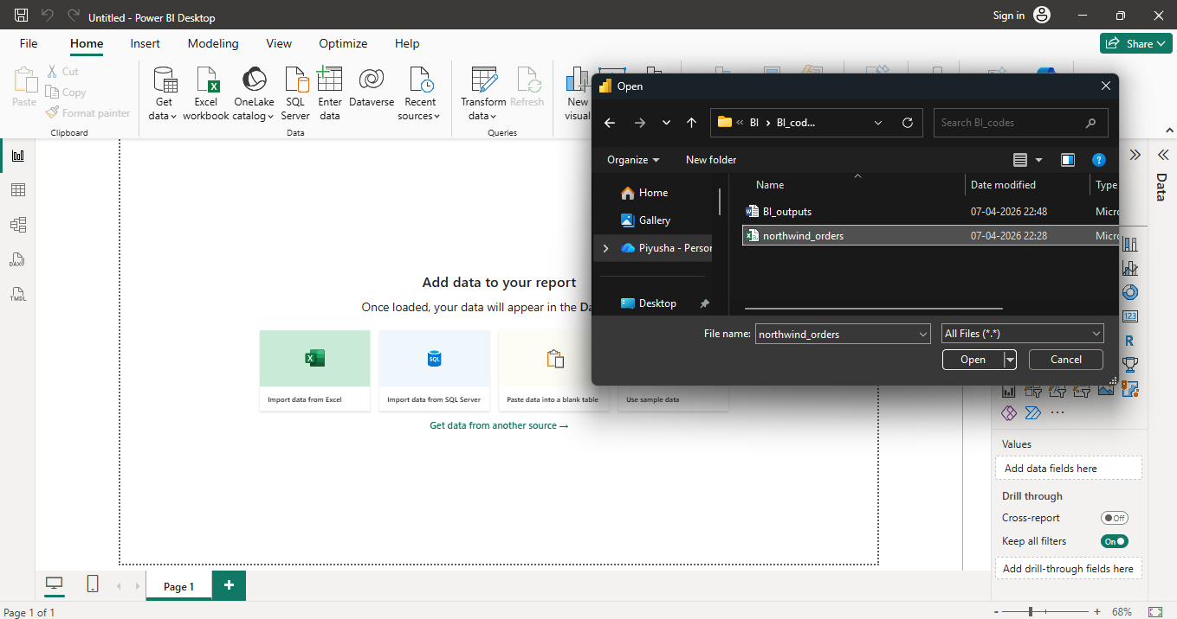

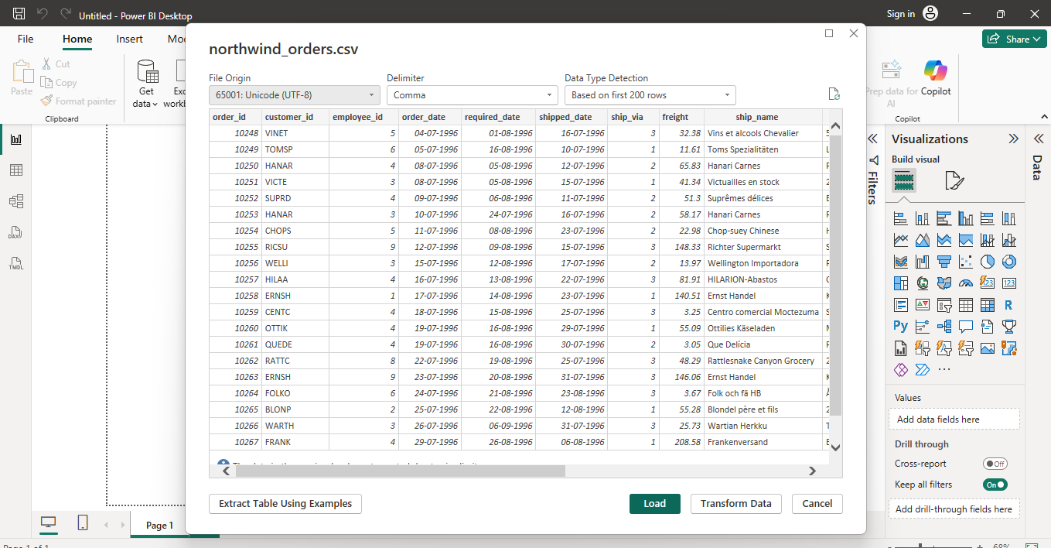
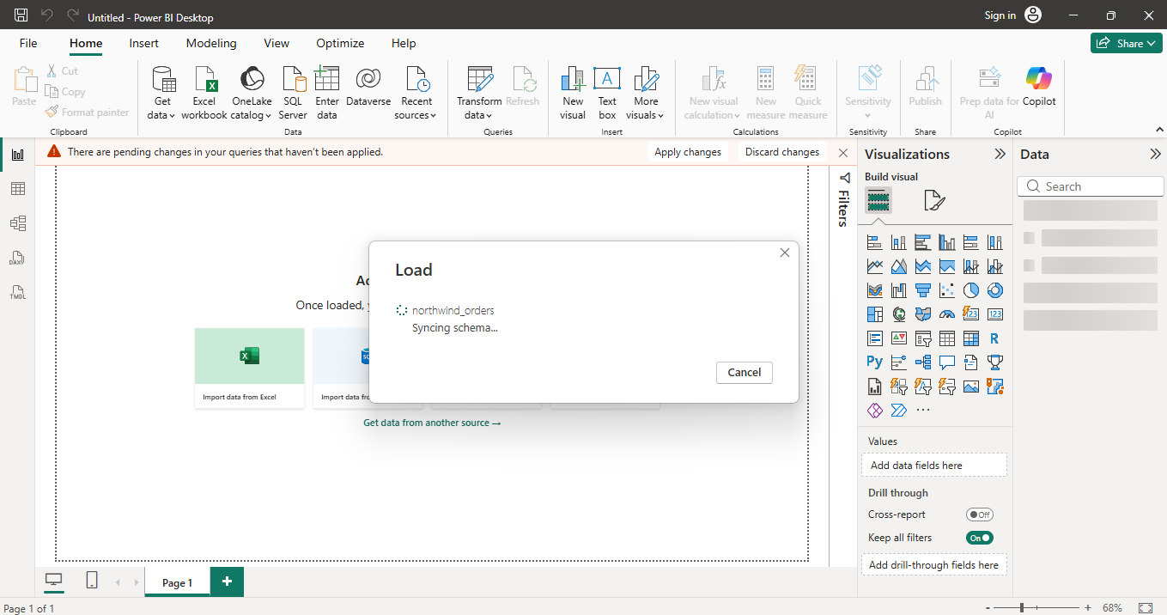
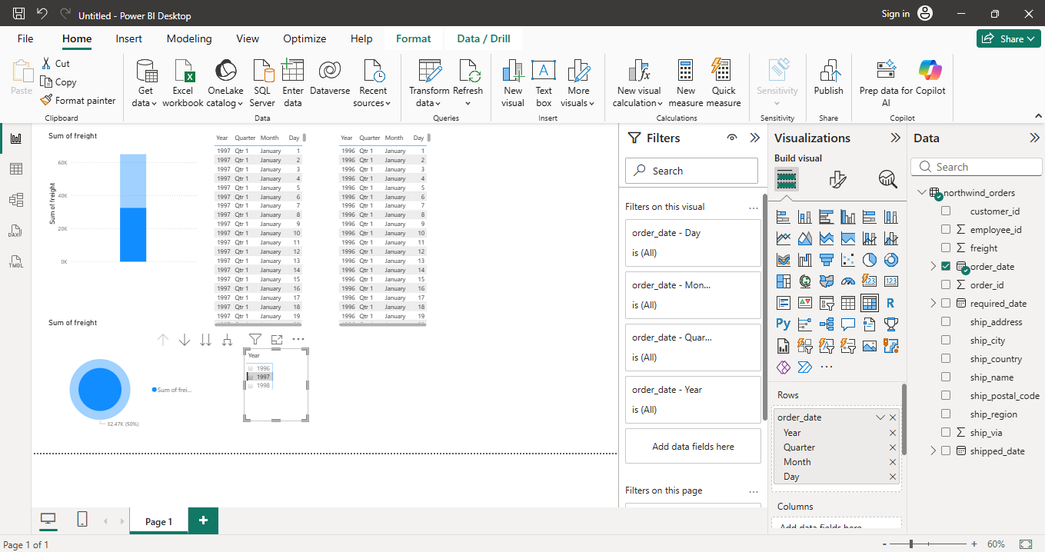

Practical 2: Perform the Extraction Transformation and Loading (ETL) process to construct the database in the Sql server.

Open Mysql workbench
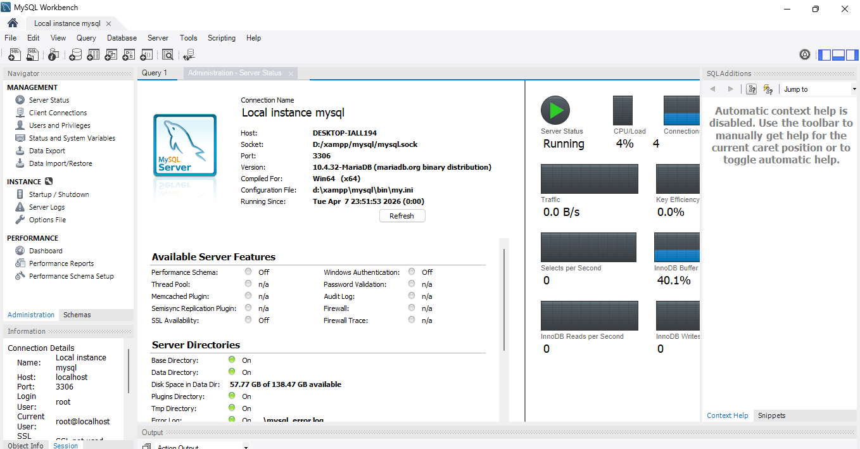

Then make a table to import our csv file, here I am using Northwind file
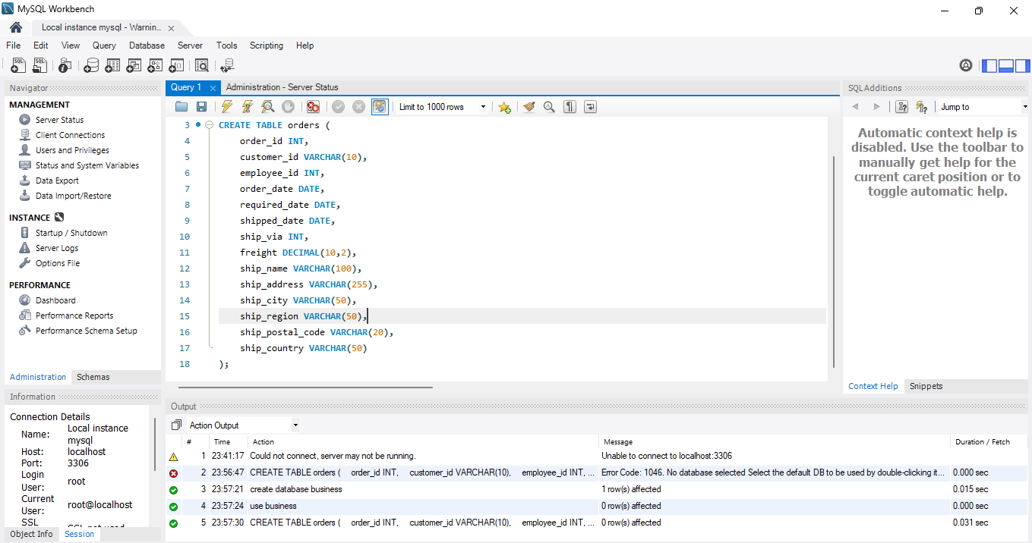

Then import the sql version of your CSV file into the workbench through data import
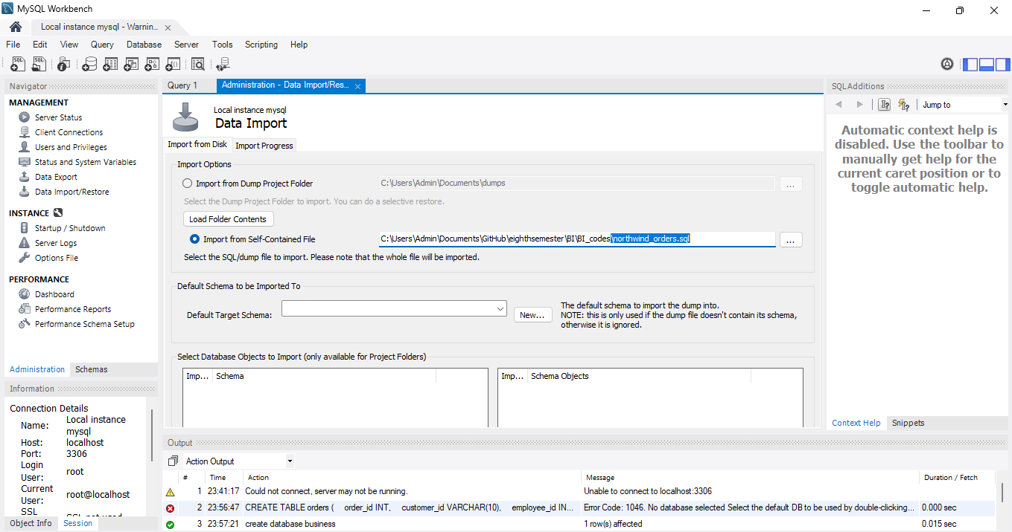

Create a new schema for the import
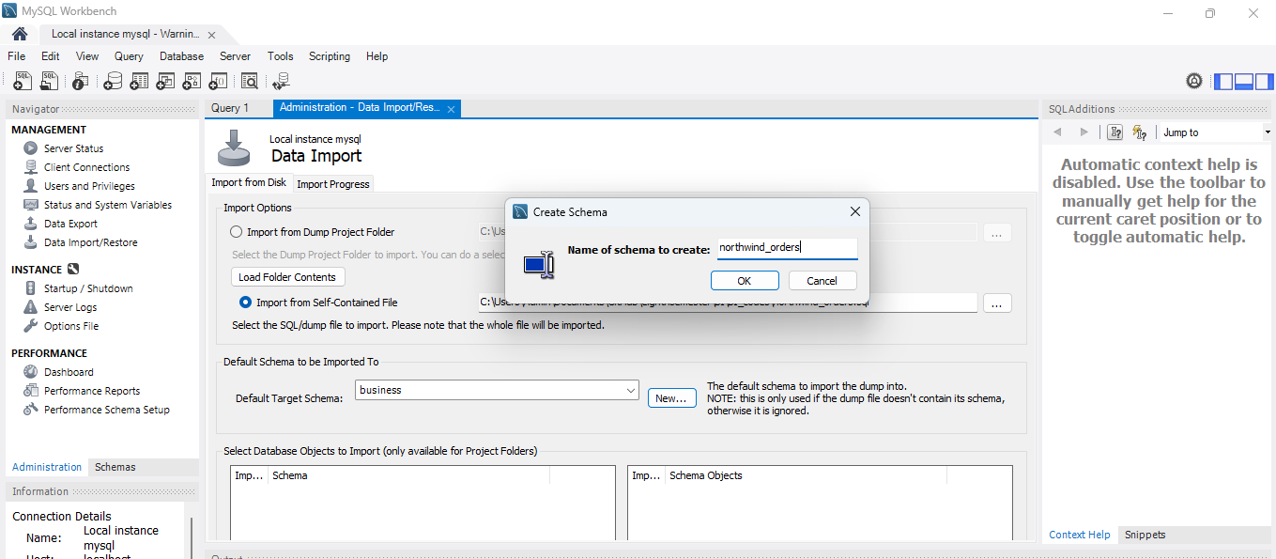

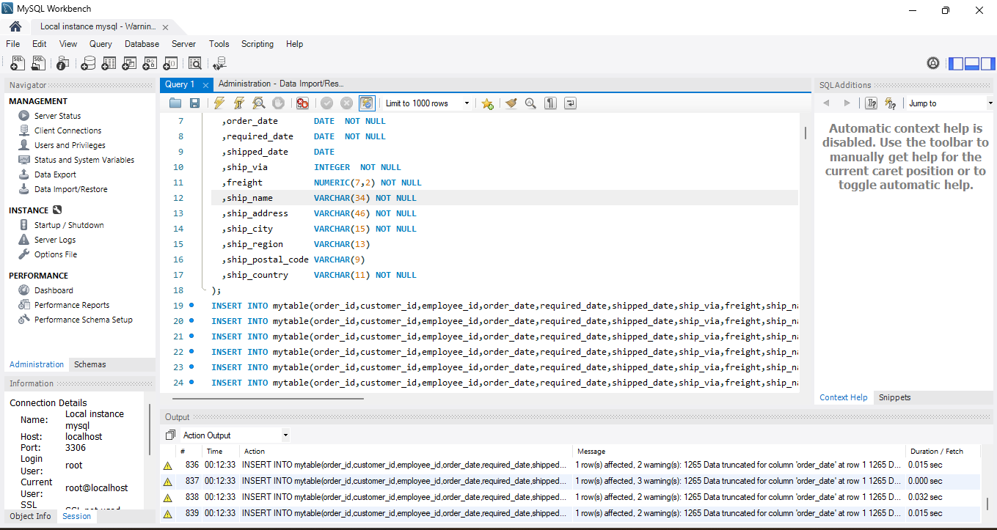
Now clean the data by replacing null values
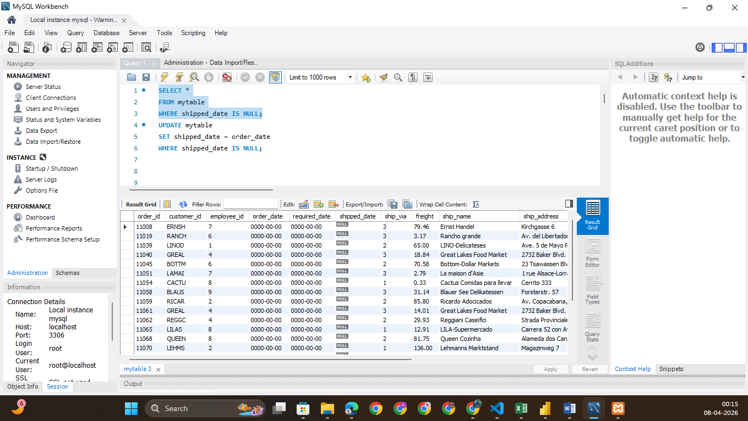

Get insights
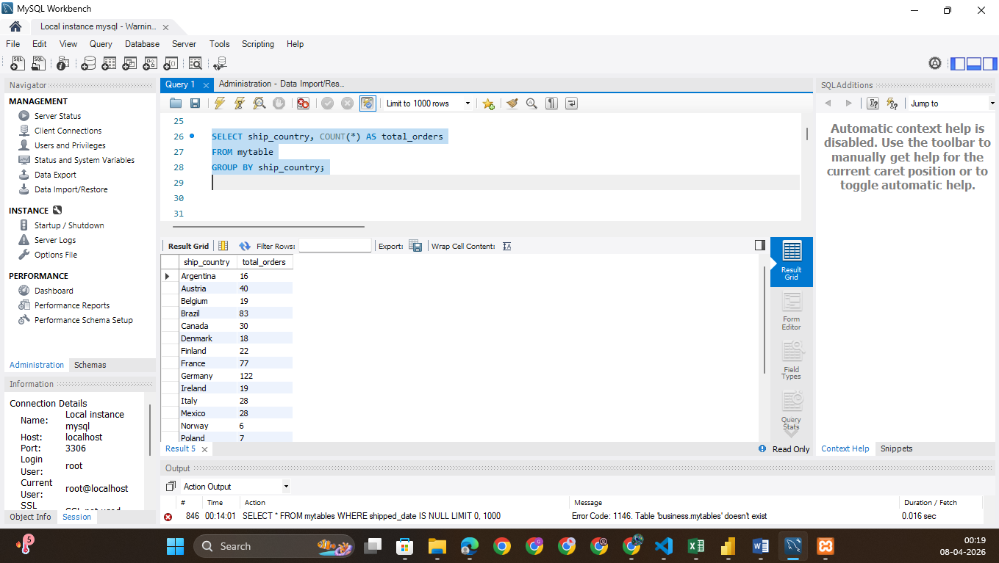
The queries used ate as follows:
SELECT *FROM mytable WHERE shipped_date IS NULL;
UPDATE mytable SET shipped_date = order_date WHERE shipped_date IS NULL;
DELETE FROM mytable WHERE order_date IS NULL;
ALTER TABLE mytable ADD delivery_days INT;
UPDATE mytable SET delivery_days = DATEDIFF(shipped_date, order_date);
ALTER TABLE mytable ADD is_delayed VARCHAR(10);
UPDATE mytable SET is_delayed = CASE WHEN shipped_date > required_date THEN 'Delayed'
ELSE 'On Time' END;
SELECT ship_country, COUNT(*) AS total_orders FROM mytable GROUP BY ship_country;
SELECT AVG(delivery_days) AS avg_delivery FROM mytable;
SET SQL_SAFE_UPDATES = 0;

Practical 3: Create the cube with suitable dimension and fact tables based on ROLAP, MOLAP and HOLAP model.
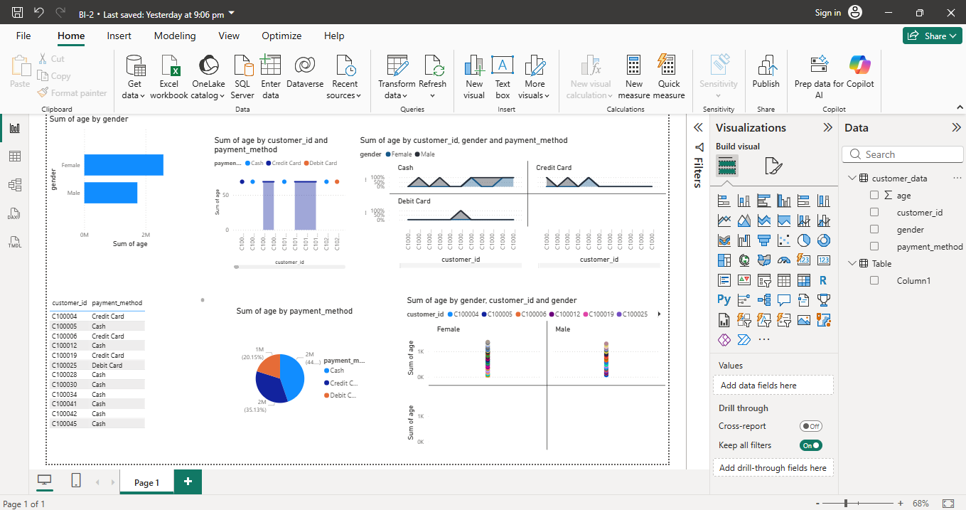

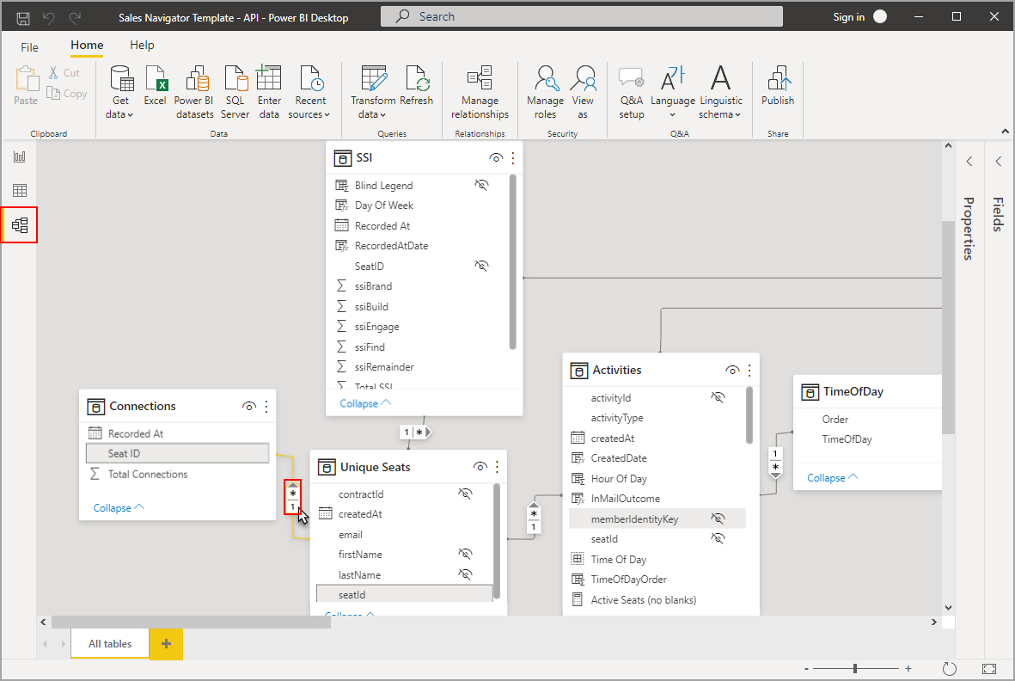

Practical 4: Import the data warehouse data in Microsoft Excel and create the Pivot table and Pivot Chart
