
Department of Computer Engineering

“BI Miniproject”

Submitted in partial fulfilment of the requirements for the degree of

BACHELOR OF ENGINEERING
In
COMPUTER ENGINEERING
Submitted By
Name of the Student: Piyusha Rajendra Supe
Roll No: 23CO315

Under the Guidance of
Mrs. Shikha J. Pachouly

ALL INDIA SHRI SHIVAJI MEMORIAL SOCIETY’S COLLEGE OF ENGINEERING PUNE-411001
Academic Year: 2025-26 (Term-II)
Savitribai Phule Pune University


Department of Computer Engineering

CERTIFICATE

This is to certify that Piyusha Rajendra Supe from Fourth Year Computer Engineering has successfully completed her work titled “Business Intelligence Mini-project” at AISSMS College of Engineering, Pune in the partial fulfillment of the Bachelor’s Degree in Computer Engineering.

Mrs. S. J. Pachouly | Dr. S. V. Athawale | Dr. D. S. Bormane
(Faculty In-charge) | (Head of Department) | (Principal)
Computer Engineering | Computer Engineering | AISSMSCOE, Pune

ACKNOWLEDGEMENT

It is with sincere gratitude and deep appreciation that I take this opportunity to acknowledge the invaluable support and guidance I have received throughout the course of this project. This journey has been both intellectually enriching and personally rewarding, significantly enhancing my understanding of the subject and its practical applications. I would like to express my heartfelt thanks to all those who provided guidance, encouragement, and constructive feedback during the development of this project. Their insights and support were instrumental in shaping the direction and quality of the work. I also extend my appreciation to the department for fostering an environment that promotes learning, innovation, and academic growth. The resources and opportunities provided played a vital role in the successful completion of this project. A special note of thanks goes to the supporting staff for their cooperation and timely assistance, which ensured that the process remained smooth and efficient at every stage. Finally, I would like to express my deepest gratitude to my parents for their constant support, encouragement, and belief in my abilities. Their motivation has been a source of strength throughout this journey. This project has not only strengthened my knowledge but has also emphasized the importance of dedication, perseverance, and continuous learning. I remain sincerely thankful to everyone who contributed, directly or indirectly, to the successful completion of this project.

Academic Year: 2025-2026
Piyusha Rajendra Supe (23CO315)

TABLE OF CONTENTS

Sr. No | Title | Page No.
1 | Acknowledgement…………………………………………… | 3
2 | Abstract ………………………………………………......... | 5
3 | Problem Definition…………………………………………... | 6
4 | Use of standard dataset ………………………………………. | 6
5 | Exploratory Data Analysis………………………………… | 7
6 | Data visualization…………………………………………… | 10
7 | Conclusion…….……………………………………………. | 12
8 | References……………………………………………………. | 12

ABSTRACT

Customer churn prediction has emerged as a critical application of Business Intelligence (BI), enabling organizations to proactively identify customers who are likely to discontinue their services. In highly competitive industries such as telecommunications, banking, and subscription-based platforms, customer retention plays a vital role in maintaining profitability and long-term growth. This case study focuses on leveraging data mining techniques and BI tools to analyze customer behavior and predict churn using historical data. By transforming raw customer data into meaningful insights, the project aims to support data-driven decision-making and improve customer retention strategies.
The methodology adopted in this study involves defining the churn problem as a supervised classification task, where customers are categorized into two classes: churn and non-churn. A standard dataset, such as the Telco Customer Churn dataset, is utilized to perform analysis and model development. The process begins with data preprocessing and cleaning, followed by exploratory data analysis (EDA) to identify patterns and key factors influencing customer behavior. Feature engineering techniques are applied to enhance the dataset, and multiple machine learning models are built and evaluated to determine the most effective approach for churn prediction.
The project also emphasizes the role of BI tools such as Microsoft Power BI and Tableau in presenting insights through interactive dashboards. These dashboards enable stakeholders to visualize key performance indicators such as churn rate, customer segmentation, and revenue impact, making complex analytical results more accessible and actionable. By integrating predictive modeling with visualization, the study bridges the gap between technical analysis and business decision-making.

Case study: Customer Churn Prediction (Telecom / Bank)

a) Problem Definition and Identification of Data Mining Task
Customer churn prediction is one of the most critical applications of Business Intelligence in modern organizations, particularly in industries such as telecommunications, banking, subscription-based services, and e-commerce. Churn refers to the phenomenon where customers discontinue their relationship with a company or stop using its services over a given period of time. In highly competitive markets, retaining existing customers is significantly more cost-effective than acquiring new ones, making churn prediction a strategically important problem. The primary objective of this case study is to analyze customer data and identify patterns or behaviors that indicate the likelihood of a customer leaving the service, thereby enabling organizations to take proactive measures to improve retention.
From a Business Intelligence perspective, this problem involves transforming raw customer data into actionable insights that can support decision-making. The dataset typically includes attributes such as customer demographics (age, gender), account information (tenure, subscription type), service usage (call duration, internet usage), and billing details (monthly charges, payment method). By analyzing these features, the goal is to understand the underlying factors contributing to churn and build a predictive model that can classify whether a customer is likely to churn or not. This not only helps in identifying at-risk customers but also supports targeted marketing strategies, personalized offers, and improved customer service.
Beyond classification, exploratory data analysis (EDA) plays a crucial role in understanding the dataset and identifying important features influencing churn. Techniques such as correlation analysis, visualization, and feature importance ranking help in uncovering hidden patterns and relationships. For instance, customers with high monthly charges and low tenure may exhibit a higher probability of churn, indicating dissatisfaction or lack of long-term engagement. Such insights are valuable not only for predictive modeling but also for strategic business decisions.
b) Identification and Use of a Standard Dataset
To effectively implement customer churn prediction, it is essential to use a well-structured and widely recognized dataset that provides sufficient features and labeled data for analysis. For this project, a standard dataset such as the Telco Customer Churn Dataset provided by IBM is commonly used. This dataset is publicly available on platforms like Kaggle and is widely adopted in academic and industry projects due to its richness, realism, and suitability for classification tasks.
The Telco Customer Churn dataset contains detailed information about customers of a telecommunications company, including demographic data, account details, and service usage patterns. Some of the key attributes include:
- CustomerID – Unique identifier for each customer
- Gender, SeniorCitizen, Partner, Dependents – Demographic information
- Tenure – Number of months the customer has stayed with the company
- Services – Phone service, internet service, streaming services, etc.
- Billing Information – Monthly charges, total charges, payment method
- Churn – Target variable indicating whether the customer has left (Yes/No)
The dataset is particularly suitable for this project because it provides a balanced mix of categorical and numerical features, allowing for comprehensive analysis and modeling. Before applying data mining techniques, the dataset undergoes preprocessing steps such as handling missing values, encoding categorical variables (e.g., one-hot encoding), and feature scaling where necessary. These steps ensure that the data is in a format suitable for machine learning algorithms.
In addition to preprocessing, feature engineering may be performed to enhance model performance. For example, new features such as average monthly spending or service usage ratios can be derived from existing attributes. These engineered features can provide deeper insights into customer behavior and improve the predictive power of the model.
1. Data Preprocessing and Cleaning
Data preprocessing is a fundamental stage in any Business Intelligence workflow, as real-world datasets are rarely clean or ready for direct analysis. In the context of customer churn prediction, the dataset often contains inconsistencies such as missing values, duplicate entries, incorrect data types, and noisy records that can significantly degrade the performance of predictive models if left unaddressed. Therefore, it becomes essential to transform the raw dataset into a structured and reliable format before proceeding to modeling. This stage ensures that the data accurately represents customer behavior and does not introduce bias or errors into the system.
The preprocessing phase typically involves several key steps:
- Handling missing values (e.g., replacing null values using mean, median, or mode)
- Removing duplicate or irrelevant records (such as customer IDs)
- Converting categorical variables into numerical form (encoding)
- Standardizing or normalizing numerical features
- Ensuring consistency in data formats and labels
By carefully executing these steps, the dataset becomes more suitable for analysis and modeling, ultimately improving the reliability and accuracy of the churn prediction system.
2. Exploratory Data Analysis (EDA)
Exploratory Data Analysis (EDA) is an essential phase that allows analysts to gain a deep understanding of the dataset before applying any machine learning algorithms. In a customer churn scenario, EDA helps uncover patterns, trends, and relationships that explain why customers leave a service. It transforms raw data into meaningful insights through statistical summaries and visual exploration. This stage is particularly important because it guides feature selection, model choice, and business strategy.
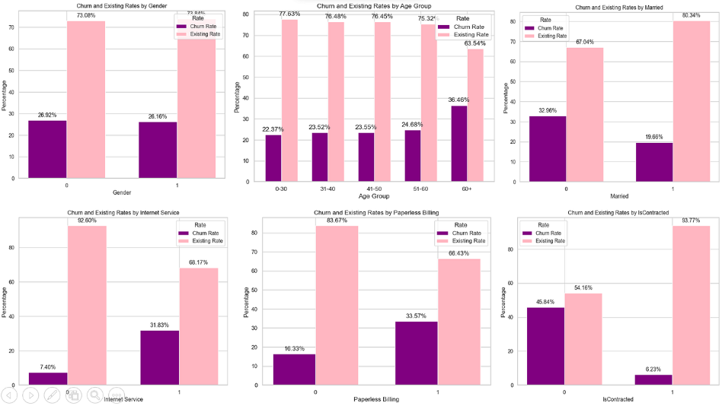

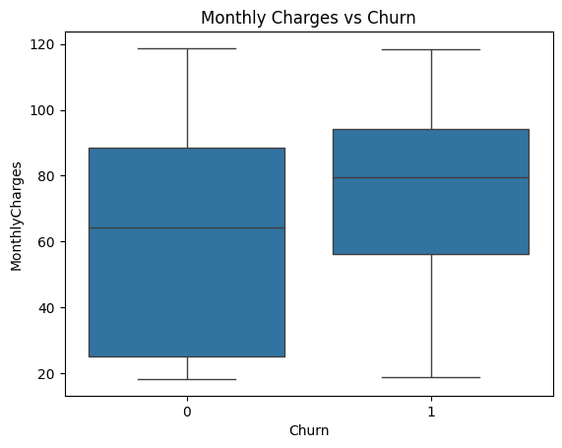
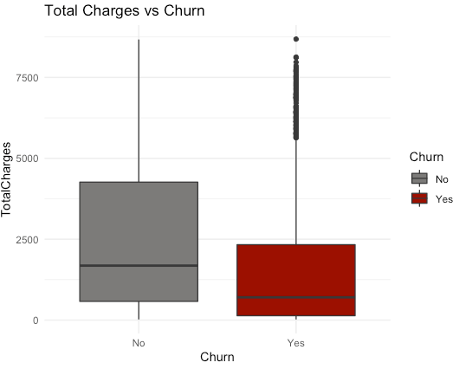

During EDA, several techniques are used to analyze the data:
- Distribution analysis (histograms, density plots)
- Relationship analysis (scatter plots, bar charts)
- Correlation analysis (heatmaps)
- Outlier detection (box plots)
For example, analysis may reveal that customers with shorter tenure or higher monthly charges are more likely to churn. Such insights not only help in building better models but also provide valuable business understanding.
3. Feature Selection and Engineering
Feature selection and engineering play a critical role in improving the performance and interpretability of machine learning models. Not all features in a dataset contribute equally to predicting customer churn; some may be redundant, irrelevant, or even misleading. Feature selection involves identifying and retaining only the most significant variables, thereby reducing dimensionality and improving model efficiency.
Feature engineering, on the other hand, focuses on creating new features that better represent underlying patterns in the data. This process enhances the model’s ability to capture complex relationships and improves predictive accuracy.
Key activities include:
- Removing irrelevant or highly correlated features
- Creating new derived features (e.g., customer lifetime value)
- Grouping or binning variables for better representation
- Transforming skewed data distributions
This step ensures that the model is trained on meaningful and informative data, leading to better generalization and performance.
4. Model Building and Selection
Model building is the core phase of the case study, where machine learning algorithms are applied to predict customer churn. Since churn prediction is a classification problem, various supervised learning models can be used. The choice of model depends on factors such as dataset size, feature complexity, and desired interpretability.
Commonly used models include:
- Logistic Regression (simple and interpretable)
- Decision Trees (rule-based and easy to visualize)
- Random Forest (ensemble method with high accuracy)
- Gradient Boosting (advanced boosting techniques)
The dataset is split into training and testing sets, and models are trained using the training data. Hyperparameter tuning techniques such as cross-validation and grid search are applied to optimize performance. The goal is to select the best-performing model that balances accuracy and generalization.
5. Model Evaluation
Model evaluation is a critical step that determines how well the trained model performs on unseen data. It ensures that the model is not overfitting and can generalize effectively to real-world scenarios. In customer churn prediction, evaluation metrics must be carefully chosen to reflect business priorities.
Key evaluation metrics include:
- Accuracy (overall correctness)
- Precision (correct positive predictions)
- Recall (ability to detect churn cases)
- F1-score (balance between precision and recall)
A confusion matrix is also used to analyze prediction outcomes in detail. For churn prediction, recall is often more important than accuracy because failing to identify a customer who is likely to churn can result in significant business losses.
6. Data Visualization and BI Dashboard
A defining characteristic of Business Intelligence projects is the ability to present insights in a visually appealing and easily interpretable manner. This is achieved through dashboards created using tools such as Tableau and Microsoft Power BI. These dashboards allow stakeholders to monitor key metrics and explore data interactively.
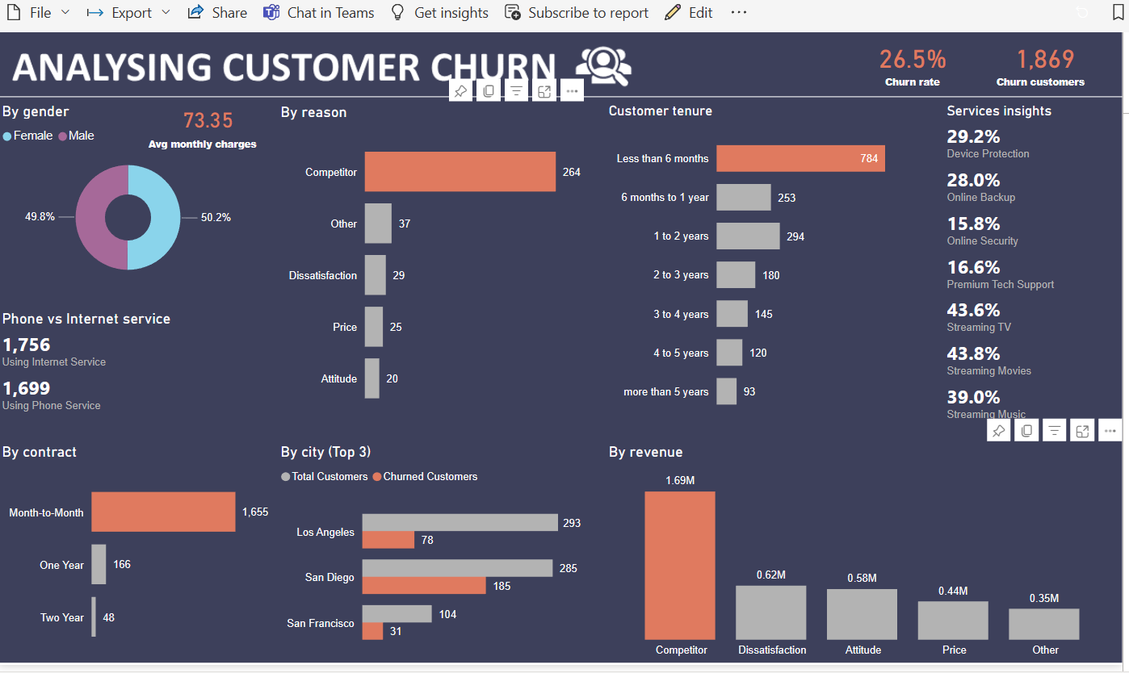
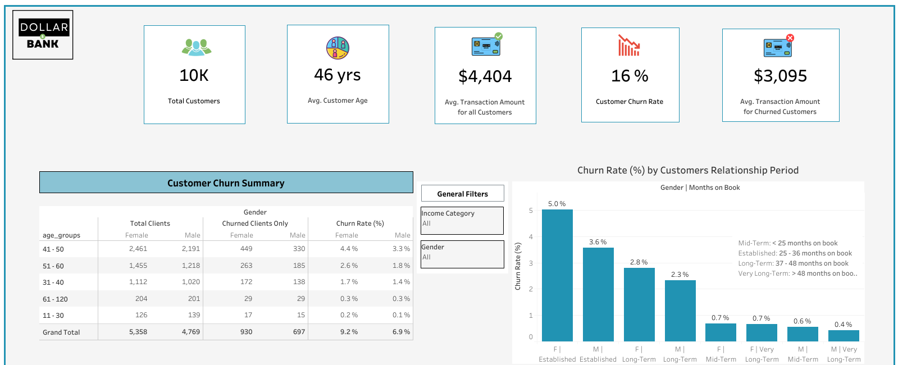
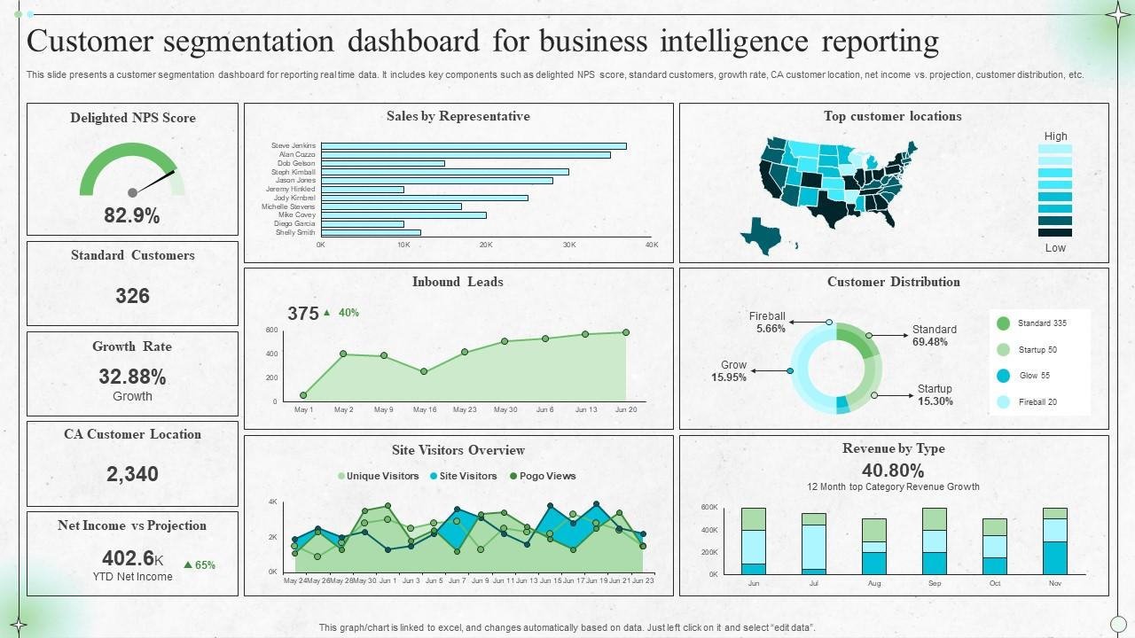
Typical dashboard components include:
- Churn rate overview
- Customer segmentation analysis
- Revenue impact of churn
- High-risk customer identification
These visual tools make it easier for decision-makers to understand complex data and take appropriate actions.
7. Business Insights and Recommendations
The ultimate objective of the case study is to derive actionable insights that can help the organization reduce customer churn and improve retention. By analyzing model outputs and data patterns, businesses can identify key drivers of churn and implement targeted strategies.
Some practical recommendations include:
- Providing personalized offers to high-risk customers
- Improving customer support for dissatisfied users
- Introducing loyalty programs for long-term customers
- Adjusting pricing strategies based on customer segments
These insights bridge the gap between technical analysis and real-world business impact.

8. Conclusion and Future Scope
The case study concludes by summarizing the key findings and highlighting the effectiveness of the BI approach in solving the churn prediction problem. It reinforces the importance of data-driven decision-making and demonstrates how predictive analytics can enhance business performance. Additionally, future scope may include the integration of real-time data, use of advanced models such as deep learning, and expansion to multi-class classification or customer lifetime value prediction.

References
• IBM Telco Customer Churn Dataset (Kaggle)
https://www.kaggle.com/datasets/blastchar/telco-customer-churn
• Customer Churn Prediction using Machine Learning (Overview)
https://www.ibm.com/topics/customer-churn
• Data Mining Concepts and Techniques (Han, Kamber, Pei)
https://www.sciencedirect.com/book/9780123814791/data-mining-concepts-and-techniques
• Microsoft Power BI Official Documentation
https://learn.microsoft.com/en-us/power-bi/
• Tableau Official Website
https://www.tableau.com
• Scikit-learn Machine Learning Documentation
https://scikit-learn.org/stable/
• Machine Learning Classification Algorithms Overview
https://developers.google.com/machine-learning/crash-course/classification
• Business Intelligence Concepts and Applications
https://www.gartner.com/en/information-technology/glossary/business-intelligence-bi

