
Department of Computer Engineering

“DL Miniproject”

Submitted in partial fulfilment of the requirements for the degree of

BACHELOR OF ENGINEERING
In
COMPUTER ENGINEERING
Submitted By
Name of the Student: Piyusha Rajendra Supe
Roll No: 23CO315

Under the Guidance of
Mr. S. S. Jadhav

ALL INDIA SHRI SHIVAJI MEMORIAL SOCIETY’S COLLEGE OF ENGINEERING PUNE-411001
Academic Year: 2025-26 (Term-II)
Savitribai Phule Pune University


Department of Computer Engineering

CERTIFICATE

This is to certify that Piyusha Rajendra Supe from Fourth Year Computer Engineering has successfully completed her work titled “Deep Learning Mini-project” at AISSMS College of Engineering, Pune in the partial fulfillment of the Bachelor’s Degree in Computer Engineering.

Mr. S. S. Jadhav | Dr. S. V. Athawale | Dr. D. S. Bormane
(Faculty In-charge) | (Head of Department) | (Principal)
Computer Engineering | Computer Engineering | AISSMSCOE, Pune

ACKNOWLEDGEMENT

It is with sincere gratitude and deep appreciation that I take this opportunity to acknowledge the invaluable support and guidance I have received throughout the course of this project. This journey has been both intellectually enriching and personally rewarding, significantly enhancing my understanding of the subject and its practical applications. I would like to express my heartfelt thanks to all those who provided guidance, encouragement, and constructive feedback during the development of this project. Their insights and support were instrumental in shaping the direction and quality of the work. I also extend my appreciation to the department for fostering an environment that promotes learning, innovation, and academic growth. The resources and opportunities provided played a vital role in the successful completion of this project. A special note of thanks goes to the supporting staff for their cooperation and timely assistance, which ensured that the process remained smooth and efficient at every stage. Finally, I would like to express my deepest gratitude to my parents for their constant support, encouragement, and belief in my abilities. Their motivation has been a source of strength throughout this journey. This project has not only strengthened my knowledge but has also emphasized the importance of dedication, perseverance, and continuous learning. I remain sincerely thankful to everyone who contributed, directly or indirectly, to the successful completion of this project.

Academic Year: 2025-2026
Piyusha Rajendra Supe (23CO315)

TABLE OF CONTENTS

Sr. No | Title | Page No.
1 | Acknowledgement…………………………………………… | 3
2 | Abstract ………………………………………………......... | 5
3 | Introduction…...……………………………………………... | 6
4 | System Requirements ………………………………………. | 7
5 | Methodology………………………………………………… | 8
6 | Implementation……………………………………………… | 13
7 | Conclusion…….……………………………………………. | 14
8 | References……………………………………………………. | 14

ABSTRACT

Gender and age detection has become an important application in the field of computer vision and deep learning, with widespread usage in areas such as surveillance systems, targeted advertising, human-computer interaction, and demographic analysis. This project focuses on designing a deep learning-based system capable of predicting both the gender (male or female) and the approximate age of a person from facial images. By leveraging convolutional neural networks (CNNs), the system aims to automatically extract meaningful features from images and perform accurate classification and regression tasks simultaneously. The proposed system utilizes facial image datasets containing labeled information about gender and age. These images are preprocessed through steps such as resizing, normalization, and face detection to ensure consistency and improve model performance. A deep learning model, typically based on a CNN architecture, is then trained to learn complex patterns and features from the facial data. The model performs two tasks: gender classification (binary classification) and age prediction (regression or multi-class classification depending on implementation). This multi-task learning approach allows the model to share features between related tasks, improving overall efficiency and accuracy. The methodology involves training the CNN model on a labeled dataset such as UTKFace or Adience dataset, which contains diverse facial images with age and gender annotations. The dataset is split into training, validation, and testing sets to ensure proper evaluation. During training, the model learns hierarchical features such as edges, textures, and facial structures, which are essential for distinguishing gender and estimating age. Loss functions such as binary cross-entropy (for gender) and mean squared error or categorical cross-entropy (for age) are used to optimize the model. The performance of the system is evaluated using metrics such as accuracy for gender classification and mean absolute error (MAE) for age prediction. Experimental results demonstrate that deep learning models, particularly CNNs, are highly effective in capturing facial features and achieving reliable predictions. However, factors such as lighting conditions, facial expressions, occlusions, and dataset imbalance can influence model accuracy and must be carefully addressed.

INTRODUCTION

Introduction: Gender and Age Detection using Deep Learning
The rapid advancement of artificial intelligence and deep learning has significantly transformed the field of computer vision, enabling machines to interpret and analyze visual data with a high degree of accuracy. Among the various applications of computer vision, gender and age detection has emerged as a crucial task with wide-ranging applications in areas such as surveillance systems, biometric authentication, targeted advertising, social media analytics, and human-computer interaction. The ability to automatically determine a person’s gender and estimate their age from facial images allows organizations to gain valuable demographic insights and enhance user experience through personalized services.
Traditionally, gender and age detection relied on manual feature extraction techniques and classical machine learning algorithms. These approaches required domain expertise to design features such as facial landmarks, texture patterns, and geometric measurements. However, such methods often struggled to handle variations in lighting, pose, facial expressions, and occlusions. With the introduction of deep learning, particularly convolutional neural networks (CNNs), the process of feature extraction has become automated and significantly more effective. CNNs are capable of learning hierarchical representations of data, starting from low-level features such as edges and textures to high-level features such as facial structures and patterns, making them highly suitable for image-based tasks.
In this project, the problem of gender and age detection is approached using deep learning techniques, where a model is trained on a dataset of facial images annotated with corresponding gender and age labels. The task can be divided into two sub-problems: gender classification and age prediction. Gender classification is a binary classification problem where the model predicts whether a person is male or female. Age prediction, on the other hand, can be treated either as a regression problem (predicting exact age) or as a multi-class classification problem (predicting age groups). By combining both tasks into a single model, the system can efficiently utilize shared features and improve overall performance through a technique known as multi-task learning.
The effectiveness of such a system depends heavily on the quality and diversity of the dataset used for training. Datasets such as UTKFace and Adience provide a wide range of facial images with variations in age, gender, ethnicity, and environmental conditions. These datasets help the model generalize better and perform accurately in real-world scenarios. Preprocessing steps such as face detection, image resizing, normalization, and data augmentation are applied to enhance the dataset and improve model robustness.
One of the major challenges in gender and age detection is dealing with variability in facial appearances due to factors such as aging, makeup, accessories (e.g., glasses, hats), and different lighting conditions. Additionally, age estimation is inherently more complex than gender classification because aging patterns vary significantly across individuals. Therefore, designing an effective deep learning model requires careful consideration of architecture, loss functions, and training strategies.

SYSTEM REQUIREMENTS

Category | Requirement | Description
Operating System | Windows / Linux / macOS | A compatible OS that supports deep learning frameworks. Linux is preferred for better performance and GPU support.
Processor (CPU) | Intel i5/i7 or AMD Ryzen 5/7 (or higher) | Multi-core processors help in faster data preprocessing and model execution.
GPU (Recommended) | NVIDIA GPU (e.g., GTX 1650 / RTX 2060 / RTX 3060 or higher) | Required for accelerating deep learning training using CUDA. Significantly reduces training time compared to CPU.
RAM | Minimum 8 GB (Recommended: 16 GB or more) | Required to handle large image datasets and batch processing during training.
Storage | Minimum 20–50 GB free space | Needed for storing datasets (images), trained models, and project files.
Programming Language | Python | Widely used for deep learning due to simplicity and extensive library support.
Deep Learning Framework | TensorFlow / PyTorch | Used to build, train, and evaluate CNN models for gender and age prediction.
Computer Vision Library | OpenCV | Used for image processing tasks such as face detection, resizing, and preprocessing.
Data Handling Libraries | NumPy, Pandas | Used for efficient data manipulation and preprocessing.
Visualization Tools | Matplotlib, Seaborn | Used for plotting training graphs, accuracy, loss curves, and result visualization.
Development Environment | Jupyter Notebook / Visual Studio Code | Used for writing, testing, and debugging code.
Dataset | UTKFace / Adience Dataset | Contains labeled facial images with age and gender annotations required for training and evaluation.

METHODOLOGY

Methodology: Gender and Age Detection using Deep Learning
The methodology of this project focuses on designing and implementing a deep learning-based system capable of predicting gender and age from facial images. The approach follows a structured pipeline that includes data collection, preprocessing, model design, training, evaluation, and deployment. By leveraging convolutional neural networks (CNNs), the system learns to extract meaningful facial features and perform both classification (gender) and regression or classification (age) tasks. The methodology ensures that the model is trained efficiently and produces accurate predictions in real-world scenarios.
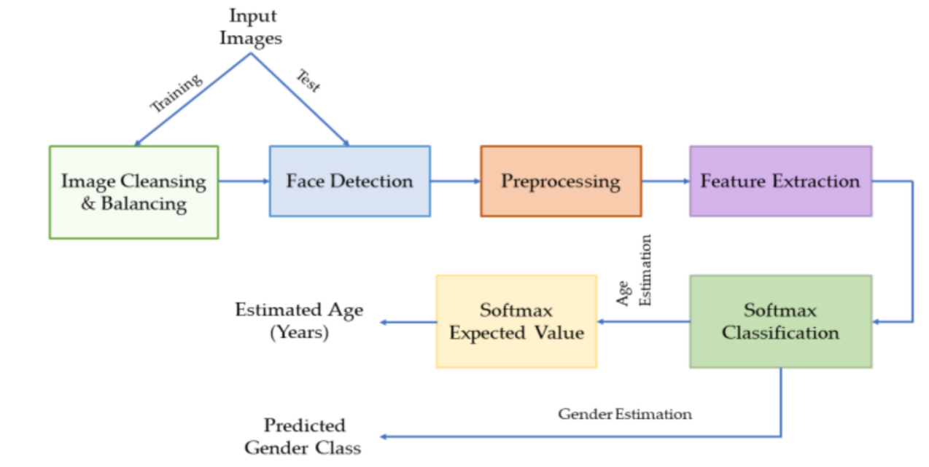
1. Overall System Workflow
The workflow begins with collecting and preprocessing facial images, followed by training a CNN model. The trained model is then used to predict gender and age for new input images. Each stage plays a critical role in ensuring the accuracy and robustness of the system.
2. Data Collection and Dataset Selection
The first step involves selecting a suitable dataset that contains labeled facial images with corresponding gender and age information. Popular datasets such as UTKFace and Adience are commonly used due to their diversity and real-world variations. These datasets include images with different ages, genders, ethnicities, lighting conditions, and facial expressions, which help the model generalize effectively.
Key dataset characteristics:
- Large number of labeled facial images
- Diversity in age groups and gender distribution
- Variations in pose, lighting, and background
- Real-world conditions for better generalization
A well-balanced dataset is essential to avoid bias and improve model performance.

3. Data Preprocessing
Before feeding the data into the model, preprocessing is performed to ensure consistency and improve learning efficiency. Since deep learning models are sensitive to input format, all images must be standardized.
Key preprocessing steps include:
- Face Detection: Using OpenCV to detect and crop facial regions
- Resizing: Converting images to a fixed size (e.g., 64×64 or 128×128 pixels)
- Normalization: Scaling pixel values (e.g., between 0 and 1)
- Data Augmentation: Applying transformations such as rotation, flipping, and zooming
These steps help improve model robustness and prevent overfitting.

4. Model Architecture Design

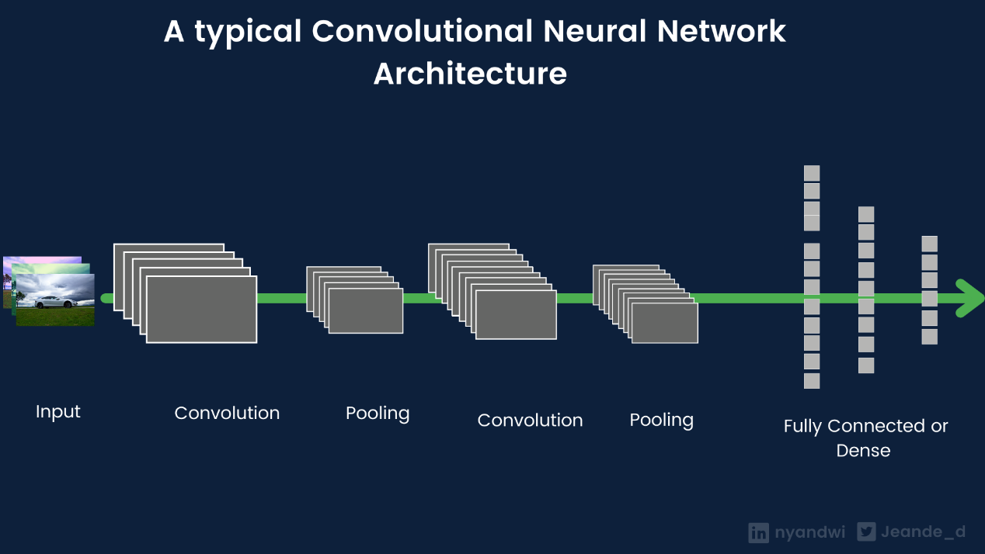
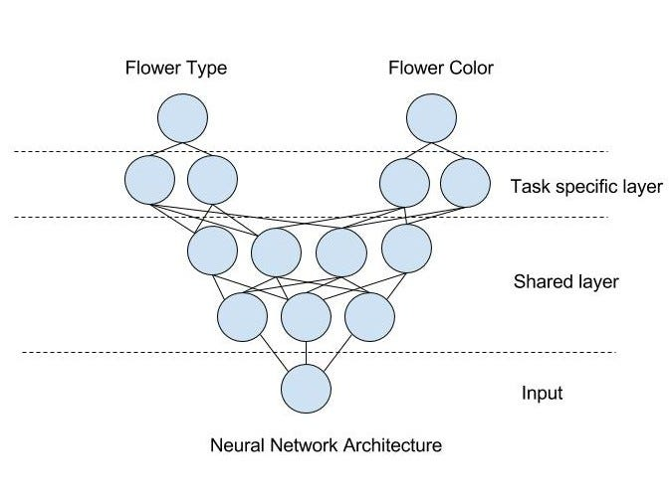
The core of the system is a convolutional neural network (CNN) designed to extract features from facial images. The architecture typically consists of multiple convolutional layers followed by pooling layers and fully connected layers. The model uses a multi-task learning approach, where shared layers extract features, and separate output layers handle gender and age prediction.
Model components:
- Convolutional Layers: Extract spatial features (edges, textures, patterns)
- Pooling Layers: Reduce dimensionality and computational cost
- Fully Connected Layers: Learn high-level representations
- Output Layers:
  - Gender → Binary classification (male/female)
  - Age → Regression or multi-class classification
This design allows the model to efficiently learn both tasks simultaneously.

5. Model Training
The model is trained using the preprocessed dataset, where it learns to map input images to corresponding gender and age labels. The dataset is divided into training, validation, and testing sets to ensure proper evaluation and avoid overfitting.
Key training components:
- Loss Functions:
  - Binary Cross-Entropy for gender classification
  - Mean Squared Error (MSE) or Categorical Cross-Entropy for age
- Optimizer: Adam optimizer for efficient gradient descent
- Batch Size & Epochs: Tuned based on dataset size and performance
- Regularization: Dropout layers to prevent overfitting
During training, the model updates its weights through backpropagation to minimize prediction error.

6. Model Evaluation

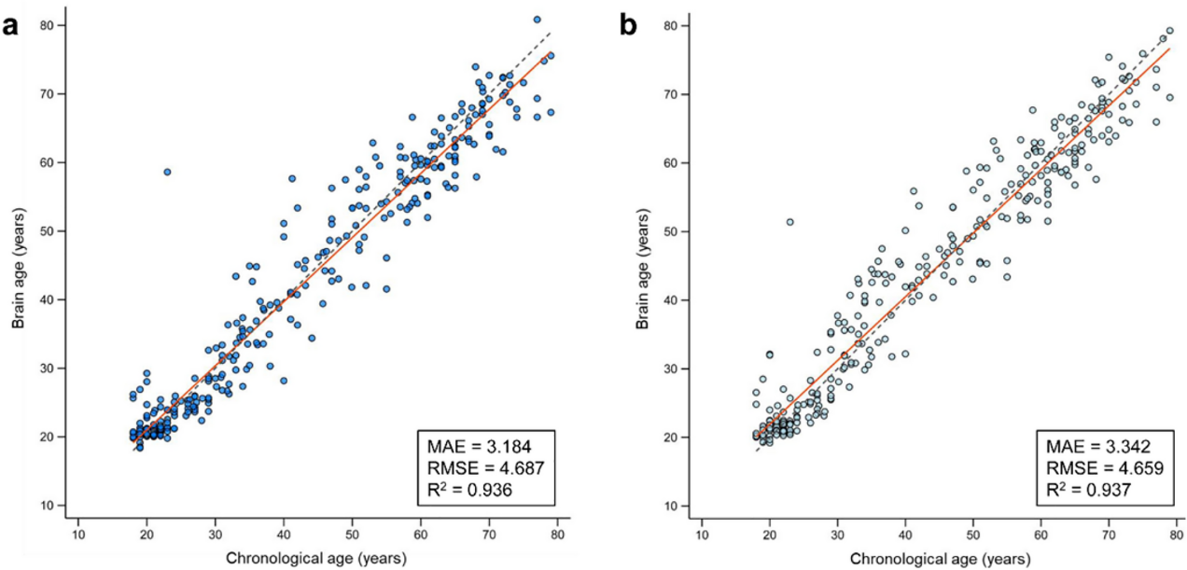
After training, the model is evaluated using the test dataset to measure its performance. Different metrics are used for gender and age prediction:
- Gender Prediction: Accuracy, Precision, Recall, F1-score
- Age Prediction: Mean Absolute Error (MAE), Mean Squared Error (MSE)
Visualization tools such as confusion matrices and training curves are used to analyze performance and identify potential improvements.

7. Prediction and Deployment
Once the model is trained and evaluated, it can be used for real-time predictions. Given a new facial image, the system performs preprocessing, extracts features using the CNN, and outputs predicted gender and age.
Steps involved:
- Input image capture
- Face detection and preprocessing
- Model inference
- Display predicted gender and age
The model can be integrated into applications such as surveillance systems, mobile apps, or web-based platforms.

8. Challenges and Optimization
Some challenges encountered in this project include:
- Variability in facial features due to age and ethnicity
- Lighting and image quality issues
- Imbalanced dataset distribution
- Difficulty in precise age prediction
To overcome these challenges, techniques such as data augmentation, transfer learning, and hyperparameter tuning can be applied.

9. Summary of Methodology
In summary, the methodology involves a complete pipeline starting from data collection and preprocessing to model training, evaluation, and deployment. By utilizing CNN-based deep learning techniques, the system effectively learns facial features and performs both gender classification and age prediction. The structured approach ensures high accuracy, scalability, and real-world applicability, making it a robust solution for facial analysis tasks.

IMPLEMENTATION

Output as expected is as follows

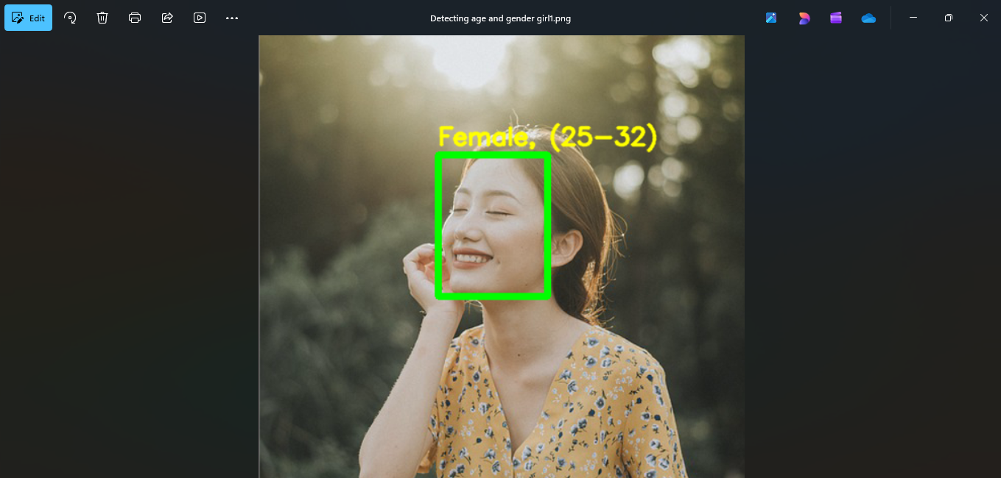

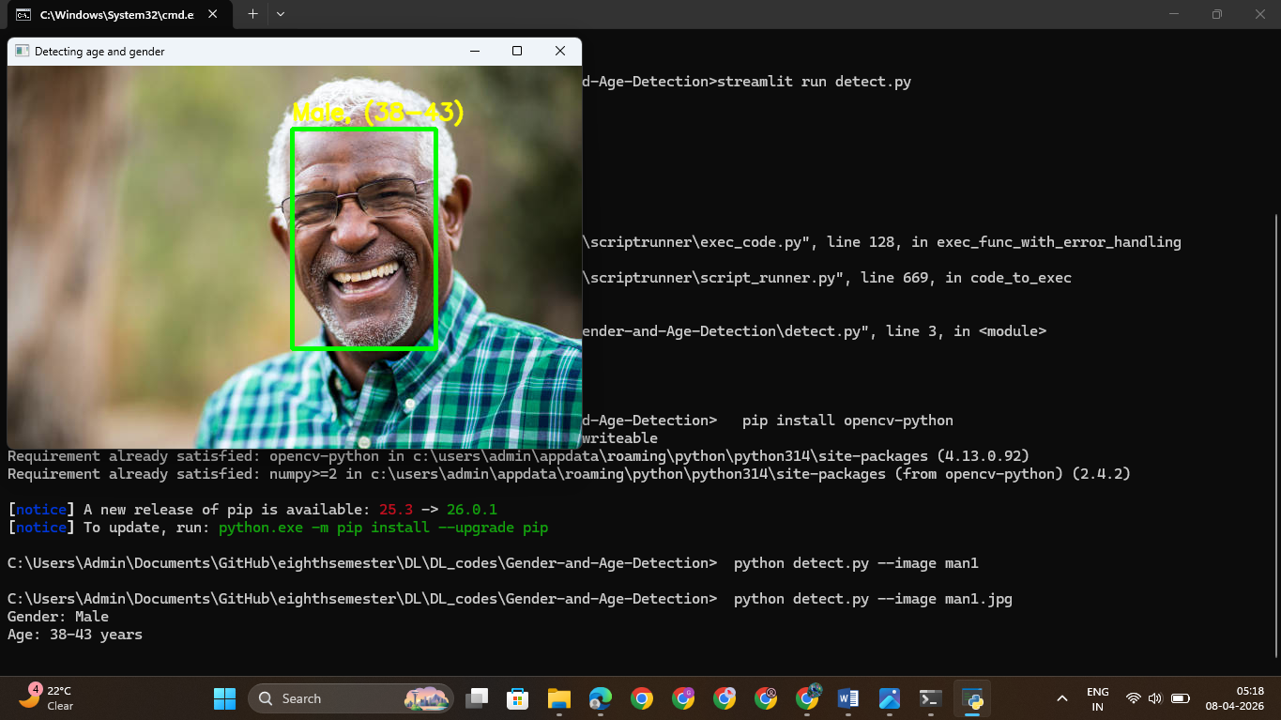

CONCLUSION

The successful implementation of the gender and age detection system demonstrates the effectiveness of deep learning techniques, particularly convolutional neural networks (CNNs), in solving complex computer vision problems. By leveraging the ability of CNNs to automatically extract hierarchical features from facial images, the model is able to accurately classify gender and estimate age with a high degree of reliability. This project highlights how deep learning eliminates the need for manual feature extraction and significantly improves performance compared to traditional machine learning approaches. Throughout the project, a structured methodology was followed, beginning with dataset selection and preprocessing, followed by model design, training, and evaluation. The use of diverse datasets ensured that the model could generalize well across different facial variations such as age groups, lighting conditions, and expressions. The multi-task learning approach, where both gender classification and age prediction are performed within a single model, proved to be efficient and effective, as it allowed shared feature learning and reduced computational redundancy.

REFERENCES

• UTKFace Dataset (Age, Gender, Ethnicity Dataset)
https://susanqq.github.io/UTKFace/
• Adience Dataset (Age and Gender Classification Benchmark)
https://talhassner.github.io/home/projects/Adience/Adience-data.html
• TensorFlow Official Documentation
https://www.tensorflow.org
• PyTorch Official Documentation
https://pytorch.org
• OpenCV Documentation
https://docs.opencv.org
• Deep Learning Book – Ian Goodfellow, Yoshua Bengio, Aaron Courville
https://www.deeplearningbook.org
• CNN Architecture Explanation
https://www.geeksforgeeks.org/convolutional-neural-network-cnn/
• Facial Analysis using Deep Learning (Research Overview)
https://ieeexplore.ieee.org/document/age-gender-detection

