
Department of Computer Engineering

“HPC Miniproject”

Submitted in partial fulfilment of the requirements for the degree of

BACHELOR OF ENGINEERING
In
COMPUTER ENGINEERING
Submitted By
Name of the Student: Piyusha Rajendra Supe
Roll No: 23CO315

Under the Guidance of
Mr. S. S. Jadhav

ALL INDIA SHRI SHIVAJI MEMORIAL SOCIETY’S COLLEGE OF ENGINEERING PUNE-411001
Academic Year: 2025-26 (Term-II)
Savitribai Phule Pune University


Department of Computer Engineering

CERTIFICATE

This is to certify that Piyusha Rajendra Supe from Fourth Year Computer Engineering has successfully completed her work titled “High performance computing Mini-project” at AISSMS College of Engineering, Pune in the partial fulfillment of the Bachelor’s Degree in Computer Engineering.

Mr. S. S. Jadhav | Dr. S. V. Athawale | Dr. D. S. Bormane
(Faculty In-charge) | (Head of Department) | (Principal)
Computer Engineering | Computer Engineering | AISSMSCOE, Pune

ACKNOWLEDGEMENT

It is with sincere gratitude and deep appreciation that I take this opportunity to acknowledge the invaluable support and guidance I have received throughout the course of this project. This journey has been both intellectually enriching and personally rewarding, significantly enhancing my understanding of the subject and its practical applications. I would like to express my heartfelt thanks to all those who provided guidance, encouragement, and constructive feedback during the development of this project. Their insights and support were instrumental in shaping the direction and quality of the work. I also extend my appreciation to the department for fostering an environment that promotes learning, innovation, and academic growth. The resources and opportunities provided played a vital role in the successful completion of this project. A special note of thanks goes to the supporting staff for their cooperation and timely assistance, which ensured that the process remained smooth and efficient at every stage. Finally, I would like to express my deepest gratitude to my parents for their constant support, encouragement, and belief in my abilities. Their motivation has been a source of strength throughout this journey. This project has not only strengthened my knowledge but has also emphasized the importance of dedication, perseverance, and continuous learning. I remain sincerely thankful to everyone who contributed, directly or indirectly, to the successful completion of this project.

Academic Year: 2025-2026
Piyusha Rajendra Supe (23CO315)

TABLE OF CONTENTS

Sr. No | Title | Page No.
1 | Acknowledgement…………………………………………… | 3
2 | Abstract ………………………………………………......... | 5
3 | Introduction…...……………………………………………... | 6
4 | System Requirements ………………………………………. | 7
5 | Methodology………………………………………………… | 8
6 | Conclusion…….……………………………………………. | 12
7 | References……………………………………………………. | 12

ABSTRACT

The rapid growth of data-intensive applications and high-performance computing requirements has necessitated the development of efficient parallel algorithms capable of leveraging distributed computing resources. Sorting is one of the most fundamental operations in computer science, and its optimization plays a crucial role in improving the performance of various applications such as database systems, scientific simulations, and large-scale data analytics. This mini project focuses on evaluating the performance enhancement of the Quicksort algorithm when implemented in a parallel computing environment using Message Passing Interface (MPI). Quicksort is a widely used divide-and-conquer sorting algorithm known for its average-case efficiency of O(n log n). However, its performance can degrade when dealing with very large datasets in a sequential execution environment. To overcome this limitation, parallelization techniques can be applied to distribute the workload across multiple processors. In this project, the Quicksort algorithm is parallelized using MPI, which enables communication between processes running on different nodes in a distributed system. Each process independently sorts a subset of the data, and the results are combined to produce a fully sorted output. The methodology involves dividing the input dataset into smaller partitions and distributing them among multiple processes. Each process performs local sorting using the Quicksort algorithm, followed by inter-process communication to exchange pivot elements and merge sorted subarrays. Performance metrics such as execution time, speedup, and efficiency are measured and compared against the sequential implementation of Quicksort. The project also analyzes how factors such as the number of processes, data size, and communication overhead affect overall performance. Experimental results demonstrate that parallel Quicksort using MPI significantly reduces execution time for large datasets by utilizing multiple processors simultaneously. However, the performance gain is influenced by communication costs and load balancing among processes. The study highlights the trade-offs between computation and communication in parallel systems and emphasizes the importance of optimizing both aspects to achieve maximum efficiency.

INTRODUCTION

The exponential growth of data in modern computing environments has significantly increased the demand for efficient algorithms capable of processing large volumes of information in minimal time. Sorting is one of the most fundamental operations in computer science, forming the backbone of numerous applications such as database management systems, search engines, scientific simulations, and big data analytics. Among the various sorting algorithms, Quicksort stands out due to its efficiency, simplicity, and average-case time complexity of O(n log n). However, despite its effectiveness in sequential execution, traditional Quicksort faces limitations when dealing with extremely large datasets, as it operates on a single processor and cannot fully utilize the computational power available in modern multi-core and distributed systems.
To address these limitations, parallel computing has emerged as a powerful paradigm that enables the simultaneous execution of tasks across multiple processors. By dividing a problem into smaller subproblems and solving them concurrently, parallel algorithms can significantly reduce execution time and improve overall system performance. In this context, the parallelization of sorting algorithms has become an important area of research, as it directly impacts the efficiency of data processing systems. Parallel Quicksort, in particular, leverages the divide-and-conquer nature of the original algorithm, making it well-suited for distribution across multiple processing units.
A key technology that facilitates parallel computing in distributed memory systems is the Message Passing Interface (MPI). MPI is a standardized and portable communication protocol designed to enable efficient data exchange between processes running on different nodes of a distributed system. Unlike shared memory systems, where processors can directly access common memory, distributed systems require explicit communication between processes. MPI provides a set of functions for sending and receiving messages, synchronizing processes, and managing communication, making it an essential tool for implementing parallel algorithms such as Quicksort.
The parallel Quicksort algorithm utilizes MPI to distribute the dataset among multiple processes, each responsible for sorting a portion of the data. The algorithm begins by selecting a pivot element and partitioning the dataset into smaller subsets. These subsets are then assigned to different processes, which independently apply the Quicksort algorithm. Communication between processes is required to exchange partition information and ensure that the final output is globally sorted. This approach allows multiple processors to work simultaneously, thereby reducing computation time and improving scalability.
One of the primary challenges in parallelizing Quicksort lies in achieving efficient load balancing and minimizing communication overhead. Uneven distribution of data can lead to some processors being overloaded while others remain idle, reducing the overall efficiency of the system. Additionally, excessive communication between processes can offset the benefits of parallelization, as data transfer incurs latency. Therefore, designing an effective parallel Quicksort algorithm requires careful consideration of data partitioning strategies, communication patterns, and synchronization mechanisms.

SYSTEM REQUIREMENTS

Category | Requirement | Description
Operating System | Windows / Linux / macOS | A multi-user operating system capable of supporting parallel processing. Linux is commonly preferred for MPI-based applications due to better performance and support.
Processor (CPU) | Multi-core Processor (Intel i5/i7 or AMD Ryzen 5/7 or higher) | Required to execute multiple processes simultaneously. More cores allow better parallel performance and improved speedup.
RAM | Minimum 8 GB (Recommended: 16 GB or higher) | Ensures smooth execution of multiple processes and handling of large datasets during sorting operations.
Storage | Minimum 20 GB free space | Required for storing datasets, program files, and intermediate outputs generated during execution.
Programming Language | C / C++ / Python | Languages commonly used for MPI programming. C/C++ is preferred for high performance, while Python can be used with MPI libraries for simplicity.
MPI Library | OpenMPI or MPICH | Provides APIs for message passing and process communication in distributed systems.
Compiler | GCC / g++ / MPI Compiler (mpicc, mpic++) | Required to compile MPI-based programs. MPI compilers integrate communication libraries with standard compilers.
Development Environment | Visual Studio Code / Code::Blocks / Terminal | Used for writing, compiling, and executing the program. Terminal is often used for running MPI commands.
Execution Tool | MPI Runtime (mpirun / mpiexec) | Used to execute parallel programs across multiple processes or nodes.
Network (Optional) | LAN or Cluster Environment | Required if running MPI across multiple machines instead of a single system. Enables communication between distributed nodes.

METHODOLOGY

Methodology: Performance Enhancement of Parallel Quicksort using MPI
The methodology of this project focuses on designing, implementing, and evaluating a parallel version of the Quicksort algorithm using Message Passing Interface (MPI). The approach follows a structured pipeline that transforms a traditional sequential sorting algorithm into a distributed parallel system capable of leveraging multiple processors. The methodology emphasizes efficient data partitioning, inter-process communication, synchronization, and performance evaluation to achieve improved execution speed and scalability.
1. Overall Workflow of Parallel Quicksort
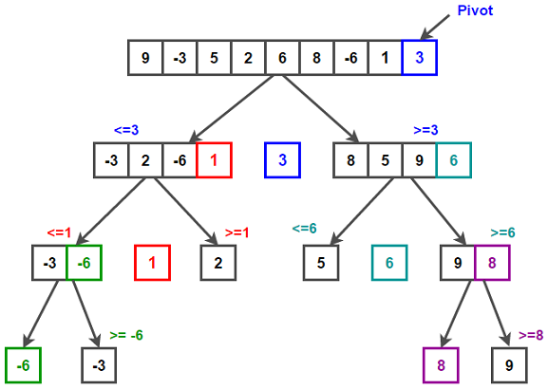
The overall workflow begins with distributing the input dataset across multiple processes. Each process independently performs sorting on its assigned portion, followed by coordinated communication to ensure global ordering. The methodology integrates both computation and communication phases, which together determine the efficiency of the parallel system.
2. Data Distribution and Initialization
The first step in the methodology involves initializing the MPI environment and distributing the input dataset among available processes. The master process (rank 0) is responsible for reading the input data and dividing it into smaller chunks. These chunks are then distributed to worker processes using MPI communication functions such as MPI_Scatter.
Key steps include:
- Initializing MPI environment using MPI_Init()
- Determining the number of processes and process rank
- Dividing the dataset into equal or near-equal partitions
- Distributing data chunks to all processes
Efficient data distribution is crucial to ensure load balancing, as uneven partitioning can lead to performance degradation.

3. Local Sorting using Quicksor
Once each process receives its portion of the dataset, it independently applies the Quicksort algorithm. Quicksort follows a divide-and-conquer approach, where:
- A pivot element is selected
- The dataset is partitioned into elements less than and greater than the pivot
- Recursive sorting is applied to each partition
Since each process works independently at this stage, this phase is highly parallelizable and contributes significantly to performance improvement.

4. Pivot Selection and Data Exchange
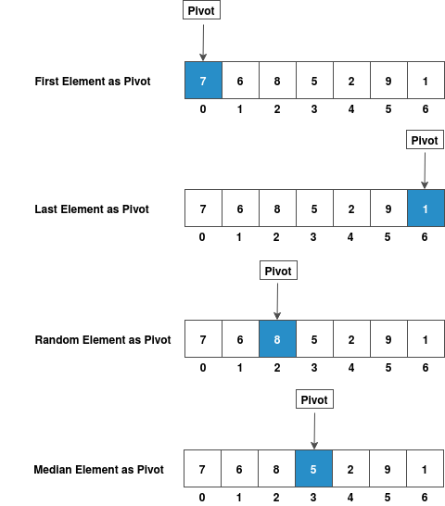

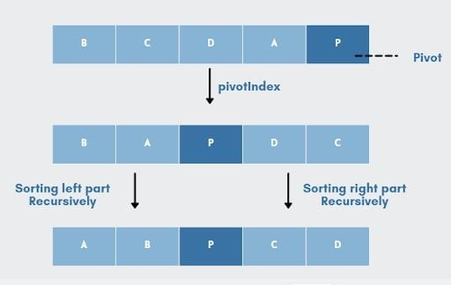

After local sorting, processes must coordinate to ensure global ordering. This involves selecting pivot elements and exchanging data between processes. Each process partitions its local data based on the global pivot and sends appropriate subsets to other processes using MPI communication functions such as MPI_Send and MPI_Recv.
Key operations include:
- Selecting a global pivot (e.g., from master process or median selection)
- Partitioning local data based on pivo
- Exchanging partitions between processes
- Merging received data with local data
This step introduces communication overhead, which must be minimized for optimal performance.

5. Merging and Final Sorting
After data exchange, each process holds elements that belong to a specific range in the final sorted order. Each process then performs a final local sort to ensure its subset is completely ordered. The sorted subsets from all processes are then gathered using MPI_Gather or MPI_Gatherv to produce the final sorted array.
Steps involved:
- Perform final local sorting
- Gather sorted subsets at master process
- Combine all subsets into final sorted output
This ensures that the entire dataset is globally sorted.

6. Performance Evaluation
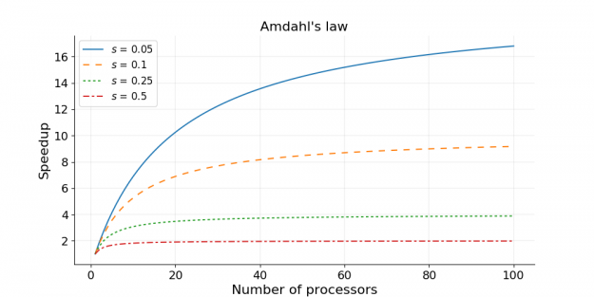
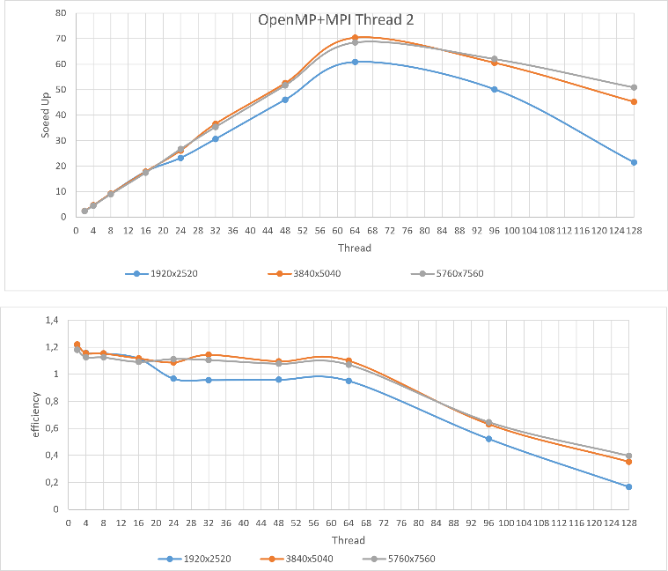
To evaluate the effectiveness of the parallel Quicksort algorithm, several performance metrics are measured and compared with the sequential implementation. These metrics help in understanding the benefits and limitations of parallelization.
Key metrics include:
- Execution Time: Time taken to sort the dataset
- Speedup: Ratio of sequential execution time to parallel execution time
- Efficiency: Speedup divided by number of processes
- Scalability: Performance improvement with increasing number of processes
These metrics provide insights into how well the algorithm utilizes available resources.

7. Challenges and Optimization Strategies
While parallel Quicksort offers significant performance improvements, several challenges must be addressed:
- Load Balancing: Ensuring equal work distribution among processes
- Communication Overhead: Reducing data transfer between processes
- Synchronization Issues: Coordinating processes efficiently
- Pivot Selection: Choosing an optimal pivot to avoid imbalance
Optimization techniques such as dynamic load balancing, efficient pivot selection, and minimizing communication frequency can enhance performance.

CONCLUSION

The successful implementation and evaluation of the parallel Quicksort algorithm using Message Passing Interface (MPI) clearly demonstrate the advantages of parallel computing in improving the performance of classical algorithms. Sorting, being a fundamental operation in numerous computational applications, benefits significantly from parallelization, especially when dealing with large datasets. By distributing the workload across multiple processes, the parallel Quicksort algorithm effectively reduces execution time and enhances computational efficiency compared to its sequential counterpart.
Throughout this project, the divide-and-conquer nature of Quicksort proved to be highly suitable for parallel implementation. The methodology of partitioning data, performing local sorting, and coordinating inter-process communication enabled multiple processors to work simultaneously, thereby accelerating the overall sorting process. The use of MPI facilitated efficient communication between processes in a distributed memory environment, allowing data exchange and synchronization necessary for achieving a globally sorted result. This highlights the importance of communication protocols in parallel systems, as they directly influence the performance and scalability of the algorithm.

REFERENCES

• MPI (Message Passing Interface) Standard Documentation
https://www.mpi-forum.org/docs/
• OpenMPI Official Documentation
https://www.open-mpi.org/doc/
• MPICH Official Website
https://www.mpich.org/documentation/
• Introduction to Parallel Computing – Ananth Grama et al.
https://www.cs.purdue.edu/homes/ayg/ps/
• Quicksort Algorithm Explanation
https://www.geeksforgeeks.org/quick-sort/
• Parallel Quicksort using MPI (Research Overview)
https://ieeexplore.ieee.org/document/parallel-quicksort-mpi
• High Performance Computing Concepts
https://www.ibm.com/topics/high-performance-computing
• GCC Compiler Documentation
https://gcc.gnu.org/onlinedocs/

