**Retrofit**

Retrofit is a type-safe HTTP client for Android and Java developed by Square. It makes it easy to consume RESTful APIs in your Android application.

Step:-1

Add dependencies for retrofit you can get these from official website and then add gson converter dependency as well

In my app I added coroutines and lifecycler dependencies as well

Because whenever you make database request either it is from local db or from API always use coroutines.

I added these

// Retrofit

implementation 'com.squareup.retrofit2:retrofit:2.9.0'

implementation 'com.squareup.retrofit2:converter-gson:2.9.0'

implementation "com.squareup.okhttp3:okhttp:4.9.0"

// Coroutines

implementation 'org.jetbrains.kotlinx:kotlinx-coroutines-core:1.4.2'

implementation 'org.jetbrains.kotlinx:kotlinx-coroutines-android:1.4.1'

// Coroutine Lifecycle Scopes

implementation "androidx.lifecycle:lifecycle-viewmodel-ktx:2.2.0"

implementation "androidx.lifecycle:lifecycle-runtime-ktx:2.2.0"

For this project we are using

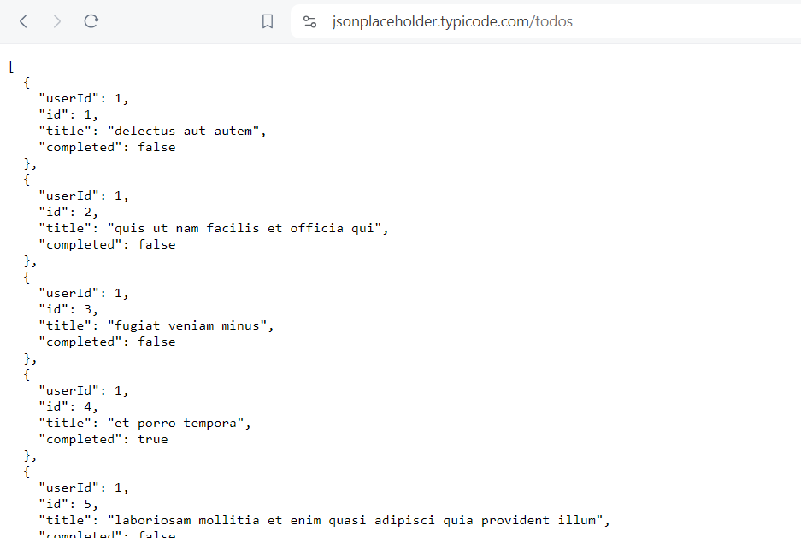

This API so in the URL

Base URL :- <https://jsonplaceholder.typicode.com/>

Url to put in get request:- /todos

Step :2

Insert internet permission in manifest

Step :3

For using API first we make one interface and inside that api we write all the functions for the api whether for getting data or setting data.

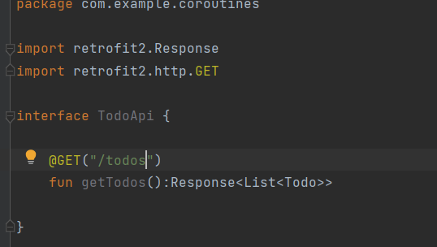

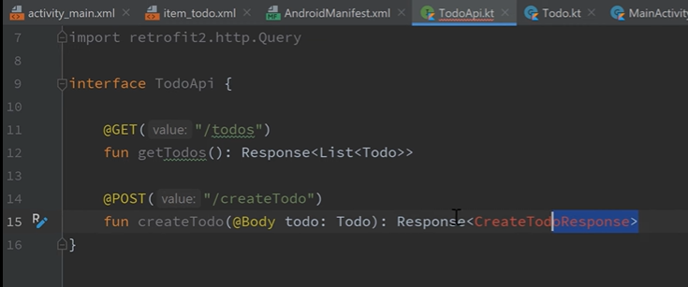

You can even post put delete the data to post it you use something like this

So this is a network call so always do that asynchronously so I am gonna use suspend keyword

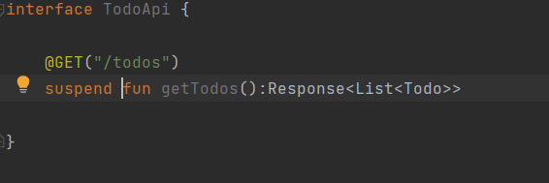

Now we need to create custom retrofit object that will create real api for us and get all the data

So for that we need to create new object or singleton

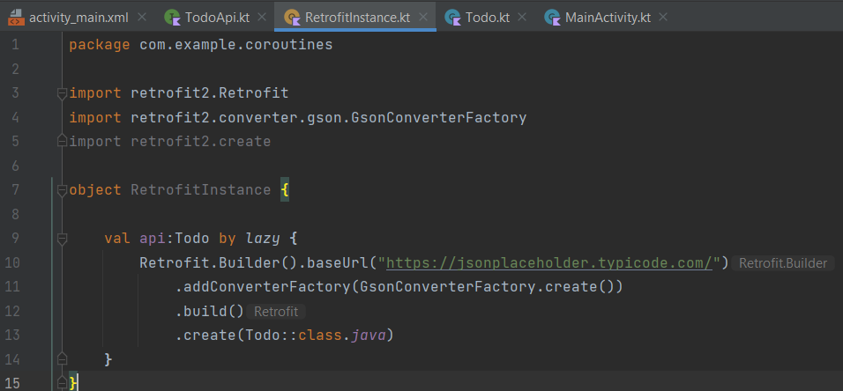

This line means

Val api is a variable of Todo class which is initialized by lazy

Lazy means we don’t have to initialize the variable right away we can do it when we use it for the first time.

Then addConverterFactory as Gson converter is to convert response in json type

After that make recuyclerview in main activity

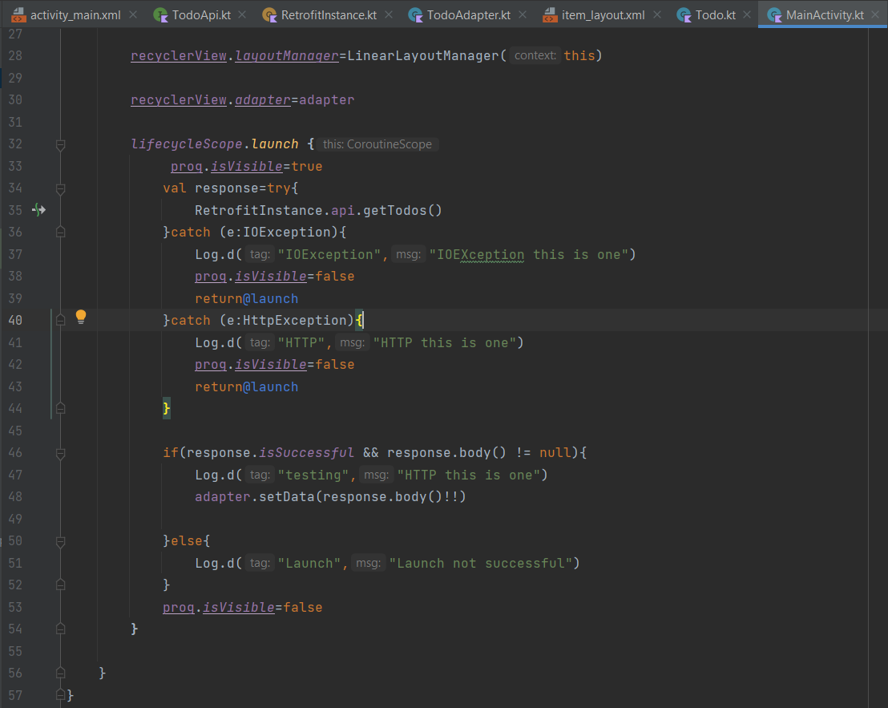

Make sure to add retrofit in coroutine so that to go everything in background

Header in retrofit



Static header

