Course Name: | Natural Language Processing | Semester: | VII
Date of Performance: | ___ / ___ / ______ | DIV/ Batch No: | A
Student Name: | Piyush Chaudhary | Roll No: | 16010123234

Experiment No: 3

Title: Implementation and Evaluation of N-Gram Language Models

Aim: To implement N-Gram language models and evaluate their performance using perplexity and smoothing techniques for predicting word sequences.

Objectives of the Experiment:
By the end of this experiment, students will be able to:

- Understand the concept of statistical language modeling.
- Construct Unigram, Bigram, and Trigram language models from a text corpus.
- Estimate sentence probabilities using N-Gram models.
- Evaluate language models using perplexity.
- Apply smoothing techniques to handle unseen word sequences.
- Compare the performance of different N-Gram language models.

COs to be achieved:
CO2: Apply language modeling and part-of-speech tagging, and analyze syntactic parsing techniques to extract sentence structures for text analysis and understanding.

Books/ Journals/ Websites referred:
Students should write

Theory:
A Language Model (LM) is a probabilistic model that predicts the likelihood of occurrence of words in a sequence. It estimates the probability of a sentence by learning patterns from a large text corpus.
Language models are widely used in Natural Language Processing applications such as machine translation, speech recognition, text generation, autocomplete, spell checking, and predictive text input.
For a sentence consisting of words
$W=(w1,w2,…,wn)$
the probability of the complete sentence is
$P(W)=P(w1)P(w2∣w1)P(w3∣w1,w2)⋯P(wn∣w1,…,wn-1)$
Estimating these probabilities directly is computationally expensive because they depend on the entire history of previous words. N-Gram models simplify this problem using the Markov assumption.

N-Gram Language Models
An N-Gram is a contiguous sequence of N words occurring together in a text.
Depending on the value of N, language models are classified as:

1. Unigram Model (N = 1)
Assumes that each word is independent of previous words.
$P(wi)$
Example
Sentence: Natural Language Processing is interesting.
Unigrams:
Natural
Language
Processing
is
interesting

2. Bigram Model (N = 2)
Assumes that each word depends only on the immediately preceding word.
$P(wi∣wi-1)$
Example: I like NLP
Bigrams
I like
like NLP

3. Trigram Model (N = 3)
Assumes that each word depends on the previous two words.
$P(wi∣wi-2,wi-1)$
Example
Sentence
I like Natural Language Processing
Trigrams
I like Natural
like Natural Language
Natural Language Processing
Increasing the value of N captures more contextual information but requires significantly larger training data.

Perplexity
Perplexity is one of the most widely used evaluation metrics for language models. It measures how well a language model predicts unseen text.
A lower perplexity value indicates a better-performing language model.
Mathematically,
$Perplexity(W) = P(W)^(1/N)$
where
- P(W) = Probability of the sentence
- N = Number of words
Lower perplexity indicates that the model assigns higher probability to the observed text.

Smoothing Techniques
During testing, a language model may encounter N-Grams that were never seen during training. Such unseen N-Grams receive zero probability, causing the probability of the entire sentence to become zero.
Smoothing techniques overcome this problem by assigning a small non-zero probability to unseen events.
One commonly used technique is: Laplace (Add-One) Smoothing.
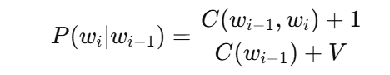
Every N-Gram count is increased by one before probability estimation.
Applications: Predictive Text Input, Auto-completion Systems, Spell Checking, Speech Recognition, Machine Translation, Optical Character Recognition (OCR), Text Generation, Information Retrieval & Grammar Checking

Problem statement/ Tasks:
Students are required to perform the following tasks:
- Import the required Python libraries.
- Load a text corpus or sample dataset.
- Perform basic text preprocessing.
- Generate Unigram, Bigram, and Trigram models.
- Calculate the frequency of generated N-Grams.
- Compute sentence probabilities using different N-Gram models.
- Evaluate the language models using perplexity.
- Apply Laplace (Add-One) smoothing to handle unseen N-Grams.
- Compare the performance of Unigram, Bigram, and Trigram models.

Expected Output: Input corpus, Generated Unigrams, Generated Bigrams, Generated Trigrams, Frequency table of N-Grams, Sentence probability, Perplexity value, Output before and after smoothing & Comparison of Unigram, Bigram, and Trigram models.

Code :
Google Colab

Output:
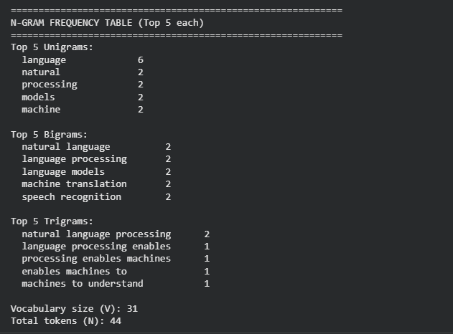
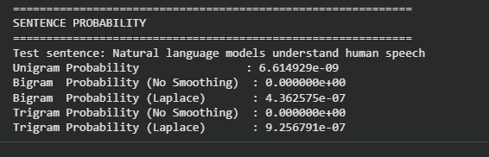
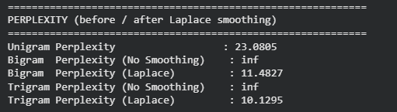
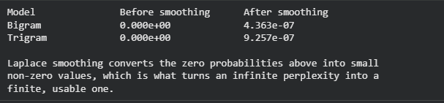
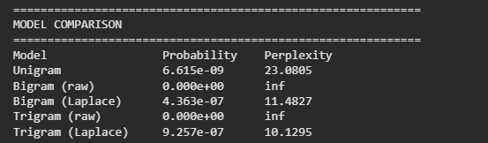

Post Lab Subjective/Objective type Questions:
- Compare statistical N-Gram language models with neural language models based on context representation, memory requirements, and performance.
Answer: Statistical N-Gram models estimate word probabilities from fixed-size local context (the previous N-1 words) using frequency counts from a training corpus. They are simple, fast to train, and easy to interpret, but suffer badly from data sparsity: as N grows, most N-Grams are never seen in a finite corpus, and their memory requirement grows exponentially with vocabulary size and N because every distinct N-Gram must be stored explicitly. Neural language models (RNNs, LSTMs, Transformers) instead represent words as dense embeddings and use hidden states or attention to capture much longer and more flexible context without needing to store every possible word combination, so they generalize far better to unseen phrasing. This comes at the cost of much higher computational and memory requirements for training, and lower interpretability. In terms of raw performance (perplexity, fluency, long-range coherence), neural models -- especially Transformer-based ones -- clearly outperform N-Gram models, but N-Gram models remain attractive for lightweight, low-resource, or real-time settings where training data or compute is limited.

- How does increasing the value of N affect the complexity and performance of a language model?
Answer: Increasing N lets the model condition on a longer history of preceding words, which improves its ability to capture grammatical structure and long-range word dependencies and can reduce perplexity when enough training data is available. However, it also causes the number of possible N-Gram combinations to grow very quickly, most of which never appear in a limited training corpus -- the data sparsity problem observed in this experiment, where the raw (unsmoothed) Bigram and Trigram probabilities for the test sentence were exactly zero because some required N-Grams were unseen. Higher N also increases memory usage and computation time since more distinct N-Grams must be counted and stored. Consequently, without smoothing, larger N models become increasingly unreliable, and in practice a small N (2 or 3) combined with a smoothing technique gives the best trade-off between context length and reliable probability estimation for small corpora.

Conclusion:
Unigram, Bigram, and Trigram language models were built from a small sample corpus. The raw (unsmoothed) Bigram and Trigram models assigned zero probability to the test sentence because it contained word sequences unseen during training -- the classic data-sparsity problem. Laplace (Add-One) smoothing fixed this by assigning small non-zero probabilities to unseen N-Grams, turning infinite perplexity into finite, comparable values. The smoothed Trigram model achieved the lowest perplexity, showing that more context improves prediction quality once sparsity is handled.

