Course Name: | Natural Language Processing | Semester: | VII
Date of Performance: | ___ / ___ / ______ | DIV/ Batch No:
Student Name: | Piyush Chaudhary | Roll No: | 16010123234

Experiment No: 6

Title: Implementation and Performance Analysis of Text Classification using Recurrent
Neural Networks (RNN) and Long Short-Term Memory (LSTM)

Aim: To implement Recurrent Neural Network (RNN) and Long Short-Term Memory (LSTM) models for text classification and analyze their performance on a Natural Language Processing dataset.

Objectives of the Experiment:
By the end of this experiment, students will be able to:
- Understand sequence modeling for Natural Language Processing.
- Implement a Recurrent Neural Network (RNN) for text classification.
- Implement a Long Short-Term Memory (LSTM) network for text classification.
- Learn how word embeddings are used as inputs to sequential neural networks.
- Train and evaluate RNN and LSTM models using appropriate performance metrics.
- Compare the performance of RNN and LSTM for text classification.
- Analyze the limitations of vanilla RNNs and the advantages of LSTM.

COs to be achieved:
CO4: Understand and apply neural language models, including RNNs, LSTMs, and attention mechanisms, for various sequence-based NLP tasks

Books/ Journals/ Websites referred:
Students should write

Theory:
- Introduction to Text Classification:
Text classification is one of the most fundamental tasks in Natural Language Processing (NLP), where the objective is to automatically assign one or more predefined categories or labels to a given text document. It enables computers to organize, filter, and analyze large volumes of textual information efficiently. Given an input text, a text classification model learns patterns from labeled training data and predicts the most appropriate class for unseen documents. The general workflow of a text classification system is shown below.
Input Text -> Text Preprocessing -> Tokenization & Padding -> Word Embedding ->
Classification Model (RNN / LSTM) -> Predicted Class

Example:

Input Text | Predicted Class
“This movie was fantastic and inspiring.” | Positive
“The product quality is very poor.” | Negative
“Congratulations! You have won ₹10,000.” | Spam
“Let's schedule a meeting tomorrow.” | Ham (Not Spam)

Traditional machine learning techniques such as Naïve Bayes, Support Vector Machines, and Logistic Regression generally represent text using Bag of Words (BoW) or TF-IDF. Although these representations are effective for many tasks, they treat documents as collections of independent words and ignore the sequential nature of language.
Consider the following sentences:
Dog bites man
Man bites dog
Both sentences contain the same words but convey entirely different meanings due to the change in word order.
Similarly,
I do not like this movie.
I like this movie.
The presence of the word “not” completely changes the sentiment of the sentence. Frequency-based representations fail to capture such contextual and sequential dependencies.
To overcome these limitations, Recurrent Neural Networks (RNNs) process text as a sequence of words while maintaining a hidden state that carries information from previous time steps. This enables the model to capture contextual information and learn sequential dependencies.
However, RNNs struggle with long-term dependencies due to the vanishing gradient problem. Long Short-Term Memory (LSTM) networks address this limitation by introducing memory cells and gating mechanisms that selectively retain or discard information over long sequences.
Consequently, RNNs and LSTMs have become effective architectures for sequence modeling tasks such as text classification, language modeling, machine translation, speech recognition, and sentiment analysis.
- RNN – Recurrent Neural Network:

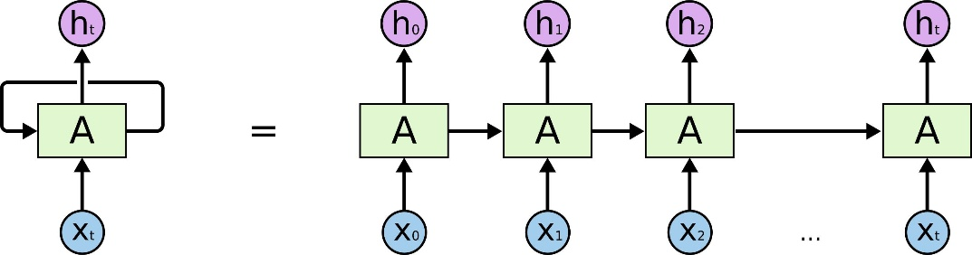
This figure illustrates:
- Input sequence $x1​,x2​,…,xT​$
- Hidden states $h1​,h2​,…,hT​$
- Output sequence $y1​,y2​,…,yT​$
- Recurrent connection carrying information from one-time step to the next.
A simple RNN processes one input token at a time while maintaining a hidden state that summarizes previous inputs. The hidden state is updated recursively, allowing the model to capture sequential dependencies in text. However, the information stored in the hidden state gradually diminishes over long sequences due to the vanishing gradient problem, making it difficult to learn long-term dependencies.
- LSTM – Long Short Term Memory:
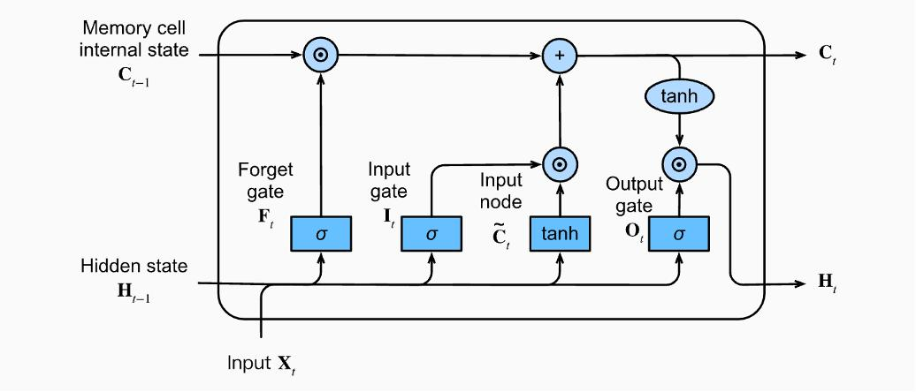
This figure shows the complete LSTM cell, including:
- $Forget Gate (ft​)$
- $Input Gate (it​)$
- $Candidate Cell State (Ct​\sim )$
- $Cell State (Ct​)$
- $Output Gate (ot​)$
- $Hidden State (ht​)$
Unlike a simple RNN, an LSTM maintains two states:
- Cell State ($Ct​$) – long-term memory
- Hidden State ($ht$​) – short-term output
The three gates regulate the flow of information:
- Forget Gate: Removes irrelevant information from the previous cell state.
- Input Gate: Determines what new information should be stored.
- Output Gate: Determines which information should be exposed as the hidden state.
This gated architecture enables LSTMs to preserve important information over long sequences and significantly reduces the vanishing gradient problem

Problem statement/ Tasks:
Students are required to perform the following tasks:

Dataset Selection
- Select a publicly available domain-specific text dataset from areas such as:
  - Healthcare
  - Medical Document Classification
  - Agriculture
  - Legal Documents
  - Financial News
  - Scientific Literature
  - Customer Support
  - Educational Content
- Split the dataset into training, validation, and testing sets.

Text Preprocessing
- Perform text cleaning and normalization.
- Convert text to lowercase.
- Tokenize the text into words.
- Remove stop words (if applicable).
- Perform lemmatization.
- Convert text into numerical sequences.
- Apply sequence padding to obtain uniform input lengths.

Word Embedding
- Generate word embeddings using one of the following approaches:
- Embedding Layer (trainable embeddings)
- Pre-trained Word2Vec embeddings (optional)
- TFIDF
- Prepare the embedding matrix for model training.

RNN Model Implementation
- Design and implement a Recurrent Neural Network (RNN) for text classification using PyTorch.
- Train the model using the prepared dataset.
- Evaluate the trained model on the test dataset.

LSTM Model Implementation
- Design and implement an LSTM-based text classification model.
- Train the model using the same dataset.
- Evaluate the trained model using identical evaluation metrics.

Performance Evaluation
- Evaluate both models using:
  - Accuracy
  - Precision
  - Recall
  - F1-score
  - Confusion Matrix
- Plot the training and validation loss curves.

Comparative Analysis
Compare the RNN and LSTM models based on:
- Classification accuracy
- Training convergence
- Computational complexity
- Ability to capture long-term dependencies
- Overall performance on the selected dataset

Expected Output: The program should display:
The program should display:
- Dataset Summary
  - Number of training, validation, and testing samples.
  - Number of classes.
  - Vocabulary size.
  - Maximum sequence length.
- Preprocessed Text Data
  - Tokenized text sequences.
  - Padded input sequences.
  - Word-to-index (vocabulary) mapping.
- Word Embedding Representation / TFIDF Matrix
  - Embedding matrix dimensions.
  - Sample word embedding vectors.
- Model Architectures
  - RNN model summary.
  - LSTM model summary.
- Training Performance
  - Training and validation loss curves.
  - Training and validation accuracy curves.
- Classification Performance
  - Accuracy
  - Precision
  - Recall
  - F1-score
  - Confusion Matrix
  - Classification Report
- Comparative Analysis
  - Comparative performance of the RNN and LSTM models based on classification accuracy, convergence, and overall effectiveness.

Dataset Details :

Code :
Colab

Output:
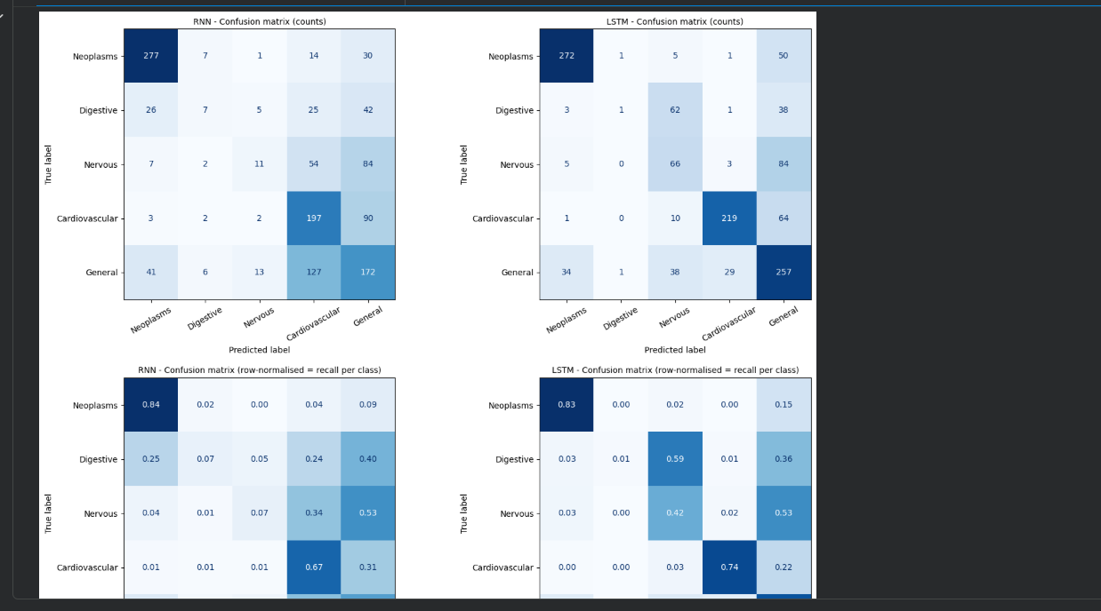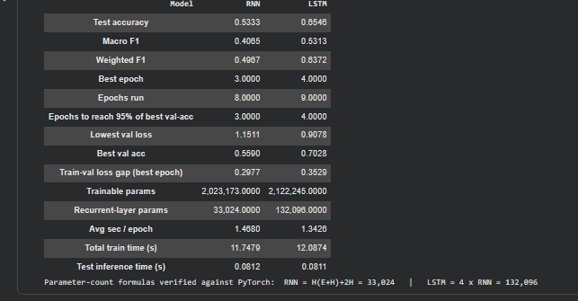
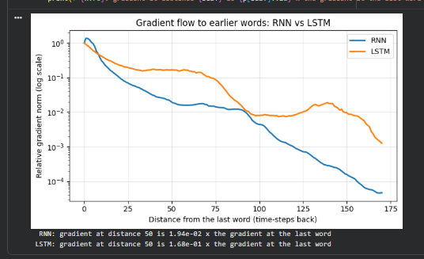>>> Training BiLSTM (2,254,981 trainable parameters) on cuda
Epoch | Train loss Train acc | Val loss Val acc | Time
1 | 1.4246 0.3841 | 1.1640 0.5912 | 4.1s *best*
2 | 0.9140 0.6610 | 0.8660 0.6594 | 6.3s *best*
3 | 0.6083 0.7627 | 0.7119 0.7261 | 2.6s *best*
4 | 0.3657 0.8648 | 0.7171 0.7590 | 2.0s
5 | 0.1919 0.9377 | 0.7228 0.7759 | 2.0s
6 | 0.0799 0.9785 | 0.7718 0.7855 | 2.4s
7 | 0.0371 0.9907 | 0.8280 0.7663 | 2.2s
8 | 0.0180 0.9959 | 0.9766 0.7751 | 2.0s
Early stopping: validation loss has not improved for 5 epochs.
Done in 23s - best epoch 3 (val loss 0.7119); best weights restored.
==========================================================================
Bi-LSTM model summary
==========================================================================
SeqClassifier(
(embedding): Embedding(15543, 128, padding_idx=0)
(rnn): LSTM(128, 128, batch_first=True, bidirectional=True)
(dropout): Dropout(p=0.3, inplace=False)
(fc): Linear(in_features=256, out_features=5, bias=True)
)

Parameter Shape # Params
------------------------------------------------------------
embedding.weight (15543, 128) 1,989,504
rnn.weight_ih_l0 (512, 128) 65,536
rnn.weight_hh_l0 (512, 128) 65,536
rnn.bias_ih_l0 (512,) 512
rnn.bias_hh_l0 (512,) 512
rnn.weight_ih_l0_reverse (512, 128) 65,536
rnn.weight_hh_l0_reverse (512, 128) 65,536
rnn.bias_ih_l0_reverse (512,) 512
rnn.bias_hh_l0_reverse (512,) 512
fc.weight (5, 256) 1,280
fc.bias (5,) 5
------------------------------------------------------------
Total trainable parameters 2,254,981

Data flow: (B,187) -> Embedding (B,187,128) -> LSTM (bi-directional) -> features (B,256) -> Linear (B,5)

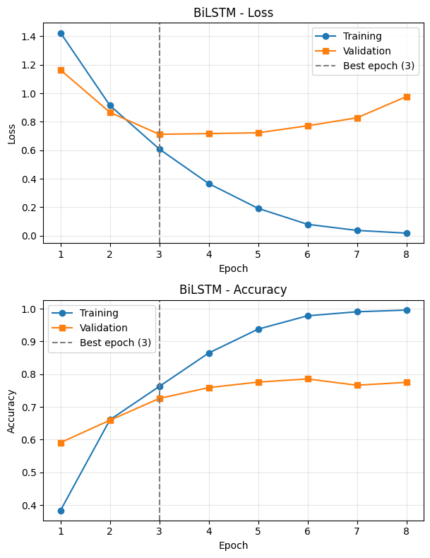
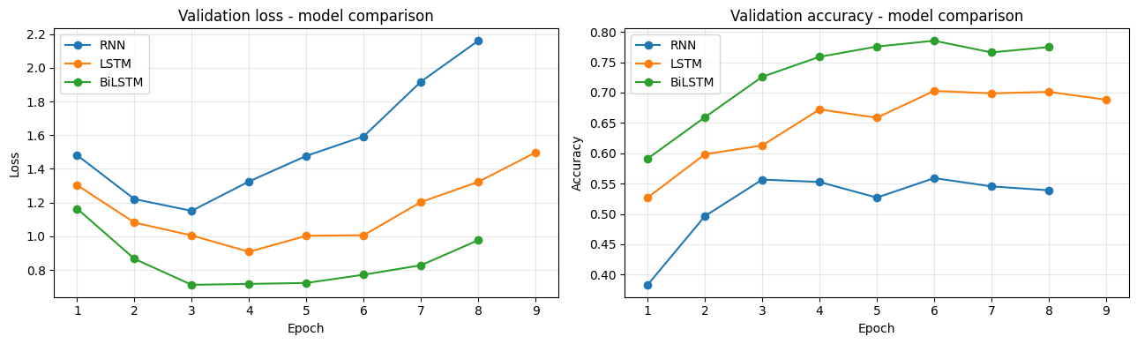
 | RNN | LSTM | BiLSTM
Accuracy | 0.5333 | 0.6546 | 0.7060
Precision (macro) | 0.4604 | 0.5897 | 0.6544
Recall (macro) | 0.4255 | 0.5430 | 0.6181
F1 (macro) | 0.4065 | 0.5313 | 0.6016
Precision (weighted) | 0.5052 | 0.6573 | 0.7196
Recall (weighted) | 0.5333 | 0.6546 | 0.7060
F1 (weighted) | 0.4967 | 0.6372 | 0.6938

 | RNN | LSTM | BiLSTM
Trainable params | 2,023,173 | 2,122,245 | 2,254,981
Avg sec / epoch | 1.5 | 1.3 | 2.9
Best epoch | 3 | 4 | 3
precision recall f1-score support

Neoplasms 0.9270 0.7720 0.8425 329
Digestive system diseases 0.3846 0.0476 0.0847 105
Nervous system diseases 0.4726 0.7089 0.5671 158
Cardiovascular diseases 0.8951 0.8129 0.8520 294
General pathological conditions 0.5925 0.7493 0.6617 359

accuracy 0.7060 1245
macro avg 0.6544 0.6181 0.6016 1245
weighted avg 0.7196 0.7060 0.6938 1245

Post Lab Questions:
- Explain the vanishing gradient problem in Recurrent Neural Networks (RNNs). Why does it affect the learning of long-term dependencies? Illustrate your answer with a suitable example.

The vanishing gradient problem occurs when gradients become very small during backpropagation through time (BPTT). As a result, the RNN cannot effectively update its weights and struggles to learn long-term dependencies.
Cause: During backpropagation, gradients are repeatedly multiplied by small values, causing them to decrease exponentially.
Example: In the sentence “The books that the student borrowed were interesting,” the RNN may fail to remember the subject “books” when predicting “were” because the words are far apart.
Solutions: LSTM, GRU, proper weight initialization, and suitable activation functions help reduce this problem.

- What is a Bidirectional Long Short-Term Memory (Bi-LSTM) network? Explain its architecture and discuss how it differs from a standard LSTM.

A Bidirectional LSTM is a neural network that processes a sequence in both forward and backward directions to capture information from past and future contexts.
Architecture:
- Forward LSTM processes the sequence from beginning to end.
- Backward LSTM processes the sequence from end to beginning.
- Their hidden states are combined and passed to an output layer for prediction.
Example: In the sentence “He sat on the bank of the river,” a Bi-LSTM uses both preceding and following words to understand the meaning of “bank.”
Difference between LSTM and Bi-LSTM:
- LSTM: Processes information in one direction.
- Bi-LSTM: Processes information in both directions.
- LSTM: Uses context available in its processing direction.
- Bi-LSTM: Uses both preceding and following context.
- LSTM: Requires less computation.
- Bi-LSTM: Requires more computation but can provide better results in tasks such as text classification and speech recognition.

Conclusion:
Thus, RNN, LSTM, and Bi-LSTM models were studied for text classification. LSTM handles long-term dependencies better than a standard RNN, while Bi-LSTM uses both forward and backward context to improve classification performance. In this experiment, Bi-LSTM achieved the highest accuracy of 70.60%, followed by LSTM at 65.46% and RNN at 53.33%.

