Course Name: | Natural Language Processing | Semester: | VII
Date of Performance: | ___ / ___ / ______ | DIV/ Batch No:
Student Name: | Piyush Chaudhary | Roll No: | 16010123234

Experiment No: 8

Title: Implementation of the Core Components of Transformer: Positional Encoding,
Self-Attention and Multi-Head Attention

Aim: To implement Positional Encoding, Scaled Dot-Product Self-Attention, and Multi-Head Attention using PyTorch, and analyze how these components enable contextual representation learning in Transformer models.

Objectives of the Experiment:
By the end of this experiment, students will be able to:
- Understand the motivation behind the Transformer architecture.
- Explain the role of positional encoding in Transformers.
- Implement sinusoidal positional encoding from scratch.
- Implement Query, Key and Value projections.
- Implement Scaled Dot-Product Self-Attention.
- Implement Multi-Head Attention from scratch.
- Visualize and interpret attention weight matrices.
- Analyze how Multi-Head Attention captures contextual relationships between words.

COs to be achieved:
CO5: Design and apply various NLP models and techniques to build real-world natural language applications.

Books/ Journals/ Websites referred:
- A. Vaswani et al., “Attention Is All You Need,” Advances in Neural Information Processing Systems (NeurIPS), 2017. https://arxiv.org/abs/1706.03762
- D. Jurafsky and J. H. Martin, Speech and Language Processing (3rd ed. draft), chapter on Transformers. https://web.stanford.edu/~jurafsky/slp3/
- J. Alammar, “The Illustrated Transformer.” https://jalammar.github.io/illustrated-transformer/
- PyTorch documentation, torch.nn.MultiheadAttention. https://pytorch.org/docs/stable/generated/torch.nn.MultiheadAttention.html
- Harvard NLP, “The Annotated Transformer.” https://nlp.seas.harvard.edu/annotated-transformer/

Theory:
1. Introduction
Transformer models have revolutionized Natural Language Processing by replacing recurrent computation with the Self-Attention mechanism. Unlike RNNs and LSTMs, which process words sequentially, Transformers process all input tokens simultaneously, enabling parallel computation and better modeling of long-range dependencies.
The Transformer architecture was introduced in the landmark paper: Attention Is All You Need: Vaswani et al., NeurIPS 2017.
Today, Transformer-based architectures form the foundation of modern NLP models such as BERT, RoBERTa, GPT, T5, LLaMA, Gemma, and Mistral.

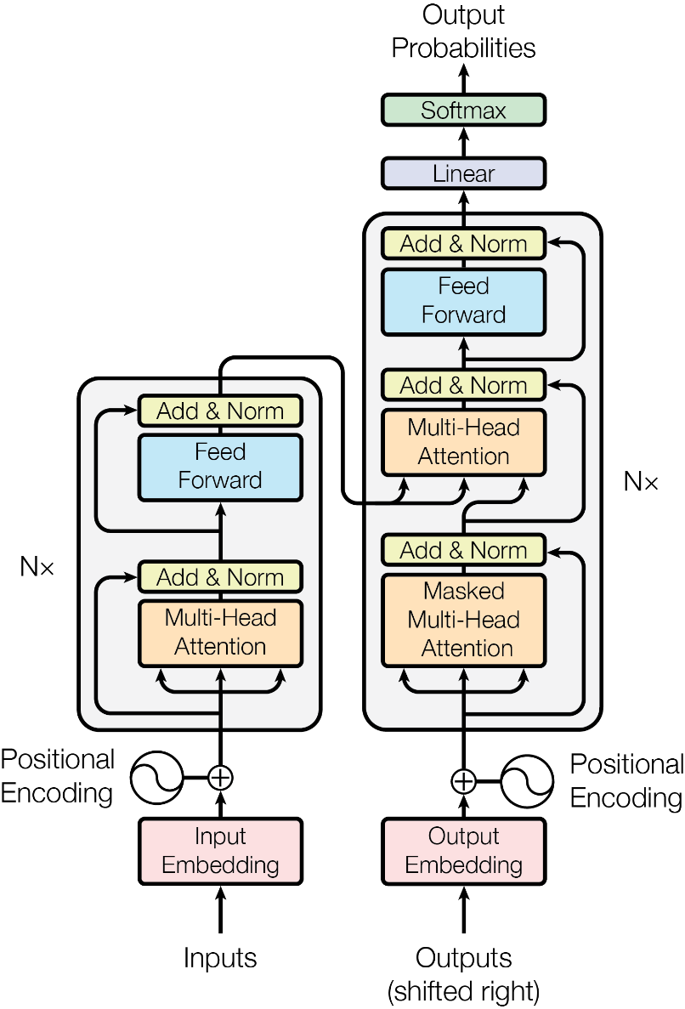
Figure 1: Transformer Architecture
The Transformer consists of:
- Input Embedding
- Positional Encoding
- Encoder Stack
- Decoder Stack
- Multi-Head Attention
- Feed Forward Network
- Residual Connections
- Layer Normalization
Note: This experiment focuses only on implementing Positional Encoding, Self-Attention, and Multi-Head Attention.

2. Why Positional Encoding?
Unlike RNNs, Transformers process all words simultaneously and therefore have no inherent notion of word order. Positional Encoding adds position information to token embeddings so that the model can distinguish between different word positions. The sinusoidal positional encoding is defined as:
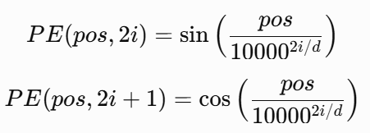
where
- pos = position of the token
- i = embedding dimension
- d = embedding size
The positional encoding is added to the token embeddings before attention is computed.

3. Self-Attention Mechanism
Self-Attention allows each word in a sentence to attend to every other word, enabling the model to capture contextual relationships. For an input embedding matrix
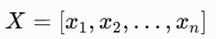
Three matrices are computed:
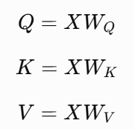

where
- Q = Query matrix
- K = Key matrix
- V = Value matrix

4. Scaled Dot-Product Attention:
The attention scores are computed using
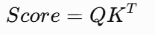

To stabilize training, the scores are divided by
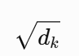
The attention weights are obtained using the Softmax function.
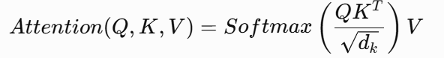
The output is a weighted representation of the input sequence.

5. Multi-Head Attention
Instead of computing a single attention function, the Transformer computes multiple attention heads in parallel.
For each head
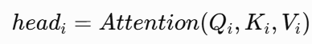
The outputs of all heads are concatenated and projected.
Multi-Head Attention enables the model to learn different contextual relationships simultaneously.
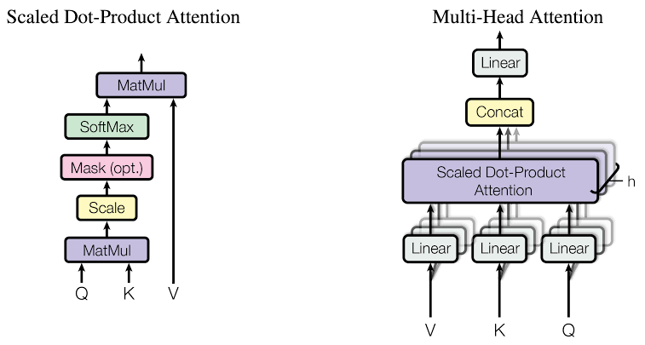
Figure 2: Multi-Head Self-Attention

Applications
Self-Attention and Multi-Head Attention are the key components of modern Transformer models used in:
- Machine Translation
- Text Summarization
- Sentiment Analysis
- Question Answering
- Chatbots
- Large Language Models (LLMs)

Dataset
A small toy corpus or a publicly available text dataset may be used.
Example input sentences:
- The cat sat on the mat.
- The dog chased the ball.
- Students enjoy learning NLP.
- Transformers are powerful models.
- Attention improves contextual understanding.
The objective is to understand the attention mechanism rather than train a large model.

Problem statement/ Tasks:
Students are required to perform the following tasks:
1. Input Preparation
- Create or load a small corpus.
- Perform tokenization.
- Build the vocabulary.
- Convert tokens into integer indices.
2. Token Embedding
- Generate token embeddings using an embedding layer.
3. Positional Encoding
Students shall implement sinusoidal positional encoding from scratch.
- Compute positional encoding values.
- Add positional encoding to token embeddings.
4. Query, Key and Value Projection
Students shall implement separate linear projection layers to generate:
- Query matrix (Q)
- Key matrix (K)
- Value matrix (V)
5. Scaled Dot-Product Attention
Students shall implement:
- Matrix multiplication 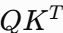
- Scaling by 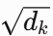
- Softmax normalization
- Weighted sum with the Value matrix
6. Multi-Head Attention
Students shall implement:
- Splitting Q, K and V into multiple heads.
- Computing Self-Attention independently for each head.
- Concatenating the outputs.
- Applying the final linear projection.
7. Visualization
Visualize:
- Attention score matrix.
- Attention weight matrix.
- Attention heatmap.
- Interpret the attention patterns for sample sentences.
8. Analysis
Discuss how different attention heads focus on different words and capture contextual information.
9. Expected Output
The program should display:
1. Tokenized input sequence.
2. Vocabulary.
3. Token embeddings.
4. Positional encoding matrix.
5. Query matrix.
6. Key matrix.
7. Value matrix.
8. Attention score matrix.
9. Attention weight matrix.
10. Context vectors.
11. Multi-Head Attention output.
12. Attention heat map.
13. Interpretation of the attention visualization.

Dataset Details :
A small toy corpus of 5 sentences was used, as suggested in the assignment: “The cat sat on the mat.”, “The dog chased the ball.”, “Students enjoy learning NLP.”, “Transformers are powerful models.”, “Attention improves contextual understanding.” Sentences were lowercased, punctuation was removed, and they were split into word tokens. This gave a vocabulary of 21 entries (20 words plus a <pad> token). Shorter sentences were padded to the longest length (6 tokens) and masked during attention. The experiment uses an embedding size of 16 and 4 attention heads (d_k = 4). The aim is to understand the attention mechanism, not to train a model.
Code: paste the notebook cells, or screenshots of them.
Output: paste screenshots of the Colab outputs. The key ones are:
- tokens and vocabulary
- the positional encoding matrix and its heatmap
- Q, K and V
- score and weight matrices
- the multi-head heatmaps
- the verification results
Interpretation of the attention visualization (expected output 13)
Each row of a heatmap shows how much one word (the query) attends to every other word (the key). Each row sums to 1. The weights come from randomly initialised projection matrices with no training, so they show how the mechanism behaves, not learned grammar. Even so, the heads clearly behave differently:
- Different heads, different focus: in “The cat sat on the mat”, Head 1 pulls mostly toward “cat”. Head 4 sends “cat” and “sat” almost entirely to “on” (0.96 and 1.00). Head 3 keeps “cat” focused on itself (1.00). Head 2 spreads weight over “the” and “cat”. The same word is therefore linked to different context words depending on the head.
- Heads differ numerically: the average weight a word puts on itself is 0.46 for Head 3 but only about 0.18–0.23 for the others. The similarity between heads’ attention maps is low (about 0.19–0.44), so they are not repeating each other.
- Context mixing: a word’s output is a weighted sum of value vectors, so “mat” receives information from “on”, and “cat” from “the” and “mat”. This is how each word’s representation becomes context-aware.
- Position matters: the two “the” tokens in sentence 1 have the same embedding but receive different attention rows. Positional encoding is what separates them, because attention alone has no sense of word order.

Code :
colab

Output:
[12] ATTENTION HEATMAPS - multi-head

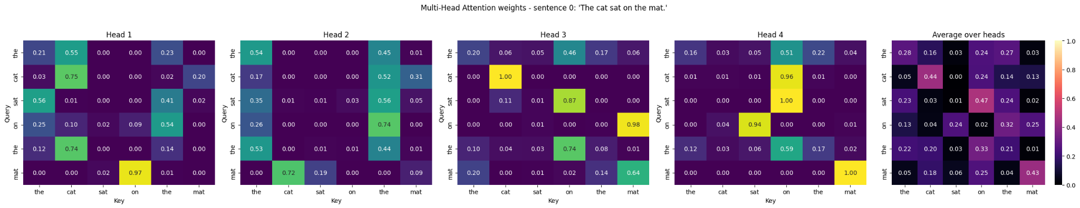
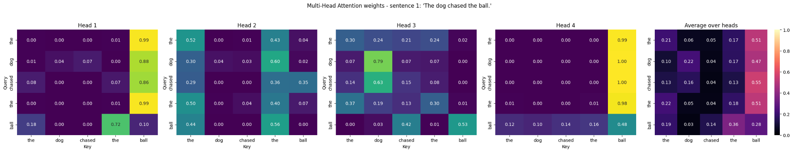
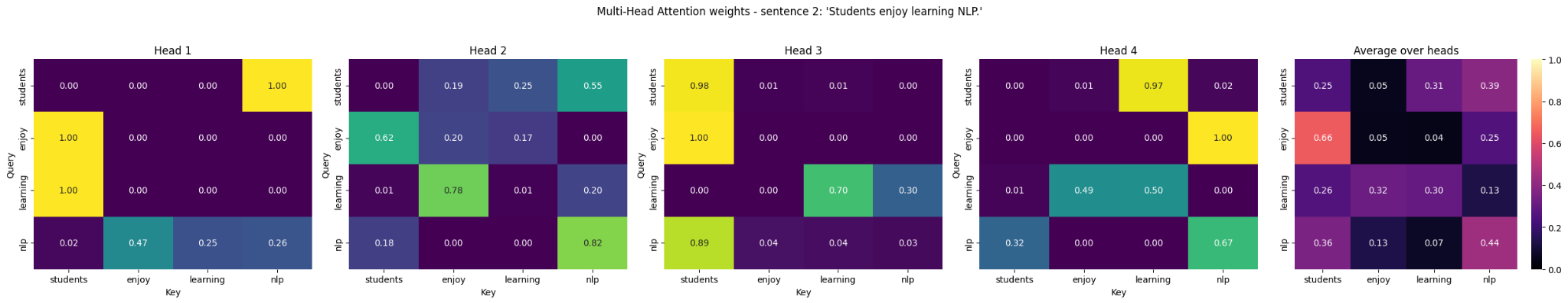
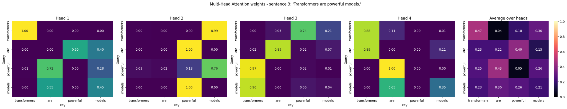
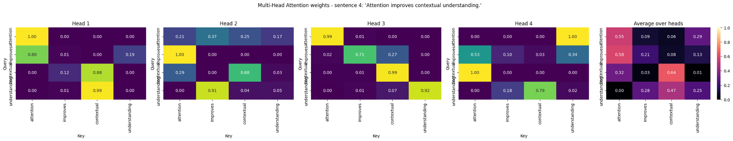
======================================================================
[13] INTERPRETATION DATA - most-attended word per query word, for each head
======================================================================

Sentence 0: 'The cat sat on the mat.'

 | Head 1 | Head 2 | Head 3 | Head 4
query word
the | cat (0.55) | the (0.54) | on (0.46) | on (0.51)
cat | cat (0.75) | the (0.52) | cat (1.00) | on (0.96)
sat | the (0.56) | the (0.56) | on (0.87) | on (1.00)
on | the (0.54) | the (0.74) | mat (0.98) | sat (0.94)
the | cat (0.74) | the (0.53) | on (0.74) | on (0.59)
mat | on (0.97) | cat (0.72) | mat (0.64) | mat (1.00)
Sentence 1: 'The dog chased the ball.'

 | Head 1 | Head 2 | Head 3 | Head 4
query word
the | ball (0.99) | the (0.52) | the (0.30) | ball (0.99)
dog | ball (0.88) | the (0.60) | dog (0.79) | ball (1.00)
chased | ball (0.86) | the (0.36) | dog (0.63) | ball (1.00)
the | ball (0.99) | the (0.50) | the (0.37) | ball (0.98)
ball | the (0.72) | the (0.56) | ball (0.53) | ball (0.48)
Sentence 2: 'Students enjoy learning NLP.'

 | Head 1 | Head 2 | Head 3 | Head 4
query word
students | nlp (1.00) | nlp (0.55) | students (0.98) | learning (0.97)
enjoy | students (1.00) | students (0.62) | students (1.00) | nlp (1.00)
learning | students (1.00) | enjoy (0.78) | learning (0.70) | learning (0.50)
nlp | enjoy (0.47) | nlp (0.82) | students (0.89) | nlp (0.67)
Sentence 3: 'Transformers are powerful models.'

 | Head 1 | Head 2 | Head 3 | Head 4
query word
transformers | transformers (1.00) | models (0.99) | powerful (0.74) | transformers (0.88)
are | powerful (0.60) | powerful (1.00) | are (0.89) | transformers (0.89)
powerful | are (0.72) | models (0.76) | transformers (0.97) | are (1.00)
models | are (0.55) | powerful (1.00) | transformers (0.90) | are (0.65)
Sentence 4: 'Attention improves contextual understanding.'

 | Head 1 | Head 2 | Head 3 | Head 4
query word
attention | attention (1.00) | improves (0.37) | attention (0.99) | understanding (1.00)
improves | attention (0.80) | attention (1.00) | improves (0.71) | attention (0.53)
contextual | contextual (0.88) | contextual (0.68) | contextual (0.99) | attention (1.00)
understanding | contextual (0.99) | improves (0.91) | understanding (0.92) | contextual (0.79)
Head-level statistics (all sentences):

 | avg weight on itself | avg entropy (higher = more spread out)
head
Head 1 | 0.226 | 0.439
Head 2 | 0.182 | 0.666
Head 3 | 0.461 | 0.551
Head 4 | 0.191 | 0.394
Cosine similarity between heads' attention maps (1 = identical pattern):

 | Head 1 | Head 2 | Head 3 | Head 4
Head 1 | 1.000 | 0.416 | 0.243 | 0.439
Head 2 | 0.416 | 1.000 | 0.240 | 0.249
Head 3 | 0.243 | 0.240 | 1.000 | 0.187
Head 4 | 0.439 | 0.249 | 0.187 | 1.000
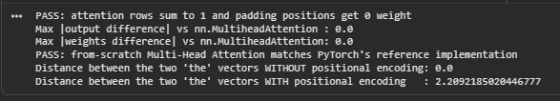

Post Lab Questions:
- Compare RNN, LSTM, and Transformer architectures with respect to information flow, memory mechanism, parallelization capability, and computational complexity.
Compare RNN, LSTM and Transformer
Aspect | RNN | LSTM | Transformer
Information flow | Sequential: each hidden state depends on the previous one | Sequential, with gates (input, forget, output) controlling the flow | All tokens are processed together; each token can attend directly to every other token
Memory mechanism | A single hidden state, which is overwritten at every step | Hidden state plus a cell state that can keep information over longer spans | No recurrent memory; the attention matrix gives direct access to all positions
Parallelization | Not possible across time steps | Not possible across time steps | Fully parallel across the sequence
Computational complexity per layer | O(n·d²), with n sequential steps | O(n·d²), a larger constant because of the gates | O(n²·d), since every token attends to every other token. Only O(1) sequential steps.
Path length between two distant words | O(n) | O(n) | O(1)

- Why do Transformer models outperform RNNs and LSTMs for long sequence processing? Explain with suitable examples.
- In an RNN, information from an early word must pass through every step in between. Gradients shrink (vanishing gradients) or blow up along the way, so long-range dependencies are hard to learn. LSTMs reduce this with gates but still pass information step by step, and they still lose detail over very long inputs.
- In a Transformer, any two words are connected by a single attention step, so the path length is constant. The model can link distant words directly and gradients flow easily.
- Example: in “The cat, which had been chased by the neighbour’s dog for most of the afternoon, finally was tired”, the verb “was” must agree with “cat”, which is far away. An RNN has to carry “cat” across all the intermediate words. A Transformer lets “was” attend to “cat” directly.
- Because the whole sequence is processed in parallel, Transformers also train much faster on GPUs and scale to large datasets. The cost is O(n²) memory and compute in sequence length.

Conclusion:
In this experiment I implemented sinusoidal positional encoding, Query/Key/Value projections, scaled dot-product self-attention and multi-head attention from scratch in PyTorch. Positional encoding gave each token a position-dependent vector, so the same word in different positions could be told apart. Self-attention let every word build its representation from all other words, and the heatmaps showed the resulting attention weights. Multi-head attention showed that different heads focus on different words, so a model can capture several contextual relationships at the same time. My implementation matched PyTorch’s built-in nn.MultiheadAttention, which confirms it is correct. This experiment helped me understand why Transformers handle long-range context better than RNNs and LSTMs, and why they are the foundation of models such as BERT and GPT.

