Course Name: | Natural Language Processing | Semester: | VII
Date of Performance: | 03/ 09/ 2026 | DIV/ Batch No: | A
Student Name: | Piyush Chaudhary | Roll No: | 16010123234

Experiment No: 5

Title: Implementation and Comparative Analysis of Text Representation Techniques
using Bag of Words (BoW), TF-IDF, and Word2Vec

Aim: To implement and analyze classical and distributed text representation techniques using Bag of Words (BoW), TF-IDF, and Word2Vec, and evaluate their effectiveness for Natural Language Processing applications.

Objectives of the Experiment:
By the end of this experiment, students will be able to:
- Understand the importance of text representation in Natural Language Processing.
- Generate numerical feature representations using Bag of Words (BoW) and TF-IDF techniques.
- Implement the Word2Vec model using either the Continuous Bag-of-Words (CBOW) or Skip-Gram architecture in PyTorch.
- Learn dense vector representations (word embeddings) from a given text corpus.
- Analyze semantic relationships between words using cosine similarity.
- Visualize the learned word embeddings using Principal Component Analysis (PCA) or t-Distributed Stochastic Neighbor Embedding (t-SNE).
- Compare BoW, TF-IDF, and Word2Vec based on representation capability, sparsity, semantic understanding, and computational characteristics.

COs to be achieved:
CO3: Utilize word representation models to capture semantic meaning and improve language understanding.

Books/ Journals/ Websites referred:
- D. Jurafsky and J. H. Martin, Speech and Language Processing, 3rd ed. (draft), 2025. Chapter 6, "Vector Semantics and Embeddings," covers TF-IDF, cosine similarity and Word2Vec.
- C. D. Manning, P. Raghavan and H. Schütze, Introduction to Information Retrieval. Cambridge University Press, 2008. Chapter 6 for term weighting and the vector space model.
- S. Bird, E. Klein and E. Loper, Natural Language Processing with Python. O'Reilly, 2009 — the NLTK book, used for tokenization, stop words and lemmatization.
- Y. Goldberg, Neural Network Methods for Natural Language Processing. Morgan & Claypool, 2017.
- S. Vajjala, B. Majumder, A. Gupta and H. Surana, Practical Natural Language Processing. O'Reilly, 2020.

Theory:
- Introduction: Natural Language Processing algorithms cannot process textual information directly. Therefore, text must first be converted into numerical representations before applying machine learning or deep learning algorithms. Text representation techniques have evolved from simple frequency-based methods to distributed semantic representations. Raw Text -> Bag of Words -> TF-IDF -> Word2Vec.
- Bag of Words (BoW): Bag of Words is one of the simplest text representation techniques. It represents each document by counting the occurrence of every word in the vocabulary while ignoring grammar, semantics, and word order.
Documents:
D1: NLP is interesting
D2: NLP is useful

Vocabulary: [NLP, is, interesting, useful]

BoW Matrix:
Document | NLP | is | interesting | useful
D1 | 1 | 1 | 1 | 0
D2 | 1 | 1 | 0 | 1

- TF-IDF (Term Frequency – Inverse Document Frequency): TF-IDF is a numerical statistic that measures the importance of a word in a document relative to a corpus. It combines term frequency (TF), which measures word frequency within a document, with inverse document frequency (IDF), which measures word rarity across documents. TF-IDF is used for text search and information retrieval. TF-IDF improves upon BoW by assigning higher weights to informative words and lower weights to commonly occurring words.
Term Frequency (TF):
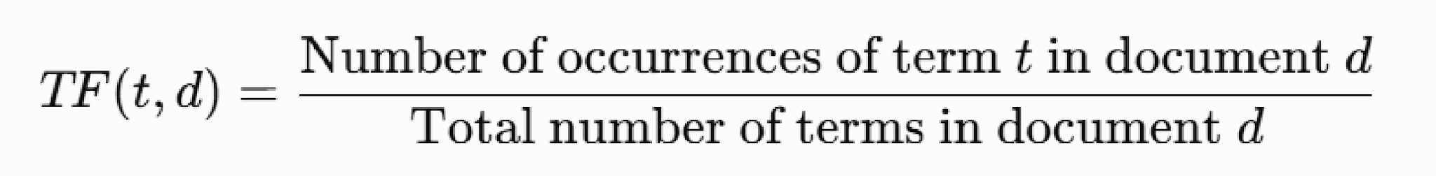

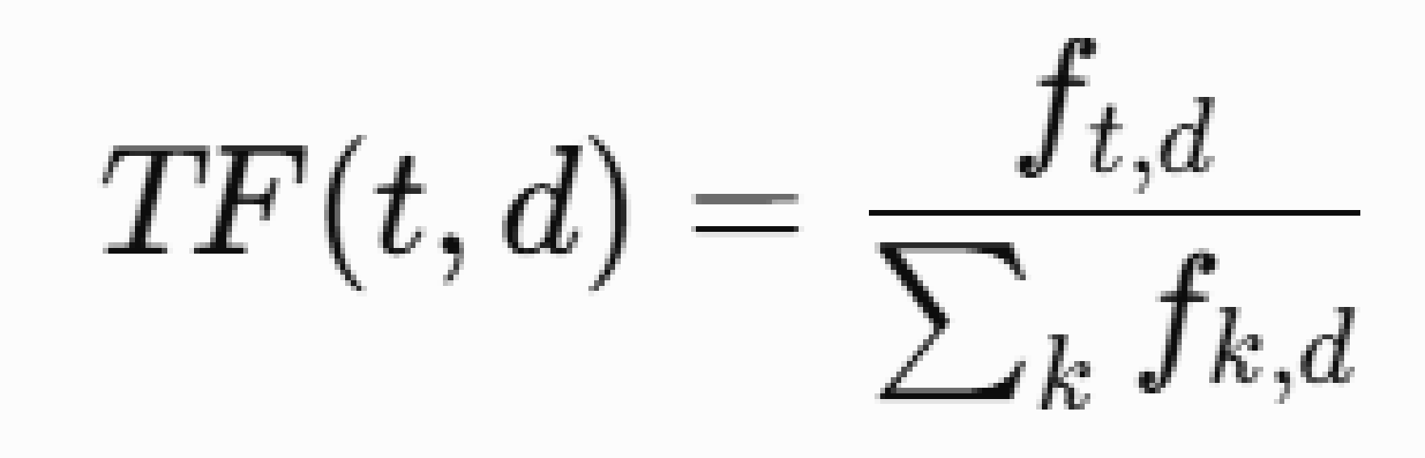

Where ​ = frequency of term in document and ​ = frequency of the word in document .
Inverse Document Frequency (IDF):
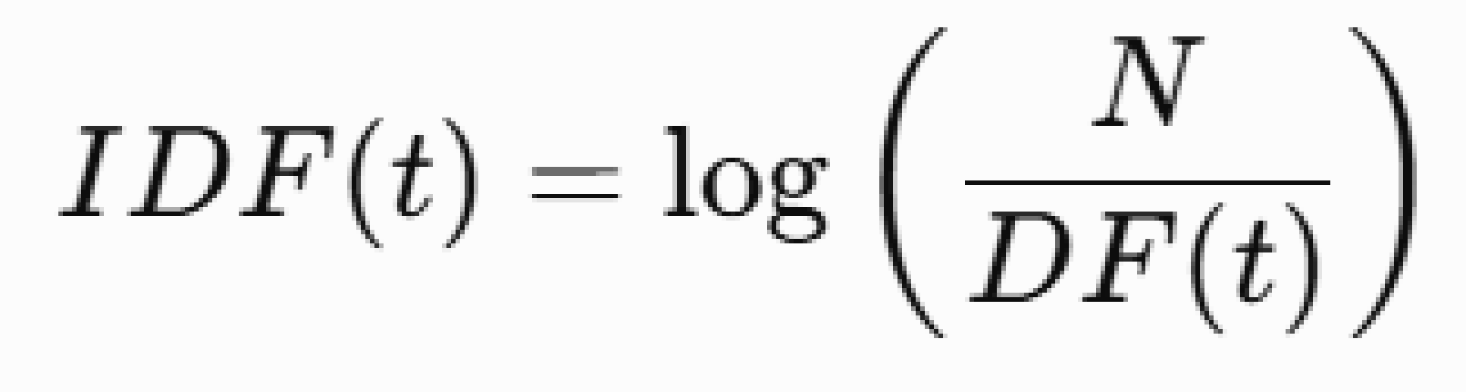

Where = Total number of documents and = Number of documents containing term
- Word2Vec: Word2Vec is a shallow neural network that learns dense vector representations (embeddings) of words from a large corpus. Unlike BoW and TF-IDF, Word2Vec captures semantic relationships among words. Words appearing in similar contexts obtain similar vector representations.
Example:
king ≈ queen
doctor ≈ physician
car ≈ automobile
Word2Vec provides two learning architectures.
- Continuous Bag-of-Words (CBOW)
- Skip-Gram
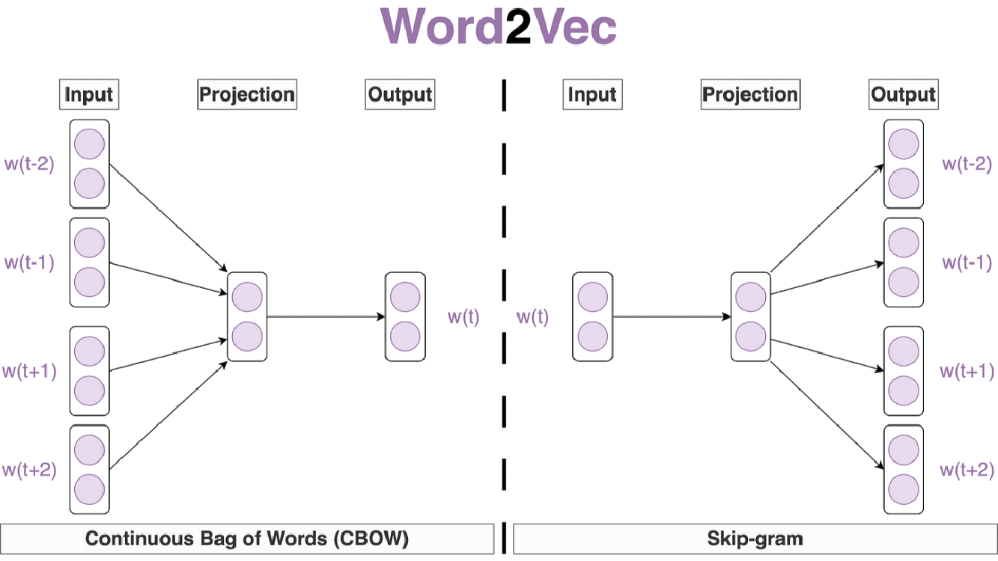

Continuous Bag-of-Words (CBOW): CBOW predicts the target word using its surrounding context words. CBOW averages the embeddings of surrounding words and predicts the center word.
Skip-Gram: Skip-Gram performs the reverse operation of CBOW. It predicts surrounding context words using the target word. Skip-Gram learns richer semantic representations, especially for infrequent words.

Problem statement/ Tasks:
Students are required to perform the following tasks:

- Corpus Preparation and Preprocessing
- Load a text corpus.
- Perform text preprocessing, including lowercase conversion, tokenization, stop-word removal, and lemmatization.
2. Bag of Words (BoW) Representation
- Construct the vocabulary from the corpus.
- Generate the Bag of Words feature matrix.
- Analyze the vocabulary size and sparsity of the feature vectors.
3. TF-IDF Representation
- Generate TF-IDF feature vectors for the corpus.
- Compare TF-IDF weights with the corresponding BoW frequencies.
4. Word2Vec Implementation
- Generate context-target training pairs from the corpus.
- Implement either the CBOW or Skip-Gram model using PyTorch.
- Train the model to learn dense word embeddings.
- Extract the learned word vectors.
5. Semantic Similarity Analysis
- Compute cosine similarity between selected word pairs using the learned embeddings.
- Retrieve the most similar words for selected query terms.
- Analyze the semantic relationships captured by the embeddings.
6. Word Embedding Visualization
- Reduce the dimensionality of the learned embeddings using PCA or t-SNE.
- Visualize the embeddings in a two-dimensional space.
- Observe and interpret the clustering of semantically similar words.
7. Comparative Analysis: Compare Bag of Words, TF-IDF, and Word2Vec based on:
- Representation technique
- Vector dimensionality
- Sparsity
- Semantic understanding
- Context awareness
- Advantages and limitations
Expected Output: The program should display:
- Preprocessed Text Corpus
- Bag of Words (BoW) Representation
- Vocabulary list.
- Bag of Words feature matrix.
- TF-IDF Representation
- TF-IDF feature matrix.
- TF-IDF scores for selected terms.
- Word2Vec Model
- Trained Word2Vec model (CBOW or Skip-Gram).
- Learned word embedding vectors for selected words.
- Semantic Similarity Analysis
- Cosine similarity scores between selected word pairs.
- List of the most similar words for selected query terms.
- Word Embedding Visualization
- Two-dimensional visualization of the learned word embeddings using PCA or t-SNE.
- Identification of semantically similar word clusters.
- Comparative Analysis
- Comparative analysis of Bag of Words, TF-IDF, and Word2Vec based on feature representation, sparsity, semantic understanding, and computational characteristics.

Code :
Google Colab

Output:
1. Environment
PyTorch 2.14.0+cu130 | device: cpu
1. Corpus loaded
28 documents
2. Preprocessed text corpus
=== Preprocessed corpus (first 4 documents) ===

D1: Natural language processing enables computers to understand human language.
['natural', 'language', 'process', 'enable', 'computer', 'understand', 'human', 'language']

D2: Natural language processing is a branch of artificial intelligence.
['natural', 'language', 'process', 'branch', 'artificial', 'intelligence']

D3: Language models assign probabilities to sequences of words in a sentence.
['language', 'model', 'assign', 'probability', 'sequence', 'word', 'sentence']

D4: A language model predicts the next word given the previous words.
['language', 'model', 'predict', 'next', 'word', 'give', 'previous', 'word']
3. Bag of Words: vocabulary and feature matrix
Vocabulary size: 117
Matrix shape : (28, 117) (documents x vocabulary)
Sparsity : 93.9%

Vocabulary: ['algorithm', 'amount', 'analysis', 'artificial', 'assign', 'backpropagation', 'bag', 'base', 'boundary',
'branch', 'classification', 'classifier', 'common', 'computer', 'context', 'continuous', 'corpus', 'cosine',
'count', 'data', 'decision', 'deep', 'dense', 'descent', 'document', 'embeddings', 'emotional', 'enable',
'engine', 'every', 'example', 'frequency', 'function', 'give', 'gradient', 'gram', 'grammar', 'human', 'ignore',
'importance', 'individual', 'information', 'intelligence', 'inverse', 'label', 'language', 'large', 'learn',
'lemmatization', 'loss', 'machine', 'many', 'measure', 'minimize', 'model', 'modern', 'natural', 'network',
'neural', 'next', 'obtain', 'occur', 'occurrence', 'order', 'pattern', 'penalize', 'polarity', 'power', 'predict',
'preprocessing', 'previous', 'probability', 'process', 'query', 'rank', 'raw', 'relevance', 'relevant',
'removal', 'represent', 'representation', 'require', 'retrieval', 'retrieve', 'search', 'semantic', 'sentence',
'sentiment', 'sequence', 'similar', 'similarity', 'skip', 'space', 'split', 'standard', 'step', 'stop', 'subword',
'supervise', 'surround', 'system', 'target', 'task', 'term', 'text', 'tokenization', 'train', 'two',
'understand', 'unit', 'update', 'use', 'user', 'vec', 'vector', 'weight', 'word']

=== BoW feature matrix (12 most frequent terms) ===
word document language train learn text predict network vector model neural data
D1 0 0 2 0 0 0 0 0 0 0 0 0
D2 0 0 1 0 0 0 0 0 0 0 0 0
D3 1 0 1 0 0 0 0 0 0 1 0 0
D4 2 0 1 0 0 0 1 0 0 1 0 0
D5 0 0 1 0 0 1 0 0 0 0 0 0
D6 0 1 0 0 0 1 1 0 0 0 0 0
D7 1 0 0 0 0 1 0 0 0 0 0 0
D8 1 0 0 0 0 1 0 0 0 0 0 0
D9 0 0 0 0 2 0 0 0 0 0 0 1
D10 0 0 1 0 1 0 0 1 0 1 1 0
D11 0 0 0 1 0 0 0 1 0 0 1 0
D12 0 0 0 2 0 0 0 0 0 1 0 1
D13 0 0 0 1 0 0 0 1 0 0 1 1
D14 0 0 0 0 0 0 0 1 0 0 1 0
D15 0 0 0 1 1 0 0 0 0 0 0 0
D16 0 0 0 1 1 0 0 0 0 0 0 1
D17 2 0 0 0 0 0 0 0 2 0 0 0
D18 2 0 0 0 1 1 0 0 0 0 0 0
D19 2 0 0 0 0 0 1 0 0 0 0 0
D20 3 0 0 0 0 0 1 0 0 0 0 0
D21 1 0 0 0 0 0 0 0 1 0 0 0
D22 1 0 0 0 0 0 0 0 1 0 0 0
D23 0 1 0 0 0 0 0 0 0 0 0 0
D24 0 1 0 0 0 0 0 0 0 0 0 0
D25 0 1 0 0 0 0 0 0 0 0 0 0
D26 0 2 0 0 0 0 0 0 0 0 0 0
D27 2 1 0 0 0 0 0 0 0 0 0 0
D28 2 1 0 0 0 0 0 0 0 0 0 0
4. TF-IDF feature matrix
=== TF-IDF feature matrix (12 highest weighted terms) ===
word document language train learn text model predict data neural network vector
D1 0.000 0.000 0.496 0.000 0.000 0.000 0.000 0.000 0.000 0.000 0.000 0.000
D2 0.000 0.000 0.302 0.000 0.000 0.000 0.000 0.000 0.000 0.000 0.000 0.000
D3 0.214 0.000 0.288 0.000 0.000 0.000 0.328 0.000 0.000 0.000 0.000 0.000
D4 0.426 0.000 0.286 0.000 0.000 0.000 0.326 0.326 0.000 0.000 0.000 0.000
D5 0.000 0.000 0.288 0.000 0.000 0.306 0.000 0.000 0.000 0.000 0.000 0.000
D6 0.000 0.267 0.000 0.000 0.000 0.300 0.000 0.322 0.000 0.000 0.000 0.000
D7 0.189 0.000 0.000 0.000 0.000 0.270 0.000 0.000 0.000 0.000 0.000 0.000
D8 0.192 0.000 0.000 0.000 0.000 0.274 0.000 0.000 0.000 0.000 0.000 0.000
D9 0.000 0.000 0.000 0.000 0.539 0.000 0.000 0.000 0.288 0.000 0.000 0.000
D10 0.000 0.000 0.265 0.000 0.282 0.000 0.301 0.000 0.000 0.301 0.301 0.000
D11 0.000 0.000 0.000 0.307 0.000 0.000 0.000 0.000 0.000 0.329 0.329 0.000
D12 0.000 0.000 0.000 0.568 0.000 0.000 0.304 0.000 0.304 0.000 0.000 0.000
D13 0.000 0.000 0.000 0.289 0.000 0.000 0.000 0.000 0.310 0.310 0.310 0.000
D14 0.000 0.000 0.000 0.000 0.000 0.000 0.000 0.000 0.000 0.299 0.299 0.000
D15 0.000 0.000 0.000 0.295 0.295 0.000 0.000 0.000 0.000 0.000 0.000 0.000
D16 0.000 0.000 0.000 0.320 0.320 0.000 0.000 0.000 0.343 0.000 0.000 0.000
D17 0.352 0.000 0.000 0.000 0.000 0.000 0.000 0.000 0.000 0.000 0.000 0.582
D18 0.394 0.000 0.000 0.000 0.282 0.282 0.000 0.000 0.000 0.000 0.000 0.000
D19 0.409 0.000 0.000 0.000 0.000 0.000 0.000 0.313 0.000 0.000 0.000 0.000
D20 0.572 0.000 0.000 0.000 0.000 0.000 0.000 0.292 0.000 0.000 0.000 0.000
D21 0.172 0.000 0.000 0.000 0.000 0.000 0.000 0.000 0.000 0.000 0.000 0.284
D22 0.164 0.000 0.000 0.000 0.000 0.000 0.000 0.000 0.000 0.000 0.000 0.272
D23 0.000 0.236 0.000 0.000 0.000 0.000 0.000 0.000 0.000 0.000 0.000 0.000
D24 0.000 0.250 0.000 0.000 0.000 0.000 0.000 0.000 0.000 0.000 0.000 0.000
D25 0.000 0.204 0.000 0.000 0.000 0.000 0.000 0.000 0.000 0.000 0.000 0.000
D26 0.000 0.481 0.000 0.000 0.000 0.000 0.000 0.000 0.000 0.000 0.000 0.000
D27 0.448 0.284 0.000 0.000 0.000 0.000 0.000 0.000 0.000 0.000 0.000 0.000
D28 0.407 0.259 0.000 0.000 0.000 0.000 0.000 0.000 0.000 0.000 0.000 0.000

=== Top TF-IDF terms per document ===
D1: language (0.496), enable (0.377), human (0.377)
D2: artificial (0.459), branch (0.459), intelligence (0.459)
D3: assign (0.437), sentence (0.437), sequence (0.437)
D4: next (0.434), previous (0.434), word (0.426)
D5: common (0.437), classification (0.437), task (0.437)
D6: analysis (0.429), emotional (0.429), polarity (0.429)
D7: individual (0.385), subword (0.385), split (0.385)
D8: lemmatization (0.392), stop (0.392), standard (0.392)
D9: learn (0.539), machine (0.384), pattern (0.384)
D10: modern (0.402), power (0.402), system (0.357)
D11: backpropagation (0.438), use (0.438), gradient (0.390)
D12: train (0.568), loss (0.405), function (0.405)
D13: amount (0.367), deep (0.367), require (0.367)
D14: every (0.399), update (0.399), descent (0.355)
D15: boundary (0.421), classifier (0.421), decision (0.421)
D16: supervise (0.457), require (0.407), algorithm (0.407)
D17: vector (0.582), space (0.359), word (0.352)
D18: corpus (0.402), vec (0.402), word (0.394)
D19: gram (0.416), skip (0.416), word (0.409)
D20: word (0.572), surround (0.388), target (0.346)
D21: similar (0.701), obtain (0.350), representation (0.312)
D22: similarity (0.670), measure (0.335), two (0.335)
D23: base (0.379), information (0.379), relevance (0.379)
D24: engine (0.402), user (0.402), search (0.402)
D25: frequency (0.583), term (0.583), importance (0.328)
D26: document (0.481), many (0.386), penalize (0.386)
D27: count (0.456), occurrence (0.456), word (0.448)
D28: grammar (0.415), ignore (0.415), order (0.415)
4. BoW frequency compared with TF-IDF weight
=== BoW count vs TF-IDF weight ===
BoW count Doc frequency IDF TF-IDF total
word 20 12 1.802 3.939
document 8 7 2.288 1.981
language 7 6 2.421 1.925
learn 6 5 2.576 1.718
data 4 4 2.758 1.245
neural 4 4 2.758 1.240
query 2 2 3.269 0.695
backpropagation 1 1 3.674 0.438
5. Word2Vec: vocabulary and training pairs
Vocabulary size: 117
Training pairs : 972
Most frequent : [('word', 20), ('document', 8), ('language', 7), ('learn', 6), ('train', 6), ('text', 5), ('model',
4), ('predict', 4)]

Sample pairs (target -> context):
natural -> language
natural -> process
natural -> enable
language -> natural
language -> process
language -> enable
5. Skip-Gram training
Epoch 1/600 | loss = 4.9057
Epoch 100/600 | loss = 2.1905
Epoch 200/600 | loss = 2.1796
Epoch 300/600 | loss = 2.1752
Epoch 400/600 | loss = 2.1745
Epoch 500/600 | loss = 2.1748
Epoch 600/600 | loss = 2.1733
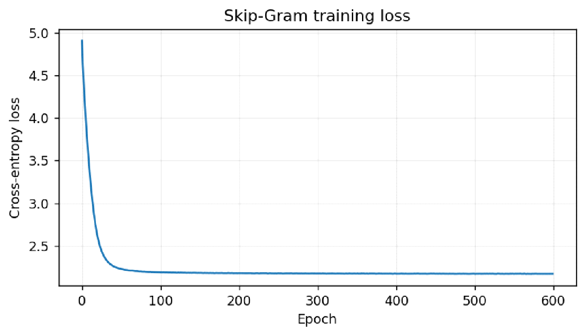

5. Learned embeddings
Embedding matrix: (117, 30)

'language' (first 8 of 30 dims): [-1.086 0.083 -1.292 -1.694 0.955 0.659 -0.598 -1.031]

'neural' (first 8 of 30 dims): [-0.863 -0.602 0.306 -1.573 0.946 3.84 -1.908 -2.98 ]

'document' (first 8 of 30 dims): [ 1.108 -0.82 2.158 3.298 1.555 -0.513 -0.017 0.432]
6. Semantic similarity analysis
=== Cosine similarity between word pairs ===
word 1 word 2 cosine similarity
0 gradient descent 0.7454
1 language processing 0.6752
2 document query 0.6402
3 neural network 0.6382
4 word embedding 0.4373
5 training data 0.3855
6 language gradient -0.0458
7 document neural -0.2005
=== Most similar words ===
language -> process (0.675), branch (0.611), computer (0.514), artificial (0.512), natural (0.511)
neural -> network (0.638), deep (0.610), power (0.568), descent (0.514), every (0.508)
document -> query (0.640), many (0.603), frequency (0.539), base (0.505), occurrence (0.504)
gradient -> update (0.751), descent (0.745), backpropagation (0.688), use (0.667), weight (0.545)
learning -> large (0.603), classifier (0.531), amount (0.524), require (0.501), deep (0.470)
7. Word embedding visualisation

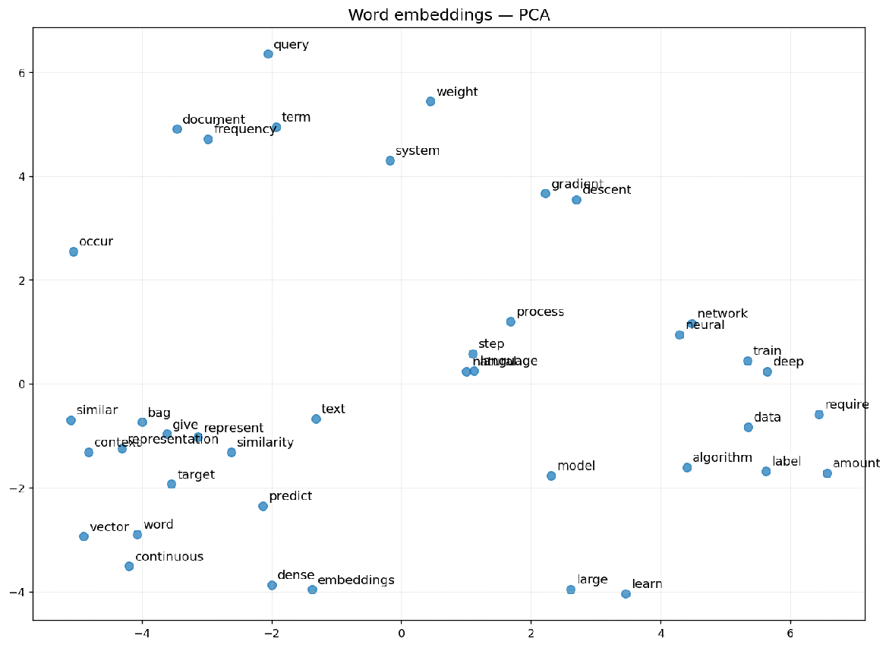

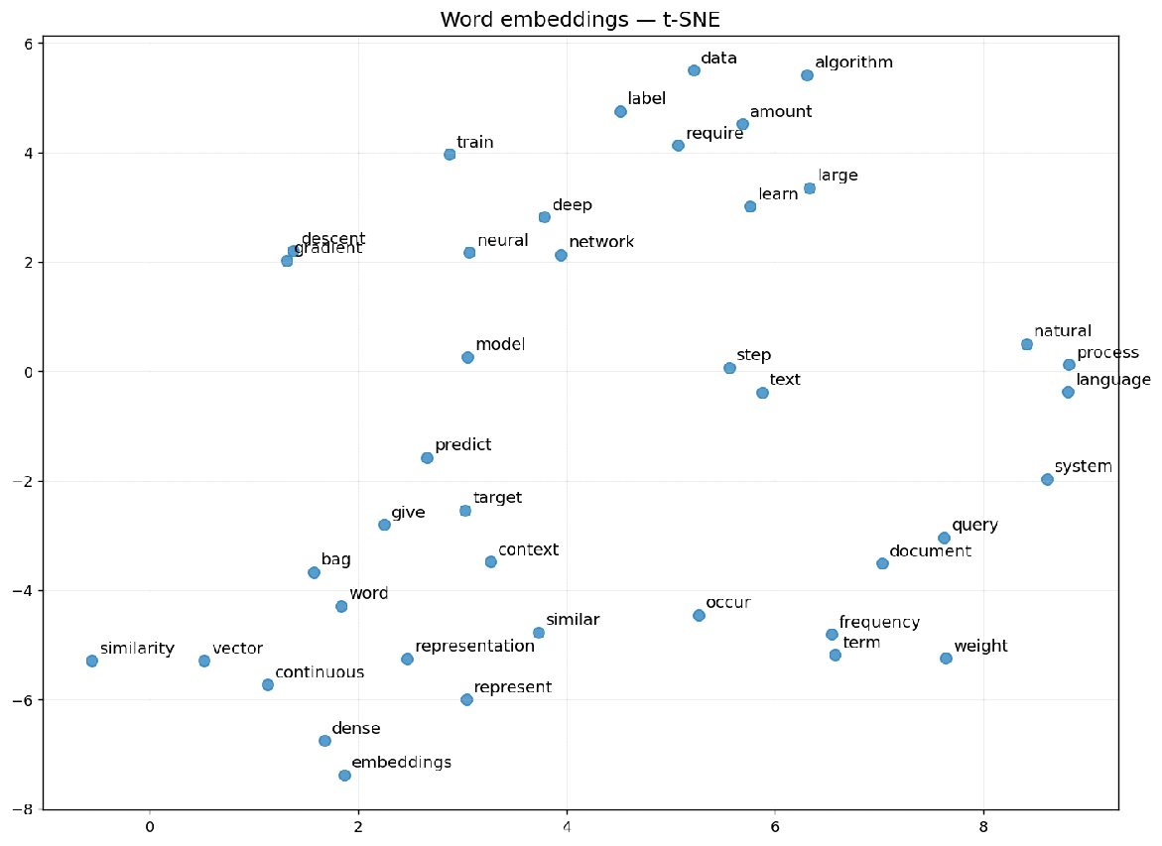

7. Cluster check
=== Average intra-theme cosine similarity ===
Neural / training : +0.360
Language / NLP : +0.119
Retrieval : +0.353
Corpus-wide baseline: +0.006
8. Comparative analysis
 | Bag of Words | TF-IDF | Word2Vec (Skip-Gram)
Representation | Frequency count | Weighted frequency | Learned dense embedding
Dimensionality | 117 (= |V|) | 117 (= |V|) | 30 (hyper-parameter)
Sparsity | 93.9% | 93.9% | 0.0%
Semantic understanding | None | None (statistical weighting only) | Yes, similar contexts give similar vectors
Context awareness | No | No | Yes (fixed window)
Computational cost | Very low | Low | High (neural training)
Advantages | Simple, interpretable, fast | Down-weights common terms, strong for search and retrieval | Compact, captures semantics, supports similarity and analogy
Limitations | Sparse, high dimensional, no semantics, ignores word order | Still sparse and high dimensional, no semantic relationships | Needs a large corpus, one static vector per word, no OOV handling

Post Lab Questions:
- How do GloVe and FastText improve upon Word2Vec?
GloVe (Global Vectors for Word Representation). Word2Vec is trained only on local context windows, so corpus-wide co-occurrence statistics never enter training directly. GloVe instead factorises a global word-word co-occurrence matrix, fitting vectors so that the dot product of two word vectors approximates the logarithm of their co-occurrence count. Combining global statistics with local context makes training efficient on the sparse count matrix and yields more stable vectors for infrequent words.
FastText. Word2Vec treats every word as an atomic unit, so it stores exactly one vector per word and can produce nothing at all for a word absent from the training corpus. FastText represents a word as the sum of its character n-gram vectors, for example playing as pla, lay, ayi, yin and ing. Morphologically related words therefore share sub-word structure, out-of-vocabulary words can still be embedded from their n-grams, and morphologically rich languages such as Hindi, Turkish and Finnish are handled considerably better.
Limitation common to all three. Each model produces a single static vector per word, so the word bank receives an identical representation in river bank and in savings bank. Contextual models such as ELMo and BERT address this by generating a different vector for every occurrence of a word based on its surrounding sentence.

Conclusion:
In this experiment three text representation techniques were implemented on a corpus of 28 documents and compared on dimensionality, sparsity and semantic capability.
- Bag of Words produced a 117-dimensional vector per document, one dimension per vocabulary term, of which 93.9 percent of all entries were zero. It is fast and fully interpretable, but the dimensionality grows with the vocabulary and word order is discarded entirely.
- TF-IDF used the same 117 dimensions but re-weighted them. Terms occurring in many documents received a low inverse document frequency and were suppressed, while rare and therefore discriminative terms such as backpropagation received the highest weights. This makes TF-IDF distinctly better than raw counts for search and retrieval, though the vectors remain sparse and carry no meaning.
- Word2Vec, implemented as a Skip-Gram network in PyTorch, compressed each word into a dense 30-dimensional vector with no zero entries. Cross-entropy loss fell from 4.91 to 2.17 over 600 epochs.
- The learned embeddings captured genuine semantic structure. Cosine similarity reached 0.745 for gradient and descent, 0.675 for language and processing, 0.640 for document and query and 0.638 for neural and network, whereas unrelated pairs such as document and neural scored -0.201. Averaged within themes the similarity was +0.360 for neural network terms and +0.353 for retrieval terms against a corpus-wide baseline of only +0.006, confirming that the clustering visible in the PCA and t-SNE plots is real and not an artefact of the projection.
- The trade-off is cost and data. Bag of Words and TF-IDF are obtained in a single counting pass, whereas Word2Vec required an iterative training loop. A corpus of 28 sentences is also far smaller than the billions of tokens used to train production embeddings, so the relationships learned here reflect co-occurrence within this specific corpus rather than general English semantics.
The experiment therefore shows a clear progression: Bag of Words captures word occurrence, TF-IDF captures word importance, and Word2Vec captures word meaning. Frequency-based methods remain preferable when the corpus is small, interpretability matters or the task is retrieval, while distributed representations are the appropriate choice when semantic relationships between words must be modelled.

