Course Name: | Natural Language Processing | Semester: | VII
Date of Performance: | 20 /08 /26 | DIV/ Batch No: | A
Student Name: | Piyush Chaudhary | Roll No: | 16010123234

Experiment No: 4

Title: Implementation of Syntax Parsing using Context-Free Grammar (CFG)
and CKY Algorithm

Aim: To implement syntax parsing using Context-Free Grammar (CFG) and the Cocke-Kasami-Younger (CKY) algorithm for generating parse trees and analyzing the syntactic structure of natural language sentences.

Objectives of the Experiment:
By the end of this experiment, students will be able to:

- Understand the concept of syntax and syntactic parsing in Natural Language Processing.
- Define and construct Context-Free Grammar (CFG) rules for simple English sentences.
- Parse sentences using CFG.
- Implement the CKY parsing algorithm for syntactic analysis.
- Generate and interpret parse trees for input sentences.
- Analyze grammatical ambiguity using multiple parse trees.

COs to be achieved:
CO2: Apply language modeling and part-of-speech tagging, and analyze syntactic parsing techniques to extract sentence structures for text analysis and understanding.

Books/ Journals/ Websites referred:
Books / Journals / Websites referred
- D. Jurafsky and J. H. Martin, Speech and Language Processing, 3rd ed. draft — Ch. 17 (Context-Free Grammars) and Ch. 18 (CKY Parsing).
- C. D. Manning and H. Schutze, Foundations of Statistical Natural Language Processing, MIT Press.
- S. Bird, E. Klein and E. Loper, Natural Language Processing with Python (NLTK Book), Ch. 8 — "Analyzing Sentence Structure", https://www.nltk.org/book/ch08.html
- NLTK API documentation — nltk.grammar, nltk.parse, https://www.nltk.org/api/nltk.parse.html

Theory:
Syntax refers to the grammatical structure of a language and defines how words are organized to form meaningful sentences. Syntax parsing (or syntactic parsing) is the process of analyzing the grammatical structure of a sentence according to a predefined grammar.
The output of a parser is typically a parse tree, which represents the hierarchical relationships among the words and phrases in a sentence.
Syntactic parsing is an essential step in many NLP applications, including machine translation, information extraction, question answering, grammar checking, and text summarization.

Context-Free Grammar (CFG)
A Context-Free Grammar (CFG) is a formal grammar used to describe the syntactic structure of natural languages.
A CFG consists of four components:
- Non-terminal symbols (N): Represent grammatical categories (e.g., S, NP, VP).
- Terminal symbols (T): Actual words in the language.
- Production rules (P): Rules that define how non-terminals are expanded.
- Start symbol (S): The initial symbol representing a complete sentence.
A production rule is represented as:
$A→α$
where:
- A is a non-terminal.
- α is a sequence of terminals and/or non-terminals.

Example CFG
Consider the sentence: The cat chased the mouse.
Example grammar:
S → NP VP
NP → Det N
VP → V NP
Det → the
N → cat | mouse
V → chased
The generated parse tree is:
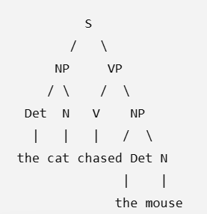
The parse tree illustrates how words are grouped into phrases according to the grammar.

Constituency Parsing
Constituency parsing divides a sentence into nested constituents (phrases).
Common phrase types include:
- Noun Phrase (NP)
- Verb Phrase (VP)
- Prepositional Phrase (PP)
- Adjective Phrase (ADJP)
- Adverb Phrase (ADVP)
Example: The young boy plays cricket.
Constituents: [NP The young boy] [VP plays cricket]

CKY (Cocke-Kasami-Younger) Algorithm
The CKY Algorithm is a bottom-up dynamic programming algorithm used for parsing sentences defined using a Context-Free Grammar in Chomsky Normal Form (CNF).
The algorithm determines whether a sentence can be generated by the grammar and constructs its parse tree efficiently.

Working Principle
- Convert the CFG into Chomsky Normal Form (CNF), if necessary.
- Create an $n×n$ parsing table for a sentence containing n words.
- Fill the diagonal cells with grammar symbols corresponding to individual words.
- Iteratively combine smaller constituents to form larger phrases using grammar production rules.
- Continue until the top-right cell of the table is filled.
- If the start symbol $(S)$ appears in the final cell, the sentence is grammatically valid and its parse tree can be generated.
The CKY algorithm has a time complexity of O(n³ × |G|), where:
- n = Number of words in the sentence
- |G| = Number of grammar production rules

Advantages of CKY Parsing
- Efficient dynamic programming approach.
- Produces complete parse trees.
- Avoids repeated computations.
- Suitable for probabilistic extensions such as PCFG.

Problem statement/ Tasks:
Students are required to perform the following tasks:
- Import the required Python libraries.
- Define a Context-Free Grammar (CFG) for simple English sentences.
- Convert the grammar into Chomsky Normal Form (CNF), if required.
- Parse sample sentences using the defined CFG.
- Generate and visualize parse trees.
- Implement the CKY parsing algorithm using the CNF grammar.
- Construct the CKY parsing table for the given input sentence.
- Determine whether the sentence is accepted by the grammar.
- Analyze syntactic ambiguity by parsing multiple sentences.
- Compare the parse trees generated using CFG parsing and CKY parsing.

Expected Output:
The program should display:
- Input sentence
- Defined CFG rules
- Parse tree generated using CFG
- CKY parsing table
- Acceptance or rejection of the sentence
- Final parse tree
- Analysis of ambiguous sentence(s).

Note for Laboratory Implementation
Students should first define and validate a simple CFG using NLTK, visualize the corresponding parse trees, and then implement the CKY algorithm to construct the parsing table and verify whether the input sentence conforms to the specified grammar. They should also analyze at least one ambiguous sentence to observe how different parse trees can represent different interpretations.

Code :
Colab Link

Output:
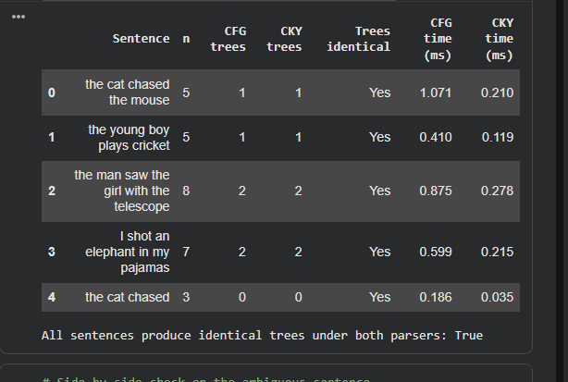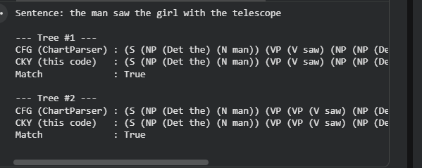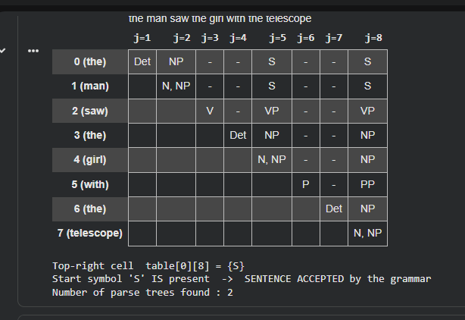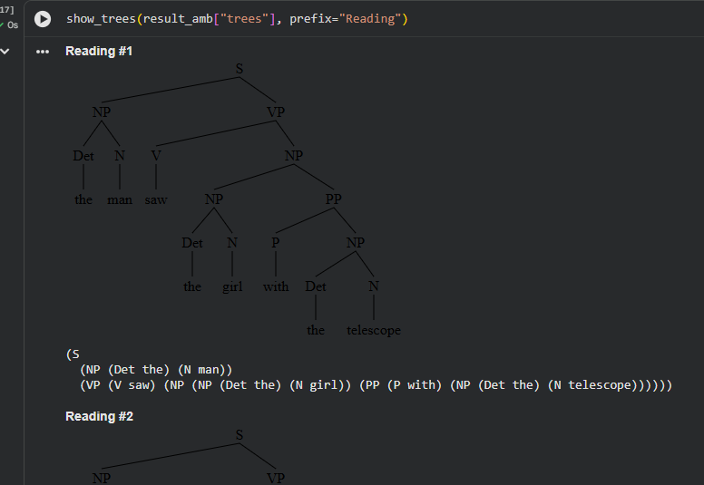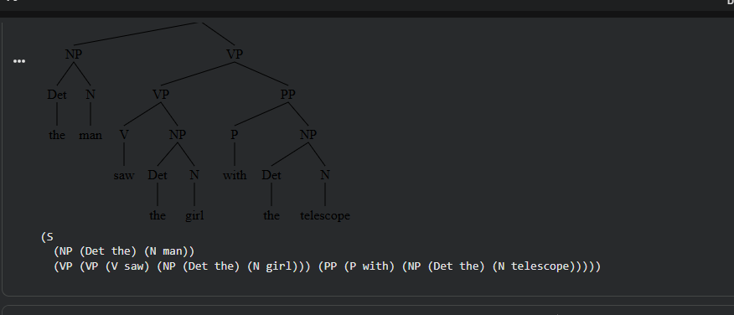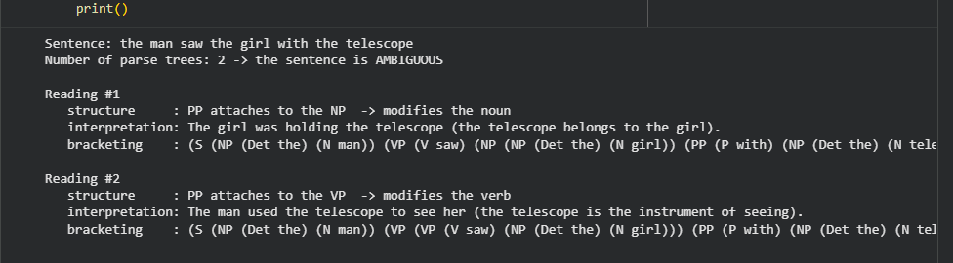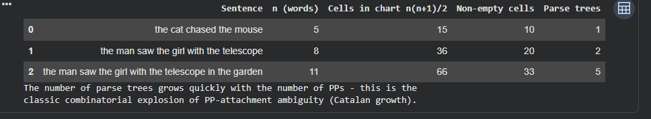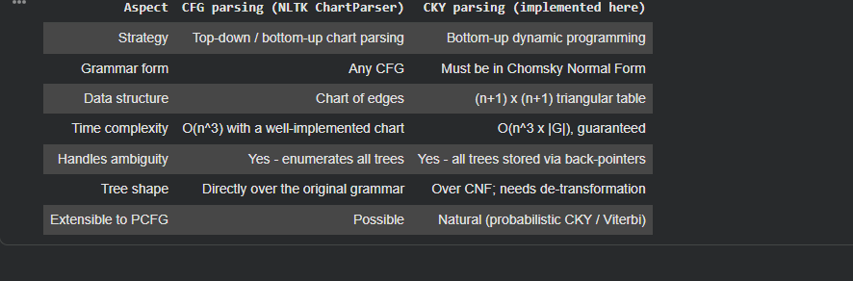

Post Lab Subjective/Objective type Questions:
- Explain the difference between constituency parsing and dependency parsing.
Constituency Parsing vs Dependency Parsing
Constituency Parsing: Divides a sentence into phrases or constituents such as Noun Phrase (NP) and Verb Phrase (VP).
Dependency Parsing: Shows grammatical relationships between individual words, such as subject, verb, and object.

Example: The boy eats an apple.

Constituency: [NP The boy] [VP eats [NP an apple]]
Dependency: eats is connected to boy (subject) and apple (object).

- How do Probabilistic Context-Free Grammars (PCFGs) improve upon traditional CFG-based parsing? Explain their significance in modern NLP
A CFG defines grammatical rules but does not indicate which valid sentence structure is more likely.

A PCFG adds a probability to each grammar rule. This helps the parser:

Handle syntactic ambiguity.
Rank multiple possible parse trees.
Choose the most probable parse.
Learn probabilities from language data.

Significance: PCFGs made parsing more statistical and data-driven, improving the handling of ambiguous sentences and forming an important foundation for modern NLP parsing techniques.

Conclusion:
In this experiment a Context-Free Grammar for a fragment of English was defined and used to parse sentences syntactically. The grammar was converted to Chomsky Normal Form by implementing the TERM, BIN and UNIT steps from scratch, and the conversion was verified to produce only A -> B C and A -> w rules. The CKY algorithm was then implemented as a bottom-up dynamic-programming parser: the (n+1)×(n+1) chart was filled span by span, the presence of the start symbol S in the top-right cell was used to accept or reject a sentence, and back-pointers stored during the fill were used to recover every parse tree.

The parse trees recovered by CKY were shown to be string-identical to those produced by NLTK's ChartParser over the original grammar, which confirms that the CNF conversion preserves the language and that the de-transformation correctly restores the original tree shape. Ambiguity was analysed on "the man saw the girl with the telescope" and "I shot an elephant in my pajamas": each received two parse trees corresponding to the two possible attachment sites of the prepositional phrase, demonstrating that a CFG can detect ambiguity but cannot resolve it — the motivation for probabilistic grammars (PCFGs) discussed in the post-lab questions.

Overall, the experiment showed how a formal grammar, a normal form and a dynamic-programming algorithm combine into a working syntactic parser, and why the O(n3×|G|) CKY recurrence remains the standard inference procedure for constituency parsing.

