Course Name: | Natural Language Processing | Semester: | VII
Date of Performance: | ___ / ___ / ______ | DIV/ Batch No:
Student Name: | Piyush Chaudhary | Roll No: | 16010123234

Experiment No: 7

Title: Implementation of an Attention-Based Sequence-to-Sequence Neural Network

Aim: To implement an Attention-based Sequence-to-Sequence (Seq2Seq) neural network for sequence generation tasks and analyze the impact of the attention mechanism on model performance.

Objectives of the Experiment:
By the end of this experiment, students will be able to:
- Understand the architecture of the Sequence-to-Sequence (Seq2Seq) model.
- Explain the limitations of vanilla Seq2Seq models without attention.
- Implement an encoder-decoder architecture using LSTM.
- Integrate an attention mechanism into the Seq2Seq model.
- Train the Attention-based Seq2Seq model for a sequence generation task.
- Visualize and interpret attention weights.
- Evaluate the performance of the model using appropriate evaluation metrics.

COs to be achieved:
CO4: Understand and apply neural language models, including RNNs, LSTMs, and attention mechanisms, for various sequence-based NLP tasks

Books/ Journals/ Websites referred:
- Bahdanau, D., Cho, K., Bengio, Y. (2015). Neural Machine Translation by Jointly Learning to Align and Translate. ICLR. arXiv:1409.0473.
- Luong, M.-T., Pham, H., Manning, C. D. (2015). Effective Approaches to Attention-based Neural Machine Translation. EMNLP. arXiv:1508.04025.
- Sutskever, I., Vinyals, O., Le, Q. V. (2014). Sequence to Sequence Learning with Neural Networks. NeurIPS. arXiv:1409.3215.
- Hochreiter, S., Schmidhuber, J. (1997). Long Short-Term Memory. Neural Computation, 9(8).
- Papineni, K., Roukos, S., Ward, T., Zhu, W.-J. (2002). BLEU: a Method for Automatic Evaluation of Machine Translation. ACL.
- Vaswani, A. et al. (2017). Attention Is All You Need. NeurIPS. arXiv:1706.03762.
- Tatoeba / ManyThings bilingual sentence pairs: https://www.manythings.org/anki/
- PyTorch documentation: https://pytorch.org/docs
- NLTK bleu_score module: https://www.nltk.org

Theory:

1. Introduction
A Sequence-to-Sequence (Seq2Seq) model is a deep learning architecture that maps an input sequence to an output sequence of variable length. Unlike text classification, where the output is a single label, Seq2Seq models generate an entire output sequence token by token.
Typical applications include:
- Machine Translation
- Text Summarization
- Dialogue Systems
- Question Answering
- Speech Recognition
- Code Generation
A Seq2Seq model consists of two components:
- Encoder: Converts the input sequence into hidden representations.
- Decoder: Generates the output sequence using the encoder information.
2. Vanilla Seq2Seq Architecture:
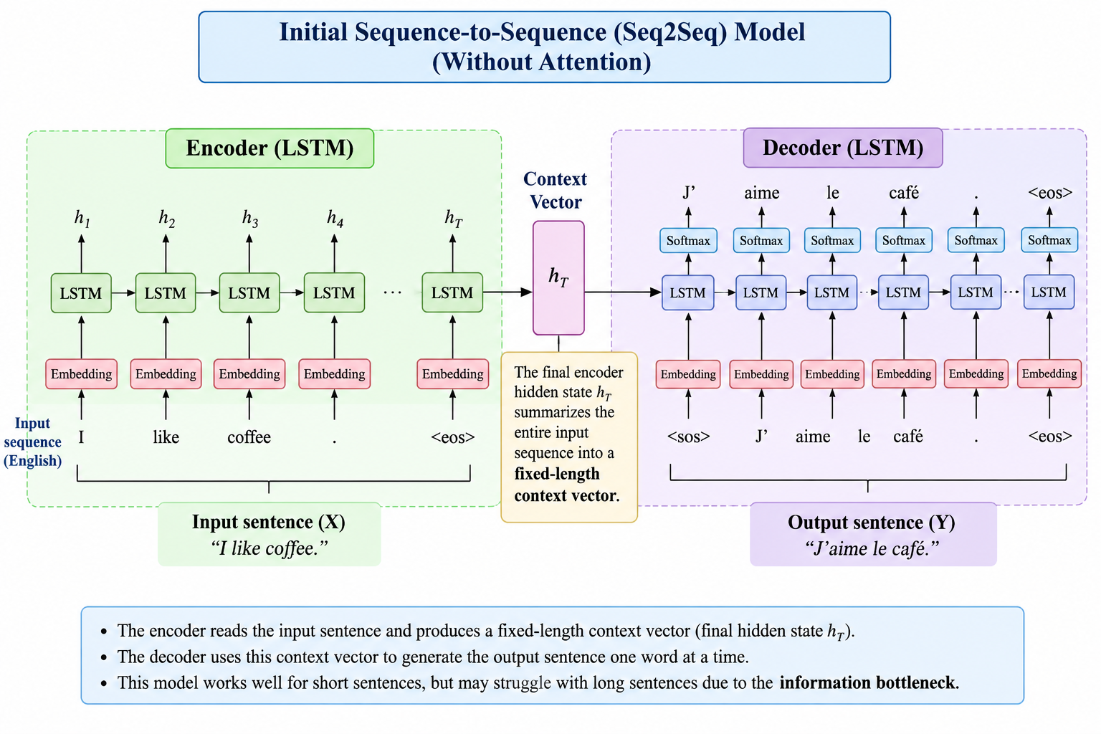
The encoder reads the input sentence one word at a time and generates hidden states.
For an input sequence
$X=(x1,x2,…,xT)$
the encoder computes
$ht=f(xt,ht-1)$
where
- $xt$ = input word
- $ht$= hidden state
- $f(⋅)$ = LSTM unit
The final hidden state $hT​$, is called the context vector, which is passed to the decoder.
The decoder predicts one output word at a time:
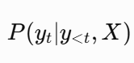

3. Limitation of Vanilla Seq2Seq
The encoder compresses the entire input sentence into a single fixed-length context vector.
As the sentence length increases,
- information loss increases,
- long-distance dependencies become difficult to learn,
- translation accuracy decreases.
This problem is known as the information bottleneck.

4. Attention Mechanism
Instead of relying only on the final encoder state, the decoder dynamically focuses on different encoder hidden states while generating each output word.
For decoder time step $t,$
the decoder hidden state is $st$
The encoder hidden states are $h1​,h2​,…,hT$​

Step 1: Alignment Score
For each encoder hidden state,
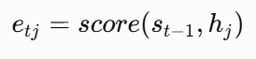
where
- $etj = alignment score$
- $st-1= previous decoder hidden state$
- $hj = encoder hidden state$
The score measures how relevant each input word is to predicting the next output word.

Step 2: Attention Weights
The alignment scores are normalized using the Softmax function.
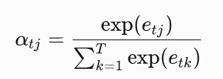
Where
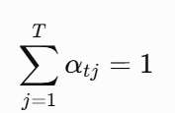
The attention weights indicate the importance of each input word.

Step 3: Context Vector
The context vector is computed as a weighted sum of all encoder hidden states.
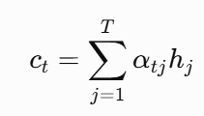
This allows the decoder to utilize information from the entire input sequence.

Step 4: Decoder Prediction
The decoder combines the previous hidden state and the context vector.
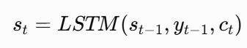
The probability of the next word is:
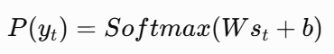
Complete Attention Pipeline is shown in diagram below:
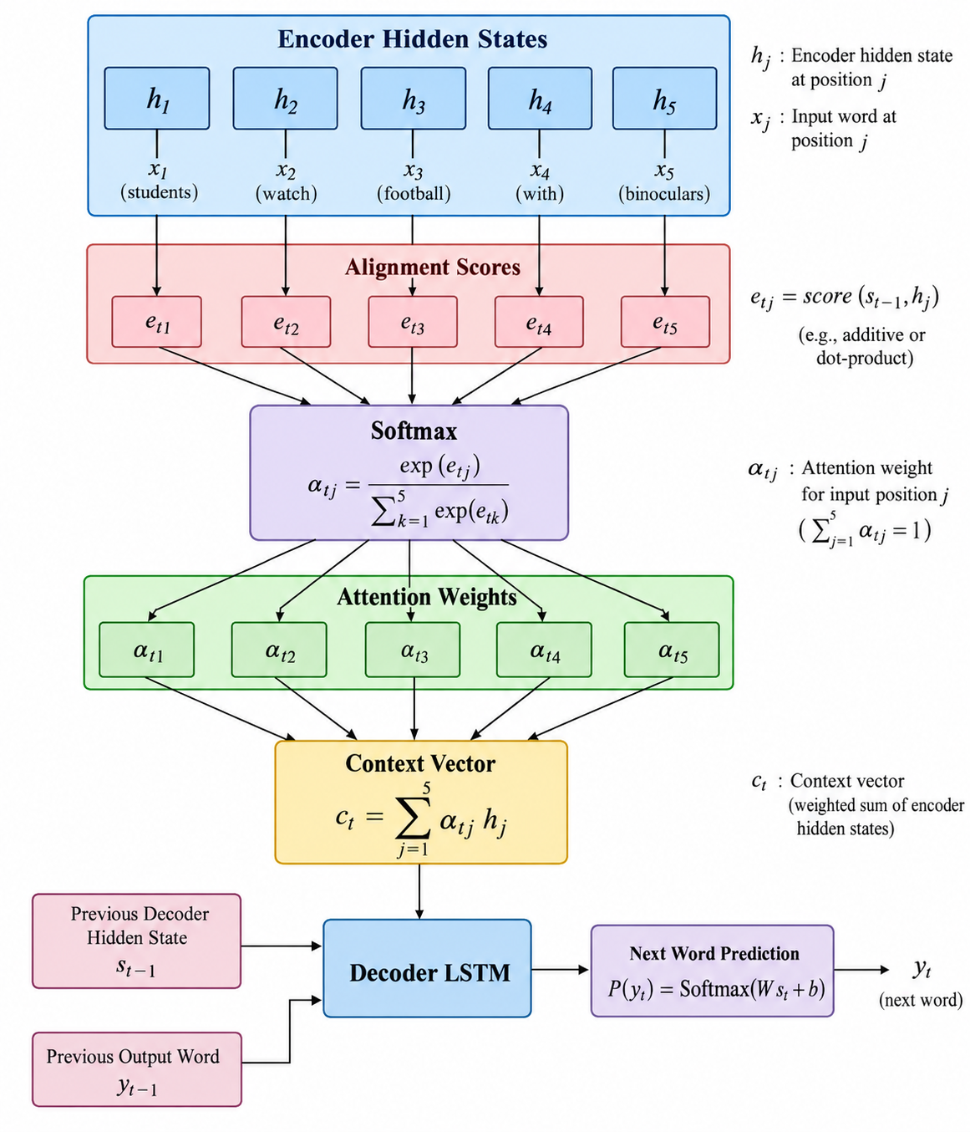

5. Bahdanau (Additive) Attention
The alignment score is
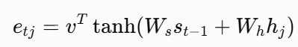
Where
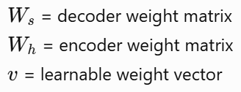
Advantages
- Better for long sequences.
- More accurate alignment.
- Used in the original Attention paper.

6. Luong (Multiplicative) Attention
The alignment score is:
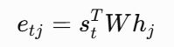
Advantages
- Computationally faster.
- Simpler implementation.
- Widely used in practical Seq2Seq models.
7. Applications
Attention-based Seq2Seq models are used in:
- Neural Machine Translation
- Text Summarization
- Speech Recognition
- Dialogue Systems
- Image Captioning
- Question Answering

8. Advantages of Attention
- Eliminates the fixed-length context vector bottleneck.
- Improves translation quality for long sentences.
- Learns alignments between source and target words.
- Provides interpretable attention weights.
- Forms the foundation of modern Transformer architectures.

Problem statement/ Tasks:
Students are required to perform the following tasks:

Dataset Preparation
- Download the ManyThings English–French Translation Dataset.
- Load the English–French sentence pairs.
- Select the first 1000–2000 sentence pairs.
- Split the dataset into training and testing sets.

Text Preprocessing
- Convert text to lowercase.
- Tokenize English and French sentences.
- Build source and target vocabularies.
- Convert words into integer sequences.
- Apply sequence padding.

Encoder Implementation
- Implement an LSTM-based encoder.
- Generate encoder hidden states and the final hidden state.

Decoder Implementation
- Implement an LSTM-based decoder.
- Initialize the decoder using the encoder output.

Attention Mechanism
- Compute attention scores between the decoder hidden state and encoder hidden states.
- Apply Softmax to obtain attention weights.
- Generate the context vector.
- Predict the next target word.

Model Training
- Train the Attention-based Seq2Seq model.
- Monitor the training and validation loss.

Model Evaluation
- Generate translations for unseen English sentences.
- Evaluate the trained model using BLEU Score.
- Visualize attention heatmaps.
- Compare the performance of:
- Vanilla Seq2Seq model
- Attention-based Seq2Seq model
- Analyze at least three incorrect translations and discuss possible reasons along with suggestions for improving translation quality.

Dataset Details :
ManyThings English–French pairs (fra-eng.zip → fra.txt), built from Tatoeba translations.
- Format: one pair per line, tab-separated: English, French, attribution (ignored).
- Size: 200,000+ pairs in total; the lab uses the first 2000.
- Order: sorted shortest to longest, so the first 2000 are mostly 1–3 word sentences.
- Duplicates: the same English sentence often has several French translations.
- Licence: CC BY 2.0 (France), Tatoeba.org.

Code :
Colab

Output:
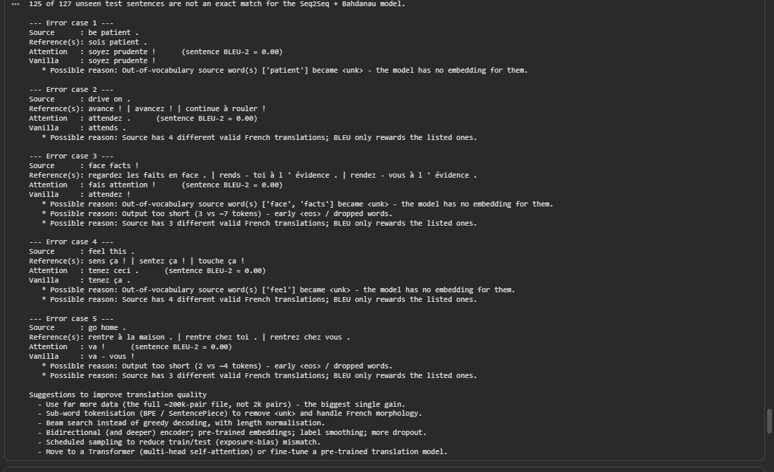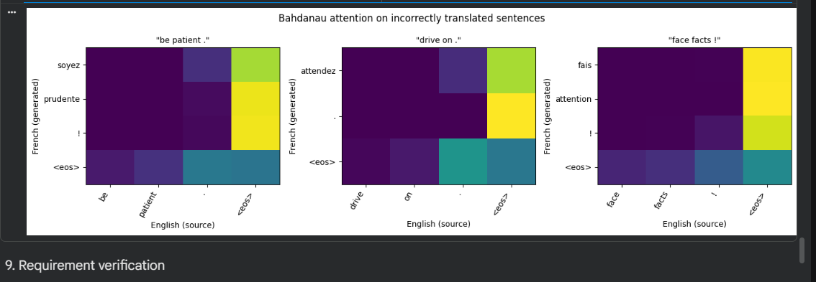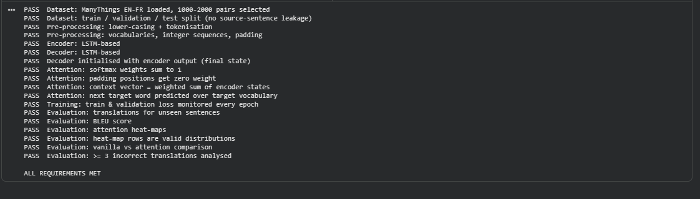

Post Lab Questions:
- Compare Seq2Seq models with and without attention.

Aspect | Vanilla Seq2Seq | Seq2Seq + attention
Source information | One fixed-length context vector (the final encoder state) | A new context vector at every decoding step, a weighted sum of all encoder states
Bottleneck | The whole sentence is squeezed into one vector, so information is lost on long inputs | No bottleneck; the decoder can look back at any source word
Long sentences | BLEU drops as length grows | Much more stable
Alignment | None, no link between target and source words | Learns soft source–target alignments
Interpretability | Black box | Attention weights and heatmaps can be inspected
Training | Simpler, fewer parameters | Slower to train, but usually converges faster and to a lower loss

- Explain the limitations of Attention-based Seq2Seq models.

- Cost: extra computation and memory, since scores are computed for every target–source pair. This hurts very long inputs.
- Sequential computation: the LSTM is still sequential, so it cannot be parallelised over time and is slow to train compared with Transformers.
- Still data-hungry: with small data it still makes lexical, gender and number errors. Rare and out-of-vocabulary words are mapped to <unk>.
- Attention is not a perfect explanation: high weights do not always mean a word caused the output. Alignments can be noisy and can repeat or skip words (over- and under-translation).
- Long-range limits remain: the encoder LSTM still has to carry information, and very long documents are still hard.
- Exposure bias and greedy decoding: training with teacher forcing does not match test time, and errors compound.
- Fixed word-level vocabulary: morphologically rich or unseen words are not handled, so you need subwords such as BPE.

Conclusion:
In this experiment I implemented an English→French Seq2Seq model with an LSTM encoder and decoder, then added Bahdanau and Luong attention, and trained all three on [N] sentence pairs from the ManyThings dataset. On the unseen test set, the vanilla model reached BLEU-4 of [x], Bahdanau attention [y] and Luong attention [z], with best validation losses of [a], [b] and [c] respectively. [Attention improved on the vanilla model by about [Δ] BLEU points / The three models performed similarly, because the sentences in the selected subset are very short and the single context vector is not yet a bottleneck.] The heatmaps showed the decoder attending to the matching English words as it generated each French word, for example [word pair from your alignment printout]. The main errors, such as [example], came from [out-of-vocabulary words / rare words / wrong gender or number / repeated tokens]. Attention is a clear step up in interpretability and, on longer sentences, in accuracy, but it adds computation and still depends on enough data. Larger datasets, subword tokenisation, beam search and Transformer models would improve the results further.

