

**:**

## Project Report on Grocery website

**Submitted By**

Name: Sumit Bisht, Piyush Dhiman, Nitin

Registration no: 12213934, 12213845, 12211510

Program Name: bachelor of technology

(Computer science and engineering)

Under the guidance of

Dr. Muhammad Faiz

School of computer science and engineering

# ACKNOWLEDGEMENt



Primarily I would like to thank God for being able to learn a new technology. Then I would like to express my special thanks of gratitude to the teacher who provide me the golden opportunity to learn a new technology from home.

I would like to also thank my own college Lovely Professional University for offering such a course which not only improve my programming skill but also taught me other new technology. Then, I would like to thank my parents and friends who have helped me with their valuable suggestions and guidance for choosing this course. I am making this project not only for marks but to also increase my knowledge.

THANKS AGAIN TO ALL

### INDEX

### ACKNOWLEDGEMENT

### INTRODUCTION

### CONTENT

### SCREENSHOTS

### CONCLUSION

### REFERENCES

INTRODUCTION

1. Ever since the evolution of smart technology, it has been way easier to access data online through various devices, be it for work, or for entertainment. Advance in technology eases people from doing some mundane tasks. Online grocery store is one which helps people to get groceries to their door step on one click. It facilitates customers to view products available online, submit online orders for items and/or services from a store that serves both walk-in customers and online customers. This web-based application helps customers to choose their daily needs and add products to their shopping cart. Our project is to build one such online Grocery store named “shop it”.
2. PROJECT DESCRIPTION: This project has been divided into two modules namely admin module and customer/user module. • Administrator When the web user sign in as an administrator, he/she acquires access rights to add new brands, add new products, delete the existing product and can also update the existing product details. The administrator also can also view/edit the details regarding the quantity of grocery products in stock. The groceries added by the administrator will be visible both to the administrator and the regular website customers/visitor.

CONTENT

1.PROJECT FEATURES: This project facilitates many functionalities which user admin can perform. Detailed description of the functionalities is given below: a. User functionalities:

• Index page: This is the first page we come up when website is opened (i.e., home page). It displays all the products available with product image, title, price details with an add to cart option below. On this page, users can not add an item to cart or make any purchases until they are logged in. For that purpose, user needs to sign in using his/her login credentials. This page will also have sign in and signup links.

• Login: User needs to enter username and password. If username and password provided are valid then user will be successfully logged into website. Otherwise, error message will be displayed.

• Home Page: This page displays all the available products along with its name, price, image and an add to cart button for each product. As this page can be viewed only after logging in, user can add products to cart, checkout, and place orders.

• Search: Users can search through the products using search keywords. These keywords are provided along with the product details by admin when he adds the product to the store. Product search keywords include product name, brand and the product related keywords which can making the searching process much more efficient.

• Cart: Every product has an add to cart button below it. By clicking this button, the grocery product is added to the user’s cart. The user can find the product the added to cart by clicking on the cart link. We can also delete or update product quantity before checkout. After the user checks out, an order is placed and cart is cleared.

• View products: Admin can view all the products stored in the database.

• Add products: To add a new product, admin provides details like product title, product price, available product quantity, product image, product brand, product category and product search key words.

• Delete Product: Administrator is given all the rights and privileges to delete any product from the database. The deleted product is not showed on the user interface anymore. This functionality will be useful when the production of product is stopped or banned due to certain reasons. In these scenarios admin can delete it so that will not be able to purchase it.

• Logout: When admin logs out, page will be redirected to index page where the home page/index page will be displayed.

2. Technologies used are HTML, CSS and Javascript. have been used to develop html pages on front end. Client-side form validation is done using Query. AJAX has been used to make server-side calls from client side. MYSQL has been used for database. MAMP server has been used for PHP and MySQL.

Screenshots:

Home page:

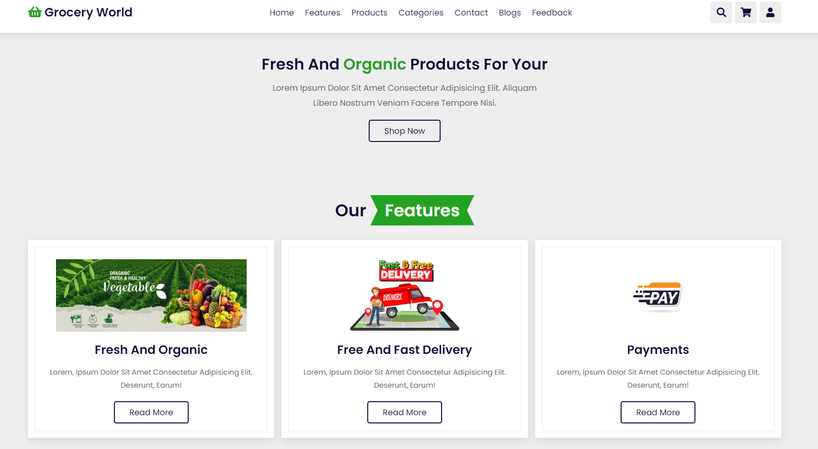

Login page:

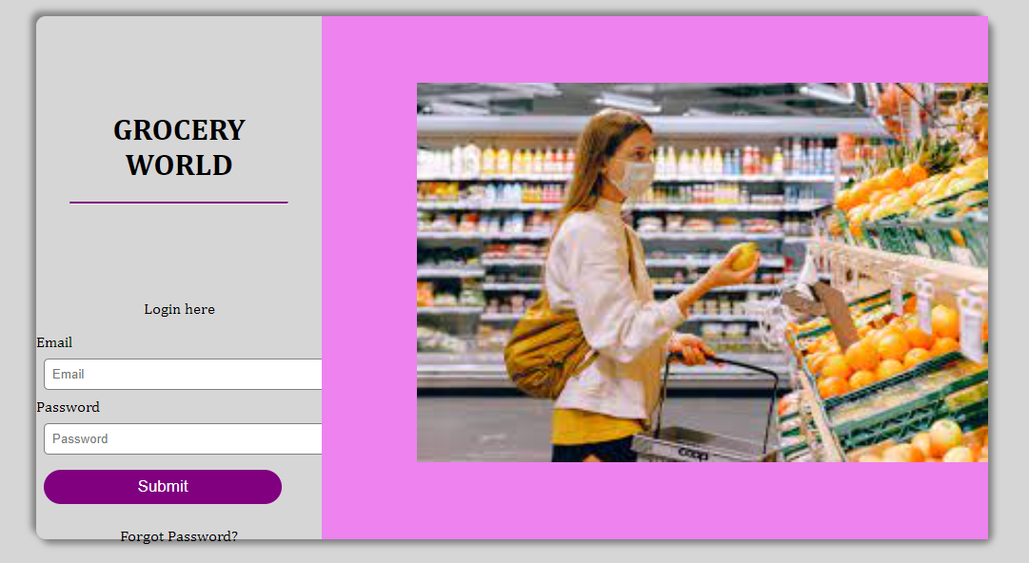

PRODUCTS PAGE:

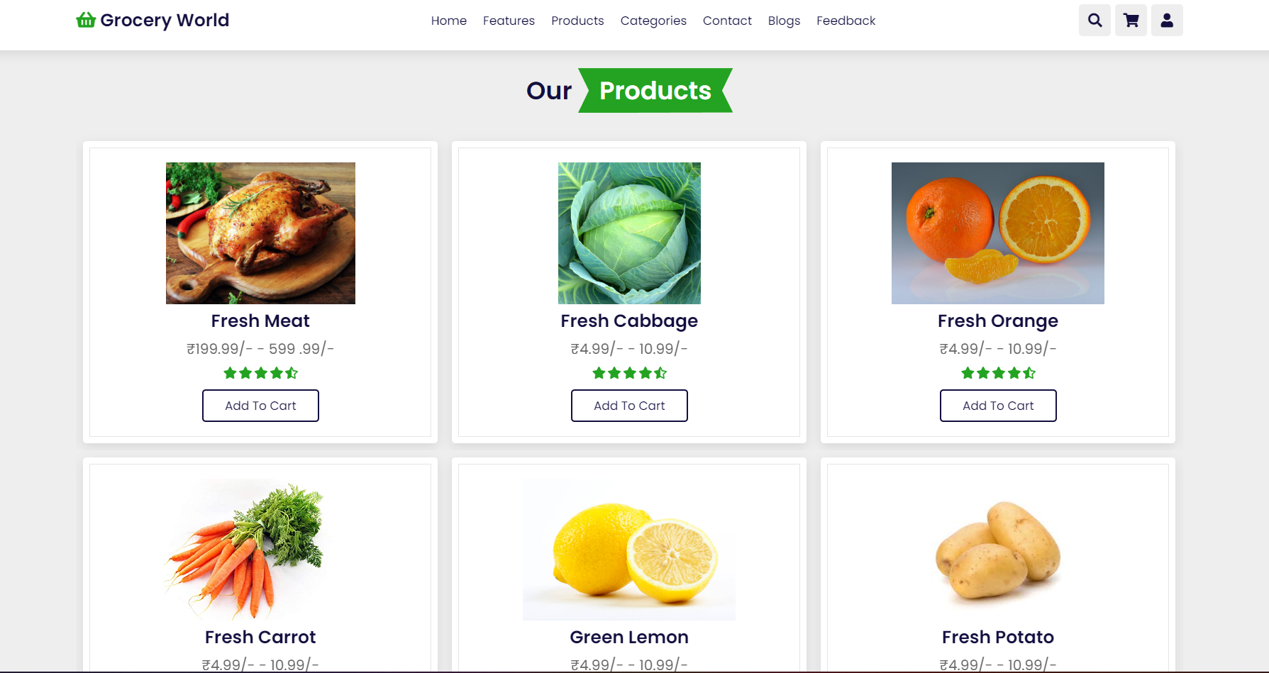

## 

### Contact page:

***Conclusion:***



In recent days, we can see every store has online website. This is currently in high demand because it caters to all basic needs of people. This project consists of all the basic functionalities like login, signup, purchasing items, viewing functionality and admin functionalities. These functionalities can be further extended to implement multiple filtering options simultaneously. ARPA grocery store helps users to order items from anywhere to any location. Hence, it can be proved that it will be very useful.

***RefeRENCES :***

[www.youtube.com](http://www.youtube.com)

[www.w3schools.com](http://www.w3schools.com)

[www.google.com](http://www.google.com)