CrowdFlow DNA
Software Requirements Document
Graph-Based Crowd Interaction Modeling for Predictive Risk Classification
Document Version: 1.9
Prepared by: Piyush Gupta and Aayushi Gupta
Date: July 10, 2026
Classification: PORTFOLIO

Table of Contents

1. Introduction

1.1 Purpose
This Software Requirements Document (SRD) defines the functional and non-functional requirements, system architecture, technology stack, and delivery workflow for CrowdFlow DNA, a graph-based crowd interaction modeling system. It serves as the reference blueprint for development, evaluation, and demonstration of the project, and establishes a shared understanding of scope between the developer and any reviewing party.

1.2 Scope
CrowdFlow DNA analyzes an uploaded crowd video to produce risk-classified output, moving beyond simple occupancy counting. The system detects and tracks individuals, constructs a dynamic interaction graph representing spatial and kinematic relationships between people, and applies a Graph Neural Network (GNN) combined with a temporal model to classify localized crowd risk into discrete categories (Safe, Congesting, Critical) over time.
The system is scoped as a portfolio-grade demonstration project. It is explicitly NOT scoped to:
- Provide real-time (live webcam, sub-second-latency) crowd monitoring in its initial release.
- Provide certified, liability-bearing safety guarantees for deployment at real public events.
- Generalize across all venue types without additional domain-specific tuning.
In-scope deliverables include: a trained detection/tracking/graph/GNN pipeline, a deployed inference demo accepting uploaded video, and an annotated output (bounding boxes, interaction graph overlay, risk heatmap, risk timeline).

1.3 Definitions, Acronyms, and Abbreviations
Term | Definition
GNN | Graph Neural Network — a neural network architecture that operates directly on graph-structured data.
GAT | Graph Attention Network — a GNN variant using attention mechanisms to weight neighbor contributions.
MOT | Multi-Object Tracking — assigning persistent identities to detected objects across video frames.
ONNX | Open Neural Network Exchange — an interoperable format for deploying trained models efficiently.
Risk Class | One of three discrete output labels (Safe / Congesting / Critical) assigned per region per time window.
Interaction Graph | A graph where nodes represent tracked individuals and edges represent pairwise relational features (proximity, relative velocity, density gradient).
Sim-to-Real Gap | The performance discrepancy between models trained on simulated data and their behavior on real-world data.
SRD | Software Requirements Document (this document).

1.4 References
- Ultralytics YOLOv8 Documentation — object detection framework.
- ByteTrack: Multi-Object Tracking by Associating Every Detection Box (research paper).
- PyTorch Geometric Documentation — GNN implementation framework.
- PySocialForce (open-source) — pedestrian simulation library based on the Social Force Model (Helbing & Molnár).
- UMN Crowd Activity Dataset and PETS2009 Dataset — public benchmark video with labeled abnormal/escape-panic sequences.

1.5 Overview
Document Structure: Section 2 describes the product overview. Section 3 specifies detailed requirements. Section 4 covers system architecture. Section 5 defines the technology stack. Section 6 outlines development and deployment. Section 7 lists future enhancements. Section 8 provides appendices.

2. Overall Description

2.1 Product Perspective
CrowdFlow DNA is a standalone, self-contained system. It is not an extension of an existing commercial product and has no dependency on proprietary third-party platforms. It is designed as an independently deployable inference pipeline with a lightweight web-based demo interface, intended for portfolio, academic, and technical-interview demonstration contexts.

2.2 Product Functions
- Ingest an uploaded crowd video clip.
- Detect and track individuals across frames.
- Construct and update a dynamic interaction graph over time.
- Classify localized crowd risk (Safe / Congesting / Critical) using a GNN + temporal model.
- Render an annotated output video with overlays (bounding boxes, graph edges, risk heatmap).
- Generate a downloadable risk timeline summarizing risk classification over the clip duration.

2.3 User Characteristics
User Type | Characteristics | Technical Proficiency
Portfolio Reviewer / Interviewer | Evaluates the project for technical depth and correctness; expects a working, explainable demo. | High (technical)
Academic Evaluator | Assesses methodology, data handling, and validation rigor. | High (domain-specific)
General Demo Viewer | Uploads a sample clip to see the system in action via the web UI. | Low to Medium

2.4 Constraints
- Zero monetary budget: all tooling, compute, and hosting must use free-tier services (Google Colab, Kaggle Notebooks, Hugging Face Spaces free CPU tier).
- Free-tier CPU inference at deployment time limits achievable frame rate; real-time (30 fps) live processing is out of scope.
- No access to real stampede/panic-event footage; risk-classification ground truth relies on simulated data (PySocialForce) supplemented by public abnormal-crowd-behavior datasets.
- Session and compute time limits on free-tier Colab/Kaggle constrain single-session training duration and dataset size.

2.5 Assumptions and Dependencies
- It is assumed that public datasets (UMN, PETS2009) remain accessible and licensed for non-commercial academic/portfolio use.
- It is assumed that Hugging Face Spaces free CPU tier provides sufficient memory/runtime for ONNX-exported model inference on short video clips.
- The project depends on continued free availability of Ultralytics YOLOv8, PyTorch Geometric, and PySocialForce as open-source libraries.
- It is assumed that simulated training data provides a reasonable, disclosed approximation of real panic dynamics; this assumption and its limitations are documented rather than concealed.

2.6 Success Criteria
The project is considered successful as a portfolio-grade deliverable when the following criteria are met:
- A working end-to-end demo is publicly deployed on Hugging Face Spaces (free CPU tier) and accepts an uploaded video clip without manual intervention.
- All High-priority functional requirements (FR-001–FR-007) are planned to be implemented and demonstrable on representative test clips.
- Risk classification achieves a minimum weighted F1 score of ≥ 0.75 across Safe / Congesting / Critical classes on held-out simulated and public benchmark clips (see Section 6.6).
- End-to-end processing of a 30-second, 480p clip completes within the target processing time defined in Section 3.2.1 on the deployment CPU tier.
- The detection/tracking stage achieves an acceptable ID-switch rate and MOTA score on the PETS2009/UMN benchmark subset (thresholds defined in Section 6.6).
- The codebase passes CI linting and the automated smoke test (Section 6.2) on every push to main.
- A reviewer or interviewer can understand the system design, methodology, and results from the README and live demo without requiring additional verbal explanation.

2.7 Known Limitations
The following limitations are inherent to the project's zero-cost, portfolio-grade scope and are disclosed rather than concealed:
- Simulated training data (PySocialForce) approximates but does not fully replicate real panic/stampede dynamics; a sim-to-real gap remains, as noted in Section 2.5 and addressed only as future work under Crowd Simulation Learner (Section 7.3).
- The system does not support true real-time or live-camera monitoring in this release; free-tier CPU inference bounds throughput below live frame rates.
- The model has not been validated across all venue types, camera angles, or crowd densities outside the training distribution.
- Risk-class thresholds (Safe / Congesting / Critical) are calibrated on a limited data volume due to free-tier compute and session-time constraints.
- Tracking accuracy degrades under heavy occlusion or extremely dense crowds — an inherent limitation of single-camera, 2D multi-object tracking.
- The system is not certified and must not be relied upon for safety-critical or liability-bearing deployment at real public events (see Section 1.2).
- No multi-camera or cross-camera re-identification support exists in this release (see Multi-Camera Memory, Section 7.2, for the roadmap item).

3. Specific Requirements

3.1 Functional Requirements
Each functional requirement is uniquely identified and prioritized. Priority reflects necessity for a minimum viable demonstrable system (High), a strong demo enhancement (Medium), or an optional refinement (Low).
ID | Requirement | Priority
FR-001 | The system shall accept an uploaded video clip (MP4/AVI) as input via the web interface. | High
FR-002 | The system shall detect all persons present in each processed video frame using an object detection model. | High
FR-003 | The system shall assign a persistent tracking ID to each detected person across consecutive frames. | High
FR-004 | The system shall construct a per-frame interaction graph where nodes represent tracked individuals and edges represent pairwise spatial/kinematic relationships. | High
FR-005 | The system shall compute edge-weight features including inter-person distance, relative velocity divergence, and local density gradient. | High
FR-006 | The system shall process the sequence of per-frame graphs through a Graph Neural Network to produce per-region embeddings. | High
FR-007 | The system shall classify each spatial region, per time window, into one of three risk categories: Safe, Congesting, Critical. | High
FR-008 | The system shall overlay bounding boxes, tracking IDs, interaction-graph edges, and a risk heatmap onto the output video. | Medium
FR-009 | The system shall generate a time-indexed risk summary (timeline) for the processed clip. | Medium
FR-010 | The system shall allow a user to download the annotated output video and the risk timeline as separate files. | Medium
FR-011 | The system shall report processing status (queued, processing, complete, failed) to the user during inference. | Low
FR-012 | The system shall log model configuration, frame sampling rate, and inference duration for each processed request. | Low

3.1.1 Acceptance Criteria
The following acceptance criteria define the observable, testable conditions under which each functional requirement is considered satisfied.
ID | Acceptance Criteria
FR-001 | The system accepts .mp4 and .avi files up to the configured size/duration limit via the web upload control, and rejects any other file type or malformed upload with an explicit, descriptive error (see Section 3.2.4.1).
FR-002 | On a validation set of sampled frames containing visible persons, the detection module returns bounding boxes meeting or exceeding the target recall/precision defined in Section 6.6.
FR-003 | A given individual retains a single, consistent tracking ID across consecutive frames absent full occlusion, with an ID-switch rate at or below the threshold defined in Section 6.6.
FR-004 | For every processed frame, a graph object is produced containing exactly one node per active tracking ID and one edge per qualifying pair within the configured proximity threshold.
FR-005 | Every edge in the interaction graph carries non-null distance, relative-velocity-divergence, and density-gradient values that match expected output on unit-test fixtures.
FR-006 | The GNN inference stage produces a fixed-dimension embedding for every spatial region and time window across all representative test clips, with no unhandled runtime errors.
FR-007 | Pipeline output includes exactly one risk label (Safe, Congesting, or Critical) and one confidence score per region per time window, for the full duration of the clip.
FR-008 | Manual visual review of sampled output frames confirms bounding boxes, tracking IDs, interaction-graph edges, and a risk heatmap are all present and correctly aligned to the underlying frame.
FR-009 | The downloadable risk-timeline artifact contains a time-indexed risk label/confidence entry covering the entire clip duration, with no gaps between time windows.
FR-010 | From the web UI, the user can independently download the annotated video and the risk timeline as two distinct files after processing completes.
FR-011 | The UI displays one of queued / processing / complete / failed at each pipeline-stage transition, verified across at least one successful and one failed run.
FR-012 | A retrievable log entry is created per processed request, containing model configuration, frame sample rate, and total inference duration, sufficient to reproduce a reported issue.

3.2 Non-Functional Requirements

3.2.1 Performance Requirements
- The system shall process a 30-second, 480p video clip (sampled at a configurable frame rate) within ≤ 3 minutes on the deployment CPU tier.
- Frame sampling rate shall be configurable to trade off latency against temporal resolution.

3.2.2 Security Requirements
- Uploaded video files shall not be persisted beyond the duration required for processing and result delivery, unless explicit user consent for retention is given.
- No personally identifiable biometric data (e.g., facial identity matching) shall be extracted or stored; tracking IDs shall be session-scoped and non-persistent across uploads.
- Input validation shall be applied to uploaded files to reject non-video or malformed content.

3.2.3 Usability Requirements
- The web interface shall clearly display processing status and estimated completion state.
- Output overlays (bounding boxes, graph edges, risk heatmap) shall use a consistent, colorblind-considerate color scheme for risk levels.

3.2.4 Reliability Requirements
- The system shall handle malformed or corrupt video uploads gracefully, returning a descriptive error rather than an unhandled failure.
- Processing failures shall be logged with sufficient detail to reproduce the issue.

3.2.4.1 Error Handling
The following table defines the standard error conditions the system shall detect and handle gracefully across the pipeline, extending the reliability requirements above.
Error Condition | Detection Point | System Response | User-Facing Message
Invalid file format (non MP4/AVI) | Upload validation (Ingestion Module) | Reject upload before pipeline execution; no partial job created | “Unsupported file type. Please upload an MP4 or AVI video.”
Corrupt or unreadable video file | Frame extraction (OpenCV) | Abort job, mark ProcessingJob status as failed, log stack trace | “This video file could not be read. Please try re-exporting and re-uploading it.”
No persons detected in entire clip | Detection Module | Complete job normally; return output with empty/'no activity' risk timeline rather than an error | “No persons were detected in this clip. Showing an empty risk timeline.”
Model inference failure (ONNX Runtime error) | GNN Inference Module (GAT + GRU + Classification) | Abort job, mark status as failed, log model/version/input shape for reproduction | “Analysis failed during risk classification. Please try again or contact support.”
Upload exceeds size or duration limit | Upload validation (Ingestion Module) | Reject upload before processing begins | “File exceeds the maximum allowed size/duration of 200 MB / 5 minutes. Please trim the clip.”
Processing timeout on free-tier CPU | Orchestration layer (pipeline-wide watchdog) | Terminate job after configured timeout, mark status as failed, preserve partial logs | “Processing is taking longer than expected and has been stopped. Try a shorter clip or lower resolution.”
Network/connection interruption during upload | Upload validation (web layer) | Discard partial upload; do not create a ProcessingJob record | “Upload was interrupted. Please check your connection and try again.”

3.2.5 Maintainability Requirements
- The codebase shall separate detection, tracking, graph construction, GNN inference, and serving logic into independent, testable modules.
- Model configuration (frame sampling rate, thresholds, risk-class boundaries) shall be externalized to a configuration file rather than hardcoded.

3.2.6 Portability Requirements
- The trained model shall be exported to ONNX format to ensure inference portability across free-tier CPU hosting environments.
- The application shall be containerizable (Dockerfile) to support redeployment across alternative free-hosting providers if required.

3.3 Interface Requirements

3.3.1 User Interfaces
A single-page web interface (Gradio or Streamlit) provides: a video upload control, a processing-status indicator, an annotated-video preview/player, a risk-timeline chart, and download links for output artifacts.

3.3.1.1 UI Wireframes
The wireframe below illustrates the layout of the single-page demo interface: upload and controls on the left, the annotated video preview and risk legend in the center/right, and the time-indexed risk timeline chart across the bottom.
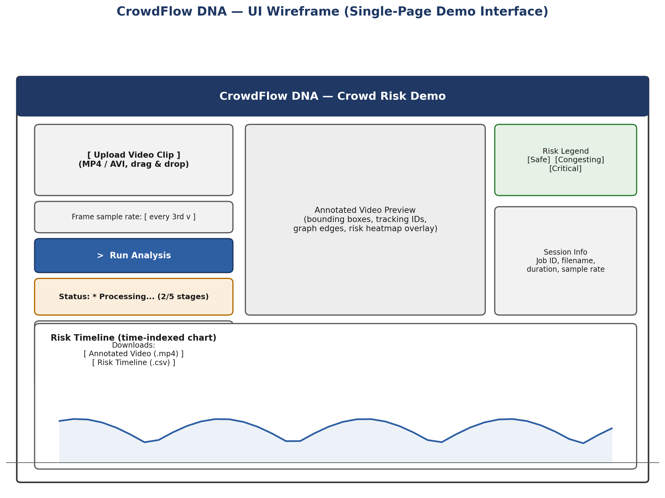
Figure 3.1 — UI wireframe of the single-page demo interface.

3.3.2 Hardware Interfaces
No dedicated hardware interfaces are required. The system does not assume access to live camera hardware in its initial scope; a future live-camera interface is noted in Section 7.

3.3.3 Software Interfaces
Interface | Description
YOLOv8 model | Provides per-frame person detections consumed by the tracking module.
ByteTrack module | Consumes detections, outputs persistent tracking IDs consumed by graph construction.
ONNX Runtime | Executes the exported GNN + temporal model for inference at serve time.
Gradio/Streamlit app | Orchestrates the end-to-end pipeline and renders results to the user.

3.3.4 Communications Interfaces
The web interface communicates with the inference backend over standard HTTPS as provided by the Hugging Face Spaces hosting environment. No custom network protocol is required.

3.4 Data Requirements

3.4.1 Data Model/Schema
Core data entities used across the pipeline:
Entity | Key Fields
Track | track_id, frame_sequence, bounding_box[], centroid[], velocity[]
InteractionGraph | frame_index, nodes[track_id], edges[(track_id_a, track_id_b, distance, relative_velocity, density_gradient)]
RiskClassification | region_id, time_window_start, time_window_end, risk_label {Safe, Congesting, Critical}, confidence_score
ProcessingJob | job_id, input_filename, status, frame_sample_rate, created_at, completed_at

3.4.2 Data Storage and Retrieval
- Training and simulation data (PySocialForce outputs, public dataset clips) shall be stored in versioned local/cloud-notebook storage during development; no paid database is required.
- At inference time, uploaded video and generated outputs shall use ephemeral storage scoped to the processing session.
- No persistent user database is required for the initial release; job status may be tracked in-memory or via a lightweight file-based store.

4. System Architecture and Design

4.1 High-Level Architecture Diagram
The diagram below shows the end-to-end Core Engine pipeline: Video Upload → Frame Extraction (OpenCV) → Person Detection (YOLOv8n) → Multi-Object Tracking (ByteTrack) → Interaction Graph Construction (NetworkX) → GNN + Temporal Model Inference (PyTorch Geometric, exported to ONNX) → Risk Classification & Overlay Rendering → Web UI Output (Gradio/Streamlit on Hugging Face Spaces).
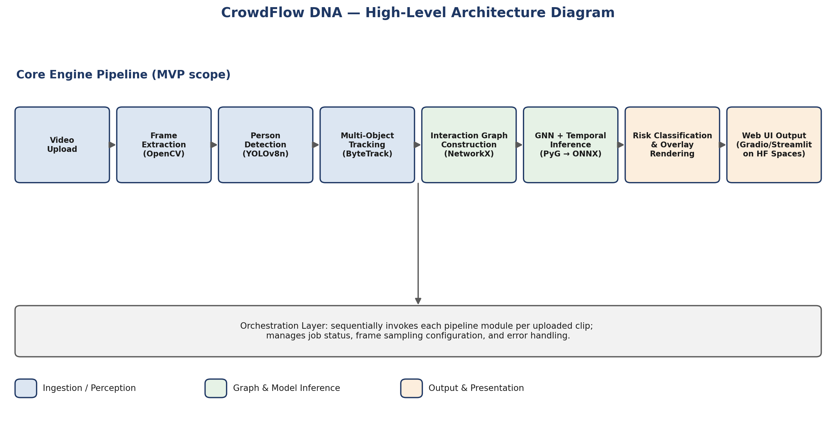
Figure 4.1 — High-level architecture / pipeline diagram.

4.2 Data Flow Diagram
The Level-1 data flow diagram below traces how data moves and transforms between pipeline processes and the data stores defined in Section 3.4.1, from the initial video upload through to the final annotated output.
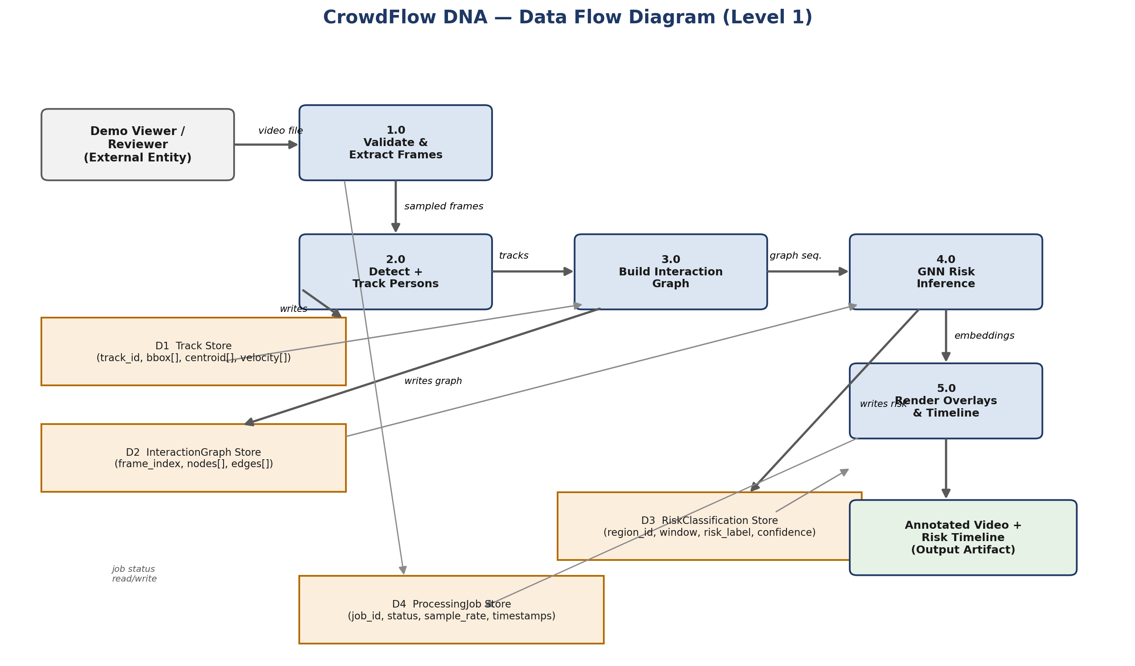
Figure 4.2 — Data flow diagram (Level 1).

4.3 Sequence Diagram
The sequence diagram below explains the end-to-end request flow in temporal order, showing the messages exchanged between the user, the web application, each Core Engine module, and the ProcessingJob store for a single uploaded clip — including the alternate (error) path referenced by the Error Handling table in Section 3.2.4.1.
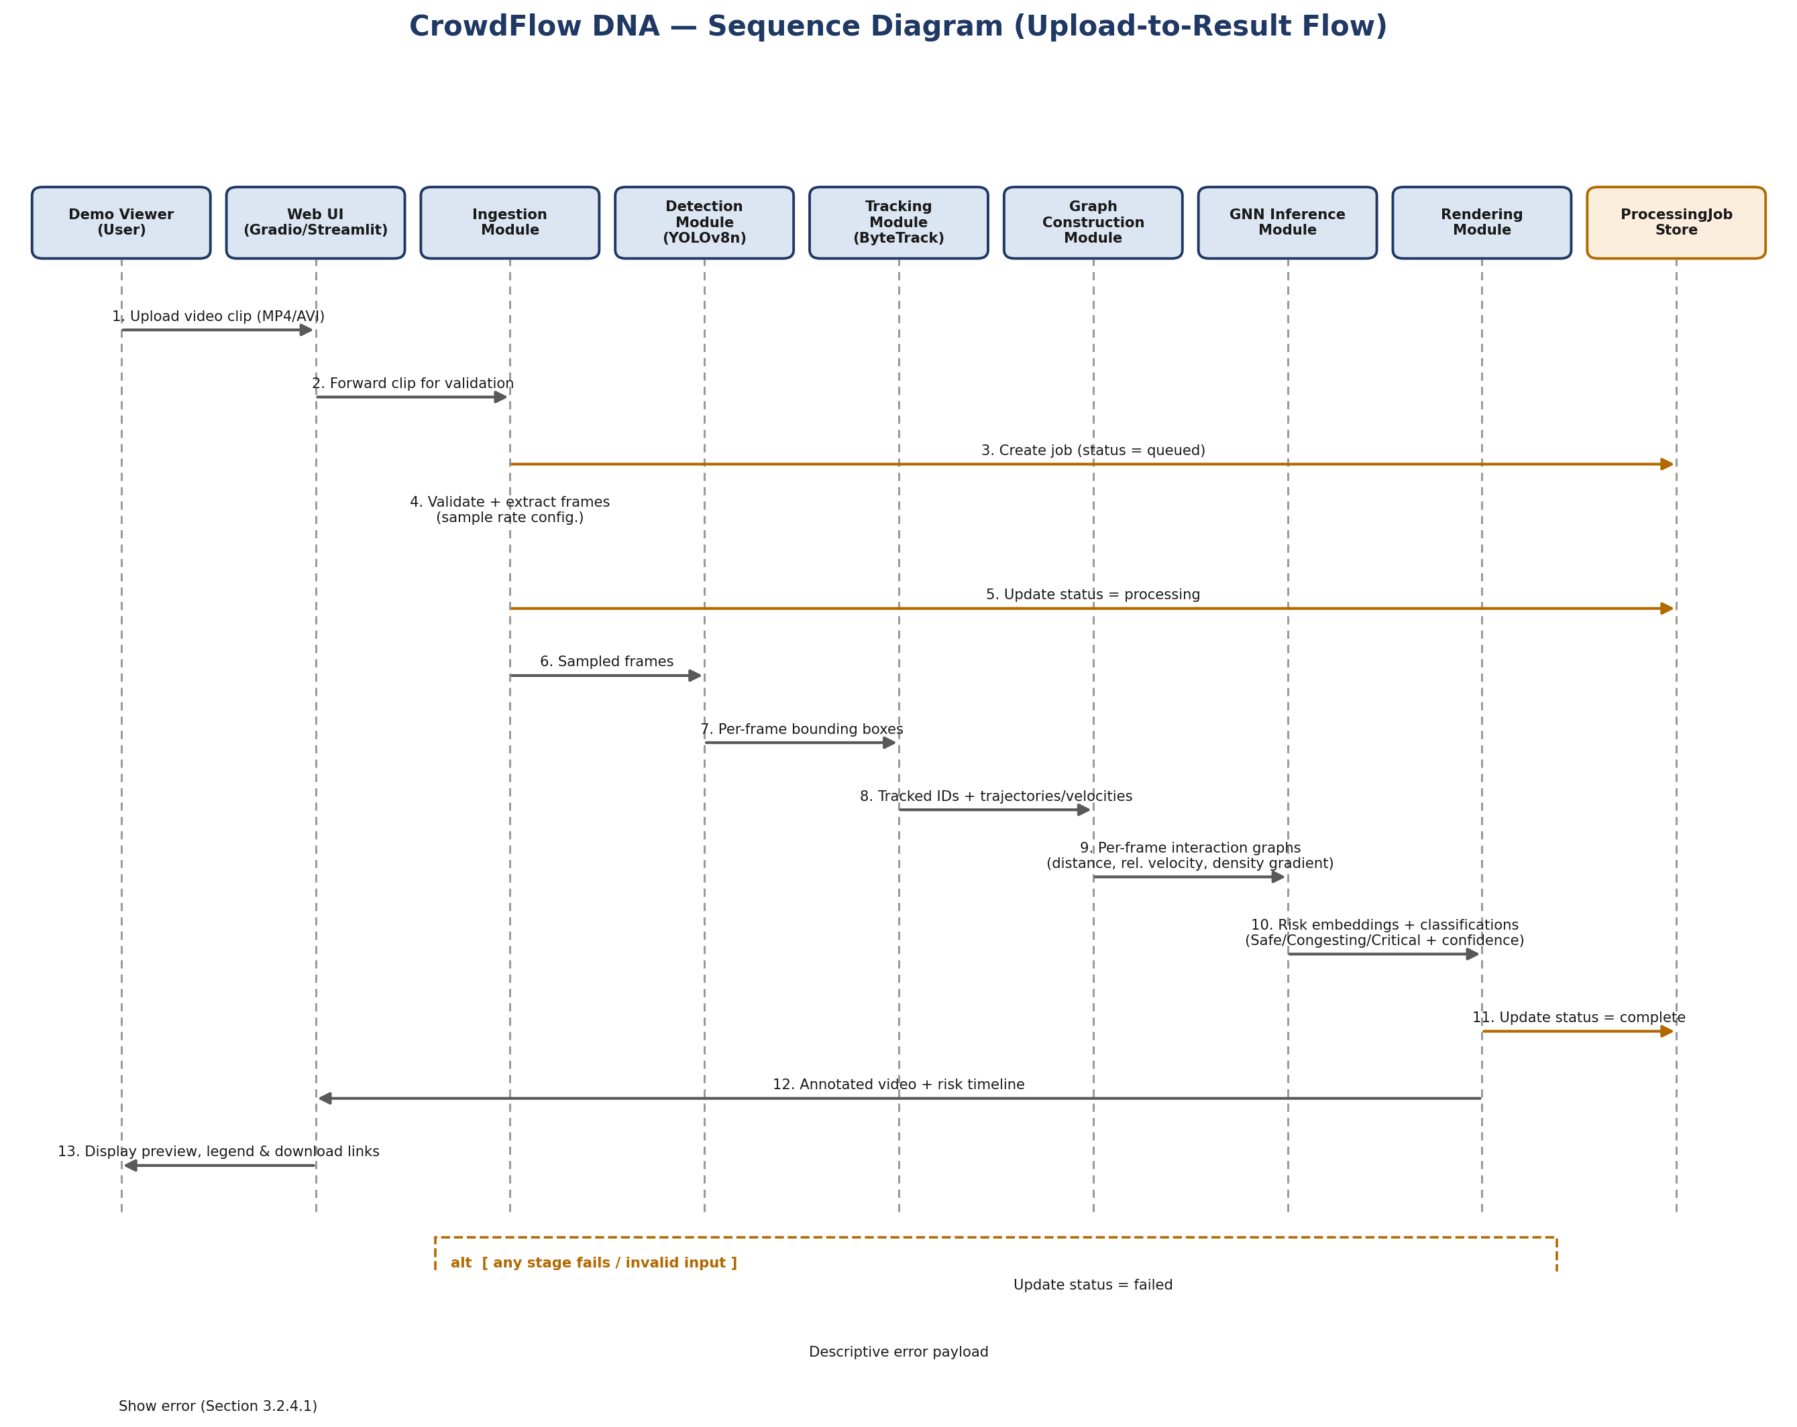
Figure 4.3 — Sequence diagram of the upload-to-result flow, including the error/alt path.
Key points illustrated by the sequence diagram:
- The Web Application Layer (Section 4.5) mediates all communication between the user and the Core Engine modules; no module is called directly by the client.
- The ProcessingJob store (Section 3.4.1) is updated at each major transition (queued → processing → complete/failed), which is what backs the status reporting in FR-011.
- Each module passes its output as input to the next stage in strict sequence (Detection → Tracking → Graph Construction → GNN Inference → Rendering), matching the pipe-and-filter style described in Section 4.4.
- The alt fragment shows that a failure at any stage short-circuits the remaining stages, updates job status to failed, and returns a descriptive error to the user rather than a partial or misleading result (Section 3.2.4.1).

4.4 Architectural Style/Pattern
The system follows a modular pipeline (pipe-and-filter) architecture for its current MVP, rather than a microservices or monolithic web-application pattern. Each stage (detection, tracking, graph construction, GNN inference, rendering) is planned to be implemented as an independently callable module, composed sequentially by an orchestration layer within the demo application. This style was chosen for its simplicity, ease of local testing per stage, and suitability for a single free-tier deployment target.
Beyond the MVP, the project is architected to evolve from a single application into a modular, three-layer platform. This layering is a design and roadmap construct, not a change to the current deployment target: only the Core Engine layer is planned for the present release. The three layers are:
- Core Engine — the planned MVP detection, tracking, interaction-graph, and GNN risk-prediction pipeline described in Sections 3 and 4.5. This is the only layer in scope for the current MVP.
- Intelligence Modules — named, pluggable capabilities built on top of the Core Engine's outputs (tracks, interaction graphs, embeddings). Each module consumes Core Engine output and adds a specific predictive or analytical capability. Detailed in Section 7.2.
- Research Modules — exploratory, long-term capabilities that extend beyond the current data, compute, and scope constraints. Detailed in Section 7.3.
This layered separation allows the Core Engine to remain a small, well-tested, independently demonstrable system, while Intelligence and Research Modules are documented as optional extensions rather than dependencies of the base system.

4.5 Key Components and their Responsibilities
Component | Responsibility
Ingestion Module | Validates and extracts frames from uploaded video at a configurable sample rate.
Detection Module | Runs YOLOv8n inference to produce per-frame person bounding boxes.
Tracking Module | Applies ByteTrack to assign persistent IDs and compute per-track trajectories/velocities.
Graph Construction Module | Builds per-frame interaction graphs from tracked positions using proximity, velocity divergence, and density-gradient features.
GNN Inference Module (GAT + GRU + Classification) | Executes the trained GAT + temporal (GRU) model via ONNX Runtime to produce per-region risk classifications.
Rendering Module | Overlays bounding boxes, graph edges, and risk heatmap onto output video frames; generates the risk timeline.
Web Application Layer | Orchestrates the pipeline end-to-end and presents results through the Gradio/Streamlit interface.

4.6 AI Model Design
This section details the model architecture choices underlying each stage of the Core Engine, expanding on the components introduced in Section 4.5.

4.6.1 Detection
- YOLOv8n (nano variant), pretrained on COCO, used out-of-the-box or lightly fine-tuned on crowd-scene imagery; inference restricted to the 'person' class.
- Confidence threshold is externalized to configuration (Section 3.2.5) to allow tuning precision/recall trade-offs per deployment scenario.
- Architectural choice rationale: YOLOv8n is selected for its balance of detection accuracy and inference speed on CPU-constrained hardware. The nano variant minimises memory footprint while achieving competitive precision on pedestrian detection tasks, making it well-suited to the free-tier deployment environment. Restricting inference to the 'person' class further reduces per-frame latency.

4.6.2 Tracking
- ByteTrack associates detections across frames using a two-stage matching strategy (high-confidence then low-confidence boxes) combined with a Kalman-filter motion model, preserving identity through brief occlusions.
- Architectural choice rationale: ByteTrack is chosen because it achieves strong multi-object tracking accuracy without requiring appearance features (re-ID embeddings), keeping the implementation lightweight and dependency-free. Its two-stage matching strategy — associating high-confidence detections first, then recovering low-confidence boxes — improves track continuity under partial occlusion, which is common in dense crowd scenes.

4.6.3 Interaction Graph Construction
- Nodes represent tracked individuals present in a given frame; edges connect pairs within a configurable proximity radius.
- Edge features: inter-person distance, relative velocity divergence, and local density gradient (Section 3.1, FR-005).
- Graph Construction Method: Edges are created between any two tracked individuals whose centroids fall within a configurable proximity radius (distance threshold). This radius-based approach is chosen for its simplicity and direct correspondence to physical crowd proximity, which is a primary indicator of congestion risk. The radius value will be treated as an externalized configuration parameter (Section 3.2.5) to allow tuning per venue type and camera resolution.
- Planned Node Features: Each node in the interaction graph represents one tracked individual and is planned to carry the following per-frame features:
- (a) 2D centroid position (x, y) in image coordinates, normalised to frame dimensions.
- (b) Instantaneous velocity vector (vx, vy), estimated from centroid displacement between consecutive sampled frames.
- (c) Bounding box dimensions (width, height), as a proxy for the individual's apparent size and distance from camera.
- (d) Local crowd density estimate: the count of neighbouring nodes within the proximity radius, normalised by area.
- Planned Edge Features: Each edge between two nodes (individuals within the proximity radius) is planned to carry the following relational features:
- (a) Inter-person distance: Euclidean distance between the two centroids.
- (b) Relative velocity divergence: magnitude of the difference between the two velocity vectors, indicating whether the pair is moving toward or away from each other.
- (c) Local density gradient: change in local density between the two nodes' neighbourhoods, indicating whether the area between them is becoming more or less crowded over time.
- Architectural choice rationale: Graph Attention Network (GAT) is selected as the GNN encoder because its attention mechanism allows the model to learn which neighbouring individuals are most relevant to the risk state of a given node, rather than treating all neighbours equally. During training, GAT learns attention coefficients to dynamically determine the importance of neighboring nodes. This is particularly important in crowd analysis, where a single high-velocity or rapidly-converging pair may dominate the risk signal in an otherwise calm region. GAT's interpretable attention weights also support the planned explainability enhancements noted in Section 7.1.

4.6.4 GNN and Temporal Model
- A Graph Attention Network (GAT) encoder performs message passing (number of rounds to be finalized) over each per-frame interaction graph to produce node/region embeddings.
- A GRU-based temporal layer consumes the sequence of per-window graph embeddings to model how risk evolves over time, rather than classifying each frame in isolation.
- A softmax classification head outputs one of three risk classes (Safe / Congesting / Critical) per spatial region per time window, together with a confidence score derived from the Softmax output probabilities.
- Definition of 'Region': Throughout this document, a region refers to a spatial cell within a uniform grid overlaid on the video frame. For planning purposes, the frame is intended to be divided into a grid of equal-sized cells (e.g., a configurable N×M grid). Each cell constitutes one region. The GNN aggregates embeddings from all tracked individuals whose centroids fall within a given cell to produce a single per-region embedding, which the classification head then maps to a risk label. The specific grid resolution will be determined during implementation based on typical crowd density and frame resolution; it is treated as an externalized configuration parameter. This grid-based definition applies wherever 'per-region risk classification' is referenced in Sections 3, 4, and 6.
- Architectural choice rationale (GRU): A Gated Recurrent Unit (GRU) models temporal risk evolution, capturing sequential state dependencies. GRU is preferred over LSTM for its simpler gating structure, which reduces parameter count and training cost under free-tier constraints (Section 2.4).

4.6.5 Training and Export
- Training uses supervised learning on simulated (PySocialForce-labeled) sequences supplemented with public abnormal-crowd-behavior datasets, using a suitable loss function (e.g., class-weighted cross-entropy or focal loss), to be finalized during experimentation to address class imbalance toward the Critical class.
- The trained PyTorch model is scripted/traced and exported to ONNX for portable, dependency-light CPU inference at serve time (Section 3.2.6).

4.6.6 Training Pipeline
- The planned end-to-end training workflow proceeds through the following ordered stages. This is a design-level description; specific tools, hyperparameters, and dataset statistics will be documented during implementation.
- Stage 1 — Dataset Preparation: Simulated pedestrian trajectories are generated using PySocialForce and risk labels are assigned using simulation-internal state (Section 4.7.2). Public benchmark clips (UMN, PETS2009) are processed and mapped to the three-class schema. The combined dataset is split into stratified train / validation / test sets (Section 4.7.3).
- Stage 2 — Detection and Tracking: YOLOv8n is run on each video clip to produce per-frame person bounding boxes. ByteTrack is applied to assign persistent track IDs and compute per-track velocity vectors.
- Stage 3 — Interaction Graph Construction: For each sampled frame, a per-frame interaction graph is built from the tracked individuals using the proximity-based method described in Section 4.6.3, producing PyTorch Geometric Data objects carrying planned node and edge features.
- Stage 4 — GAT Training: The GAT encoder (Section 4.6.4) is trained on sequences of per-frame interaction graphs using a suitable supervised loss function (e.g., class-weighted cross-entropy or focal loss), to be finalized during experimentation based on class imbalance and validation performance. Interaction graphs are batched using PyTorch Geometric's batching mechanism during training. Training is performed on Google Colab (free GPU tier), where free-tier runtime limits may require multiple training sessions, with checkpointing used to resume training (Section 6.7, R-02).
- Stage 5 — GRU Temporal Modeling: The GRU temporal layer (Section 4.6.4) is trained jointly with the GAT encoder, consuming sequences of per-window graph embeddings to learn risk evolution over time. The combined GAT + GRU + classification head is trained end-to-end.
- Stage 6 — Evaluation: The trained model is evaluated on the held-out test set using the metrics defined in Section 6.6 (Weighted F1, Accuracy, ROC-AUC, MCC, ECE). If time permits after completion of the MVP, an optional graph-feature ablation study may be conducted to evaluate the contribution of individual edge features.
- Stage 7 — Model Export (ONNX): The trained PyTorch model is scripted or traced and exported to ONNX format (Section 4.6.5). The ONNX artifact is validated against the PyTorch model outputs on test samples to confirm numerical equivalence.
- Stage 8 — Deployment: The ONNX model is committed to the project repository. The Gradio web application loads the ONNX artifact via ONNX Runtime at startup and exposes it through the demo interface on Hugging Face Spaces (free CPU tier), as described in Section 6.4.
- Figure 4.4 — Training pipeline: Dataset → Detection (YOLOv8n) → Tracking (ByteTrack) → Interaction Graph Construction → GAT Training → GRU Temporal Modeling → Evaluation → ONNX Export → Deployment (Gradio / Hugging Face Spaces).
Model Component | Architecture | Framework | Purpose
Detector | YOLOv8n (nano) | Ultralytics | Per-frame person bounding-box detection
Tracker | ByteTrack (Kalman filter + IoU matching) | ByteTrack / NumPy | Persistent ID assignment across frames
Graph Encoder | GAT architecture (exact depth to be finalized during implementation) | PyTorch Geometric | Per-frame/per-region embeddings from interaction graph
Temporal Model | GRU | PyTorch | Models risk evolution across time windows
Classification Head | Softmax (3-class) | PyTorch | Safe / Congesting / Critical prediction + confidence
Deployment Artifact | Traced/scripted graph | ONNX / ONNX Runtime | Portable CPU inference at serve time

4.6.7 Out of Scope (AI Model)
The following capabilities are intentionally excluded from the initial MVP and are considered future enhancements:
• Transformer-based temporal models
• Multi-camera tracking
• Person re-identification
• Online/continual learning
• Real-time optimization
• Multi-modal inputs

Table 4.1 — Pipeline Summary
Stage | Input | Output
Detection | Video Frames | Person Bounding Boxes
Tracking | Bounding Boxes | Track IDs
Graph Construction | Track IDs | Interaction Graph
GAT Encoder | Interaction Graph | Graph Embeddings
GRU | Graph Embeddings | Temporal Features
Classification | Temporal Features | Risk Labels
Rendering | Risk Labels | Annotated Video + Risk Timeline

4.7 Dataset Planning
Because no real stampede/panic footage is available (Section 2.4), dataset planning combines simulated ground truth with public benchmark video.

4.7.1 Data Sources
- PySocialForce simulated pedestrian trajectories, with risk ground truth derived from simulation-internal density/velocity-divergence heuristics (rule-based panic/congestion flags).
- UMN Crowd Activity Dataset — public benchmark clips with labeled normal/abnormal crowd behavior.
- PETS2009 Dataset — public multi-view benchmark with pedestrian tracking and crowd-density annotations.

4.7.2 Labeling Approach
- Simulated data is auto-labeled from simulation-internal state (e.g., a panic/escape flag and local density in PySocialForce), avoiding manual annotation cost.
- Public dataset clips are labeled (or use existing published labels where available) for abnormal/escape-panic segments, mapped onto the three-class Safe / Congesting / Critical schema.
- Planned Risk Labeling Methodology:
- Safe: In PySocialForce simulation, frames in which agents move at low velocity, with low local density and no active panic or escape flag, will be assigned the Safe label. For public dataset clips, sequences annotated as 'normal activity' or low-density pedestrian flow will be mapped to Safe.
- Congesting: Simulation frames in which local density exceeds a moderate threshold and relative velocity divergence between neighbouring agents is increasing — indicating compression without active escape — will be labeled Congesting. For public datasets, sequences annotated as 'anomalous' but without clear escape or panic motion (e.g., crowd queuing or slow-flow bottleneck) will be mapped to Congesting where distinguishable.
- Critical: Simulation frames in which the panic or escape flag is active, characterised by high velocity divergence, rapidly increasing local density, and directional fragmentation among agents, will be labeled Critical. For public datasets, sequences annotated as 'escape' or 'abnormal evacuation' (e.g., UMN escape scenarios) will be mapped to Critical.
- The precise simulation-internal thresholds used to separate Congesting from Critical will be defined and documented during the data generation phase (Section 6.1, Phase 5 of the implementation plan) rather than fixed here, to avoid prematurely constraining the labeling schema before the simulation behaviour has been observed. All labeling decisions will be recorded in the dataset manifest (Section 4.7.4) for reproducibility.

4.7.3 Splitting, Balancing, and Augmentation
- Train / validation / test splits are stratified both by risk-class distribution and by data source (simulated vs. public real footage), so validation performance separately reflects in-distribution and sim-to-real generalization (Section 2.5, 2.7).
- The Critical class, naturally rare, is addressed via oversampling and/or class-weighted loss during training (Section 4.6.5).
- Augmentation includes temporal jitter, spatial flips, and simulation-side variation of camera perspective and crowd density to increase scenario diversity within the zero-cost constraint.

4.7.4 Storage and Versioning
- Datasets are versioned in cloud-notebook storage (Colab/Kaggle) during development; a lightweight dataset manifest (source, split, label counts) is tracked in the Git repository instead of raw video, respecting size and licensing constraints (Section 2.5).
Dataset | Source Type | Purpose | Approx. Size | License / Usage Note
PySocialForce Simulation | Synthetic (generated) | Primary labeled training data for all three risk classes | Configurable, generated on demand | Open-source library; generated data is project-owned
UMN Crowd Activity Dataset | Public real-world benchmark | Validation/test for real abnormal-behavior generalization | ~11 short clips (normal + escape scenarios) | Free for non-commercial academic/research use
PETS2009 | Public real-world benchmark | Validation/test; multi-view tracking and density reference | Multiple sequences, several views each | Free for non-commercial academic/research use

5. Technology Stack

5.1 Programming Languages
- Python 3.x — primary language for the entire pipeline (data processing, modeling, inference, serving).

5.2 Frameworks and Libraries
Category | Tools
Detection | Ultralytics YOLOv8 (nano variant)
Tracking | ByteTrack
Graph Construction | NetworkX, NumPy, SciPy
GNN / Deep Learning | PyTorch, PyTorch Geometric (GAT), GRU-based temporal layer
Simulation | PySocialForce
Computer Vision Utilities | OpenCV
Model Deployment Format | ONNX, ONNX Runtime
Web Interface | Gradio (preferred for Hugging Face Spaces) or Streamlit
API Layer (optional) | FastAPI

5.3 Databases
No persistent relational or NoSQL database is required for the initial release. Job/session state, if needed, is managed via lightweight file-based or in-memory storage. SQLite may be introduced in a future iteration if persistent multi-user history is required.

5.4 Cloud Platform/Infrastructure
Purpose | Platform (Free Tier)
Model Training / Experimentation | Google Colab (free GPU tier)
Backup Training Compute | Kaggle Notebooks (free GPU tier, 30 hrs/week)
Application Hosting | Hugging Face Spaces (free CPU tier)
Source Control | GitHub (public repository)

5.5 Other Tools and Technologies
- Docker — containerization for portability across hosting providers.
- GitHub Actions — free-tier CI for automated smoke tests on push.
- Matplotlib/Plotly — risk timeline chart generation.

6. Project Pipeline and Workflow

6.1 Development Workflow
The project follows an iterative, milestone-based workflow suited to a solo-developer portfolio project rather than formal Agile ceremonies. Each milestone corresponds to a pipeline stage (detection → tracking → graph construction → GNN training → deployment), with a working, demonstrable checkpoint at the end of each stage.

6.2 CI/CD Pipeline Overview
- On each push to the main branch, GitHub Actions shall run linting and a smoke test that executes the pipeline on a short sample clip.
- Successful builds shall trigger (manual or automatic) redeployment of the updated Gradio/Streamlit app to Hugging Face Spaces.

6.3 Testing Strategy
Level | Scope | Approach
Unit Testing | Individual functions (e.g., edge-weight feature computation, bounding-box IoU utilities). | pytest
Integration Testing | Detection → Tracking → Graph Construction pipeline correctness on sample frames. | pytest with fixture video clips
End-to-End Testing | Full pipeline from upload to rendered output on representative test clips (real + simulated). | Manual + scripted smoke test in CI
Model Evaluation | Precision/recall/F1 of risk classification against held-out simulated and real labeled clips; ablation of graph-feature contribution. | Offline evaluation notebook

6.4 Deployment Strategy
- The trained PyTorch model shall be exported to ONNX format post-training to minimize inference footprint.
- The Gradio/Streamlit application shall be deployed to Hugging Face Spaces (free CPU tier) as the primary public-facing demo.
- A Dockerfile shall be maintained to allow redeployment to an alternative free-tier host if Hugging Face Spaces limits are exceeded.

6.5 Deployment Diagram
The diagram below shows the physical/environment view of the deployment: training environments feed a versioned ONNX artifact into the GitHub repository, GitHub Actions CI validates and triggers redeployment, and Hugging Face Spaces serves the application to the end user over HTTPS, with a Dockerfile maintained as a portable fallback target.
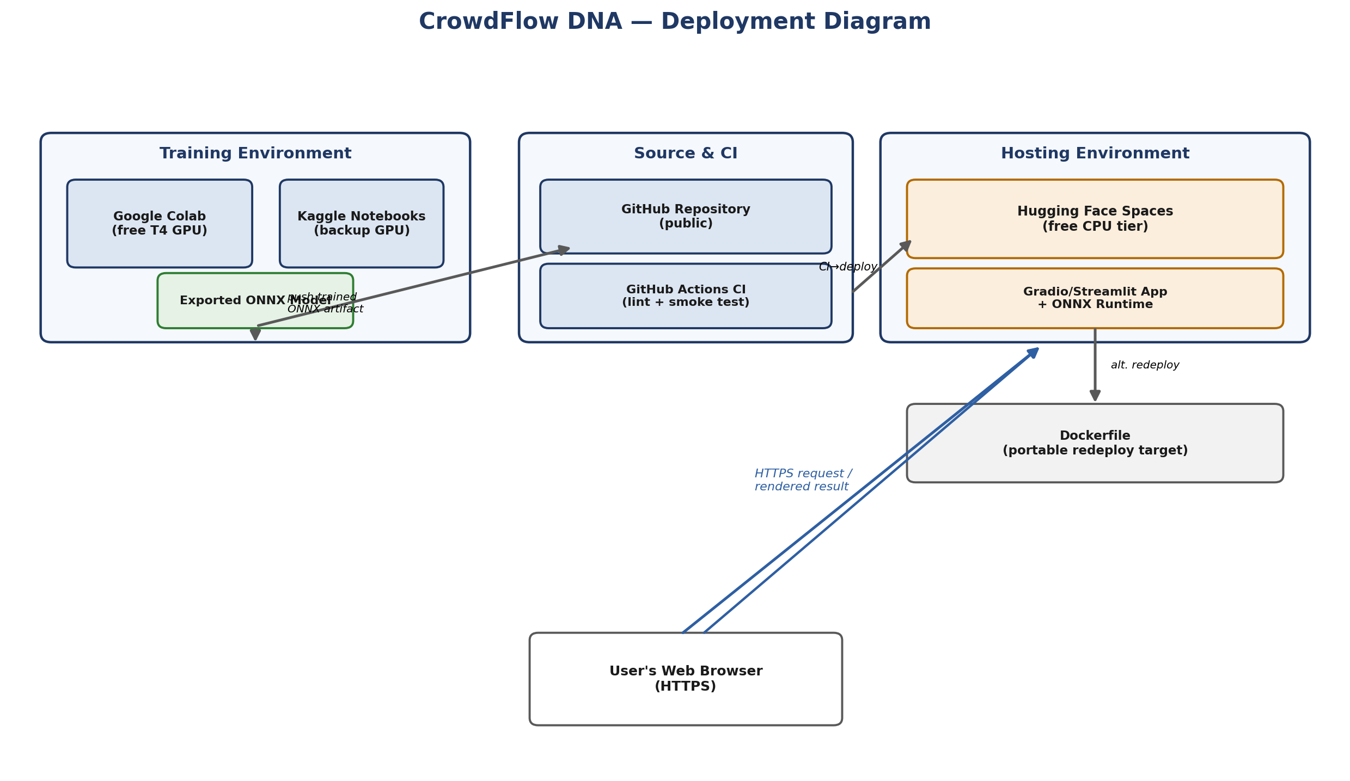
Figure 6.1 — Deployment diagram.

6.6 Evaluation Metrics
This section formalizes the metrics used to evaluate the trained model and the deployed system, and is referenced by the Success Criteria (Section 2.6) and Model Evaluation testing level (Section 6.3).
Metric | Definition | Target / Threshold | Measurement Method
Precision / Recall / F1 (per class + weighted) | Standard classification metrics for Safe / Congesting / Critical predictions | Weighted F1 ≥ ≥ 0.75 | Planned offline evaluation against held-out labeled clips
ROC-AUC (one-vs-rest) | Area under ROC curve for each risk class treated as binary | ≥ 0.85 | Offline evaluation notebook
Matthews Correlation Coefficient (MCC) | Balanced measure robust to class imbalance across the 3-class output | ≥ 0.60 | Offline evaluation notebook
Confusion Matrix | Full breakdown of predicted vs. actual risk class | Reviewed qualitatively, no single threshold | Offline evaluation notebook
Expected Calibration Error (ECE) | Gap between predicted confidence and empirical accuracy | ≤ 0.10 | Offline calibration analysis (Section 7.1 uncertainty estimation)
MOTA / MOTP / ID-switch rate | Standard multi-object tracking accuracy/precision and identity-switch count | ≥ 0.65 / low ID-switch rate | Evaluated against PETS2009/UMN ground-truth tracks
End-to-end latency / FPS | Wall-clock time and effective frame rate for a 30s/480p clip | Meets Section 3.2.1 target | Measured on deployment CPU tier
CPU / memory utilization | Peak resource consumption during inference | Within Hugging Face Spaces free-tier limits | Measured during load/smoke testing
Graph-feature ablation | Change in F1 when removing density-gradient or velocity-divergence edge features | Reported, not thresholded | Offline ablation study

6.7 Risks & Mitigation
The table below identifies key project risks, their likelihood and impact, and the corresponding mitigation strategy adopted, given the project's zero-cost, solo-developer constraints (Section 2.4).
Risk ID | Risk Description | Likelihood | Impact | Mitigation Strategy
R-01 | Sim-to-real gap causes poor generalization to real-world footage | Medium | High | Supplement training/validation with public real datasets (UMN, PETS2009); explicitly document the limitation (Section 2.7); track Crowd Simulation Learner (Section 7.3) as a future mitigation.
R-02 | Free-tier compute/session limits interrupt model training | High | Medium | Checkpoint training runs; use Kaggle as backup compute (Section 5.4); keep model size small (YOLOv8n, shallow GNN).
R-03 | Free CPU hosting tier is insufficient to meet latency targets | Medium | Medium | Export to ONNX for lean inference; make frame sampling rate configurable (Section 3.2.1); document target vs. actual timing.
R-04 | Public dataset license or availability changes | Low | Medium | Cache local copies during development; document the dependency explicitly (Section 2.5).
R-05 | Tracking fails under dense occlusion or extreme crowd density | Medium | Medium | Document as a known limitation (Section 2.7); consider re-identification enhancements under Multi-Camera Memory (Section 7.2) as future work.
R-06 | Hugging Face Spaces free tier is deprecated, limited, or unavailable | Low | High | Maintain a Dockerfile for redeployment to an alternative free host (Section 3.2.6, 6.4).
R-07 | Reviewers misinterpret roadmap items (Section 7) as already delivered | Medium | Medium | Explicit MVP-vs-roadmap labeling in the Section 7 introduction and in Section 4.4's layer description.
R-08 | Malformed or unexpected uploads crash the pipeline | Medium | Medium | Input validation (Section 3.2.2) combined with the standardized Error Handling table (Section 3.2.4.1).

7. Future Considerations / Roadmap
This section documents the project's evolution from a single application into a modular, three-layer platform: the Core Engine (planned MVP), Intelligence Modules (near-to-medium-term, pluggable), and Research Modules (long-term, exploratory). Only the Core Engine is a committed deliverable of the current MVP defined in Section 3. Intelligence and Research Modules are documented to establish architectural direction and research awareness; they should be presented to reviewers as roadmap and vision, not as work completed or in progress.

7.1 Layer 1 — Core Engine (Planned MVP Scope)
The Core Engine is the foundation all other layers build on. It corresponds directly to the functional requirements in Section 3.1, the components in Section 4.5, and the model design in Section 4.6:
- Detection — YOLOv8n person detection per frame.
- Tracking — ByteTrack persistent identity assignment across frames.
- Interaction Graph — per-frame graph construction with proximity, relative-velocity, and density-gradient edge features.
- GNN Risk Prediction — GAT + temporal (GRU) model producing the Safe / Congesting / Critical classification.
Recommended near-term hardening of the Core Engine, feasible within the zero-cost constraint, before building Intelligence Modules on top of it:
- Richer graph edge features — heading similarity, acceleration, trajectory curvature, interaction duration, local clustering coefficient.
- Multi-class risk severity (Very Low / Low / Moderate / High / Critical), extending the existing 3-class output head.
- Basic uncertainty estimation (e.g., MC-dropout or a small ensemble) attached to each risk prediction.
- Explainable AI (feature importance) via torch_geometric.explain or attention-weight visualization on the GAT layer.

7.2 Layer 2 — Intelligence Modules (Near-to-Medium-Term, Pluggable)
Intelligence Modules are independent capabilities that consume Core Engine output (tracks, interaction graphs, risk embeddings) without modifying the Core Engine itself. Each is designed to be addable/removable without breaking the base pipeline.

PanicWave Predictor
- Spatio-temporal risk prediction — forecasting crowd risk state 3–10 seconds ahead of the current frame.
- Early panic prediction and stampede probability estimation, built on the forecasted risk state.
- Risk evolution timeline prediction, extending the existing risk timeline (Section 3.4.1) with a forecast horizon.

Crowd Energy Map
- Perspective-aware density estimation and a continuous crowd 'energy' surface derived from local velocity/acceleration magnitude, as a complement to the discrete risk heatmap.
- Real-time crowd heatmap and region-based risk statistics for the dashboard (Section 3.3.1).

Queue Intelligence
- Bottleneck forecasting and exit-congestion prediction based on flow-rate analysis at defined ROIs.
- Automatic Region of Interest (ROI) detection, to identify queue/choke points without manual configuration.

Conflict Predictor
- Edge risk prediction — anticipating dangerous pairwise interactions before they occur, using the existing interaction-graph edge features.
- Crowd behavior classification (Normal, Congestion, Panic, Evacuation, Bidirectional Conflict).

EscapeRoute Optimizer
- Crowd flow simulation and dynamic evacuation route recommendation, using Core Engine risk output as a cost input to a routing algorithm.

Multi-Camera Memory
- Multi-camera crowd tracking and cross-camera person re-identification, extending single-camera tracking to a multi-view setting.
- Occlusion handling and recovery, improving track continuity within and across camera views.
Supporting analytics and deployment items relevant across Intelligence Modules:
- Explainable risk reports and feature-contribution visualization per module.
- Interaction graph visualization, event replay/playback, and AI decision logs.
- Downloadable analytics report (PDF/CSV) and incident playback interface.
- Cloud-based inference API with REST/WebSocket support, to serve modules independently of the demo UI.

7.3 Layer 3 — Research Modules (Long-Term, Exploratory)
Research Modules require resources (real-world panic/incident data, GPU/edge hardware, multi-camera deployments, or organizational partnership) well outside the current zero-cost, solo-developer scope. They are documented to demonstrate awareness of the broader research space, not as planned work.

CrowdGenome AI
- Crowd behavior embedding / 'Crowd DNA' representation learning.
- Self-supervised pretraining for crowd representation learning, and eventual movement toward a crowd-behavior foundation model.

Crowd Digital Twin
- A persistent, simulation-backed digital twin of a monitored venue, combining live Core Engine output with PySocialForce-based simulation for what-if analysis.
- City-scale crowd intelligence, aggregating multiple venue-level digital twins.

Human Swarm Intelligence
- Swarm intelligence-based crowd modeling and multi-agent AI for crowd simulation, as an alternative/complementary modeling paradigm to the graph-based approach.

Crowd Simulation Learner
- Domain adaptation from simulation to real-world data, directly addressing the sim-to-real gap noted in Section 2.5 and 2.7.
- Active learning and semi-supervised learning pipelines to reduce labeling cost as real data becomes available.
- Continual learning; reinforcement learning for evacuation planning; federated learning (noted as future scope only, given infrastructure demands).

Invisible Leader Detection
- Crowd influence analysis — identifying individuals whose movement disproportionately predicts subsequent crowd behavior.
- Graph centrality and interaction metrics; community detection within crowds, to support influence analysis.
Additional long-term directions noted for completeness, not tied to a specific module above:
- Human intent prediction and crowd emotion estimation.
- Integration with large vision-language models (e.g., LLaVA, Qwen-VL, GPT-4.1 Vision) for scene-level reasoning.
- Autonomous event management assistant.
- Real-time live camera support and edge deployment (e.g., Jetson Orin, Raspberry Pi AI) — contingent on hardware/GPU access outside the current free-tier constraint.
- Kubernetes-based distributed multi-camera processing, as a scaling path once Multi-Camera Memory (Section 7.2) is implemented.

7.4 Evaluation Metrics Roadmap
The current, formalized evaluation metrics used to assess the MVP are defined in Section 6.6. As Layer 1 hardening items (Section 7.1) are added — multi-class severity, uncertainty estimation, explainability — the metric set is expected to expand to include calibration error across additional classes and attention-weight-based explainability scores.

7.5 Scalability Plans
- Migration from CPU-only inference to a paid or sponsored GPU tier if concurrent multi-user demo load, or any Layer 2/3 module, exceeds free-tier capacity.
- Introduction of a lightweight persistent store (e.g., SQLite or another lightweight embedded database) if multi-session history or comparative analysis across uploads is required.
- A plugin-style module interface (each Intelligence/Research module consuming a stable Core Engine output contract) to allow modules to be added without modifying the Core Engine.

8. Appendices

8.1 Glossary
See Section 1.3 (Definitions, Acronyms, and Abbreviations) for core terminology used throughout this document.

8.2 Use Cases

Use Case: Upload and Analyze a Crowd Video Clip
Field | Description
Actor | Demo Viewer / Reviewer
Precondition | User has a video clip depicting a crowd scene in a supported format (MP4/AVI).
Trigger | User uploads the clip via the web interface.
Main Flow | 1) User uploads clip. 2) System validates and extracts frames. 3) System runs detection, tracking, and graph construction. 4) System runs GNN inference to classify risk per region/time window. 5) System renders annotated output and risk timeline. 6) User views and downloads results.
Postcondition | User has access to an annotated video and a risk timeline summarizing the clip.
Exception Flow | If the upload is invalid or processing fails, the system displays a descriptive error and does not produce partial/misleading output (see Section 3.2.4.1).

