Calculation of accuracy and normalized accuracy

Let us suppose that there are two classes of proteins, one class has 10 examples (Positive) and one with 1000 (Negative). Let further suppose that the prediction comes as

True Positive | False Negative | False Positive | True Negative
6 | 4 | 10 | 990

The standard accuracy for the positive class would be:

Acc= (6)/(6+10)= 37.5%

The normalized accuracy will be

nAcc= (6/10)/(6/10 + 10/1000) = 98.4%

For detail description please see:

Pierleoni A, Martelli PL, Fariselli P, Casadio R: BaCelLo: a balanced subcellular localization predictor. Bioinformatics 2006, 22(14):e408-416.

Table S1: List of shared Pfam domains.

 | AAA |  | FH2
 | AAA_5 |  | FKBP_C
 | Acetyltransf_1 |  | Filament
 | Actin |  | GED
 | Adap_comp_sub |  | GTP_EFTU
 | Amidohydro_1 |  | GTP_EFTU_D2
 | Ank |  | GTP_EFTU_D3
 | Arf |  | Gal-bind_lectin
 | ArfGap |  | HATPase_c
 | Arm |  | HEAT
 | B56 |  | HECT
 | BACK |  | HIN
 | BH4 |  | HMG_box
 | BIR |  | HSF_DNA-bind
 | BTB |  | Helicase_C
 | Bcl-2 |  | HhH-GPD
 | Bystin |  | Hydrolase
 | C1_1 |  | I-set
 | C2 |  | IBN_N
 | CARD |  | IFP_35_N
 | CBS |  | IF_tail
 | CRAL_TRIO |  | KH_1
 | CRAL_TRIO_N |  | Kelch_1
 | CSD |  | Kelch_2
 | CUB |  | Kinesin
 | Collagen |  | Kunitz_BPTI
 | DAGK_acc |  | LBP_BPI_CETP
 | DAGK_cat |  | LBP_BPI_CETP_C
 | DEAD |  | LIM
 | DNA_gyraseB |  | LRR_1
 | DNA_topoisoIV |  | Lactamase_B
 | DSPc |  | LisH
 | DUF1055 |  | M
 | DnaJ |  | MATH
 | DnaJ_C |  | MEF2_binding
 | DnaJ_CXXCXGXG |  | MH1
 | Dynamin_M |  | MH2
 | Dynamin_N |  | MIF4G
 | EFG_C |  | MMR_HSR1
 | EFG_IV |  | Mad3_BUB1_I
 | ERG4_ERG24 |  | Metallophos
 | Exo_endo_phos |  | Miro
 | F-box |  | NHL
 | NID |  | SAM_1
 | NTF2 |  | SAM_2
 | NumbF |  | SAND
 | PA |  | SH2
 | PAAD_DAPIN |  | SH3_1
 | PABP |  | SH3_2
 | PAS |  | Sec63
 | PAS_3 |  | Synuclein
 | PB1 |  | TACC
 | PDZ |  | TIG
 | PH |  | TPR_1
 | PID |  | TPR_2
 | POLO_box |  | TPR_MLP1_2
 | PP2C |  | Tap-RNA_bind
 | PUA |  | Tubulin
 | PWWP |  | Tubulin_C
 | PX |  | UBA
 | Peptidase_C48 |  | UCH
 | Peptidase_M1 |  | UQ_con
 | Pkinase |  | Vert_HS_TF
 | Pkinase_C |  | WD40
 | Pkinase_Tyr |  | WW
 | Pox_A_type_inc |  | ZZ
 | Pro_isomerase |  | adh_short
 | RBD |  | bZIP_1
 | RCC1 |  | bZIP_2
 | RGS |  | dNK
 | RHD |  | dUTPase
 | RMMBL |  | dsrm
 | RRM_1 |  | efhand
 | Rap_GAP |  | tRNA_anti
 | Ras |  | ubiquitin
 | RhoGEF |  | zf-B_box
 | Rhodanese |  | zf-C2H2
 | Ribosomal_L7Ae |  | zf-C3HC4
 | Ribosomal_S4 |  | zf-MYND
 | S4

Table S2: Name of exclusive Pfam nuclear domains.
 | 2-Hacid_dh |  | CDI
 | 2-Hacid_dh_C |  | CENP-B_N
 | 3_5_exonuc |  | CHD5
 | A1pp |  | CHDCT2
 | A4_EXTRA |  | CHDNT
 | AAA_3 |  | CITED
 | AAR2 |  | CP2
 | AARP2CN |  | CPSF_A
 | AF-4 |  | CRM1_C
 | AKAP95 |  | CSE2
 | APC8 |  | CTF_NFI
 | APSES |  | CTNNB1_binding
 | AP_endonuc_2 |  | CUT
 | ARID |  | Caudal_act
 | AT_hook |  | CbiA
 | A_deamin |  | Cbl_N
 | AflR |  | Cbl_N2
 | Androgen_recep |  | Cbl_N3
 | AreA_N |  | Cdc6_C
 | Astacin |  | Cenp-B_dimeris
 | Aurora-A_bind |  | CenpB-DNA-bind
 | B-block_TFIIIC |  | Chromo
 | BAF |  | Chromo_shadow
 | BAF1_ABF1 |  | Clp1
 | BAH |  | Cmyb_C
 | BDHCT |  | Copper-fist
 | BOP1NT |  | Coprinus_mating
 | BRCT |  | Cor1
 | BRF1 |  | Creb_binding
 | BSD |  | Cyclin_C
 | Basic |  | Cyclin_N
 | Beta-trefoil |  | DBP10CT
 | Big_2 |  | DDE
 | Brix |  | DDT
 | Bromo_TP |  | DEAD_2
 | Bromodomain |  | DENN
 | C1_4 |  | DIM1
 | CAF1 |  | DKCLD
 | CBF |  | DMAP1
 | CBFB_NFYA |  | DMAP_binding
 | CBFD_NFYB_HMF |  | DNA_RNApol_7kD
 | CDC24 |  | DNA_binding_1
 | CDC45 |  | DNA_ligase_A_C
 | DNA_ligase_A_M |  | Fork_head
 | DNA_ligase_A_N |  | Fork_head_N
 | DNA_methylase |  | FtsJ
 | DNA_mis_repair |  | Fungal_trans
 | DNA_pol_B |  | G-patch
 | DNA_pol_B_exo |  | GAGA
 | DNA_pol_E_B |  | GATA
 | DNA_pol_delta_4 |  | GATA-N
 | DP |  | GCFC
 | DSHCT |  | GCR
 | DTHCT |  | GLE1
 | DUF1086 |  | GRAM
 | DUF1087 |  | GTF2I
 | DUF1227 |  | GUCT
 | DUF1518 |  | Gal4_dimer
 | DUF1546 |  | Gar1
 | DUF1605 |  | Glyco_hydro_35
 | DUF1610 |  | GoLoco
 | DUF1726 |  | HA2
 | DUF1744 |  | HAND
 | DUF1777 |  | HAT
 | DUF592 |  | HCNGP
 | DUF663 |  | HDAC_interact
 | DUF699 |  | HH_signal
 | DUF902 |  | HIRAN
 | DUF906 |  | HLH
 | DZF |  | HMG14_17
 | Dfp1_Him1_M |  | HNF-1A_C
 | Dpy-30 |  | HNF-1B_C
 | E2F_TDP |  | HNF-1_N
 | ELM2 |  | HORMA
 | ERCC4 |  | HRDC
 | ETS_PEA3_N |  | HSA
 | Ebp2 |  | HSBP1
 | Ets |  | HTH_9
 | F-actin_cap_A |  | Hairy_orange
 | FAT |  | Hint
 | FATC |  | Hira
 | FF |  | Hist_deacetyl
 | FHA |  | Histone
 | FTZ |  | Homeobox
 | FYRC |  | Hormone_recep
 | FYRN |  | Hox9_act
 | Fibrillarin |  | IBR
 | Fip1 |  | INCENP_ARK-bind
 | IRF |  | Mog1
 | Isy1 |  | Mpp10
 | JmjC |  | Mre11_DNA_bind
 | JmjN |  | MutL_C
 | Jun |  | MutS_I
 | K167R |  | MutS_II
 | KAR9 |  | MutS_III
 | KIX |  | MutS_IV
 | KOW |  | MutS_V
 | KRAB |  | Myb_DNA-bind_2
 | Kdo |  | Myb_DNA-binding
 | Ku |  | Myc-LZ
 | Ku_C |  | Myc_N
 | Ku_N |  | Myotub-related
 | Ku_PK_bind |  | NAC
 | LAG1-DNAbind |  | NAP
 | LEA_4 |  | NCD1
 | LEM |  | NCD2
 | LIM_bind |  | NGP1NT
 | LNS2 |  | NIC
 | LSM |  | NOG1
 | La |  | NOGCT
 | Linker_histone |  | NOP5NT
 | Lipin_N |  | NOPS
 | Lsm_interact |  | NOSIC
 | M-inducer_phosp |  | NOT2_3_5
 | MAT1 |  | NTP_transf_2
 | MBD |  | NUC194
 | MBT |  | NUP50
 | MCM |  | Nab1
 | MIF4G_like |  | Nep1
 | MIF4G_like_2 |  | Nol1_Nop2_Fmu
 | MOZ_SAS |  | Nop
 | MRG |  | Nop52
 | MT-A70 |  | Nop53
 | MYT1 |  | Not1
 | Mad3_BUB1_II |  | Not3
 | Maf_N |  | Nsp1_C
 | Mago_nashi |  | Nuc_rec_co-act
 | Mak16 |  | Nucleoplasmin
 | Med5 |  | Nucleopor_Nup85
 | Menin |  | Nucleoporin
 | Methyltransf_1N |  | Nucleoporin2
 | Mis12 |  | Nucleoside_tran
 | Mis6 |  | Nuf2
 | Nup133 |  | PROCT
 | Nup133_N |  | PRP1_N
 | Nup153 |  | PRP38
 | Nup84_Nup100 |  | Paf1
 | OAR |  | Peptidase_C50
 | OGG_N |  | Peptidase_M24
 | ORC2 |  | Pescadillo_N
 | ORC3_N |  | Pirin
 | ORC6_1 |  | Pirin_C
 | ORC6_2 |  | Pol_alpha_B_N
 | Occludin_ELL |  | Pou
 | Oest_recep |  | Pre-SET
 | P120R |  | Prefoldin_2
 | P53 |  | Prog_receptor
 | P53_TAD |  | Protamine_3
 | P53_tetramer |  | Protamine_P1
 | P68HR |  | Protamine_P2
 | PA26 |  | Prothymosin
 | PADR1 |  | Prox1
 | PAH |  | Prp18
 | PAP1 |  | Prp19
 | PAP_RNA-bind |  | PseudoU_synth_1
 | PAP_central |  | PurA
 | PARP |  | QLQ
 | PARP_reg |  | R3H
 | PAX |  | RAG2
 | PBC |  | RBB1NT
 | PC4 |  | RBM1CTR
 | PCAF_N |  | RB_A
 | PCNA_C |  | RB_B
 | PCNA_N |  | RED_C
 | PD-C2-AF1 |  | RED_N
 | PHD |  | RFC1
 | PI-PLC-X |  | RFX1_trans_act
 | PI-PLC-Y |  | RFX_DNA_binding
 | PI3_PI4_kinase |  | RNA_POL_M_15KD
 | PLC-beta_C |  | RNA_polI_A14
 | PLDc |  | RNA_pol_A_bac
 | PMC2NT |  | RNA_pol_I_A49
 | PNK3P |  | RNA_pol_L
 | POP1 |  | RNA_pol_N
 | POPLD |  | RNA_pol_Rpa2_4
 | PPP5 |  | RNA_pol_Rpb1_1
 | PRO8NT |  | RNA_pol_Rpb1_2
 | PROCN |  | RNA_pol_Rpb1_3
 | RNA_pol_Rpb1_4 |  | Ribonuclease_3
 | RNA_pol_Rpb1_5 |  | Rotamase
 | RNA_pol_Rpb1_6 |  | Rox3
 | RNA_pol_Rpb1_7 |  | Rtt106
 | RNA_pol_Rpb1_R |  | Runt
 | RNA_pol_Rpb2_1 |  | RunxI
 | RNA_pol_Rpb2_2 |  | S1
 | RNA_pol_Rpb2_3 |  | SAM_PNT
 | RNA_pol_Rpb2_4 |  | SAP
 | RNA_pol_Rpb2_5 |  | SCA7
 | RNA_pol_Rpb2_6 |  | SCAN
 | RNA_pol_Rpb2_7 |  | SCP-1
 | RNA_pol_Rpb4 |  | SET
 | RNA_pol_Rpb5_C |  | SF3b1
 | RNA_pol_Rpb5_N |  | SH3BGR
 | RNA_pol_Rpb6 |  | SIP1
 | RNA_pol_Rpb7_N |  | SIR2
 | RNA_pol_Rpb8 |  | SKIP_SNW
 | RNA_pol_Rpc34 |  | SLIDE
 | RNA_pol_Rpc4 |  | SMC_N
 | RNA_pol_Rpc82 |  | SMC_hinge
 | RPA_C |  | SNF2_N
 | RRM_3 |  | SNF5
 | RRS1 |  | SPRY
 | RTC |  | SPT2
 | RTC_insert |  | SRC-1
 | Rad10 |  | SRF-TF
 | Rad17 |  | SRP40_C
 | Rad21_Rec8 |  | SSDP
 | Rad21_Rec8_N |  | SSrecog
 | Rad4 |  | STAG
 | Rad51 |  | STAT_alpha
 | Rad54_N |  | STAT_bind
 | Rad9_Rad53_bind |  | STAT_int
 | Ran_BP1 |  | STE
 | Rap1-DNA-bind |  | SURF6
 | Rb_C |  | SWIB
 | RecQ5 |  | SWIRM
 | Red1 |  | Sad1_UNC
 | Rep-A_N |  | Sec20
 | RepA_N |  | Sedlin_N
 | Rep_fac-A_3 |  | Serine_rich
 | Rep_fac-A_C |  | Sina
 | ResIII |  | Ski_Sno
 | Response_reg |  | Skp1
 | Skp1_POZ |  | TP2
 | Snf7 |  | TP6A_N
 | Sof1 |  | TPX2
 | Sp100 |  | TRF
 | Spb1_C |  | Tcp11
 | Spc97_Spc98 |  | Telo_bind
 | Spot_14 |  | Tfb2
 | Spt4 |  | Tfb4
 | Ssl1 |  | ThiF
 | Supt5 |  | Tis11B_N
 | Surp |  | Translin
 | T-box |  | Transposase_5
 | TAF |  | TruB_N
 | TAF4 |  | U-box
 | TAFH |  | UBACT
 | TAFII28 |  | UBA_2
 | TAFII55_N |  | UDG
 | TAP_C |  | UME
 | TBP |  | Ustilago_mating
 | TBP-binding |  | UvrD-helicase
 | TBPIP |  | Vg_Tdu
 | TCH |  | WGR
 | TEA |  | WT1
 | TEBP_beta |  | Wos2
 | TFIIA |  | XPA_C
 | TFIIA_gamma_C |  | XPA_N
 | TFIIA_gamma_N |  | XPC-binding
 | TFIIB |  | XPG_I
 | TFIIB_Zn_Ribbon |  | XPG_N
 | TFIID-18kDa |  | XRN_N
 | TFIID-31kDa |  | Xpo1
 | TFIID_20kDa |  | YEATS
 | TFIID_30kDa |  | YL1
 | TFIID_90kDa |  | YL1_C
 | TFIIE_alpha |  | Zfx_Zfy_act
 | TFIIE_beta |  | Zn_clus
 | TFIIF_alpha |  | Zw10
 | TFIIF_beta |  | bZIP_Maf
 | TFIIH_BTF_p62_N |  | c-SKI_SMAD_bind
 | TFIIS |  | dDENN
 | TFIIS_C |  | eIF-3_zeta
 | TFIIS_M |  | efhand_like
 | TF_AP-2 |  | mRNA_cap_C
 | TLE_N |  | mRNA_cap_enzyme
 | TP1 |  | mRNA_triPase
 | pKID |  | zf-DNA_Pol
 | uDENN |  | zf-GRF
 | z-alpha |  | zf-LYAR
 | zf-C2HC |  | zf-MIZ
 | zf-C4 |  | zf-NF-X1
 | zf-C4_C |  | zf-PARP
 | zf-C5HC2 |  | zf-RNPHF
 | zf-CCCH |  | zf-RanBP
 | zf-CCHC |  | zf-TAZ
 | zf-CXXC |  | zf-U1
 | zf-DBF |  | zf-UBR

Table S3: Exclusive non-nuclear Pfam domains.
 | 14-3-3 |  | ATE_N
 | 2-oxoacid_dh |  | ATP-cone
 | 2OG-FeII_Oxy |  | ATP-grasp_2
 | 3-HAO |  | ATP-gua_Ptrans
 | 3Beta_HSD |  | ATP-gua_PtransN
 | 3HCDH |  | ATP-synt
 | 3HCDH_N |  | ATP-synt_10
 | 4HBT |  | ATP-synt_C
 | 5-FTHF_cyc-lig |  | ATP-synt_DE
 | 5_nucleotid |  | ATP-synt_DE_N
 | 5_nucleotid_C |  | ATP-synt_Eps
 | 60KD_IMP |  | ATP-synt_ab
 | 7tm_1 |  | ATP-synt_ab_C
 | A1_Propeptide |  | ATP-synt_ab_N
 | AAA_2 |  | ATP11
 | AA_kinase |  | ATP12
 | ABC1 |  | ATX_III
 | ABC_membrane |  | Abhydro_lipase
 | ABC_membrane_2 |  | Abhydrolase_1
 | ABC_tran |  | Abi
 | ACBP |  | Acetyltransf_2
 | ACC_central |  | Acid_phosphat_A
 | ACOX |  | Aconitase
 | ACT |  | Aconitase_C
 | ADAM_spacer1 |  | Acp26Ab
 | ADH_N |  | Acyl-CoA_dh_1
 | ADH_zinc_N |  | Acyl-CoA_dh_2
 | ADK |  | Acyl-CoA_dh_M
 | ADK_lid |  | Acyl-CoA_dh_N
 | AHSP |  | Acyl_CoA_thio
 | AIRS |  | Acyltransferase
 | AIRS_C |  | Adaptin_N
 | ALG3 |  | Adenylsucc_synt
 | ALO |  | AdoHcyase
 | AMP-binding |  | AdoHcyase_NAD
 | ANATO |  | Adrenomedullin
 | ANP |  | Agenet
 | ANTH |  | Agouti
 | APG5 |  | AhpC-TSA
 | APH |  | AlaDh_PNT_C
 | ART |  | AlaDh_PNT_N
 | ATE_C |  | Ald_Xan_dh_C
 | Ald_Xan_dh_C2 |  | Asp_Arg_Hydrox
 | Aldedh |  | Asparaginase
 | Aldo_ket_red |  | Atracotoxin
 | Alg6_Alg8 |  | Attacin_C
 | Alpha-amylase |  | Attacin_N
 | Alpha-amylase_C |  | Avidin
 | Alpha-mann_mid |  | Axin_b-cat_bind
 | Alpha_adaptinC2 |  | B12-binding
 | Amelin |  | B12-binding_2
 | Amelogenin |  | B3_4
 | Amidase |  | B5
 | Amidohydro_2 |  | BAAT_C
 | Amino_oxidase |  | BAR
 | Aminotran_1_2 |  | BCMA-Tall_bind
 | Aminotran_3 |  | BCS1_N
 | Aminotran_4 |  | BDS_I_II
 | Aminotran_5 |  | BNIP3
 | An_peroxidase |  | BNR
 | Anemone_cytotox |  | BPL_LipA_LipB
 | Annexin |  | BRICHOS
 | Anp1 |  | BSP_II
 | Anticodon_1 |  | BTG
 | Antimicrobial10 |  | BTK
 | Antimicrobial12 |  | B_lectin
 | Antimicrobial_1 |  | Band_41
 | Antimicrobial_2 |  | Band_7
 | Antimicrobial_3 |  | Bap31
 | Antimicrobial_4 |  | Bclx_interact
 | Antimicrobial_6 |  | Bile_Hydr_Trans
 | Antimicrobial_7 |  | Biliv-reduc_cat
 | Antistasin |  | Bim_N
 | Apo-CII |  | Biotin_carb_C
 | Apo-CIII |  | Biotin_lipoyl
 | ApoA-II |  | Bombinin
 | ApoC-I |  | Bradykinin
 | ApoL |  | Branch
 | ApoLp-III |  | Brevenin
 | Apolipoprotein |  | C1-set
 | Arfaptin |  | C1q
 | ArgJ |  | C5-epim_C
 | Arg_tRNA_synt_N |  | CAP_GLY
 | Arginase |  | CBM_1
 | Arylesterase |  | CBM_10
 | Asp |  | CBM_14
 | Asp-B-Hydro_N |  | CBM_20
 | CDC37_C |  | CXCXC
 | CDC37_M |  | Caenor_Her-1
 | CDC37_N |  | Calc_CGRP_IAPP
 | CDC48_2 |  | Calpain_III
 | CDC48_N |  | Calreticulin
 | CDP-OH_P_transf |  | Calx-beta
 | CH |  | Carb_anhydrase
 | CHCH |  | Carboxyl_trans
 | CHRD |  | Carn_acyltransf
 | CI-B14_5a |  | Casein
 | CIA30 |  | Casein_kappa
 | CIDE-N |  | Catalase
 | CLP_protease |  | Cation_ATPase_C
 | CNH |  | Cation_ATPase_N
 | CNTF |  | Cation_efflux
 | CN_hydrolase |  | Cecropin
 | COG4 |  | Cerato-platanin
 | COLFI |  | Chitin_synth_1
 | COPI_C |  | Chitin_synth_1N
 | COX1 |  | Chitin_synth_2
 | COX15-CtaA |  | Choline_kin_N
 | COX17 |  | Choline_kinase
 | COX2 |  | Citrate_synt
 | COX2_TM |  | Clat_adaptor_s
 | COX3 |  | Clathrin
 | COX4 |  | Clathrin-link
 | COX5A |  | Clathrin_lg_ch
 | COX5B |  | Clathrin_propel
 | COX6A |  | Clavanin
 | COX6C |  | Clusterin
 | COX7B |  | CoA_binding
 | COX7C |  | CoA_trans
 | COX7a |  | Coagulin
 | COX8 |  | Coatamer_beta_C
 | CO_deh_flav_C |  | Coatomer_E
 | COesterase |  | Coatomer_WDAD
 | CPSase_L_D2 |  | Cobalamin_bind
 | CPSase_L_D3 |  | Cofilin_ADF
 | CPSase_L_chain |  | Coleoptericin
 | CPSase_sm_chain |  | Colipase
 | CRF |  | Colipase_C
 | CSF-1 |  | Complex1_49kDa
 | CTP_transf_1 |  | Complex1_51K
 | CTP_transf_2 |  | Complex1_LYR
 | CUE |  | Conotoxin
 | Coprogen_oxidas |  | DUF1000
 | Coq4 |  | DUF1081
 | CorA |  | DUF1787
 | Cornifin |  | DUF1866
 | Cpn10 |  | DUF1903
 | Cpn60_TCP1 |  | DUF1929
 | Crisp |  | DUF1943
 | CtaG_Cox11 |  | DUF1981
 | Cu-oxidase |  | DUF1986
 | Cu-oxidase_2 |  | DUF290
 | Cu-oxidase_3 |  | DUF619
 | Cu_amine_oxid |  | Dak1
 | Cu_amine_oxidN2 |  | Dak2
 | Cu_amine_oxidN3 |  | Dala_Dala_lig_C
 | Cutinase |  | Death
 | CybS |  | Defensin_1
 | Cys_Met_Meta_PP |  | Defensin_2
 | Cys_knot |  | Defensin_3
 | Cys_rich_FGFR |  | Defensin_beta
 | Cystatin |  | Defensin_propep
 | Cyt-b5 |  | Dickkopf_N
 | Cyto_heme_lyase |  | Dishevelled
 | Cytochrom_C |  | Dor1
 | Cytochrom_C1 |  | Drf_GBD
 | DAG1 |  | Dynamitin
 | DALR_1 |  | Dynein_heavy
 | DAO |  | Dynein_light
 | DDOST_48kD |  | E1-E2_ATPase
 | DED |  | E1_DerP2_DerF2
 | DEP |  | E1_dh
 | DFF-C |  | E3_binding
 | DHC_N1 |  | EBP
 | DHC_N2 |  | ECH
 | DHHA1 |  | ECM1
 | DHO_dh |  | EF_TS
 | DHQ_synthase |  | EGF
 | DHquinase_I |  | EGF-like_subdom
 | DIL |  | EGF_2
 | DIM |  | EGF_CA
 | DIX |  | ELFV_dehydrog
 | DNA_pol_A |  | ELFV_dehydrog_N
 | DOPA_dioxygen |  | ELO
 | DPM2 |  | EMI
 | DPM3 |  | EMP24_GP25L
 | DSBA |  | ENTH
 | EPO_TPO |  | FMN_dh
 | EPSP_synthase |  | FOLN
 | ERG2_Sigma1R |  | FTCD
 | ERM |  | FTCD_C
 | ERp29 |  | FTCD_N
 | ERp29_N |  | FTHFS
 | ETC_C1_NDUFA4 |  | FYVE
 | ETC_C1_NDUFA5 |  | F_actin_bind
 | ETF |  | Fasciclin
 | ETF_QO |  | Fer2
 | ETF_alpha |  | Fer2_2
 | EXTL2 |  | Fer4
 | E_raikovi_mat |  | Ferritin
 | Ectatomin |  | Ferrochelatase
 | Elicitin |  | Fibrinogen_C
 | Endonuclease_5 |  | Fibroin_P25
 | Endonuclease_NS |  | Filament_head
 | Endosulfine |  | Filamin
 | Endothelin |  | Flavodoxin_1
 | Enolase_C |  | Flavodoxin_2
 | Enolase_N |  | Flavoprotein
 | Ependymin |  | Focal_AT
 | Epimerase |  | Folate_rec
 | Esterase |  | Formyl_trans_C
 | Euplotes_phero |  | Formyl_trans_N
 | Evr1_Alr |  | Frataxin_Cyay
 | Exonuc_X-T |  | Fringe
 | Exostosin |  | FtsH_ext
 | Extensin_1 |  | Fucokinase
 | F5_F8_type_C |  | G-gamma
 | FAD-oxidase_C |  | G6PD_C
 | FAD_binding_1 |  | G6PD_N
 | FAD_binding_2 |  | GAS2
 | FAD_binding_3 |  | GAT
 | FAD_binding_4 |  | GATase
 | FAD_binding_5 |  | GBP_repeat
 | FAD_binding_6 |  | GCC2_GCC3
 | FARP |  | GCV_H
 | FA_desaturase |  | GCV_T
 | FCH |  | GCV_T_C
 | FDX-ACB |  | GDA1_CD39
 | FG-GAP |  | GDC-P
 | FGF |  | GDI
 | FGGY_C |  | GFO_IDH_MocA
 | FGGY_N |  | GHMP_kinases_C
 | GHMP_kinases_N |  | Glyco_hydro_38C
 | GLTP |  | Glyco_hydro_45
 | GMAP |  | Glyco_hydro_47
 | GMC_oxred_C |  | Glyco_hydro_49
 | GMC_oxred_N |  | Glyco_hydro_6
 | GMP_synt_C |  | Glyco_hydro_61
 | GNT-I |  | Glyco_hydro_62
 | GPI2 |  | Glyco_hydro_63
 | GRIM-19 |  | Glyco_hydro_67C
 | GRIP |  | Glyco_hydro_67M
 | GSHPx |  | Glyco_hydro_67N
 | GST_C |  | Glyco_hydro_7
 | GST_N |  | Glyco_transf_15
 | GTPase_binding |  | Glyco_transf_17
 | Gaa1 |  | Glyco_transf_22
 | Gal_Lectin |  | Glyco_transf_29
 | Galactosyl_T |  | Glyco_transf_34
 | Galactosyl_T_2 |  | Glyco_transf_43
 | Galanin |  | Glycos_transf_1
 | Gamma-COP |  | Glycos_transf_2
 | Gamma-thionin |  | Glycos_transf_4
 | Gastrin |  | Gp_dh_C
 | GatB |  | Gp_dh_N
 | GatB_N |  | GrpE
 | GatB_Yqey |  | Guanylate_cyc
 | Gelsolin |  | Guanylate_kin
 | Gla |  | Guanylin
 | Gln-synt_C |  | HEAT_PBS
 | Gln-synt_N |  | HELP
 | Globin |  | HGTP_anticodon
 | Glucosamine_iso |  | HIT
 | Glutaminase |  | HMA
 | Glutaredoxin |  | HMG-CoA_red
 | Gly_transf_sug |  | HMGL-like
 | Glyco_hydro_10 |  | HMG_CoA_synt_C
 | Glyco_hydro_11 |  | HMG_CoA_synt_N
 | Glyco_hydro_12 |  | HNOB
 | Glyco_hydro_15 |  | HNOBA
 | Glyco_hydro_16 |  | HR1
 | Glyco_hydro_18 |  | HS2ST
 | Glyco_hydro_28 |  | HSP20
 | Glyco_hydro_31 |  | HSP70
 | Glyco_hydro_32C |  | HSP90
 | Glyco_hydro_32N |  | Hamartin
 | Glyco_hydro_38 |  | He_PIG
 | Hemocyanin_C |  | I_LWEQ
 | Hemocyanin_M |  | IlvC
 | Hemocyanin_N |  | IlvN
 | Hemopexin |  | Img2
 | Hepcidin |  | Inhibitor_I29
 | Hexokinase_1 |  | Inos-1-P_synth
 | Hexokinase_2 |  | Inositol_P
 | Hirudin |  | Ins145_P3_rec
 | His_binding |  | Insulin
 | Hormone_1 |  | Interferon
 | Hormone_2 |  | Involucrin
 | Hormone_3 |  | Involucrin2
 | Hormone_4 |  | Ion_trans
 | Hormone_5 |  | Iso_dh
 | Hormone_6 |  | JHBP
 | Hydrophobin |  | KR
 | Hydrophobin_2 |  | KRE9
 | IATP |  | Kazal_1
 | IBB |  | Kazal_2
 | ICL |  | Kringle
 | ICMT |  | L-fibroin
 | ICln_channel |  | L51_S25_CI-B8
 | IF2_N |  | LAG1
 | IFN-gamma |  | LEAP-2
 | IGF2_C |  | LETM1
 | IGFBP |  | LIP
 | IKI3 |  | LMWPc
 | IL1 |  | LON
 | IL10 |  | LRRNT
 | IL11 |  | Laminin_B
 | IL12 |  | Laminin_EGF
 | IL13 |  | Laminin_G_1
 | IL15 |  | Laminin_G_2
 | IL17 |  | Laminin_I
 | IL2 |  | Laminin_II
 | IL3 |  | Laminin_N
 | IL4 |  | Lamprin
 | IL4Ra_N |  | Ldh_1_C
 | IL5 |  | Ldh_1_N
 | IL6 |  | Ldl_recept_a
 | IL7 |  | Lectin_C
 | IL8 |  | Lectin_leg-like
 | ILVD_EDD |  | Leptin
 | IP_trans |  | Leuk-A4-hydro_C
 | IQ |  | Ligase_CoA
 | Lipase |  | Mo25
 | Lipase_3 |  | MoCF_biosynth
 | Lipocalin |  | MoeA_C
 | Lipocalin_2 |  | MoeA_N
 | Lipoprotein_11 |  | Moricin
 | Lipoxygenase |  | Motile_Sperm
 | Lon_C |  | Motilin_assoc
 | Lys |  | Motilin_ghrelin
 | Lysyl_oxidase |  | Mpv17_PMP22
 | M20_dimer |  | Mt_ATP-synt_B
 | MACPF |  | Mtap_PNP
 | MAGE |  | Mtc
 | MAGP |  | Mu-conotoxin
 | MAGSP |  | Muskelin_N
 | MAM |  | MyTH4
 | MAM33 |  | Myelin_MBP
 | MANEC |  | Myosin_N
 | MAS20 |  | Myosin_TH1
 | MBA1 |  | Myosin_head
 | MBOAT |  | NACHT
 | MFAP1_C |  | NADH_dehy_S2_C
 | MFS_1 |  | NADH_oxidored
 | MGAT2 |  | NAD_Gly3P_dh_C
 | MGC-24 |  | NAD_Gly3P_dh_N
 | MGS |  | NAD_binding_1
 | MHC_I |  | NAD_binding_2
 | MHC_II_alpha |  | NAD_binding_4
 | MHC_II_beta |  | NAD_binding_5
 | MIF |  | NAPRTase
 | MIP |  | NB-ARC
 | MIR |  | NC
 | MM_CoA_mutase |  | NDK
 | MORN |  | NDUFA12
 | MRJP |  | NDUF_B12
 | Malic_M |  | NDUF_B4
 | MaoC_dehydratas |  | NDUF_B7
 | Melittin |  | NDUF_B8
 | Met_synt_B12 |  | NDUF_C2
 | Metallothionein |  | NGF
 | Methyltransf_11 |  | NIF3
 | Methyltransf_12 |  | NMT
 | Microtub_assoc |  | NMT_C
 | Mit_preoteolip |  | NMU
 | Mito_carr |  | NNMT_PNMT_TEMT
 | Mo-co_dimer |  | NSF
 | NTR |  | PDEase_I
 | NUDIX |  | PDEase_I_N
 | Na_Ca_ex |  | PDGF
 | Na_H_Exchanger |  | PEPCK
 | Neur_chan_LBD |  | PET122
 | Neurokinin_B |  | PEX11
 | Neuromodulin |  | PGI
 | Nexin_C |  | PGK
 | Nitrophorin |  | PGM_PMM_I
 | Noggin |  | PGM_PMM_II
 | Nramp |  | PGM_PMM_III
 | Nuc_sug_transp |  | PGM_PMM_IV
 | OCD_Mu_crystall |  | PG_binding_1
 | OLF |  | PIG-F
 | OSCP |  | PIG-L
 | OST3_OST6 |  | PIGA
 | OTCace |  | PIR
 | OTCace_N |  | PLA2G12
 | OTU |  | PLA2_B
 | Olfactory_mark |  | PLA2_inh
 | Omega-toxin |  | PLAC
 | Opiods_neuropep |  | PLAT
 | Orexin |  | PMI_typeI
 | Osmo_CC |  | PMM
 | Osteopontin |  | PMP1_2
 | Oxidored_molyb |  | PMT
 | Oxidored_q1 |  | PNTB
 | Oxidored_q3 |  | PP-binding
 | Oxysterol_BP |  | PPR
 | P-mevalo_kinase |  | PQQ
 | P4Ha_N |  | PSP94
 | PAF-AH_p_II |  | PS_Dcarbxylase
 | PALP |  | PUF
 | PAM2 |  | PXA
 | PAN_1 |  | PYC_OADA
 | PAP2 |  | P_proprotein
 | PAPS_reduct |  | Pam16
 | PAP_assoc |  | Parathyroid
 | PBD |  | Pardaxin
 | PBP |  | Patatin
 | PBP_GOBP |  | Penaeidin
 | PCI |  | Pentaxin
 | PCMT |  | Pep3_Vps18
 | PCRF |  | Pep_M12B_propep
 | PDCD9 |  | Peptidase_A22B
 | Peptidase_C1 |  | Pro-NT_NN
 | Peptidase_C12 |  | Pro_dh
 | Peptidase_C14 |  | Prokineticin
 | Peptidase_C1_2 |  | Pterin_bind
 | Peptidase_C2 |  | Pyr_redox
 | Peptidase_C26 |  | Pyr_redox_2
 | Peptidase_M10 |  | Pyr_redox_dim
 | Peptidase_M14 |  | Pyrophosphatase
 | Peptidase_M16 |  | RF-1
 | Peptidase_M16_C |  | RIH_assoc
 | Peptidase_M17 |  | RINT1_TIP1
 | Peptidase_M17_N |  | RNA_pol
 | Peptidase_M18 |  | RNB
 | Peptidase_M2 |  | RNase_U2
 | Peptidase_M20 |  | RPM2
 | Peptidase_M28 |  | RRF
 | Peptidase_M3 |  | RYDR_ITPR
 | Peptidase_M41 |  | Radical_SAM
 | Peptidase_M43 |  | RasGAP
 | Peptidase_M48 |  | Redoxin
 | Peptidase_M49 |  | Reeler
 | Peptidase_S10 |  | Reprolysin
 | Peptidase_S8 |  | Rer1
 | Peptidase_S9 |  | Resistin
 | Peptidase_S9_N |  | Reticulon
 | Pericardin_rpt |  | RhoGAP
 | Peroxin-13_N |  | Rho_GDI
 | Peroxin-3 |  | Rhomboid
 | Pex14_N |  | Rib_recp_KP_reg
 | Pex16 |  | Ribonuc_2-5A
 | Pex19 |  | Ribonuc_L-PSP
 | Pex2_Pex12 |  | Ribonuc_red_lgC
 | Phe_hydrox_dim |  | Ribonuc_red_lgN
 | Phosphodiest |  | Ribonuc_red_sm
 | Phosphoesterase |  | Ribophorin_I
 | Phospholip_A2_1 |  | Ribophorin_II
 | Phospholip_A2_2 |  | Ribosomal_L1
 | PhyH |  | Ribosomal_L10e
 | Plectin |  | Ribosomal_L11
 | Porin_3 |  | Ribosomal_L11_N
 | Prefoldin |  | Ribosomal_L12
 | Prenyltransf |  | Ribosomal_L14
 | Presenilin |  | Ribosomal_L16
 | Preseq_ALAS |  | Ribosomal_L17
 | Pribosyltran |  | Ribosomal_L18e
 | Ribosomal_L18p |  | SCP
 | Ribosomal_L2 |  | SCP2
 | Ribosomal_L23 |  | SEA
 | Ribosomal_L27 |  | SGL
 | Ribosomal_L28 |  | SH3BP5
 | Ribosomal_L2_C |  | SHMT
 | Ribosomal_L3 |  | SHR3_chaperone
 | Ribosomal_L32p |  | SKI
 | Ribosomal_L36 |  | SKN1
 | Ribosomal_L44 |  | SNAP-25
 | Ribosomal_L5 |  | SNARE
 | Ribosomal_L5_C |  | SOCS_box
 | Ribosomal_L6 |  | SP_C-Propep
 | Ribosomal_L9_N |  | SQS_PSY
 | Ribosomal_MRP8 |  | SRCR
 | Ribosomal_S10 |  | SRP-alpha_N
 | Ribosomal_S11 |  | SRP14
 | Ribosomal_S12 |  | SRP19
 | Ribosomal_S13 |  | SRP54
 | Ribosomal_S14 |  | SRP54_N
 | Ribosomal_S15 |  | SRP72
 | Ribosomal_S16 |  | SRP9
 | Ribosomal_S18 |  | SRP_SPB
 | Ribosomal_S19 |  | SRX
 | Ribosomal_S2 |  | SSB
 | Ribosomal_S3Ae |  | START
 | Ribosomal_S3_C |  | SUN
 | Ribosomal_S3_N |  | SURF1
 | Ribosomal_S5 |  | SURF4
 | Ribosomal_S6 |  | S_100
 | Ribosomal_S7 |  | SapA
 | Ribosomal_S8 |  | SapB_1
 | Ribosomal_S9 |  | SapB_2
 | Ricin_B_lectin |  | Sdh_cyt
 | Rieske |  | Sds3
 | RnaseA |  | Sec1
 | RrnaAD |  | Sec10
 | S-AdoMet_synt_C |  | Sec23_BS
 | S-AdoMet_synt_M |  | Sec23_helical
 | S-AdoMet_synt_N |  | Sec23_trunk
 | S-methyl_trans |  | Sec34
 | S1-P1_nuclease |  | Sec6
 | S10_plectin |  | Sec62
 | SBP56 |  | Sec7
 | SCO1-SenC |  | SecY
 | SelP_C |  | TB
 | SelP_N |  | TCTP
 | Sema |  | TFR_dimer
 | Semenogelin |  | TGF_beta
 | Semialdhyde_dh |  | TGFb_propeptide
 | Semialdhyde_dhC |  | TGS
 | Sep15_SelM |  | THF_DHG_CYH
 | Serendipity_A |  | THF_DHG_CYH_C
 | Serinc |  | TIL
 | Serpin |  | TIMP
 | Serum_albumin |  | TIR
 | Seryl_tRNA_N |  | TK
 | Sex_peptide |  | TNF
 | ShK |  | TNFR_c6
 | Shikimate_DH |  | TPMT
 | Shikimate_dh_N |  | TPP_enzyme_C
 | Sod_Cu |  | TPP_enzyme_M
 | Sod_Fe_C |  | TPP_enzyme_N
 | Sod_Fe_N |  | TPT
 | Somatomedin_B |  | TRAM1
 | Somatostatin |  | TRAP-delta
 | Spectrin |  | TRAP-gamma
 | SpoU_methylase |  | TRAPP_Bet3
 | SpoU_sub_bind |  | TRAP_alpha
 | Spond_N |  | TRAP_beta
 | Spp-24 |  | TROVE
 | Sprouty |  | TSP_1
 | Stanniocalcin |  | TSP_3
 | Statherin |  | Tannase
 | Stathmin |  | TauD
 | Sterol_desat |  | Terpene_synth_C
 | Striatin |  | Thiolase_C
 | Subtilisin_N |  | Thiolase_N
 | Succ_DH_flav_C |  | Thioredoxin
 | Sulfatase |  | Thr_dehydrat_C
 | Sulfotransfer_1 |  | Thymosin
 | SurE |  | Thyroglobulin_1
 | Surfac_D-trimer |  | Tim17
 | Sushi |  | Tim44
 | Sushi_2 |  | Tom22
 | Sybindin |  | Tom7
 | Syja_N |  | Topoisom_I
 | Synaptobrevin |  | Topoisom_I_N
 | Syntaxin |  | Torsin
 | T4_deiodinase |  | Toxin_1
 | Toxin_11 |  | UCR_hinge
 | Toxin_12 |  | UDP-g_GGTase
 | Toxin_13 |  | UDPGP
 | Toxin_14 |  | UPAR_LY6
 | Toxin_16 |  | UPF0224
 | Toxin_2 |  | URO-D
 | Toxin_20 |  | UbiA
 | Toxin_21 |  | Ubiq-Cytc-red_N
 | Toxin_23 |  | Ubiq_cyt_C_chap
 | Toxin_24 |  | UcrQ
 | Toxin_25 |  | Upf2
 | Toxin_3 |  | Uricase
 | Toxin_30 |  | Uteroglobin
 | Toxin_32 |  | V-ATPase_G
 | Toxin_33 |  | V-SNARE
 | Toxin_34 |  | V-set
 | Toxin_4 |  | VAR1
 | Toxin_5 |  | VHS
 | Toxin_6 |  | VPS9
 | Toxin_7 |  | VSP
 | Toxin_8 |  | VWA
 | Toxin_9 |  | VWC
 | Transferrin |  | VWD
 | Transglut_C |  | Vault
 | Transglut_N |  | Vinculin
 | Transglut_core |  | VitD-bind_III
 | Transket_pyr |  | Vitellogenin_N
 | Transketolase_C |  | Vps16_C
 | Transketolase_N |  | Vps16_N
 | Transthyretin |  | Vps26
 | Trefoil |  | Vps35
 | Trehalase |  | Vps5
 | Trehalase_Ca-bi |  | WAP
 | Triabin |  | WH2
 | Tropomyosin |  | WHEP-TRS
 | Trypsin |  | WIF
 | Tsg |  | Xlink
 | TspO_MBR |  | Y_phosphatase
 | Tub |  | Yeast-kill-tox
 | Tuberin |  | ZU5
 | UAA |  | Zip
 | UCR_14kD |  | Zona_pellucida
 | UCR_6-4kD |  | aPHC
 | UCR_TM |  | eRF1_1
 | UCR_UQCRX_QCR9 |  | eRF1_2
 | eRF1_3 |  | tRNA-synt_1c_C
 | efhand_1 |  | tRNA-synt_1d
 | efhand_2 |  | tRNA-synt_1e
 | efhand_Ca_insen |  | tRNA-synt_1g
 | fn1 |  | tRNA-synt_2
 | fn2 |  | tRNA-synt_2b
 | fn3 |  | tRNA-synt_2c
 | ig |  | tRNA-synt_2d
 | mTERF |  | tRNA_SAD
 | malic |  | tRNA_synt_1c_R1
 | p450 |  | tRNA_synt_1c_R2
 | p47_phox_C |  | wnt
 | peroxidase |  | zf-A20
 | polyprenyl_synt |  | zf-Sec23_Sec24
 | tRNA-synt_1 |  | zf-TRAF
 | tRNA-synt_1b |  | zf-Tim10_DDP
 | tRNA-synt_1c

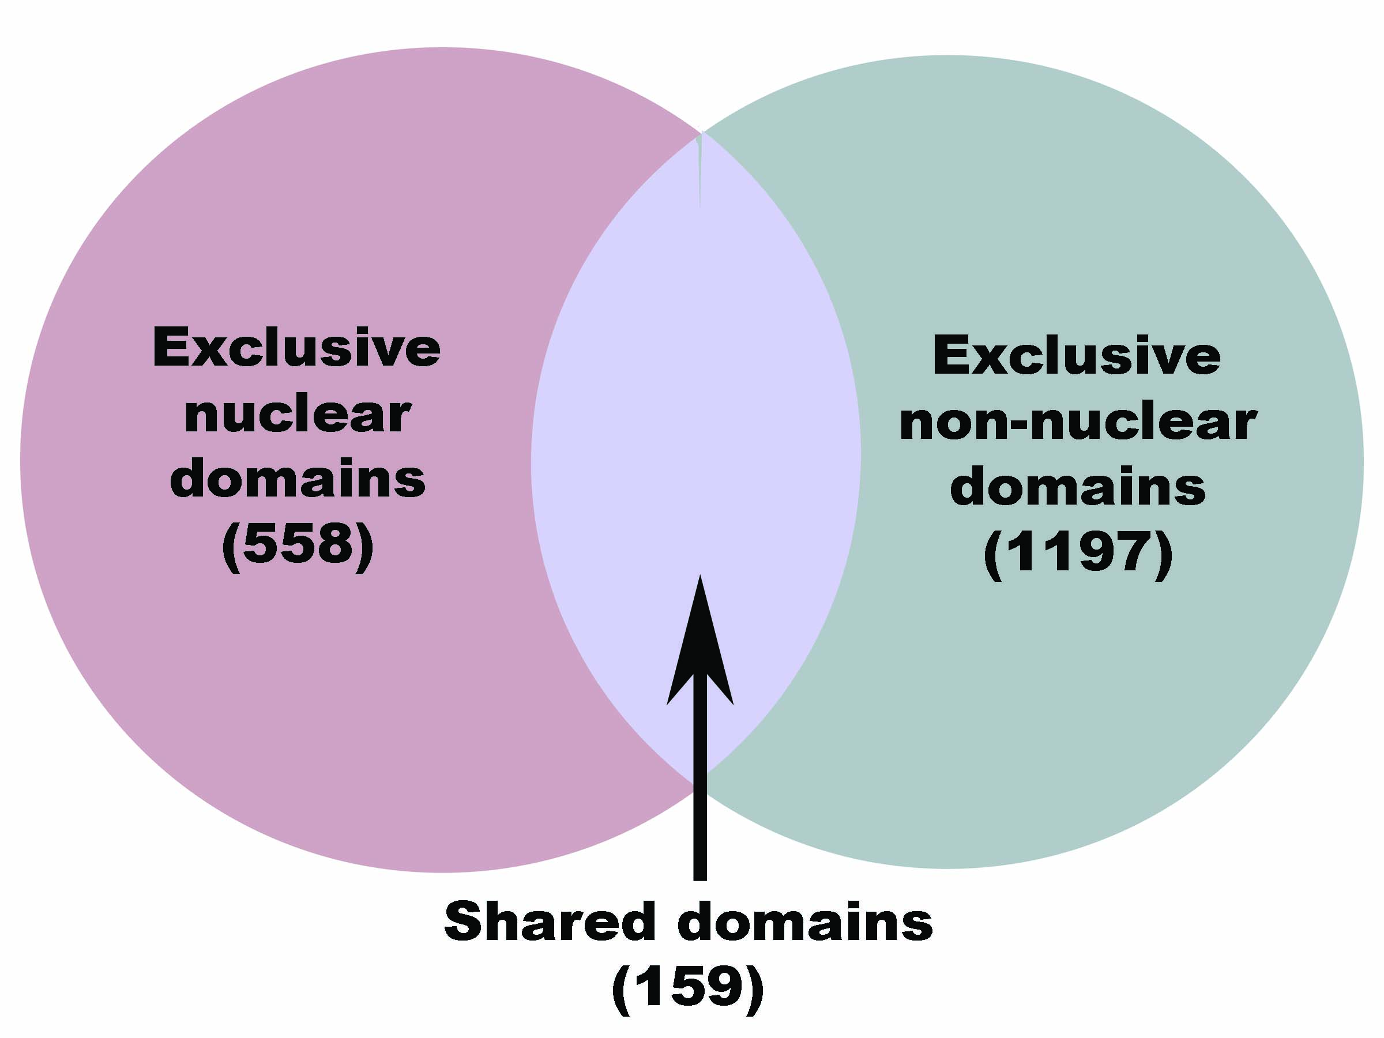

Figure S1: Distribution in exclusive nuclear, non-nuclear and shared domains in NucPfam database.

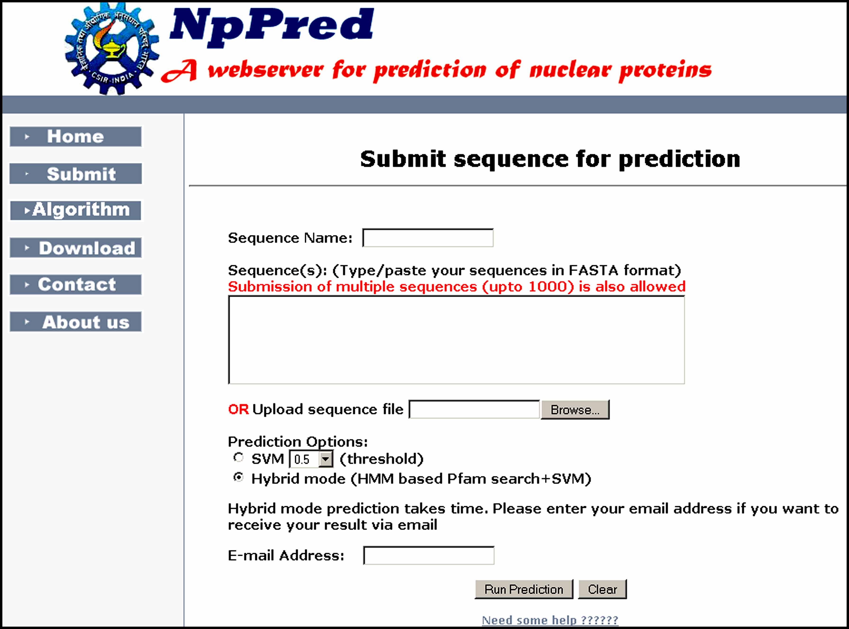

Figure S2: Submission page of NpPred webserver.
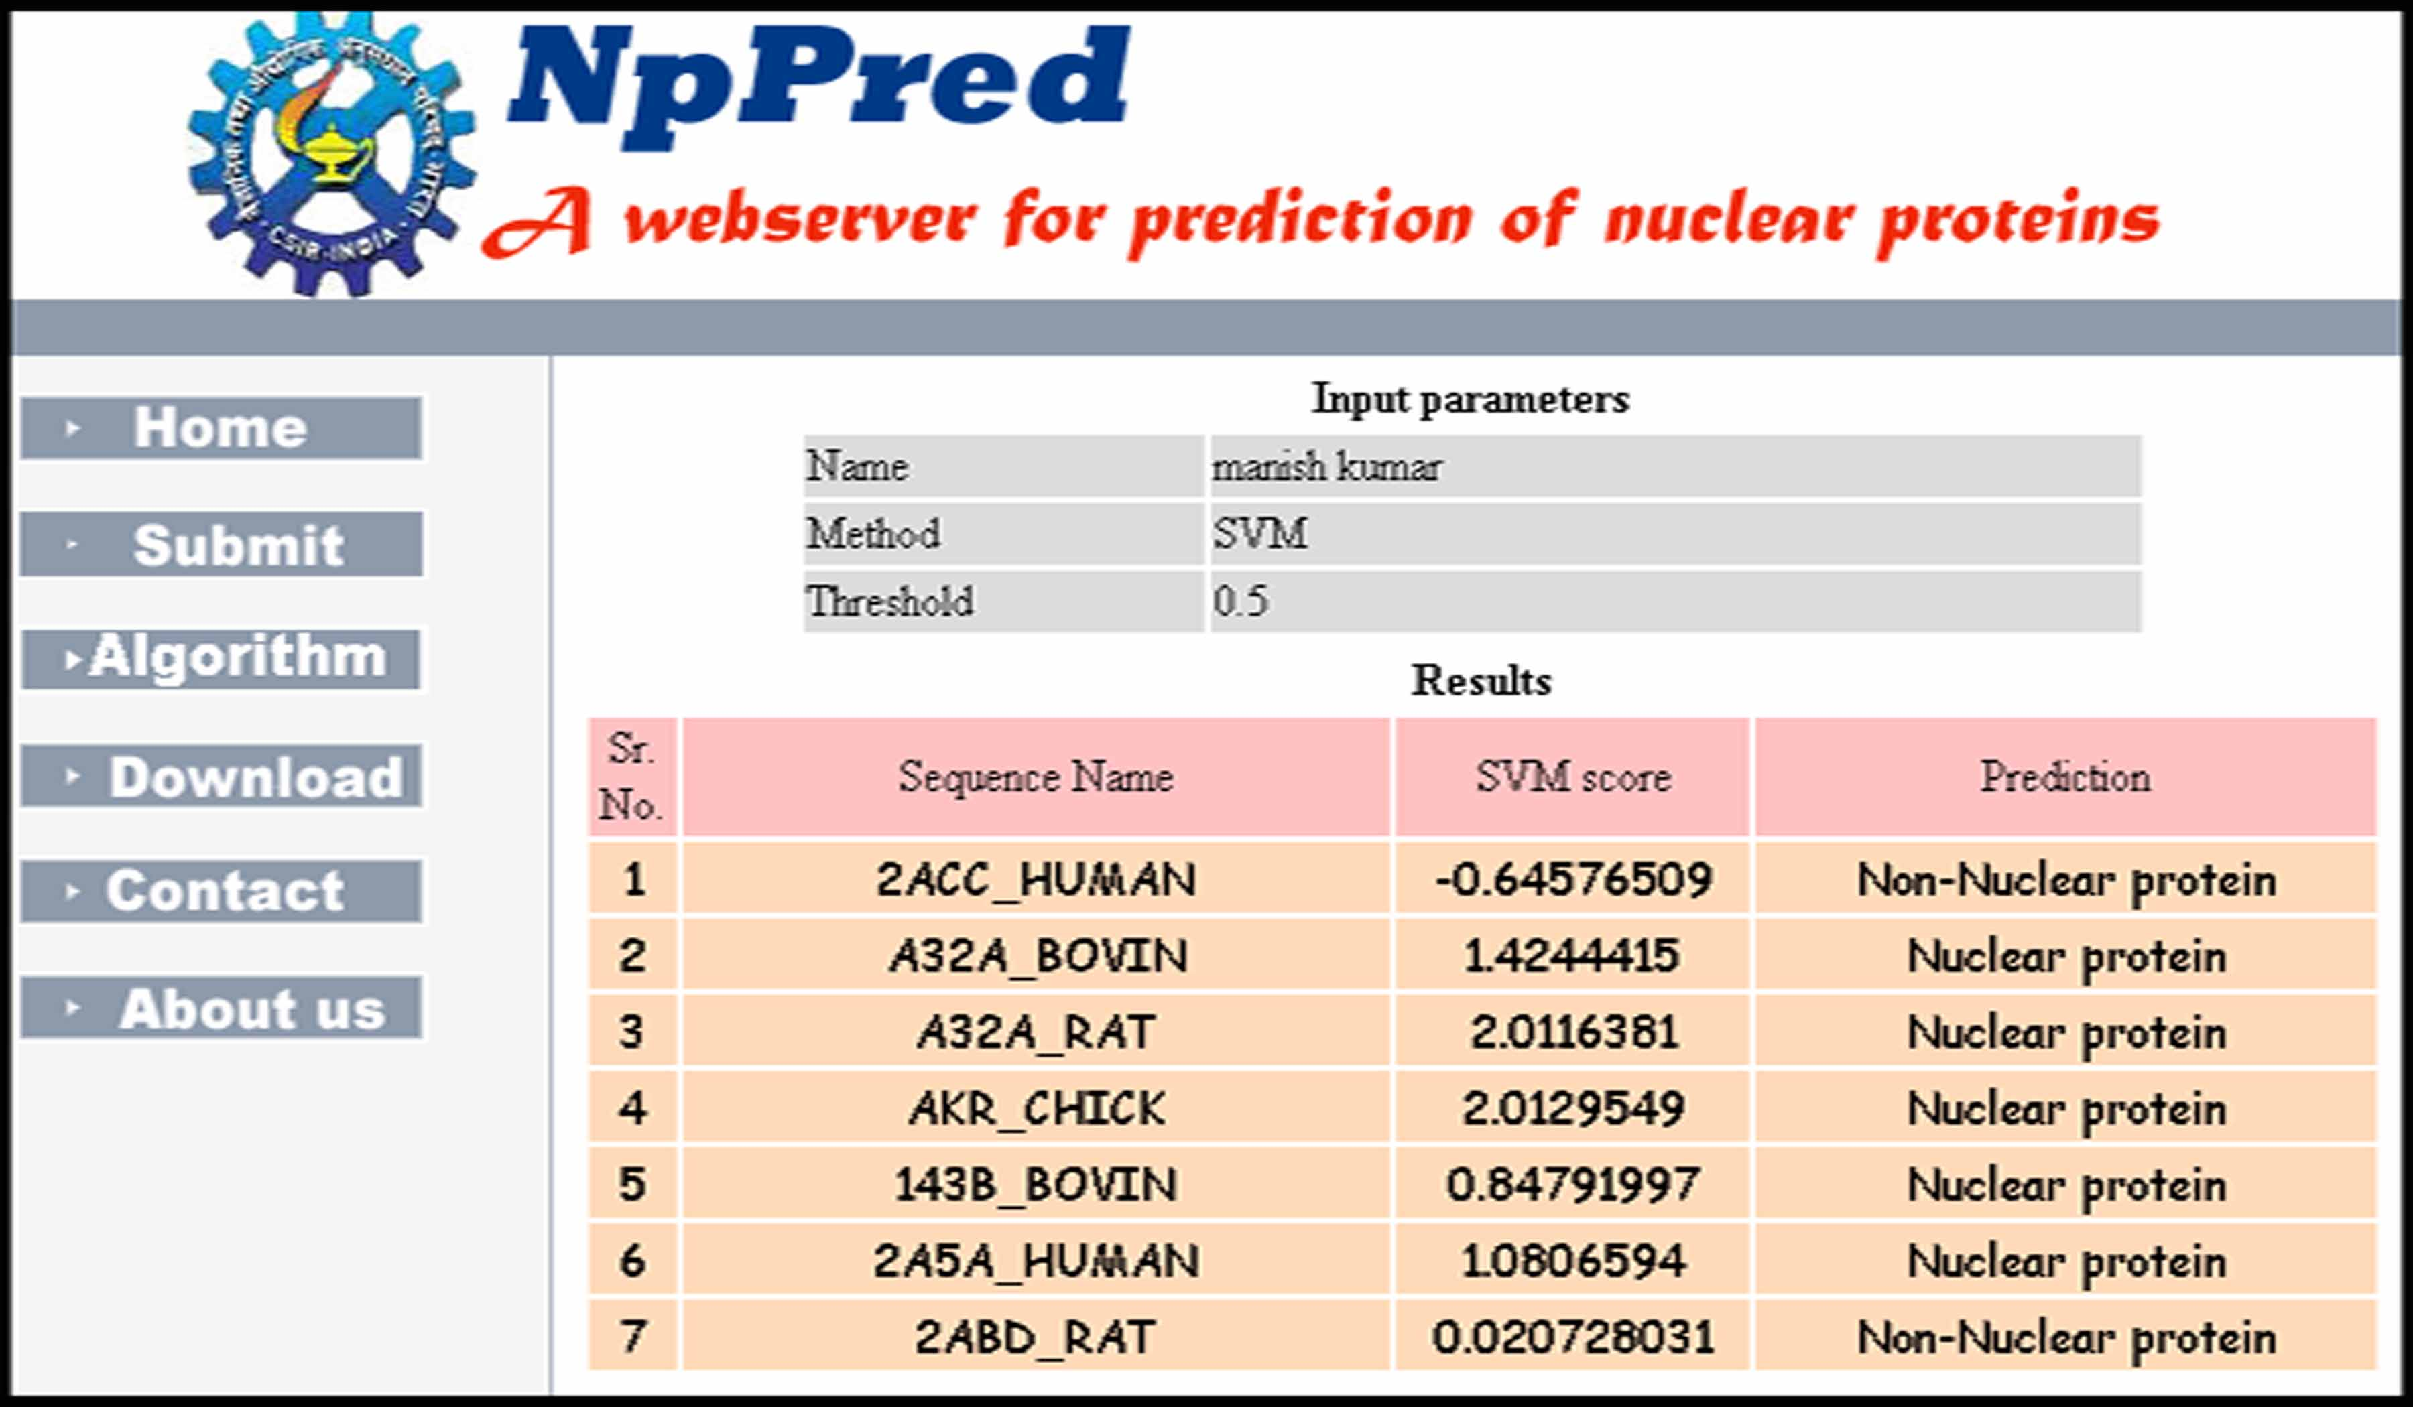

Figure S3: Prediction result of NpPred with SVM approach.
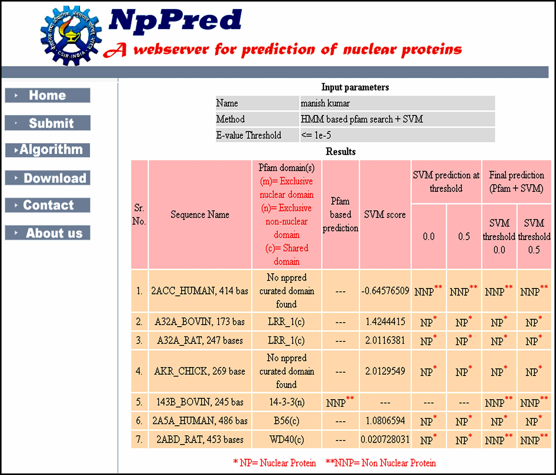

Figure S4: Prediction result of NpPred with hybrid approach of HMM based Pfam search and SVM.

