Software Architecture and Design (SAD)
Project | Operation Theatre Management System (OTMS)
Version | 1.0
Authors | Team 01: Pulkit Handa (PES1UG24AM209), Piyush Nadgir (PES1UG24AM190), Poorvi Rangaswamy (PES1UG24AM193), Riyana K (PES1UG24AM226)
Date | 12-10-2026
Status | Final

Revision history
Version | Date | Author | Change summary
0.9 | 11-10-2026 | Team 01 | First complete draft with diagrams
1.0 | 12-10-2026 | Team 01 | Final: data stores and schema added (3.6.1), diagrams redrawn and captioned, API tables completed, UX wireframes added, traceability extended with design references, glossary and cross-references corrected

Approvals
Role | Name | Signature / Date
Course Coordinator
Project Guide

1. Introduction

1.1 Purpose
This document specifies the architecture and design of the Operation Theatre Management System (OTMS).

1.2 Scope
Covers surgery scheduling with conflict detection, emergency prioritization and preemption, staff management with access control, equipment and theatre management, notifications and utilization reporting. Out of scope: patient clinical records, billing, and integration with external hospital systems.

1.3 Audience
Developers, QA engineers, security reviewers, instructors and evaluators.

1.4 Definitions
OT – Operation Theatre; OTMS – Operation Theatre Management System; RBAC – role-based access control; TLS – Transport Layer Security; REST – Representational State Transfer; API – application programming interface; STRIDE – threat categories (Spoofing, Tampering, Repudiation, Information disclosure, Denial of service, Elevation of privilege); SRS – Software Requirements Specification; STP – Software Test Plan; RTM – Requirements Traceability Matrix. The SRS holds the full list.

2. Document overview

2.1 How to use this document
Section 3 describes the architecture: goals, stakeholders, component diagram and descriptions, architecture pattern, technology stack, data stores and schema, risks, traceability to requirements and security. Section 4 describes the design: sequence diagrams, API design, error handling, UX and open issues.

2.2 Related documents
OTMS SRS v1.0 (requirement IDs, and the RTM in its section 8) and OTMS STP v1.0 (test cases and the test traceability matrix).

3. Architecture

3.1 Goals and constraints
Goals: correct and conflict-free scheduling, fast emergency handling, secure handling of patient and staff data, and modules that four developers can build and test independently. Constraints: academic timeline, TLS 1.2+ for all traffic, and no integration with external hospital systems.

3.2 Stakeholders and concerns
Stakeholder | Concern
Schedulers | Speed, clear conflict messages, reliability during emergencies
Doctors and nurses | Accurate schedule and timely notification of changes
Hospital admin / management | Data accuracy, resource utilization visibility, access control
Developers | Modularity, clear interfaces, testability
Evaluators | Traceability from requirements to design and tests

3.3 Component diagram
The system is a layered web application: a browser-based Web UI, a REST API gateway with authentication and role checks, business services (one module per team member) and a relational database. Figure 3.1 shows the components and their main calls; Section 3.4 describes each component.
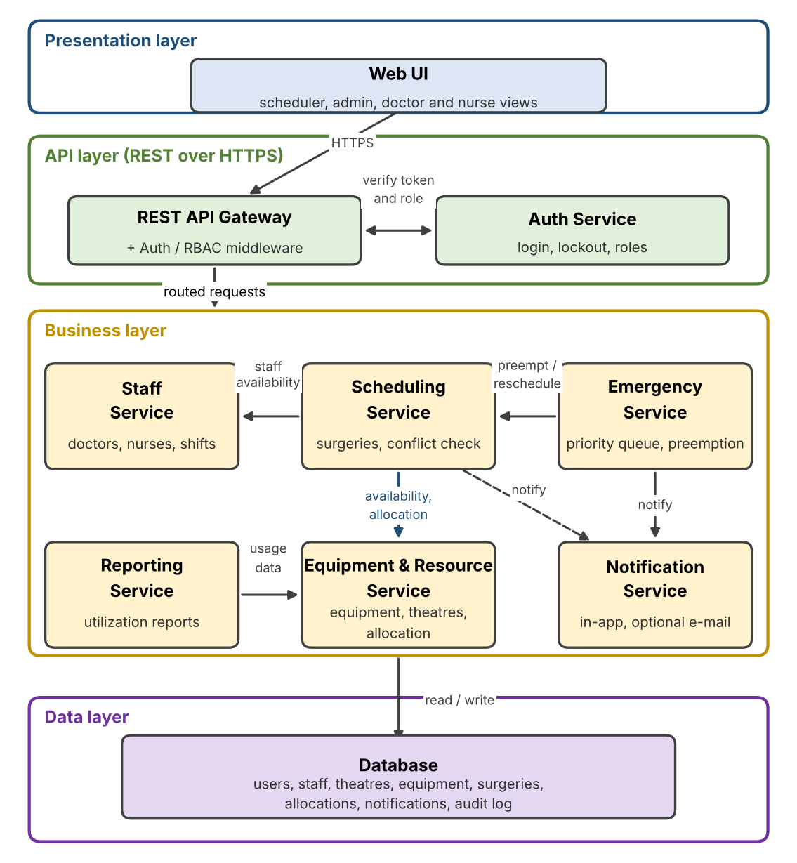
Figure 3.1 – Component diagram of the OT Management System (layered architecture)

3.4 Component descriptions
Component | Responsibility | Owner
Web UI | Role-based screens: calendar, scheduling forms, emergency banner, staff and equipment pages, reports | Team (per module)
API Gateway + Auth / RBAC middleware | Single REST entry point; authenticates sessions and enforces role permissions | Poorvi
Auth Service | Login, password hashing, lockout, roles | Poorvi
Scheduling Service | Create, change, cancel surgeries; conflict detection across theatre, staff and equipment | Pulkit
Emergency Service | Emergency intake, priority queue, slot preemption and rescheduling | Piyush
Staff Service | Doctor and nurse records, shifts, availability, assignment rules | Poorvi
Equipment and Resource Service | Equipment and theatre inventory and status (available, in use, maintenance), availability checks, and all-or-nothing allocation and release of equipment and theatre per surgery; rejects overlapping bookings | Riyana
Reporting Service | Utilization reports by date range for theatres and equipment, computed from surgery and allocation records | Riyana
Notification Service | Creates in-app notifications (optional email) for schedule changes | Piyush
Database | Surgeries, staff, equipment, allocations, notifications, users, audit log | Team

Equipment and theatre status rules
Item | Change | Trigger
Equipment | Available → In use | Allocation starts with its surgery
Equipment | In use → Available | Surgery completed, cancelled or pre-empted, so its resources are released
Equipment | Available → Maintenance | Admin marks the item as under maintenance
Equipment | Maintenance → Available | Admin clears the maintenance status
Equipment | In use → Maintenance | Not allowed; the item must be released first
Theatre | Available, Occupied, Cleaning, Maintenance | Occupied while a surgery is in progress; Cleaning and Maintenance are set by an admin
Allocation rule. A request names the theatre and equipment for a surgery’s time slot. Every item must be free for the whole slot (no overlap with another reserved or active allocation, and not under maintenance). If any item is unavailable nothing is allocated and the response (409) names the unavailable items. Releasing the same allocation twice has no further effect.

3.5 Chosen architecture pattern and rationale
A layered architecture (presentation, API, business services, data) is chosen. Each business service lives in its own module with a defined interface, so one team member can work on a module without waiting for the others. Services run in one deployable application. Microservices were rejected because a separate deployment per service adds operational complexity that is unnecessary at this scale. A monolith without module boundaries was rejected because it would make parallel development and independent testing harder.

3.6 Technology stack and data stores
Proposed stack (to be confirmed by the team before implementation): Python 3.11 with a REST framework (for example FastAPI), a relational database (SQLite for development, PostgreSQL for deployment), pytest for testing, GitHub Actions for continuous integration, and a browser-based front end. All traffic uses TLS 1.2 or higher.

3.6.1 Data stores and schema
The system uses one relational database (SQLite in development, PostgreSQL in deployment) as its only persistent store. Reports are computed from the stored surgery and allocation records when requested; nothing is exported or cached outside the database. Figure 3.2 shows the tables and their relationships; the table below lists their key columns.
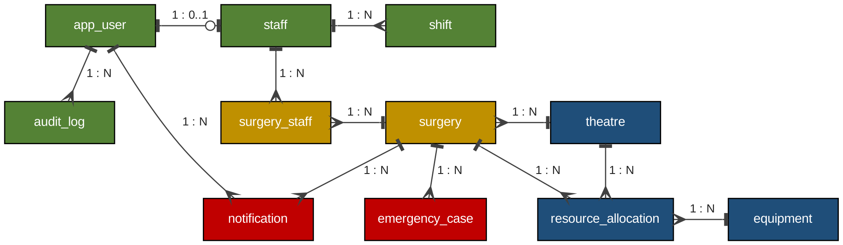
Figure 3.2 – Data schema overview. Colour shows the owning module: green staff and access, amber scheduling, red emergency and notifications, blue equipment and resources
Table | Key columns | Owner | Notes
app_user | user_id (PK), username (unique), password_hash, role, failed_attempts, locked_until | Poorvi | Passwords stored hashed only
staff | staff_id (PK), user_id (FK, optional), name, staff_type (doctor or nurse), specialization, is_active | Poorvi | Deactivated, not deleted
shift | shift_id (PK), staff_id (FK), start_time, end_time | Poorvi | Shifts of one person must not overlap
surgery | surgery_id (PK), patient_name, theatre_id (FK), start_time, end_time, priority (routine, urgent, critical), status, created_by (FK) | Pulkit | No theatre double-booking for the same time
surgery_staff | surgery_id (FK), staff_id (FK); both form the primary key | Pulkit | Doctors and nurses assigned to a surgery
emergency_case | emergency_id (PK), surgery_id (FK), logged_by (FK), logged_at | Piyush | One row per logged emergency
notification | notification_id (PK), user_id (FK), surgery_id (FK), message, created_at, is_read | Piyush | In-app notifications
theatre | theatre_id (PK), name (unique), status (available, occupied, cleaning, maintenance) | Riyana | Status changes follow Section 3.4
equipment | equipment_id (PK), name, category, status (available, in use, maintenance), is_active | Riyana | Deactivated, not deleted
resource_allocation | allocation_id (PK), surgery_id (FK), resource_type (equipment or theatre), equipment_id (FK) or theatre_id (FK), start_time, end_time, state (reserved, active, released, cancelled) | Riyana | Exactly one of equipment_id and theatre_id is set; reserved or active rows for one resource never overlap
audit_log | log_id (PK), user_id (FK), action, entity, entity_id, logged_at | Poorvi | Append-only
Integrity and retention.
- Double-booking is prevented inside the save transaction: the overlap check and the insert happen together, so two simultaneous requests cannot take the same theatre, person or equipment (PostgreSQL can also enforce this with an exclusion constraint).
- Equipment, staff and allocation records are deactivated or marked released instead of being deleted, so history stays available for reports and for the data-retention requirement (OT-NF-004).
- Foreign keys are enforced; passwords are stored only as hashes; the audit log is append-only.

3.7 Risks and mitigations
Risk | Mitigation
Modules built in parallel do not fit together | Shared models and function interfaces merged first; integration tests run on main
Double-booking caused by simultaneous requests | Database transactions and a uniqueness/overlap check at save time
Emergency preemption moves a surgery incorrectly | Never move equal or higher priority surgeries; unit tests for every rule; audit log of every move
Unauthorized access to patient data | Server-side RBAC, hashed passwords, lockout, TLS
Unequal team contribution or merge conflicts | One folder per owner, small PRs, mandatory review, protected main branch
Report figures disagree with the source data | Compute reports directly from surgery and allocation records; test against a seeded data set with hand-computed totals
Different behaviour between SQLite (development) and PostgreSQL (deployment) | Keep SQL portable and avoid engine-specific features; run the integration tests on both before the demo

3.8 Traceability to requirements
Requirements | Component | Design reference
OT-F-010 to OT-F-013 | Scheduling Service | 4.2 Sequence Diagram 1; 4.3 /surgeries
OT-F-020 to OT-F-023, OT-NF-001 | Emergency Service, Notification Service | 4.2 Sequence Diagram 2; 4.3 /emergencies
OT-F-030, OT-F-031, OT-F-033 | Staff Service | 3.6.1 staff, shift, surgery_staff; 4.3 /staff
OT-F-032, OT-SR-002, OT-SR-003, OT-SR-004 | Auth Service, API Gateway | 3.9; 4.3 /auth/login
OT-F-040 to OT-F-042 | Equipment and Resource Service | 3.4 status rules; 3.6.1; 4.3 /equipment, /theatres, /allocations
OT-F-043, OT-NF-005 | Reporting Service | 4.3 /reports/utilization; 4.5 Utilization Dashboard
OT-SR-001, OT-SR-005, OT-SR-006 | All services and Database (TLS, audit log, input validation) | 3.9; 4.4
OT-NF-002, OT-NF-003, OT-NF-004 | Whole system, Web UI, Database | 4.4 monitoring; 4.5 UX; 3.6.1 retention

3.9 Security architecture
Threat modeling (STRIDE):
Threat | Example in OTMS | Control
Spoofing | Someone logs in as a scheduler | Hashed passwords, account lockout, session expiry
Tampering | Schedule or allocation changed without permission | RBAC on every endpoint, audit log, input validation
Repudiation | A user denies cancelling a surgery | Append-only audit log with user and time
Information disclosure | Patient or staff data read by the wrong role | TLS 1.2+, role checks, no sensitive data in logs
Denial of service | Flood of requests blocks emergency scheduling | Rate limiting, priority handling of emergency endpoint
Elevation of privilege | Nurse calls an admin endpoint | Server-side RBAC, deny by default

4. Design

4.1 Design overview
Each business service exposes a small set of functions and REST endpoints. Every request first passes through the API gateway, which checks the session token and the user’s role. Cross-module calls go through agreed interfaces: staff availability, equipment and theatre availability, conflict detection, rescheduling and emergency handling. Shared data models (Surgery, Doctor, Nurse, Equipment, Theatre, Priority) are kept in one common module so every service uses the same definitions.

4.2 UML sequence diagrams
Sequence Diagram 1 shows how a scheduler books a surgery. The Scheduling Service checks staff availability and then theatre and equipment availability. A conflict returns 409 with the reasons; otherwise the surgery is saved together with its reserved resources (OT-F-010, OT-F-013).
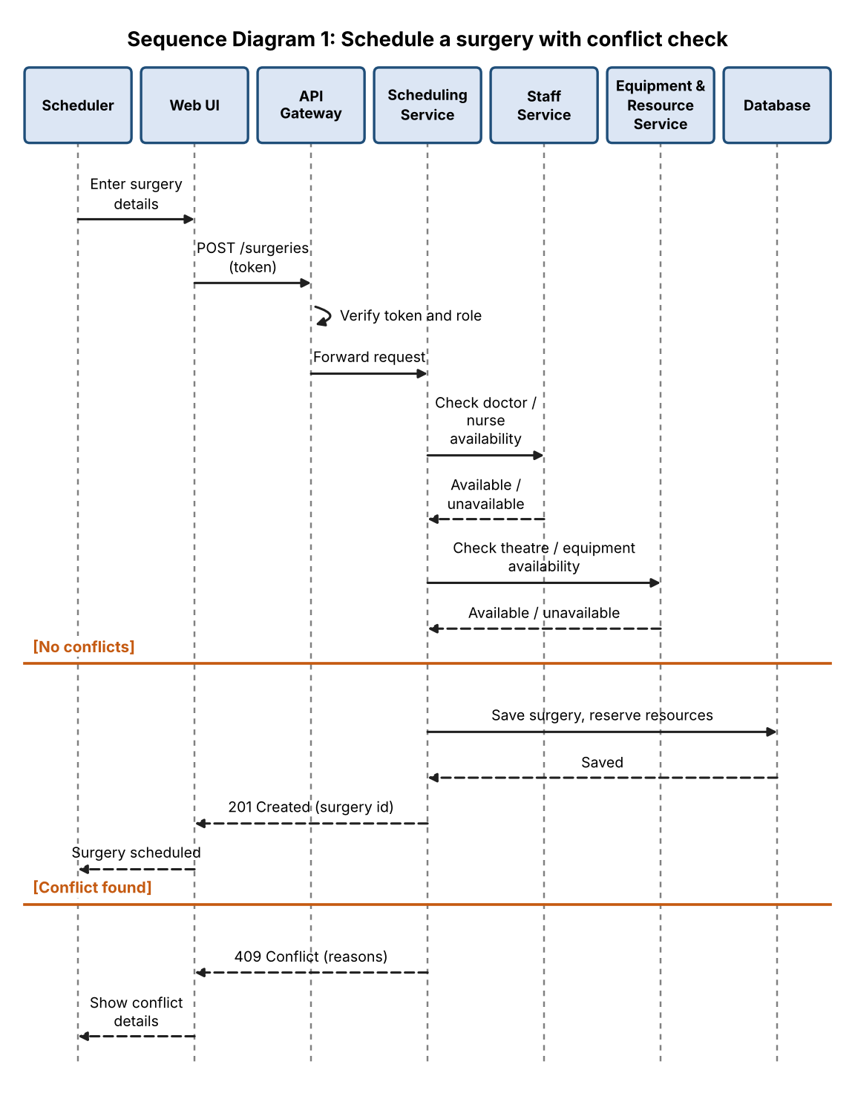
Figure 4.1 – Schedule a surgery with conflict check
Sequence Diagram 2 shows an emergency pre-empting a scheduled surgery. The Emergency Service finds overlapping lower-priority surgeries. If an equal or higher priority surgery blocks the slot the request fails with 409; otherwise the affected surgeries are rescheduled, the emergency is saved and the affected staff and patients are notified (OT-F-020 to OT-F-023, OT-NF-001).
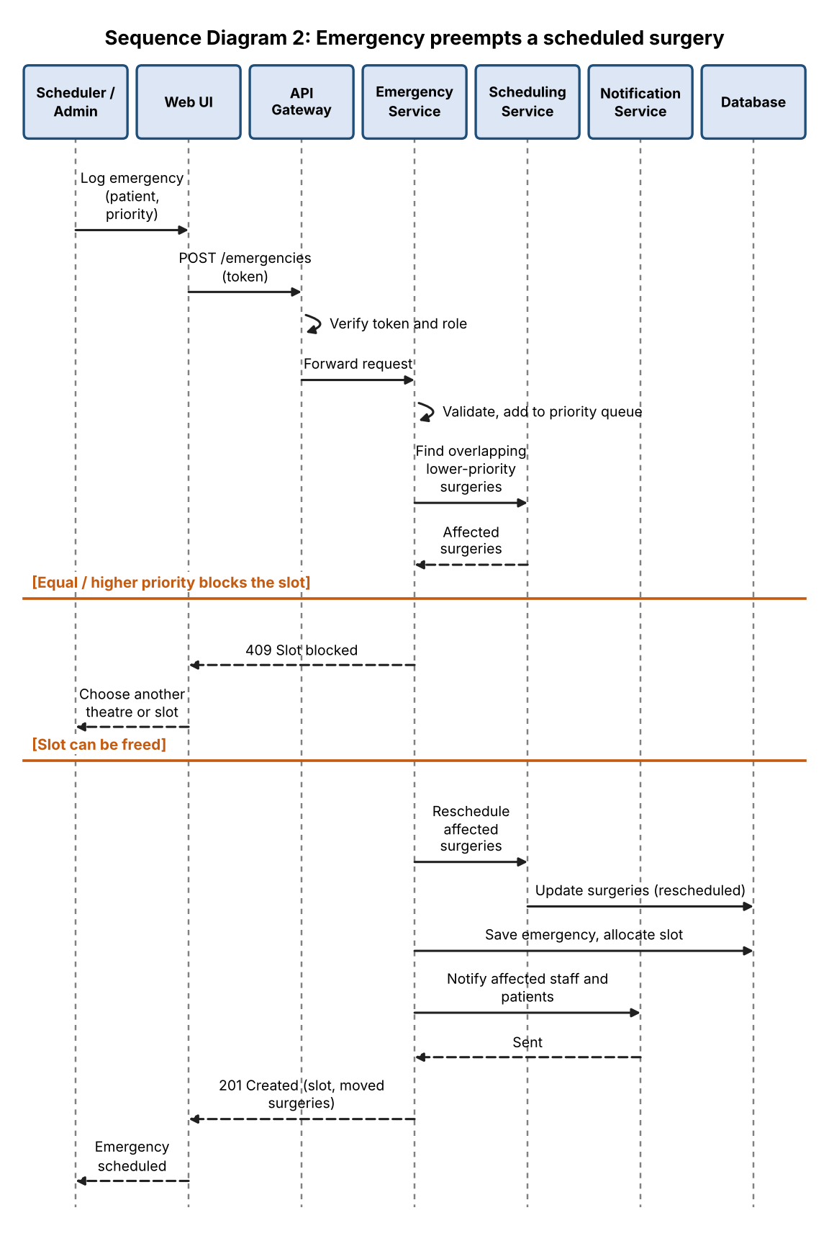
Figure 4.2 – Emergency pre-empts a scheduled surgery

4.3 API design
All endpoints use JSON over HTTPS and require a valid session token, except POST /auth/login. Any endpoint can also return 401 (missing or invalid token) and, where roles apply, 403 (role not allowed); role restrictions are enforced on the server. Errors use the format in Section 4.4.

Scheduling Service (Pulkit)
Endpoint | Method | Request | Response | Errors
/surgeries | POST | {patientName, theatreId, start, end, doctorIds, nurseIds, equipmentIds, priority} | 201 {surgeryId, status} | 400 invalid input, 403 role, 409 conflict {reasons}
/surgeries/{id} | PUT | {start, end, theatreId, doctorIds, nurseIds, equipmentIds} | 200 {surgery} | 404 not found, 409 conflict
/surgeries/{id} | DELETE | - | 200 {status: cancelled} | 404 not found, 403 role
/surgeries?date= | GET | query: date, theatreId | 200 [surgery] | 400 bad date

Emergency Service (Piyush)
Endpoint | Method | Request | Response | Errors
/emergencies | POST | {patientName, theatreId, start, end, priority: urgent|critical, doctorIds, nurseIds} | 201 {emergencyId, slot, movedSurgeries[]} | 400 routine priority or invalid, 409 slot blocked by equal/higher priority
/emergencies/queue | GET | - | 200 [emergency] ordered by priority | 403 role

Staff and Auth Service (Poorvi)
Endpoint | Method | Request | Response | Errors
/auth/login | POST | {username, password} | 200 {token, role} | 401 invalid credentials, 423 account locked
/staff | POST | {name, type: doctor|nurse, specialization} | 201 {staffId} | 400 invalid, 403 role
/staff | GET | query: type, specialization | 200 [staff] | 403 role
/staff/{id} | PUT | {name, specialization} | 200 {staff} | 400 invalid, 403 role, 404 not found
/staff/{id} | DELETE | - | 200 {status: deactivated} | 403 role, 404 not found
/staff/{id}/availability | GET | query: start, end | 200 {available: true|false} | 404 not found
/staff/{id}/shifts | PUT | {shifts: [{start, end}]} | 200 {shifts} | 400 overlap or invalid
Staff-to-surgery assignment (OT-F-033) is made through doctorIds and nurseIds on /surgeries and checked with /staff/{id}/availability.

Equipment and Reporting Service (Riyana)
Endpoint | Method | Request | Response | Errors
/equipment | POST | {name, category (optional), status} | 201 {equipmentId} | 400 invalid, 403 role
/equipment | GET | query: status, category | 200 [equipment] | 403 role
/equipment/{id} | PUT | {name, category, status} | 200 {equipment} | 400 invalid, 403 role, 404 not found
/equipment/{id} | DELETE | - | 200 {status: deactivated} | 403 role, 404 not found, 409 has future allocations
/equipment/{id}/availability | GET | query: start, end | 200 {available: true|false} | 400 bad range, 404 not found
/theatres | GET | - | 200 [theatre] with status | 403 role
/theatres/{id}/status | PATCH | {status} | 200 {theatre} | 400 invalid status, 403 role, 404 not found
/allocations | POST | {surgeryId, theatreId, equipmentIds} | 201 {allocationId} | 400 invalid, 403 role, 404 surgery not found, 409 resource unavailable {resources}
/allocations/{id}/release | POST | - | 200 {status: released} | 403 role, 404 not found
/reports/utilization | GET | query: from, to, theatreId (optional) | 200 {theatres[], equipment[]} usage % | 400 bad range, 403 role

4.4 Error handling, logging and monitoring
- Standard error format {error, message, details} with correct HTTP status codes
- No passwords, tokens or unnecessary patient details in logs
- Audit log entry for every create, change, cancel and login event
- Monitoring of request failure rate, emergency allocation time and system uptime

4.5 UX design
- Role-based dashboards: scheduler sees a calendar of theatre slots; doctors and nurses see their own upcoming surgeries
- Colour-coded slots by priority with inline conflict messages that name the conflicting resource; colour is never the only signal, so status is also shown as text and an icon
- Prominent emergency banner and a one-screen emergency form
- Readable font sizes, keyboard navigation and a high-contrast mode
- Target: schedule a surgery in at most 8 interactions (OT-NF-003)
- Equipment & Theatre Board: theatre status tiles and an equipment list with search, status filter and per-item actions (edit, change status, allocate), as in Figure 4.3
- Utilization Dashboard: key figures, utilization per theatre, top equipment by usage and a date-range filter, with the report available for export, as in Figure 4.4
- When allocating equipment while scheduling, only items free for the surgery’s time slot are offered; a conflict names the item
- Destructive actions (deactivating equipment or staff, releasing resources) ask for confirmation
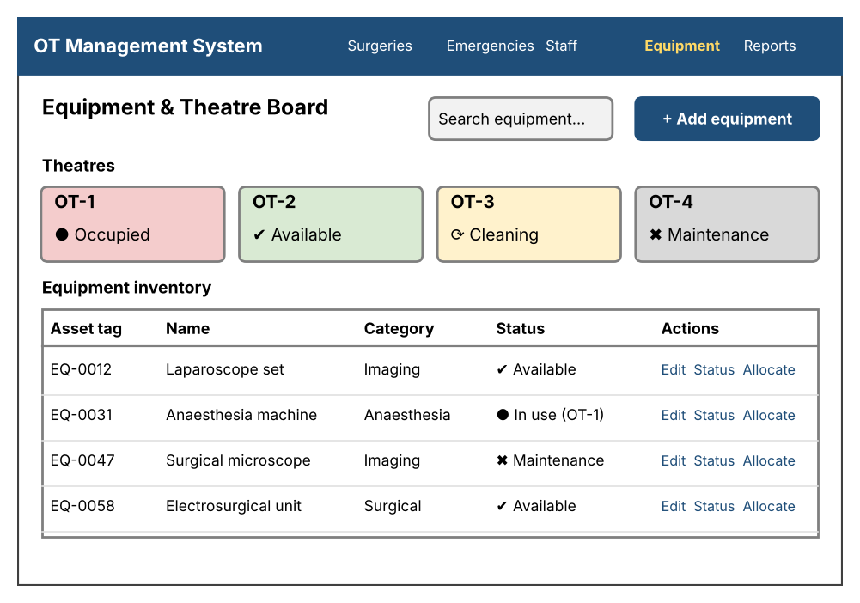
Figure 4.3 – Wireframe: Equipment & Theatre Board
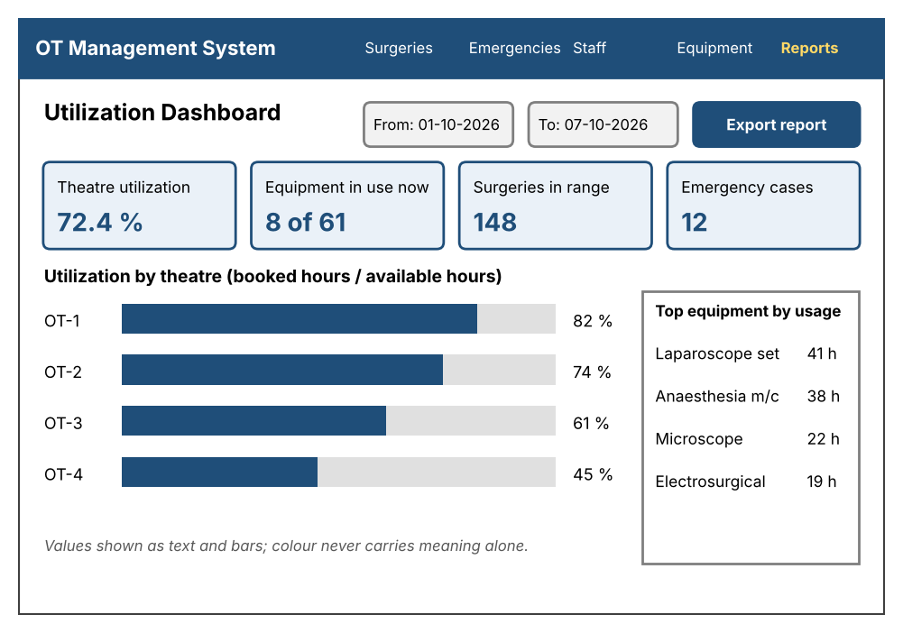
Figure 4.4 – Wireframe: Utilization Dashboard (sample values for illustration)

4.6 Open issues and next steps
- Confirm the technology stack as a team before implementation starts
- Decide whether email notifications are included or only in-app notifications
- Future enhancements: calendar sync, patient record integration, automatic suggestion of alternative slots, scheduled equipment maintenance windows and barcode scanning of equipment tags
- Define an endpoint for reading in-app notifications (the Notification Service currently has no read API in Section 4.3)

5. Appendices
5.1 Glossary: see Section 1.4 (OT, OTMS, RBAC, TLS, REST, API, STRIDE, SRS, STP, RTM).
5.2 References: IEEE 42010, OWASP Top 10, NIST SP 800-160, WCAG 2.1, OTMS SRS v1.0, OTMS STP v1.0.
5.3 Tools: Graphviz and Matplotlib (diagrams), Postman (API), GitHub (version control and CI).

