Software Requirements Specification (SRS)
Project | Operation Theatre Management System (OTMS)
Version | 1.0
Authors | Team 01: Pulkit Handa (PES1UG24AM209), Piyush Nadgir (PES1UG24AM190), Poorvi Rangaswamy (PES1UG24AM193), Riyana K (PES1UG24AM226)
Date | 11-10-2026
Status | Draft for review

Revision history
Version | Date | Author | Change summary | Approval
1.0 | 11-10-2026 | Team 01 | First complete draft with diagrams

Approvals
Role | Name | Signature / Email | Date
Course Coordinator
Project Guide

Table of contents
1. Introduction
2. Overall description
3. External interface requirements
4. System features (detailed)
5. Non-functional requirements (detailed)
5.1 Security
6. Quality attributes and acceptance tests
7. System models and diagrams
8. Requirements Traceability Matrix (RTM)

1. Introduction

1.1 Purpose
This Software Requirements Specification (SRS) describes the Operation Theatre Management System (OTMS). It defines the functional and non-functional requirements, security requirements, interfaces and verification criteria for the system.

1.2 Scope
OTMS manages surgeries, doctors, nurses, equipment and theatre slots. It detects scheduling conflicts, prioritizes emergency cases and improves resource utilization through reports. It does not cover billing, patient medical records, pharmacy or integration with existing hospital information systems.

1.3 Audience
Developers, QA engineers, instructors and evaluators, and hospital administrators who would use the system.

1.4 Definitions
Term | Meaning
OT / OTMS | Operation Theatre / Operation Theatre Management System
SRS, SAD, STP | Software Requirements Specification, Software Architecture and Design document, Software Test Plan
FR / NFR | Functional requirement / Non-functional requirement
RBAC | Role-based access control
TLS | Transport Layer Security
API | Application Programming Interface
RTM | Requirements Traceability Matrix
Priority (surgery) | Routine, urgent or critical. Critical outranks urgent, which outranks routine.

2. Overall description

2.1 Product perspective
OTMS is a web application used by hospital staff. It consists of a web user interface, a REST API with business services (scheduling, emergency, staff, equipment, reporting, notification) and a database. It is a stand-alone system for this project.

2.2 Major product functions
- Schedule, reschedule and cancel surgeries
- Detect conflicts in theatre, doctor, nurse and equipment bookings
- Log emergencies, queue them by priority and preempt lower-priority surgeries
- Manage doctor and nurse records, shifts and availability
- Manage equipment and theatre inventory and allocation
- Login with role-based access
- Notify staff of schedule changes
- Generate theatre and equipment utilization reports

2.3 User roles and characteristics
Role | Description
Admin | Manages staff, equipment and theatres; views reports. Moderate technical comfort.
Scheduler | Schedules and reschedules surgeries, logs emergencies, allocates resources. Uses the system all day and needs speed and clarity.
Doctor | Views own upcoming surgeries and receives notifications. Occasional user.
Nurse | Views own upcoming surgeries and receives notifications. Occasional user.

2.4 Operating environment
Browser-based client (current versions of Chrome, Edge, Firefox) over a hospital intranet or the internet using HTTPS. Server-side services run on a standard server or cloud virtual machine with a relational database.

2.5 Constraints
- Patient and staff data must be protected in line with applicable data protection rules
- All network traffic must be encrypted (TLS 1.2 or higher)
- The system is an academic project built by a four-member team within the course timeline
- The system shall expose a documented REST API so that modules can be developed and tested independently

3. External interface requirements

3.1 User interfaces
A responsive web UI with role-based dashboards, a calendar view of theatre slots, clear conflict messages and an emergency banner. Accessibility features include readable font sizes, keyboard navigation and a high-contrast mode.

3.2 Hardware interfaces
No special hardware. Standard client workstations or tablets with a web browser.

3.3 Software interfaces
- REST API (JSON over HTTPS) between the web UI and the business services
- Relational database for surgeries, staff, equipment, allocations, notifications and audit logs
- Optional email service for notification delivery

3.4 Communications
HTTPS with TLS 1.2 or higher for all connections. Session tokens expire after a period of inactivity.

4. System features (detailed)
Each requirement includes acceptance criteria and a reference test case. Functional requirement IDs follow OT-F-###. The total is 16 functional requirements.

4.1 Surgery scheduling and conflict detection
Description: Create, change and cancel surgeries and make sure no resource is double-booked.
Req ID | Requirement (shall...) | Type | Priority | Source / Stakeholder | Acceptance criteria / Test case ref | Comments / Dependencies
OT-F-010 | The system shall allow a scheduler to create a surgery with patient, theatre, time slot, doctor(s), nurse(s) and equipment. | Functional | High | Hospital Admin | AC-OT-F-010: A surgery with valid inputs appears in the schedule with status "scheduled". Test: TC-Sched-01 | Needs Staff and Equipment services
OT-F-011 | The system shall allow a scheduler to change the slot or resources of a scheduled surgery and re-validate it. | Functional | High | Hospital Admin | AC-OT-F-011: Updated surgery is saved only if no conflicts exist; otherwise the old booking is kept. Test: TC-Sched-02 | Uses OT-F-013
OT-F-012 | The system shall allow a scheduler to cancel a surgery and release its theatre, staff and equipment. | Functional | High | Hospital Admin | AC-OT-F-012: Cancelled surgery shows status "cancelled" and its resources become available again. Test: TC-Sched-03 | -
OT-F-013 | The system shall detect and reject double-booking of a theatre, doctor, nurse or equipment item, and report the reason. | Functional | High | Operations | AC-OT-F-013: Overlapping bookings are rejected with a message naming the conflicting resource. Test: TC-Sched-04, TC-Sched-05 | Core feature

4.2 Emergency prioritization and rescheduling
Description: Record emergencies, order them by priority and free a slot by moving lower-priority surgeries.
Req ID | Requirement (shall...) | Type | Priority | Source / Stakeholder | Acceptance criteria / Test case ref | Comments / Dependencies
OT-F-020 | The system shall allow logging of an emergency case with patient details and priority (urgent or critical). | Functional | High | Clinical Staff | AC-OT-F-020: Valid emergency is recorded; a routine priority or missing patient name is rejected. Test: TC-Emg-01 | -
OT-F-021 | The system shall order emergency cases in a priority queue: critical before urgent, first come first served within the same priority. | Functional | High | Clinical Staff | AC-OT-F-021: Queue returns cases in the expected order for mixed priorities and arrival times. Test: TC-Emg-02 | -
OT-F-022 | The system shall assign an emergency to a theatre slot by moving lower-priority surgeries in that theatre to the next free slot, and shall never move equal or higher priority surgeries. | Functional | High | Clinical Staff | AC-OT-F-022: Lower-priority surgeries are rescheduled with status "rescheduled"; a blocking equal/higher priority surgery causes a clear rejection. Test: TC-Emg-03, TC-Emg-04 | Uses Scheduling Service
OT-F-023 | The system shall notify affected doctors, nurses and schedulers when a surgery is moved because of an emergency. | Functional | Medium | Operations | AC-OT-F-023: A notification naming the surgery, old slot and new slot is created for each affected person. Test: TC-Emg-05 | In-app notification; email optional

4.3 Staff management and access control
Description: Maintain doctor and nurse data and availability, and control who can do what.
Req ID | Requirement (shall...) | Type | Priority | Source / Stakeholder | Acceptance criteria / Test case ref | Comments / Dependencies
OT-F-030 | The system shall allow an admin to add, update and deactivate doctor and nurse records including specialization. | Functional | High | Hospital Admin | AC-OT-F-030: Staff changes are saved and deactivated staff cannot be assigned to new surgeries. Test: TC-Staff-01 | -
OT-F-031 | The system shall record staff shifts and availability. | Functional | High | Hospital Admin | AC-OT-F-031: Availability query for a time range returns correct available staff. Test: TC-Staff-02 | Input to conflict detection
OT-F-032 | The system shall authenticate users and restrict features by role (admin, scheduler, doctor, nurse). | Functional | High | Security | AC-OT-F-032: Valid login creates a session; each role can access only its permitted features. Test: TC-Auth-01, TC-Auth-02 | See OT-SR-003
OT-F-033 | The system shall allow assigning a doctor or nurse to a surgery only if the person is active, on shift and (for doctors) suitably specialized. | Functional | High | Operations | AC-OT-F-033: Assignment of unavailable or unqualified staff is rejected with a reason. Test: TC-Staff-03 | -

4.4 Equipment, theatre resources and utilization reports
Description: Maintain equipment and theatre inventory, allocate resources and report on usage.
Req ID | Requirement (shall...) | Type | Priority | Source / Stakeholder | Acceptance criteria / Test case ref | Comments / Dependencies
OT-F-040 | The system shall allow an admin to add, update and retire equipment and theatres, with a status (available, in use, maintenance). | Functional | High | Hospital Admin | AC-OT-F-040: Equipment and theatre records can be created and edited; equipment under maintenance cannot be booked. Test: TC-Eq-01 | -
OT-F-041 | The system shall track equipment and theatre availability for any time range. | Functional | High | Operations | AC-OT-F-041: Availability query returns correct results given existing bookings and statuses. Test: TC-Eq-02 | Input to conflict detection
OT-F-042 | The system shall allocate equipment and a theatre to a surgery and release them on completion or cancellation. | Functional | High | Operations | AC-OT-F-042: Resources show as allocated during the surgery and available again afterwards. Test: TC-Eq-03 | -
OT-F-043 | The system shall generate a utilization report of theatre and equipment usage for a chosen date range. | Functional | Medium | Management | AC-OT-F-043: Report shows usage percentage per theatre and equipment item and can be filtered by date range. Test: TC-Rpt-01, TC-Rpt-02 | -

5. Non-functional requirements (detailed)
NFRs are measurable and tied to test cases. IDs follow OT-NF-###.
Req ID | Requirement | Category | Priority | Acceptance criteria / Measurement
OT-NF-001 | Allocating an emergency slot (including rescheduling affected surgeries) shall complete within 3 seconds for 95% of requests under normal load. | Performance | High | 95th percentile ≤ 3 s in a load test. Test: TC-Perf-01
OT-NF-002 | The system shall be available at least 99.5% of the time during scheduled hospital hours each month, excluding planned maintenance. | Reliability | High | Uptime report shows ≥ 99.5% per month. Test: TC-Rel-01
OT-NF-003 | A trained scheduler shall be able to schedule a surgery in at most 2 minutes and 8 interactions without help. | Usability | Medium | Usability test with 5 users meets the target. Test: TC-UX-01
OT-NF-004 | Surgery, allocation and audit records shall be retained for at least 5 years. | Data Retention | High | Records older than 1 year remain retrievable; no automatic deletion before 5 years. Test: TC-OPS-01
OT-NF-005 | Utilization report figures shall match the stored booking data exactly for the test dataset. | Accuracy | High | Report totals equal manually computed totals. Test: TC-Rpt-03

5.1 Security

5.1.1 Security objectives
Objective | Description
SO-1 Confidentiality | Only authorized users can view patient and staff information.
SO-2 Integrity | Schedules, allocations and records cannot be changed without authorization, and every change can be traced to a user.
SO-3 Availability | Scheduling and emergency handling remain usable and protected against abuse that could block them.

5.1.2 Security requirements
Req ID | Requirement (shall...) | Type | Priority | Acceptance criteria / Test case ref
OT-SR-001 | TLS 1.2 or higher shall be mandatory for all network connections. | Security | High | Plain HTTP is refused; TLS scan shows no protocol below 1.2. Test: TC-Sec-01
OT-SR-002 | Passwords shall be stored only as salted hashes and shall never appear in logs. | Security | High | Database and logs contain no plaintext passwords. Test: TC-Sec-02
OT-SR-003 | Role-based access control shall be enforced on the server for every endpoint. | Security | High | Requests outside a role's permissions return 403. Test: TC-Sec-03
OT-SR-004 | An account shall be locked after 5 consecutive failed logins and an audit event recorded. | Security | High | 6th attempt is blocked even with the right password until unlocked. Test: TC-Sec-04
OT-SR-005 | Every create, change and cancel action on surgeries and allocations shall be written to an append-only audit log with user, time and action. | Security | High | Each action produces one log entry that cannot be edited through the application. Test: TC-Sec-05
OT-SR-006 | All inputs shall be validated and database access shall use parameterized queries to prevent injection. | Security | High | Injection test strings are rejected or stored harmlessly. Test: TC-Sec-06

6. Quality attributes and acceptance tests
- Exit criteria for acceptance: all high-priority functional requirements implemented and verified, no critical NFR failures, and the RTM shows all test cases passed.
- Acceptance test suites: Scheduling, Emergency, Staff and Access, Equipment and Reports, Performance, Security and Usability.
- Every requirement in this document has at least one test case listed in the RTM (section 8) and in the Software Test Plan.

7. System models and diagrams

7.1 UML use-case diagrams
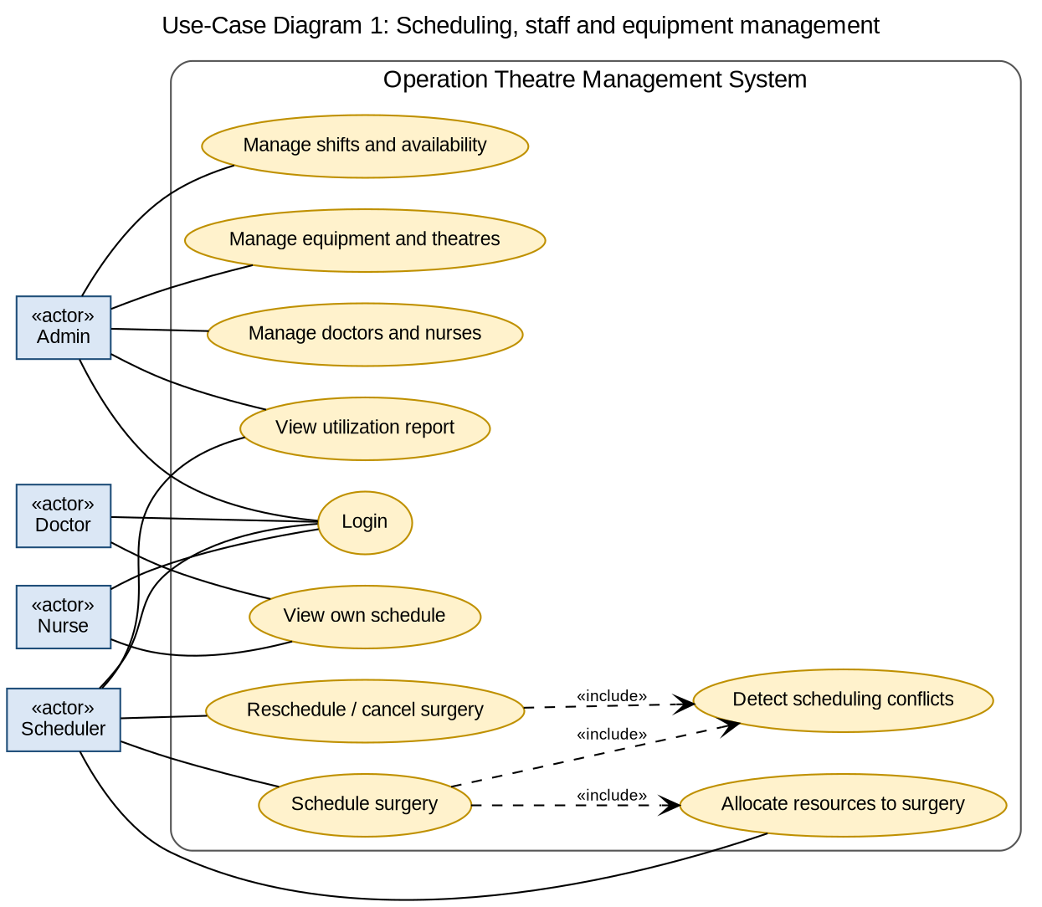
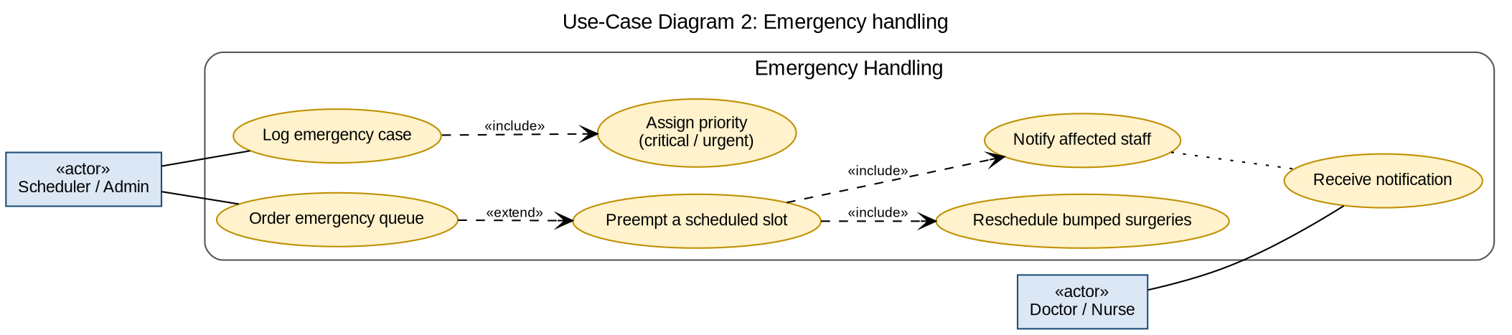

8. Requirements Traceability Matrix (RTM)
Status: N = not started, P = in progress, A = accepted (tests passed).
Req ID | Requirement (short) | Section / Design ref | Module | Test case(s) | Status | Owner
OT-F-010 | Schedule surgery | 4 / DS-Scheduling | SchedulingService | TC-Sched-01 | N | Pulkit
OT-F-011 | Reschedule surgery | 4 / DS-Scheduling | SchedulingService | TC-Sched-02 | N | Pulkit
OT-F-012 | Cancel surgery | 4 / DS-Scheduling | SchedulingService | TC-Sched-03 | N | Pulkit
OT-F-013 | Detect conflicts | 4 / DS-Scheduling | SchedulingService | TC-Sched-04, TC-Sched-05 | N | Pulkit
OT-F-020 | Log emergency | 4 / DS-Emergency | EmergencyService | TC-Emg-01 | N | Piyush
OT-F-021 | Emergency priority queue | 4 / DS-Emergency | EmergencyService | TC-Emg-02 | N | Piyush
OT-F-022 | Preempt and reschedule | 4 / DS-Emergency | EmergencyService | TC-Emg-03, TC-Emg-04 | N | Piyush
OT-F-023 | Notify on change | 4 / DS-Emergency | EmergencyService | TC-Emg-05 | N | Piyush
OT-F-030 | Manage staff records | 4 / DS-Staff | StaffService | TC-Staff-01 | N | Poorvi
OT-F-031 | Shifts and availability | 4 / DS-Staff | StaffService | TC-Staff-02 | N | Poorvi
OT-F-032 | Login and role-based access | 4 / DS-Auth | AuthService | TC-Auth-01, TC-Auth-02 | N | Poorvi
OT-F-033 | Assign staff to surgery | 4 / DS-Staff | StaffService | TC-Staff-03 | N | Poorvi
OT-F-040 | Manage equipment and theatres | 4 / DS-Equipment | EquipmentService | TC-Eq-01 | N | Riyana
OT-F-041 | Track availability | 4 / DS-Equipment | EquipmentService | TC-Eq-02 | N | Riyana
OT-F-042 | Allocate and release resources | 4 / DS-Equipment | EquipmentService | TC-Eq-03 | N | Riyana
OT-F-043 | Utilization report | 4 / DS-Reporting | ReportingService | TC-Rpt-01, TC-Rpt-02 | N | Riyana
OT-NF-001 | Emergency allocation time | 5 / DS-Emergency | EmergencyService | TC-Perf-01 | N | Piyush
OT-NF-002 | Availability | 5 / DS-All services | All services | TC-Rel-01 | N | Piyush
OT-NF-003 | Ease of use | 5 / DS-Web UI | Web UI | TC-UX-01 | N | Riyana
OT-NF-004 | Record retention | 5 / DS-Database | Database | TC-OPS-01 | N | Riyana
OT-NF-005 | Report accuracy | 5 / DS-Reporting | ReportingService | TC-Rpt-03 | N | Riyana
OT-SR-001 | TLS 1.2+ everywhere | 5.1 / DS-Security | Auth / All services | TC-Sec-01 | N | Poorvi
OT-SR-002 | Hashed passwords | 5.1 / DS-Security | Auth / All services | TC-Sec-02 | N | Poorvi
OT-SR-003 | Server-side RBAC | 5.1 / DS-Security | Auth / All services | TC-Sec-03 | N | Poorvi
OT-SR-004 | Account lockout | 5.1 / DS-Security | Auth / All services | TC-Sec-04 | N | Poorvi
OT-SR-005 | Audit log | 5.1 / DS-Security | Auth / All services | TC-Sec-05 | N | Poorvi
OT-SR-006 | Input validation | 5.1 / DS-Security | Auth / All services | TC-Sec-06 | N | Poorvi

