**SU’s Developments Functionality Over BT_Beta**

VSU’s development is updated over Bluetriton application, this development is under Object workspace tab.

# **Functionality**:

**Step 1:** For VSU, we are following the functionality of the workflow we required here two users like Admin and non-Admin with different browsers. So, in this application we logged-in from Global Admin in chrome and Test 1 is Non-admin in Microsoft edge browser.

Logged-in from **Global Admin** in Chrome and create the object.

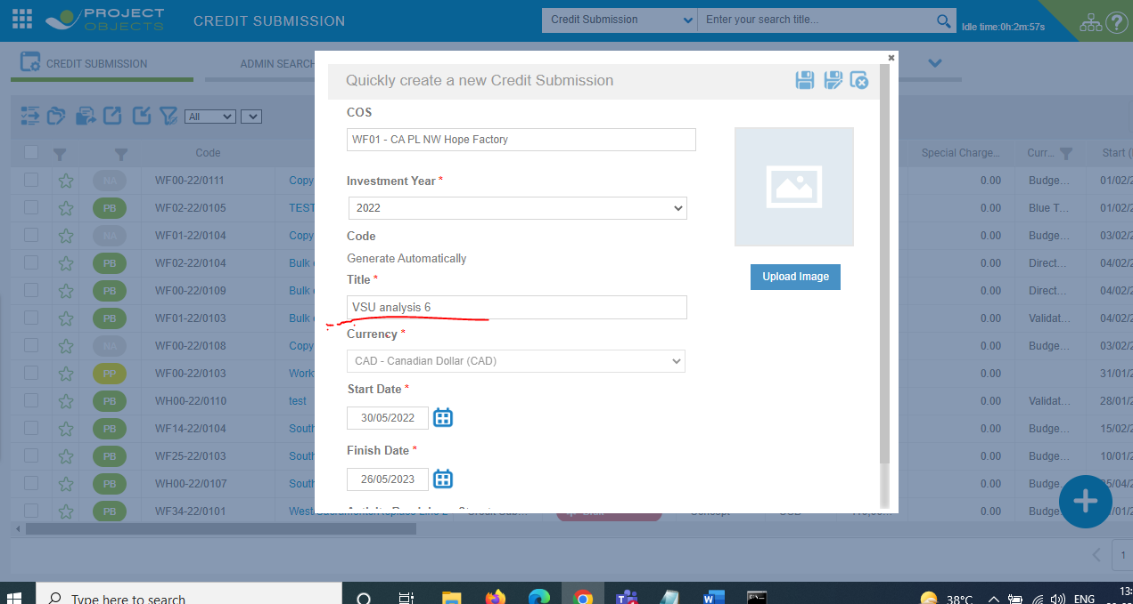

And login from **Test 1 (Non-Admin User)** in Microsoft edge and object is visible in credit register.

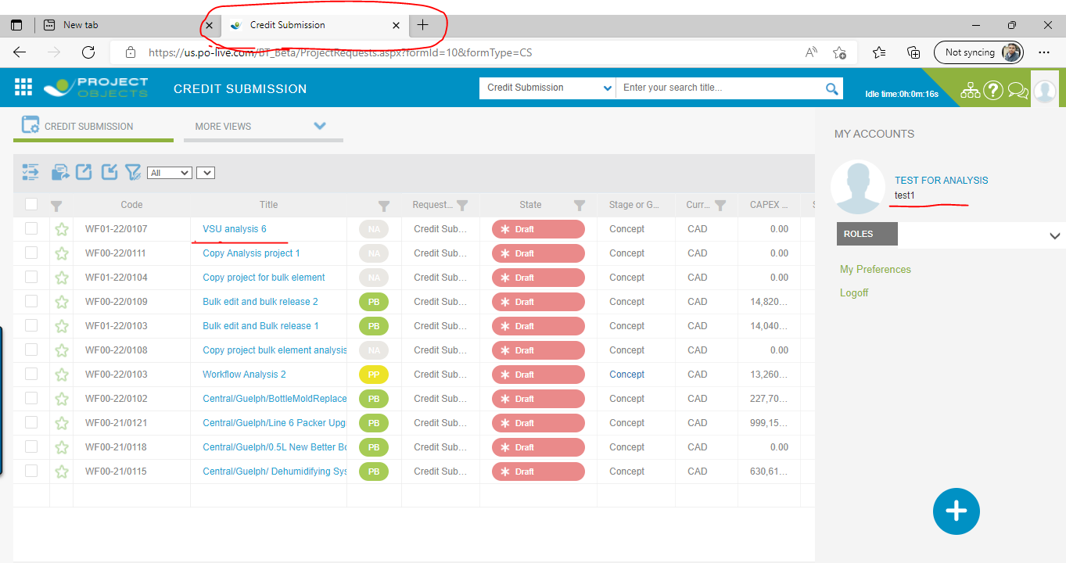

**Step 2:** From **Global Admin,** we go to the object workspace from credit register and fill data of Cost element data.

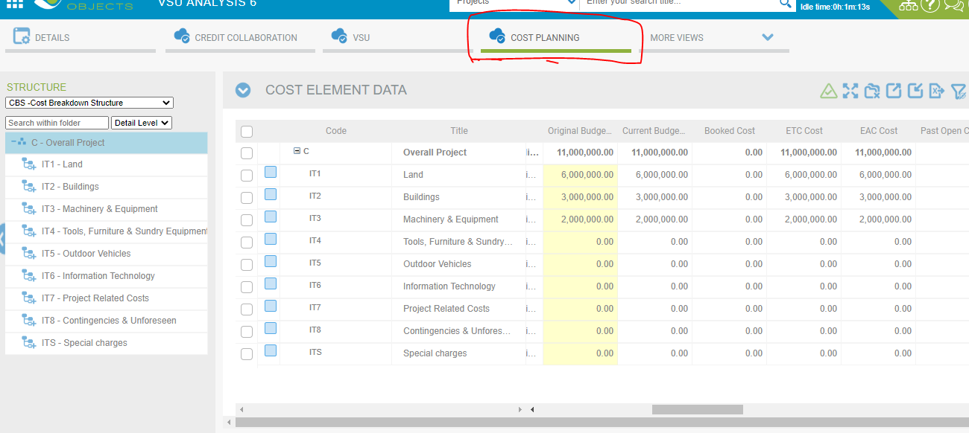

**Step 3:** After define the cost of the object then we proceed the VSU tab follow the process step by step. In VSU tab select date to initiate date then click **Go.**

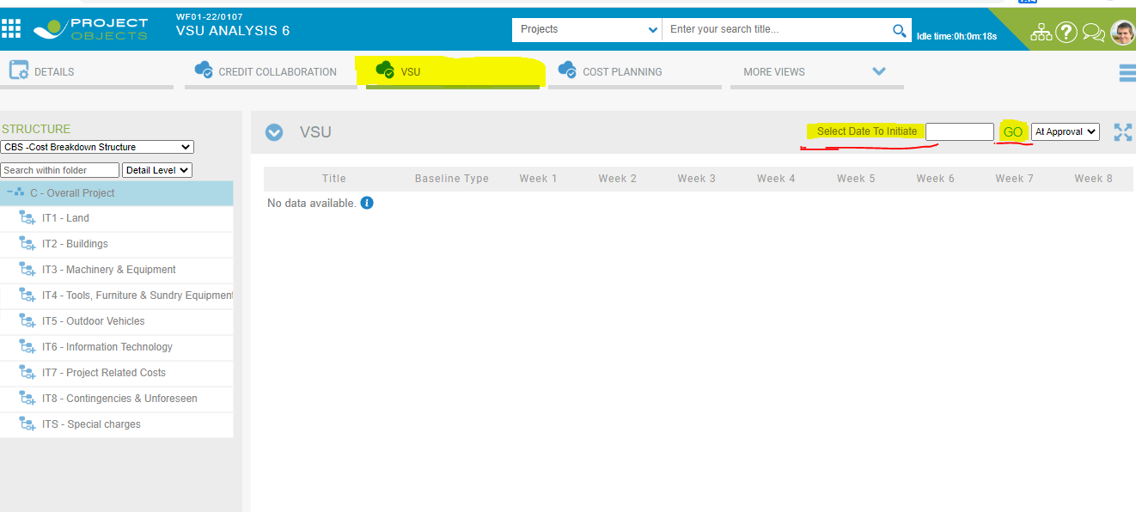

Below Screenshot we select the date and click GO then, Dates would be come in the calendar week days column but here are calendar week days columns follow the condition. Condition is here that if you select any date (Current date or Future Date) It will be consider from Monday date in column of weeks and we can’t take the past date in Date initiate field. Three rows also add in the widget.

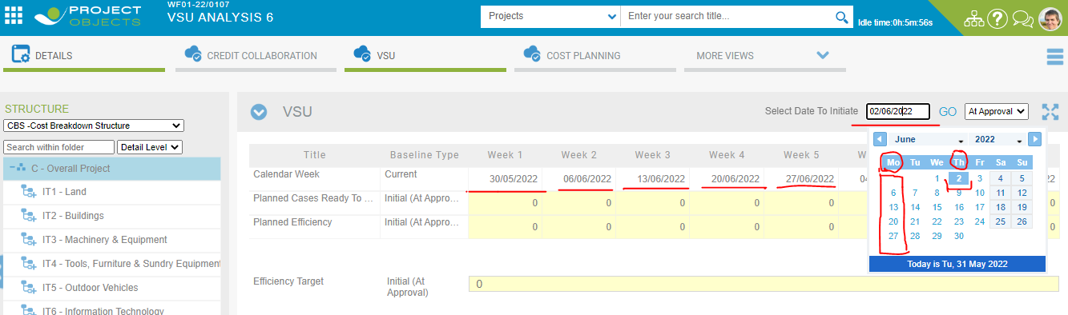

And after these changes we also check with another non-admin User (Test 1) over different browser (Microsoft edge) and see same update on same Object (VSU analysis 6).

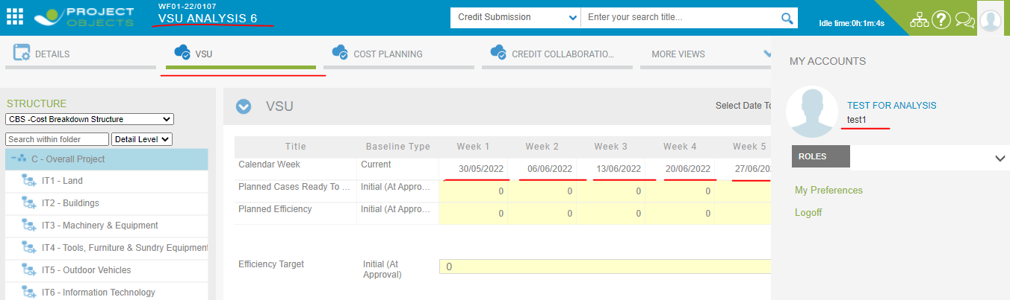

**Step 4:** In VSU widget grid add automatically three rows like Planned case, Planned Efficiency and Efficiency Target which is editable form for Global Admin and Non-Admin user for different browsers.

**Note: ( Conditions )**

* **In VSU widget all three rows of planned case, planned efficiency and Efficiency Target should be editable form and this is always editable form for Global Admin User in application.**
* **But for a Non-admin User, In VSU widget all three rows of planned case, planned efficiency and efficiency target would be editable form till unless we are not release the all steps of the object completely. Then after released object, object visible in the project register then VSU widget all three fields are visible non-editable form for non-admin user, editable only before release object completely.**

**Global Admin User- VSU widget always editable.**

**Non-Admin User- Editable only before object released completely.**

* **Planned Case row – Only take Numeric Value (Not take decimal value).**

**Planned Efficiency – Only take percentage % Value (Not take any decimal value).**

**Efficiency Target – Only take percentage % Value (Not take any decimal Value).**

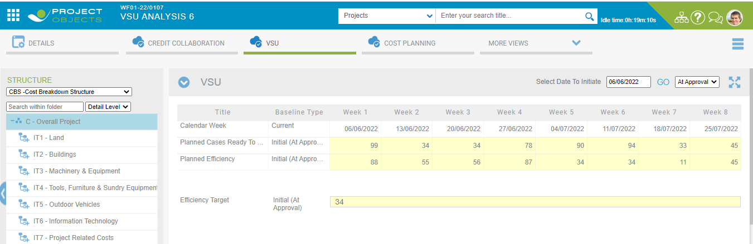

**As s**ame for Non-Admin User VSU tab in editable form.

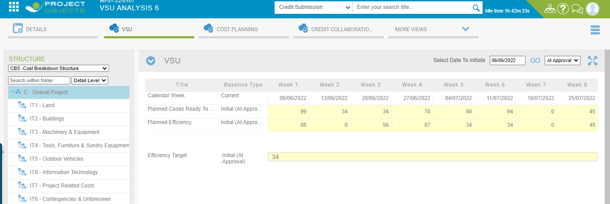

Step 5: Now we are started to release the steps of the object step by step from credit register.

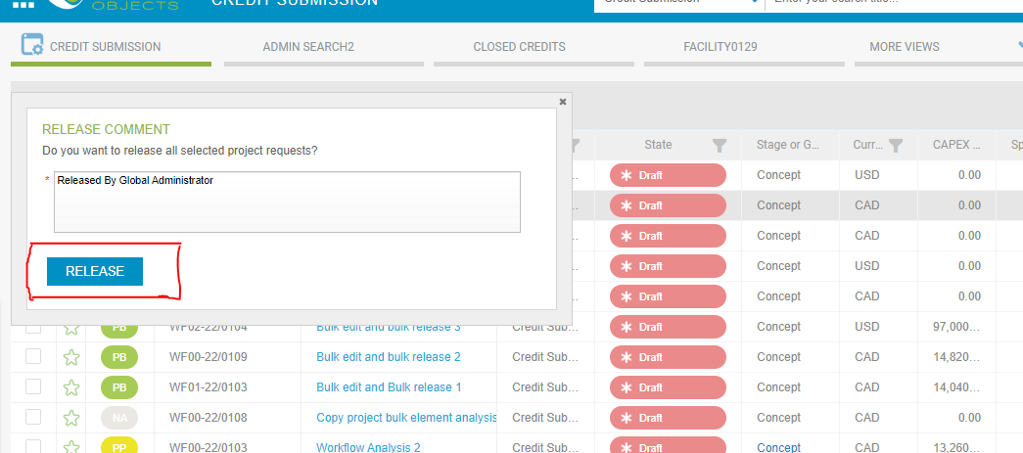

Release steps completely, Our object visible in the project register.

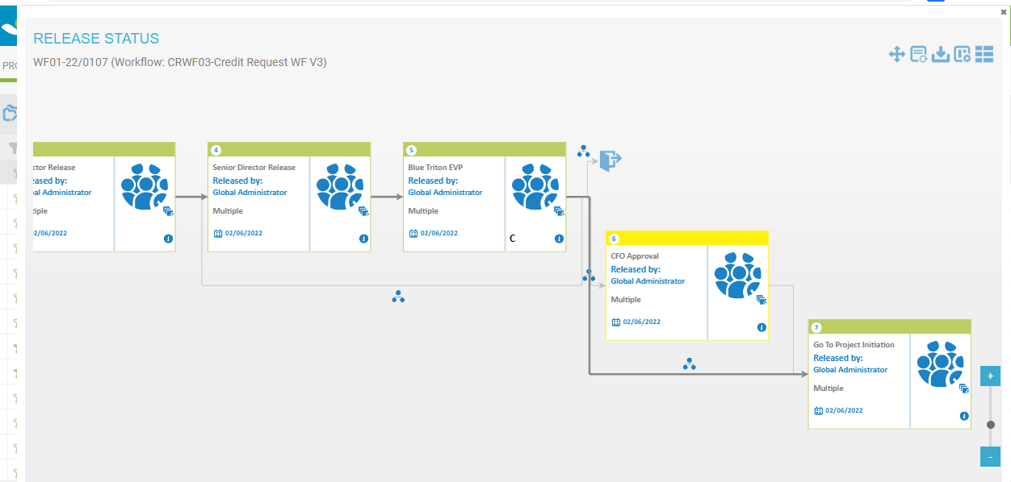

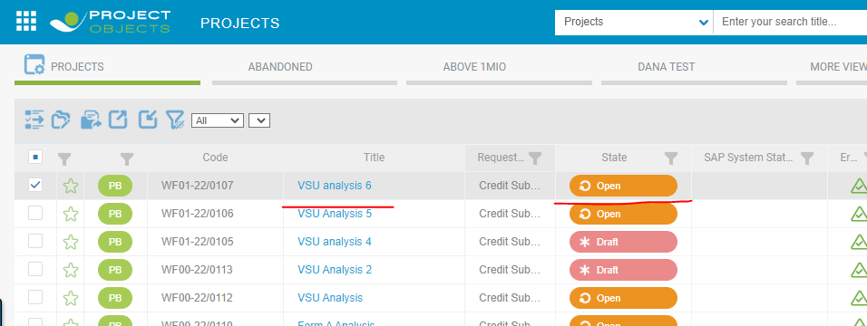

After that go to the project workspace and select VSU tab. Here in VSU tab two rows add in VSU widget, that name is Actual case, Actual efficiency. User global admin always editable form.

**Actual Case:** **Only take percentage % Value (Not take any decimal value).**

**Actual Efficiency: Only take Numeric Value (Not take decimal value).**

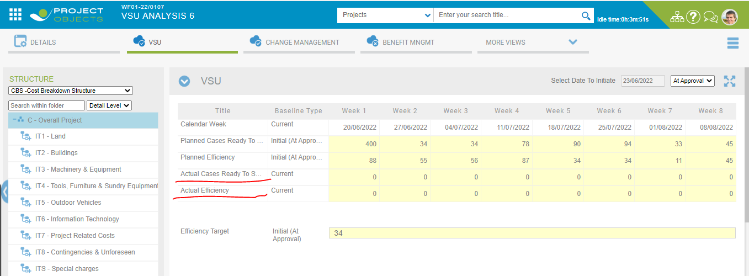

And same as it is also check for non-admin user over different browsers for widget update. But here is the condition, In VSU widget for non-admin user only two new rows are editable and remaining rows read only form.

**Only Actual Case and Actual Efficiency is editable form for non-admin user.**

**Here we mention the Project Review Process (PRP) conditions.**

For creating Project review process, we go to the project details > Financial indicators > Select checkbox of Review required > Save.

Then after this we proceed to the Collaboration Menu and select Project review process and create PRP for particular project.

After creation of PRP, it is visible in object VSU widget dropdown field like PRV-22-0001.

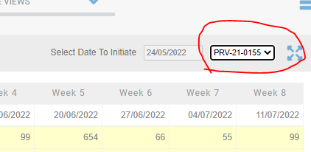

**Condition: Whenever we would be to create PRP then it just working like benefit tracking. Unless PRP’s releasing steps is not released completely then till VSU’s all rows would be editable.**

**After released PRP all steps completely, that’s PRP data row in VSU widget (Both Actual row) for editable and remaining rows would be read only form. This is for Non-Admin User.**

**Calendar week Condition: Completion of date week in VSU date column then it would be visible in read only form. Means The condition of the row of calendar week is that as the date week gets completed, that week column will get changed in read only form.**

**After one week till Tuesday will be editable form and from Wednesday particular date would be visible in read only form for NON-ADMIN user.**

**----------------------------------------------------------------------------------------------------------------------------------------------------------------------------------------------------------------------------------------------------------------------------**

# **VSU Development Changes at 15/07/2022**

**Development Cases: -**

VSU changes updated over BT_Beta.

1. Change label "Select Date to Initiate" to "STT Date:"
2. Keep actual and planned for "Cases Ready to ship" together, same for "Efficiency"
3. Efficiency target field is read-only and derives from planned efficiency in week 8
4. As soon as Actual date given the forecast STT date will be aligned to it and all planned values will be shifted accordingly.
5. Actual date cannot be earlier than today.

**Again Changes 24/07/2022**

1. VSU Actual date and other changes  
   -Change label "Select Date to Initiate" to "STT Date:"  
   -Keep actual and planned for "Cases Ready to ship" together, same for "Efficiency"  
   -Efficiency target field is read-only and derives from planned efficiency in week 8  
   -When user enters first actual popup needs to ask user for actual date of STT
2. Financial Indicator Shift to trade (Check for Monthly Report also)
3. Safety Report form performance
4. Safety Report Data in Monthly Report