

Disaster Recovery Test_II-SPM 2023

Document nr.: UPPWISE-DR-2023-2

Revision: 2

Date: Dec 2023

**Author: Raunak Sharma**

**R.sharma@uppwise.com**

Contents

**1.** **Information Technology Statement of Intent** 3

**2.** **Objectives** 3

**3.** **IT Disaster Recovery Plan Revision History** 3

**4.** **Disaster Recovery Solution** 4

4.1 About Site Recovery for servers 4

4.2 What does site Recovery Provide us? 4

**5.** **Azure Disaster Solution Architecture** 5

5.1 Azure Server Architecture for Failover Site 5

5.2 ASR Replication structure for servers over Azure 6

**6.** **Technology Disaster Recovery Plan** 7

6.1 Specifications for <SPM-APP> 7

6.2 Backup Strategy and Disaster Recovery Procedure 8

**7.** **Disaster Recovery Plan Execution** 9

7.1 Failover Incident 10

7.1.1 Activation of Disaster Recovery Team 10

7.1.2 Emergency Alert 11

7.1.3 Action Taken by Disaster Recovery Team 11

7.1.4 Outcomes arising from actions taken. 11

7.2 Failback Incident 12

7.2.1 Activation of Disaster Recovery Team 12

7.2.2 Emergency Alert 13

7.2.3 Action Taken by Disaster Recovery Team 13

7.2.4 Outcomes arising from actions taken. 13

7.3 Assessment of the effectiveness of the DRT 15

**8.** **Management of DR Activity Form** 15

**9.** **Disaster Recovery Event Recording Form** 16

# **Information Technology Statement of Intent**

This document delineates our policies and plans test for technology disaster recovery. This document summarizes our procedures and outcomes of drill in the event of an actual emergency like situations.

Our mission is to ensure information system uptime, data integrity and availability, and business continuity.

# **Objectives**

The principal objective of the disaster recovery program is to develop, test and document a well-structured and easily understood Failover test which will help the company recover as quickly and effectively as possible from an unforeseen disaster or emergency which interrupts information systems and business operations.

When disaster strikes, business suffers. A goal of business planning is to mitigate disruption of product and services delivery to the greatest degree possible when disruption due to disaster occurs. Business continuity is the overarching concern.

An IT disaster recovery plan is the lynchpin of an overall business continuity strategy. And the purpose of business continuity is to maintain a minimum level of service while restoring the organization to business as usual.

**UPPWISE SRL** encourages to proactively execute an IT Disaster Recovery plan and periodically test of plan.

# **IT Disaster Recovery Plan Revision History**

|  |  |  |  |
| --- | --- | --- | --- |
| **REVISION** | **DATE** | **NAME** | **DESCRIPTION** |
| UPPWISE-DR-2023-2 | * 16-Dec-23 * 17-Dec-2023 | Disaster Recovery  Test: SPM | * Failover of SPM Servers to secondary region * Failback of servers to primary region |

# **Disaster Recovery Solution**

## 4.1 About Site Recovery for servers

Azure Recovery Services contributes to our BCDR strategy:

* **Site Recovery service**: Site Recovery ensure business continuity by keeping business apps and workloads running during outages. Site Recovery replicates workloads running on physical and virtual machines (VMs) from a primary site to a secondary location. When an outage occurs at our primary site, we can fail over to secondary location, and access apps from there. After the primary location is running again, we can fail back to it.
* **Backup service**: The Azure Backup service keeps our data safe and recoverable.

Site Recovery can manage replication for:

* Azure VMs replicating between Azure regions.

## 4.2 What does site Recovery Provide us?

|  |  |
| --- | --- |
| **Azure VM replication** | we set up disaster recovery of Azure VMs from a primary region (west Europe) to a secondary region (North Europe). |
| **RTO and RPO targets** | Keep recovery time objectives (RTO) and recovery point objectives (RPO) within organizational limits. Site Recovery provides us continuous replication for Azure VMs and replication frequency as low as 30 seconds. |

# **Azure Disaster Solution Architecture**

## 5.1 Azure Server Architecture for Failover Site

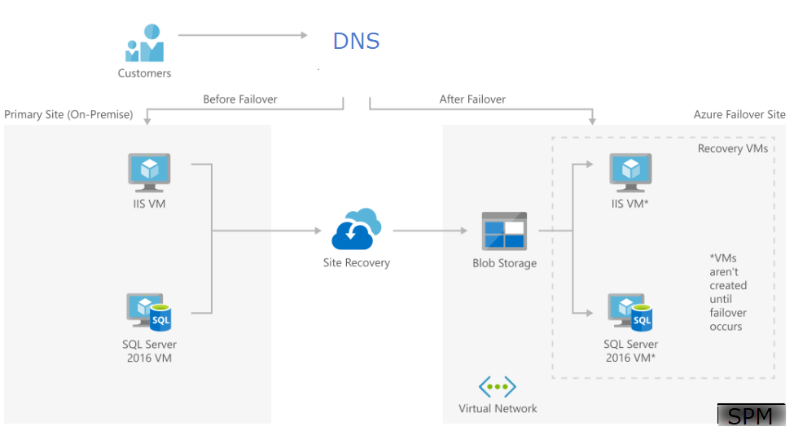

Nort Europe

West Europe

## 5.2 ASR Replication structure for servers over Azure

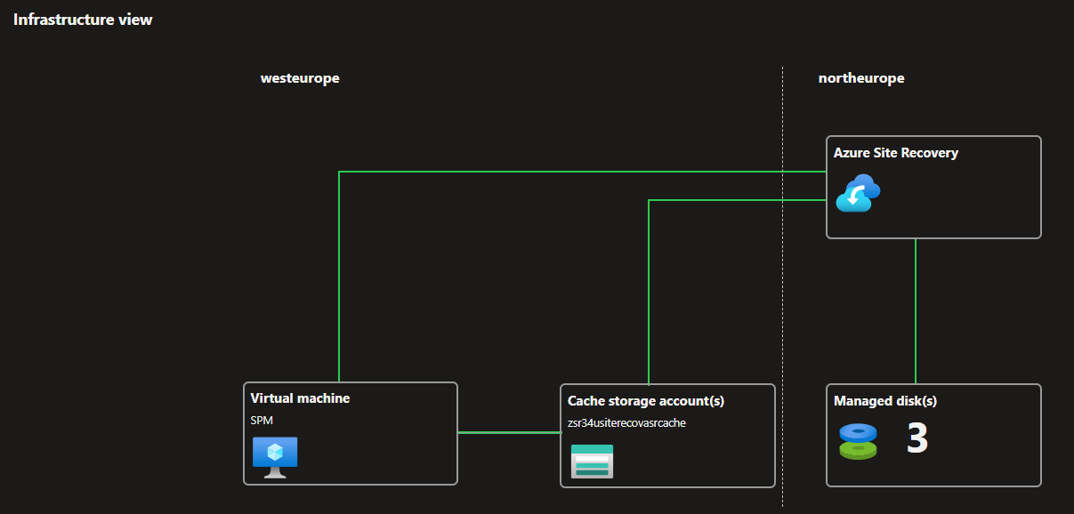

# **Technology Disaster Recovery Plan**

## 6.1 Specifications for <SPM-APP>

|  |  |
| --- | --- |
| **SYSTEM** | Microsoft Azure Virtual Machine- **SPM-APP** |

|  |  |
| --- | --- |
| **OVERVIEW** |  |
| **PRODUCTION SERVER** | **Location:**  West Europe  **Server Model:**  Standard D8s_V3  **Operating System:**  Windows server 2019 Datacenter  **CPUs:**  8 vCPUs  **Memory:**  32 GiB  **Total Disk:**  OS & One Data Disk  **DNS Entry:**  Spm.uppwise.com |
| **APPLICATIONS**  (Use bold for Hot Site) | <Https://spm.uppwise.com/SPM/Logonform.aspx> |
| **ASSOCIATED SERVERS** | SQL Server’s VM  Microsoft Azure Virtual Machine- **SPM** |

## 6.2 Backup Strategy and Disaster Recovery Procedure

|  |  |
| --- | --- |
| **BACKUP STRATEGY**  **FOR SYSTEMS** |  |
| App server | Daily Backup every 24 Hours |
| SQL Server | Daily Backups of SQL server |
| Retention Period | 30 Days for App server and 30 Days for SQL backups |
|  |  |
| **DISASTER RECOVERY**  **PROCEDURE** | 1. Manual failover on Primary Region servers 2. SPM-App 3. SPM   Servers get shutdown at primary region after failover started.   1. ASR automatically assigned similar properties of virtual network at secondary (North Europe) region from primary region and continuously synchronized the server. 2. After servers are in running state at secondary region, Network security group and New Public IP for servers is to attach on network interface card in **spm-rg-vnet-asr**. 3. Public IP of application server (SPM-App) in secondary region is to be added to Domain name servers i.e., **spm.uppwise.com**. 4. By RDP connect to all servers and check all the services/properties are in running state. 5. Check Application link back in running state and now running from secondary region that is North Europe region. 6. After checking everything re-protect the servers in Azure site recovery which start synchronization this time from secondary to primary region. 7. After synchronization completed first RPO/RTO will be generated. 8. After things become stable at primary side do Failback process to get servers back at primary region. 9. After failback do re-protect and synchronization will be completed by ASR. |

# **Disaster Recovery Plan Execution**

Below screens shows servers are in running state at Primary (West Europe) Region before failover, and application service is accessible from primary region servers.

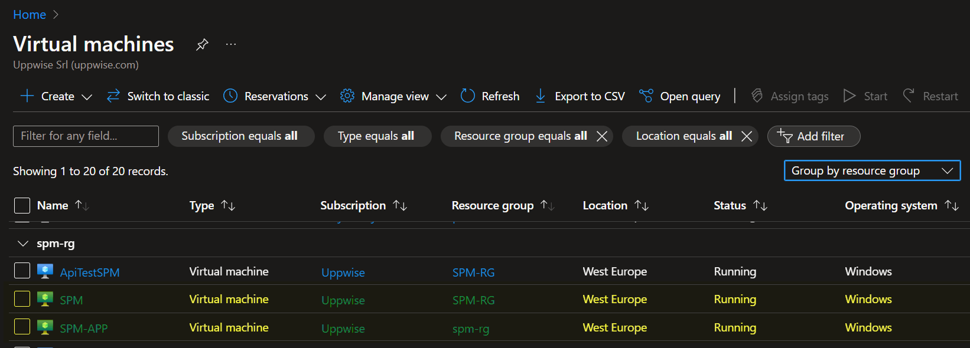

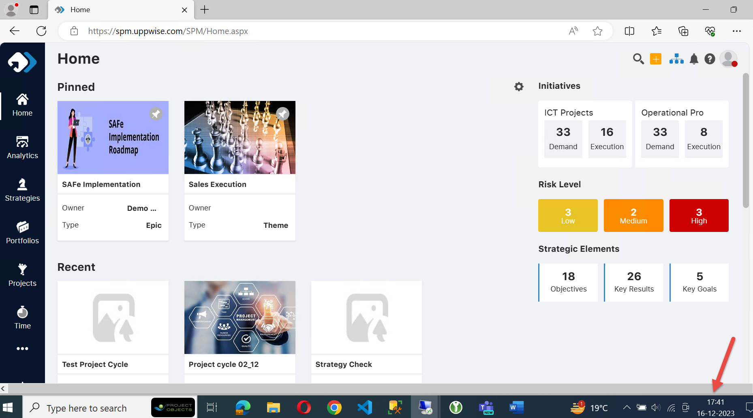

## 7.1 Failover Incident

### Activation of Disaster Recovery Team

The Failover Incident has started on **16th of Dec 2023 at 17:42 IST/12:12 UTC.**

Below screenshot shows the failover start and completion time on Azure site recovery.

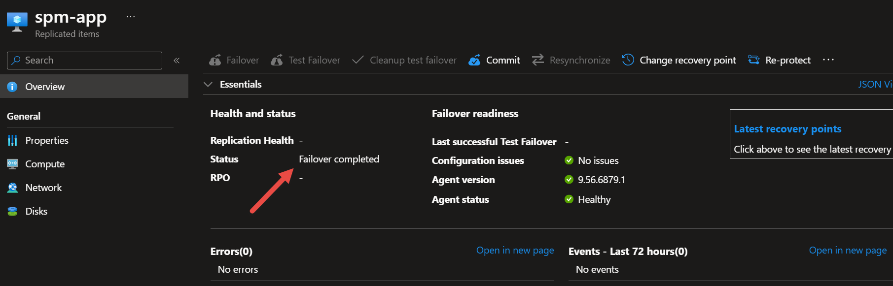

When incident occurs the Disaster Recovery Team (DRT) is activated

Responsibilities of the DRT are to:

* + - Respond immediately to a potential disaster and inform to the Team.
    - Restore key services within 20-30 minutes of the incident.
    - Start Executing steps those are predefined in DRP.
    - Recover to application link as usual within20 to 30 Minutes after the incident.
    - Coordinate activities, first responders, etc.

### Emergency Alert

The persons getting Alerts at time of incident the Disaster Recovery Team in the order listed:

Disaster Recovery Team

* + - Raunak Sharma
    - Mauro Contini
    - Ravi P Gupta
    - Luca Paciolla

### Action Taken by Disaster Recovery Team

As soon as Alert is notified Disaster Recovery Team quickly started to execute all predefined steps in disaster recovery procedure to complete failover process from Primary region to secondary region.

### Outcomes arising from actions taken.

Team successfully completed Disaster Recovery actions and we were able to get our servers in running state at secondary region after failover.

Our application and services back to business and accessible from secondary region servers in span of less than **16 minutes** only after disruption occurred due to failover.

**Disaster Recovery failover process completed at 17:58 IST/12:28 UTC (16th of Dec 23)**

Below screen shows now servers are in running state at North Europe Region after failover

Also, below screenshot shows we were able to access our application from secondary region servers at **17:58 IST/12:28 UTC (16th of Dec 23) successfully without any disruption or malfunctioning.**

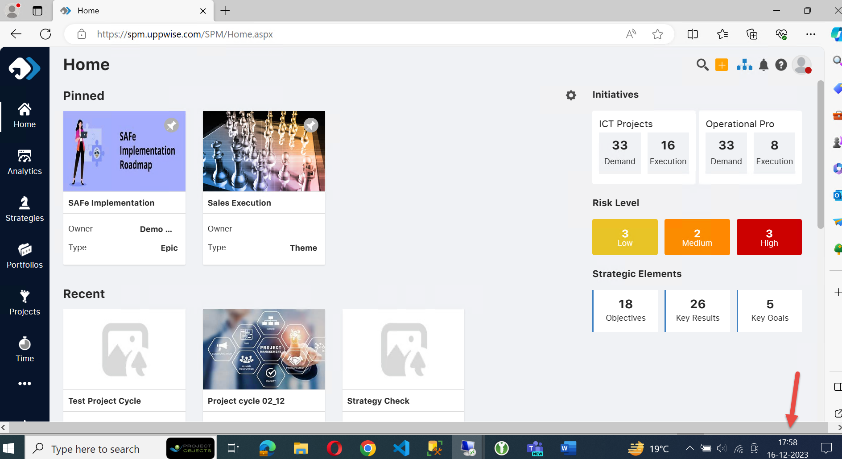

## Failback Incident

### Activation of Disaster Recovery Team

The Failback Incident has started on **17th of Dec 2023 at 2:33 PM IST/09:03 AM UTC.**

Below screenshot shows the failover start and completion time on Azure site recovery.

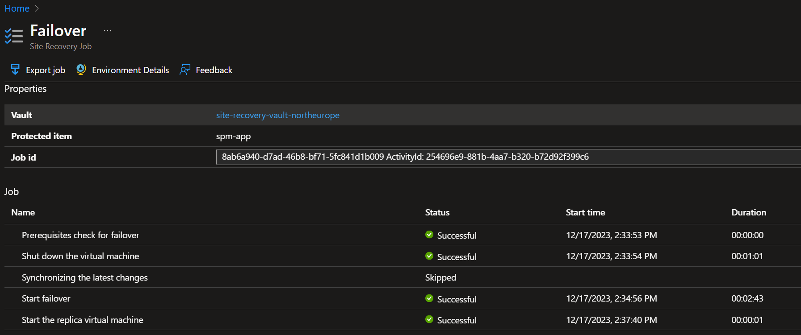

When incident occurs the Disaster Recovery Team (DRT) is activated.

Responsibilities of the DRT are to:

* + - Respond immediately to a potential disaster and inform to the Team.
    - Restore key services within 30 minutes of the incident.
    - Start Executing steps those are predefined in DRP.
    - Recover to application link as usual within 20 to 30 Minutes after the incident.
    - Coordinate activities, first responders, etc.

### Emergency Alert

The persons getting Alerts at time of incident the Disaster Recovery Team in the order listed:

Disaster Recovery Team

* + - Raunak Sharma
    - Mauro Contini
    - Ravi P Gupta
    - Luca Paciolla

### Action Taken by Disaster Recovery Team

As soon as Alert is notified Disaster Recovery Team quickly started to execute all predefined steps in disaster recovery procedure to complete failback process from secondary region to primary region.

### Outcomes arising from actions taken.

Team successfully completed Disaster Recovery failback actions and we were able to get our servers in running state at Primary region after failover.

Our application and services back to business and accessible from primary region servers in approximately **12 minutes only**.

**Disaster Recovery failback process completed at 02:44 PM IST / 09:14 AM UTC (17th of Dec 23)**

Below screen shows now servers are in running state again at West Europe Region after failback.

Also, below screenshot shows we were able to access our application from Primary region servers at **02:44 PM IST / 09:14 AM UTC (17th of Dec 23) successfully without any disruption or malfunctioning.**

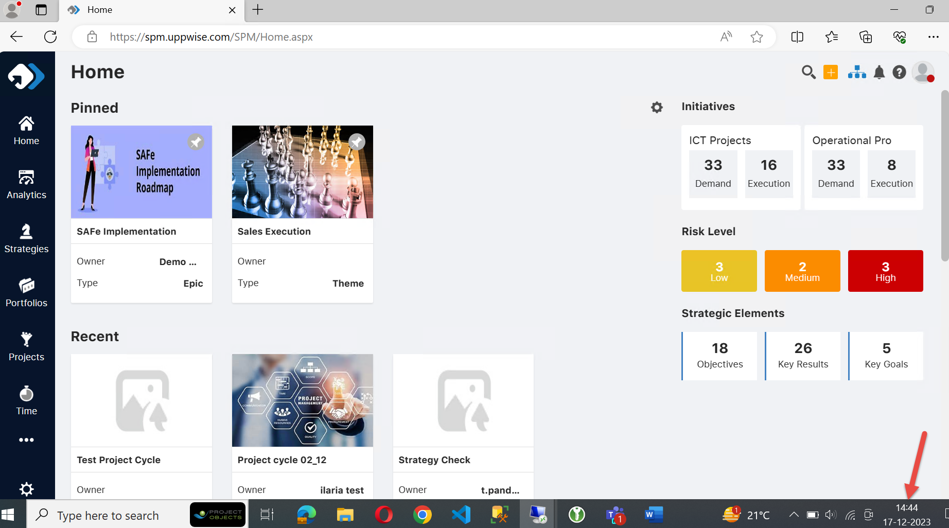

## Assessment of the effectiveness of the DRT

The Disaster Recovery test assessment verified we have well planned and effective disaster recovery management, as an organization goal of business planning, we are capable to mitigate disruption of product and services delivery to the greatest degree possible when disruption due to disaster occurs. Business continuity is the overarching concern, and in this test drill we regain our services back in running state in timeframe of less than 15-20 minutes only.

**After Disaster Recovery test completed all servers are re-protected and synchronized again with secondary region.**

# **Management of DR Activity Form**

|  |
| --- |
| **Activity Name:** Disaster Recovery Test over SPM Servers |
| **Reference Number:** UPPWISE-DR-2023-2 |
| **Brief Description:** Manual failover is done over SPM server’s and recovery is done from west Europe region to north Europe region.  Business is back in running state in secondary region in less than 15 minutes of failover has started.  After things get back to normal, we again did failback of servers to primary region on 17th Dec 23, failback process is also completed in approximately 15 minutes of timespan, and everything is working fine. |

|  |  |  |  |  |
| --- | --- | --- | --- | --- |
| **Process** | **Commencement Date/Time** | **Completion Date/Time** | **VM Involved** | **In Charge** |
| Failover | 16th Dec 23,  17:42 PM IST/12:12 PM UTC | 16th Dec 23,  17:58 PM IST/12:28 PM UTC | 1.SPM-APP  2.SPM | Raunak Sharma |
| Failback | 17th Dec 23,  02:33 PM IST/09:03 AM UTC | 17th Dec 23,  02:44 PM IST/09:14 AM UTC | 1.SPM-APP  2.SPM | Raunak Sharma |

# **Disaster Recovery Event Recording Form**

|  |
| --- |
| **Description of Disaster:** Disaster Recovery Test over SPM environment Servers  (Failover and Failback) |
| **Commencement Date: Failover-** 16-December-23  **Failback-** 17- December- 23 |
| **Time DR Test: Failover -**17:42 PM IST/12:12 PM UTC – 17:58 PM IST/12:28 PM UTC  **Failback-** 02:33 PM IST/09:03 AM UTC – 02:44 PM IST/09:14 AM UTC |

|  |  |  |  |  |
| --- | --- | --- | --- | --- |
| **Activities Undertaken by**  **DR Team** | **Start Date &**  **Time** | **End Date & Time** | **Outcome** | **Follow-On Action Required** |
| Failover Process of SPM Environment servers | 16th Dec 23,  17:42 PM IST/  12:12 PM UTC | 16th Dec 23,  17:58 PM IST/  12:28 PM UTC | Manual Failover Test is  Successfully completed and Application services are in running state again in less than 15 minutes from Failover | No follow-up action is required |
| Failback process of SPM Environment Servers | 17th Dec 23,  02:33 PM IST/  09:03 AM UTC | 17th Dec 23,  02:44 PM IST/  09:14 AM UTC | Failback of all SPM servers to primary region is done and application services are back again in 15 minutes only. | No follow-up action is required |