**NIMT SAP Functional Flow**

Revision: 1.0

Date: 03/November/2023

For further information please contact:

[support@uppwise.com](mailto:support@uppwise.com)  
[www.uppwise.com](http://www.uppwise.com)

**NIMT (Nestle Integrated Management Tool)**

NIMT Tools in designed to Manage the projects of Nestle, involving the project budget definition over the Cost Breakdown Structure. They are managing there cost data through SAP.

After the Credit final approval budget gets pushed to SAP, and fetching the Actual/Committed data from the SAP.

We have the Credit Request in NIMT tool, which includes the following information.

* Credit identification: here we can specify the Credit dates, currency and COS Details
* Additional Classification: Investment Year and Cos related information.
* Project Details, Summary and Justifications.
* Project Charter Details
* Workflow Decisions

Creating the Credit Submission

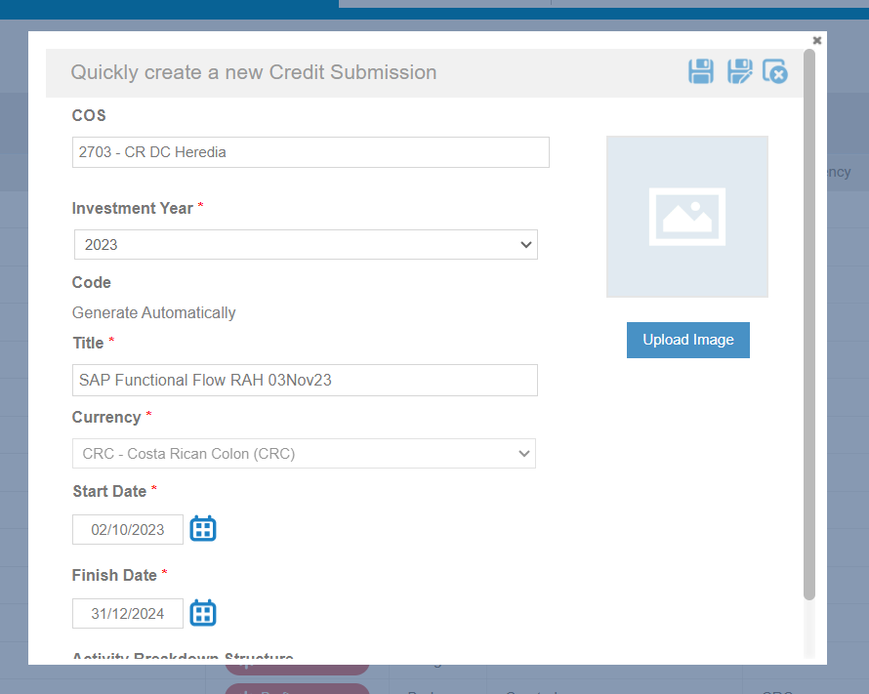

We have created the Credit over the COS Facility Node where the SAP Lock is Disabled,

now we can define the Cost Element Structure and specify the budget over these elements.

There are 3 fields on the Facility Level which get copied to project once we create it.

1. Responsible Cctr
2. Request Cctr
3. VertexCode

These are copied further to the cost elements and can be modified at the element level.

Once the budget is defined over the Project and these 3 attributes are defined over the project then. After the final step approval of Credit Request, SAP Project is created externally. (its mandatory to define these fields over the Projects and Element to create the project successfully over the SAP)

**Cost breakdown structure hierarchy.**

In past years from strating nestle was following the OLD Structure of CBS as we have defined below, and during the 2023 year they have re defined there default CBS Structure as we have mentioned below.

**Old Structure:**

**Root**

**IT1** (Investment type)

**PU** (Process Unit)

**Assets** (3 attributes defined above is mandatroy for the SAP project creation)

**New Structure:**

**Root** (Project)

**Special Charge**

**ITS** (Special Charge)

**PU** (Process Unit)

**Capex**

**IT1 – IT8** (Investment Type)

**PU** (Process Unit)

**Asset**

**SAP Project Creation**

Once the Credit is apporved from the final Step External SAP Project is Created Automatically,

In case its not created, we can manually create SAP project from the project context menu (Sync Project with SAP) or from Project Workspace burger menu (Reconnect project with SAP).

SAP project State is set to CRTD => **REL** when the project is created, also the CBS Structure is also synced in SAP along with the budget defined at the level 1 for the new structure and level 0 (root) in case of old Structure.

Green tick, External WBS specify that the elements and nodes are created over the SAP, for the new structure

**IT1 -IT8** and **ITS** Element and nodes are not synced/created over the SAP.

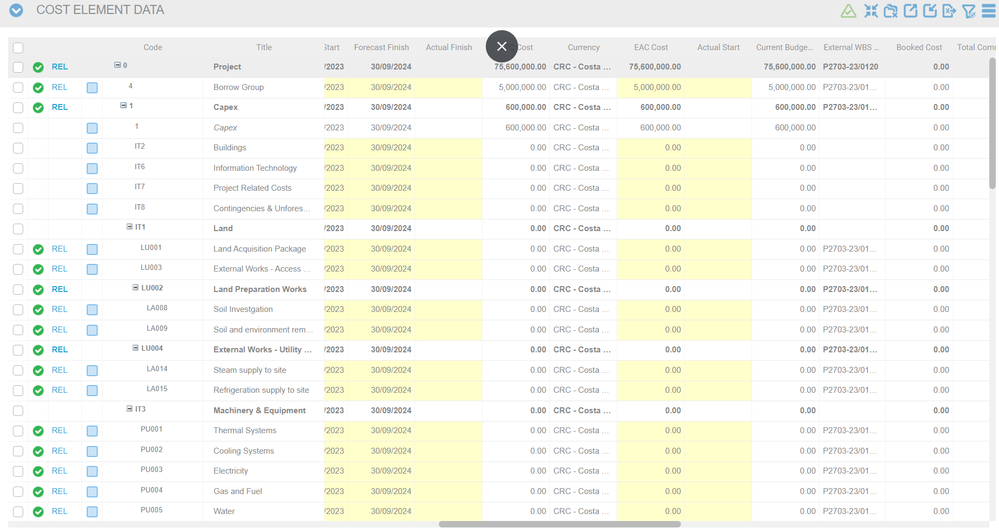

**WBS Structure Synchronization**

WBS structure sync is a bi-directional process, NIMT changes will take the precedence over the change on SAP, so in case of Conflict SAP project will be overwrite with NIMT WBS during the structure comparision.

NIMT -> SAP

SAP->NIMT

**Sync Project from context menu**: will sync the WBS Structure and also push the latest Budget to SAP and update SAP project state to ‘REL’ same operation is performed from the Project Workspace burger menu (Reconnect project with SAP)

**Cost Widget Sync operations**

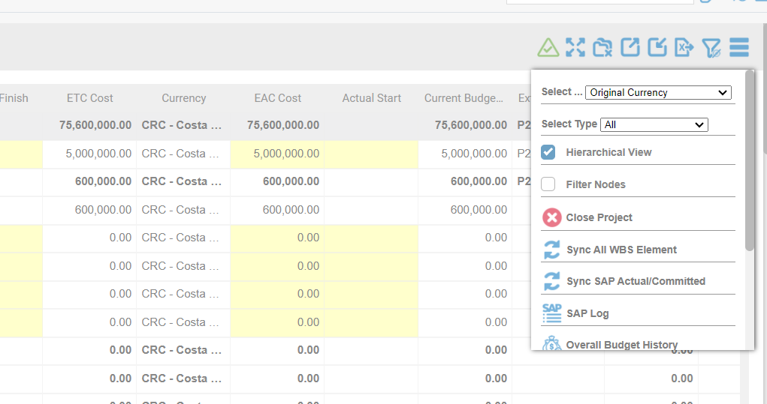

1. **Sync All WBS Element:** will sync NIMT to SAP and SAP to NIMT WBS Structure, if the element is created from SAP and it got created on NIMT then it will be identify with orange color indicator in the grid first column.
2. **Sync SAP Actual/Commited:** In NIMT Actual and Commited fields on cost is disabled as these get inserted from the SAP and we have the feature to fetch the Actual/Booked and Committed from the SAP and these are pushed over the last level which is Assets

In case of Actual/Booked it is fetched till the project time now and committed are fetched accross the time now.

And we receives multiple entries over the asset element and summarized values get inserted in the NIMT cost actual and commited fields.

1. **SAP Log:**  We can check for the SAP Log to check for the success and failure in syncing.

**Advance Cost SAP Actual/Commitment Items:**

we have another widget on project workspace where we can check the Actual/Committed items fetched from the SAP, there will be multiple entries for the single element, along with the posting period which will indicate on which monthly period of Actual/Commited value will be summarized and pushed.

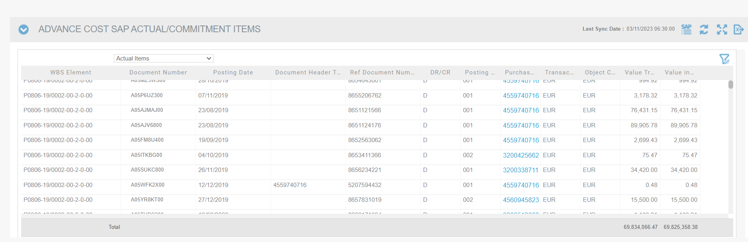

**NIMT SAP Tables**

1. TAB_EXTERNAL_ENTRIES
2. NESTLE_SAP_COST_ITEMS
3. NESTLE_SAP_SYNC_DATE
4. NESTLE_PROJECTCREATE_SAPEXCEPTION
5. NESTLE_ACTUAL_VALUES
6. TAB_NESTLE_BUDGET_RECORD
7. Project_Cost_Sync_Details
8. SAP_MONTHLY_ACTUALS
9. SG_PPO_PRJ
10. SAP_BULK_IMPORT_LOG

**Procedures**

1. Update_nestle_sap_actual
2. [USP_NSTLManageExternalEntries]
3. [UspUpdateExternalWbsCode]
4. [ClearSapConnectByProjectID]

**SAP Technical Flow:**