Firstly, we need to associate the WBS and internal orders received from SAP, to the projects. Based on this association only the data for resource and cost will be synced.

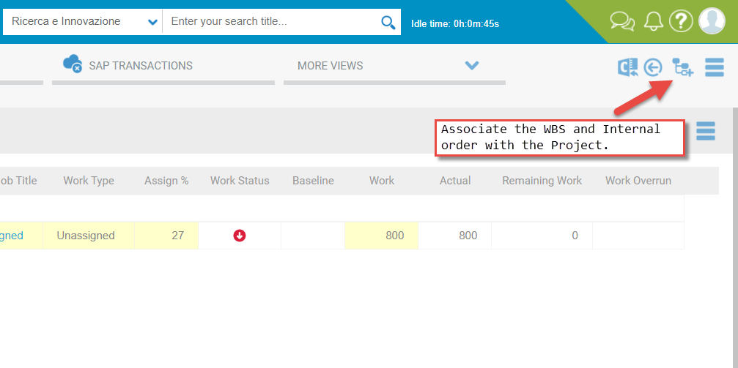

The following popup will load all the data received from SAP via SOAP service dedicated for WBS and internal order.

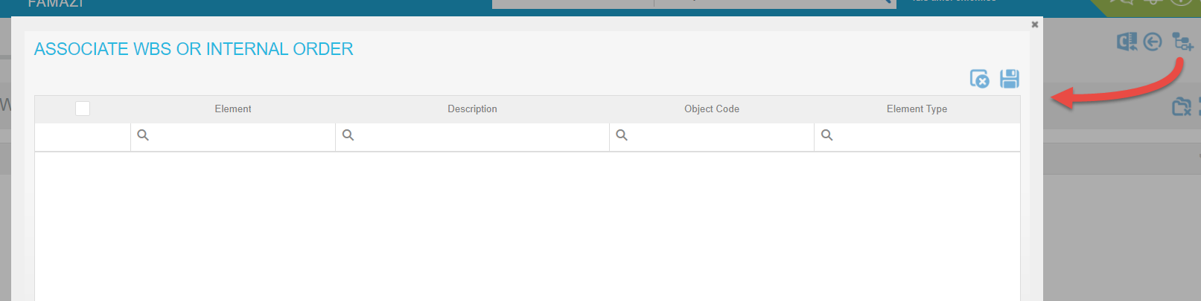

**Associated WBS and internal order**

The following widget will load the associated WBS and internal order with the projects, and it is a read only widget.

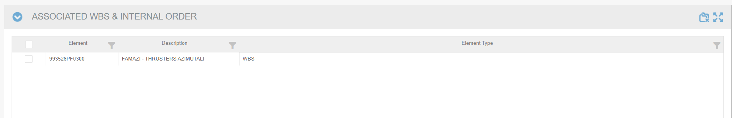

**SAP Cost Transactional Data**

The following widget then will load all the cost related data associated with the WBS and internal order. It is a read only widget, developed only to display data from SAP.

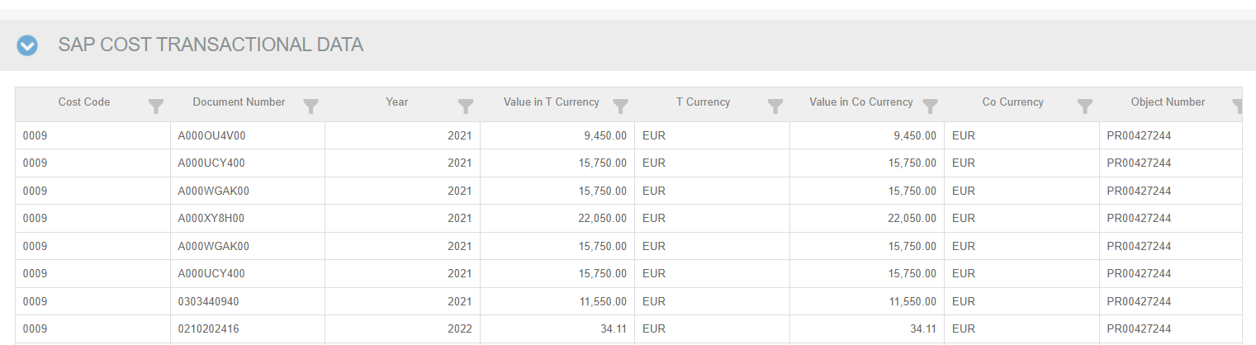

**SAL Data**

Following widget displays the SAL data received from SAP via SOAP service. It is read-only, and have not come into any use till now.

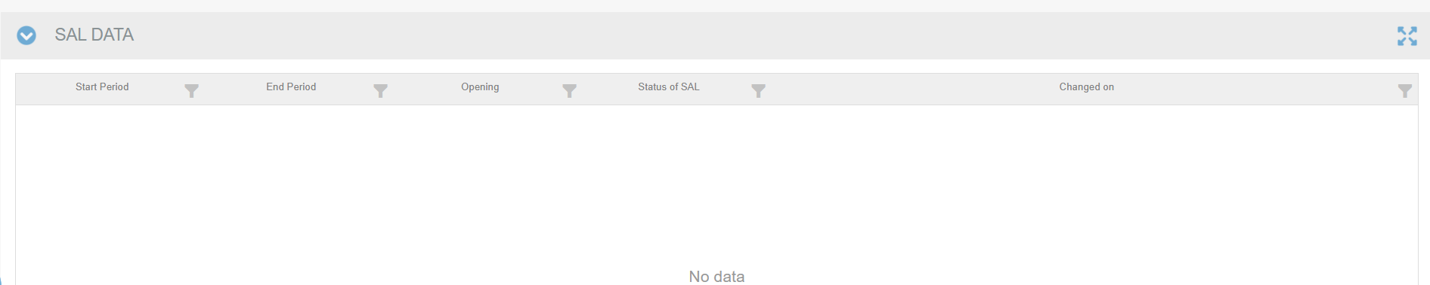

**Resource assignment**

On Resource assignment widget, we perform the data sync. The data will be synced only on the hard coded resource named “Internal Hours.”

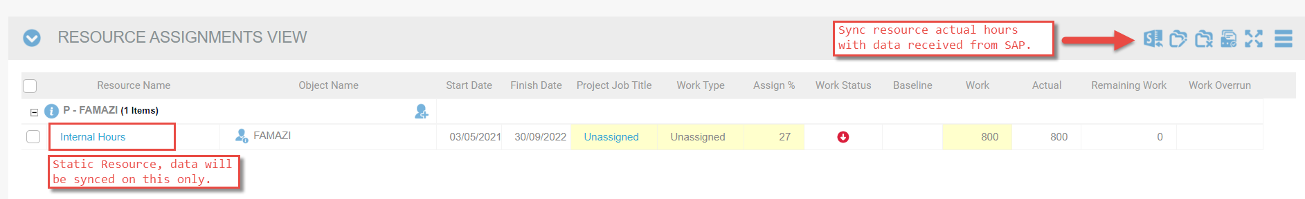

**Cost by Account Codes**

Same goes with the Cost by Account Codes widget, where we have the possibility to Sync the cost data. But we need to link the SAP cost codes with the PO cost codes.

We have developed a new entity in standard codes called “SAP Cost Account Codes”, it loads all the cost master data received from SAP.

These are then linked with PO Cost account codes.

