This document is reference to manage Noventi servers. Here we have discussed briefly about the accessibility, and update of the servers.

**Accessibility**

We need to get the access via TeamViewer with the following server Ids,

**Database Server – 564780234\***

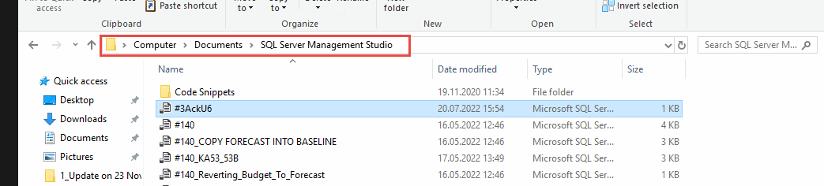

Figure Path to scripts

**PreProd Server – 738279259**

**Prod Server – 1001898996**

Their respective passwords as provided in separate document.

Once logged in to the server via TeamViewer we need to login to the systems with user name projectobject, credentials to which are into the same document for creds.

**Update**

After successfully login into the system, we need to perform the update (if needed). Please follow the below steps to perform the system update.

1. Publish the web app (Pox Master).
2. Upload the published files to cloud for transfer purpose only to the remote server.
3. Access the cloud link on server to download the publish.
4. Go to the following location, and create 2 folders namely New and Backup, and paste the new files and the existing files into them respectively,

**C:/POUpdates**

1. Now go to the main application folder as per the following location (Figure 2), and paste the new files except for the following:
   1. Environment folder.
   2. SlickLib Folder.
   3. Temp Folder.
   4. Web.config file.

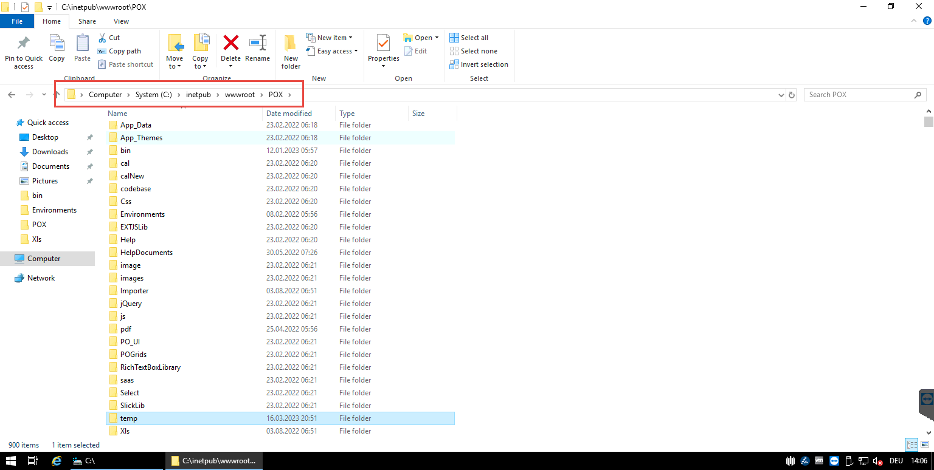

Figure Main App Path