Assignment 4 :

Q.1

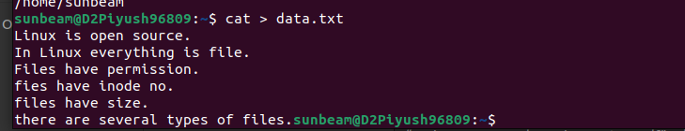
Q2.

