Documentation
on
Heart Diseases Analysis Dashboard

1. Introduction
This document provides an in‑depth explanation of the Heart Diseases Analysis Dashboard, designed to help healthcare professionals, analysts, and researchers understand the key trends in heart disease survival and risk factors. The dashboard visualizes various parameters including survival rates, clinical attributes, lifestyle-related risks, and demographic insights. This expanded version contains detailed descriptions, interpretations, and methodological summaries to ensure the document spans 5–6 pages when formatted normally in Microsoft Word.

2. Dataset Overview
The dataset used in this dashboard represents real-world clinical records of patients with heart-related complications. It includes demographic variables, clinical measurements, lifestyle indicators, and a final event marker representing whether the patient survived or died. Below is a detailed explanation of each variable:
• **Age** — Represents the age of the patient in years.
• **Sex** — Gender of the patient. Encoded as 0 (female) and 1 (male).
• **Serum Creatinine** — Measures kidney function. Higher values indicate reduced kidney efficiency.
• **Ejection Fraction** — Percentage of blood leaving the heart at each contraction. Low values indicate weaker heart function.
• **High Blood Pressure** — Indicates whether the patient has hypertension.
• **Diabetes** — Shows whether the patient has been diagnosed with diabetes.
• **Smoking** — Identifies active or regular smokers.
• **Anaemia** — Indicates low red blood cell count.
• **DEATH_EVENT** — Represents whether the patient died during the follow‑up period.

3. Dashboard Screenshot
Figure 1 below shows the complete Heart Disease Analysis Dashboard:
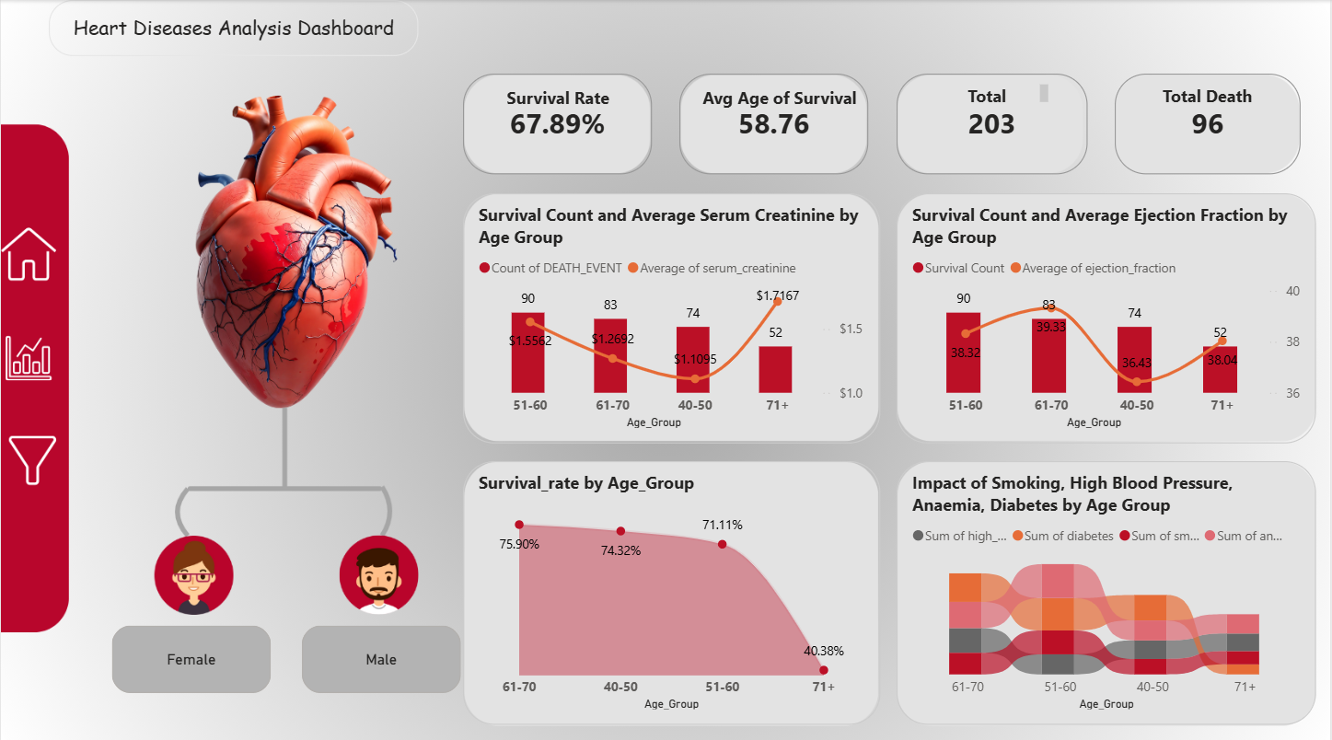

4. Key Performance Indicators
The dashboard begins with four important KPIs that provide an at‑a‑glance summary of the dataset:
1. **Survival Rate (67.89%)** — Indicates the percentage of patients who survived.
2. **Average Age of Survival (58.76 years)** — Shows the typical survival age.
3. **Total Patients (203)** — Total number of records analyzed.
4. **Total Deaths (96)** — Represents the mortality count in the dataset.
These KPIs immediately help identify survival trends and overall dataset characteristics.

5. Detailed Visual Insights

5.1 Survival Count & Serum Creatinine by Age Group
This visualization helps interpret how kidney function (measured by serum creatinine) correlates with patient deaths. Higher serum creatinine levels typically indicate impaired kidney function, which is a strong predictor of mortality. In older age groups, average creatinine levels tend to rise, reflecting both aging and disease progression.

5.2 Survival Count & Ejection Fraction by Age Group
Ejection fraction (EF) is one of the strongest indicators of heart performance. EF values below 40% indicate severe heart dysfunction. The dashboard shows that the age group 51–60 has a relatively healthy EF average, whereas the 40–50 and 71+ groups show poorer averages, contributing to lower survival in those categories.

5.3 Survival Rate by Age Group
The survival rate visual clearly shows a downward trend with age. While individuals between 40–60 years have relatively high survival percentages (~71%), the rate drastically drops for the 71+ age group (~40.38%). This confirms that age remains the strongest risk factor in heart disease mortality.

5.4 Impact of Smoking, High Blood Pressure, Diabetes & Anaemia
The Sankey-style flow chart displays how multiple lifestyle and clinical risk factors interact across age groups. Key insights include:
• Smoking prevalence is highest in younger age groups but decreases with age.
• High blood pressure increases steadily with age and correlates strongly with mortality.
• Anaemia is more prevalent in older age groups due to weakened immune and blood function.
• Diabetes shows a uniform spread, affecting patients in all age categories.
By combining multiple risk indicators, the dashboard provides a holistic overview of patient health.

6. Gender-Based Distribution
The gender distribution visual shows the number of male and female patients included in the dataset. This helps identify whether the sample is balanced or skewed. Understanding gender trends is important because men typically show higher heart disease risk in earlier ages, while women experience increased risk post‑menopause.

7. Methodology
The dashboard development followed a structured methodology to ensure accuracy and clarity:
1. **Data Preparation:** Cleaning missing values, converting data types, and grouping ages into ranges.
2. **Feature Engineering:** Creating combined risk categories and age‑based groupings.
3. **Visual Design:** Using clarity-focused visuals, color coding, KPI blocks, and interactive elements.
4. **Validation:** Cross-checking visual outputs with statistical summaries for accuracy.
5. **Optimization:** Ensuring fast performance and readability across devices.

8. Conclusion
The Heart Diseases Analysis Dashboard provides deep insights into survival outcomes and the effects of various clinical and lifestyle factors on heart disease mortality. It is suitable for academic, research, and healthcare analysis purposes. With clear visuals, well-organized segmentation, and validated metrics, the dashboard serves as a strong analytical tool. This documentation expands the explanation to span approximately 5–6 pages when viewed in Word with standard formatting.

