**Continuous Integration and Deployment Lab**

**Viva (Experiment Task)**

**Implementing Master/Slave Architecture in Jenkins and Create 1 Master and 2 Slaves in Jenkins**

By :-

Devansh Markan

R171218036

500069794

Batch :- 1

**1. RUNNING JENKINS**

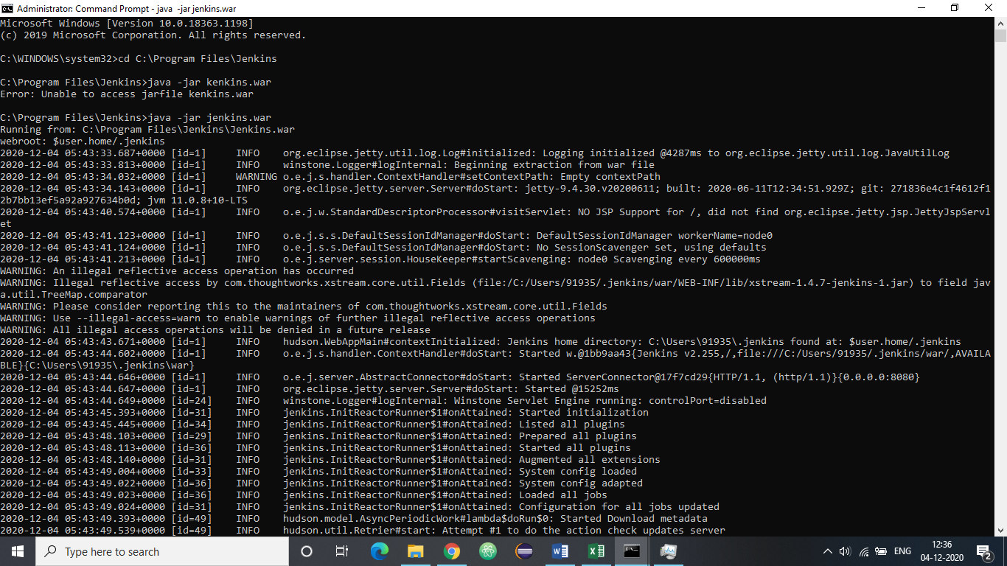

**2. CLICK ON MANANGE NODES AND CLOUDS**

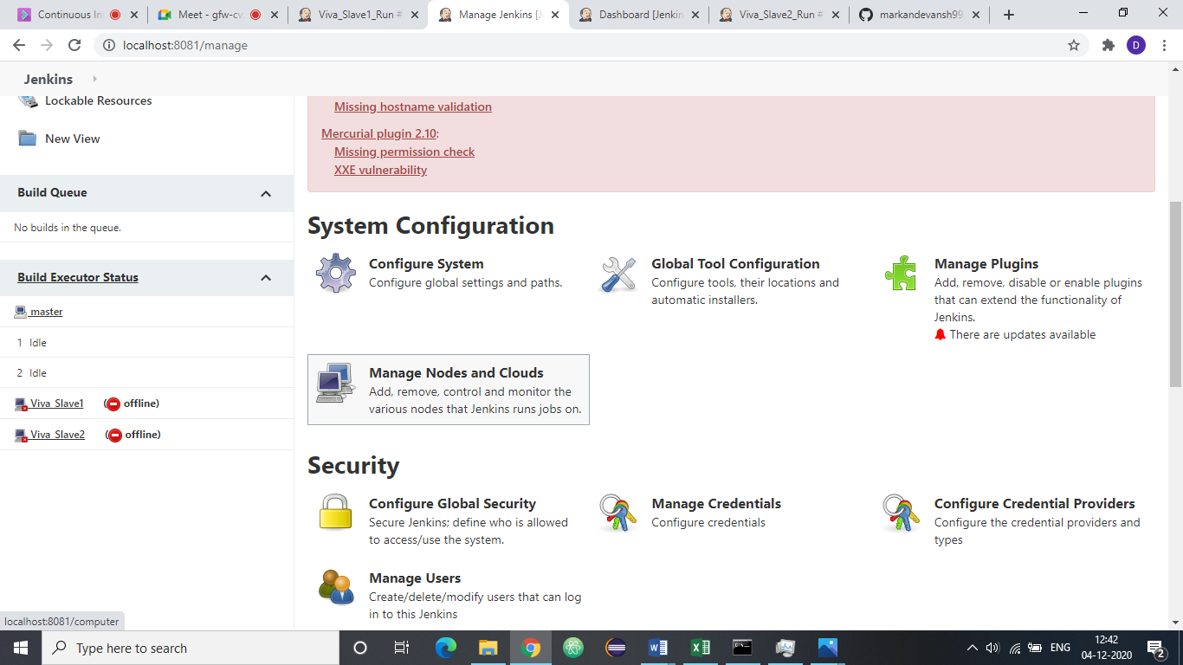

**3. 1ST SLAVE**

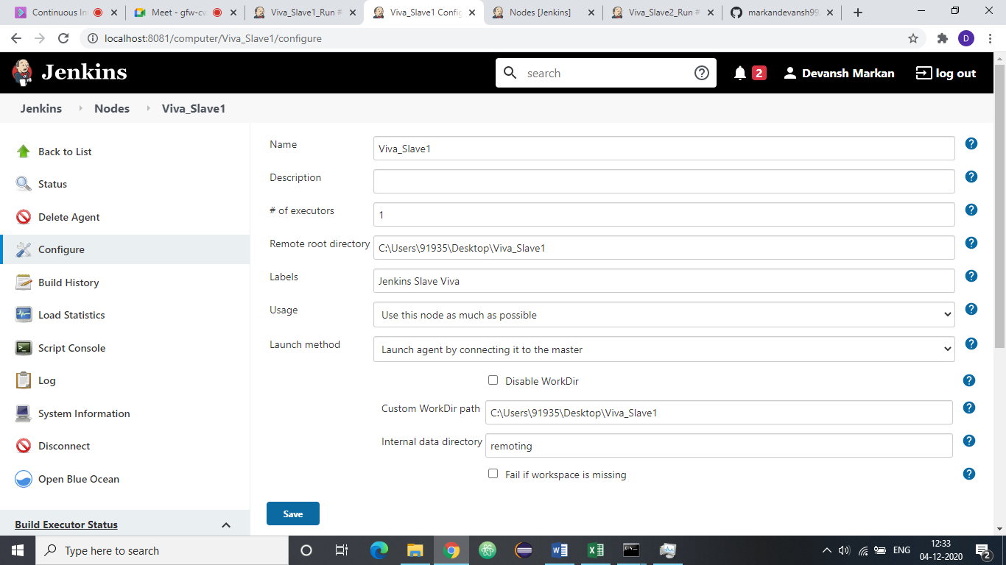

**4. 2nd SLAVE**

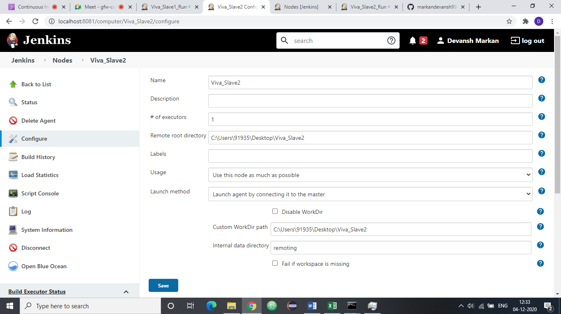

**5. RUNNING SLAVE 1**

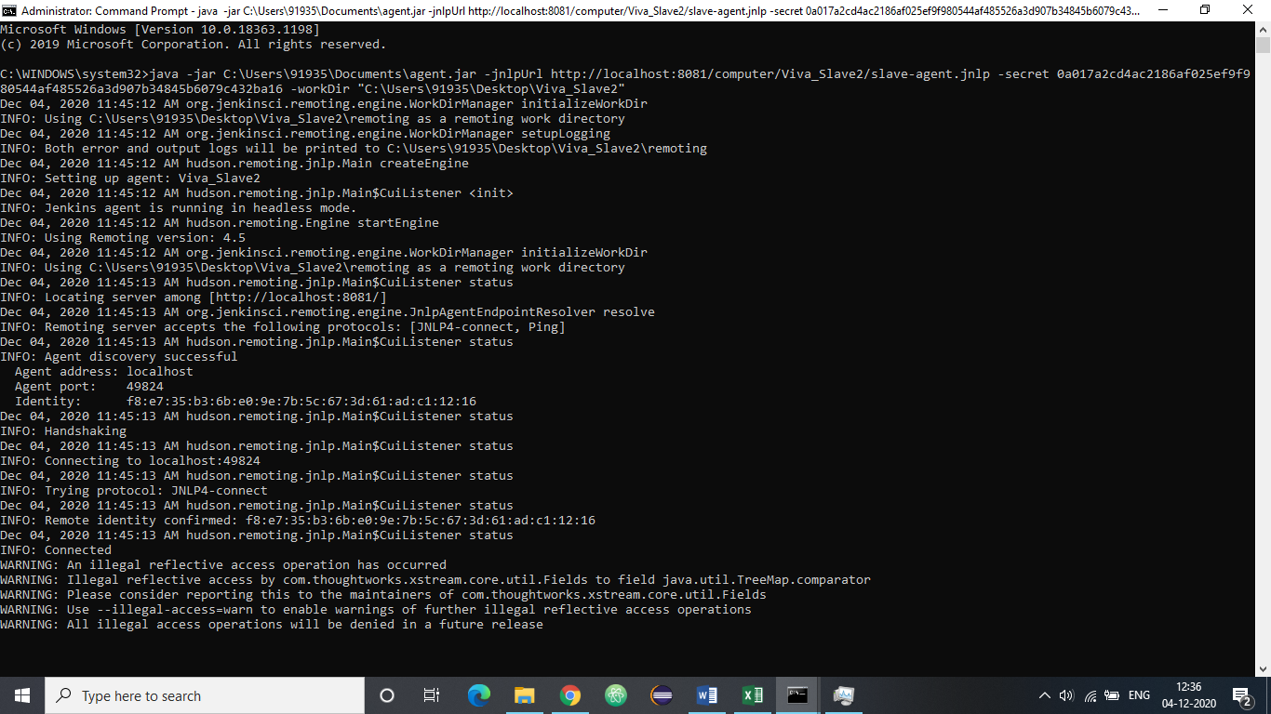

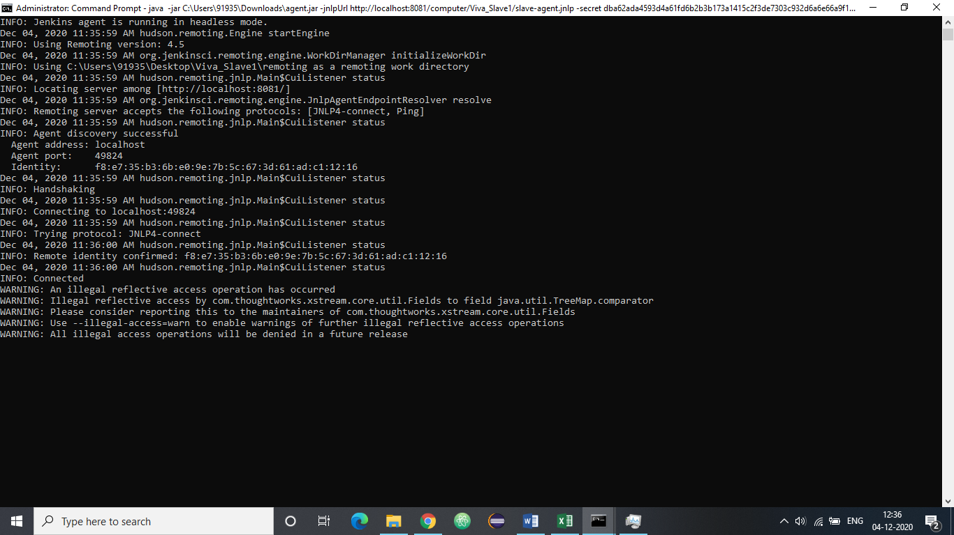

6. BOTH SLAVES ARE RUNNING NOW. THEY ARE UP.

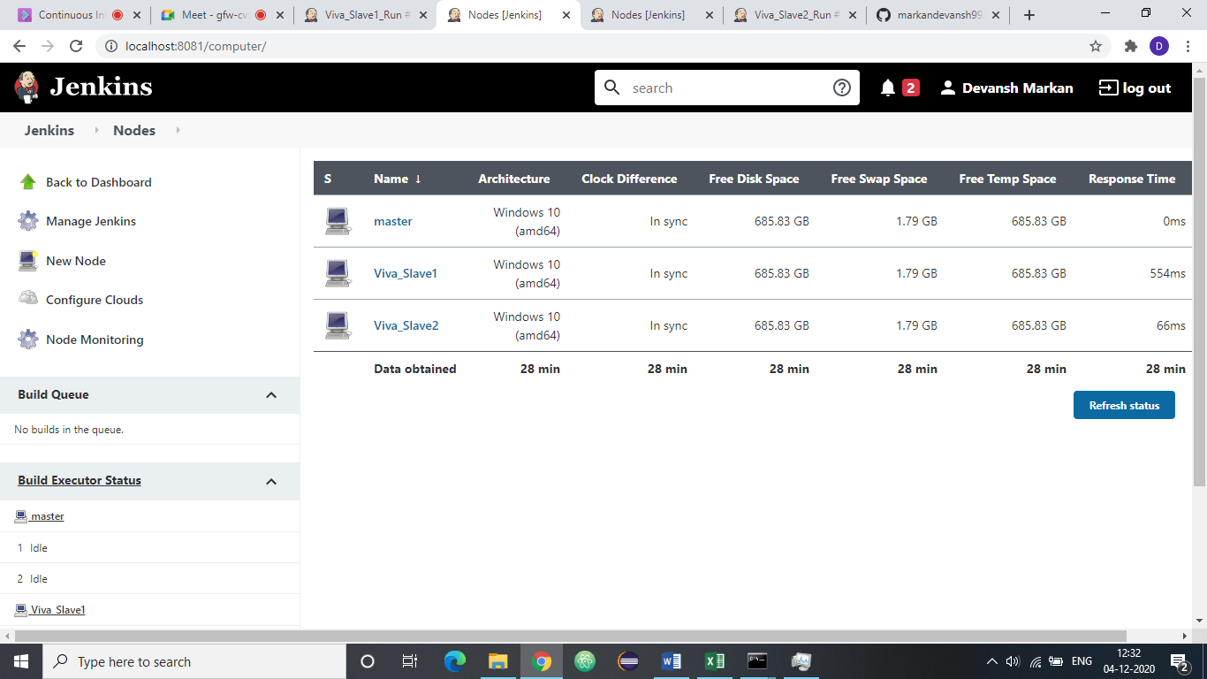

7. CREATE MAVEN PROJECT.

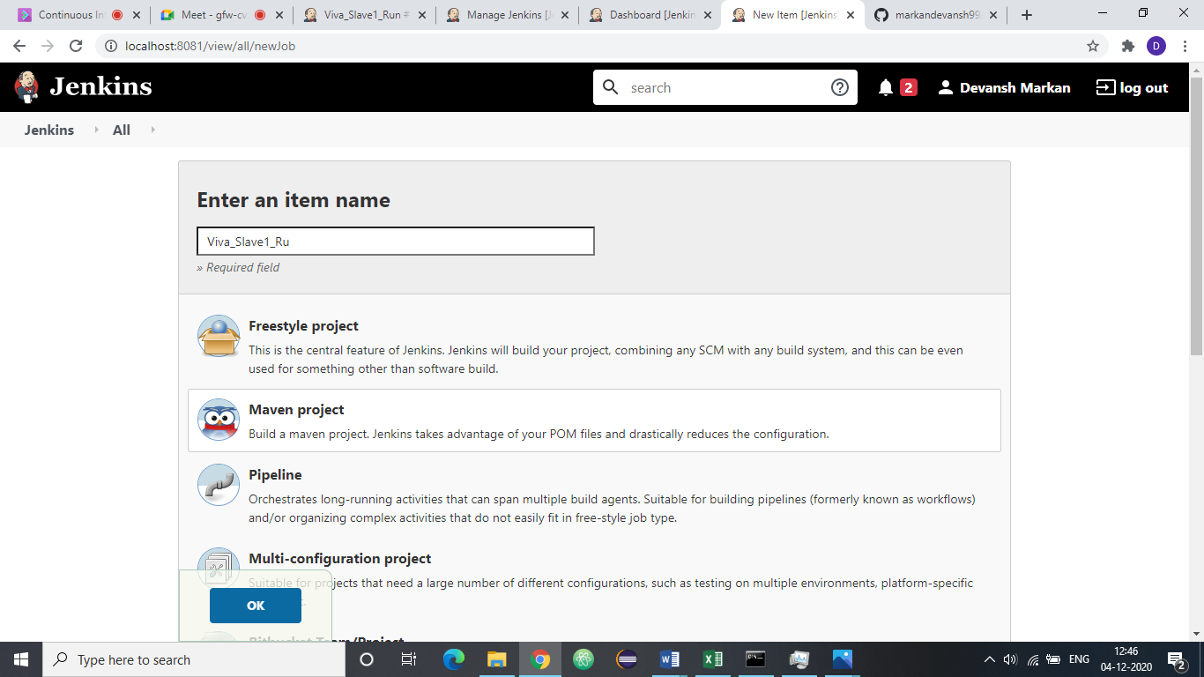

8. RESTRICT THE PROJECT TO RUN ONLY ON 1ST SLAVE.

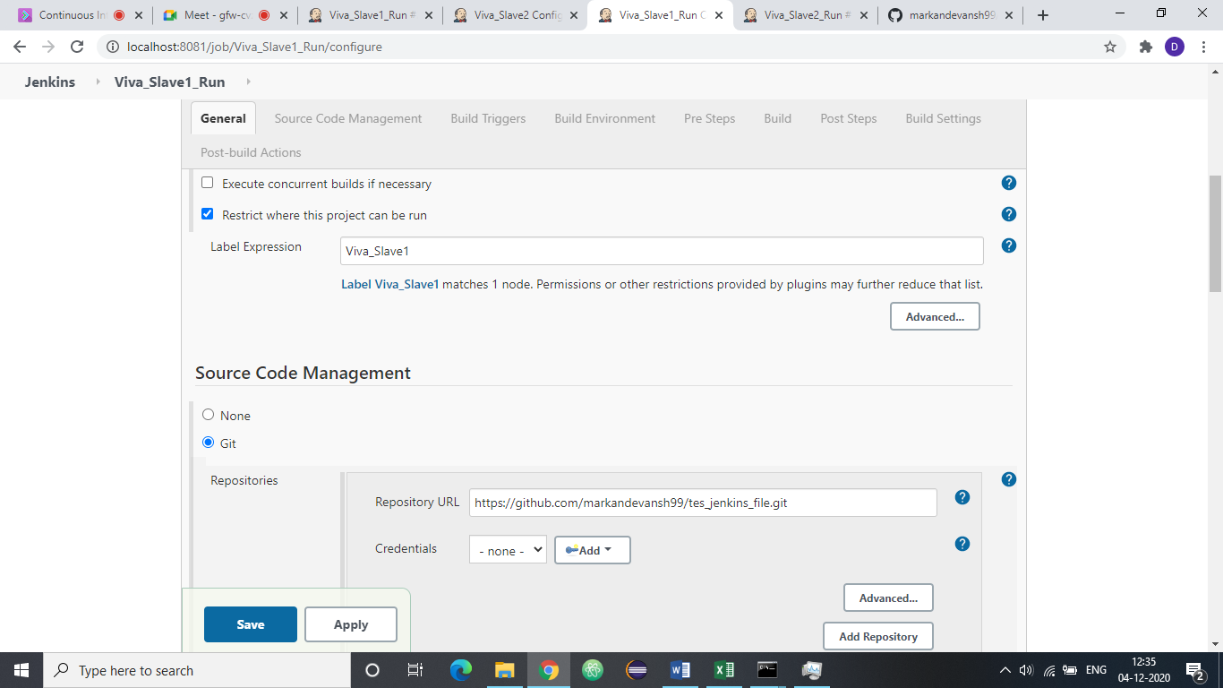

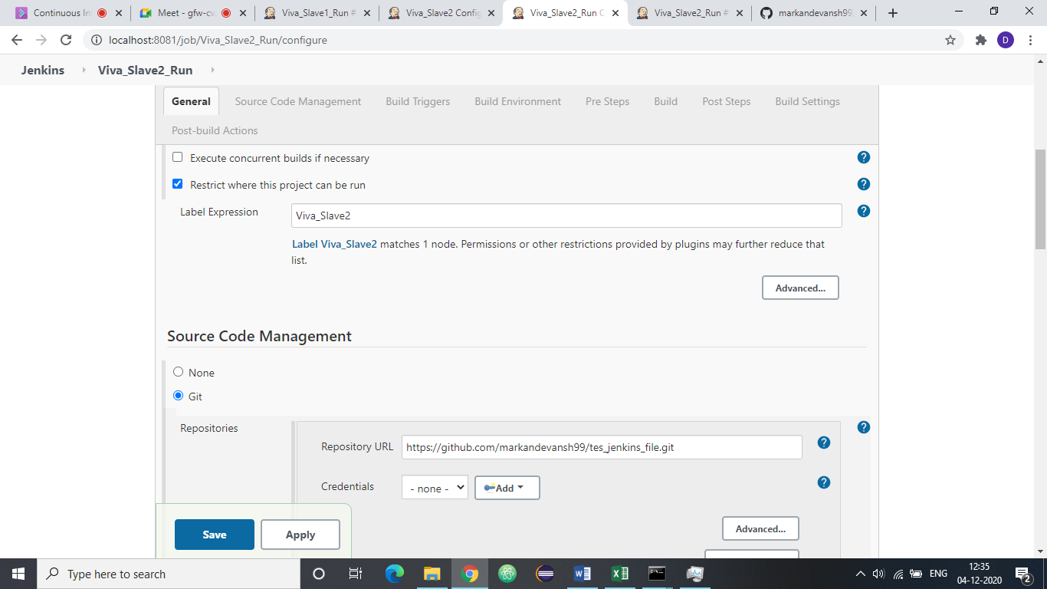

CLICK ON BUILD NOW TO RUN THE MAVEN PROJECT ON 1ST SLAVE.

