**Name: Harshil Bhardwaj**

**Roll Number: R171218045**

**SAP ID: 500068580**

**Lab: Final viva**

**Master and slave architecture**

**Solution:**

**Go to your jenkins folder in cmd and run command : java -jar jenkins.war**

**Now your jenkins local host will be up and learning.**

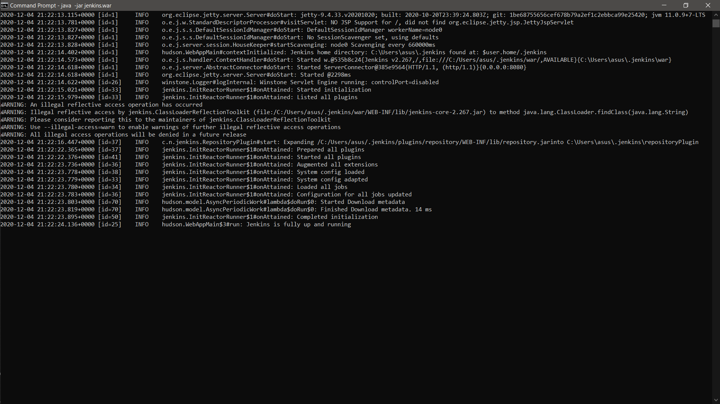

**Now go to your web browser and run your localhost8080**

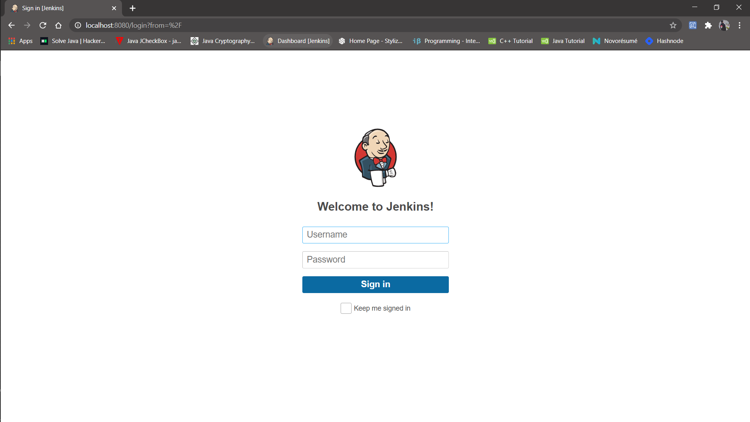

**Now enter your credentials and you will be logged into your jenkins account.**

**Once logged in you would be able to see manage jenkins in your dashboard click it**

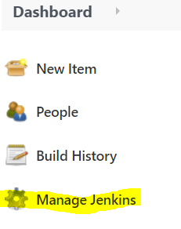

**After clicking you will be directed to panel of options you have to select manage nodes option**

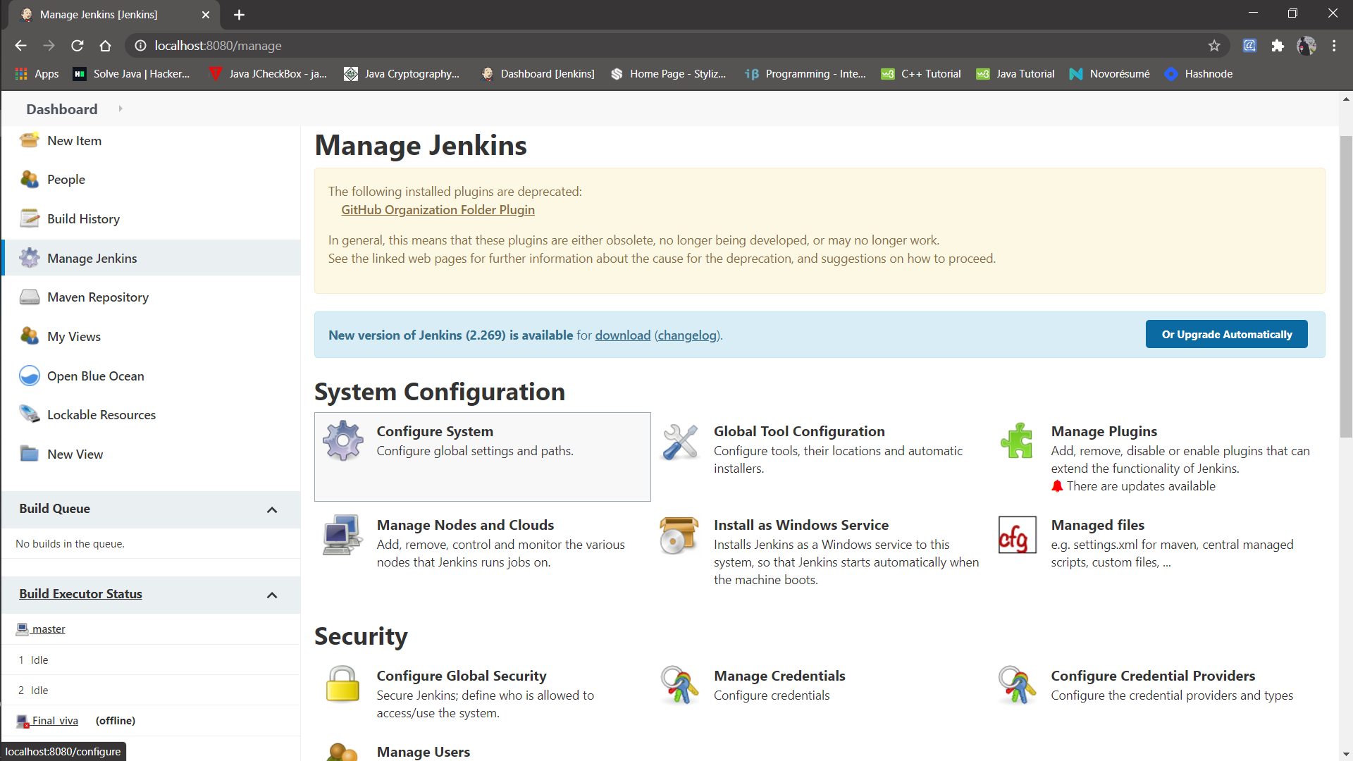

Click on it and you will be directed to nodes dash board

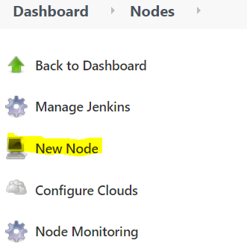

**Click on new node in that and you will be directed to configuration panel of that node.**

**Fill in the details and once done click on save and your slave will be up and running .**

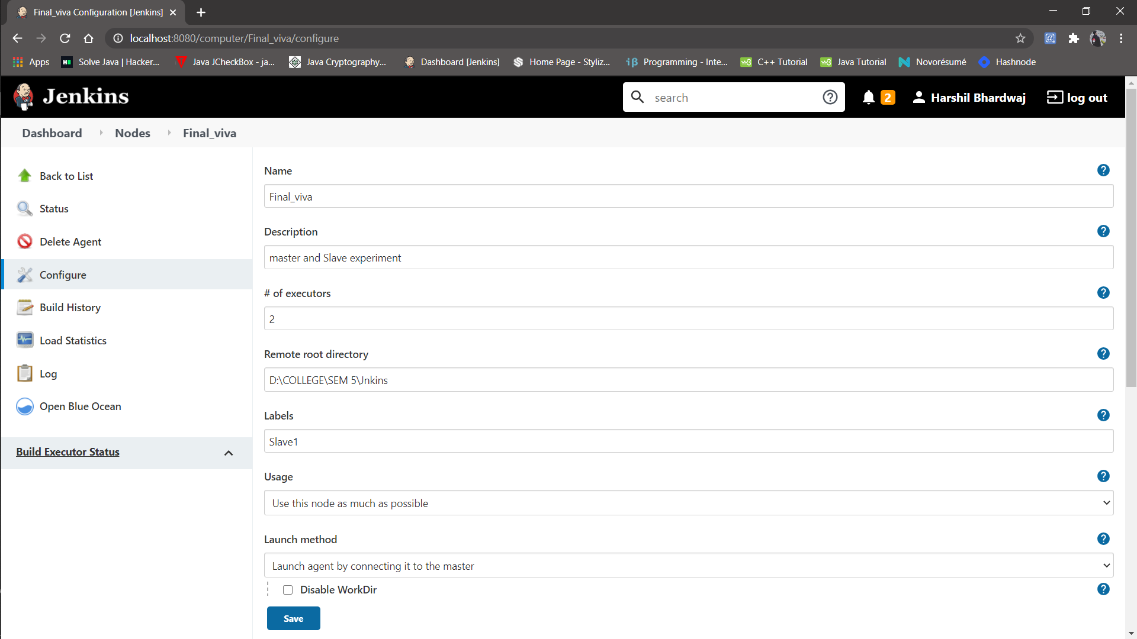

**Now your slave is up and running so lets make a job for it.**

**For that I already have an existing job and I will run this job on this slave. Open this job and click on configure. Now here in the General section, click on “Restrict where this project can be run”. Here in Label Expression, enter the name of the slave and save it. Now click on Build now and see the output of this job. Everything is correct you will see the output as Success.**

