5.What is the difference between a while & a do-while loop.Draw flowcharts for both of them. What is the minimum no. of times the body of the loop in each case will be executed?
Answer:
1] In Java While loop, the condition is tested at the beginning of the loop, and if the condition is True, then only statements in that loop will be executed. So, the While loop executes the code block only if the condition is True.
2] While loop is Entry controlled loop
3]Syntax;
while ( condition) {
statements; //body of loop
}
4]Semi-colon not used.

1]In Java Do While loop, the condition is tested at the end of the loop. So, the Do While executes the statements in the code block at least once even if the condition Fails.
2]Do While loop is a Exit controlled loop
3]Syntax:
do{
.
statements // body of loop.
.
} while( Condition );

4]Semi-colon used at the end of loop.

Flowchart for while loop:
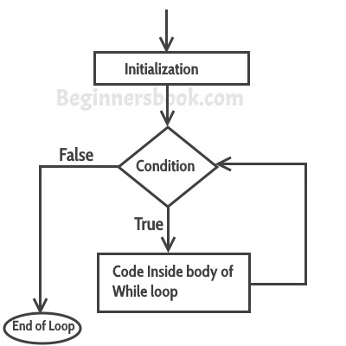

Flowchart for do while loop:
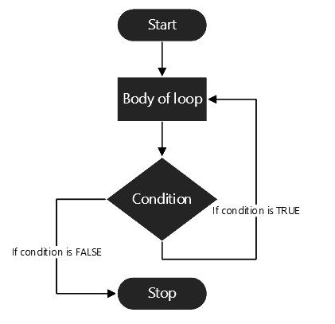

8. List down the primitive data types supported by Java along with their ranges.
There are 8 types of primitive data types:
- boolean data type
The Boolean data type is used to store only two possible values: true and false.
- byte data type
Its value-range lies between -128 to 127 (inclusive).
- char data type
Its value-range lies between -128 to 127 (inclusive).
- short data type
Its value-range lies between -32,768 to 32,767 .
- int data type
Its value-range lies between - 2,147,483,648 (-2^31) to 2,147,483,647 (2^31)
- long data type
Its value-range lies between -9,223,372,036,854,775,808(-2^63) to 9,223,372,036,854,775,807(2^63 -1)
- float data type
Its value range is unlimited.
- double data type
Its value range is unlimited.

10. In the Hello world program, make your class public and execute the program. Then change the name of the class (without changing the file name). What happens?
In java file name and class name should be the same. When the above law is violated a compiler error message will appear.
Error: Could not find or load main class helloworld
Caused by: java.lang.ClassNotFoundException: helloworld

11. Keep the classname different than the filename. Then, remove the ‘public’ before the class name and compile and run the program. What happens?
Yes it can be called if it has a main method!

12. Add another 1-2 empty non-public classes in the file. Now, compile and run the program. How many .class files are created.
I have created 3 non-public classes in the file and after compiling 3 .class file were created.

