System Architecture
Urban Pulse – Bengaluru Smart City Mobility Intelligence Platform
Urban Pulse consolidates six authentic Bengaluru mobility datasets into a single Power BI intelligence platform. The architecture below traces the complete data journey — from raw ingestion through cleaning, modeling, analytics, and visualization — to the stakeholders who act on the resulting insights.
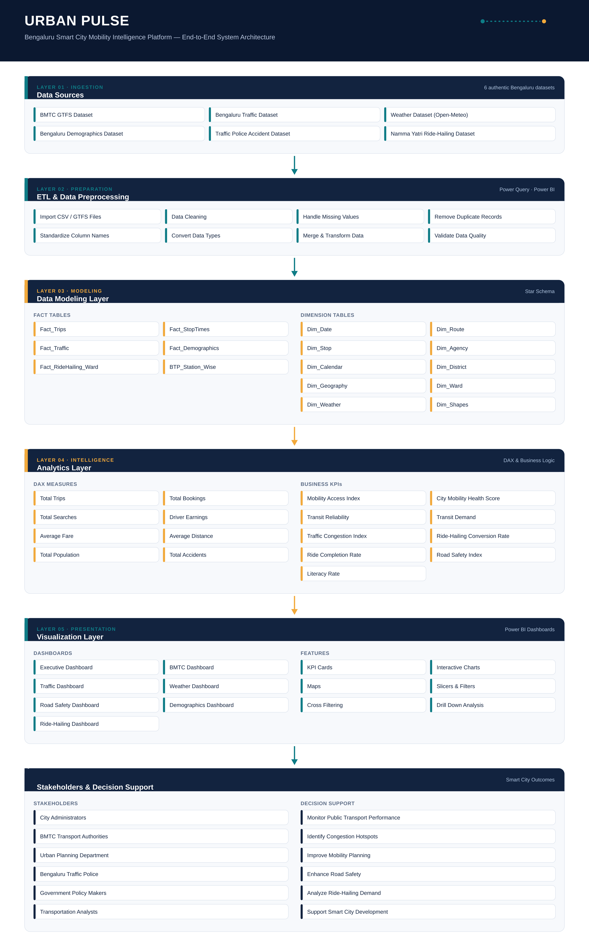
Figure 1. Urban Pulse end-to-end system architecture, from data sources to stakeholder decision support.

1. Data Sources
The platform integrates multiple authentic Bengaluru datasets, including BMTC GTFS, traffic, weather, demographics, accident records, and Namma Yatri ride-hailing data. Together these datasets provide comprehensive coverage of different aspects of urban mobility.

2. ETL & Data Preprocessing
Raw datasets are imported into Power Query, where they undergo extraction, transformation, and loading (ETL). Data cleaning includes removing duplicates, handling missing values, converting data types, standardizing column names, and validating data quality to ensure consistency.

3. Data Modeling
The cleaned data is organized using a multi-star schema. Fact tables store measurable events such as trips, traffic, accidents, and ride-hailing activity, while dimension tables provide descriptive attributes like routes, stops, dates, districts, wards, and weather. This structure improves query performance and simplifies analytical reporting.

4. Analytics Layer
Using DAX (Data Analysis Expressions), reusable business measures and KPIs are created. These include project-specific metrics such as the Mobility Access Index, City Mobility Health Score, Transit Reliability, Traffic Congestion Index, Ride-Hailing Conversion Rate, and Road Safety Index, enabling comprehensive mobility analysis.

5. Visualization Layer
The analytical outputs are presented through interactive Power BI dashboards. Separate dashboard pages focus on executive insights, BMTC operations, traffic conditions, weather impact, road safety, demographics, and ride-hailing performance. Interactive filters, slicers, KPI cards, maps, and drill-down capabilities allow users to explore the data dynamically.

6. Stakeholders
The final dashboards support decision-making for city administrators, BMTC officials, urban planners, Bengaluru Traffic Police, government policymakers, and transportation analysts. These stakeholders can monitor mobility performance, identify operational issues, optimize transportation services, and support smart city planning through data-driven insights.

