1. Poročilo

**Izdelava TIV ploščice**

Kazalo

Navodila vaje 4

Vezalna shema 4

Rezultati 4

Program 5

Kosovnica 6

Pripomočki 6

Komentar 6

# Navodila vaje

# Vezalna shema

# Rezultati

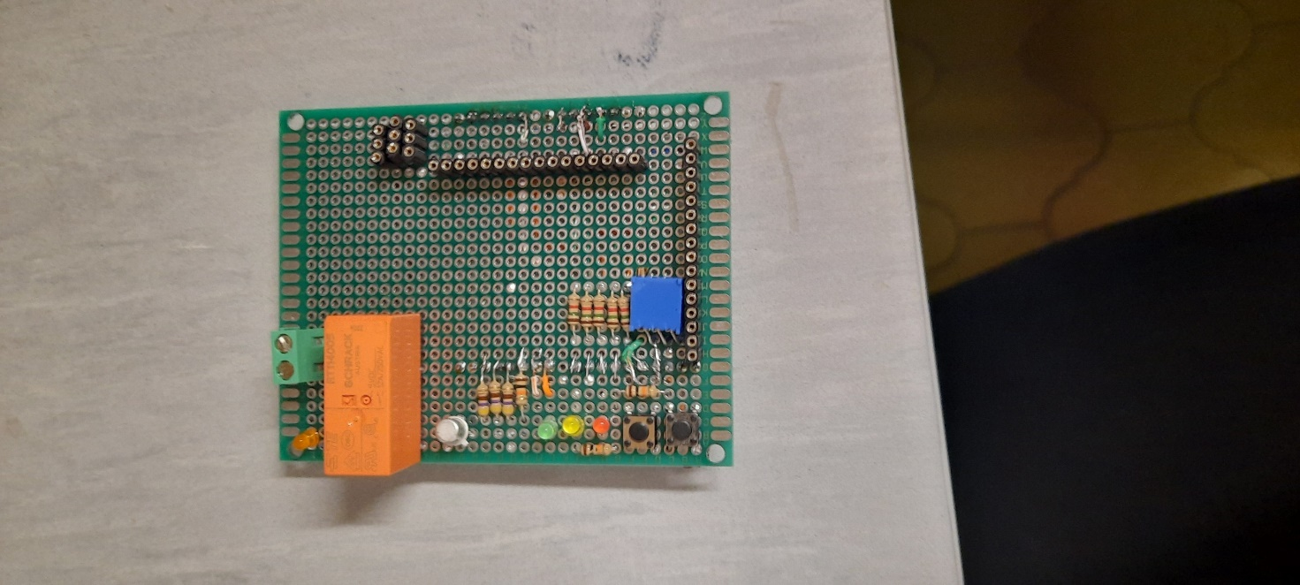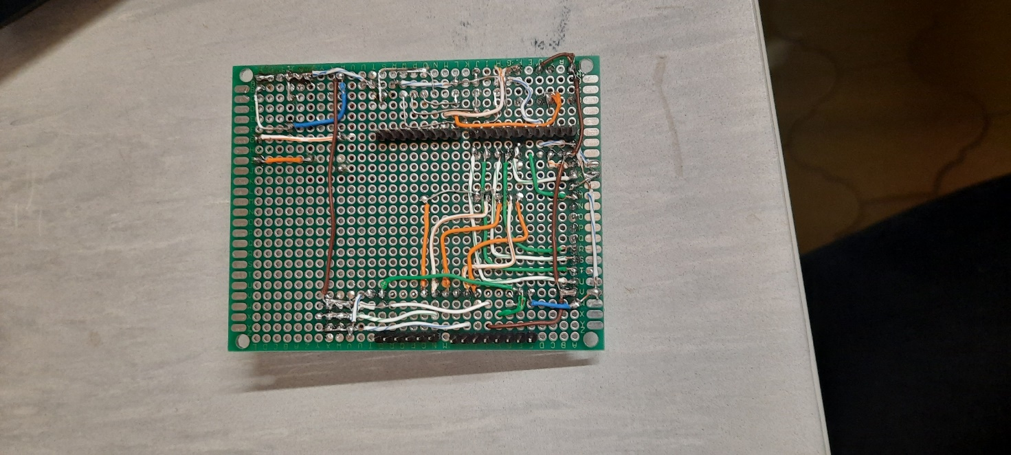

# Program

|  |
| --- |
| // include the library code:  #include <LiquidCrystal.h>  bool stanjereleja = 0;  // initialize the library by associating any needed LCD interface pin  // with the arduino pin number it is connected to  const int rs = 13, en = 12, d4 = 11, d5 = 10, d6 = 9, d7 = 8;  LiquidCrystal lcd(rs, en, d4, d5, d6, d7);  void setup() {  // set up the LCD's number of columns and rows:  lcd.begin(16, 2);  // Print a message to the LCD.  lcd.print("hello, world!");  pinMode(2, OUTPUT);  pinMode(3, OUTPUT);  pinMode(4, OUTPUT);  pinMode(2, HIGH);  pinMode(3, HIGH);  pinMode(4, HIGH);  pinMode(5, OUTPUT);  pinMode(A1, INPUT);  for (int i = 0; i<14; i++){  pinMode(i, OUTPUT);  }  pinMode(7, INPUT);  pinMode(6, INPUT);  Serial.begin(9600);  }  void loop() {  // set the cursor to column 0, line 1  // (note: line 1 is the second row, since counting begins with 0):  lcd.setCursor(0, 1);  // print the number of seconds since reset:  lcd.print(millis() / 1000);  pinMode(2,!stanjereleja);  delay(1000);  Serial.print(analogRead(A1));  Serial.print(digitalRead(6));  Serial.println(digitalRead(7));  } |

# Kosovnica

|  |  |  |  |
| --- | --- | --- | --- |
| N​ | Naziv materiala ​ | Kosov/dijak​ | Oznaka v shemi​ |
| 1​ | LED dioda ZELENA , Φ 3mm​ | 1​ | LED1​ |
| 2​ | LED dioda RUMENA , Φ 3mm​ | 1​ | LED2​ |
| 3​ | LED dioda RDEČA , Φ 3mm​ | 1​ | LED3​ |
| 4​ | LED dioda ORANŽNA , Φ 3mm​ | 1​ | LED4​ |
| 5​ | UPOR, 470 ohm , 1/4 W​ | 3​ | R1, R2, R3​ |
| 6​ | UPOR , 1k , 1/4 W​ | 1​ | R5​ |
| 7​ | UPOR, 10k , 1/4 W​ | 3​ | R4, R6, R7​ |
| 8​ | UPOR, 1k5 , 1/4 W​ | 5​ | R8, R9, R10, R11, R12​ |
| 9​ | UPOR,  1 ohm , 25 W​ | 1​ | Se ne uporablja pri tej vaji​ |
| 10​ | UPOR , 0,1 ohm , 5 W​ | 1​ | Se ne uporablja pri tej vaji​ |
| 11​ | RELE, 5V(DC) , Imax 8A​ | 1​ | Re1​ |
| 12​ | Tranzistor , Si , BC107B​ | 1​ | Tr1​ |
| 13​ | Si dioda , 1N4004​ | 1​ | D1​ |
| 14​ | Pin slot F​ | 3​ | K1, K2, K4​ |
| 15​ | Pin slot M​ | 3​ | K5, K6​ |
| 16​ | Pin slot F , daljši priključki , 8 pin​ | 2​ | K7​ |
| 17​ | HALL Tokovni pretvornik ACS712 , 5A ​ | 1​ | Se ne uporablja pri tej vaji​ |
| 18​ | Tokovni merilni trafo 5A/50mA ,  ZHT103-5​ | 1​ | Se ne uporablja pri tej vaji​ |
| 19​ | LCD Display 16x2 , moder​ | 1​ | Se ne uporablja pri tej vaji​ |
| 20​ | TFT Display, 1,8 inch, 128x160​ | 1​ | Se ne uporablja pri tej vaji​ |
| 21​ | Tipka 6x6x5mm​ | 2​ | T1, T2​ |
| 22​ | Ploščica TIV 7x9cm​ | 1​ | TIV-1​ |
| 23​ | Trimer potenciometer 10k, lin​ | 1​ | P1​ |
| 24​ | Sponke DG301 2P 5.08mm​ | 1​ | SP1​ |
| 25​ | Mikro krmilnik (last dijaka)​ | 1​ | ​ |

# Pripomočki

Za izdelovanje vaje sem potreboval spajkalnik, klešče, ščipalke in osciloscop s katerim sem preveril delovanje posameznih komponent in vezav.

# Komentar

Ploščica mi je delala malo težav pri povezavi z TFT zaslonom in hladnimi spoji, ti so nastali zaradi uporabe prestarega cina.