Homework 1

R13525009 羅筠笙

Part 1

1. Upside-down

Description: Reverse the entire array.

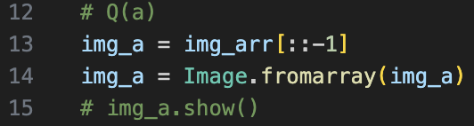

1. Right-side-left

Description: Invert the column.

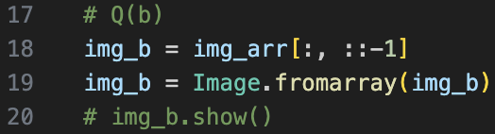

1. Diagonally flip

Description: Transpose the array.

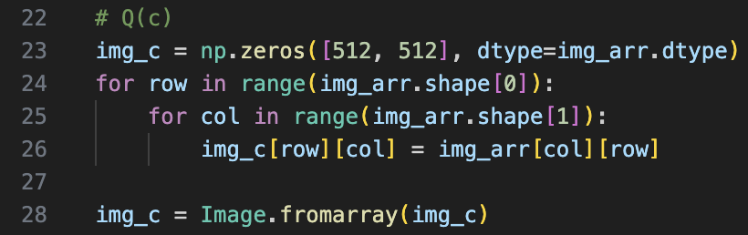

Part 2

1. Rotate 45 degrees clockwise

Description: Use the Image Module to rotate the image.

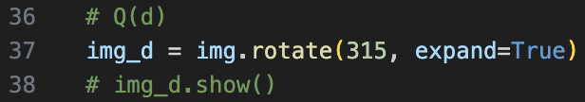

1. Shrink in half

Description: Using the Image Module to shrink the image in half.

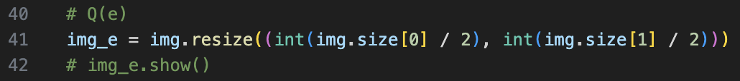

1. Binarize at 128 to get a binary image

Description: Using the OpenCV Module to threshold the image.

