Homework 3

R13525009 羅筠笙

1. Original image and its histogram.

Description: Calculate the frequency of each pixel intensity value (0–255) by iterating through the image. Store the counts in an array to plot a histogram that visualizes the distribution of pixel intensities.

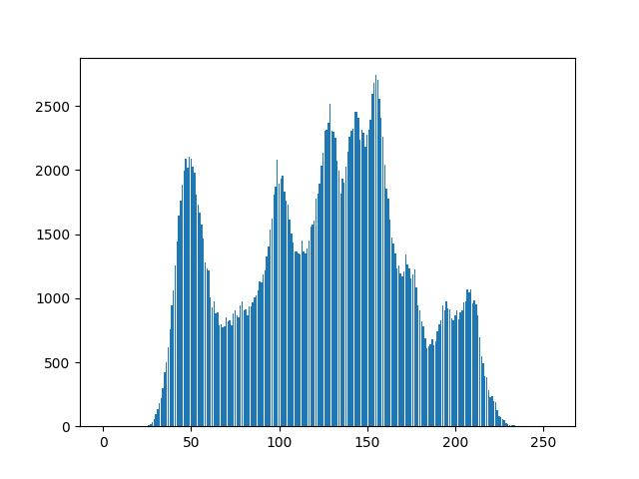

1. # Q1
2. his_a = np.zeros(256)
3. for i in range(img_arr.shape[0]):
4. for j in range(img_arr.shape[1]):
5. his_a[img_arr[i, j]] += 1
6. plt.fill(his_a)
7. Image with intensity divided by 3 and its histogram.

Description: Similar to question a. Calculate the frequency of each pixel intensity value, but with the values divided by 3, by iterating through the image. Store the counts in an array and plot a histogram to visualize the altered distribution of pixel intensities.

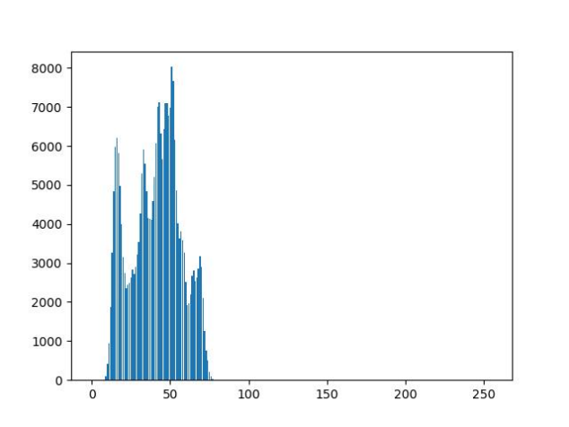

1. # Q2
2. img_b_arr = (img_arr / 3).astype(img_arr.dtype)
3. his_b = np.zeros(256)
4. for i in range(img_arr.shape[0]):
5. for j in range(img_arr.shape[1]):
6. his_b[img_b_arr[i, j]] += 1
7. plt.bar(range(256), his_b)
8. img_b = im.fromarray(img_b_arr)
9. Image after applying histogram equalization to (b) and its histogram.

Description: Apply histogram equalization by calculating the cumulative distribution function (CDF) of the modified histogram. Use the CDF to remap pixel values in the image and create a new equalized image. Finally, calculate and save the histogram of the equalized image.

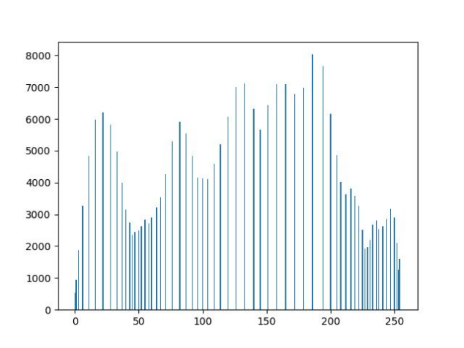 

1. # Q3
2. img_c_arr = np.zeros_like(img_b_arr)
3. his_e = np.zeros(256)
4. hist = his_b.copy()
5. cdf = hist.cumsum()
6. cdf_min = cdf.min()
7. cdf_max = cdf.max()
8. cdf_normalized = ((cdf - cdf_min) / (cdf_max - cdf_min) * 255).astype('uint8')
9. img_c_arr = cdf_normalized[img_b_arr]
10. img_c = im.fromarray(img_c_arr)
11. for i in range(img_c_arr.shape[0]):
12. for j in range(img_c_arr.shape[1]):
13. his_e[img_c_arr[i, j]] += 1
14. plt.bar(range(256), his_e)
15. plt.ylim(0, )