TimeLiner

Table of Contents
1. Introduction 2
2. Main Window 3
2.1. Timeline Grid 3
2.2. Home Menu 4
2.3. Info Panel 5
3. Editing 6
3.1. Creating a Timeline Item 6
3.2. Editing a Timeline Item 7
3.3. Deleting a Timeline Item 7
3.4. Creating a Timeline 7
3.5. Renaming a Timeline 7
3.6. Deleting a Timeline 7
3.7. Moving a Timeline Item 7
3.8. Moving a Timeline 7
3.9. Undo / Redo 7
4. Zooming 7
5. Scrolling 8
6. Navigating 8
7. Measuring 9
7.1. Measuring a Time Point 9
7.2. Measuring a Period 9
8. Command-Line 10
9. TimeLiner File Format 10
10. Known Issues 11
11. Planned Features 11

Introduction
I started working on TimeLiner in 2020 while analyzing software defects in my daily work. Many of these analyses involved events from different sources, such as log files, traces, or monitoring data, all related by time.

At that point, I often ended up drawing timelines on paper to understand the sequence of events. This worked for rough overviews, but it quickly became impractical when precise timing mattered or when many events had to be correlated. Measuring durations or comparing overlapping time spans was especially cumbersome.
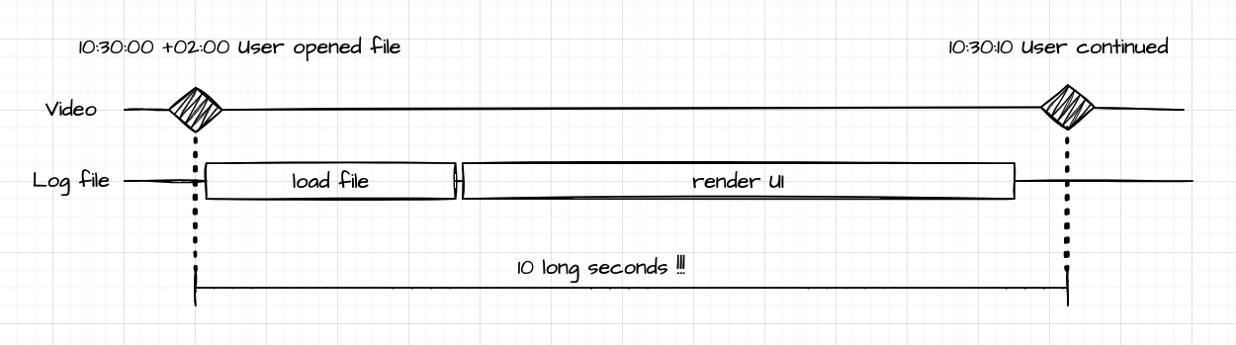
I looked for an existing tool that would let me draw timelines freely, place events accurately in time, and measure distances between them. Since I could not find anything that matched these requirements, I decided to write a small tool myself.

TimeLiner grew out of this very practical need. Its purpose is not to manage projects or schedules, but to visualize time-based data, correlate events, and support precise analysis of time sequences. I still use it regularly for this kind of work and hope that others may find it useful as well.

Christian Pistor

Main Window
The main window of TimeLiner is divided into three areas:
- Timeline Grid
- Home Menu
- Info Panel
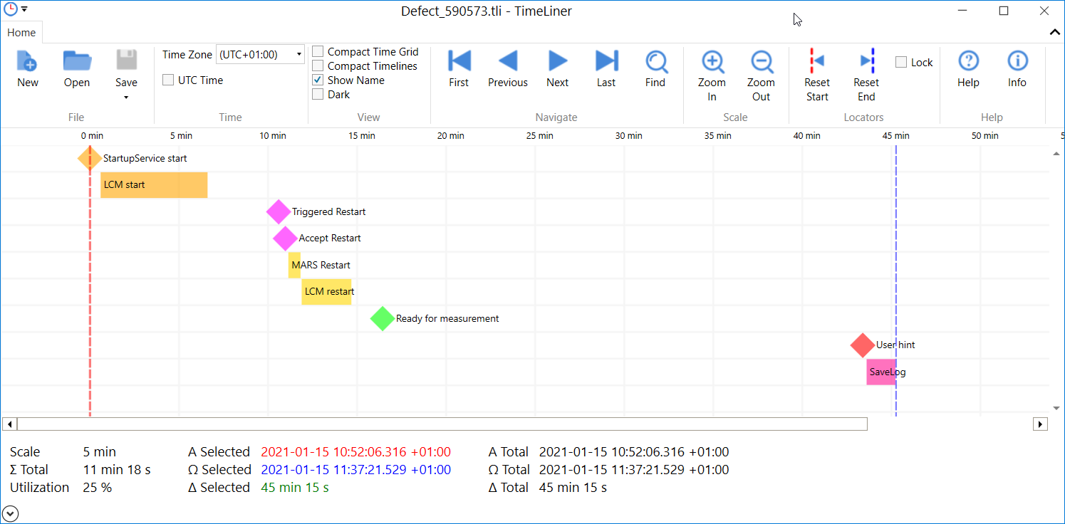
Home Menu
Timeline Grid
Info Panel
Each area is described in detail in the following sections.

Timeline Grid
The timeline grid is the central workspace. Timelines are arranged vertically, while time is displayed horizontally using equally spaced period columns. The time scale is shown at the top of the grid:
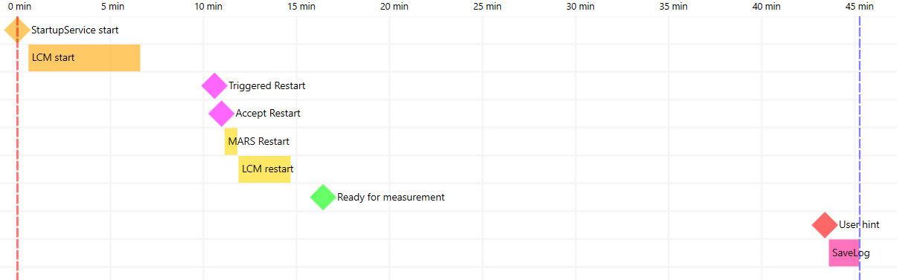Each timeline may contain one or more timeline items.
Time Scale
Timeline Item
Start-Time Locator
End-Time Locator
Timeline

A timeline can also remain empty and be used as a visual spacer.

A timeline item represents either:
- a time event, or
- a time span
A time event is shown as a diamond. Its tooltip displays the item name and the exact time:
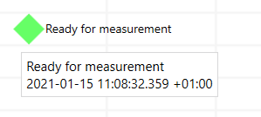
A time span is shown as a horizontal bar. The width of the bar represents its duration. The tooltip shows the name, start time (Α), end time (Ω), and duration (Δ):
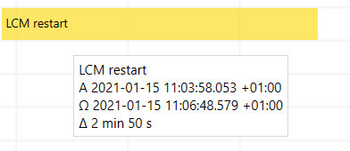
The grid also contains two locators:
- the red start-time locator
- the blue end-time locator
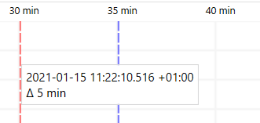
These locators are used to measure time points and time periods. Tooltips display the exact time values and the distance between the locators (see Measuring).

Home Menu
The Home Menu provides quick access to commonly used commands:
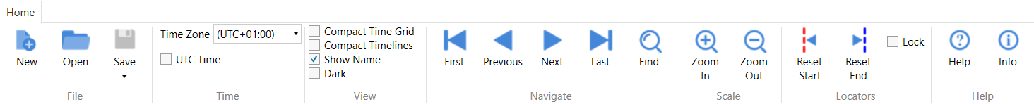
File
- New – Create an empty TimeLiner file.
- Open – Open an existing TimeLiner file.
- Save – Save the current file.
- Save As – Save the current file under a new name.
Time
- Time Zone – Select a time zone.
- UTC Time – Switch between UTC time and the selected time zone.
View
- Compact Time Grid – Switch between normal and compact time grid (half width).
- Compact Timelines – Switch between normal and compact timelines (half height).
- Show Name – Show or hide timeline item names.
- Dark – Switch between the light and dark color theme.
Navigate
- First – Jump to the first timeline item.
- Previous – Jump to the previous timeline item.
- Next – Jump to the next timeline item.
- Last – Jump to the last timeline item.
- Find – Locate a timeline item by name.
Scale
- Zoom In – Increase the time scale.
- Zoom Out – Decrease the time scale.
Locators
- Reset Start – Set the start-time locator to the first timeline item.
- Reset End – Set the end-time locator to the last timeline item.
- Lock – Keep the locators fixed while scrolling.
Help
- Help – Open this document.
- Info – Show version and copyright information.
The menu can be hidden or shown by clicking the arrow button in the upper-right corner or by pressing Shift+F1.

Info Panel
The info panel displays calculated values related to the current selection: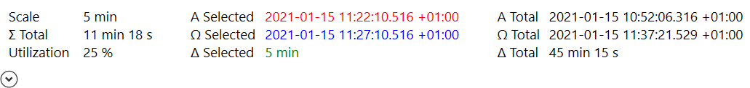
Values:
- Scale – The selected time scale. For example, one grid column may represent five minutes.
- Α Selected – Time of the start-time locator.
- Α Total – Time of the first timeline item.
- Ω Selected – Time of the end-time locator.
- Ω Total – Time of the last timeline item.
- Δ Selected – Duration between the two locators (= Ω Selected - Α Selected).
- Δ Total – Duration between the first and the last timeline item (= Ω Total - Α Total).
- ∑ Total – Sum of all timeline item durations.
- Utilization – Percentage of how much the total time range is occupied by timeline items (= ∑ Total / Δ Total * 100 %). This may be helpful, for example, to investigate performance bottlenecks in a multi-threading application. Utilization below 100% indicates idle time, while values above 100% indicate parallel activity.
The info panel can be shown or hidden using the arrow button in the lower-left corner.

Editing
The following sections explain how to create and modify timelines and timeline items.

Creating a Timeline Item
To create a new timeline item, double-click on the grid. Alternatively, right-click and select New Item from the context menu:
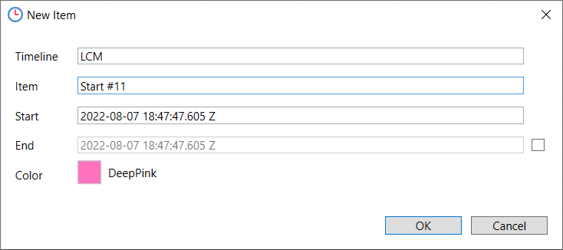
You can specify:
- Timeline – Name of the timeline.
- Item – Name of the timeline item.
- Start – Start time.
- End – End time for time spans.
- Color – Color of the item.
The color can be changed by double-clicking the color field: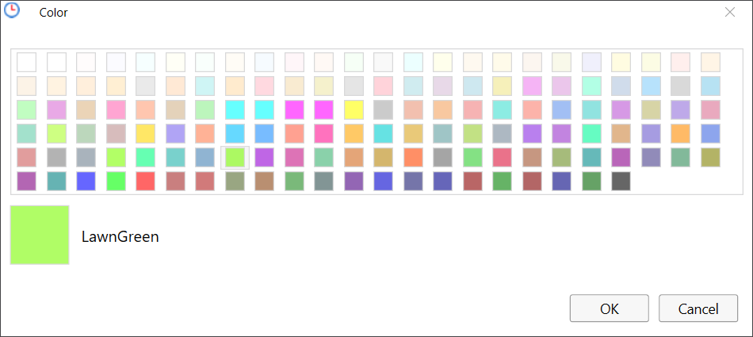
The color name can be selected and copied to the clipboard using Ctrl+C, which is useful when editing TimeLiner files manually.

Editing a Timeline Item
Double-click a timeline item, or right-click and choose Edit Item from the context menu.

Deleting a Timeline Item
Right-click a timeline item, or right-click it and choose Delete Item. If the last item of a timeline is removed, the empty timeline remains and can be deleted separately (see Deleting a Timeline).

Creating a Timeline
Right-click on the grid or an existing timeline and choose New Timeline.

Renaming a Timeline
Right-click a timeline and choose Rename Timeline.

Deleting a Timeline
Right-click a timeline and choose Delete Timeline to remove it together with all items.

Moving a Timeline Item
Hold Shift and drag a timeline item with the left mouse button to move it horizontally or vertically. Alternatively, edit the item and change its start time (see Editing a Timeline Item).

To move an item beyond the existing timelines, create an empty timeline first (see Creating a Timeline).

Moving a Timeline
Hold Shift and drag a timeline vertically to move it together with all contained items.

Undo / Redo
Press Ctrl+Z to undo the most recent change, and Ctrl+Y to redo it.
The last 10 changes are available for undo and redo.

Zooming
Zooming changes the time scale of the timeline grid:
- Zooming in increases detail.
- Zooming out provides an overview.
Supported time scales range from weeks down to milliseconds.

You can zoom:
- using Zoom In or Zoom Out in the home menu
- using mouse wheel while holding Ctrl
- using Ctrl+Plus and Ctrl+Minus
To zoom into a specific range, hold Alt, drag with the left mouse button, and release: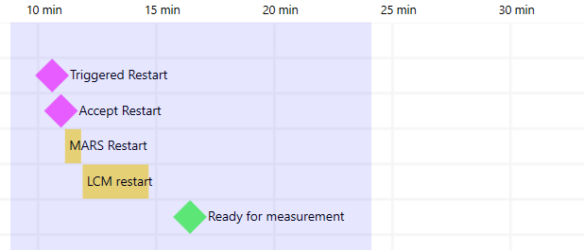

Scrolling
Timelines can be scrolled when they exceed the window size.

Scrolling with the mouse:
- Click on the timeline grid, hold the left mouse button, and move the mouse to scroll freely.
- Use the horizontal or vertical scroll bars.
- Use the mouse wheel to scroll horizontally.
- Hold Alt while using the mouse wheel to scroll vertically.
Scrolling with the keyboard:
- Left / Right – Scroll horizontally by one period column.
- Up / Down – Scroll vertically by one timeline.
- Home – Scroll horizontally to the first timeline item.
- End – Scroll horizontally to the last timeline item.
- Ctrl+Home – Scroll vertically to the first timeline.
- Ctrl+End – Scroll vertically to the last timeline.
- Shift + Up / Down – Scroll vertically by multiple timelines.
- Page Up / Page Down – Scroll vertically by one page.

Navigating
Navigation commands move the view to timeline items and highlight them:
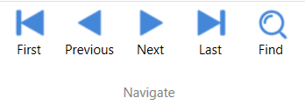
Commands:
- First – Moves to the first timeline item.
- Previous – Moves to the previous item relative to the current selection or view.
- Next – Moves to the next item relative to the current selection or view.
- Last – Moves to the last timeline item.
- Find – Searches for a timeline item by name or partial name.

In the example below, the timeline item “LCM restart” is selected: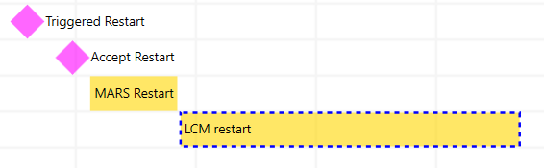
Press Esc to remove the selection.

Measuring
The start-time and end-time locators are used to measure time points and durations.

Measuring a Time Point
- Set the start-time locator with Ctrl + left-click
- Alternatively, set the end-time locator with Ctrl + right-click
- Or drag a locator with the mouse
The selected time is shown in the tooltip and in the info panel:
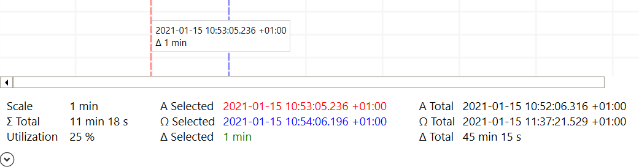
In the info panel, you can select the time and copy it to the clipboard with Ctrl+C.

Measuring a Period
- Set the start-time locator with Ctrl + left-click
- Set the end-time locator with Ctrl + right-click
- Or drag the locators with the mouse

The duration is displayed in the tooltip and the info panel:
In the info panel, you can select the duration and copy it to the clipboard by pressing Ctrl+C.

Command-Line
TimeLiner supports the following command-line syntax:

TimeLiner.exe [file] [-minimal] [-maximize] [-timezone <time zone id|local|utc>]

Options:
- file – File to open.
- -minimal – Start without menu and info panel.
- -maximize – Start with maximized window.
- -timezone – Selected time zone. Specify a time zone ID (e.g. “China Standard Time”), “local” for the local time zone, or “utc” for Coordinated Universal Time.
Available time zone IDs can be listed using the Windows command-line tool "tzutil”:

tzutil.exe /l

TimeLiner File Format
The TimeLiner file format is intentionally simple. It is designed for manual editing and for automatic generation by tools. It is based on CSV and can be processed with standard text editors or CSV-aware applications.

The CSV file consists of the following fields:
- TimeLine – Name of the timeline.
- Item – Name of the timeline item.
- Start – Start time of the timeline item.
- End – End time of the timeline item.
- Color – Color of the timeline item.
Rules:
- The CSV header line is optional and ignored by TimeLiner.
- Fields are separated by a comma. Escaping is not supported.
- Field values may contain spaces.
- Time values must be accepted by the .NET type System.DateTime.
- Time values may be specified either as local time or as UTC.
- The TimeLine field is mandatory.
- The Item field may be empty to create an empty timeline.
- The End field may be empty to create a time event.
- The Color field may contain either a color name defined by the .NET type System.Windows.Media.Color, or an ARGB value in the form #AARRGGBB.
If the field is empty, the default color is applied.
- Timelines may appear in any order in the file.
- The vertical order of timelines in the grid is determined by their first appearance in the file.
- An empty timeline can be created by specifying a TimeLine name and leaving all other fields empty.
- Blank lines are ignored and are removed when the file is saved.
- Lines starting with # are treated as comments and are removed when the file is saved.
Supported file extensions:
- .csv – Used for compatibility with external tools such as Microsoft Excel.
- .tli – Used to associate the file type with TimeLiner and enable direct opening.

Example:

TimeLine,Item,Start,End,Color
Timeline 1,Item 1.1,2022-08-04T08:59:54.4410000Z,,Red
Timeline 1,Item 1.2,2022-08-04T09:00:54.5610000Z,,#FFFFD700
# This is a comment
Timeline 2,,,,
Timeline 3,Item 3.1,2022-08-04T09:01:24.2610000Z,2022-08-04T09:02:24.2610000Z,

Resulting diagram:

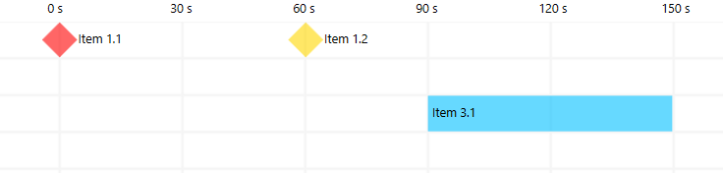

Known Issues
TimeLiner may become slow when displaying very large numbers of timeline items due to WPF rendering limitations.

Planned Features
TimeLiner is maintained in the author's spare time. As a result, the implementation of planned features may take longer:
- Set time locator precisely by typing time

