

Interactive Lecture Slide Control Project

Interactive Lecture Slide Control Project

System Documentation

Date:
May 2026
Submitted by:
Calvo, Cherose Angela C.
Marcellano, Jane C.
BSIT – 3A

Submitted for:
Mr. Josie Degorio

System Description

The Interactive Lecture Slide Control is a web-based presentation control system designed to allow presenters to manage slideshows using both a desktop interface and a mobile remote control. The system supports PDF and PowerPoint (PPTX) file formats and provides presenter tools for seamless and interactive presentations.
The platform enables presenters to upload presentations, manage slides, and control presentations remotely through a mobile device connected via MQTT protocol. It also includes presenter tools such as timer, next slide preview, speaker notes, fullscreen mode.
The system uses MQTT (Message Queuing Telemetry Transport) for real-time communication between the presenter’s computer and the mobile remote controller.

Statement of the Problem

Traditional presentation systems often require presenters to remain near their computers or use expensive remote-control devices to navigate slides during presentations. These limitations reduce mobility and interaction during lectures and presentations.
Specifically, this system addresses the following problems:
- Limited mobility of presenters during presentations.
- Dependence on physical presentation clickers or remotes.
- Difficulty controlling slides remotely using mobile devices.
- Lack of integrated presenter tools such as timer, notes, and slide preview.
- Inconvenient management of presentation files.
- Absence of real-time communication between presenter and remote controller

Objectives

The main objective of this project is to develop a web-based Interactive Lecture Slide Control system using MQTT protocol for real-time remote presentation management.
Specifically, it aims to:
- Allow presenters to remotely control slides using mobile devices.
- Support PDF and PPTX presentation formats.
- Provide presenter tools such as timers, notes, and slide previews.
- Enable QR code-based mobile connection for easy access.
- Improve presenter mobility and audience interaction.
- Store presentation files locally using IndexedDB.
- Implement real-time communication using MQTT protocol.

User Roles & Access

The Interactive Lecture Slide Control System has two distinct user roles with clear access levels. No account registration or authentication is required for any role, ensuring quick and frictionless setup.

Role | Access Method | Key Permissions
Presenter | Desktop Browser Access | Upload presentations, control slides, manage presenter tools
Mobile Remote User | QR Code / Mobile Browser Access | Navigate slides,View Curret slide, End Current Show

System Features

Presentation Management Dashboard
- Upload and store PDF and PPTX files locally.
- View uploaded presentations in a grid layout.
- Search presentations using the search feature.
- Delete unnecessary presentations.

Presenter Interface
- Display current slides with navigation controls.
- Support fullscreen presentation mode.
- Show next slide preview.
- Provide speaker notes section.
- Include presentation timer and current clock.
- Audience View window for Current Slide presentation.

Mobile Remote Control
- Generate QR code for mobile device connection.
- Navigate slides using Previous and Next buttons.
- View Curret slide.
- End Current Show mode remotely.
- Display real-time connection status.

File Format Support
- Support PDF files using PDF.js.
- Support PowerPoint presentations using PPTXjs.

Real-Time MQTT Communication
- Use MQTT.js for communication between devices.
- Connect through the EMQX public MQTT broker.
- Use MQTT topics for remote control commands.
- Ensure real-time slide navigation and control.

Technologies & Components
Frontend Technologies
- HTML5 for structure and layout.
- CSS3 for styling and responsive design.
- JavaScript (ES6+) for application logic.

Libraries & APIs
- MQTT.js for real-time communication.
- QRCode.js for QR code generation.
- PDF.js for PDF rendering.
- PPTXjs for PowerPoint rendering.
- IndexedDB for local file storage.
- Fullscreen API for fullscreen presentations.
Communication Protocol
- MQTT (Message Queuing Telemetry Transport)
- Broker: wss://broker.emqx.io:8084/mqtt
- Topic Structure: lecture/{roomId}/control

System Architecture Design

The core architecture relies on an event-driven publish-subscribe model powered by a central MQTT broker, with all data flows standardized on QoS level 1 (At-Least-Once Delivery). Choosing QoS 1 strikes the right balance for this system: compared to QoS 0, it mitigates the risk of dropping critical real-time traffic updates over unstable mobile connections; compared to QoS 2, it avoids the massive processing overhead of "exactly-once" delivery for little practical payoff. The reality check is that in near-real-time monitoring, an occasional duplicate packet is perfectly fine, whereas a completely lost update is not. As an instructor note, emphasize this architectural tradeoff, because students often default to thinking higher QoS is always better, but QoS 1 optimizes network throughput while keeping a reliable data baseline.
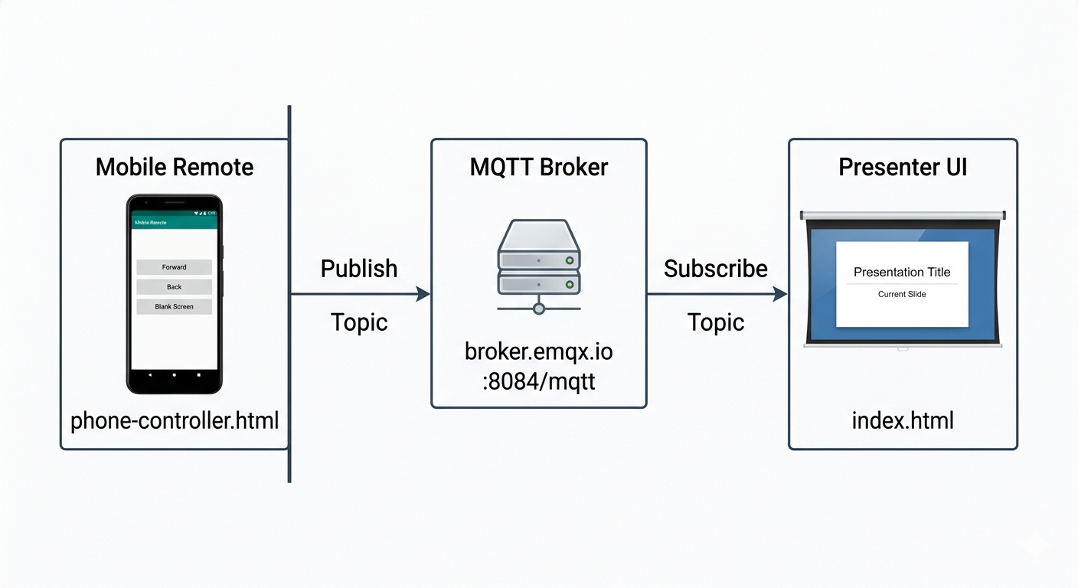

Procedures

This system allows you to present PDF/PPTX files and control them remotely from your phone using MQTT. The workflow is:
- For Presenters with workflow:
Open Dashboard → Upload File → Select Presentation → Connect Remote → Deliver Presentation → End Show
- For Remote Controllers with workflow:
Scan QR Code → Connect → View Slide Preview → Control Presentation

- Used the same bullet point style with proper indentation
- Kept the troubleshooting and technical details sections in the same format
- Maintained all original information about how the system works

MQTT PROCEDURE

This section documents the step-by-step procedure for setting up the Interactive Lecture Slide Control Project.

Step 1: Open the Presenter Dashboard

1. Open https://interactive-lecture-slide-control.kesug.com/ web browser
2. You will see the Dashboard View with:
- Sidebar with "Dashboard" and "Presentation"
- "My Presentations" title
- Search bar
- Upload area and file list
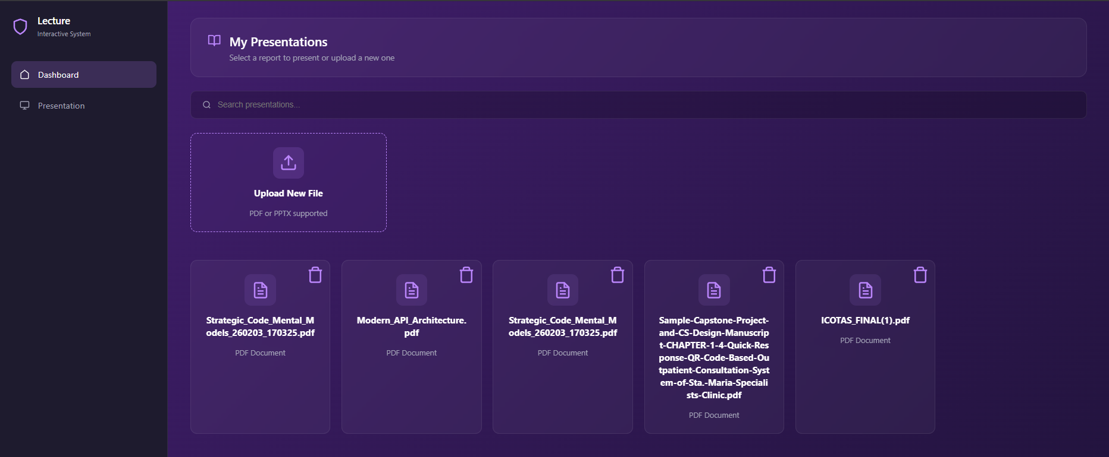

Step 2: Upload Your Presentation

  - Click the "Upload New File" card
  - Select a PDF or PPTX file from your computer
  - The file will automatically be saved to your browser's IndexedDB storage
  - Your uploaded files will appear in the file list
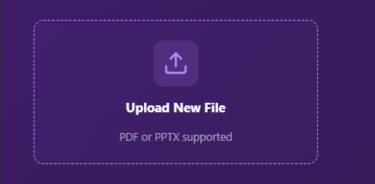

Step 3: Start Your Presentation

1. Click on the file you want to present from the file list
2. The view will switch to the Presenter View
3. You will see:
- Current slide on the left
- Next slide preview and speaker notes on the right
- Top bar with timer, slide counter, and navigation
- Bottom tools bar

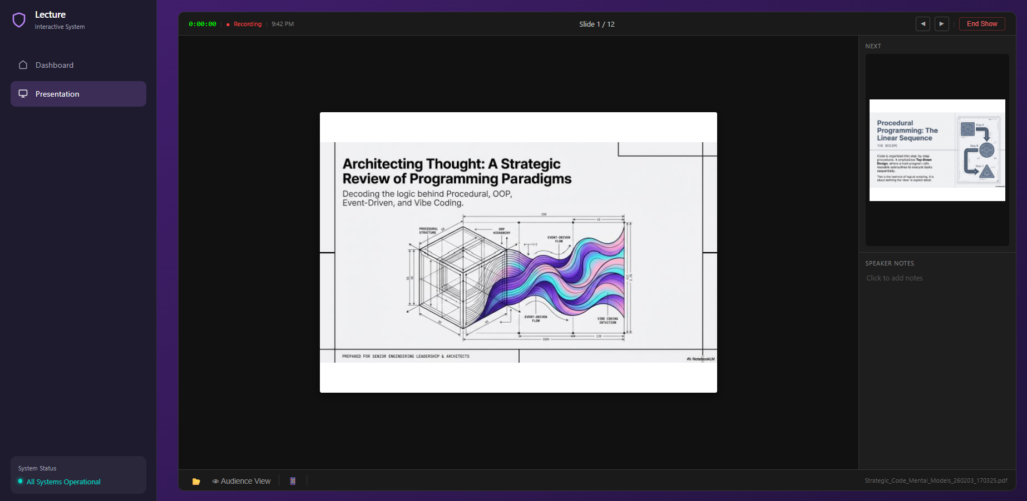

Step 4: Connect Your Phone as a Remote Control

1. In the Presenter View, click the 📱 Remote Access button
2. A QR code will appear
3. Scan the QR code with your phone's camera
4. This will open phone-controller.html on your phone
5. Wait for "Connected" status on your phone
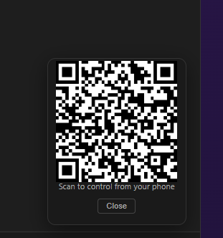

Step 5: Control the Presentation
You can control the presentation from either your computer or your phone:

From Your Computer:
- Use Arrow Keys (Right/Next, Left/Previous)
- Use Spacebar to advance
- Click the ◀ and ▶ buttons in the top bar

From Your Phone:
- Tap ⬅ Prev to go back
- Tap Next ➡ to advance
- Tap 🔲 Exit Fullscreen to exit fullscreen mode

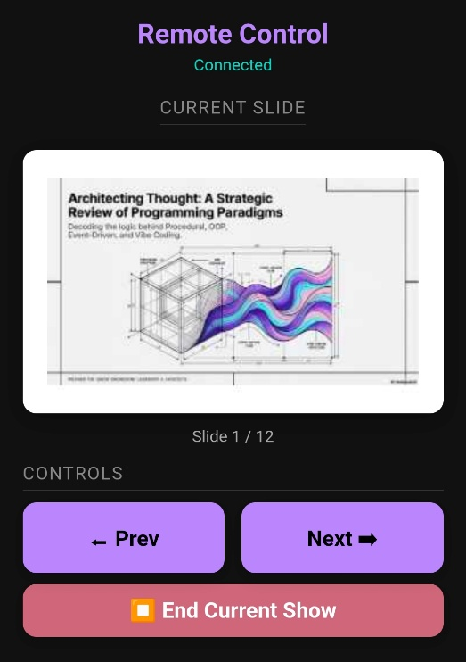

Step 6: End the Presentation

1. Click End Show in the top bar
2. You will return to the Dashboard View



Summary & Conclusion

The Lecture Interactive System demonstrates a practical application of modern web technologies to solve a common presentation challenge. The system offers significant value through its ease of use with an intuitive interface that requires no training, broad accessibility that works on any modern web browser without installation, portability with presentations stored locally for offline access, cost-effectiveness using a free public MQTT broker for quick setup, and scalability that can be deployed with private brokers for enterprise use. Its key strengths include real-time communication via MQTT that provides low-latency, reliable message delivery, cross-platform compatibility working on Windows, macOS, Linux, iOS, and Android, offline support with presentations stored locally in IndexedDB, no account requirement with quick setup through QR code pairing, and a clean architecture with well-separated presenter and remote control interfaces. Looking ahead, potential future enhancements include adding audience interaction features like live polls, Q&A, and feedback, integrating with cloud storage services such as Google Drive, Dropbox, or OneDrive, adding screen recording capabilities, supporting multiple presenters for collaborative presentations, and implementing analytics to track presentation duration, slide views, and audience engagement. Ultimately, this system successfully bridges the gap between traditional presentation software and modern mobile interaction. By leveraging MQTT for real-time communication and web technologies for broad accessibility, it provides a reliable, cost-effective solution for anyone needing to deliver presentations with remote control functionality. Whether used for classroom lectures, business meetings, or conference presentations, the Lecture Interactive System offers a modern, user-friendly alternative to proprietary presentation tools.
modernizes public traffic communication by combining the immediacy of real-time messaging with the simplicity of a no-registration public dashboard — delivering a complete, admin-controlled traffic intelligence ecosystem.

