**Notes on the geolocator analysis**

1. **Twilight annotation** 
   * It may be necessary to adjust the geolocators for clock drift, and adjust the twilight times by the sampling interval of geolocators
   * MK6 geolocators have a sampling interval of 120 seconds, which is the same as the geolocators used in the study by Knight et al. (2018), however, geolocators fit to blackpoll warblers have visibly more shading than those fit to tree swallows.
   * The Intigeo geolocators have a sampling interval of 5 minutes, which minimum frequency that that FlightR can work with.

Figure . light plot for a tree swallow (ind103)

Figure . light plot for a blackpoll warbler (V8295 005)

* + The intigeo geolocators seem to be more susceptible to shading

Figure . Light plot for a blackpoll warbler (C from Deluca et al. 2015)

* + For geolocators located at high latitudes (e.g., Nome Alaska, and the NWT), it seems like the expected twilight time lines of the tsimageDeploymentLines function do not match the twilights times observed at all.
  + For some geolocators, it appears that the time was not recorded in GMT or UTC, so additional hours must be added or subtracted manually. I don’t have any reference on the actual amount of time beyond the expected sunrise and sunset times at the deployment location.
  + Deluca et al. 2015 provide some estimates of the blackpoll warbler’s speed during the fall migration: between 0.7 and 13.4 m/s

**Questions related to the geolocator data analysis**

**For Elizabeth:**

* What was the method used to address false and unclear twilight times? Were they detected and removed manually by scanning all the twilight times of each geolocator? Would this affect reproducibility
  + Elizabeth mentioned that the corrections were manual for at least some birds. She also said that one way to check which approach is the best would likely be to use both.

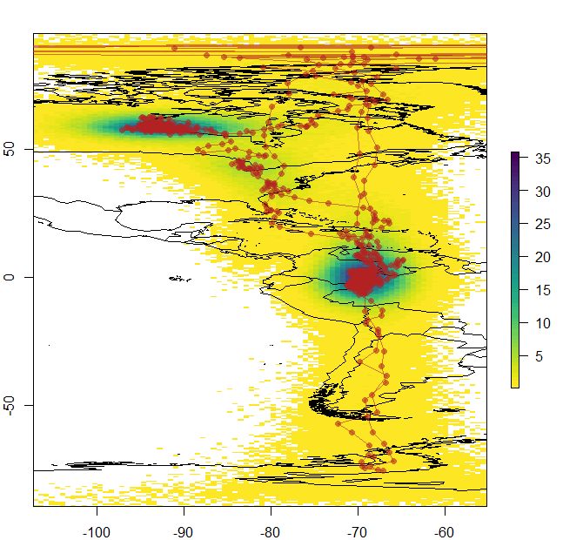

Figure Track for 4105-008 with normal mask

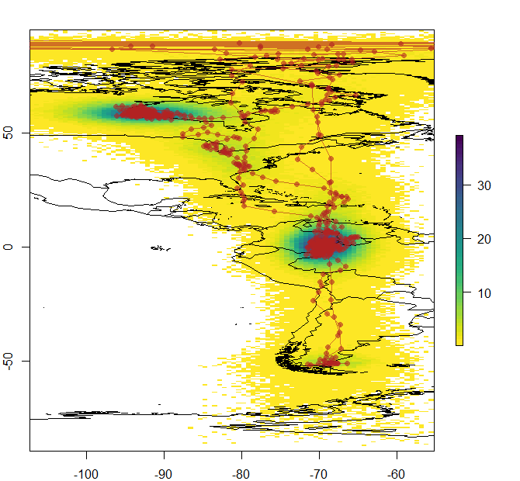

Figure . Track for 4105-008 from MoveBank

Figure . Track for 4105-008 with complex mask

**For Bill:**

* What was the total number of geolocators deployed (outside of those deployed in the 2015 and 2019 studies)?
* What was the length of the lightstalks used on the geolocators?
* Note: missing geolocators for Newfoundland and British Columbia
  + I expect 1 additional geolocator in BC (Watson Lake)
  + One in Yukon (swan lake)
  + 2 in Newfoundland
  + These could be some of the lig. Files that do not have associated data.
* I am also missing the recovery date for some geolocators.