**Experiment No.4 Implement UML Class diagram**

**Learning Objective**: To implement UML class diagram for the project.

**Tools:** MS Word, draw.io

**Theory:**

Class Diagrams:

Classes are the structural units in object oriented system design approach, so it is essential to know all the relationships that exist between the classes, in a system. All objects in a system are also interacting to each other by means of passing messages from one object to another.

**Elements in class diagram**

Class diagram contains the system classes with its data members, operations and relationships between classes.

* Class: A set of objects containing similar data members and member functions is described by a class. In UML syntax, class is identified by solid outline rectangle with three compartments which contain
* Class name: A class is uniquely identified in a system by its name. A textual string [2]is taken as class name. It lies in the first compartment in class rectangle.
* Attributes: Property shared by all instances of a class. It lies in the second compartment in class rectangle.
* Operations: An execution of an action can be performed for any object of a class. It lies in the last compartment in class rectangle
* Relationships: Existing relationships in a system describe legitimate connections between the classes in that system.
* Association: It is an instance level relationship that allows exchanging messages among the objects of both ends of association. A simple straight line connecting two class boxes represent an association. We can give a name to association and also at the both end we may indicate role names and multiplicity of the adjacent classes. Association may be uni-directional.
* Aggregation: It is a special form of association which describes a part-whole relationship between a pair of classes. It means, in a relationship, when a class holds some instances of related class, then that relationship can be designed as an aggregation
* Multiplicity: It describes how many numbers of instances of one class is related to the number of instances of another class in an association

Class diagrams are the most popular UML diagrams used for construction of software applications. It is very important to learn the drawing procedure of class diagram.Class diagrams have a lot of properties to consider while drawing but here the diagram will be considered from a top level view.

Class diagram is basically a graphical representation of the static view of the system and represents different aspects of the application. A collection of class diagrams represent the whole system.

The following points should be remembered while drawing a class diagram −

* The name of the class diagram should be meaningful to describe the aspect of the system.
* Each element and their relationships should be identified in advance.
* Responsibility (attributes and methods) of each class should be clearly identified
* For each class, minimum number of properties should be specified, as unnecessary properties will make the diagram complicated.
* Use notes whenever required to describe some aspect of the diagram. At the end of the drawing it should be understandable to the developer/coder.
* Finally, before making the final version, the diagram should be drawn on plain paper and reworked as many times as possible to make it correct.

**Procedure**:

When required to describe the static view of a system or its functionalities, we would be required to draw a class diagram. Here are the steps you need to follow to create a class diagram.

Step 1: Identify the class names --The first step is to identify the primary objects of the system.

Step 2: Distinguish relationships --Next step is to determine how each of the classes or objects are related to one another. Look out for commonalities and abstractions among them; this will help you when grouping them when drawing the class diagram.

Step 3: Create the Structure-- First, add the class names and link them with the appropriate connectors. You can add attributes and functions/ methods/ operations later.

Example class diagram:

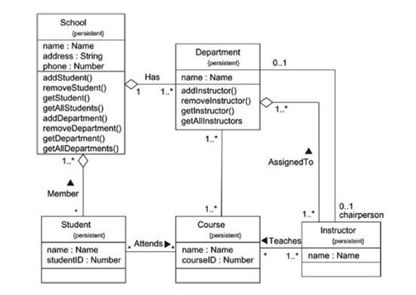

**Result and discussion:**

Project title: Music recommendation system

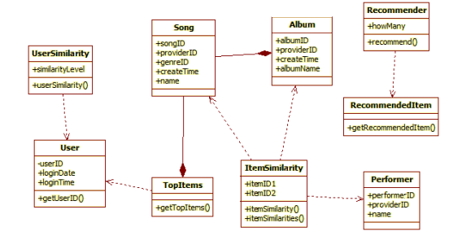

**Learning Outcomes:** The student should have the ability to:

LO 1: Identify the importance of class diagrams.

LO 2: Draw class diagrams for a given scenario.

**Course Outcomes:** Upon completion of the course we were able to understand and

demonstrate class diagrams.

**Conclusion:** Thus, students have understood and successfully drawn class diagrams.

For Faculty Use

| **Correction Parameters** | **Formative Assessment [40%]** | **Timely completion of Practical [ 40%]** | **Attendance / Learning Attitude [20%]** |  |
| --- | --- | --- | --- | --- |
| **Marks Obtained** |  |  |  |