PREDICTOPS: INTELLIGENT EQUIPMENT HEALTH AND FAILURE PREDICTION PLATFORM
Project submitted to the
SRM University – AP, Andhra Pradesh
for the partial fulfillment of the requirements to award the degree of
Bachelor of Technology
In
Computer Science and Engineering
School of Engineering and Sciences
Submitted by
[Student Name 1] [Register No. 1]
[Student Name 2] [Register No. 2]
[Student Name 3] [Register No. 3]
[Student Name 4] [Register No. 4]
[Insert university logo here]
Under the Guidance of
[Guide Name]
[Designation], Dept. of CSE
SRM University–AP
Neerukonda, Mangalagiri, Guntur
Andhra Pradesh – 522 240
[Month], [Year]

CERTIFICATE
Date: [DD-MM-YYYY]
This is to certify that the work presented in this Project entitled “PredictOps: Intelligent Equipment Health and Failure Prediction Platform” has been carried out by [Student Name 1], [Student Name 2], [Student Name 3], [Student Name 4] under my supervision. The work is genuine, original, and suitable for submission to the SRM University – AP for the award of Bachelor of Technology in School of Engineering and Sciences.
Supervisor
(Signature)
[Guide Name]
[Designation],
Department of CSE

Acknowledgements
Our sincere thanks go to our project guide, [Guide Name], whose advice shaped this work from the choice of problem to the way we tested it, and who kept reminding us to check our results before trusting them. Each member of our team gave time and skill to a different part of the project, from data analysis and modelling to the application and this report, and we are grateful to one another. We also thank the authors of the MetroPT-3 dataset for publishing real sensor data from an operating train, and SRM University – AP for the facilities and support that made the project possible.

ABSTRACT
Metro trains depend on an on-board compressor for braking and suspension air, and when it breaks down unexpectedly the train is withdrawn from service and the repair bill rises. In this project we developed PredictOps, a platform that watches the health of this compressor, known as the Air Production Unit (APU), using MetroPT-3: a public collection of about 1.5 million readings from fifteen sensors recorded between February and September 2020. No column in the data says when the machine was faulty; the operator only reported four periods of air-leak failure, and these are our sole ground truth.
Our processing chain checks and cleans the readings, splits the record wherever the logger stopped, marks periods where sensors were stuck, and derives 132 features that look only at past values. Training, validation and test periods follow the calendar, so the model never sees the future. Five classifiers, four anomaly detectors and two neural networks were compared. The classifiers recognised the two validation failures almost perfectly, yet none of them noticed the final, held-back failure, whose sensor pattern was different; SHAP analysis explains this gap. A One-Class SVM that only ever saw healthy operation flagged every one of the three failures we evaluated, the held-back one included, while raising roughly one false alarm a week. Warning of a failure several hours in advance was also attempted, and the data did not support it.
These scores drive a transparent health and risk module, a FastAPI service backed by SQLite, and a Streamlit dashboard of eleven pages that offers replay of recorded days, a clearly marked simulated live feed, maintenance alerts, downloadable PDF and CSV reports, and drift tracking. The software passes 73 automated tests and runs inside Docker. Our main finding is that, when failure examples are this scarce, learning what normal looks like and evaluating carefully beats trying to learn what failure looks like.
COMPONENTS:
- Machine learning: Python, scikit-learn, XGBoost, PyTorch, SHAP
- Back-end: FastAPI (Python) with SQLite via SQLAlchemy
- Front-end: Streamlit with Plotly charts
- Deployment: Docker and Docker Compose
Keywords: compressor health monitoring, railway maintenance, novelty detection, explainable machine learning, leakage-free evaluation, Streamlit, FastAPI.

Table of Contents
1. Introduction
1.1 Purpose
1.2 Scope
1.3 Definitions, Acronyms, and Abbreviations
1.4 References
1.5 Overview
2. The Overall Description
2.1 Product Perspective
2.2 Product Functions
2.3 User Characteristics
2.4 Constraints
2.5 Assumptions and Dependencies
3. External Interface Requirements
3.1 User Interfaces
3.2 Hardware Interfaces
3.3 Software Interfaces
3.4 Communication Interfaces
4. System Features
4.1 Data Validation and Ingestion
4.2 Time-Series Feature Engineering
4.3 Anomaly Detection (primary detector)
4.4 Failure-Signature Classifier
4.5 Health and Risk Engine
4.6 Explainable AI
4.7 Alerts and Maintenance
4.8 Historical Replay and Live Simulation
4.9 Reports and Monitoring
5. Other Non-Functional Requirements
5.1 Performance Requirements
5.2 Software System Attributes
5.3 Business Rules
6. Dataset and Methodology
6.1 Dataset
6.2 Preprocessing and Targets
6.3 Feature Engineering
6.4 Class Imbalance
6.5 Models
7. Diagrams
Use Case Diagram
DFD Level-0
DFD Level-1
System Architecture
Activity Diagram
Class Diagram
State Diagram
Sequence Diagram
ER Diagram
Deployment Diagram
Data Dictionary
8. Testing
8.1 Function Testing
8.2 Path Testing
8.3 Bugs Found by Testing
9. Front-End Description
10. Back-End Description
11. Results
11.1 Supervised Failure Detection
11.2 Anomaly Detection (main result)
11.3 Health Engine and Deep Learning
11.4 Application Screenshots
12. Conclusion
13. Future Work
14. References

(Right-click the table and choose “Update Field” in Word to refresh page numbers.)

List of figures
- Figure-1 : Reported failure windows over the recording period
- Figure-2 : Machine-learning pipeline
- Figure-3 : Use Case Diagram
- Figure-4 : DFD Level-0
- Figure-5 : DFD Level-1
- Figure-6 : System Architecture
- Figure-7 : Activity Diagram
- Figure-8 : Class Diagram
- Figure-9 : State Diagram (equipment health status)
- Figure-10 : Sequence Diagram — batch prediction
- Figure-11 : ER Diagram
- Figure-12 : Deployment Diagram
- Figure-13 : Test-set comparison of supervised models
- Figure-14 : One-Class SVM anomaly score around the unseen test failure (event 4)
- Figure-15 : Global SHAP feature importance of the XGBoost signature model
- Figure-16 : Overview page
- Figure-17 : Failure Prediction page
- Figure-18 : Explainable AI page
- Figure-19 : Maintenance alerts page
- Figure-20 : Live Simulation page (synthetic data, labelled)
List of tables
- Table-1 : Definitions, Acronyms, and Abbreviations
- Table-2 : Hardware requirements
- Table-3 : Software stack
- Table-4 : Main REST API endpoints (29 in total)
- Table-5 : Measured performance
- Table-6 : MetroPT-3 dataset summary
- Table-7 : Chronological data splits (12 h embargo between splits)
- Table-8 : Models compared
- Table-9 : Data Dictionary
- Table-10 : Automated test suite
- Table-11 : Function test cases
- Table-12 : Bugs found and fixed
- Table-13 : Supervised models: validation vs unseen test (event 4)
- Table-14 : Anomaly detectors (event-level evaluation)

1. Introduction
Modern machines are fitted with sensors that report their condition many times a minute. When these readings are analysed to spot wear before it becomes a breakdown, maintenance can be scheduled in advance rather than carried out in a hurry; this practice is called predictive maintenance. In a metro train, the Air Production Unit (APU) compresses the air used by the brakes, the suspension and the doors. If a pipe or seal leaks, the compressor has to keep running to hold pressure, its oil heats up, and the train may eventually have to be taken off the line.
This project presents PredictOps, a complete machine-learning application that reads recorded APU sensor data and reports how healthy the equipment is, whether its behaviour is unusual, which measurements explain that judgement, and what the maintenance team should do. We also paid particular attention to evaluating it correctly: information from the future is never used during training, the final test is never used for tuning, and results that did not work out are reported as they are.

1.1 Purpose
The purpose of this project is to build a robust, explainable and usable platform that turns raw compressor sensor readings into actionable maintenance information, and to evaluate it with a methodology that would hold up in a real deployment.
- Detect abnormal and failure behaviour of the compressor from its sensors.
- Estimate equipment health and failure risk, and explain them in terms of sensor measurements.
- Present results in an interactive dashboard with alerts, reports and monitoring.

1.2 Scope
The project covers the complete life-cycle: dataset inspection, exploratory data analysis (EDA), preprocessing, time-series feature engineering, supervised models, anomaly detection, deep learning, explainability, a health and risk engine, a REST API, a database, a web dashboard, automated tests, monitoring and Docker deployment. The data is the public MetroPT-3 dataset from one metro APU compressor (UCI dataset 791). The system works on recorded data (historical replay and a labelled synthetic simulation); connection to live sensors is outside the scope.

1.3 Definitions, Acronyms, and Abbreviations
Term | Meaning
APU | Air Production Unit — the train’s compressor system that is monitored
PdM | Predictive Maintenance — maintenance planned from the measured condition of equipment
EDA | Exploratory Data Analysis
TP2 / TP3 | Pressure at the compressor outlet / pneumatic panel (bar)
DV_pressure | Pressure drop when the air dryer towers discharge (bar)
LPS | Low Pressure Switch — digital signal raised when pressure is too low
OCSVM | One-Class Support Vector Machine — learns the boundary of normal data
XGBoost | Extreme Gradient Boosting — tree-ensemble classifier
SHAP | SHapley Additive exPlanations — per-feature contribution to a prediction
PR-AUC | Area under the precision–recall curve (main metric for rare failures)
MCC | Matthews Correlation Coefficient
SMOTE / ADASYN | Synthetic minority over-sampling methods for imbalanced data
API / REST | Application Programming Interface / Representational State Transfer
PSI / KS | Population Stability Index / Kolmogorov–Smirnov test (drift monitoring)
Leakage | Training on information that a real system could not know when it makes a prediction
Table-1: Definitions, Acronyms, and Abbreviations

1.4 References
The main references for this work are the MetroPT dataset papers [1]–[3], the original papers of each algorithm used [4]–[15], and guidance on validating time-series models [16]. The full list is given in Section 14.

1.5 Overview
Section 2 describes the product, its functions, users and constraints. Section 3 lists the external interface requirements, Section 4 the system features and Section 5 the non-functional requirements. Section 6 describes the dataset and the machine-learning methodology. Section 7 contains the design diagrams, Section 8 the testing, Sections 9–10 the front end and back end, and Sections 11–13 the results, conclusion and future work.

2. The Overall Description

2.1 Product Perspective
PredictOps is a self-contained system made of an offline training pipeline and an online application that share the same Python package, so the preprocessing used in training is exactly the preprocessing used for predictions.
- Functional units: data ingestion and validation, feature pipeline, anomaly detector, failure-signature classifier, health and risk engine, explainability module, REST API, database and dashboard.
- Operation: runs on a laptop or as two Docker containers (API and dashboard); a Render cloud blueprint is included.
- Traceability: every prediction run stores the model versions that produced it; experiments are tracked in MLflow.
- User experience: a dark industrial dashboard with status shown as icon plus text, colour-blind-safe charts and charts that never draw across missing data.

2.2 Product Functions

Upload and validate sensor data
Users upload a CSV of raw readings or pick a sample file. The system checks columns, types, timestamps, ranges, empty files and file size, and reports every problem clearly.

Assess equipment health
The pipeline builds one-minute features, scores them with the anomaly model and the failure-signature model, and combines the evidence into a health score (0–100), a status (Healthy / Warning / Critical), a failure risk (Low / Medium / High), reasons and recommended actions.

Detect anomalies and raise alerts
A persistent anomaly (at least 10 flagged minutes in 30) becomes an alert episode, which maintenance staff can acknowledge with a note.

Explain predictions
For any minute, the system shows the SHAP contributions of the failure-signature model and the sensors that deviate most from normal operation.

Historical replay and live simulation
Replay steps through recorded 2020 data and re-runs the full pipeline at each step. The live simulation streams clearly labelled synthetic data that degrades into failure at random times, to demonstrate the system reacting in real time.

Reports and monitoring
Results can be downloaded as CSV or a PDF report. Data drift (KS test, PSI) and prediction drift are monitored month by month.

2.3 User Characteristics
- Maintenance engineer: uploads data, watches health and alerts, reads explanations, acknowledges alerts and downloads reports. Needs clear status and plain-language reasons, not ML terminology.
- Data scientist: reviews model performance, drift and experiments, and retrains the pipeline. Needs full metrics, curves and reproducible scripts.
- Administrator: deploys and configures the system (API key, database, ports) using Docker or the cloud blueprint.

2.4 Constraints
- Data constraints: the record covers a single compressor over about seven months and contains just four reported failures, all air leaks; there is no label column, and the logger has 230 gaps and 7 stuck-sensor periods.
- Scientific constraints: no random splits on time series, no resampling of validation or test data, no model selection by accuracy, no tuning on the test failure, anomaly ≠ failure, and SHAP is not proof of cause.
- Technical constraints: must run on a laptop with 8 GB RAM; the API container must fit in about 512 MB for free cloud hosting.
- Honesty constraints: replay must not be called real-time; simulated data must be labelled as simulated; hours-ahead prediction is not claimed because the data does not support it.

2.5 Assumptions and Dependencies
- The four failure windows in the official dataset description are the only ground truth; their boundaries are approximate.
- Normal operation in February–April 2020 is representative of healthy behaviour of this compressor.
- Uploaded files follow the MetroPT-3 CSV schema (15 sensor columns and a timestamp).
- The application depends on the trained model artifacts in models/; if they are missing, the API reports a degraded state and the pipeline can rebuild them.

3. External Interface Requirements

3.1 User Interfaces
The dashboard has eleven pages grouped into three sections: Monitor (Overview, Sensor Monitoring, Historical Replay, Live Simulation), Intelligence (Failure Prediction, Anomaly Detection, Explainable AI, Equipment Health, Maintenance) and Models & Data (Model Performance, Data & Model Monitoring).
- Status cards show health score, failure risk and anomaly status with an icon and text label (never colour alone).
- Interactive Plotly charts with zoom, hover and shaded failure or alert windows.
- Clear error messages for invalid uploads, unavailable API or missing data.
- Responsive wide layout; the same views are captured in the screenshots in Section 11.

3.2 Hardware Interfaces
Component | Minimum | Used in this project
CPU | 64-bit, 2 cores | Apple Silicon, 8 cores
RAM | 4 GB to run the app; 8 GB to retrain | 8 GB
Storage | 1 GB (app + artifacts); 2 GB with raw data | SSD
GPU | Not required (deep learning runs on CPU) | Apple MPS used for LSTM training
Table-2: Hardware requirements

3.3 Software Interfaces
Layer | Software
Language | Python 3.12
Data | pandas, NumPy, PyArrow (Parquet), SciPy
Machine learning | scikit-learn, imbalanced-learn, XGBoost, PyTorch, SHAP
Experiment tracking | MLflow (local SQLite store)
Back end | FastAPI, Pydantic, Uvicorn, SQLAlchemy, SQLite
Front end | Streamlit, Plotly
Reports | reportlab (PDF), CSV export
Testing & deployment | pytest, Streamlit AppTest, Playwright, Docker, Docker Compose
Table-3: Software stack

3.4 Communication Interfaces
The dashboard talks to the back end over HTTP/HTTPS using a REST API with JSON bodies. When the API is exposed publicly, every request must carry an X-API-Key header. Interactive API documentation is generated automatically at /docs. The main endpoints are listed below.
Method | Endpoint | Purpose
GET | /health | Service, model and database status
POST | /datasets/upload | Upload and validate a sensor CSV
POST | /predict | Run the full assessment on a dataset
POST | /predict/observations | Assess readings sent as JSON
POST | /explain | SHAP and deviation explanation of a minute
GET | /alerts | List alert episodes
POST | /alerts/{id}/acknowledge | Acknowledge an alert with a note
GET | /history | Pre-computed assessments for charts
GET | /replay/step | Historical replay of one time step
POST / GET | /simulation/start · /stop · /state | Labelled synthetic live stream
GET | /monitoring/drift | Data and prediction drift (KS, PSI)
GET | /reports/run/{id}.pdf | PDF report of a prediction run
Table-4: Main REST API endpoints (29 in total)

4. System Features

4.1 Data Validation and Ingestion
Checks schema, timestamps, data types, missing or infinite values, binary digital sensors and file size; splits the series into segments at logger gaps longer than 10 minutes so that no feature is computed across a gap.

4.2 Time-Series Feature Engineering
Every minute of 10-second readings is summarised into one row, and 132 features are derived from it: statistics over the previous 5 minutes, 30 minutes and 2 hours, how much of the time the compressor was loaded, how often it switched on, recent changes, and the gap between current values and the last 24 hours. An automated test confirms that appending later data never alters an earlier feature.

4.3 Anomaly Detection (primary detector)
The main detector is a One-Class SVM fitted on healthy months only. Its alarm levels are set from a separate stretch of healthy data, and a warning becomes an alert only when at least 10 of the last 30 minutes look abnormal, so that single spikes are ignored.

4.4 Failure-Signature Classifier
An XGBoost model recognises the air-leak pattern of previously reported failures and adds supporting evidence.

4.5 Health and Risk Engine
Four pieces of evidence are weighted and combined into a score from 0 to 100: the anomaly level (40%), the failure-pattern model (30%), sensors outside their usual range (20%) and recent alerts (10%). A score of 75 or more is Healthy, 45 to 75 is Warning and below 45 is Critical, and the status is raised further when both models agree. Each result carries readable reasons and a suggested action.

4.6 Explainable AI
For the XGBoost model, exact Shapley values are computed with TreeSHAP, and a test confirms that they add up to the model output. For the One-Class SVM, KernelSHAP is used on chosen minutes, and the dashboard also lists the sensors that are furthest from their normal values.

4.7 Alerts and Maintenance
Alert episodes with severity, reasons and recommended actions; engineers can acknowledge them and add notes, which are stored in the database.

4.8 Historical Replay and Live Simulation
Replay re-runs the pipeline on recorded data at each step. The simulation streams synthetic readings (recombined real normal and failure recordings) that fail at random times; it is labelled “SIMULATED” and never stored with real results.

4.9 Reports and Monitoring
CSV and PDF reports; monthly KS/PSI data drift and prediction drift relative to training data.

5. Other Non-Functional Requirements

5.1 Performance Requirements
The following performance figures were measured on the development machine with scripts/benchmark.py:
Operation | Measured
Raw CSV (218 MB) → typed Parquet | 5 s
Feature build, full dataset (1.5 M rows → 252,719 minutes) | ≈ 2 s
Model loading at API start | 0.07 s
Assess one day of raw data (8,661 readings) | 0.17 s
SHAP for 100 minutes | 0.52 s
API /health · /history (2 days) · /replay/step | 5 ms · 95 ms · 162 ms
API container memory | ≈ 370 MB
Table-5: Measured performance

5.2 Software System Attributes

5.2.1 Reliability
73 automated tests (unit, integration, API and UI) pass. Errors return structured 4xx responses; unexpected errors return a generic 500 and are logged. If model files are missing, the API starts in a degraded state and reports it on /health instead of crashing.

5.2.2 Availability
The application runs as two independent Docker containers with a persistent database volume and a health check, so it can be restarted or redeployed without losing history.

5.2.3 Security
- Optional API-key authentication and a CORS allow-list.
- Upload size, type and schema validation; protection against path traversal (tested).
- Secrets read from environment variables, never stored in the repository; the container runs as a non-root user.

5.2.4 Maintainability
Code is modular (data, preprocessing, features, models, anomaly, engine, inference, monitoring); all settings are in one YAML configuration file; every stage is documented in docs/ and in executed notebooks; the code is version-controlled on GitHub.

5.3 Business Rules
- An alert is raised only for a persistent anomaly (≥ 10 flagged minutes in 30).
- Anomaly status, failure risk and health status are reported separately — an anomaly is not called a failure.
- Every prediction run records the model versions used.
- Simulated data is always labelled and never stored with real results.
- Models are never retrained during a request; retraining is an explicit offline step.

6. Dataset and Methodology

6.1 Dataset
Property | Value
Source | MetroPT-3, UCI Machine Learning Repository (id 791)
Rows × columns | 1,516,948 × 17 (timestamp + 15 sensors + index)
Period | 1 Feb – 1 Sep 2020; sampled every ≈ 10 s
Analog sensors (7) | TP2, TP3, H1, DV_pressure, Reservoirs, Oil_temperature, Motor_current
Digital sensors (8) | COMP, DV_eletric, Towers, MPG, LPS, Pressure_switch, Oil_level, Caudal_impulses
Data quality | No missing values; 230 logger gaps > 10 min (231 segments); 7 frozen-sensor periods (3.3% of rows)
Ground truth | 4 reported air-leak windows (18 Apr, 29–30 May, 5–7 Jun, 15 Jul) = 1.97% of rows; no label column
Table-6: MetroPT-3 dataset summary
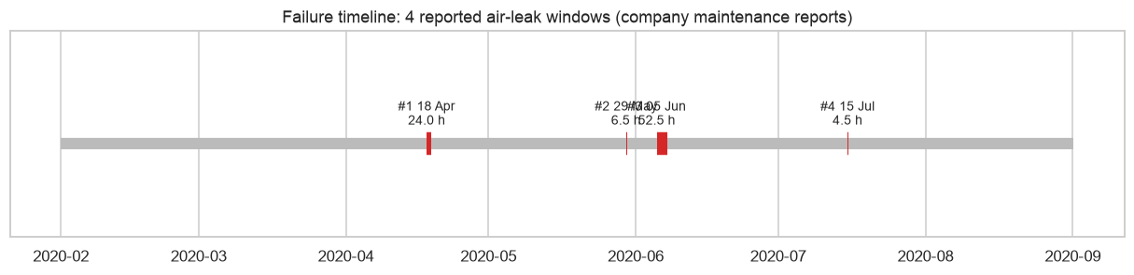
Figure-1: Reported failure windows over the recording period

6.2 Preprocessing and Targets
Timestamps are parsed and sorted, the schema is validated, and data types are reduced (float32/int8, 4× less memory). Data is split into segments at gaps; frozen-sensor rows and three unreported failure-like episodes are flagged and excluded from training and metrics, never relabelled. Scaling uses a StandardScaler fitted on training rows only.
Split | Period | Failure events
Train | Feb – 20 May 2020 | Event 1
Validation | 21 May – 30 Jun 2020 | Events 2 and 3
Test (used once) | Jul – Aug 2020 | Event 4
Table-7: Chronological data splits (12 h embargo between splits)

6.3 Feature Engineering
Each minute of readings becomes one row, covering the interval that ends at that minute, and 132 features are calculated inside each uninterrupted stretch of data using past values only. Keeping only what is useful on the training months (dropping near-constant columns, then near-duplicate ones with |r| > 0.98, then ranking by XGBoost gain) leaves 33 features for the classifiers, while the anomaly detectors use 18 physically meaningful features that need no labels.

6.4 Class Imbalance
Just 1.1% of training minutes fall inside a failure, and every one of them comes from the same event. We tried SMOTE, ADASYN, random over-sampling, random under-sampling and class weighting, always applying them to the training part of each fold and never to the data used for checking. The models ranked failures equally well (PR-AUC between 0.97 and 0.999) with or without them, so we did not use synthetic samples and relied on class weights and tuned thresholds instead.

6.5 Models
Family | Models | Role
Supervised | Logistic Regression, Decision Tree, Random Forest, RBF-SVM, XGBoost | Failure-signature recognition; XGBoost selected before testing
Anomaly detection | Isolation Forest, LOF, One-Class SVM, robust-z | Primary detector; One-Class SVM selected on validation
Deep learning | LSTM, 1D-CNN (60-min × 13-channel sequences) | Experiment; not deployed (unstable across seeds)
Table-8: Models compared
Hyper-parameters were searched at random and scored on folds that always train on earlier months and check on the following failure. Each model’s alarm threshold was taken from these out-of-fold predictions, and the winning model was written to disk, with a time stamp, before any test data was loaded.
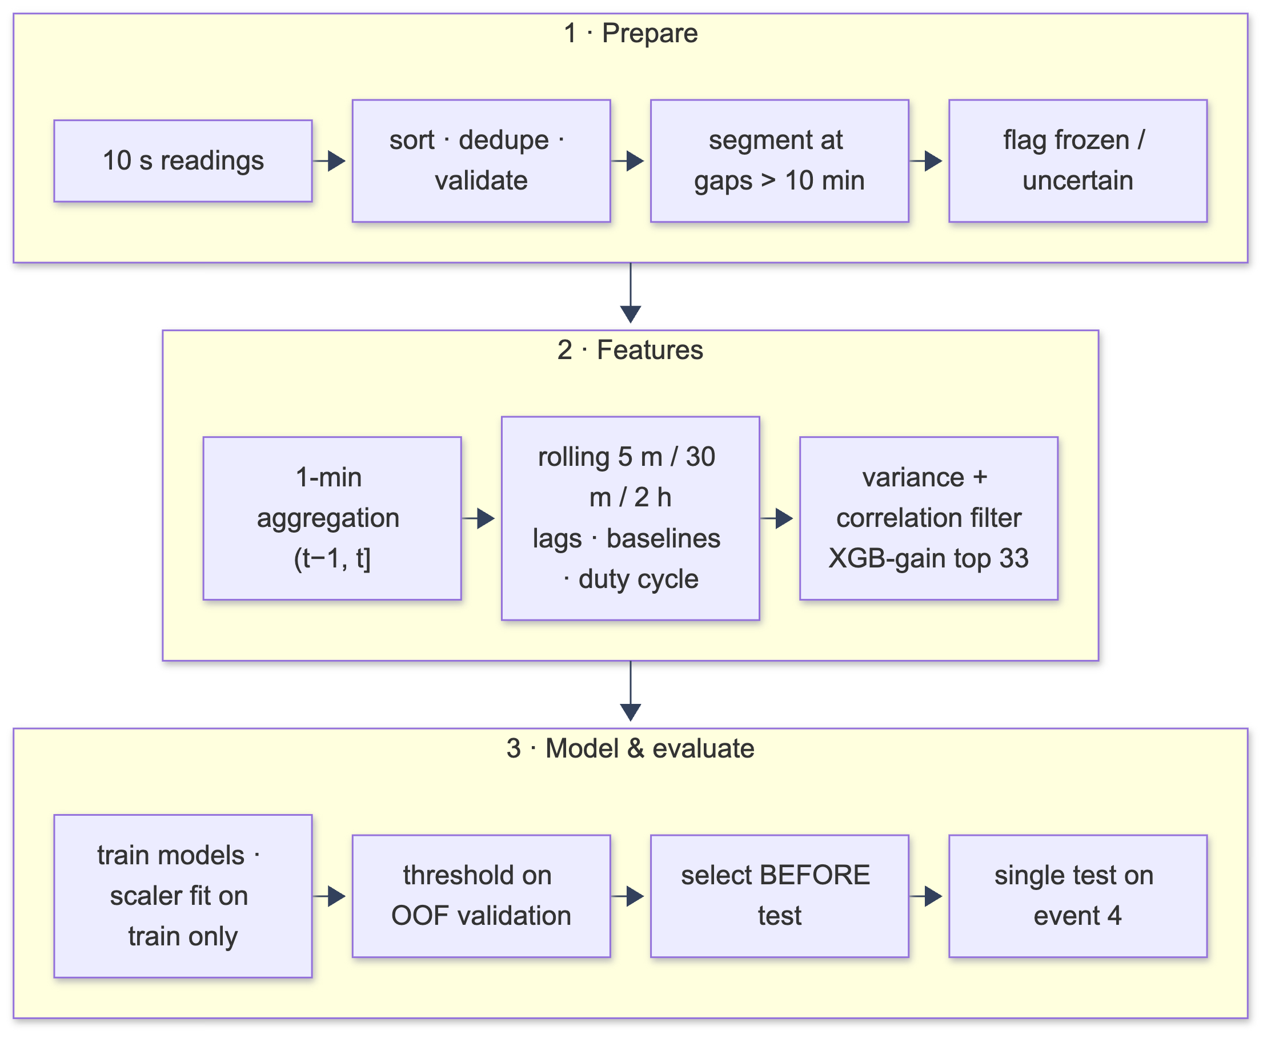
Figure-2: Machine-learning pipeline

7. Diagrams

Use Case Diagram
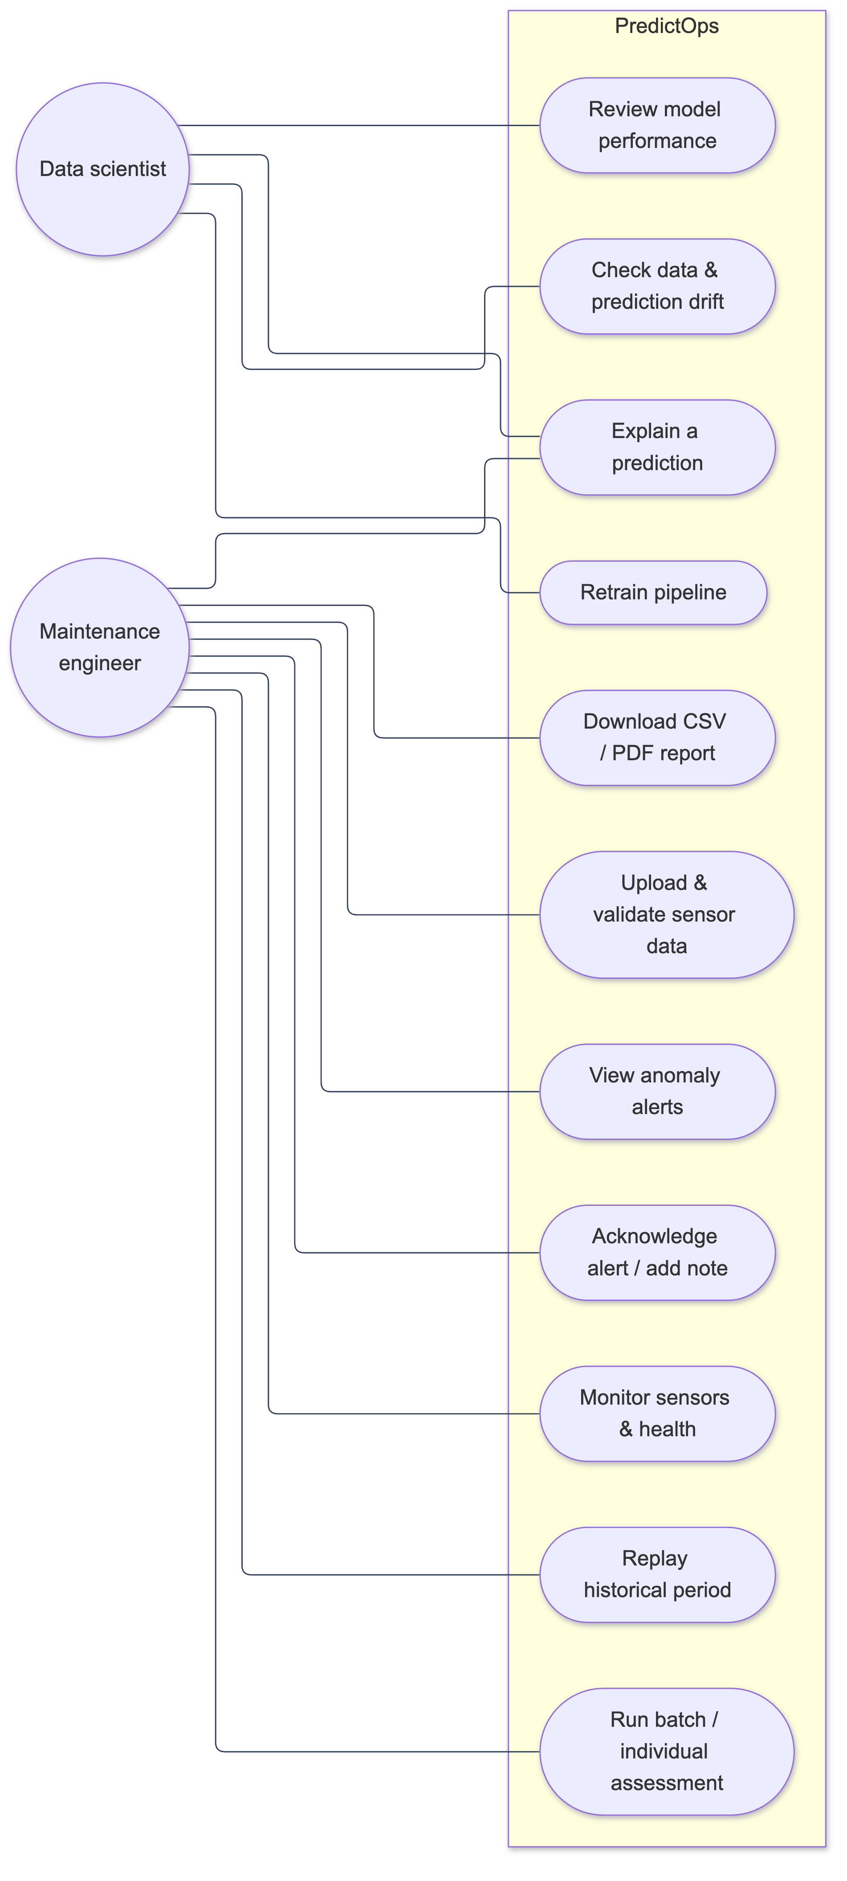
Figure-3: Use Case Diagram

DFD Level-0
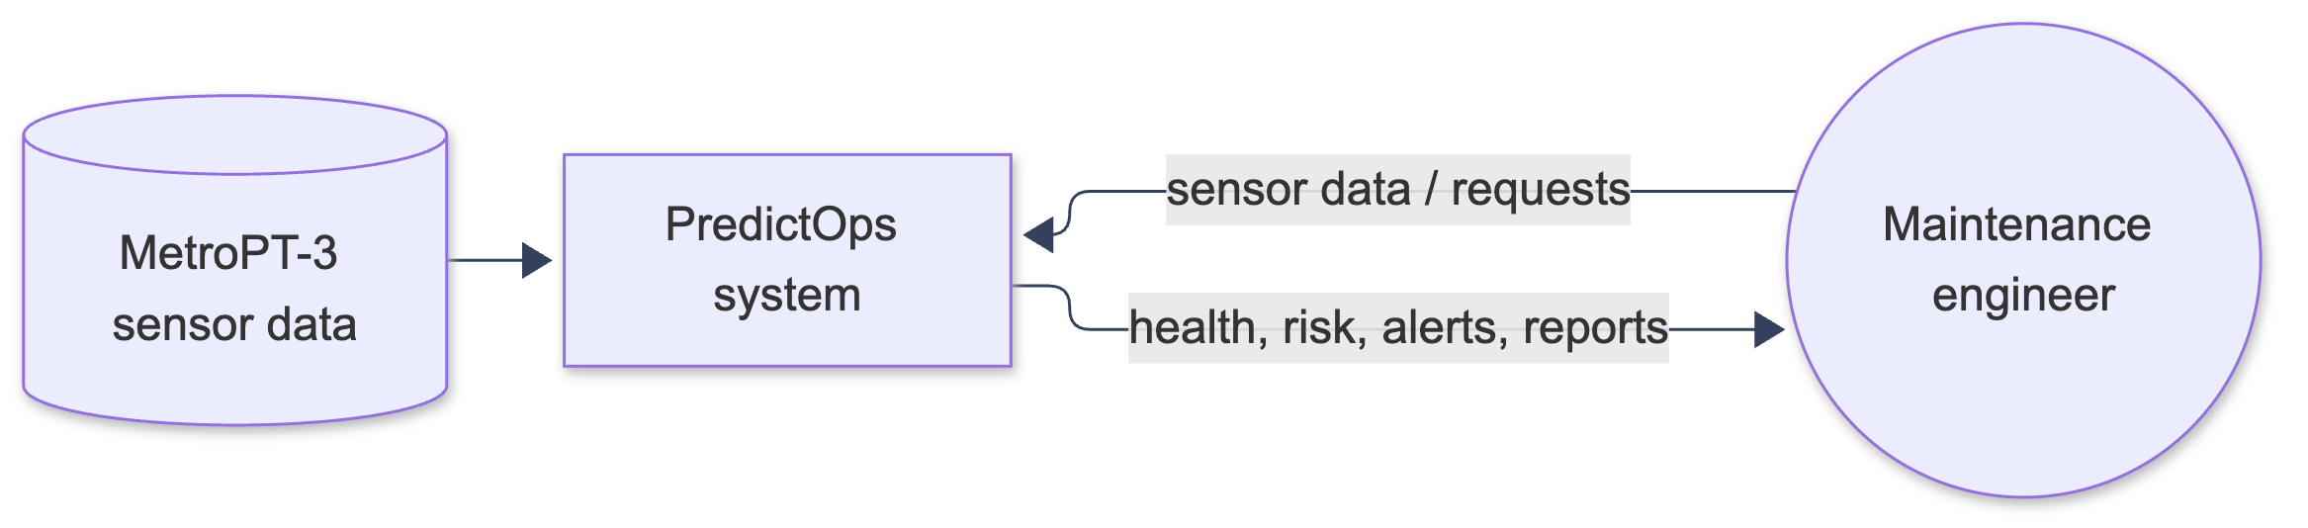
Figure-4: DFD Level-0

DFD Level-1
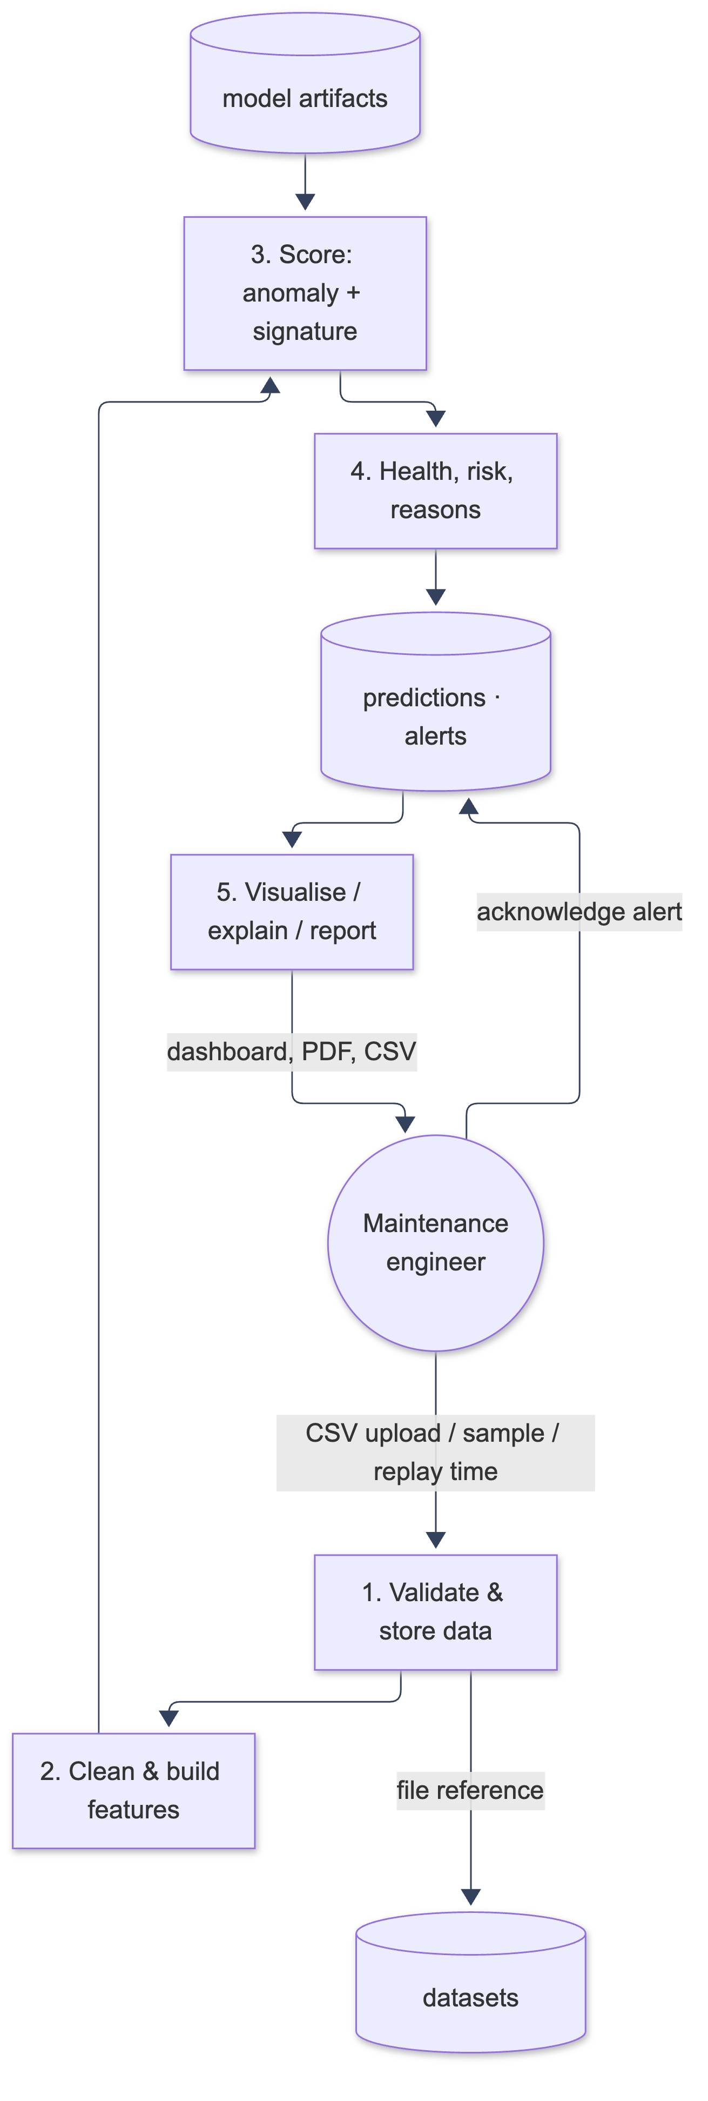
Figure-5: DFD Level-1

System Architecture
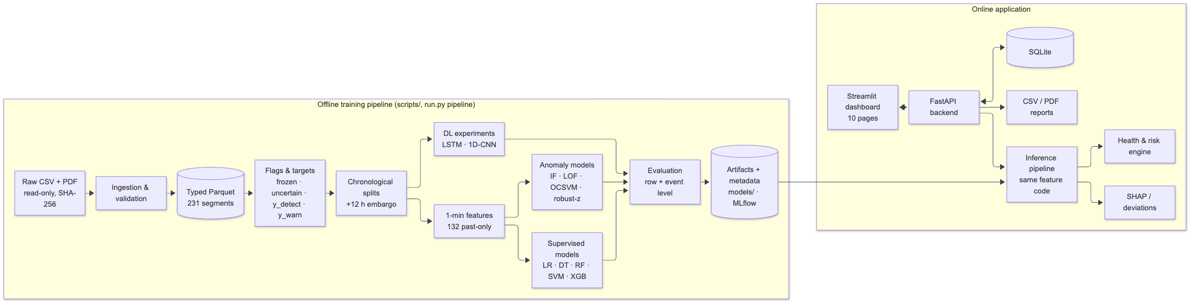
Figure-6: System Architecture

Activity Diagram
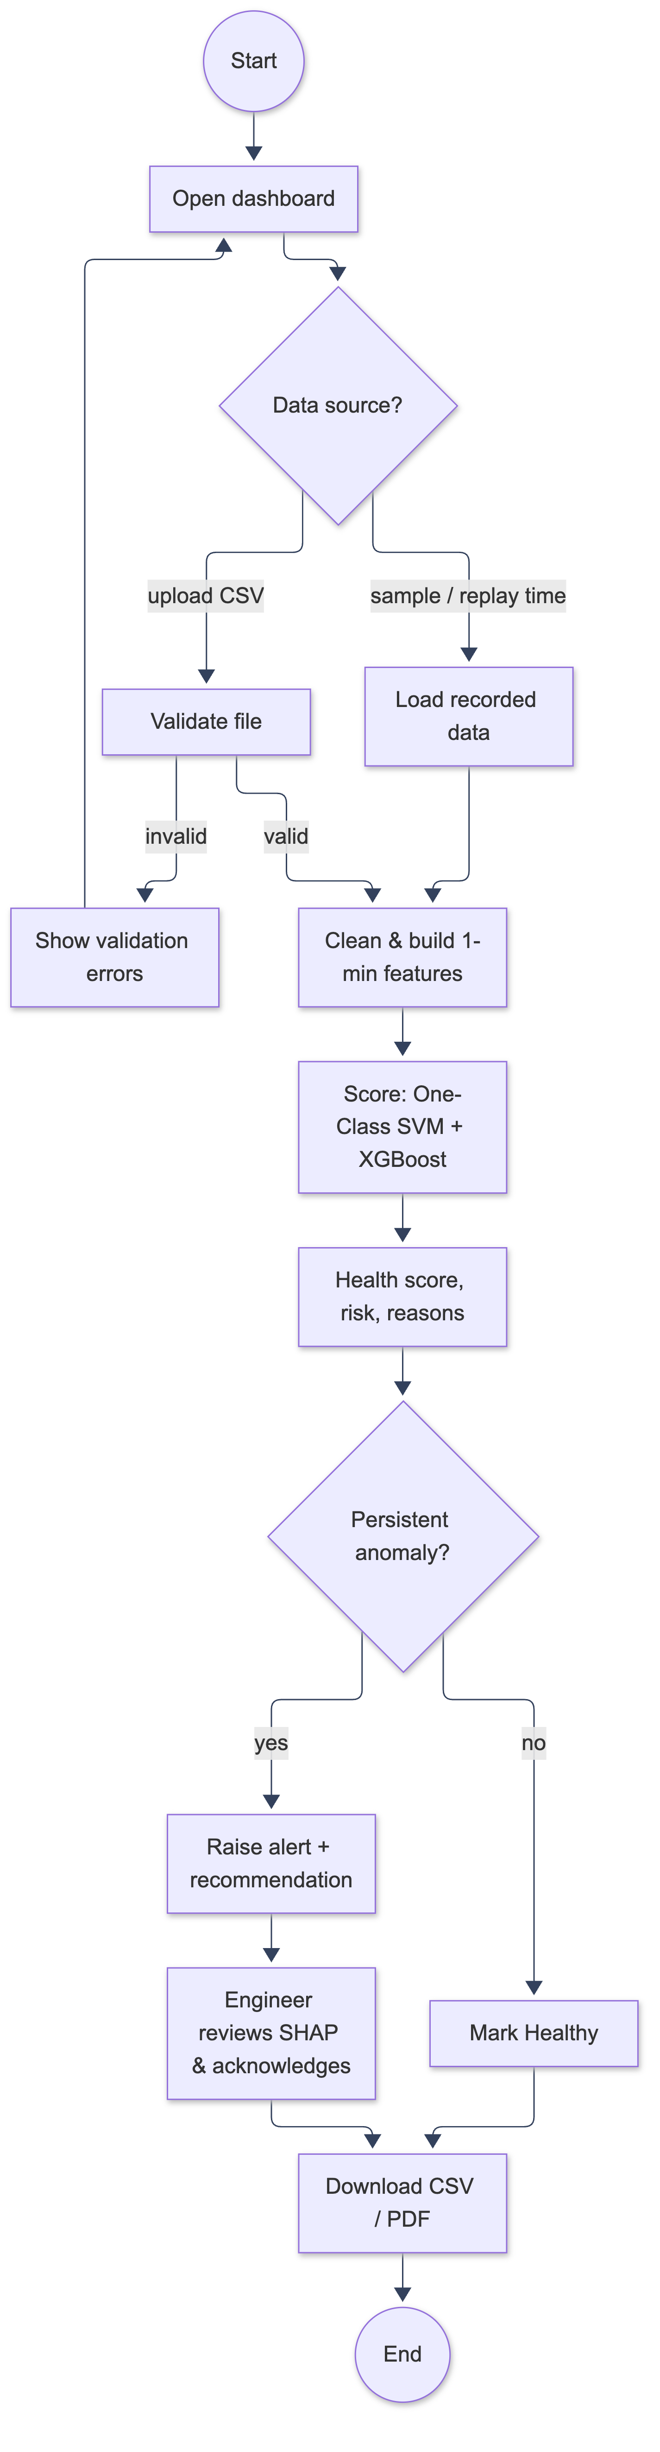
Figure-7: Activity Diagram

Class Diagram
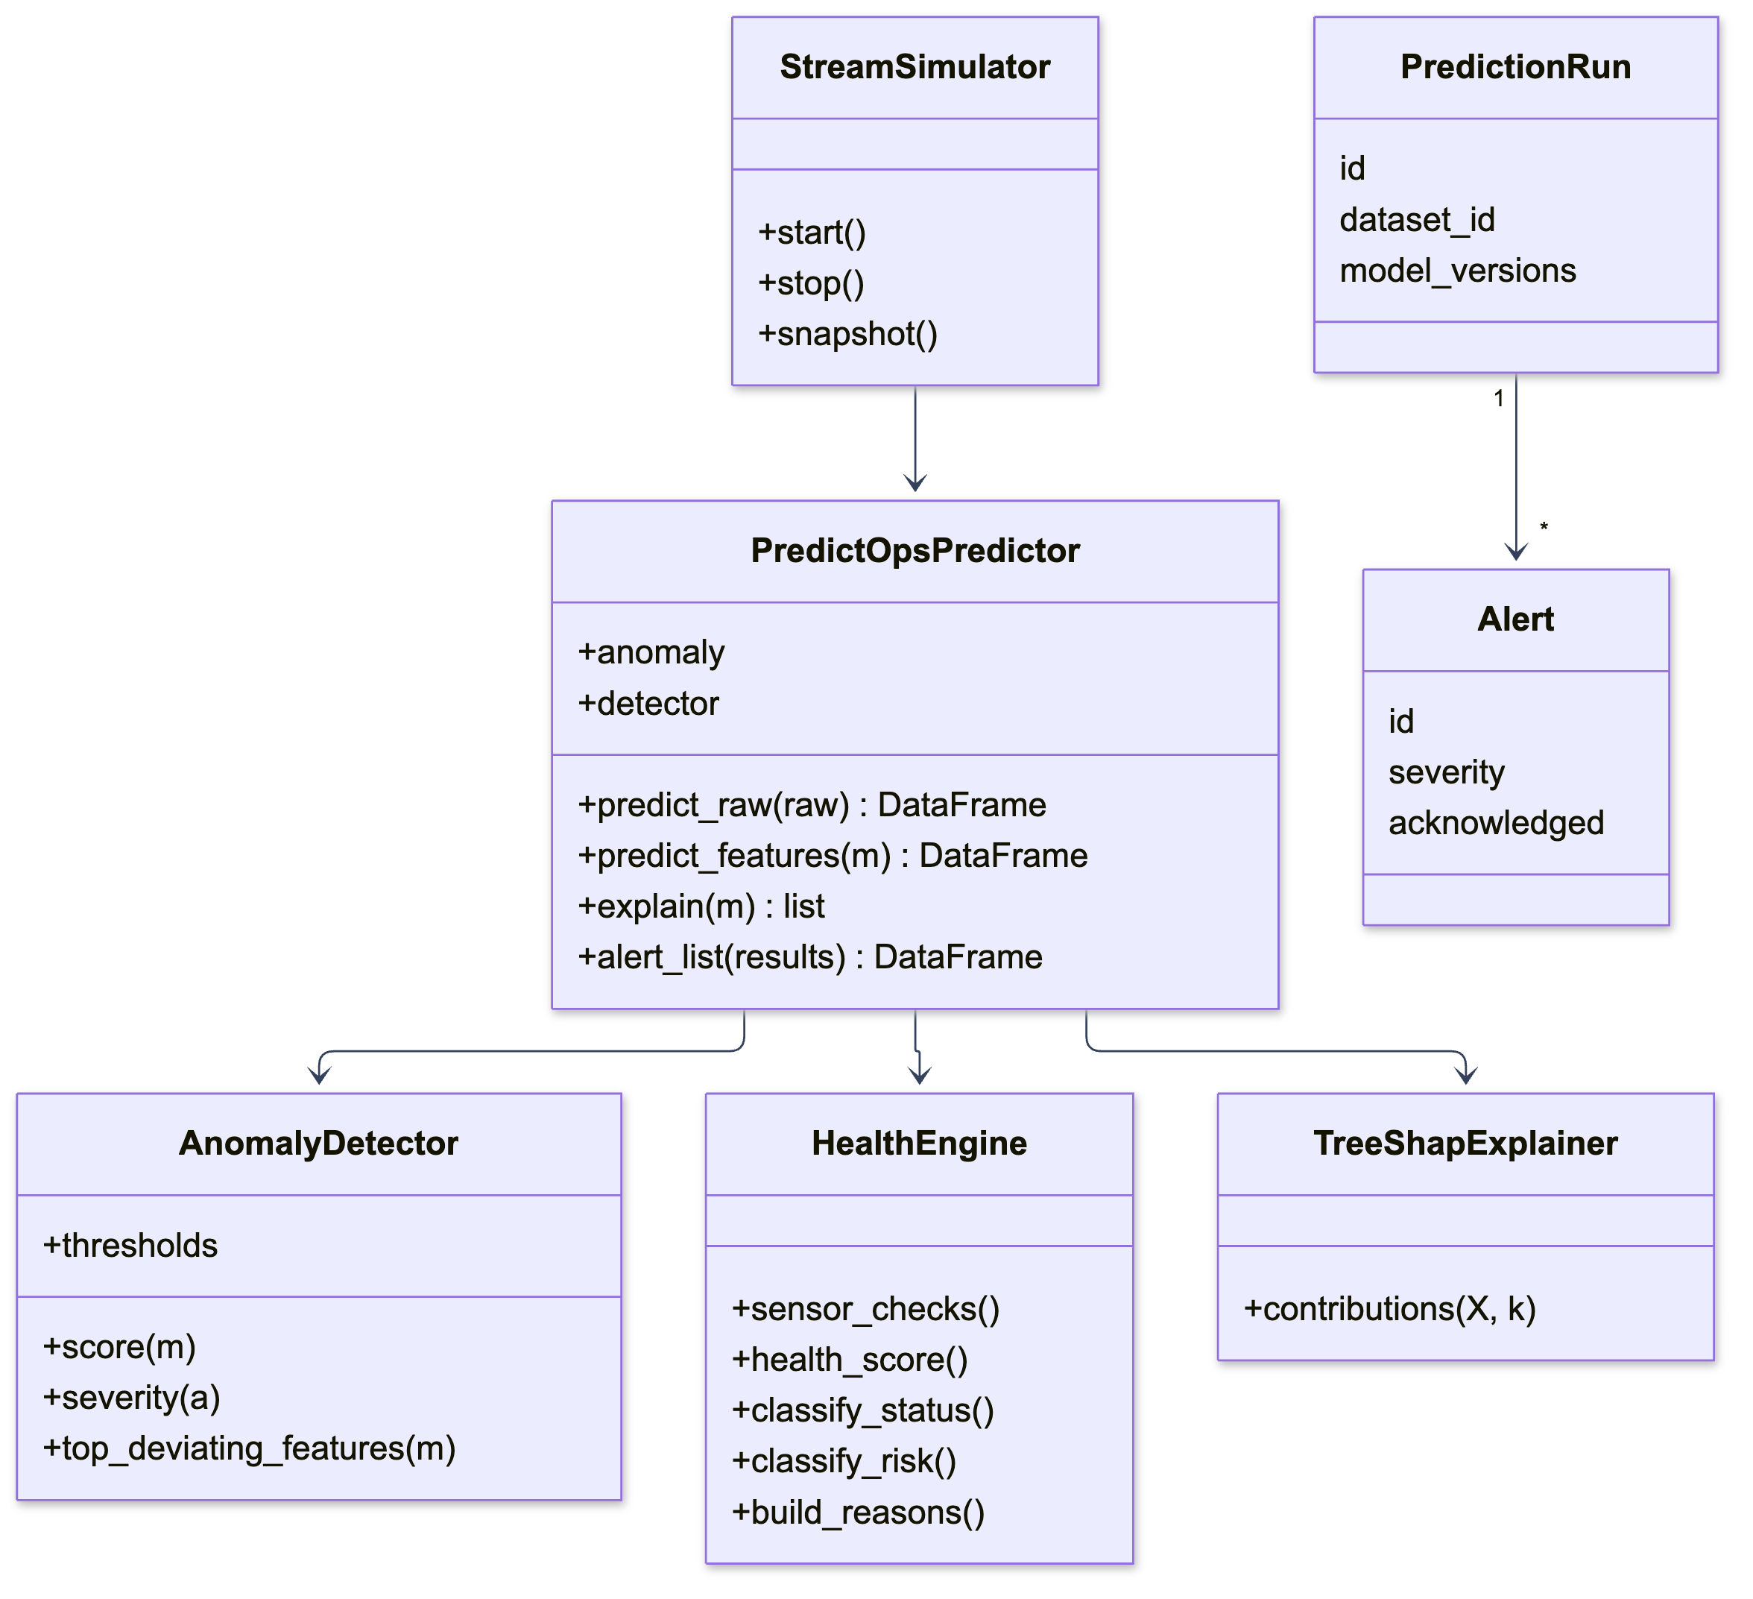
Figure-8: Class Diagram

State Diagram
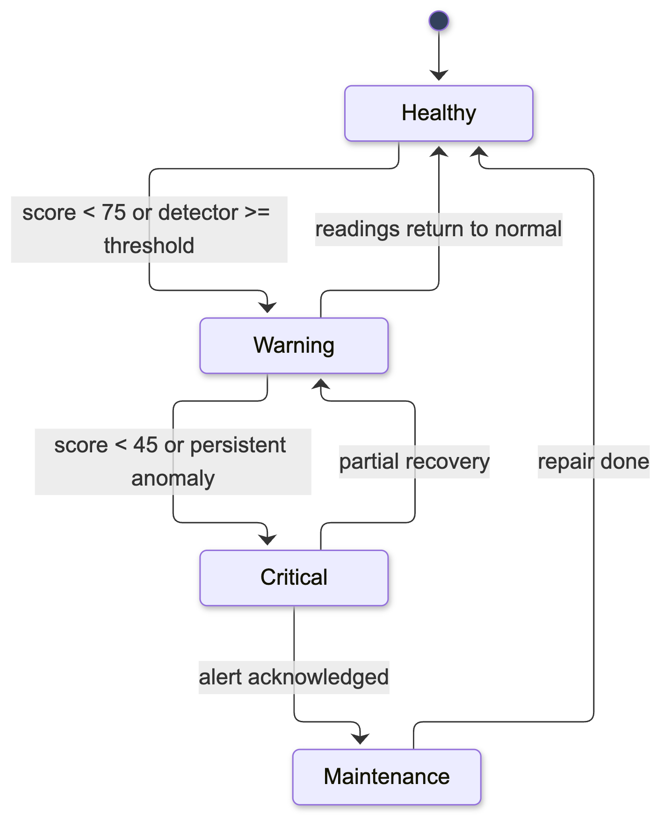
Figure-9: State Diagram (equipment health status)

Sequence Diagram
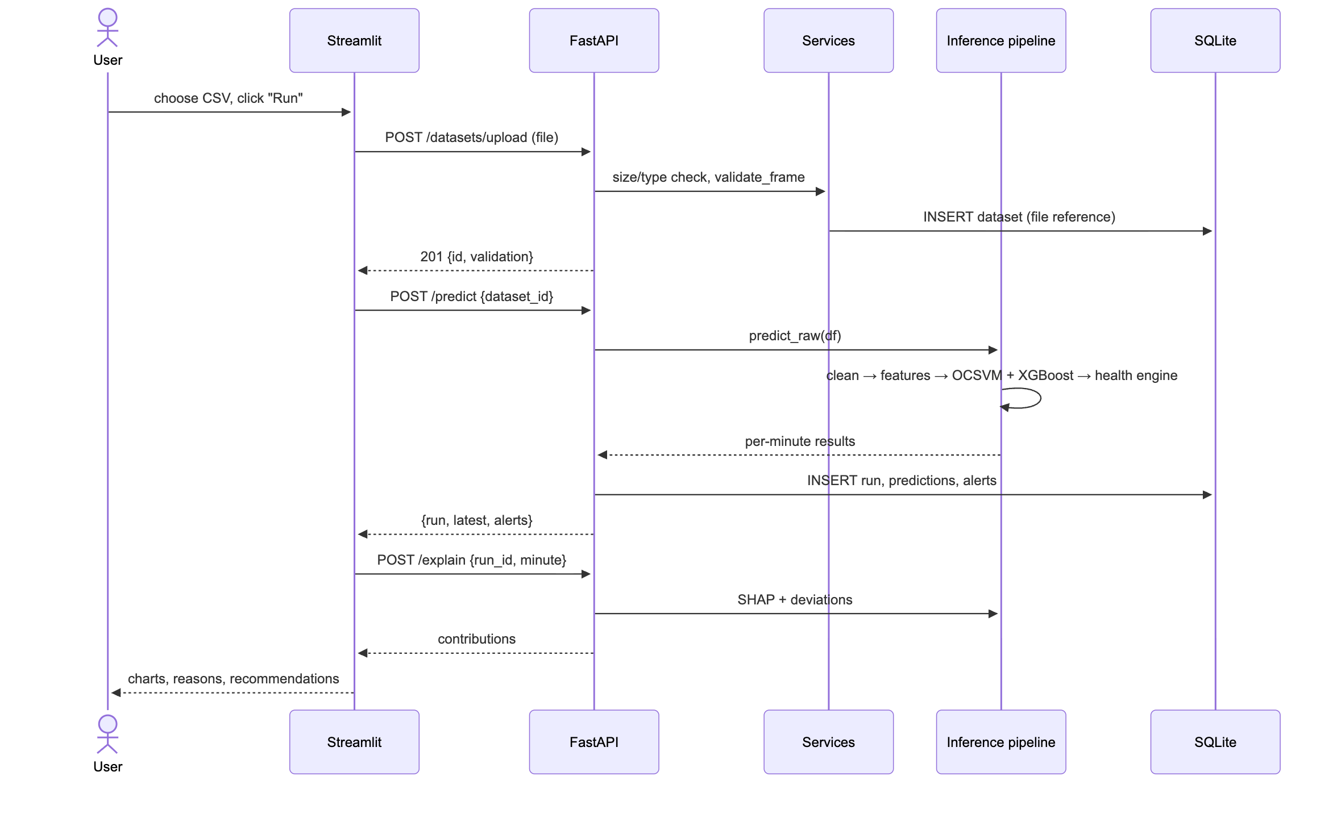
Figure-10: Sequence Diagram — batch prediction

ER Diagram
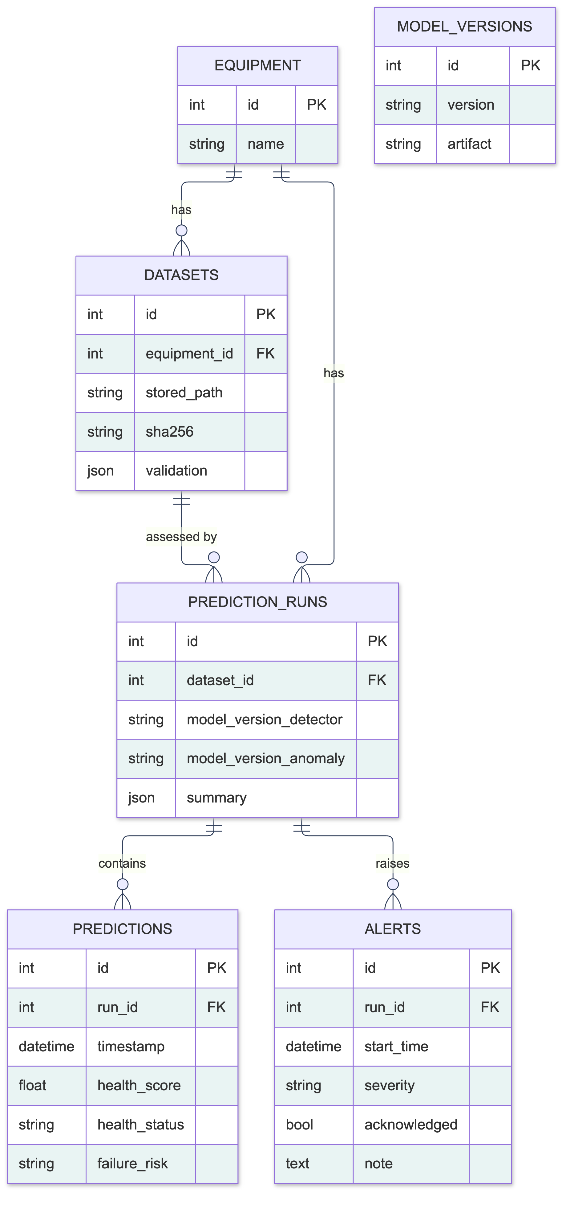
Figure-11: ER Diagram

Deployment Diagram
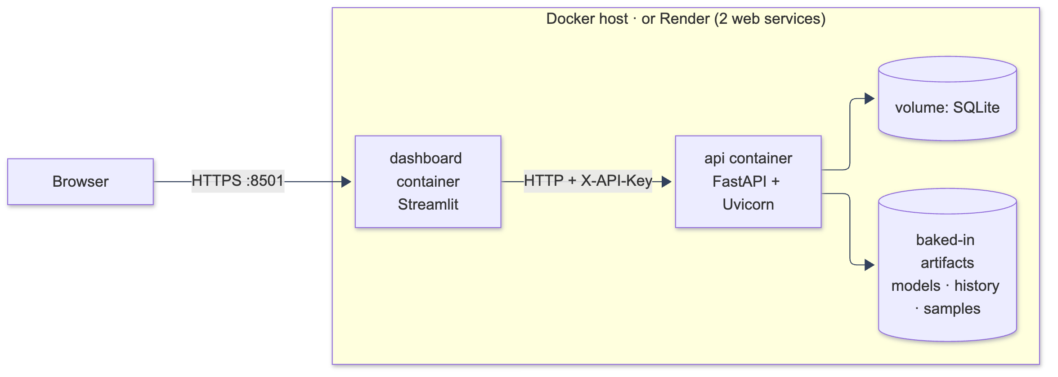
Figure-12: Deployment Diagram

Data Dictionary
Element | Description | Type
Equipment | The monitored APU compressor | Entity
Dataset | Uploaded or sample sensor file (stored as a file reference) | Entity
Prediction run | One assessment of a dataset, with model versions | Entity
Prediction | Per-minute health score, status, risk, anomaly score | Entity
Alert | Persistent-anomaly episode with severity and acknowledgement | Entity
Model version | Version and artifact of a deployed model | Entity
Upload & validate | Check and store a sensor file | Process
Build features | Clean data and compute one-minute features | Process
Score | Run anomaly and signature models | Process
Assess | Compute health, risk, reasons and recommendations | Process
Explain | SHAP contributions and sensor deviations | Process
Raw readings | 10-second sensor values | Dataflow
Assessment | Per-minute results sent to the dashboard | Dataflow
Report | CSV or PDF summary of a run | Data
Table-9: Data Dictionary

8. Testing
Testing used pytest. The suite has 73 tests, all passing (python run.py test). They cover four levels:
Test file | Tests | What is verified
test_ingestion.py | 11 | Schema validation: missing/extra columns, bad timestamps, non-numeric and infinite values, empty file, segment splitting
test_intermediate_data.py | 3 | Row count, sorting, raw CSV unchanged (SHA-256)
test_eda.py | 4 | Operating states, frozen-run detection, failure-window flags
test_preprocessing.py | 12 | Labels never peek ahead; the scaler learns from training rows only; splits follow the calendar with a gap
test_features.py | 4 | Adding later rows leaves earlier features unchanged; windows stop at logger gaps
test_engine_inference.py | 9 | Score stays within 0–100, status and risk rules, full CSV-to-result run, SHAP values add up
test_api.py | 16 | All main endpoints, invalid uploads, path traversal, oversize files, replay, PDF, simulation
test_simulation.py | 2 | Simulation phase order; healthy vs failure separation
test_frontend_pages.py | 12 | All 11 dashboard pages render; prediction flow end to end
Table-10: Automated test suite

8.1 Function Testing

8.1.1 Failure Prediction Module
Functional testing of the Failure Prediction module ensures that users can upload sensor data, run an assessment and receive correct, explained results.
# | Test case | Expected result | Status
1 | Upload the valid sample CSV | Validation passes; dataset stored | Pass
2 | Upload a CSV with a missing sensor column | Clear error naming the missing column | Pass
3 | Upload an empty or non-CSV file | Rejected with an error message | Pass
4 | Upload a file above the size limit | HTTP 413 error | Pass
5 | Run prediction on the event-4 sample | Critical minutes and alerts raised | Pass
6 | Run prediction on a normal day | > 90% of minutes Healthy | Pass
7 | Request explanation of a minute | SHAP values sum to the model output | Pass
8 | Acknowledge an alert with a note | Alert marked acknowledged; note saved | Pass
9 | Download CSV and PDF reports | Files returned with correct content | Pass
10 | Replay a time when the logger was off | HTTP 422 “no recorded data” | Pass
11 | Request an unknown run ID | HTTP 404 | Pass
Table-11: Function test cases

8.2 Path Testing

8.2.1 classify_status()
Pseudo code of the function that assigns the health status:
- If score ≥ 75 then status = Healthy
- Else if score ≥ 45 then status = Warning
- Else status = Critical
- If (alert or detector hit) and status = Healthy then status = Warning
- If alert and detector hit then status = Critical
- Return status
The control flow graph has 4 decision nodes. Cyclomatic complexity V(G) = number of decisions + 1 = 5, so five independent paths were tested: (score ≥ 75, no evidence) → Healthy; (score 45–75) → Warning; (score < 45) → Critical; (score ≥ 75 with alert) → Warning; (alert and detector hit) → Critical. All five are covered by test_health_score_bounds_and_monotonic and the status escalation tests.

8.2.2 classify_risk()
High if the detector ratio ≥ 1 or a medium/high-severity alert is present; else Medium if any alert, unusual severity, detector ratio ≥ 0.5 or a sensor out of range; else Low. Two decisions give V(G) = 3, and all three paths are tested.

8.3 Bugs Found by Testing
Bug | Found by | Fix
NaN values broke JSON responses | API test | Convert NaN to null
Health score 1e-14 instead of 0 | Health bounds test | Round to 0.1
Charts drew lines across logger gaps | Screenshot review | Insert gap markers
Cross-validation used future data | Design review | Forward-chaining folds + test
Table-12: Bugs found and fixed

9. Front-End Description

Streamlit Front-End Overview
The front end is built with Streamlit, a Python framework for data applications, so the same language is used from model to interface. Navigation uses st.navigation with grouped pages. Every number on screen comes from the back-end API; the front end performs no model computation.

Reusable UI Components
A custom theme module (frontend/lib/ui.py) defines status cards, badges with icon and label, section headers, notes and a Plotly chart template, giving every page the same dark industrial look. Colours were checked with a colour-blindness validator.

API Client
frontend/lib/api.py wraps all HTTP calls, caches read-only requests, adds the API key when configured and turns server errors into readable messages.

Charts
Plotly charts support zoom and hover. Long ranges are down-sampled and rendered with WebGL. A gap-breaking helper inserts empty rows at logger gaps so that lines never suggest data that does not exist.

Live Updates
The Live Simulation page uses st.fragment(run_every=2) to refresh the cards and charts every two seconds without reloading the page.

10. Back-End Description

FastAPI and Uvicorn
The back end is a FastAPI application served by Uvicorn. It is organised in layers: routes (HTTP), services (business logic), data access (SQLAlchemy) and the shared inference package. Pydantic models validate every request and response, and interactive documentation is generated automatically.

Inference Pipeline
PredictOpsPredictor loads the trained models once at start-up and exposes predict_raw, predict_features, explain and alert_list. The same feature code is used in training and inference, which guarantees identical preprocessing.

Database
SQLite through SQLAlchemy stores equipment, datasets (as file references), prediction runs with model versions, per-minute predictions, alerts and model versions, with foreign keys, cascades and indexes. Changing DATABASE_URL switches to PostgreSQL.

Middleware and Security
Request logging with timing, optional API-key dependency, CORS allow-list, upload limits and structured error handlers.

MLOps
Model artifacts are saved with metadata (version, features, thresholds, training period, data fingerprint). Experiments are logged in MLflow. A monitoring module computes KS and PSI drift, and the whole stack is containerised with Docker.

11. Results

11.1 Supervised Failure Detection
Model | Validation PR-AUC | Test PR-AUC | Test ROC-AUC | Test recall
XGBoost (selected) | 0.9992 | 0.480 | 0.985 | 0.00
Logistic Regression | 0.9992 | 0.040 | 0.581 | 0.00
SVM (RBF) | 0.9987 | 0.003 | 0.200 | 0.00
Random Forest | 0.9939 | 0.163 | 0.988 | 0.00
Decision Tree | 0.9880 | 0.046 | 0.686 | 0.00
Table-13: Supervised models: validation vs unseen test (event 4)
In the test months, only 270 of the 72,651 minutes belong to a failure (a base rate of 0.0037). Any model that simply answers “normal” every time is therefore right 99.6% of the time, which is exactly what happened here, and it is the reason we never picked a model by its accuracy. Although validation scores were close to perfect, no classifier raised an alarm during event 4 at the threshold it had learned. SHAP points to the cause: the models had come to rely on the DV_pressure pattern seen in events 1–3, whereas event 4 showed a low TP3, an active LPS and hot oil. We did not lower the thresholds after seeing this, because doing so would turn the test set into a tuning set.
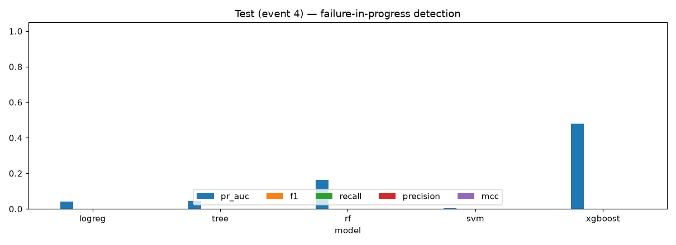
Figure-13: Test-set comparison of supervised models

11.2 Anomaly Detection (main result)
Detector | Validation events | Test events | False alarms / day | Minute recall / precision
One-Class SVM (selected) | 2/2 | 1/1 | 0.16 | 0.61 / 0.29
Isolation Forest | 2/2 | 1/1 | 0.26 | 0.45 / 0.23
LOF | 0/2 | 0/1 | 0 | 0 / 0
Robust z-score | 2/2 | 0/1 | 0 | 0 / 0
Table-14: Anomaly detectors (event-level evaluation)
Using only healthy months for training, the One-Class SVM caught every one of the three failures it was evaluated on, the held-back one included, and raised roughly one false alarm a week. Its alarms came between 16 and 34 minutes after each reported start, so the system recognises a failure that is under way; it does not forecast one hours ahead. We also tried predicting failures 2, 6 and 12 hours in advance, and these models did no better than guessing, so the application does not offer that feature.
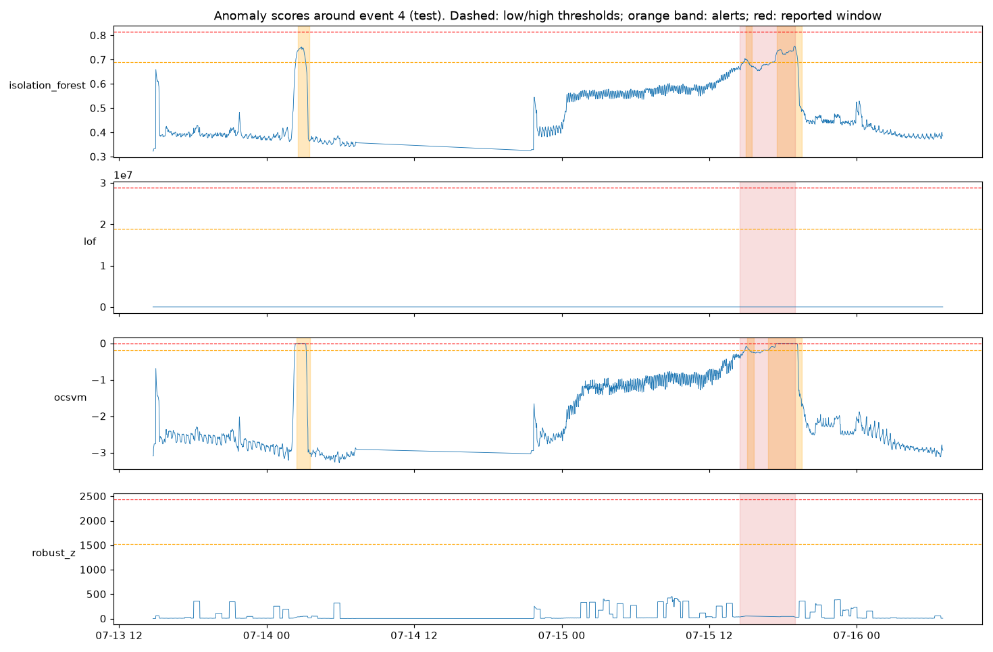
Figure-14: One-Class SVM anomaly score around the unseen test failure (event 4)

11.3 Health Engine and Deep Learning
Across the test months, the health engine labelled 99.3% of normal minutes as Healthy and 61.5% of the minutes inside event 4 as Critical, with about one false Critical episode every ten days. The two neural networks scored a perfect 1.0 on validation, but the LSTM found event 4 in only three of four training runs and the 1D-CNN in none, so neither was put into the application.
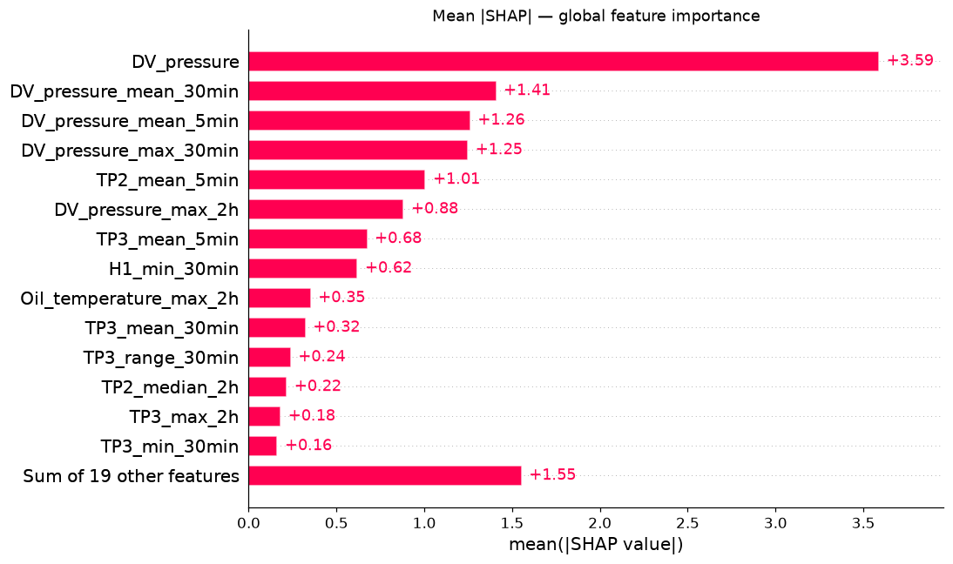
Figure-15: Global SHAP feature importance of the XGBoost signature model

11.4 Application Screenshots
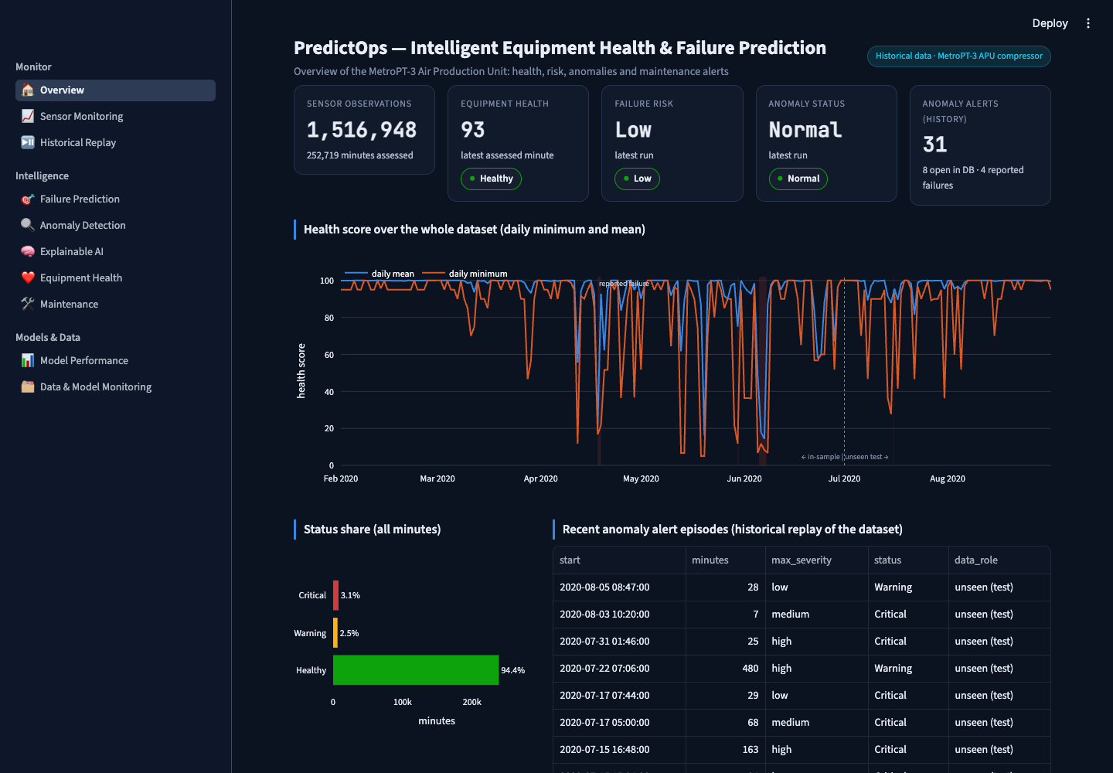
Figure-16: Overview page
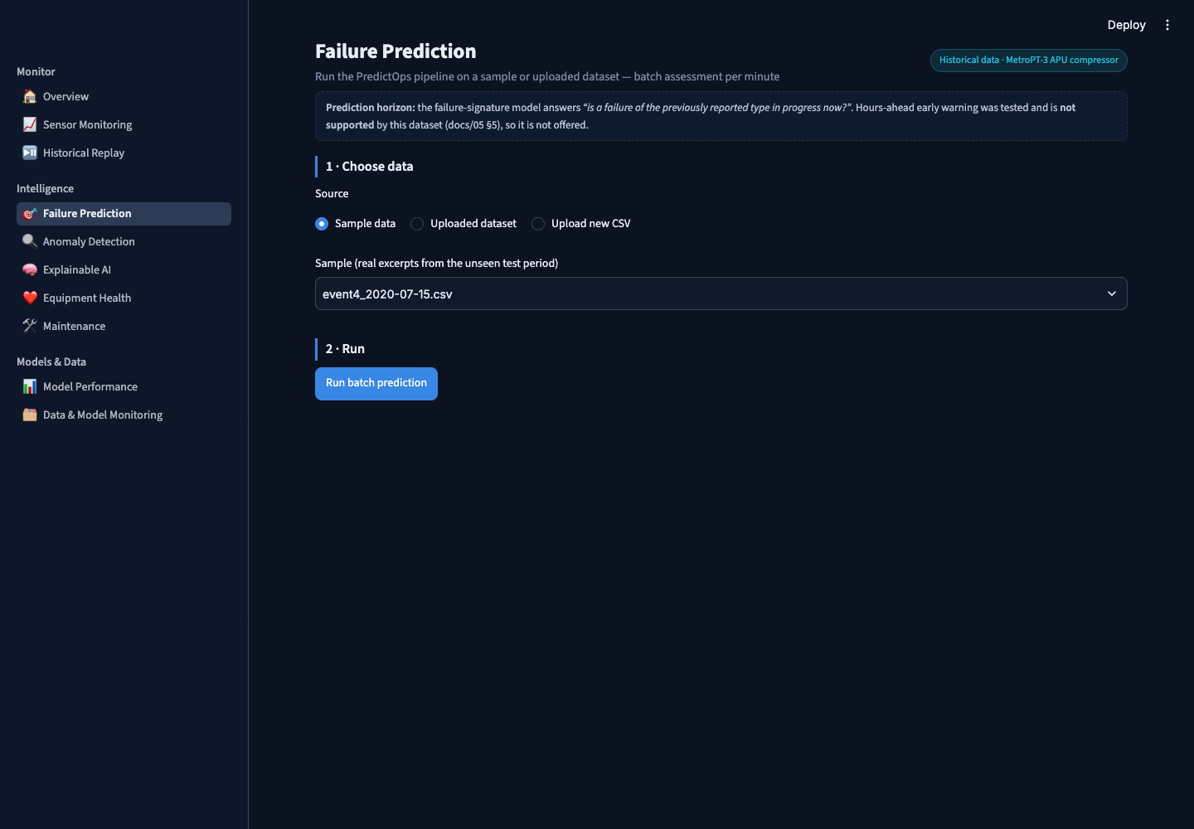
Figure-17: Failure Prediction page
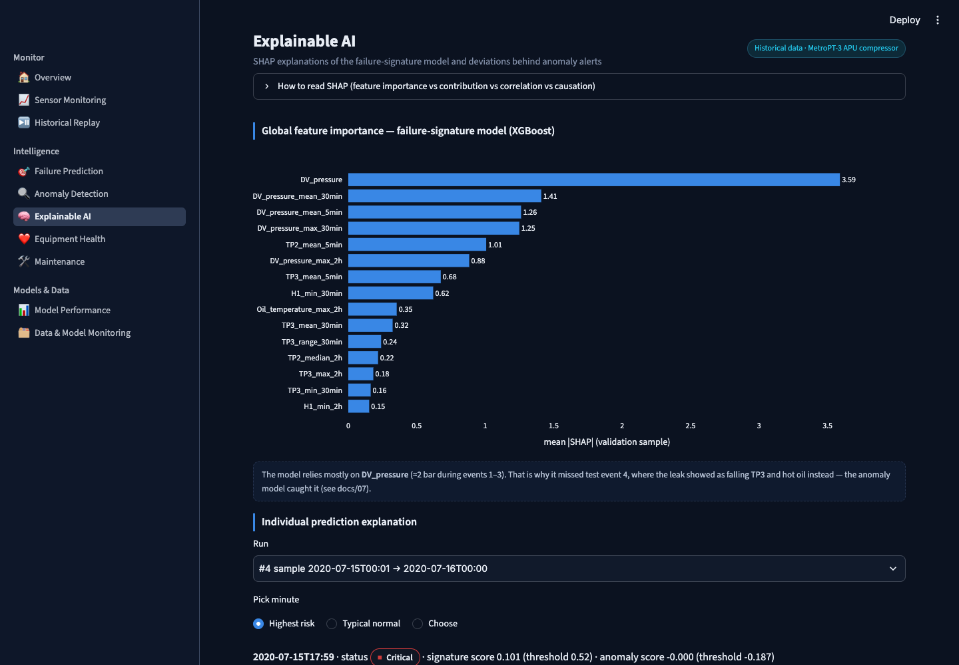
Figure-18: Explainable AI page
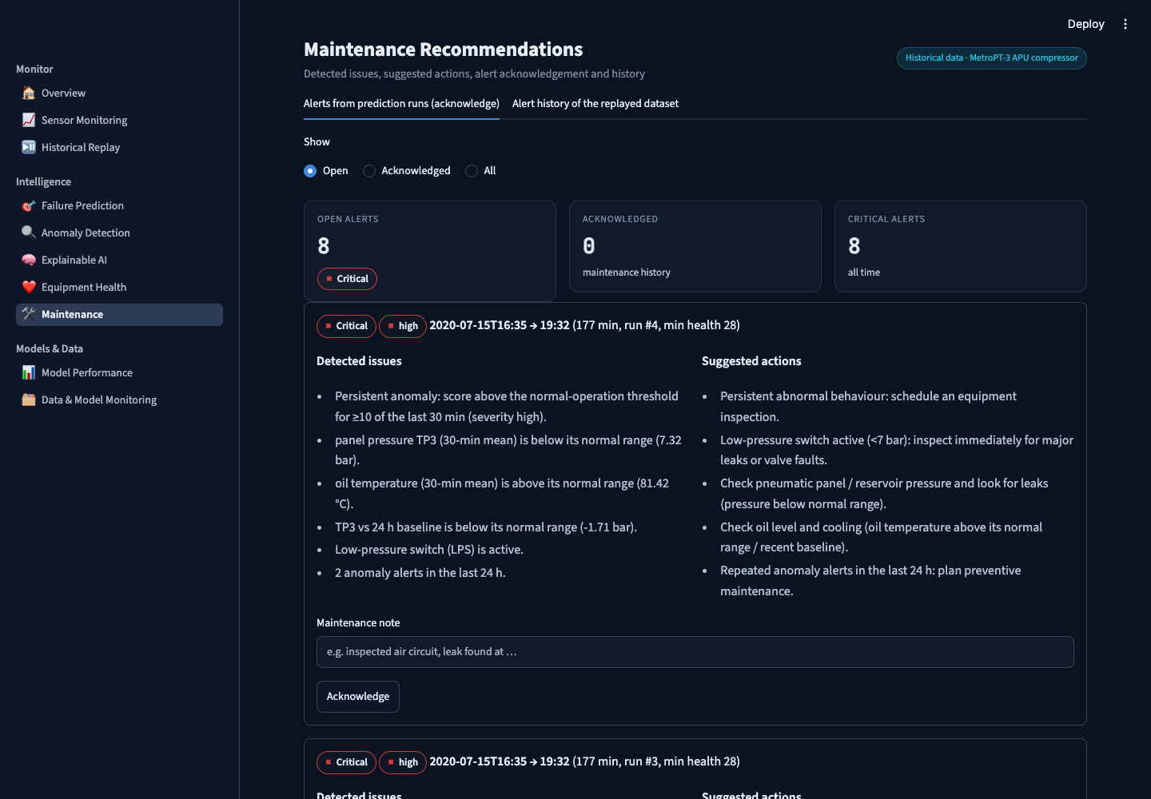
Figure-19: Maintenance alerts page
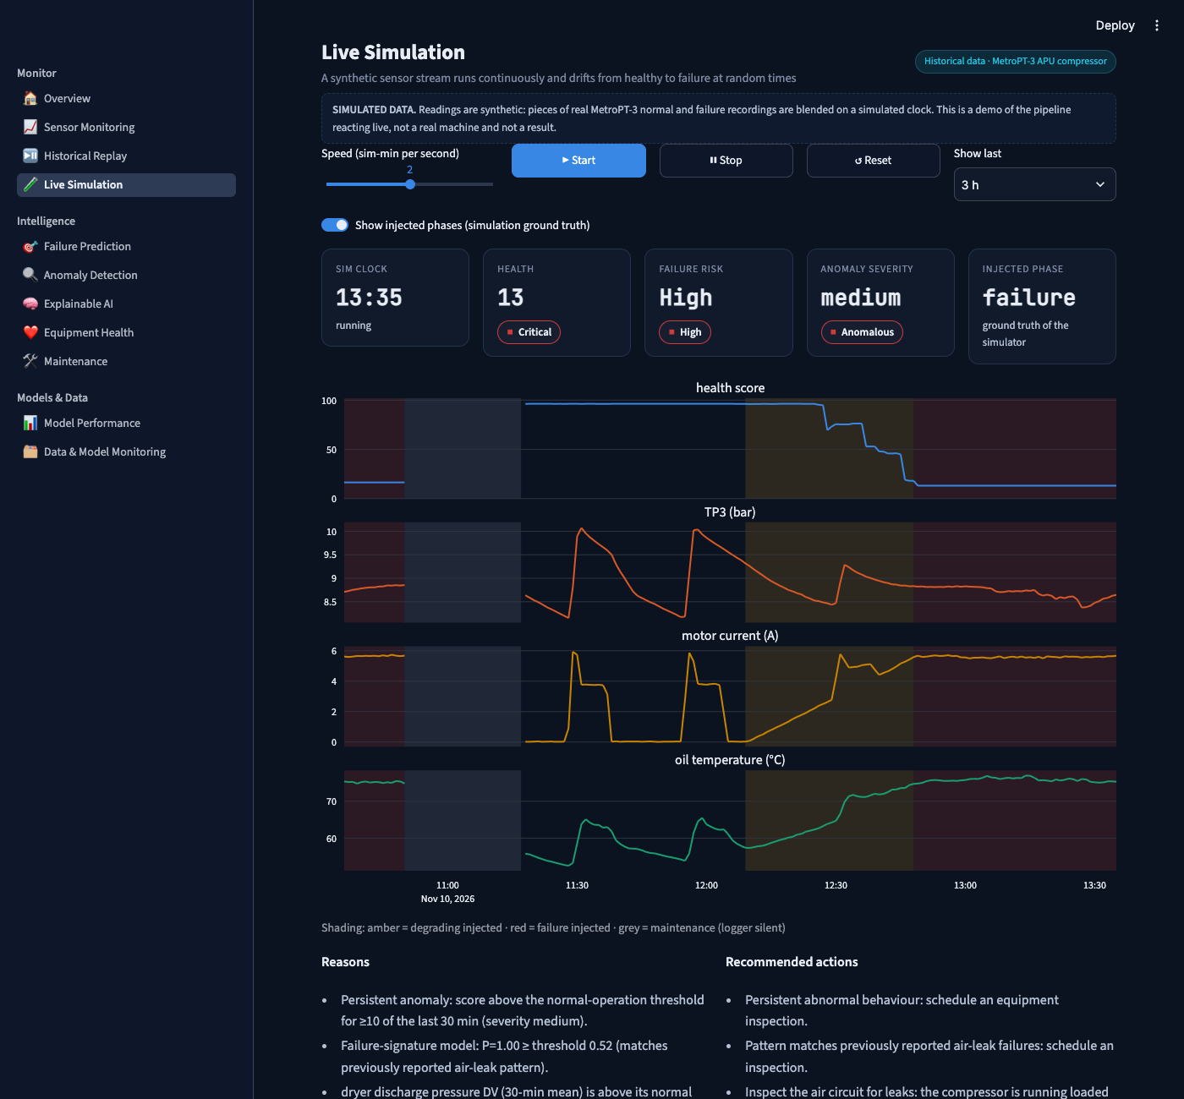
Figure-20: Live Simulation page (synthetic data, labelled)

12. Conclusion
We have produced a working predictive-maintenance system for real compressor data, covering every step from raw sensor files to a deployed dashboard: careful data handling, three families of models, explanations, a health score, an API with a database, eleven dashboard pages, reports, drift checks, 73 tests and Docker packaging.
The part of the work we value most is the way it was evaluated. Because one failure was kept completely aside until the end and was never used for tuning, we could see that the classifiers which looked perfect during development did not carry over to a new failure. Being open about this, and about the early-warning and deep-learning experiments that also fell short, led us to the design that does hold up: a model of normal behaviour feeding a transparent health score, which caught every failure we tested at a cost of about one false alarm a week.
The main lesson is that with very few failure examples, high validation scores can be misleading, and a model that learns what “normal” looks like is more reliable than one that memorises past failures.

13. Future Work
- More failure data: add other MetroPT trains and maintenance logs to retest supervised and early-warning models on more events.
- Early warning from anomaly trends: the anomaly score rose for about 14 hours before event 4; with more events this trend could become an explicit early-warning signal.
- Adaptive thresholds: online learning and per-operating-regime models to handle seasonal drift.
- Live sensor integration: MQTT or OPC-UA ingestion with a time-series database such as TimescaleDB.
- User accounts and roles: per-user authentication and role-based access for engineers and administrators.
- Cost-sensitive alerting: tune alert thresholds with maintenance staff based on the cost of missed failures versus false alarms.

14. References
- N. Davari, B. Veloso, R. P. Ribeiro, P. M. Pereira, J. Gama, “Predictive maintenance based on anomaly detection using deep learning for air production unit in the railway industry,” IEEE DSAA, 2021.
- B. Veloso, R. P. Ribeiro, P. M. Pereira, J. Gama, “The MetroPT dataset for predictive maintenance,” Scientific Data, 9, 764, 2022.
- M. Barros, B. Veloso, P. M. Pereira, R. P. Ribeiro, J. Gama, “Failure detection of an air production unit in the operational context,” Springer, 2020.
- L. Breiman, “Random Forests,” Machine Learning, 45(1), 2001.
- T. Chen, C. Guestrin, “XGBoost: A Scalable Tree Boosting System,” ACM SIGKDD, 2016.
- C. Cortes, V. Vapnik, “Support-vector networks,” Machine Learning, 20(3), 1995.
- F. T. Liu, K. M. Ting, Z.-H. Zhou, “Isolation Forest,” IEEE ICDM, 2008.
- M. M. Breunig, H.-P. Kriegel, R. T. Ng, J. Sander, “LOF: Identifying Density-Based Local Outliers,” ACM SIGMOD, 2000.
- B. Schölkopf et al., “Estimating the support of a high-dimensional distribution,” Neural Computation, 13(7), 2001.
- N. V. Chawla et al., “SMOTE: Synthetic Minority Over-sampling Technique,” JAIR, 16, 2002.
- H. He, Y. Bai, E. A. Garcia, S. Li, “ADASYN: Adaptive synthetic sampling approach for imbalanced learning,” IEEE IJCNN, 2008.
- T. Saito, M. Rehmsmeier, “The precision-recall plot is more informative than the ROC plot when evaluating binary classifiers on imbalanced datasets,” PLoS ONE, 10(3), 2015.
- S. Hochreiter, J. Schmidhuber, “Long Short-Term Memory,” Neural Computation, 9(8), 1997.
- S. M. Lundberg, S.-I. Lee, “A Unified Approach to Interpreting Model Predictions,” NeurIPS, 2017.
- S. M. Lundberg et al., “From local explanations to global understanding with explainable AI for trees,” Nature Machine Intelligence, 2, 2020.
- C. Bergmeir, J. M. Benítez, “On the use of cross-validation for time series predictor evaluation,” Information Sciences, 191, 2012.
- F. Pedregosa et al., “Scikit-learn: Machine Learning in Python,” JMLR, 12, 2011.
- MetroPT-3 Dataset, UCI Machine Learning Repository, https://archive.ics.uci.edu/dataset/791/metropt+3+dataset

