Report

Full Demo link:

* Complexity 1:

<https://drive.google.com/file/d/1sxbtiDV62vvpgvk8Fzi2wfEHPeLdTmhn/view?usp=sharing>

* Complexity 2:

<https://drive.google.com/file/d/1KrQmqweILM3DzxnldAn13-Ijelkldkr6/view?usp=sharing>

* Complexity 3:

# Project Description:

Step is a two-player game where 2 players race. The winner of the game is the player who wins the most races out of 5. The flashing LED’s represents which feet the player needs to move. Players control their feet by using the joysticks.

# User Guide:

### Rules:

On release of the start button, the game immediately starts. When the respective player’s left LED turns on, the respective player must move their left foot. When the respective player’s right LED turns on, the respective player must move their right foot.

### Controls:

There is a push button that starts the game. When the game is running, pressing that button again will reset the entire game. After each round, the button will start the next round. After each game, players can start another game by turning the board off and on again.

Each player has 1 joystick each. Move the joystick left to move the left foot. Move the joystick right to move the right foot. Push the button between each round.

### Special Considerations:

Velit aliquet sagittis id consectetur. Non enim praesent elementum facilisis leo vel fringilla est. Lorem dolor sed viverra ipsum nunc aliquet. Scelerisque felis imperdiet proin fermentum leo vel. Sed enim ut sem viverra aliquet eget sit. Sed turpis tincidunt id aliquet risus feugiat in. Enim lobortis scelerisque fermentum dui faucibus in.

# Source File Description:

* File 1.c - Viverra justo nec ultrices dui sapien eget mi proin sed.
* File 2.h - Ut tristique et egestas quis ipsum. Donec massa sapien faucibus et. Pellentesque pulvinar pellentesque habitant morbi tristique senectus et netus.
* File 3.c - Purus in mollis nunc sed id. Eu feugiat pretium nibh ipsum consequat nisl vel pretium lectus. **Code obtained from** [**https://www.sparkfun.com/products/10168**](https://www.sparkfun.com/products/10168)

# Component Visualization

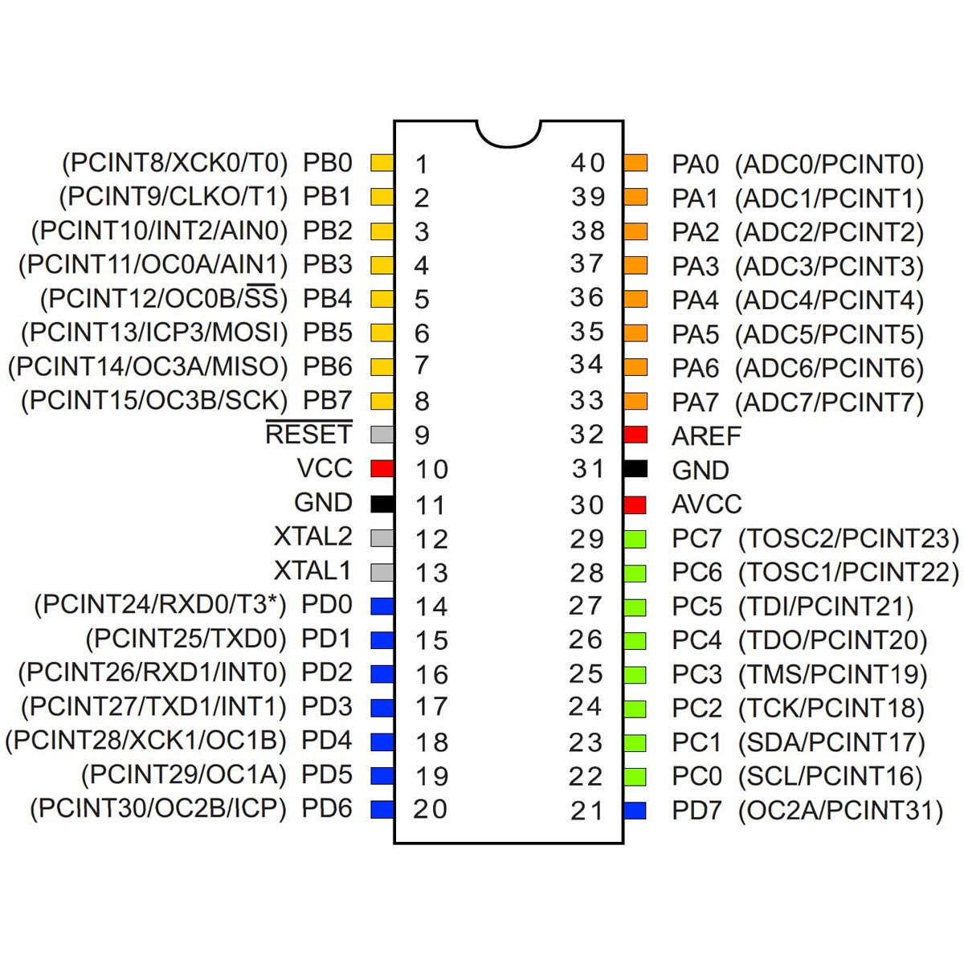

There are two ATMEGA1284 chips in use.

# Technologies Learned

Lectus urna duis convallis convallis. Urna neque viverra justo nec ultrices dui sapien eget. Magna fringilla urna porttitor rhoncus dolor purus non enim praesent. Amet venenatis urna cursus eget. Suspendisse interdum consectetur libero id faucibus nisl tincidunt. Eget aliquet nibh praesent tristique magna sit amet purus. Ac felis donec et odio pellentesque.