**How to set up the new tester**

**Important:** PC must have 2 network cards; use 1Gigabit port to connect with PLC network.  
The virtual network also fine for setup but it can cause the slow issue when running.

**Software**:  
- GIT  
- TortoiseGIT  
- NI Labview 32-bit & 64-bit.  
- NI TestStand 32 bit & 64 bit.  
- NI DSC  
- NI OPC  
- COVA (Valeo software)

**Setup instruction**

1. Setup network.  
   The setting on network port to connect to PLC as following.
   1. IP address = 192.168.60.x, x is identify in the latest “Control Access IP address” file.
   2. Subnet mask = 255.255.255.0
   3. No Gateway.
2. Install following these step.
   1. Git
   2. TortoiseGIT
   3. NI LabView
   4. NI TestStand
   5. NI OPC
   6. NI DSC
   7. COVA

From C to F, you can just install the NI software suite 1 time.  
 It will auto install step C-F for you. **DO NOT FORGET TO INSTALL THE LICENSE**

1. Restart PC.
2. When the PC come back, Copy HVAC folder from backup to C:\HVAC\.
3. Open the OPC from taskbar. Go File->Open and then open the C:\HVAC\OPC\OPC.opf file.
4. After file load, right click on HAVC device and select properties.  
   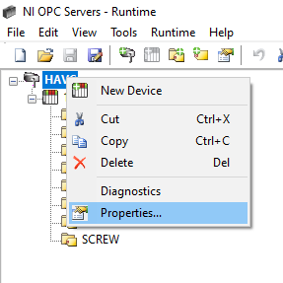
5. Go to “Network Interface” tab, Changethe drop down from “Default” to “network card which has an IP address in 192.168.60.x” network. (where x in step#7 is same as x in step#1)  
   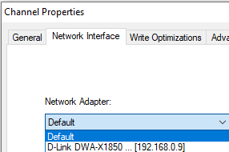
6. Open the command prompt, type “regsvr32
7. Setup COVA.

Done.