# Notes

Jan 5th, 2018

While reading: <https://medium.com/javascript-scene/master-the-javascript-interview-what-is-functional-programming-7f218c68b3a0>

Functional Programming:

Shared state: variable, object, or memory space shared in a scope | property passed between scopes;

Functions are timing dependent

Immutability: the data flow will be lossy

Side effects

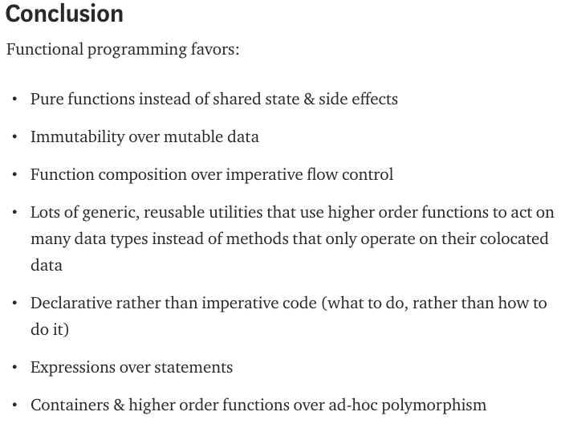

Jan 6th, 2018

While reading: <https://medium.com/@dan_abramov/you-might-not-need-redux-be46360cf367>